MOBILE SOURCE EMISSIONS
(June 2011)

Introduction

Mobile sources include on-road and off-road vehicles and engines. On-road mobile sources include vehicles certified for highway use – cars, trucks, and motorcycles. For reporting on-road mobile source emissions, vehicles are divided into two major classes – light-duty and heavy-duty. Light-duty vehicles include passenger cars, light-duty trucks (up to 8500 lbs gross vehicle weight [GVW]), and motorcycles. Heavy-duty vehicles are trucks of more than 8500 lbs GVW.

Off-road mobile equipment encompasses a wide variety of equipment types that either move under their own power or are capable of being moved from site to site. Off-road mobile equipment sources are defined as those that move or are moved within a 12-month period and are covered under the EPA’s emissions regulations for nonroad mobile sources. Off-road mobile sources are vehicles and engines in the following categories:

- Agricultural equipment, such as tractors, combines, and balers;
- Aircraft, jet and piston engines;
- Airport ground support equipment, such as terminal tractors;
- Commercial marine vessels, such as ocean-going deep draft vessels;
- Commercial and industrial equipment, such as fork lifts and sweepers;
- Construction and mining equipment, such as graders and back hoes;
- Lawn and garden equipment, such as leaf and snow blowers;
- Locomotives, switching and line-haul trains;
- Logging equipment, such as shredders and large chain saws;
- Pleasure craft, such as power boats and personal watercraft;
- Railway maintenance equipment, such as rail straighteners;
- Recreational equipment, such as all-terrain vehicles and off-road motorcycles; and
- Underground mining and oil field equipment, such as mechanical drilling engines.

Road dust emissions estimates are also included in the mobile source emissions category, and are discussed separately with the fugitive dust emissions inventory summary.

Mobile Source Inventory Scope

The scope of the WRAP mobile sources emission inventories is as follows:

Geographic domain: Emissions were estimated by county for all counties in 14 states: Alaska, Arizona, California, Colorado, Idaho, Montana, Nevada, New Mexico, North Dakota, Oregon, South Dakota, Utah, Washington, and Wyoming.

Temporal resolution: Emissions were estimated for an average day in each of the four seasons, and for an average annual weekday. Seasons are defined as three-month periods: spring is March through May; summer is June through August; fall is September through November; and winter is December through February. Emissions were estimated for the 2002 base year and for three future years – 2008, 2013, and 2018.

Pollutants: Emissions were estimated for primary particulate matter (PM₁₀ and PM_{2.5}), nitrogen oxides (NO_{x}), sulfur dioxide (SO₂), volatile organic compounds (VOCs), carbon monoxide (CO), ammonia (NH₃), elemental and organic carbon (EC/OC), and sulfate (SO₄).

Sources: For all pollutants, emissions were estimated separately by vehicle class for on-road sources and by equipment type/engine type for off-road sources. Emissions were summarized for gasoline and diesel-fueled engines.

Approach For Estimating Mobile Source Emissions

As with most emissions sources, on-road and off-road mobile source emissions are estimated as the products of emission factors and activity estimates. Except for California, the on-road mobile sources emission factors were derived from EPA’s MOBILE6 model, available at http://www.epa.gov/OMSWWW/m6.htm. Activity for on-road mobile sources is vehicle miles traveled (VMT). State and local agencies were provided default modeling inputs and VMT levels for base and future years for review and update; all states and several agencies provided updated. The California Air Resources Board (CARB) provided on-road emissions estimates by county and vehicle class directly; these were based on CARB’s in-house version of their EMFAC model.

For all states except California, EPA’s draft NONROAD2004 model was used to estimate so-called traditional off-road sources, all sources listed above except aircraft, commercial marine, and locomotives. The NONROAD model includes estimates of emission factors, activity levels, and growth factors for all traditional off-road sources. The default activity levels were provided to state agencies for input and update; however, no state provided updated off-road activity data. Emissions estimation methods for aircraft, commercial marine, and locomotives were similar to approaches EPA has recently used in developing national emission inventories. For California, CARB provided off-road emissions estimates by source category and county directly.

Emissions Models Used and Additional Calculations for Air Quality Modeling

On-road and off-road mobile source emissions are estimated as the products of emission factors and activity estimates. Except for California, the on-road mobile sources emission factors were derived from the EPA MOBILE6 model. Activity for on-road mobile sources is vehicle miles traveled (VMT). EPA’s NONROAD2004 model was used to estimate emissions from off-road mobile sources except for aircraft, commercial marine, and locomotives.

EPA MOBILE6 Model

The MOBILE model is EPA’s regulatory model for estimating on-road mobile source gram per mile emission factors for VOC (exhaust and evaporative), NO_{X}, CO, PM, NH₃, and SO₂. The current regulatory version of the model is MOBILE6, released in 2002. The model and supporting documentation may be found on EPA’s Web site at http://www.epa.gov/OMSWWW/m6.htm.

The MOBILE6 model includes the effects of all of the following “on the books” Federal regulations for on-road motor vehicles:

- Tier 1 light-duty vehicle standards, beginning with, beginning MY 1996;
- National Low Emission Vehicle (NLEV) standards, beginning MY 2001;
- Tier 2 light-duty vehicle standards beginning MY 2005, with low sulfur gasoline beginning summer 2004;
- Heavy-duty vehicle standards beginning MY 2004; and
- Heavy-duty vehicle standards beginning MY 2007, with low sulfur diesel beginning summer 2006.

MOBILE6 estimates emissions by vehicle class, for 28 vehicle classes. For the WRAP modeling, the emissions were estimated for eight vehicle classes, which are combined from these 28. The eight vehicle classes are those that were modeled in the prior generation of the mode, MOBILE5, as shown in Table 1.

Table 1
MOBILE5 Vehicle Classes for Which Emissions Were Estimated

Vehicle Class | MOBILE Code | Weight Description
Light-duty gasoline vehicles (passenger cars) | LDGV | Up to 6000 lb gross vehicle weight (GVW)
Light-duty gasoline trucks¹  (pick-ups, minivans, passenger vans, and sport-utility vehicles) | LDGT1 | Up to 6000 lb GVW
 | LDGT2 | 6001-8500 lb GVW
Heavy-duty gasoline vehicles | HDGV | 8501 lb and higher GVW equipped with heavy-duty gasoline engines
Light-duty diesel vehicles (passenger cars) | LDDV | Up to 6000 lb GVW
Light-duty diesel trucks | LDDT | Up to 8500 lb GVW
Heavy-duty diesel vehicles | HDDV | 8501 lb and higher GVW
Motorcycles² | MC
¹ Emissions for light-duty trucks are modeled separately for two weight classes with different emissions standards in the Clean Air Act.
² Highway-certified motorcycles only are included in the model. Off-road motorcycles, such as dirt bikes, are modeled as a no-road mobile source in EPA’s NONROAD model.

The particulate matter emission factors in MOBILE6 are from an earlier EPA particulates emission factor model called PART5. The tire and brake wear estimates from PART5 used in MOBILE6 are dated, and newer brake wear estimates were available (Garg et al,) and were used to develop revised brake wear emission factors, the same as used in the previous WRAP mobile sources emission inventory (Pollack et al., 2004).

EPA NONROAD Model

Off-road mobile equipment encompasses a wide variety of equipment types that either move under their own power or are capable of being moved from site to site. Off-road mobile equipment sources are defined as those that move or are moved within a 12-month period and are covered under the EPA’s emissions regulations for nonroad mobile sources. Emissions for so-called traditional nonroad sources are estimated by EPA in their NONROAD emissions model, available on the NONROAD Web page at http://www.epa.gov/otaq/nonrdmdl.htm.

At the time that the off-road emissions were estimated for this project, the latest version of the model was draft NONROAD2004. In December of 2005 final NONROAD2005 was released. The Web page above provides now only the NONROAD2005 final model.

The NONROAD model includes both emission factors and default county-level population and activity data. The model therefore estimates not just emission factors but also emissions. Technical documentation of all aspects of the model can be found on the EPA NONROAD Web page.

The NONROAD model includes more than 80 basic and 260 specific types of nonroad equipment, and further stratifies equipment types by horsepower rating and fuel type, in the following categories:

- Airport ground support, such as terminal tractors;
- Agricultural equipment, such as tractors, combines, and balers;
- Construction equipment, such as graders and back hoes;
- Industrial and commercial equipment, such as fork lifts and sweepers;
- Recreational vehicles, such as all-terrain vehicles and off-road motorcycles;
- Residential and commercial lawn and garden equipment, such as leaf and snowblowers;
- Logging equipment, such as shredders and large chain saws;
- Recreational marine vessels, such as power boats;
- Underground mining equipment; and
- Oil field equipment.

The NONROAD model does not include commercial marine, locomotive, and aircraft emissions. Emissions for these three source categories are estimated using other EPA methods and guidance documents (described in Sections 5-7). However, support equipment for aircraft, locomotive, and commercial marine operations and facilities are included in the NONROAD model.

The NONROAD model estimates emissions for six exhaust pollutants: hydrocarbons (HC), NO_{x}, carbon monoxide (CO), carbon dioxide (CO₂), sulfur oxides (SO_{x}), and PM. The model also estimates emissions of non-exhaust HC for six modes — hot soak, diurnal, refueling, resting loss, running loss, and crankcase emissions.

The NONROAD model used in this study incorporates the effects of all of the following “on the books” Federal nonroad equipment regulations:

- Emission standards for new nonroad spark-ignition engines below 25 hp;
- Phase 2 emission standards for new spark-ignition handheld engines below 25 hp;
- Phase 2 emission standards for new spark-ignition non-handheld engines below 25 hp;
- Emission standards for new gasoline spark-ignition marine engines;
- Tier 1 emission standards for new nonroad compression-ignition engines above 50 hp;
- Tier 1 and Tier 2 emission standards for new nonroad compression-ignition engines below 50 hp including recreational marine engines;
- Tier 2 and Tier 3 standards for new nonroad compression-ignition engines of 50 hp and greater not including recreational marine engines greater than 50 hp; and
- Tier 4 emissions standards for new nonroad compression-ignition engines above 50 hp, and reduced nonroad diesel fuel sulfur levels.

The NONROAD model provides emission estimates at the national, state, and county level. The basic equation for estimating emissions in the NONROAD model is as follows:

Emissions = (Pop)(Power)(LF)(A)(EF)

where
Pop = Engine Population
Power = Average Power (hp)
LF = Load Factor (fraction of available power)
A = Activity (hrs/yr)
EF = Emission Factor (g/hp-hr)

The national or state engine population is estimated and multiplied by the average power, activity, and emission factors. Equipment population by county is estimated in the model by geographically allocating national engine population through the use of econometric indicators, such as construction valuation. The manner in which the geographic allocation is performed is as follows:

(County Population)_{i} /(National Population)_{I} = (County Indicator)_{i} /(National Indicator)_{i}

where i is an equipment application like construction or agriculture.

Activity is temporally allocated through the use of monthly, and day of week fractions of yearly activity.

The NONROAD model has default estimates for all variables and factors used in the calculations. All of these estimates are in model input files, and can be changed by the user if data more appropriate to the local area are available.

California Models

The California Air Resources Board (CARB) provided on-road and off-road emissions data for base and future years for use in this project. CARB has developed their own models for on-road and off-road emissions estimation. CARB’s on-road model is referred to as EMFAC. The version of the model that was used to generate the CARB on-road emissions was EMFAC2002 (available at http://www.arb.ca.gov/msei/on-road/latest_version.htm), with internal updates for some of the activity data that were not publicly available.

For many years, CARB has been developing its own off-road emissions model, called OFFROAD. Although CARB has developed most of the model inputs as part of their analyses in support of their off-road equipment regulations, the model has never been publicly released.

For all California emissions, CARB provided their emissions estimates for the base and future years. Emissions data only were provided, not activity data and emission factors.

Pollutants Added for Air Quality Modeling

For CMAQ modeling, additional model species are required beyond what is estimated in MOBILE, NONROAD, EMFAC, and OFFROAD. Specifically, particulate matter needed to be split into elemental carbon (EC), organic carbon (OC), and sulfate (SO₄); and NO_{X} needed to be split into NO and NO₂.

EC and OC were estimated by applying EC/OC fractions to the PM₁₀ and PM_{2.5} emissions estimates. The EC/OC splits used for these calculations are summarized in Table 2. These are the same EC/OC fractions used in the previous WRAP mobile sources emissions estimates; their derivation is described in Pollack et al., 2004. Sulfate was then estimated as PM – EC – OC, for both PM₁₀ and PM_{2.5}. Coarse PM is calculated as PM₁₀ – PM_{2.5.}

Table 2
Elemental Carbon/Organic Carbon Fractions

Process/Pollutant | EC | OC | Source
Gasoline Exhaust | 23.9% | 51.8% | Gillies and Gertler, 2000
Light-Duty Diesel Exhaust | 61.3% | 30.3% | Gillies and Gertler, 2000
Heavy-Duty Diesel Exhaust | 75.0% | 18.9% | Gillies and Gertler, 2000
Tire Wear | 60.9% | 21.75% | Radian, 1988
Brake Wear | 2.8% | 97.2% | Garg et al, 2000

While there have been several studies and reviews of particulate composition (e.g. U.S. EPA, 2001 and Turpin and Lim, 2000) since the time of the work referenced in Table 2, there has not been a comparable comprehensive evaluation of particulate composition. Many particulate source/receptor statistical modeling efforts have been attempted, but all used source profiles that predate those listed in Table 2. A comprehensive evaluation of source profiles needs to include the effect of the proper age distribution and maintenance history of in-use vehicles. No recent studies have investigated the source profiles using such an evaluation, and so could not be used for this work. In addition, the default EPA resource for compositional estimates of emissions, SPECIATE, has not provided any revised profiles since October 1999.

The ratio of NO to NO₂ for NO_{x} emissions from mobile sources is a result of the chemical equilibrium formed during internal combustion with NO the primary constituent of NO_{x}. Aftertreatment devices may begin to perturb the ratio of NO and NO₂ as NO_{x} and particulate control are applied to diesel engines (Tonkyn, 2001, Herndon, 2002, and Chatterjee, 2004). However, these systems have not yet been widely employed, so it is not possible to judge what the proportion of NO_{x} that NO and NO₂ will be in the future. For this work the EPA default proportions of NO and NO₂ (90/10) were used to apportion the NO_{x} emission estimates.

Temporal Profiles

The on-road and off-road emissions are estimated as average day, per season. For use in air quality modeling, these average day emissions must be temporally allocated to the 24 hours of the day for each day of the week. This temporal allocation is done in the SMOKE emissions processing system. The EPA temporal profiles for on-road and off-road emissions were reviewed and found to be deficient for on-road sources. The EPA defaults for on-road temporal profiles vary only by weekday vs. weekend; for both weekdays and weekends the 24-hour profiles do not vary by vehicle class. And there are only two day of week profiles – one for light-duty gasoline vehicles and one for all vehicle classes.

ENVIRON has analyzed an extremely large database of detailed traffic counter data by vehicle class, roadway type, and state under contract to EPA (Lindhjem, 2004). From this work using national databases of vehicle activity maintained by the Federal Highway Administration (FHWA), revised temporal profiles for on-road sources were developed. The databases used were the FHWA Traffic Volume Trends (http://www.fhwa.dot.gov/policy/ohpi/travel/index.htm) for temporal activity of vehicles, and the FHWA Vehicle Travel Information System (VTRIS) (http://www.fhwa.dot.gov/ohim/ohimvtis.htm) that identifies individual vehicle classes to estimate temporal variation in the vehicle mix. Three sets of profiles were developed: day of week profiles by vehicle class (Figure 1); hour of day profiles for weekdays, by vehicle class (Figure 2); and hour of day profiles for weekends, by vehicle class (Figure 3). These temporal profiles show important differences in vehicle activity by vehicle class across the days of the week and the hours of the day.

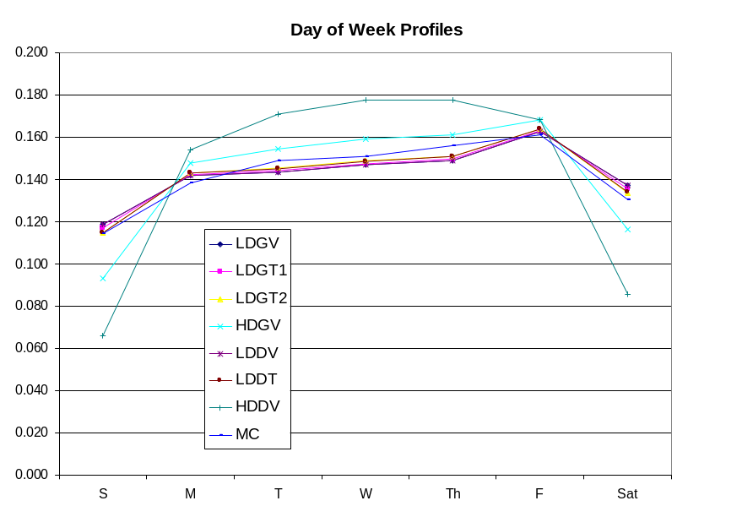

Figure 1. Day of week profiles by vehicle class.

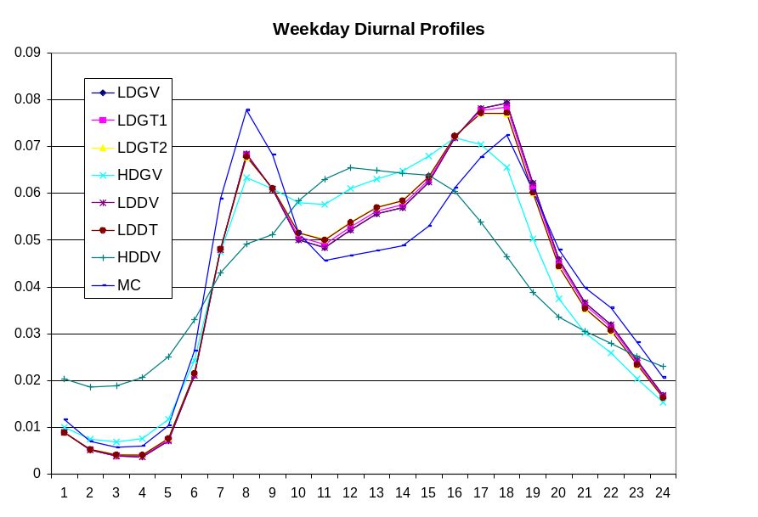

Figure 2. Weekday hour of day profiles by vehicle class.

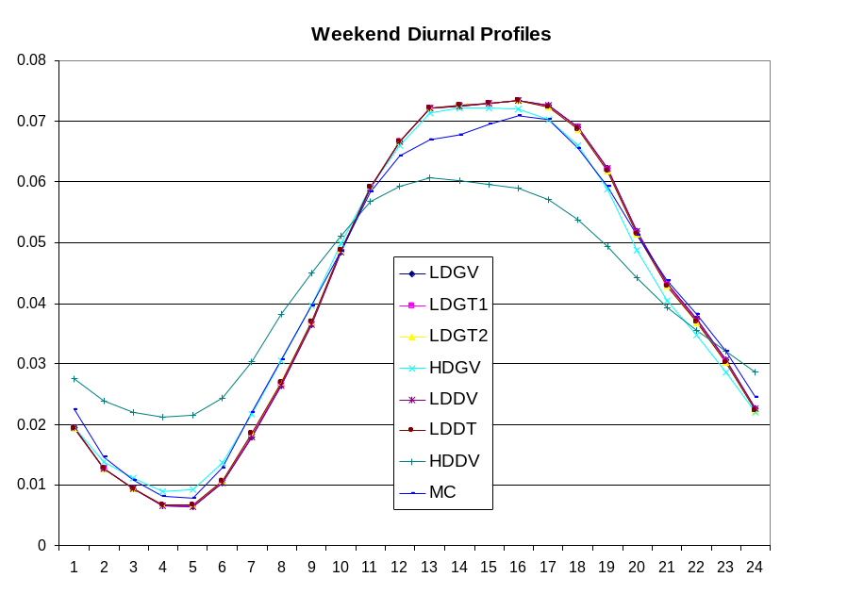

Figure 3. Day of week profiles by vehicle class.

Locomotive Emissions Estimation Methodology

County-level locomotive emissions estimates were estimated as the product of locomotive fuel consumption and average locomotive emission factors. Previous WRAP locomotive emissions estimates (Pollack et al., 2004) allocated national fuel consumption estimates to counties using emissions data offered by the National Emissions Inventory. A detailed revision to that allocation method was developed for allocating 2002 national fuel consumption estimates. Emission factors were also revised to combine line-haul and switching engines because only national total fuel consumption was available. Additional emission factors for ammonia and fuel sulfur provided by EPA were also incorporated and form the basis from which sulfur dioxide was estimated.

2002 Locomotive Emissions

Development of the 2002 locomotive emissions involved spatially allocated 2002 national locomotive activity, in the form of fuel consumption, using historic data of freight movements. The 2002 Class I railroad activity data were derived from national fuel consumption data reported by the Association of American Railroads (AAR, 2003), and the activity data for Class II/III railroads from data reported by the American Short Line & Regional Railroad Association (ASLRRA, 1999 and Benson, 2004). To allocate this national fuel consumption to the county-level, ENVIRON used the most recent county-level rail activity estimates available. These activity estimates were ton-miles of freight movement estimated by the Bureau of Transportation Statistics (2002), using data from 1995. The 2002 national activity data were allocated to each county in the WRAP states using the fraction of the 1995 national rail activity that occurred in each county and then multiplying that fraction by the 2002 national rail activity, as demonstrated in equation (1).

CA02 = NA02 * (CA95/NA95) (1)

where
CA02 = 2002 county locomotive fuel consumption
NA02 = 2002 national locomotive fuel consumption
CA95 = 1995 county million gross ton miles (MGTM)
NA95 = 1995 national total MGTM

The spatial allocation of the national emissions in this work followed the methods of the EPA National Emission Inventory (NEI, 1999 and unchanged for 2002) of allocating locomotive activity. The 1995 activity data were obtained as GIS shapefiles containing track segments and an associated database of rail density per mile (MGTM/mi) corresponding to those segments. The segment-specific rail density estimates were provided as ranges. For each segment, the midpoint of the density range was assumed to represent the average track loading on that segment. Table 3 shows a list of the ranges and the midpoint values used in this study. The top end density was reported as an open-ended range, greater than 100 MGTM/mi, which was estimated as 120 MGTM/mi. This differs from the allocation method used in the NEI 2002, which represented the top end traffic density as 100 MGTM/mi. The use of 120 MGTM/mi is expected to more accurately reflect the relative importance of those main line track segments than using the minimum value of 100 MGTM/mi.

Table 3
Track Segment Density Ranges Used for Allocation to Counties (MGTM/mi)

Density ID | Segment Density Range | Assumed Segment Density
0 | unknown, abandoned, or dummy | 0
1 | 0.1 to 4.9 | 2.5
2 | 5.0 to 9.9 | 7.45
3 | 10.0 to 19.9 | 14.95
4 | 20.0 to 39.9 | 29.95
5 | 40.0 to 59.9 | 49.95
6 | 60.0 to 99.9 | 79.95
7 | 100.0 and greater | 120

To obtain county-level rail density from track segment density, a shapefile was first created that contained all US counties. Next, the two shapefiles were projected to the same map projection so that the counties were overlaid by the BTS track segments. Then, track segments were intersected by the county borders so that county-specific track segments were created. For each county it was then possible to sum the products of segment densities and county-specific segment lengths to obtain the total county activity as 1995 ton-miles. The county fraction of 1995 national rail activity was then the sum of activity in that county over the sum of activity in all counties. The relative county locomotive activity for the western states is shown in Figure 4.

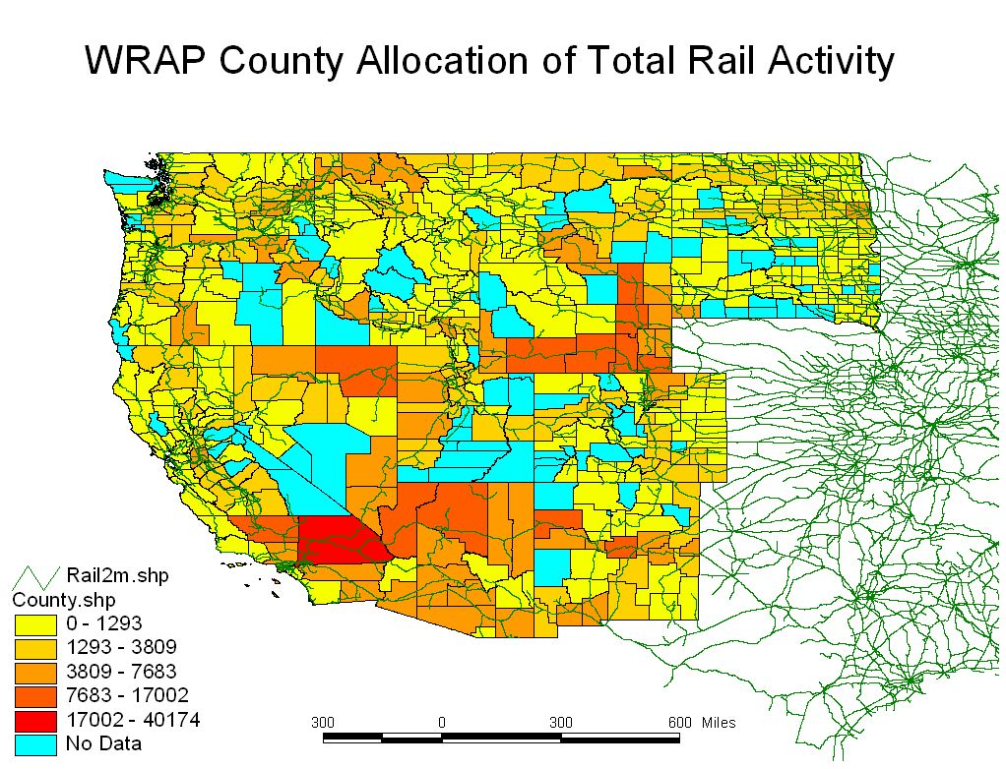

Figure 4. County-level rail activity in the WRAP states.
Year 2002 county rail fuel consumption was estimated using the 1995 county fraction of national rail activity as demonstrated in equation (1). National locomotive fleet average emissions factors with units of grams per gallon of fuel were obtained from the U.S. EPA (1997). The emission factors for 2002 are summarized in Table 4. County level emissions of hydrocarbons (HC), NO_{x} and particulate matter (PM₁₀) were calculated by multiplying 2002 county-level fuel consumption by these emission factors.

Table 4
National Fleet Average Emission Factors (gram per gallon) From EPA (1997)

Engine Type | HC | CO | NOx | PM | SO2¹ | NH3²
2002 Fleet Average | 10.7 | 27.4 | 248.8 | 6.8 | 16.4 | 0.116
¹ Reported as SO2 and derived from an average sulfur level of 2600 ppm. (U.S. EPA, 2004b)
² U.S. EPA (2004a)

One issue was to determine the fraction of the total PM emissions that is sulfate. Equation (2) was derived from test data from an EPA study that measured the PM weight change that resulted from a change in the fuel sulfur level. The percentage of sulfate PM was estimated to be 19.4%. The remaining PM was split between EC and OC using the historic National Emission Trends report estimate of 80% as elemental carbon and 20% as organic carbon.

Sulfate PM (BSFC units) = BSFC * 7.0 * 0.02247 * 0.01 * (SOx_{fuel} - SOx_{bas}) (2)

where
SOx_{bas} = 0% sulfur for entirely elemental and organic carbon PM
SOx_{fuel} = % sulfur in fuel used (0.26%)

Sulfate PM = 0.0004 (g/gram fuel) or 1.32 (g/gallon) or 19.4% of the PM rate in
Table 4.

Equation (2) was derived by estimating that the fuel sulfur partially (2.247%) converts to SO₃ (with the remainder emitted as SO₂), which rapidly hydrolyzes in the humid exhaust to hydrated sulfuric acid [H₂SO₄*(7)H₂O] and condenses on other PM. From this assumption arises the molecular weight adjustment of 7.0 (ratio of hydrated sulfuric acid to elemental sulfur). The figure 0.01 in the equation is to adjust values in percent (%) to fractional values.

County-level locomotive emissions were estimated for all WRAP counties based on the procedure described above, except for those areas for which emissions data were supplied by local or state agencies. Four states - Alaska, Arizona, Wyoming, and Idaho - and one county - Clark County, NV - supplied more detailed locomotive emissions estimates from local surveys and other information derived from specific activity in those states. In the case of Arizona and Wyoming, ENVIRON performed surveys of all railroad activity (Pollack et al, 2004a; Pollack et al, 2005). The Alaska Department of Environmental Conservation (Edwards, 2005) and the Idaho Department of Environmental Quality (Reinbold, 2005) supplied their own estimates, as did the Clark County Department of Air Quality Management (Li, 2005).

The spatial allocation of annual locomotive NO_{x} emissions is shown in Figure 5. Seasonal emissions were estimated based on an assumption of uniform year-round activity. Figure 5 shows the effect of the major east-west corridors from Los Angeles through Arizona and New Mexico, Northern California through Nevada, Utah and Wyoming, and Washington, Northern Montana and North Dakota; the north-south corridor through California, Oregon, and Washington; and the coal mining region of eastern Wyoming. Other major and minor routes are also evident though the size of the county affects the emission totals estimated, so a major line that runs through a small or narrow county may not appear significant, and, likewise, a large county may appear over-weighted compared with a neighboring county with less through mileage.

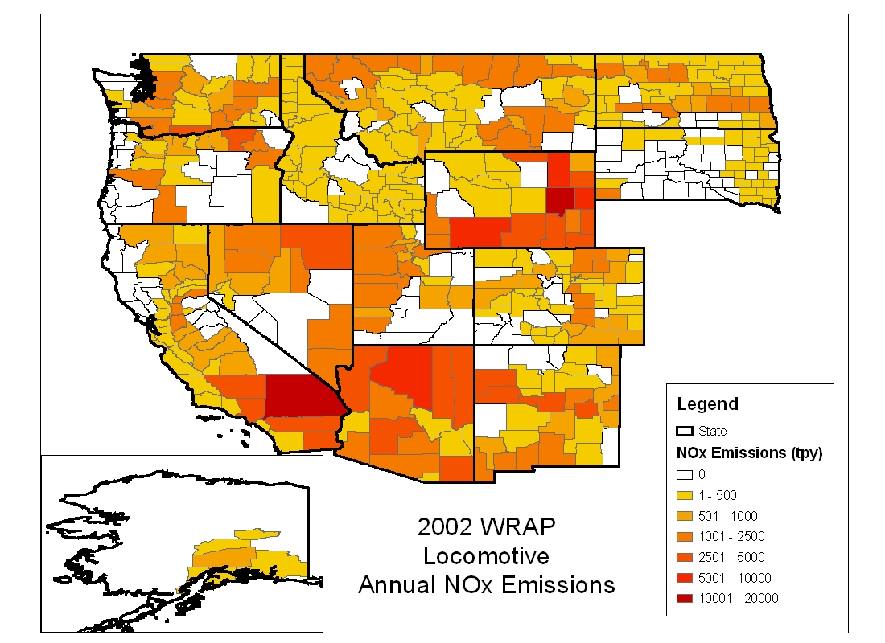

Figure 5. County-level rail NO_{x} emissions (tons per year) in the WRAP states.

2018 Locomotive Emissions

To estimate future year activity, a trend analysis was performed on the historical fuel consumption of the activity of the two predominant (in the West, Union Pacific and BNSF) railroads’ activity. Figure 6 shows the company-wide fuel consumption calculated from historic revenue ton-mile and fuel consumption per revenue ton-mile. National freight transfers and the regression of fuel efficiency were used to determine the fuel consumption trend over as long a period as possible. Freight transfers (ton-mile) are not a sufficient activity indicator alone because the efficiency (ton-miles per gallon of fuel consumed) of railroads has been improving over time. AAR (2005) provided historical efficiency (gallons per ton-mile) for Burlington Northern (predating the merger with the Atchison Topeka and Santa Fe [ATSF] railroad) and Union Pacific (predating the merger with Southern Pacific and others). The historic trend in fuel efficiency for each company (Union Pacific and Burlington Northern) was combined with the revenue ton-mile for Union Pacific and Southern Pacific, and BN and ATSF. A trend in fuel consumption for the combined companies was thus estimated from 1990 through 2002 as shown in Figure 6 despite the merger activity that occurred during this period. The future year projected activity was then determined from a linear regression of the fuel consumption for the combined company operations of the predominant railroads in their current configuration as Union Pacific and BNSF.
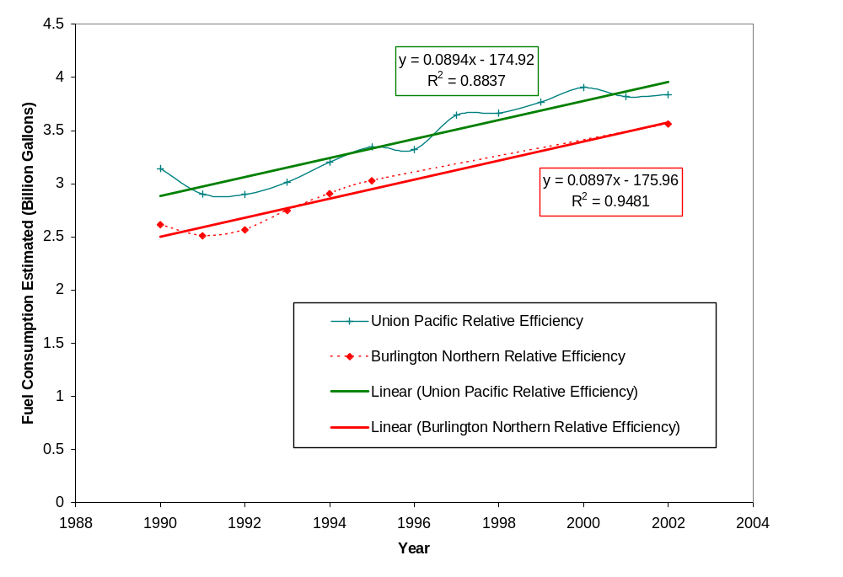
Figure 6. Trends in historical rail fuel consumption by railroad.

The resulting future year projection factors are listed in Table 5 for the two major railroads and the combined projection. The trends for the two railroads are very similar.

Table 5
Locomotive Activity Growth Projection for This Work

Comparison Years | Union Pacific | BNSF | Combined
2008 / 2002 | 1.13 | 1.15 | 1.14
2013 / 2002 | 1.24 | 1.27 | 1.26
2018 / 2002 | 1.35 | 1.40 | 1.37

In addition to projected railroad activity, the emission rates were projected using EPA future year emission rates (1997, Regulatory Support Document), as shown in Table 6.

Table 6
Locomotive Emission Rate Projections

Comparison Years | HC | CO | NOx | PM | SO2* | NH3
2008/2002 | 0.892 | 1.000 | 0.693 | 0.882 | 0.192 | 1
2013/2002 | 0.819 | 1.000 | 0.627 | 0.802 | 0.006 | 1
2018/2002 | 0.763 | 1.000 | 0.580 | 0.740 | 0.006 | 1
* Fuel sulfur averaged 2600 ppm in 2002, assumed to average 500 ppm in 2008 and 15 ppm in 2013 and 2018. (EPA, Clean Air Nonroad Diesel Rule Fact Sheet, May, 2004) PM emission rates were not adjusted for fuel sulfur level though a reduction should be realized with low sulfur fuel.

The overall emissions from locomotives for future years were then determined by combining the activity growth in Table 5 and the emission rate projections in Table 6.

California Locomotive Emissions

CARB provided locomotive emissions for the base and three future years from their internal emissions data bases. CARB’s emission estimates assumed 2500 ppm sulfur in the fuel for all years, and so adjustments were made to the SO₂ and PM emissions to reflect the lower mandated levels in future years. Federal requirements are for sulfur levels to be 500 ppm in 2008 and 15 ppm in 2013 and 2018. However, ARB expects fuel sulfur levels to be 129 in 2008. SO₂ emissions were adjusted using a direct scalar of the fuel sulfur levels assumed in the emissions estimated by ARB and the regulated levels. The PM emissions were adjusted to reflect the lower sulfur levels using a PM adjustment derived by ARB staff, as provided to ENVIRON.

The CARB emissions did not include NH3; NH3 was estimated by developing a scaling factor based on SO_{x} emissions. Yearly fuel consumption estimates were derived based on SO_{x} emissions and the CARB assumed 2500ppm fuel sulfur content. A per-volume NH₃ emission factor was applied to the estimated fuel consumption to estimate NH3 emissions for each year at the county level. Lastly, PM was split among sulfate, EC, and OC using the same methods as for the other states described above.

Aircraft Emissions Estimation Methodology

County-level aircraft emissions for 2002 for the WRAP states were obtained from work performed for EPA’s 2002 National Emissions Inventory (NEI2002). Activity data for aircraft emissions are takeoff cycles (LTOs), and emission factors are primarily from the Federal Aviation Administration (FAA) Emissions and Dispersion Modeling System (EDMS). The 2002 emissions were projected to future years using forecast LTOs available from the FAA. More detailed estimates were provided for some states.

The FAA EDMS model combines specified aircraft and activity levels with default emissions factors in order to estimate annual inventories for a specific airport. Aircraft activity levels in EDMS are expressed in terms of LTOs, which consist of the four aircraft operating modes: taxi and queue, take-off, climb-out, and landing. Default values for the amount of time a specific aircraft spends in each mode, or the time-in-modes (TIMs), are coded into EDMS.

Aircraft emissions are estimated for four aircraft categories:

- Air carriers, which are larger turbine-powered commercial aircraft with at least 60 seats or 18,000 lbs payload capacity;
- Air taxis, which are commercial turbine or piston-powered aircraft with less than 60 seats or 18,000 lbs payload capacity;
- General aviation aircraft, which are small piston-powered, non-commercial aircraft; and
- Military aircraft.

2002 Aircraft Emissions

For the 2002 aircraft emissions, annual emissions files prepared for the NEI2002 formed the basis of the work. These files were sent to ENVIRON by EPA’s contractor, Eastern Research Group (Billings, 2005). For this work, ERG ran the EDMS model for about 1100 towered airports across the U.S. using detailed 2002 aircraft/LTO activity data. Additional calculations were performed to estimate the additional pollutants needed for WRAP modeling. Key elements of those calculations are described by aircraft type below.

Air Carriers – The NEI2002 inventory data for VOC, CO, NOx, and SO₂ for Air Carriers were used directly. Additional calculations were made to estimate the emissions of the additional pollutants in the WRAP inventory:

- The NO_{x} inventory speciation values for NO and NO₂ were assumed to be 90% and 10%, respectively, which are the default EPA speciations.
- It was assumed that no NH₃ is emitted from air carrier turbine engines, which normally run lean.
- All of the fuel-bound sulfur was assumed to form SO₂ in the engine exhaust.
- Due to the lack of other, more recent sources for aircraft particulate emission factors, the total suspended particulate (TSP) emissions from the air carriers were estimated using a commercial fleet-average emission factor from EPA’s 1985 National Acid Precipitation Assessment Program (NAPAP). To calculate PM_{2.5}, according to the NEI2002, 97.6% of the particulate matter emitted from Commercial Aircraft was assumed to be PM_{2.5}, as is assumed in the NEI2002.

Air Taxi, General Aviation and Military Aircraft – The NEI2002 inventory data for VOC, CO, NO_{x}, SO₂, PM₁₀, and PM_{2.5} for these Aircraft types were used directly. Additional calculations were made to estimate the emissions of the additional pollutants in the inventory:

- As for the air carriers, 90% of the NOx emissions were assumed to be NO and 10% were assumed to be NO₂.
- For ammonia, air taxi and military aircraft were assumed to be dominated by turbine-powered aircraft running lean, thus producing a negligible amount of ammonia. For general aviation, ammonia was estimated using a fleet-average fuel consumption rate from the EDMS data for piston engines, operational mode-specific fuel flow rates weighted by the typical time spent in each mode, average hours of operation estimated from FAA data, and a g/gallon emission factor for non-catalyst light-duty gasoline engines.
- As for air carriers, all of the fuel-bound sulfur was assumed to form SO₂ in the engine exhaust.

State Updates

The NEI2002-based inventory estimates were updated with additional information provided for six areas:

For Alaska, Sierra Research, under contract to the WRAP Emissions Forum, developed seasonal aircraft emissions estimates for all aircraft types for Alaska in 2002. These data were used instead of the NEI2002 data described above. A number of minor modifications needed to be made to the data to make them consistent with the rest of the aircraft data. The most significant difference was that air carriers and air taxis were lumped into one category. These were then coded as the air carriers SCC, and WRAP Alaska air taxi emissions were set to zero.

For Arizona, the NEI2002-based inventory was updated with emissions estimates from the Arizona 2002 inventory work previously done by ENVIRON (Pollack et al., 2004). This work included detailed EDMS modeling based on activity data obtained from both the FAA and local sources. Further updates were made for specific airports with emissions data provided by Pima and Maricopa Counties.

The Idaho DEQ provided 2002 aircraft emissions for all counties for general aviation and military aircraft.

Clark County (Nevada) provided 2002 emissions estimates for three airports in the county, based on a recent airport emissions study (Ricondo, 2004).

For Wyoming, the NEI2002-based inventory was updated emissions estimates from Wyoming 2002 inventory work previously done by ENVIRON (Pollack et al., 2005). This work included detailed EDMS modeling based on activity data obtained from both the FAA and local sources.

The California Air Resources Board (CARB) provided both base and future year aircraft emissions estimates, discussed below.

Seasonal Emissions Estimates

The NEI2002 aircraft emissions are annual estimates, as were most of the updates provided by state and local agencies. To estimate seasonal county-level emission inventories, the monthly distribution of activity for airports in the WRAP region was obtained from the FAA’s Air Traffic Activity Data System (ATADS) (http://www.apo.data.faa.gov/main/atads.asp). The ATADS is the official source for historical monthly or annual air traffic statistics for airports with FAA-operated or FAA-contracted traffic control towers. The average seasonal distribution was calculated by state and aircraft type from the ATADS dataset. These state-level seasonal distributions were then applied to the annual county-level emissions in each state to derive the seasonal county-level emissions for each state.

2018 Aircraft Emissions

For all states except California, aircraft emissions were projected to the three future years from the 2002 emissions, by county and aircraft type, using FAA LTO forecasts as the activity data. Emission factors were assumed to be unchanged over time. The International Civil Aviation Organization (ICAO) has promulgated NO_{x} and CO emission standards for commercial aircraft, exempting general aviation and military engines from the rule (ICAO, 1998), and the majority of engines are already meeting this standard. EPA officially promulgated the ICAO standards for air carriers in a final rule in November 2005.

The historic and projected LTO data by airport are available online from the Federal Aviation Administration (FAA) Terminal Area Forecast (TAF) database (http://www.apo.data.faa.gov/main/taf.asp) for all aircraft categories for which emissions were estimated. Projected LTO data for years 2008, 2013, and 2018, and historic data for 2002 were used to develop future year growth factors for all aircraft types. Growth factors were calculated as the ratio of the sum of LTOs by county and aircraft type in each future year to the sum of LTOs by county and aircraft type in 2002. These future year growth factors were then applied to 2002 emission estimates by county and aircraft to develop future year emission inventories.

A small number of counties had no aircraft LTOs in 2002 and a significant number of LTOs in future years. For these counties, emissions were calculated using projected future year LTOs and Emission Factors by aircraft type.

California Aircraft Emissions

CARB provided annual, winter, and summer aircraft emissions estimates by county and aircraft type for the 2002 base year and the three future years. A number of processing steps were required to generate off-road emissions for California that are similar in content and format to the emissions for the remaining WRAP states:

- The CARB aircraft emissions for commercial aircraft and air taxis were combined. The SCC for commercial aircraft was assigned to the combined emissions, and zero emissions were assigned to the SCC for air taxis.

- Spring and fall emissions were calculated at the county and SCC level as:
Spring or fall emissions = (4 * annual emissions - winter emissions - summer emissions)/2
- Ammonia emissions were calculated using NH₃/SO_{x} scaling factors at the county and SCC level.
- The additional pollutants needed for WRAP modeling were calculated using speciation factors and appropriate formulas.

Detailed discussions of the development of the mobile source emissions inventories can be found in Pollack, et al., 2004.

Generation of SMOKE and NIF Files

All mobile source emissions files were generated in the format needed for SMOKE emissions processing. Annual average day county-level locomotive emissions SMOKE files were generated, for all WRAP states combined, only for years 2002 and 2018, the years for which the WRAP air quality modeling is performed. The pollutants included in the SMOKE files are VOC, NO_{x}, CO, NH₃, SO₂, PM₁₀, EC₁₀, OC₁₀, SO₄(₁₀), PM_{2.5}, EC_{2.5}, OC_{2.5}, SO₄(_{2.5}), coarse PM (PM_{C}), NO, and NO₂. Separate files were prepared for each year.

Emissions Summaries

Summaries of the gridded mobile source emissions for the Base02b, Plan02c, Plan02d, Base18b, and PRP18a inventories by state and county, annual and seasonal periods, can be found on the TSS at: http://vista.cira.colostate.edu/tss/Results/Emissions.aspx.

References

AAR 2003. “Analysis of Class I Railroads, 2002,” and RR Industry Info: Railroad and States, http://www.aar.org/AboutTheIndustry/StateInformation.asp, Association of American Railroads.

AAR. 2005. Fuel consumption and revenue ton-mile data for Burlington Northern and Union Pacific railroads, personal communication with Clyde Crimmel, May 4, 2005.

ASLRRA. 1999. “1999 Annual Data Profile of the American Short Line & Regional Railroad Industry.” Developed by the American Short Line & Regional Railroad Association and the Upper Great Plains Transportation Institute North Dakota State University. (Available online at: http://www.shortlinedata.com/).

Benson, D. 2004. Personal communication with Doug Benson, February 19. See also ASLRRA, 1999.

Billings, 2005. Richard Billings, Eastern Research Group. Data files and explanations. Personal communication. January.

BTS. 2002. “2002 National Transportation Atlas Data Shapefile Download Center.” Bureau of Transportation Statistics, Washington, D.C. Internet address: http://websas.bts.gov/website/ntad02/.

Carlin, James. 2005. E-mail communication, "Unpaved Road VMT Calculation Procedure". June 8.

Chatterjee, S.S., R. Conway, S. Viswanathan, T. Viswanathan, and T. Jacobs. 2004. “Diesel Particulate Filter Diesel Particulate Filter Technology for Low Temperature Technology for Low Temperature and Low NOx/PM Applications and Low NOx/PM Applications,” DEER Conference.

Edwards, A. 2005. 2002 locomotive emissions for the State of Alaska provided by Alice Edwards (Alaska Department of Environmental Conservation; Alice_Edwards@dec.state.ak.us), personal communication.

Garg et al. 2000. “Brake Wear Particulate Matter Emissions,” Environmental Science and Technology, Vol. 34, No. 21.

Gillies, J.A. and A.W. Gertler. 2000. “Comparison and Evaluation of Chemically Speciated Mobile Source PM2.5 Particulate Matter Profiles.” Journal of the Air & Waste Management Association, Vol. 50, August.

Herndon et al. 2002. “Gas Phase Emission Ratios From In-Use Diesel and CNG Curbside Passenger Buses in New York,” American Geophysical Union, Fall Meeting.

ICAO. 1998. "Committee on Aviation Environmental Protection Fourth Meeting Report," International Civil Aviation Organization, Doc 9720, CAEP/4, Montreal, 6-8 April 1998.

Li, Z. 2005. 2002 locomotive emissions for Clark County, Nevada provided by Zheng Li (Clark County Department of Air Quality Management; Zli@co.clark.nv.us). Personal communication. February.

Lindhjem, C. 2004. “Development Work for Improved Heavy-Duty Vehicle Modeling Capability Data Mining FHWA Datasets Phase II: Final Report”, EPA Contract No. 68-C-02-022, Work Assignment No. 2-6, Prepared for: Evelyn Sue Kimbrough, Atmospheric Protection Branch Office of Research and Development U.S. Environmental Protection Agency, September.

Pollack, A.K., R. Chi, C. Lindhjem, C. Tran, P. Chandraker., P. Heirigs, L. Williams, S. S. Delaney, M. A. Mullen, and D. B. Thesing. 2004. “Development of WRAP MOBILE Source Emission Inventories.” Prepared for Western Governors’ Association, Denver, Colorado. February.

Pollack et al., 2004a. “Pollack, A.K., C. Tran, J. Russell, P. Chandraker, S. Rao. 2004. “Arizona 2002 Emission Inventory.” Prepared for Arizona Department of Environmental Quality, Phoenix, AZ. June.

Pollack et al., 2005: Pollack, A.K., J. Russell, S. Rao, G. Mansell, J. Scarborough. 2005. “Wyoming 2002 Emission Inventory: Mobile and Area Source Emissions.” Prepared for Wyoming Department of Environmental Quality, Cheyenne, WY. November.

Radian. 1988. “Air Emissions Species Manual. Volume II. Particulate Matter Species Manual,” Prepared by Radian Corporation for the U.S. Environmental Protection Agency, EPA-45/2-88-003b. April.

Ricondo, 2004. Clark County Airport Emissions Inventories 2002. April.

Reinbold, G. 2005. 2002 locomotive emissions for the State of Idaho provided by Gary Reinbold (Air Quality Division; Department of Environmental Quality; greinbol@deq.idaho.gov). Personal communication. February.

Tonkyn, R., S.E. Barlow, S. Yoon, A. Panov, A. Ebeling, and M.L. Balmer. 2001. “Lean NOx Reduction By Plasma Assisted Catalysis,” Pacific Northwest National Laboratory, Diesel Engine Emission Reduction (DEER) Conference.

Turpin, B. and H-J. Lim. 2000. “Species Contributions to PM2.5 Mass Concentration: Revisiting Common Assumptions for Estimating Organic Mass.” Aerosol Science and Technology, 33.

U.S. EPA. 1997. “Emission Factor for Locomotives.” Environmental Protection Agency, EPA420-F-97-051. December.

U.S. EPA. 1997. “Locomotive Emission Standards.” Regulatory Support Document, U S Environmental Protection Agency, Office of Mobile Sources, April. And EPA 1997, “Emission Factors for Locomotives.” Environmental Protection Agency, EPA420-F-97-051. December.

U.S. EPA. 2001. “Guidance For Demonstrating Attainment of Air Quality Goals For PM2.5 And Regional Haze,” Draft 2.1, January 2.

U.S. EPA. 2004a. Personal communication with Craig Harvey, March 10.
U. S. EPA. 2004b. Personal communication with Lester Wyborny, March 11.

The final version of NONROAD (NONROAD2005, available at http://www.epa.gov/otaq/nonrdmdl.htm) was released after the work in this project was completed.

