WRAP TECHNICAL SUPPORT SYSTEM WEB SITE DESCRIPTION

June 18, 2007

OVERVIEW

The Technical Support System (TSS) (http://vista.cira.colostate.edu/tss/) has been developed by the Western Regional Air Partnership (WRAP) to provide a single portal to technical data and analytical results prepared by WRAP Forums and Workgroups. The data, results, an methods displayed on the TSS are intended to support the air quality planning needs of western state and tribes, and will be maintained and updated to support both the implementation of regional haze plans and other Western air quality analysis and management needs. The concept for the TSS is based on the final recommendations of the Attribution of Haze Phase I project (http://wrapair.org/forums/aoh/ars1/report.html).

The primary purpose of the TSS is to provide key summary analytical results and methods documentation for the required technical elements of the Regional Haze Rule, to support the preparation, completion, evaluation, and implementation of the regional haze implementation plans to improve visibility in Class I areas. The TSS provides technical results prepared using a regional approach, including summaries and analyses of the comprehensive datasets used to identify the sources and regions contributing to regional haze in the Western Regional Air Partnership (WRAP) region.

The secondary purpose of the TSS is to be the one-stop-shop for access, visualization, analysis, and retrieval of the technical data and regional analytical results prepared by WRAP Forums and Workgroups in support of regional haze planning in the West. The TSS specifically summarizes results and consolidates information about air quality monitoring, meteorological and receptor modeling data analyses, emissions inventories and models, and gridded air quality/visibility regional modeling simulations. These large and diverse data sets are integrated for application to air quality planning purposes by prioritizing and refining key information and results into explanatory tools.

The TSS integrates a number of different information resources, or data nodes, under one web-based umbrella. The data nodes currently supporting the TSS include:

- Visibility Information Exchange Web System (VIEWS) – VIEWS is an online exchange of air quality data, research, and ideas designed to support the Regional Haze Rule enacted by the U.S. EPA to reduce regional haze and improve visibility in national parks and wilderness areas.

- Causes of Haze Assessment (CoHA) – The CoHA web site is an online report that answers questions about the chemical components that cause regional haze, relationships of haze to meteorology, the emissions that cause haze, and the effects of previous and future emissions reductions on the worst and best visibility levels.

- Emissions Data Management System (EDMS) – The WRAP EDMS is an emission inventory data warehouse and web-based application that provides a consistent approach to regional emissions tracking to meet the requirements for State Implementation Plan (SIP) and Tribal Implementation Plan (TIP) development and periodic review and updates.

- Fire Emissions Tracking System (FETS) – The FETS is a database with a web interface for planned and unplanned fire events. Users can view fire data on-screen with a mapping tool and query the database for downloads of data into model-ready formats and CSV or DBF formats.

- WRAP Regional Modeling Center (RMC) – The WRAP RMC assists State and Tribal agencies in conducting regional haze analyses over the western U.S. by operating regional scale, three-dimensional air quality models that simulate the emission, transformation, and transport of pollutants and the effects on visibility in WRAP Class I Areas.

The value of the TSS is that it takes each of these separate data nodes and incorporates their key data sets, analysis results, and documentation. These key elements are presented in a straightforward, easily understandable manner. Planners and analysts requiring in-depth information beyond that summarized on the TSS can access the data nodes directly from the Projects page (http://vista.cira.colostate.edu/TSS/Projects/Default.aspx) on the TSS Home page.

The following sections describe the major TSS web pages and provide some insight into how to best apply the analytical tools available.

HOME PAGE

The TSS Home page is accessible at: http://vista.cira.colostate.edu/tss/. Navigation from this page includes the left-hand navigation bar (available from most of the TSS pages, and can be hidden if desired) and the buttons with yellow arrows in the center of the page. System log-in and user account options are readily accessible, though users are not required to log in. TSS-related news items are also featured on the Home page. Figure 1 shows the layout of the Home page.

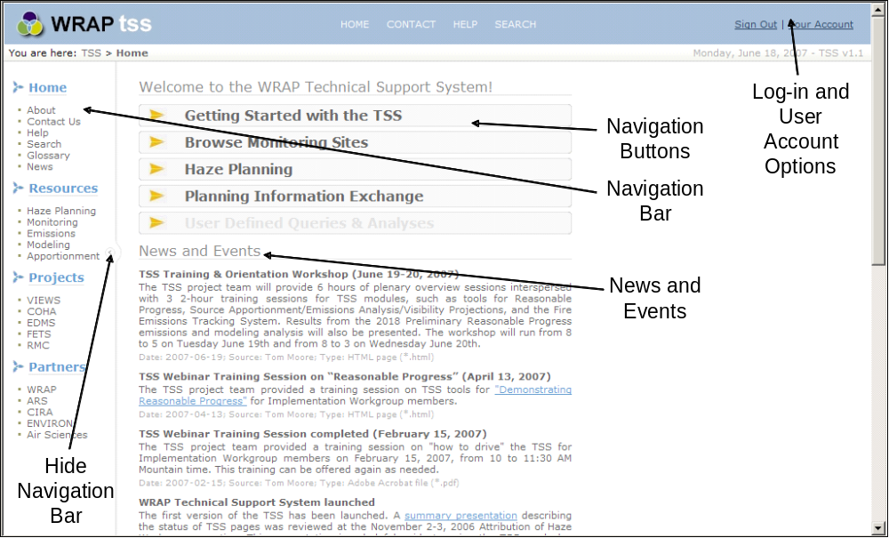
Figure 1. The TSS Home Page.

RESOURCES PAGE

The Resources page is the gateway to the site’s analytical tools and methods documentation. From this page the user can choose to investigate the following topics:

- Haze Planning – This page leads to a variety of data and analysis review tools designed to support RHR reasonable progress demonstrations. Methods documentation for these tools and analyses can be found on the specific data type pages as indicated in the following bullets.

- Monitoring – This page leads to monitoring data review tools and descriptive documents, including:
- A detailed overview of the IMPROVE monitoring network;
- An overview of WRAP data substitutions methods use for sites not meeting RHR data completeness guidelines;
- An overview of how natural conditions were estimated for use with the revised IMPROVE algorithm; and
- A detailed overview of WRAP’s recommended metrics for use in determining reasonable progress (such as what IMPROVE algorithm to use, how to use modeling data to project future visibility, etc.).

- Emissions – This page leads to emissions data review tools and descriptive documents, including:
- An overview of emissions inventory and processing activities; and
- Individual documents for each type of emissions inventory prepared for WRAP.

- Modeling – This page leads to modeling review tools and descriptive documents, including:
- A detailed overview of WRAP’s air quality modeling; and
- An overview of WRAP’s meteorological back trajectory modeling.

- Apportionment – This page leads to source apportionment analysis review tools and descriptive documents, including:
- An overview of the PM Source Apportionment Technology (PSAT) air quality modeling technique used to trace Sulfur/SOx and Nitrate/NOx from source regions to Class I areas;
- An overview of the Weighted Emissions Potential (WEP) technique, a qualitative analysis to investigate the potential for specific regional emissions to impact Class I areas; and
- An overview of the Organic Aerosol Tracer technique used to distinguish between various types of organic aerosol modeled to arrive at Class I areas.

HAZE PLANNING PAGE – Reasonable Progress Demonstration

The Regional Haze Rule sets a 60 year timeline for states to improve visibility within mandatory Federal Class I areas from “baseline” (2000-04) levels to “natural conditions” by 2064. States are required to show that “reasonable progress” is expected to be made toward this goal over the course of intermediary planning periods. Reasonable progress is defined both in terms of what can be measured and projected using current scientific understanding and, when reviewing controls for existing facilities, specific compliance-related statutory factors. These factors are not addressed by the TSS, but include:

- Cost of compliance
- Time necessary for compliance
- Energy and non-air quality environmental impacts of compliance
- Remaining useful life of any existing source subject to such requirements

Regional Haze Rule guidance documents outline methods for tracking progress (http://www.epa.gov/ttn/oarpg/t1/memoranda/rh_tpurhr_gd.pdf), calculating natural conditions (http://www.epa.gov/ttn/oarpg/t1/memoranda/rh_envcurhr_gd.pdf), and using model results to project future visibility impacts (http://www.epa.gov/ttn/scram/guidance/guide/final-03-pm-rh-guidance.pdf). Using these guidance documents as a starting point, WRAP has developed a process that addresses the technical aspects of determining reasonable progress. This process is supported by two WRAP documents, Applying Monitoring Metrics for Regional Haze Planning and Draft Reasonable Progress Protocol which can be found on the Planning Information Exchange page (http://vista.cira.colostate.edu/TSS/Planning/RHSupport.aspx).

RHR guidance requires reasonable progress to be tracked using the Haze Index (deciviews), which is determined as a logarithmic transformation of the sum of all light extinction terms in the IMPROVE light extinction algorithm. This method does not provide information regarding the relative contributions of individual species’ extinction to overall visibility. In addition, some species (sulfate and nitrate) originate from largely anthropogenic sources, while others originate from a mixture of both anthropogenic and natural sources. Therefore, WRAP adopted the additional method of tracking individual species’ extinction contributions in a manner similar to that outlined in RHR guidance for total deciview.

The major steps in WRAP’s recommended technical analyses for reasonable progress demonstration that are supported by the TSS Haze Planning tools include the following for each Class I area:

- Determine Baseline (2000-04) visibility conditions (deciviews and species’ extinction) using the revised IMPROVE algorithm, following RHR guidance to select the 20% worst and best visibility days, and using WRAP-approved substituted data when appropriate.

- Determine Natural Conditions (deciviews and species’ extinction), based on the alternate method developed specifically for the revised IMPROVE algorithm.

- Determine the Glide Slope between Baseline and Natural Conditions (deciviews and species’ extinction), and identify the glide slope value in 2018.

- Using relative change between Baseline and 2018 modeling results, project 2018 visibility (deciviews and species’ extinction). (WRAP defined three methods to calculate visibility projections, the EPA default method and two alternate methods.)

- Review the comparisons between the 2018 projected values and the 2018 glide slope values. The deciview comparison is required by the RHR. The species comparisons provide information on the degree to which progress is expected to be made for individual pollutants. This progress is closely tied to whether emissions sources responsible for the pollutants are anthropogenic or natural.

- Review the change in emissions from the Baseline to the 2018 inventories. This can be done on a regional, state, and county level. Specific analysis requirements are determined by the nature of the visibility impacts at and the location of the Class I area.

- Review the source region contributions of modeled pollutants to Class I areas. This analysis should facilitate conversations between states where a shared impact on visibility exists. This analysis also identifies international source contributions beyond a state’s jurisdiction. There are two methods for this review:
- The RMC performed the PSAT analysis, which tracked emissions responsible for sulfate and nitrate aerosols from source regions (WRAP states, Pacific offshore, Canada, Mexico, CENRAP, Eastern U.S., and boundary conditions) to Class I areas. This is the most reliable attribution method performed on WRAP regional haze data.
- The second method is the WEP analysis, which combined emissions densities with back trajectory residence times to evaluate the potential for emissions to impact to Class I areas. This method did not model atmospheric chemistry or deposition, so its results should be interpreted qualitatively.

HAZE PLANNING PAGE – Data Review Tools

The Haze Planning page integrates all of WRAP’s major data sets and provides review tools designed to support a reasonable progress demonstration. The following subsections describe how to use the tools and provide help in interpreting results.

Site Selection

Upon entering the Haze Planning page, the user is presented with a map showing the WRAP region, the WRAP Federal Class I areas, and the locations of IMPROVE monitoring sites. All currently operating or historically significant IMPROVE sites are available for selection, but not all tools are populated with data from outside the WRAP region. Figure 2 is annotated to identify key items and options on the Site Map. The controls along the top of the map are used to change the map view or select regions for analysis. Tool tips, associated with some of the map controls, appear on the screen by hovering over the control icons. The map controls include:

- Map Mode tools – These controls include zoom and center options for the map. When zoomed in sufficiently, site, Class I area, and tribal names become visible.

- Select tools – These controls allow for selection of single site or entire state (Select Object tool), multiple sites (Select Box tool), and clearing a previous selection (Clear Selection tool).

- Regional Views – Various pre-defined zoomed views are available. The default view is WRAP.

- Tribal Lands – WRAP tribal lands can be added to the map. Pre-defined zoomed views are available for selected tribes. WRAP tribal lands have been associated with the most representative IMPROVE monitors for analysis on the TSS.

Monitoring sites can also be selected from the Site List. The Site List is hidden by default and must be opened to use. Figure 3 is annotated to identify key options available. Multiple sites can be selected, and the list can be sorted by any of the headings. For example, clicking on the “State” heading sorts the sites by state.

Tool Selection

Below the Site Map and Site List are four (4) buttons, each of which opens a series of tools. Figure 4 shows these choices. Clicking on the “Class I Area Summary Table” opens and a table populated with key Class I area results for demonstrating reasonable progress. Figure 5 shows the tool options associated with the “Monitoring” button. Clicking on the “Emissions and Source Apportionment” and “Modeling” buttons reveals tool options for those data sets.

The many options listed in Figure 5 represent only two distinct tools: a Time Series tool and a Glide Slope tool. Within these tools the user can select many options for display. However, since the Regional Haze Rule and WRAP’s method for demonstrating reasonable progress requires very specific choices, these choices have been pre-selected as indicated in this list.

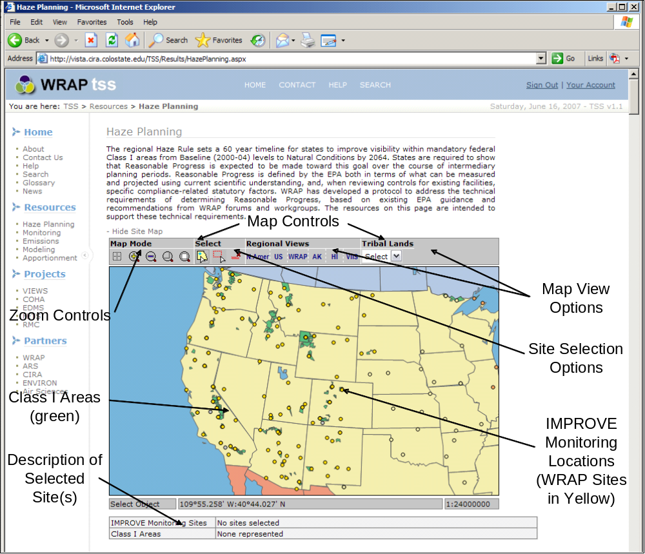
Figure 2. Haze Planning page site selection map.

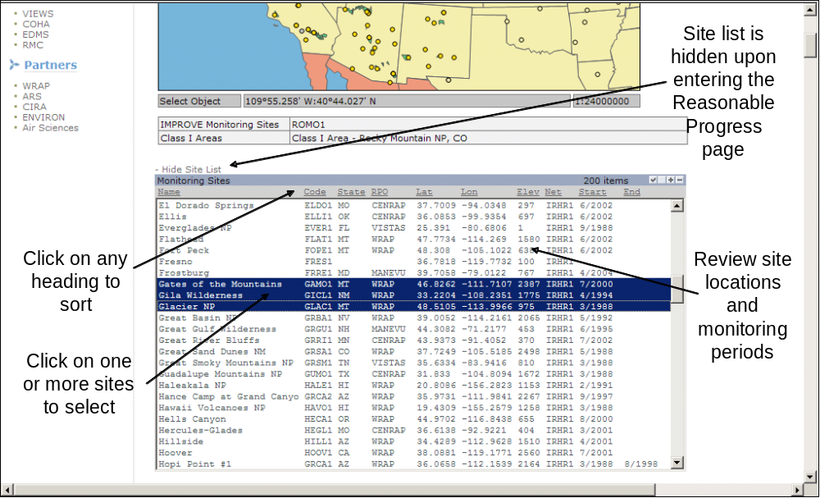
Figure 3. Haze Planning page site selection list.

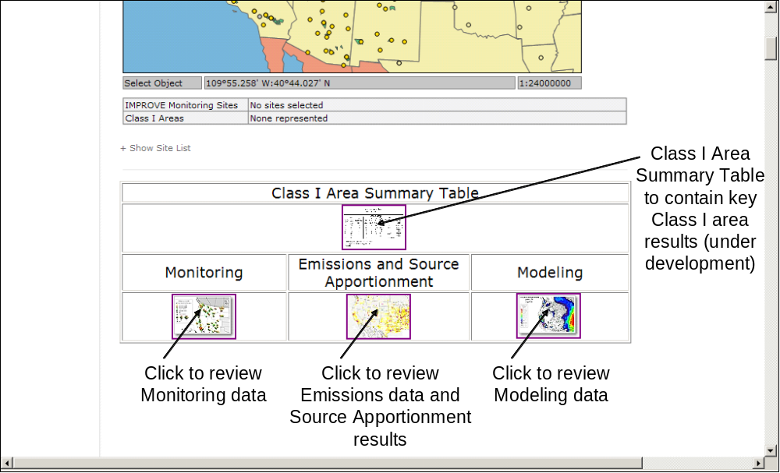
Figure 4. Tool selection panel on the Haze Planning page.

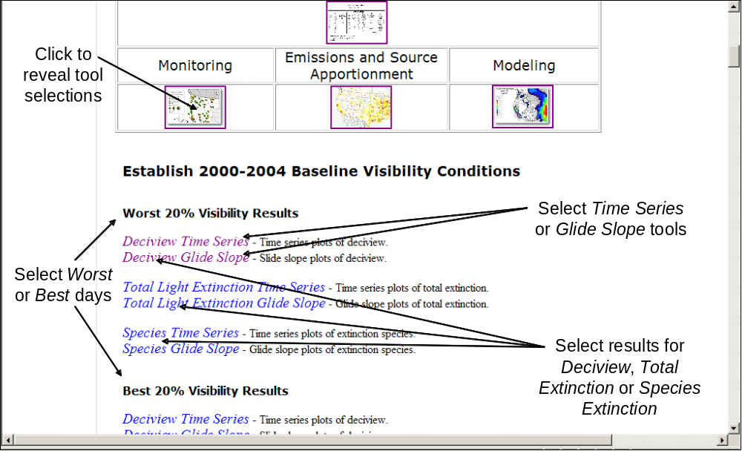
Figure 5. Monitoring data tools. Clicking on the “Emissions and Source Apportionment” and “Modeling” buttons reveals tool options for those data sets.

CLASS I AREA SUMMARY TABLE

– Tool currently under construction –
MONITORING: Time Series Tool

The Interagency Monitoring of Protected Visual Environments (IMPROVE) monitoring program reports speciated PM data and associated estimates of light extinction. Beginning in 1988, IMPROVE is a nation-wide network which began in 1988 and expanded significantly in 2000 in response to the EPA’s Regional Haze Rule. The Regional Haze Rule specifically requires data from this program to be used by states and tribes to track progress in reducing haze. Further information regarding the IMPROVE program and related monitoring data activities can be found under the Monitoring Methods section (http://vista.cira.colostate.edu/TSS/Results/Monitoring.aspx).

The Time Series tool can be found by clicking on the “Monitoring” button on the Haze Planning page. The purpose of the Time Series tool is to allow the user to review and investigate IMPROVE data based on specific temporal selections made via the tool Control Panel. Options for the Control Panel selection boxes are shown in Figure 6 and described below:

- Parameter Group – These options select predetermined groups of parameters. The Mass selection automatically selects all major mass components from the Parameter list (below) and graphically displays in units of µg/m³. The Light Extinction selection selects all major extinction components and graphically displays in units of Mm⁻¹. Both of these options are commonly used to display temporal and contribution changes in all species in one graphic.

- Parameter – This option allows the user to select one or more extinction, deciview, or mass parameters to display. All parameters selected will display as a stacked bar chart or line graph, so it is possible to select non-compatible or meaningless combinations (e.g., Total Extinction and Deciview – both are measured in different units). The user must be careful to select parameter combinations that provide meaningful information.

- IMPROVE Algorithm – This option allows the user to determine how light extinction is calculated from measured mass parameters. The user can select the original or revised IMPROVE algorithm. The WRAP recommendation is for states to use the revised algorithm; therefore this selection is always the default, no matter what tool is chosen. Due to differences in how species are handled, the choice of IMPROVE algorithm can affect the selection of worst and best days. This generally has a small, but often unexpected effect on resulting averages.

- Year – This option allows the user to select one or more years to display in the range 1988 – 2005. The baseline period (2000-04) is the default. Longer timelines provide insight into historical trends.

- Selection of Days – This option allows the user to select what set of days to display (if Daily is selected in the Averaging box) or what days to include in a displayed average (if Monthly or Annual is selected in the Averaging box). The Worst or Best 20% IMPROVE days are allowable only for those years which have met the RHR data completeness requirements. The IMPORVE Sampled option uses all available IMPROVE data for the time periods selected. This choice should be used with care as any averages based on all collected data have no regulatory significance and may be misleading for periods of poor data capture.

- Averaging – This option allows the user to select daily, monthly, and annual averaging periods.

- Quarter – This option allows the user to select one or more specific quarters. Display of all quarters is the default.

- Chart Type – This option allow the user to select between a Timeline, which plots each parameter as in independent line graph, and Bar Chart, which plots single parameters as a bar and multiple parameters as a stacked bar.

Figure 7 presents several commonly used combinations of Control Panel selections for quick reference. Many of these selection boxes appear in other data review tools and perform the same functions described here.

The graphic displays cannot be altered beyond the selections described above. They can be saved or copied by right-clicking and making the appropriate selection. The data table below the graphic can be copied and pasted into spreadsheet software such as Microsoft Excel.

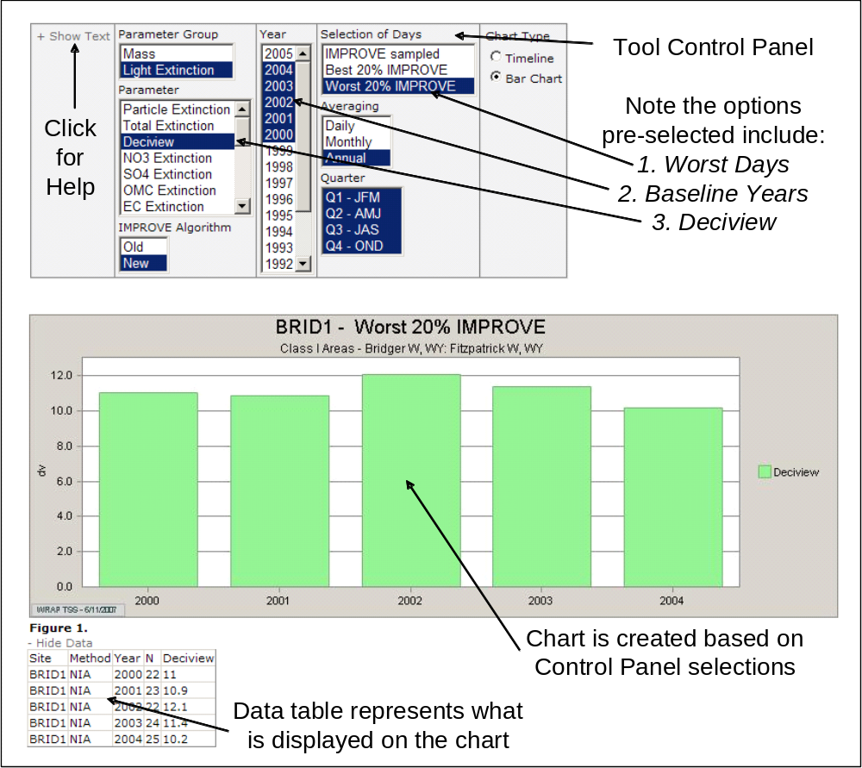
Figure 6. Monitoring: Time Series Tool. The pre-selected options for this tool were based on the choice of “Deciview Time Series.”

Monitoring Time Series Graphical Displays | Control Panel Selections
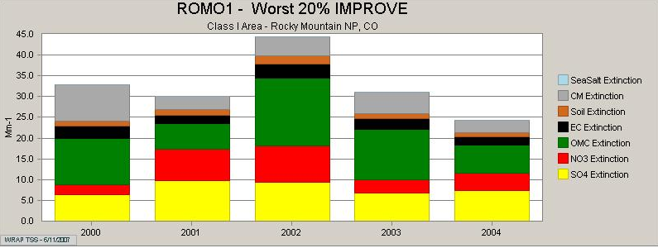  Annual Baseline Species Extinction, Worst Days | 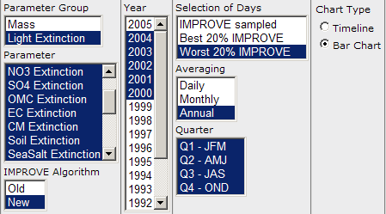
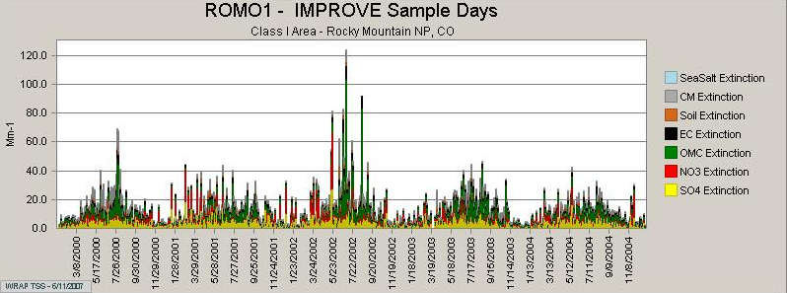  Daily Baseline Species Extinction, all IMPROVE Days | 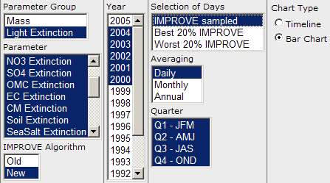
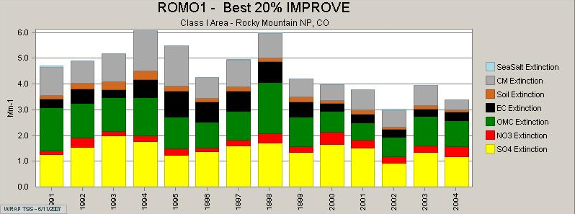  Historical Timeline of Annual Best Days | 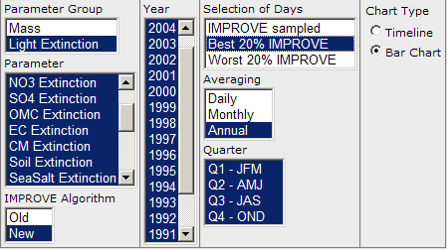
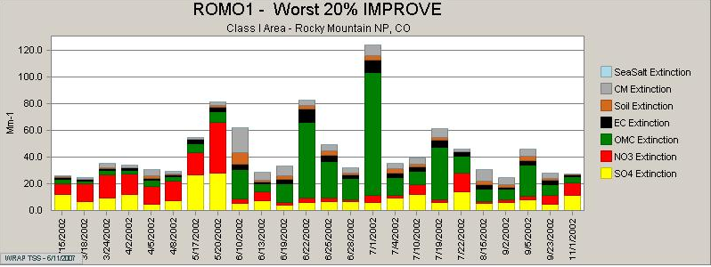  Individual Worst Days for 2002 | 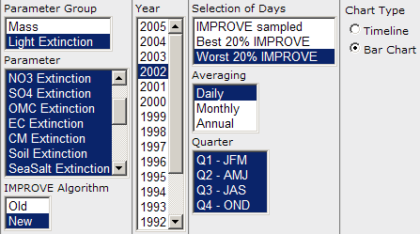
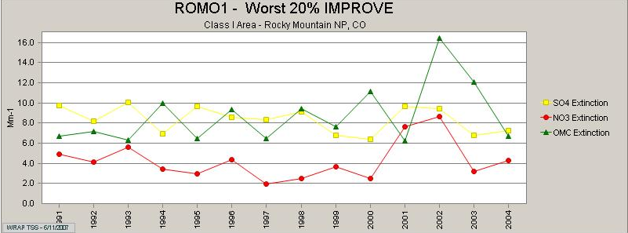  Historical Contribution Timelines of Top 3 Species | 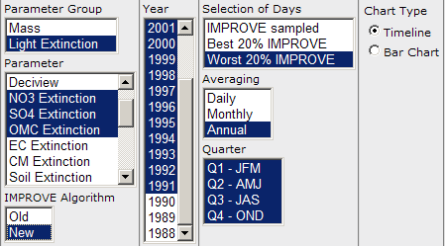
Figure 7. Monitoring: Time Series Tool. Common graphical outputs and associated Control Panel selections.
MONITORING: Glide Slope Tool

IMPROVE data are used to determine baseline visibility conditions, to estimate natural visibility conditions, and to calculate the RHR glide slope between current future (natural) conditions.

The Glide Slope tool can be found by clicking on the “Monitoring” button on the Haze Planning page. The purpose of the Glide Slope tool is to allow the user to review the required RHR deciview glide slope and optional individual species extinction glide slopes. All results are presented based on extinction/deciview calculations using the revised IMPROVE algorithm. Extinction glide slopes are not defined in the RHR guidance, so their inclusion here is to support demonstrations of reasonable progress as defined by WRAP protocol. Options for the Control Panel selection boxes are shown in Figure 8 and described below:

- Parameter Group – These options select predetermined groups of parameters, as described in the “MONITORING: Time Series Tool.”

- Parameter – This option allows the user to select one or more extinction, deciview, or mass parameters to display. If parameters with different units are selected together, a second y-axis will appear on the left side of the graph.

- Selection of Days – This option allows the user to select between the Worst and Best days, based on collected IMPROVE data. Note that there is no IMPORVE Sampled option as in the “MONITORING: Time Series Tool.” The Regional Haze Rule does not require states to calculate a glide slope for the Best days, so only the baseline and natural conditions values are displayed when the Best days option is selected.

- Annual Baseline Data – This option allows the user to select individual annual averages to display on the chart. These values provide an understanding of the inter-annual variability during the baseline period.

- IMPROVE Data Set – This option allows the user to select WRAP substituted data sets, if applicable. The Substitute option can be used only with sites that did not meet RHR data completeness requirements (BALD1, CAPI1, GLAC1, KAIS1, NOCA1, RAFA1, SEQU1, TONT1). The user can link to a page on the VIEWS web site that lists all IMPROVE sites which have required data substitutions. Further information regarding the WRPA data substitutions can be found under the Monitoring Methods section (http://vista.cira.colostate.edu/TSS/Results/Monitoring.aspx)

The graphic displays cannot be altered beyond the selections described above. They can be saved or copied by right-clicking and making the appropriate selection. The data table below the graphic can be copied and pasted into spreadsheet software such as Microsoft Excel.

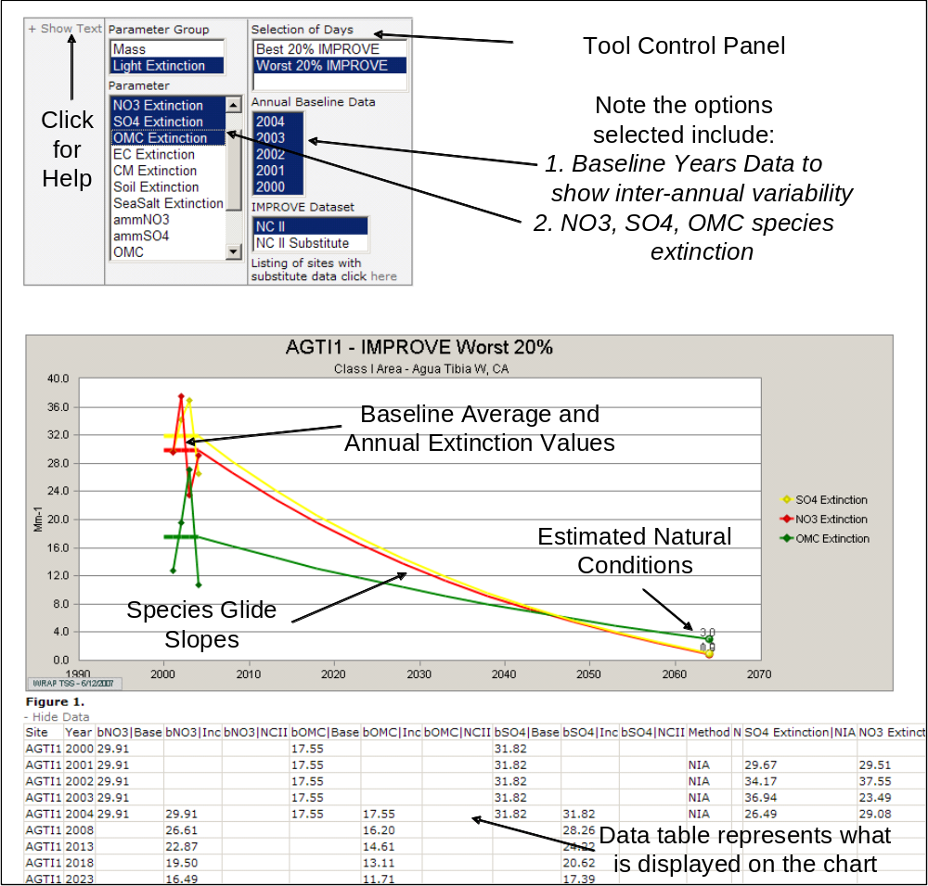
Figure 8. Monitoring: Glide Slope Tool. Glide slopes for Nitrate, Sulfate, and Organic Mass Extinction are shown.

EMISSIONS & SOURCE APPORTIONMENT: SOx/NOx Tracer Tool

WRAP’s Regional Modeling Center performed a source apportionment analysis using the CAMx air quality model and the PSAT (PM Source Apportionment Technology) tool. Results from this analysis provide information regarding which source regions and source categories are responsible for particulate aerosol modeled at a receptor. Due to resource limitations, this analysis was restricted to SOx and NOx emissions resulting in sulfate and nitrate mass. The results do not directly represent actual sulfate and nitrate measurements, nor can they accurately be transformed into extinction values. Therefore, these results should be viewed in relative terms among source regions and between emissions scenarios. Further information regarding the PSAT modeling technique can be found under the Source Apportionment Methods section (http://vista.cira.colostate.edu/TSS/Results/SA.aspx).

The SOx/NOx Tracer tool can be found by clicking on the “Emissions and Source Apportionment” button on the Haze Planning page. The purpose of the SOx/NOx Tracer tool is to allow the user to investigate modeled attribution results for sulfate and nitrate mass at Class I areas. Options for the Control Panel selection boxes are shown in Figure 9 and described below:

- Parameter – This option allows the user to select either Nitrate/NOx or Sulfate/SOx results to display. The CAMx/PSAT methodology was not used to trace other pollutants due to resource constraints.

- Emissions Scenario – This option allows the user to select one or more emissions scenarios. Display of Baseline and 2018 Base Case scenarios is the default.

- Source Categories – This option allows the user to select one or more emissions source categories. Display of all categories is the default.
- Point – All point source emissions
- Anthropogenic Fires (WRAP) – All WRAP fire emissions categorized by WRAP as man-made
- Mobile – All on- and off-road mobile source emissions
- Natural Fires and Biogenics (WRAP) – All WRAP fire emissions categorized by WRAP as natural and WRAP biogenic emissions
- Elevated Fires (non-WRAP) – All non-WRAP fire emissions
- Area – All area source emissions

- Source Regions – This option allows the user to select one or more WRAP states as source regions. Display of all WRAP states if the default.

- Selection of Days – This option allows the user to select what set of model days to display or what days to include in a displayed average. The Worst or Best 20% IMPROVE days options select modeled days identical with the 2002 IMPROVE Worst and Best days. The IMPROVE Sampled option uses all modeled days that correspond to available IMPROVE days in 2002. The All Days option uses all 365 modeled days for 2002.

- Averaging – This option allows the user to select daily, monthly, and annual averaging periods. Daily and monthly selections should be used only when single Source Regions have been selected.

- Quarter – This option allows the user to select one or more specific quarters. Display of all quarters is the default.

The pie charts display relative regional contributions to total annual modeled sulfate or nitrate mass. The WRAP contribution is separated from the rest of the pie for easy identification. The remaining pie slices include those regions listed in the Source Region box plus the sum of the model’s Initial and Boundary Conditions, termed “Outside Domain.” The total modeled mass traced to the Class I area is displayed below each pie. The pie charts will change based on selections in the Parameter, Emissions Scenario and Selection of Days boxes. They will not change based on selections in the Source Category or Source Region boxes.

The bar chart displays source region and source category contributions of sulfate or nitrate mass. Display of all WRAP states is the default. Once all WRAP states’ contributions have been reviewed, those with significant contributions can be selected individually and reviewed using the Monthly or Daily Averaging selections. This will identify any temporal patterns in a state’s contributions.

Figure 10 presents several commonly used combinations of Control Panel selections for quick reference. The graphic displays cannot be altered beyond the selections described above. They can be saved or copied by right-clicking and making the appropriate selection. The data table below the graphic can be copied and pasted into spreadsheet software such as Microsoft Excel.

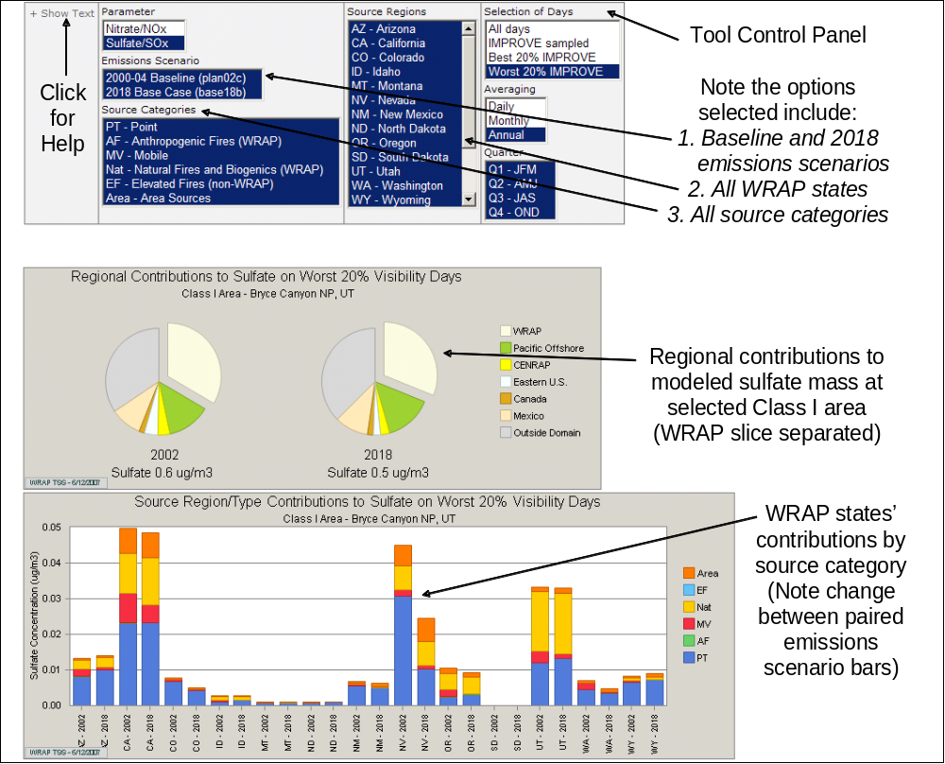
Figure 9. Emissions & Source Apportionment: SOx/NOx Tracer Tool. This tool displays regional and state contributions to sulfate or nitrate mass.

Source Apportionment Graphical Displays | Control Panel Selections
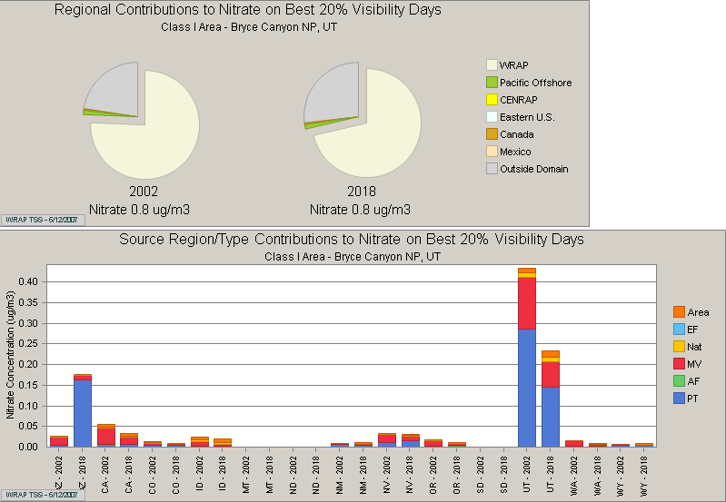  Annual Contribution of Nitrate, Best Days | 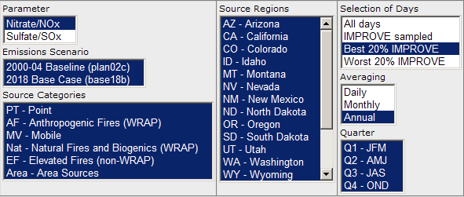
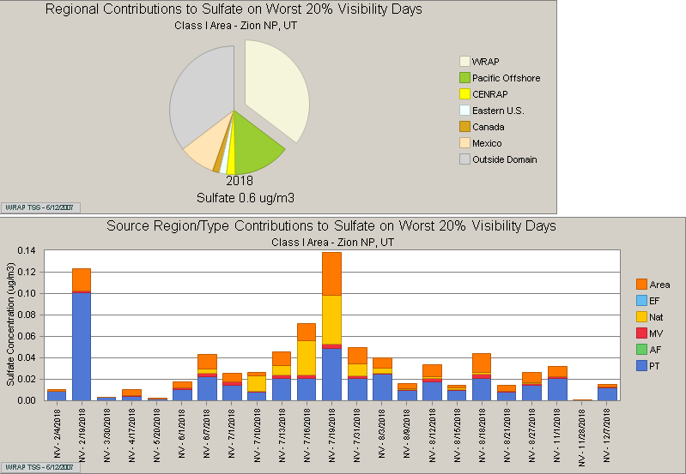  Single State, Daily Contribution of Sulfate, Worst Days | 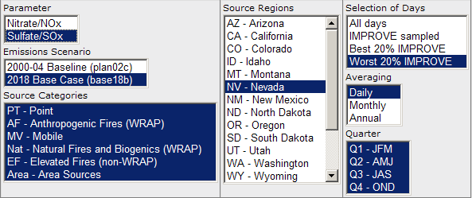
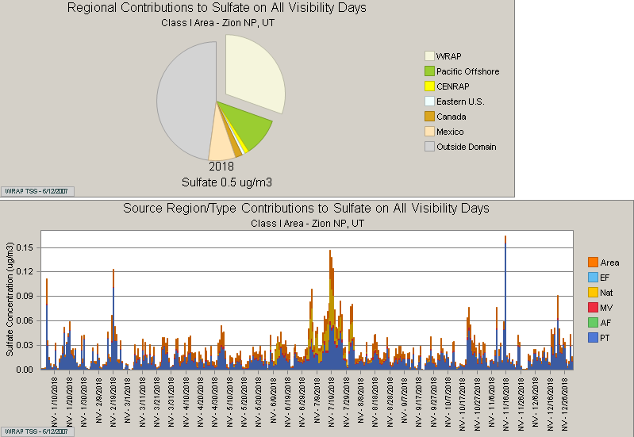  Single State, Daily Contribution, All Model Days | 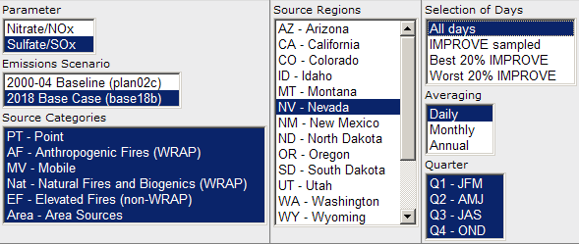
Figure 10. Emissions & Source Apportionment: SOx/NOx Tracer Tool. Common graphical outputs and associated Control Panel selections.
EMISSIONS & SOURCE APPORTIONMENT: Weighted Emissions Potential Tool

The Weighted Emissions Potential (WEP) analysis was developed as a screening tool for states to decide which source regions have the potential to contribute to haze formation at specific Class I areas, based on both the baseline and 2018 emissions inventories. Unlike the SOx/NOx Tracer analysis, this method does not account for chemistry and removal processes. Instead, the WEP analysis relies on an integration of gridded emissions data, meteorological back trajectory residence time data, a one-over-distance factor to approximate deposition, and a normalization of the final results. Residence time over an area is indicative of general flow patterns, but does not necessarily imply the area contributed significantly to haze at a given receptor. Therefore, users are cautioned to view the WEP analysis as one piece of a larger, more comprehensive weight of evidence analysis. Further information regarding the WEP analysis method can be found under the Source Apportionment Methods section (http://vista.cira.colostate.edu/TSS/Results/SA.aspx).

The WEP tool can be found by clicking on the “Emissions and Source Apportionment” button on the Haze Planning page. Options for the Control Panel selection boxes are shown in Figure 11 and described below:

- Parameter – This option allows the user to select results for one parameter at a time. The gridded emissions used for this analysis represent annual totals.

- Source Categories – This option allows the user to select one or more emissions source categories. Display of all categories is the default.

- Source Regions – This option allows the user to select one or more source regions, including: individual WRAP states, Pacific Offshore, CENRAP, Eastern U.S., Canada, and Mexico. Display of all regions is the default.

- Selection of Days – This option allows the user to select meteorological back trajectory residence time fields based on the Worst and Best IMPROVE days.

The WEP bar charts display normalized (unitless), residence time- and distance-weighted annual emissions value, by emissions source region. These WEP results are reminiscent of the SOx/NOx Tracer tool results. However, the WEP results are considered less rigorous and should be used only as a screening tool to identify regions with the potential to impact Class I areas. The bar chart presents results for the Baseline, 2018 Base, and 2018 PRP emissions scenarios. Note that a reported change in regional percent contribution between two scenarios does not necessarily imply a larger or smaller impact on haze formation.

The WEP map matrix contains 7 individual maps. The left column contains maps of the annual Baseline, 2018 Base Case, and 2018 Preliminary Reasonable Progress emissions inventories, with all sources combined. The central single map depicts the Worst or Best days residence times for the baseline period, determined using the revised IMPROVE algorithm. The same residence time field is used with all emissions scenarios. The right column contains maps of the normalized, weighted emissions. Geographical regions and individual grid cells with significant potential to impact the selected Class I area are easily distinguished in these maps. Each map can be enlarged by clicking on it.

The graphic displays cannot be altered beyond the selections described above. They can be saved or copied by right-clicking and making the appropriate selection. The data table below the bar chart can be copied and pasted into spreadsheet software such as Microsoft Excel.

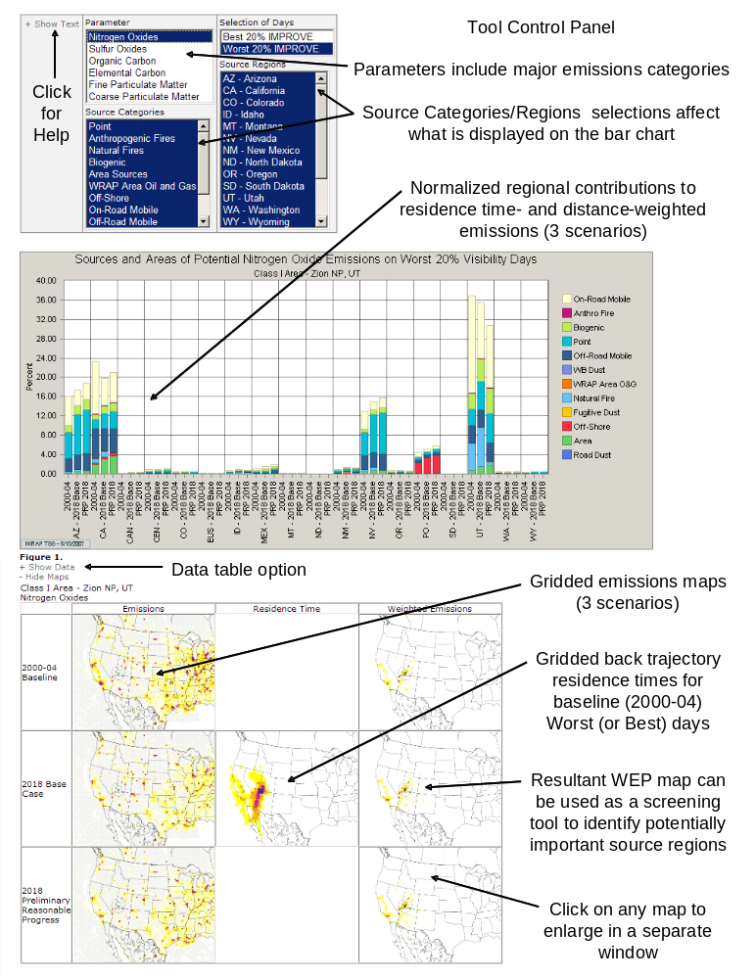
Figure 11. Emissions & Source Apportionment: Weighted Emissions Potential Tool. Annual emissions inventories were weighted by back trajectory residence time and distance, and then normalized. Results indicate geographic regions with the potential to impact selected Class I areas.

EMISSIONS & SOURCE APPORTIONMENT: Organic Aerosol Tracer Tool

The CMAQ model results were analyzed to identify organic carbon aerosol source contributions as originating in one of three categories:

- Primary organics (anthropogenic and biogenic sources), resulting from direct organic aerosol emissions;

- Anthropogenic secondary organics, resulting from aromatic VOCs, such as xylene, toluene, and cresols; and

- Biogenic secondary organics, resulting from biogenic VOCs, such as terpenes.

This analysis did not include identification of emissions source regions or detailed source category information. Further information regarding the Organic Aerosol Tracer technique can be found under the Source Apportionment Methods section (http://vista.cira.colostate.edu/TSS/Results/SA.aspx).

The Organic Aerosol Tracer tool can be found by clicking on the “Emissions and Source Apportionment” button on the Haze Planning page. The purpose of the tool is to allow the user to investigate the contribution of primary and secondary anthropogenic and biogenic sources on modeled organic carbon at Class I areas. Options for the Control Panel selection boxes are shown in Figure 12 and described below:

- Parameter – This option allows the user to select among the three types of organic aerosol. Display of all types is the default.

- Emissions Scenario – This option allows the user to select one or more emissions scenarios.

- Selection of Days – This option allows the user to select what set of model days to display or what days to include in a displayed average. The Worst or Best 20% IMPROVE days options select modeled days identical with the 2002 IMPROVE Worst and Best days. The IMPROVE Sampled option uses all modeled days that correspond to available IMPROVE days in 2002. The All Days option uses all 365 modeled days for 2002. Aerosol loadings from large fire events can clog IMPROVE filters and result in lost data. It is advisable to review results using both the All Days option and the IMPROVE Sampled option to understand if significant events captured by the model are missed by the selection of IMPROVE Sample days only.

- Averaging – This option allows the user to select daily, monthly, and annual averaging periods.

- Quarter – This option allows the user to select one or more specific quarters. Display of all quarters is the default.

The bar chart displays modeled contributions to organic aerosol. Individual organic aerosol parameter types and specific time aggregations and periods can be selected for a detailed review of temporal patterns. Figure 13 illustrates how the tool can be used to see the modeled change in organic aerosol contribution between the Baseline and 2018 Base Case scenarios. The graphic displays cannot be altered beyond the selections described above. They can be saved or copied by right-clicking and making the appropriate selection. The data table below the graphic can be copied and pasted into spreadsheet software such as Microsoft Excel.
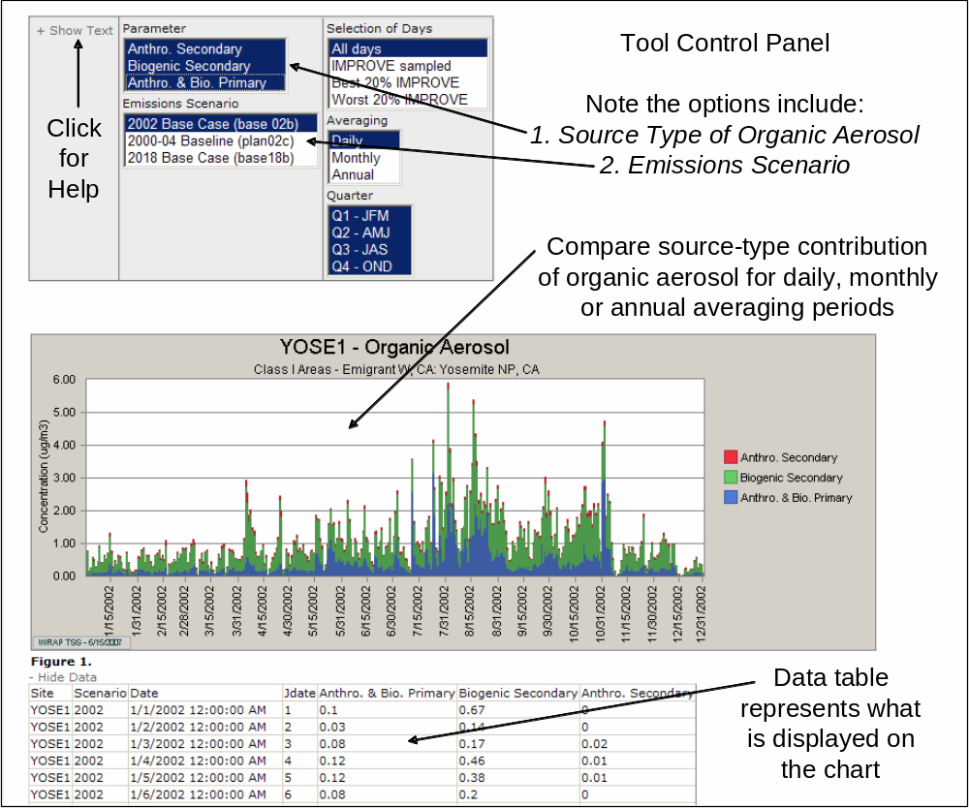
Figure 12. Emissions & Source Apportionment: Organic Aerosol Tracer Tool. This tool identifies organic carbon source type contributions as: 1) primary organics (anthropogenic and biogenic); 2) anthropogenic secondary organics; and 3) biogenic secondary organics. The results do not include emissions source regions or detailed source category information.

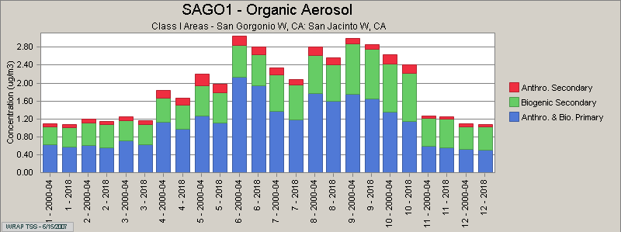 | 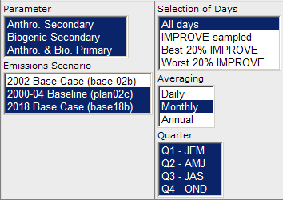
Figure 13. Emissions & Source Apportionment: Organic Aerosol Tracer Tool. Monthly results for the Baseline and 2018 emissions scenarios are shown here. Each pair of bars illustrates the modeled change in organic aerosol.

EMISSIONS & SOURCE APPORTIONMENT: Emissions Review Tool

– Tool currently under construction –

MODELING: Model Performance Tool

The WRAP developed a set of comprehensive emissions inventories for 2002, the baseline period (2000-04), and 2018. These inventories were used to model visibility impacts for the same time periods. Further information regarding the WRAP modeling techniques can be found under the Modeling Methods section (http://vista.cira.colostate.edu/TSS/Results/Modeling.aspx).

The Model Performance tool can be found by clicking on the “Modeling” button on the Haze Planning page. The purpose of the Model Performance tool is to allow the user to gauge model performance on a site-by-site basis by comparing the 2002 modeling results (Base02) with the IMPROVE monitoring data collected in 2002. Model performance varies by species and sometimes by time of year, so it is important for users to review these results in more than one way. Options for the tool’s Control Panel selection boxes are shown in Figure 14 and described below:

- Parameter Group – These options select predetermined groups of parameters, as described in the “MONITORING: Time Series Tool.”

- Parameter – This option allows the user to select one or more mass or visibility parameters to display. All parameters selected will display as a stacked bar chart or line graph, so it is possible to select non-compatible or meaningless combinations (e.g., Total Extinction and Deciview – both are measured in different units). The user must be careful to select parameter combinations that provide meaningful information.

- IMPROVE Algorithm – This option allows the user to determine how light extinction is calculated from measured mass parameters. The user can select the original or revised IMPROVE algorithm. The WRAP recommendation is for states to use the revised algorithm; therefore this selection is the default. Due to differences in how species are handled, the choice of IMPROVE algorithm can affect the selection of worst and best days. This generally has a small, but often unexpected effect on resulting averages.

- Selection of Days – This option allows the user to select what set of model days to display or what days to include in a displayed average. The Worst or Best 20% IMPROVE days options select modeled days identical with the 2002 IMPROVE Worst and Best days. The IMPROVE Sampled option uses all modeled days that correspond to available IMPROVE days in 2002. The All Days option uses all 365 modeled days for 2002.

- Averaging – This option allows the user to select daily, monthly, and annual averaging periods.

- Quarter – This option allows the user to select one or more specific quarters. Display of all quarters is the default.

- Chart Type – This option allow the user to select between a Timeline, which plots each parameter as in independent line graph, and Bar Chart, which plots single parameters as a bar and multiple parameters as a stacked bar.

The graphic displays cannot be altered beyond the selections described above. They can be saved or copied by right-clicking and making the appropriate selection. The data table below the graphic can be copied and pasted into spreadsheet software such as Microsoft Excel.

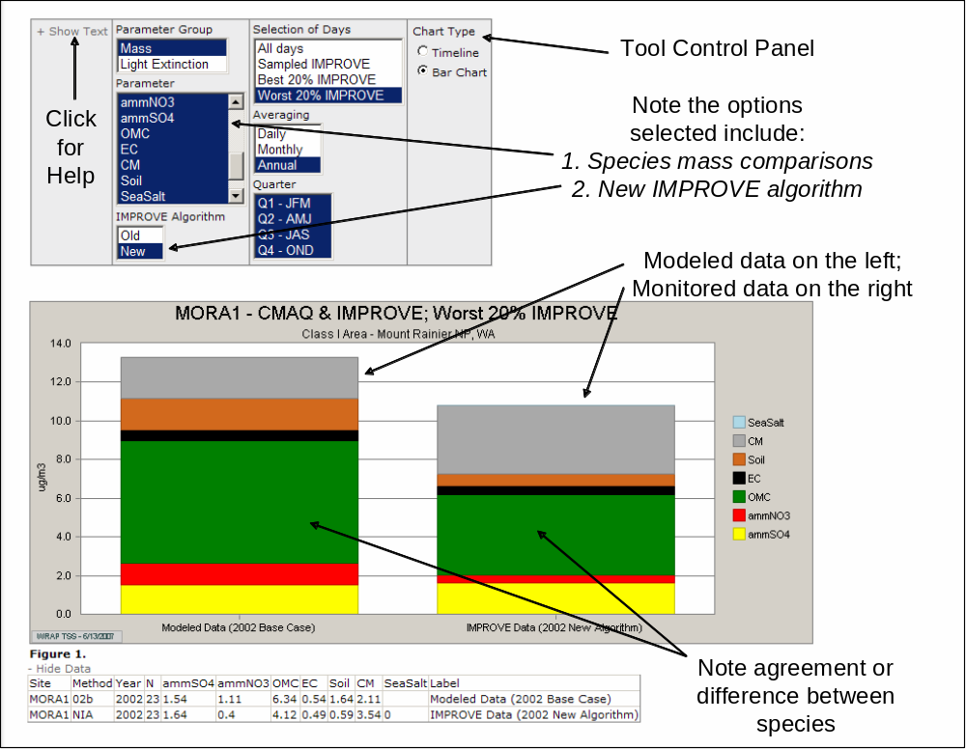
Figure 14. Modeling: Model Performance Tool. This tool allows users to determine model performance for individual IMPROVE monitoring sites.

MODELING: Visibility Modeling Results Tool

The Visibility Modeling Results tool can be found by clicking on the “Modeling” button on the Haze Planning page. The purpose of the Model Performance tool is to allow the user to view time series of individual model runs or compare aggregates of different model runs. Information regarding the WRAP modeling techniques can be found under the Modeling Methods section (http://vista.cira.colostate.edu/TSS/Results/Modeling.aspx). Options for the tool’s Control Panel selection boxes are shown in Figure 15 and described below:

- Parameter Group – These options select predetermined groups of parameters, as described in the “MONITORING: Time Series Tool.”

- Parameter – This option allows the user to select one or more mass or visibility parameters to display. All parameters selected will display as a stacked bar chart or line graph, so it is possible to select non-compatible or meaningless combinations (e.g., Total Extinction and Deciview – both are measured in different units). The user must be careful to select parameter combinations that provide meaningful information.

- IMPROVE Algorithm – This option allows the user to determine how light extinction is calculated from measured mass parameters. The user can select the original or revised IMPROVE algorithm. The WRAP recommendation is for states to use the revised algorithm; therefore this selection is the default. Due to differences in how species are handled, the choice of IMPROVE algorithm can affect the selection of worst and best days. This generally has a small, but often unexpected effect on resulting averages.

- Selection of Days – This option allows the user to select what set of model days to display or what days to include in a displayed average. The Worst or Best 20% IMPROVE days options select modeled days identical with the 2002 IMPROVE Worst and Best days. The IMPROVE Sampled option uses all modeled days that correspond to available IMPROVE days in 2002. The All Days option uses all 365 modeled days for 2002.

- Averaging – This option allows the user to select daily, monthly, and annual averaging periods.

- Quarter – This option allows the user to select one or more specific quarters. Display of all quarters is the default.

- Emissions Scenario – This option allows the user to select one or more emissions scenarios. Display of baseline and 2018 scenarios is the default. The 2002 Base Case modeling run can be compared to the 2000-04 Baseline run to review the effects of averaging fire emissions (and other changes) in the Baseline run. Only the Baseline run can be meaningfully compared to the 2018 runs.

- Chart Type – This option allow the user to select between a Timeline, which plots each parameter as in independent line graph, and Bar Chart, which plots single parameters as a bar and multiple parameters as a stacked bar.

The options available on this tool are almost identical with those available on the “Monitoring: Time Series tool,” and individually selected model runs can be displayed in similar ways. When viewing model results from multiple Emissions Scenarios it is helpful to restrict the Averaging option to Monthly or Annual.

The graphic displays cannot be altered beyond the selections described above. They can be saved or copied by right-clicking and making the appropriate selection. The data table below the graphic can be copied and pasted into spreadsheet software such as Microsoft Excel.

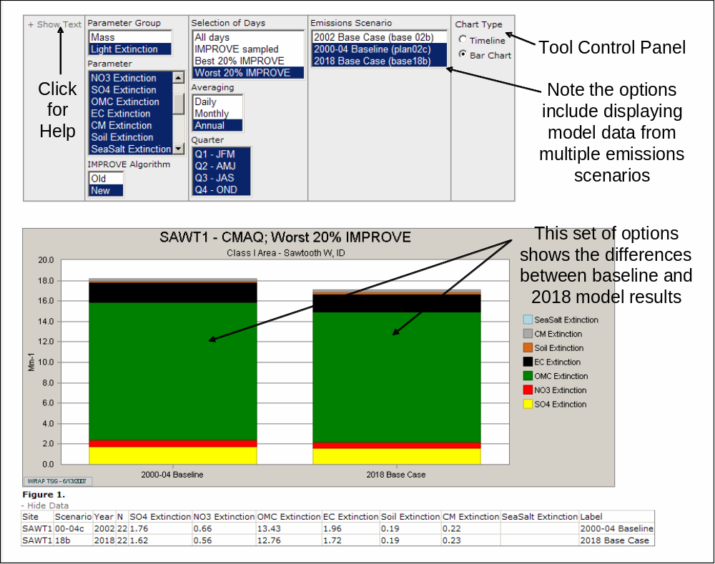
Figure 15. Modeling: Visibility Modeling Results Tool. This tool is very similar to the “Monitoring: Time Series Tool”, and allows users to view time series plots of model data and compare different model runs.

MODELING: Visibility Projections Tool

Visibility projections are calculated by multiplying a species-specific relative response factor (RRF) to the baseline monitored result, and then converting to extinction and deciview. The RRF is defined as the ratio of future-to-current modeled mass. For example, the projected sulfate extinction is calculated by the following generalized formulas:

- SO₄ RRF = [2018 Modeled Sulfate/Baseline Modeled SO₄]

- Projected SO₄ Mass = Baseline IMPROVE SO₄ x RRF

- Projected SO₄ Extinction = Conversion via IMPROVE Algorithm of Proj. SO₄ Mass

WRAP has defined three RRF calculation methods which differ in how the days for the calculation are selected:

- Specific Days (EPA) – This is the EPA default method. In this method, single species’ RRFs are calculated across observed Worst or Best days in the base model year.

- Quarterly Weighted – In this method, four (4) quarterly species’ RRFs are calculated from the 20% worst or best days in each quarterly, regardless of how those days compare to the overall annual Worst and Best days.

- Monthly Weighted – In this method, twelve (12) monthly species’ RRFs are calculated from the 20% worst or best days in each month, regardless of how those days compare to the overall annual Worst and Best days.

Details of the visibility projection methodology are described in the Applying Monitoring Metrics for Regional Haze Planning on the Regional Haze Planning Support page (http://vista.cira.colostate.edu/TSS/Planning/RHSupport.aspx).

The Visibility Projections Tool displays data very similar to the “Monitoring: Glide Slope Tool,” with the addition of projected visibility values for 2018. Options for the Control Panel selection boxes are shown in Figure 16 and described below:

- Parameter Group – These options select predetermined groups of parameters, as described in the “MONITORING: Time Series Tool.”

- Parameter – This option allows the user to select one or more extinction, deciview, or mass parameters to display. If parameters with different units are selected together, a second y-axis will appear on the left side of the graph. Figure 17 presents the visibility projections for the 3 dominant species at the same site depicted in Figure 16.

- Selection of Days – This option allows the user to select between the Worst and Best days, based on collected IMPROVE data. The Regional Haze Rule does not require states to calculate a glide slope for the Best days, so only the baseline, natural conditions, and 2018 projected values are displayed when the Best days option is selected.

- Annual Baseline Data – This option allows the user to select individual annual averages to display on the chart. These values provide an understanding of the inter-annual variability during the baseline period.

- IMPROVE Data Set – This option allows the user to select WRAP substituted data sets, if applicable. The Substitute option can be used only with sites that did not meet RHR data completeness requirements (BALD1, CAPI1, GLAC1, KAIS1, NOCA1, RAFA1, SEQU1, TONT1). The user can link to a page on the VIEWS web site that lists all IMPROVE sites which have required data substitutions. Further information regarding the WRPA data substitutions can be found under the Monitoring Methods section (http://vista.cira.colostate.edu/TSS/Results/Monitoring.aspx)

- RRF Calculation Method – This option allows the user to select among WRAP’s three methods for calculating relative response factors (RRFs). The Specific Days selection is the EPA default.

- Base Emissions Scenario – This is not a selection box. It reminds the user that the RRFs will be calculated using whatever future scenario is selected and the Baseline emissions scenario.

- Projection Emissions Scenario – This option allows the user to select from various versions of the 2018 emissions scenarios.

The graphic displays cannot be altered beyond the selections described above. They can be saved or copied by right-clicking and making the appropriate selection. The data table below the graphic can be copied and pasted into spreadsheet software such as Microsoft Excel.

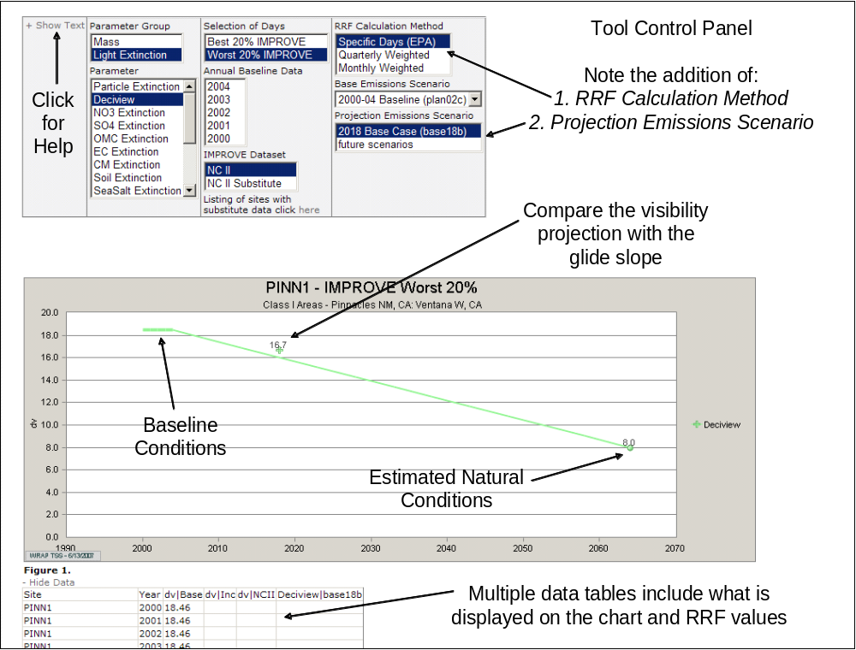
Figure 16. Modeling: Visibility Projections Tool. This tool is nearly identical to the “Monitoring: Glide Slope Tool.” In addition to showing deciview of species glide slopes, this tool also displays the projected visibility parameter value for 2018.

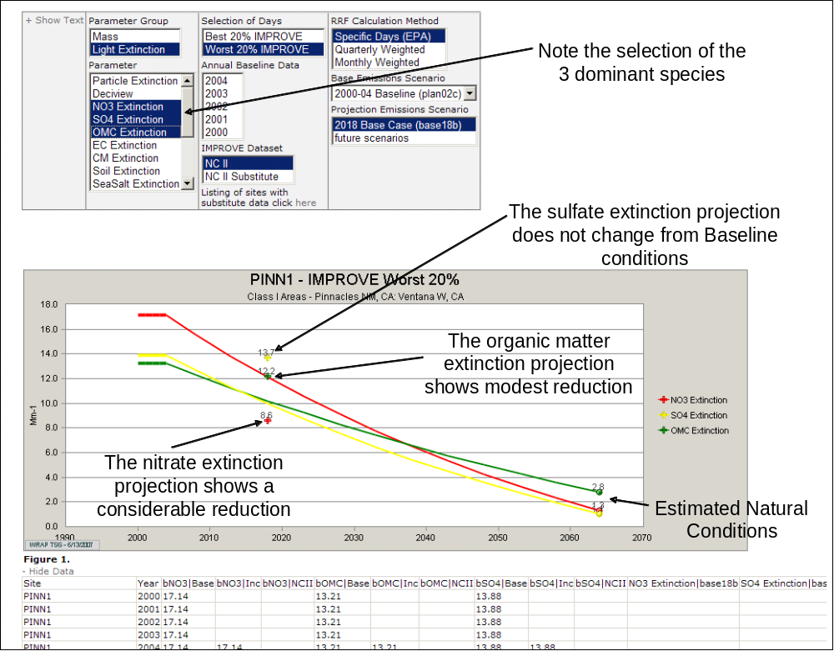
Figure 17. Modeling: Visibility Projections Tool. In this view, species extinction glide slopes and 2018 projections are shown for the 3 dominant species at this site.

