Introduction

Commercial marine emissions comprise a wide variety of vessel types and uses. Table 1 describes the different types of commercial marine vessel activity. In the previous WRAP mobile sources emission inventory work, emissions were estimated for most types of vessels (Pollack et al., 2004). Military emissions were not estimated because the activity data are not publicly available, and offshore emissions were not considered at that time.

Table 1. Commercial vessel types.
Source Definition | Purpose | Geographic Area
Deep draft | Ocean-going large vessels | Ocean Traffic
Deep draft | Ocean-going large vessels | Near port
Tow or Push Boats | Barge Freight | River Traffic
Tow or Push Boats | Barge Freight | Ocean Traffic
Tugs | Vessel assist and support functions | Near port
Ferries | River or lake ferrying | Regular routes
Other Commercial Vessels | Smaller support or excursion boats | Near dock
Dredges | Dredging projects | Varies
Commercial Fishing | Market fishing | Ocean
Military | Coast Guard and Navy | Ocean & Port

Emissions were estimated for deep draft vessels within shore and near port using port call data, and offshore emissions generated from ship location data. The most important revision for commercial marine emissions leading to regional haze (PM, SOx, and NOx) was the estimation of emissions for the offshore activity, primarily of ocean-going vessels. This activity was not previously estimated for the WRAP emission inventory, and has been a subject of concern as vessel traffic passes out from and along and upwind of the western coast of the US. The other revision conducted here was to update in-shore deep-draft vessel emissions to reflect changing fleet mix, especially the retirement of steamship powered vessels.

One issue for modelers was which vertical grid layer to introduce the deep draft emissions. The stack height of 34 to 58 meters (Starcrest, 2004) and plume rise for ocean-going (deep draft) vessels indicated that the emissions should be placed in the second vertical layer (above 36 and below 73 meters). The plume rise was estimated at 2 meters using standard plume rise models with the vessel speed of 17 to 25 knots as the wind speed, exhaust exit rate of 35 to 40 meters per second with an average stack diameter of about 1.3 meters (Anderson, 2000).

Off-Shore Emissions Estimation Methodology

The method used to estimate the offshore marine emissions uses location identification data from a sample of vessels within the region of interest, and scaling factors by vessel type to estimate all ships. The ship proximity data and methods used to develop the ship population and emissions offshore are described in Pollack, et al., 2006. In short, this method uses positioning data generated by a subset of the world’s ships, assumes the sample is a random sample, and scales that sample to the entire world fleet.

Emissions estimates using this method were compared with the emissions generated using the Puget Sound port activity estimates described below. The grid cell emission totals at the entrance/exit of the Strait of Juan de Fuca using the scaled proximity method were approximately half of what were predicted using just the US port traffic, ignoring the traffic to and from Vancouver, Canada. Using the proximity method it would be expected that the emissions would be underestimated as ships near land, because positioning systems would be turned off or, if manually operated, would not be actively engaged during this period of time. This would reduce the number of ship indicators in areas near land and underestimate the ship traffic. Therefore, emissions in the first whole grid cell and any partial grid cells near the coast were zeroed out and replaced with emission estimates derived from the in-port activity for Oregon and Washington ports (Puget Sound, Columbia River, Coos Bay, and Grays Harbor) with remaining near coast estimates unchanged, as shown in Figure 1. The most apparent difference can be observed in Figure 1 for the grid cells near the mouth of the Columbia River where the nearest four grid cells now have higher emissions. There are also higher emissions at the entrance to the Strait of Juan de Fuca, but that result is less clear in Figure 1.

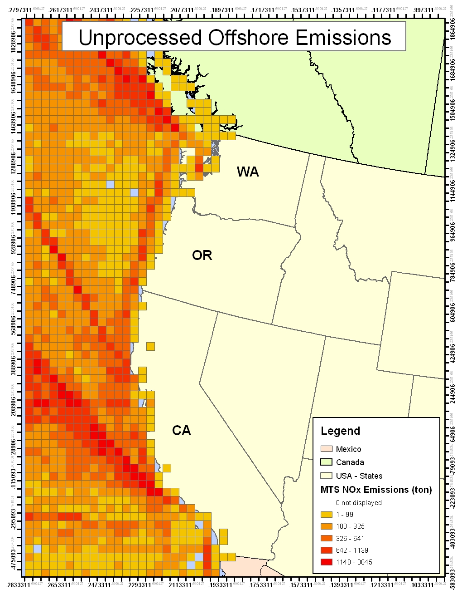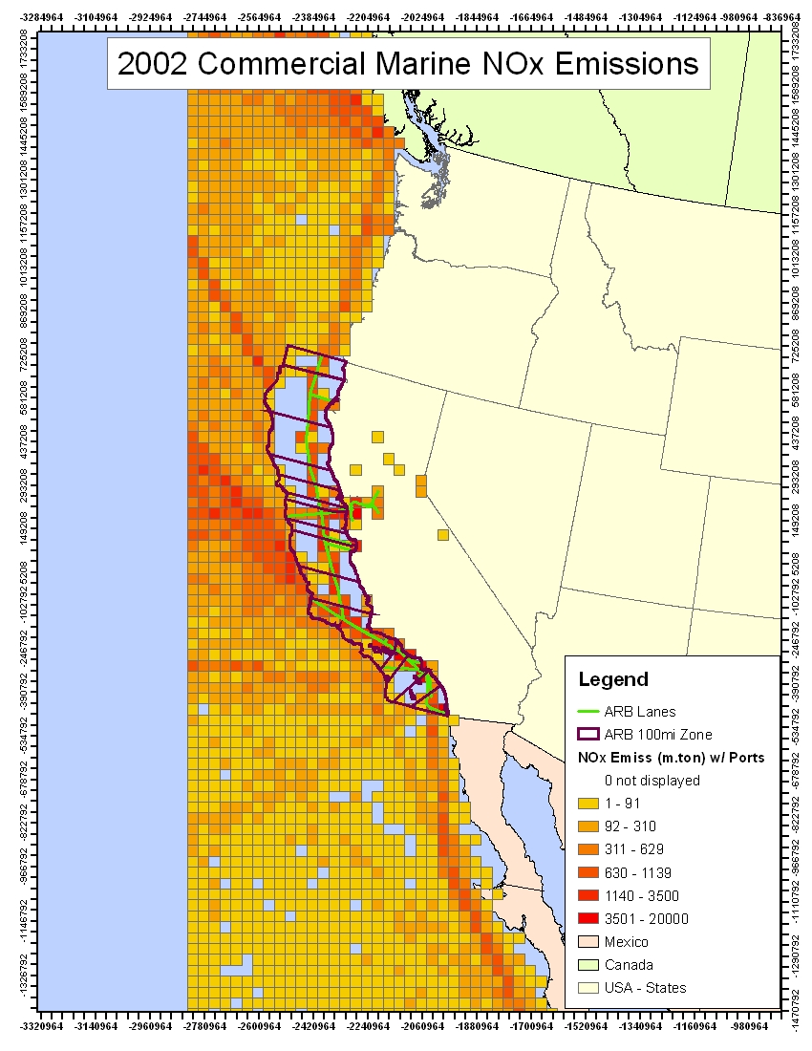
Figure 1. Raw offshore emission estimates and with near port emissions substituted
(Blue grids indicate no emissions over water).

The commercial marine vessel emission inventory estimates provided by the California Air Resources Board (CARB) includes estimates for ships in transit within 100 miles of the coast (CARB, 2005). The transit emissions predicted using the proximity method in this work were zeroed out for the zone where CARB estimates were applicable. They were replaced by the CARB transit emissions estimates that were spatially assigned to the coastal shipping lanes defined by CARB. The result of this replacement along the California coast is apparent in the right side of Figure 1. The CARB data also included large vessel activity in ports. Therefore, in addition to using the CARB transit emissions for the California coastal zone, the CARB in port emissions were used for the California ports.

Because the emissions offshore represent entirely new estimates of emissions in the WRAP modeling domain, a summary of emissions is shown in Table 2 by state compared with the emissions near the ports and for California within the coastal zone. For purposes of preparing state emissions totals for offshore activity, the states were defined using the latitudes where the state borders meet the shore, as shown in Figure 2. For the near port totals in Table 2, it should be noted that the Columbia River vessel traffic (especially the transit up and down the river) was primarily allocated to the State of Washington counties.

Table 2. 2002 Large ocean-going ship emissions by location (tons/year).
State | VOC | CO | NOx | PM10 | SO2
Washington (offshore) | 1,451 | 2,941 | 44,692 | 3,247 | 25,130
Washington (near port) | 103 | 209 | 3,467 | 335 | 2,483
Washington (within shore) | 277 | 1,206 | 10,764 | 763 | 5,352
Oregon (offshore) | 1,331 | 2,706 | 41,113 | 2,986 | 23,119
Oregon (near port) | 22 | 44 | 736 | 72 | 532
Oregon (within shore) | 23 | 271 | 1,415 | 42 | 212
California (offshore) | 4,269 | 8,681 | 131,930 | 9,587 | 74,181
California (coastal zone) | 5,387 | 14,345 | 111,550 | 6,042 | 46,059
Total | 12,863 | 30,403 | 345,667 | 23,074 | 177,068

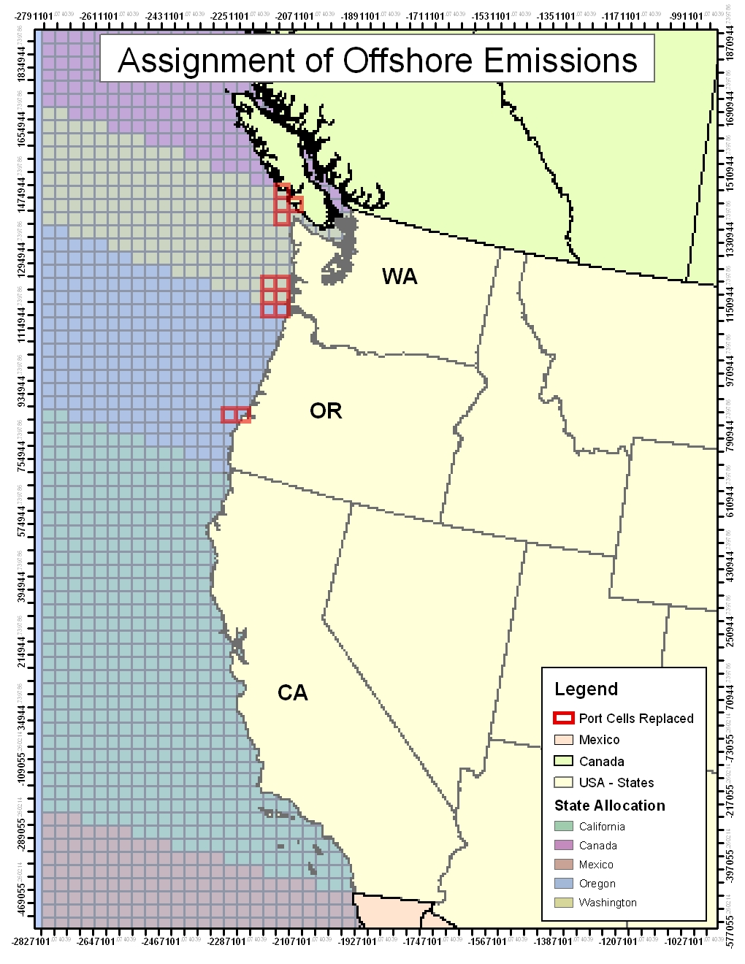
Figure 2. Offshore emissions by state and grid cells replaced with near port data.

In-shore Port Revisions

Ocean-going vessel emissions near ports were revised from the previous WRAP estimates (Pollack et al., 2004) to account for fleet turnover and more recent emission rate estimates. The fleet turnover aspect of the work considered the entire replacement of steamships with motorships, especially for projecting future year estimates.

Emission Factors Revisions

Table 3 shows the emission factors estimated by the U.S. EPA for Category 2 and 3 engines (EPA, 1999a, 2003) used in previous WRAP emission inventory estimates. For the Category 2 engines, the average values shown in Table 3 were the average values used to estimate the emission reductions from the new emission standards (Samulski, 1999), and are quite similar to the emission factors for the highest power Category 1 engines. For Category 3 engines, EPA relied on a review of the base emission factors by ENVIRON (2002), based on the available data to date when the study was conducted.

Table 3. US EPA (1999a, 2003) baseline emission factors for marine engines.
Engine Category | HC  [g/kW-hr] | CO  [g/kW-hr] | NO_{X}  [g/kW-hr] | PM  [g/kW-hr]
Category 2  (5-30 l/cylinder) | 0.134 | 2.48 | 13.36 | 0.32  low sulfur
Category 3  Medium Speed  (> 300 rpm, > 30 l/cylinder) | 0.5* | 0.7 | 16.6 | Fuel sulfur dependence
Category 3  Slow speed | 0.5* | 1.1 | 23.6 | Fuel sulfur dependence
* Converted from kg/tonne units in Lloyds (1995) using 210 (g/kW-hr) for “medium speed” engines.

Since the previous WRAP work, additional studies related to marine engine emissions have been published, including Cooper (2001 and 2003) and ENTEC (2002). Emission estimates from these studies were cited in the Port of Los Angeles (PoLA) emission inventory report (Starcrest, 2004). Table 4 summarizes emission factors from these studies.

Table 4. Emission factors for marine engines in the Port of Los Angeles emission inventory report.
Engine Category | HC  [g/kW-hr] | CO  [g/kW-hr] | NO_{X}  [g/kW-hr] | PM  [g/kW-hr]
Main Engine  (Medium Speed – Residual Oil) | 0.5 | 1.1 | 14.0 | 0.72
Main Engine  (Slow Speed – Residual Oil) | 0.6 | 1.4 | 18.1 | 1.92
Auxiliary Engine  (Medium Speed – Residual Oil) | 0.4 | 1.1 | 14.7 | 0.30
Auxiliary Engine  (Medium Speed – Gas Oil) | 0.4 | 1.1 | 13.9 | 0.30

The author of the 2002 ENTEC study later published a report to supplement the emission data compiled in the ENTEC study for marine engines (IVL, 2004). The emission data used in the IVL 2004 study are summarized in Table 5 for engines built prior to the MARPOL NOx emission reduction requirement. Note the dramatic difference in the slow speed particulate emission rate estimates of 1.92 or 1.3 g/kW-hr.

Table 5. Emission factors found in the IVL 2004 report for average 1999 conditions.
Engine Category | BSFC  [g/kW-hr] | HC  [g/kW-hr] | CO  [g/kW-hr] | NO_{X}  [g/kW-hr] | PM  [g/kW-hr]
Medium Speed – Residual Oil (2.4% sulfur) | 215 | 0.2 | 1.1 | 14.0 | 0.5
Medium Speed – Gas Oil (0.4% sulfur) | 205 | 0.2 | 1.1 | 13.2 | 0.2
Slow Speed – Residual Oil (2.4% sulfur) | 195 | 0.3 | 0.5 | 18.1 | 1.3
Slow Speed – Gas Oil (0.4% sulfur) | 185 | 0.3 | 0.5 | 17.0 | 0.2

There remains considerable uncertainty about the particulate emissions rates, especially for engines using high sulfur fuels. The IVL (2004) and ENTEC (2002) estimates indicate that the authors consider the uncertainty in the PM10 emission rates to be in excess of 50%. This may stem from the method of collection, filter handling, or other factors associated with the hygroscopic nature of the particulate formed from diesel engines burning high sulfur fuels. The particulate emissions rates and sulfur relationship used for the current WRAP inventories are not intended to be the final word on the subject, but provide a reasonable range of estimates consistent with the best understanding at this time.

Revised Estimates for Ocean-Going Vessels

EPA (1999b) reviewed estimates of the ocean-going vessel activity for Coos Bay and Puget Sound ports. In this document, a method is also described to extrapolate ocean-going vessel activity for other ports and to allocate activity to individual Puget Sound ports. Two data sources existed for the EPA (1999b) report, one of which gathered general information about the total number of trips by vessel type for the top 95 US ports, and the other gathered more specific information for several ports including the Puget Sound ports totals and Coos Bay. The more general information was used to allocate the more specific activity information to each of the Puget Sound ports and to extrapolate an estimate of the activity of the Columbia River ports. This method was identical to previous WRAP emission inventories with the replacement of steamships with motorships of the same gross tonnage. The revised emission estimates are shown in Table 6 for Puget Sound ports to be used to cross reference to the Columbia River ports. Emission rates for motorships are higher for NOx but lower for PM and SOx than for steamships.

Table 6. Emission estimates for Puget Sound (excluding Grays Harbor) ocean-going vessels in 2002.
Estimate | HC  (tons/year) | CO  (tons/year) | NOx  (tons/year) | PM  (tons/year) | SO2  (tons/year)
Cruise (25 miles to entrance of the Strait) | 52 | 106 | 1,759 | 170 | 1,400
Reduced Speed Zone | 135 | 275 | 4,554 | 440 | 3,255
Maneuvering | 23 | 67 | 203 | 24 | 164
Hotelling | 28 | 523 | 2,814 | 68 | 302
Total | 238 | 971 | 9,329 | 701 | 5,121

The emissions estimated in Table 6 do not include Canadian vessel traffic, and so may underestimate the emissions within and just outside the Strait of Juan de Fuca. A Canadian study (Levelton, 2002) added in Canadian traffic, which significantly increased (by 1.5 to 4 times) the reduced speed zone and cruise mode emissions for Washington State emissions exclusively in the transit modes through the Strait of Juan de Fuca. The scope of the inventory does not include the Canadian traffic emissions, but it should be understood that this emission source affects Washington marine emissions.

For geographic allocation, the emissions for each port were separated into three segments: cruise, reduced speed zone (RSZ), maneuvering and hotelling/dwelling. For emissions associated with Grays Harbor vessel calls, all emissions were considered to occur in Grays Harbor County. For all Puget Sound vessel calls, the cruise condition emissions were assumed to occur in Clallum County. For all Puget Sound vessel calls, the maneuvering and hotelling emissions were allocated to the county of the port of interest. The emissions for the reduced speed zone were allocated to the counties along the primary shipping channel according to estimates of the fraction of time spent in each county. For example, port calls to Olympia included RSZ emissions in Clallum, Jefferson, Kitsap, Pierce, and Thurston counties; and Port calls to Bellingham included transit through Clallum, San Juan, and Whatcom counties. Because shipping lanes often straddle county boundaries, these county designations were made for expedience and could be improved by plotting emissions along the actual shipping lanes rather than the county in general.

The basic data for the vessel calls and emission estimates were for 1996, the same as the previous emission inventory, but the scaling (growth) estimates from 1996 to 2002 were updated with freight movement information for 2002 compared to 1996. These scaling factors are shown in Table 7 for each port.

Table 7. Freight tonnage from 1996 to 2002 by port.
Port | 1996 | 2002 | 2002/1996
Seattle Harbor, WA | 23,547,000 | 19,591,009 | 0.83
Tacoma Harbor, WA | 21,491,000 | 20,587,109 | 0.96
Anacortes Harbor, WA | 13,844,000 | 15,362,650 | 1.11
Everett Harbor, WA | 4,007,000 | 3,009,175 | 0.75
Port Angeles Harbor, WA | 2,780,000 | 1,673,985 | 0.60
Grays Harbor, WA | 1,990,000 | 1,485,991 | 0.75
Bellingham Harbor, WA | 1,419,000 | 250,000 | 0.18
Olympia Harbor, WA | 1,893,000 | 1,440,439 | 0.76
Puget Sound Totals | 68,981,000 | 61,914,367 | 0.90
Port of Astoria, OR | 324,000 | 95,000 | 0.29
Port of Kalama, WA | 8,223,000 | 6,386,161 | 0.78
Port of Longview, WA | 5,163,000 | 4,705,771 | 0.91
Port of Portland, OR | 29,734,000 | 26,635,044 | 0.90
Port of Vancouver, WA | 7,704,000 | 6,610,345 | 0.86
Columbia River Totals | 51,148,000 | 44,432,321 | 0.87
Coos Bay | 3,322,000 | 1,706,821 | 0.51
Valdez, AK | 77,116,000 | 50,513,074 | 0.66
Ketchikan, AK | 1,341,000 | 753,000 | 0.56
Nikiski, AK | 6,608,630 | 7,235,098 | 1.09
Anchorage, AK | 3,401,000 | 2,983,137 | 0.88

Columbia River Ports

The Columbia River ports were estimated according to the procedure described in EPA (1999b), where a scaling factor was determined with a similar port, in this case, the Puget Sound totals. Adjustments were made to the actual vessel activity such as reduced speed zone load and time in mode based on discussions with the River Pilots for the Columbia River ports. Other factors, such as cruise, maneuvering, and hotelling time and load, were kept the same with the adjusted number of vessel calls.

Vessels arriving near the mouth of the Columbia River are guided by Bar pilots across the Columbia Bar to Astoria (approximately 14 nautical miles), where River pilots begin piloting ships to their destination. The River pilots estimate that 12 knots is a typical average speed for ships once the pilots take command.

There were five major ports in the Columbia River for which EPA (1999b) identified and estimated total vessel visits. These total vessel visits were compared with the total activity for Puget Sound ports (including Grays Harbor) for which a more detailed estimate has already been produced, as shown in the Table 8. The port call information provided here does not necessarily match the actual deep draft vessel calls because often smaller ships are included in the Army Corps estimates than would be included in a port specific data of deep draft vessels. The individual vessel visits by type of vessel for each Columbia River port were divided by the Puget Sound totals and multiplied by the more detailed estimate of the Puget Sound ports totals to produce an estimate of vessel activity for each of the Columbia River ports.

Table 8. Port activity totals as presented by EPA (1999b) for 1995.
Activity Data | Puget Sound Ports | Port of Portland,  OR | Port of Kalama,  WA | Port of Vancouver, WA | Port of Longview, WA | Port of Astoria, OR
RSZ Mileage (Nautical) | -- | 93 | 69 | 94 | 59 | 14
Bulk Carrier | 1378 | 694 | 378 | 446 | 543 | 397
Container Ship | 2667 | 540 | 0 | 7 | 0 | 0
General Cargo | 428 | 69 | 1 | 111 | 44 | 5
Other | 82 | 0 | 0 | 0 | 0 | 1
Passenger | 101 | 792 | 0 | 20 | 5 | 9
Reefer | 108 | 10 | 0 | 0 | 13 | 0
Roll on/Roll off | 795 | 126 | 0 | 7 | 15 | 4
Tanker | 1000 | 299 | 20 | 28 | 9 | 0
Vehicle Carrier | 1069 | 247 | 0 | 13 | 0 | 0

By using the ratio of total visits, the emissions for the Columbia River ports were directly calculated from the Puget Sound totals for cruise, maneuvering, and hotelling emissions. The resulting emissions adjusted to eliminate steamships for 1996 activity are shown in Table 9; Table 10 shows the emissions projected to 2002. Cruise conditions are assumed here to begin 14 miles out from Astoria where the reduce speed zone ends. Reduced speed zone emissions used the ratio of total visits and the ratios of load and time in mode for each Columbia River port. For instance, the reduced speed zone in the Puget Sound ranges from the entrance of the Strait of Juan de Fuca to near each port while the reduced speed zone for the Columbia River ports ranges from 14 miles out and in the Columbia River. Both the vessel speed (which affects the engine load) and the time in mode are different between the Puget Sound and Columbia River.

Table 9. Emission estimates for Columbia River ocean-going vessels in 1996.
Estimate | HC  (tons/year) | CO  (tons/year) | NOx  (tons/year) | PM  (tons/year) | SO2  (tons/year)
Port of Astoria, OR | 6 | 69 | 395 | 14 | 76
Port of Kalama, WA | 11 | 78 | 555 | 30 | 198
Port of Longview, WA | 15 | 114 | 789 | 41 | 264
Port of Portland, OR | 62 | 330 | 2662 | 174 | 1196
Port of Vancouver, WA | 20 | 118 | 914 | 56 | 377

Table 10. Emission estimates for Columbia River ocean-going vessels in 2002.
Estimate | HC  (tons/year) | CO  (tons/year) | NOx  (tons/year) | PM  (tons/year) | SO2  (tons/year)
Port of Astoria, OR | 3 | 22 | 146 | 7 | 44
Port of Kalama, WA | 11 | 65 | 512 | 31 | 212
Port of Longview, WA | 18 | 113 | 862 | 51 | 344
Port of Portland, OR | 72 | 328 | 2935 | 209 | 1470
Port of Vancouver, WA | 21 | 109 | 920 | 61 | 423

Overall emissions for vessels visiting each port are shown in Table 10 for 2002. However, transit emissions occur in the Columbia River downstream of each port rather than in the port area. The geographic allocation for the transit (cruise and RSZ) emissions were to the Washington counties (Pacific for cruise and some RSZ, Wahkiakum, Cowlitz, or Clark) below each port according to the fraction of time spent in each county. Maneuvering and hotelling emissions were allocated to the county of the port, whether Washington or Oregon.

The port of Coos Bay was determined differently in that no steamships called at this port in 1996. Therefore, no adjustment to the vessel fleet was made for this work other than using the revised NOx emission factors described here.

California Coastal Transit and Ports

Emissions for commercial marine vessels operating near and within the State of California were provided by CARB (CARB, 2005). Emissions were provided for several major categories, labeled by ARB as SHIPS IN-TRANSIT, SHIPS MANEUVERING and SHIPS BERTHING. The IN-TRANSIT category was defined as corresponding to operations on shipping lanes within 100 miles of the California coast. The MANUEVERING and BERTHING categories correspond to operations at ports. Emissions were also provided for a category labeled COMMERCIAL BOATS that accounts for the activity of smaller vessels near ports and on interior waterways. To incorporate the data provided by CARB into the WRAP commercial marine inventory, the CARB county level emissions estimates were spatially allocated to the 36 kilometer grid.

One of two methods was used to spatially allocate the California marine vessel emissions, depending on the emission category. For the IN-TRANSIT emissions, CARB provided a shapefile that defined the 100 mile coastal zone and a shapefile that defined the shipping lanes within that zone. By overlaying the 100 mile zone for each county with the shipping lanes and the WRAP grid, it was possible to assign a fraction of the county total emissions to each grid cell. For the remaining emissions categories, the emissions were assigned to the grid cells that encompassed the major port in the county. The exception to such port assignments were inland counties where emissions were assigned to major lakes or rivers. Figure 3 shows the grid cells to which IN-TRANSIT and the port/inshore emissions were assigned by these procedures.

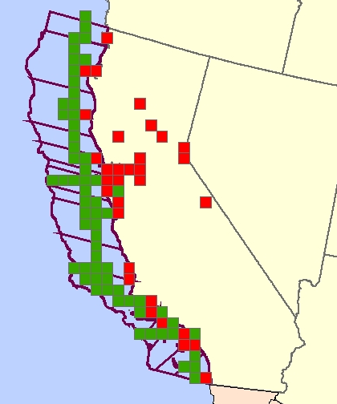

Figure 3. Grid assignment of California in-transit (green) and port/inshore (red) emissions.

The grid cell assigned emissions were then added to the other WRAP offshore and near port gridded emissions. Any overlap of the two inventories was eliminated. This yielded a comprehensive emission inventory for commercial marine operations on the west coast that encompasses all the zones shown in Figure 4.

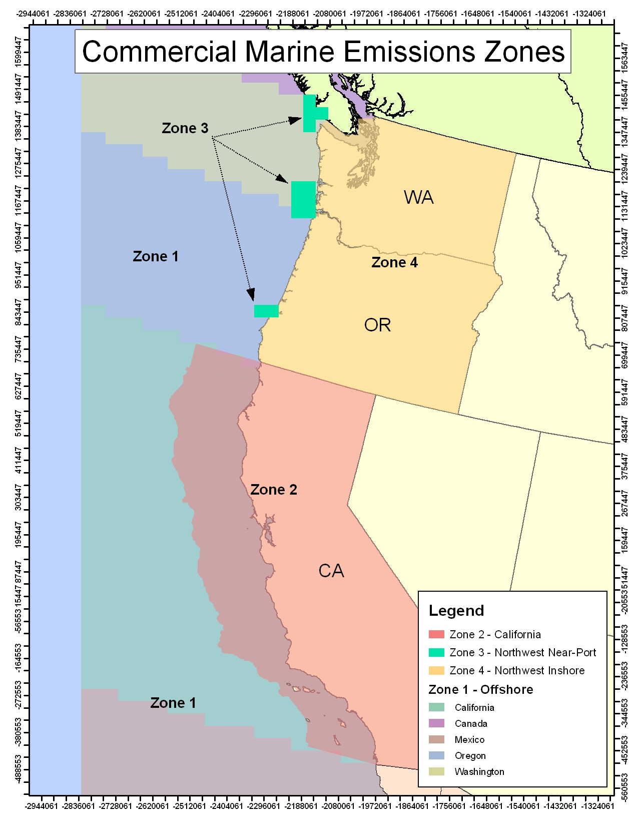
Figure 4. Distinct zones included in the WRAP commercial marine emissions inventory.

2018 Off-shore Emissions

Projection factors for future year commercial marine emissions were derived from a study performed by Corbett and Wang (2005). This projection was based on an investigation of the historic trend in the larger vessels’ installed power. The installed power combines the propulsion power of individual vessels and number of calls of each vessel to the WRAP coastal ports. The historic trend shown in Figure 3 does not provide a sufficient number of years to determine the form of the equation to use to project future year activity. The fit of the historic data was equivalent whether an exponential fit (equivalent to compound annual growth rate (CAGR)) or a linear regression was used. For this work, therefore, an average of the exponential and linear regression was used to project future year commercial marine activity, per agreement and discussion with CARB staff, and thereby matching CARB projections (CARB, 2005). These average projection factors are shown in Table 11; they were applied to all three west coast states, to all in-shore and offshore emissions. No emission rate decrease was projected because international standards are not expected to affect emissions.

More detailed discussions of the development of the off-shore mobile source emissions inventories can be found n Pollack, et al., 2006.

Table 11. Projection factors for ocean-going vessels.
Future Year | Relative to 2002
2008 | 1.39
2013 | 1.79
2018 | 2.30

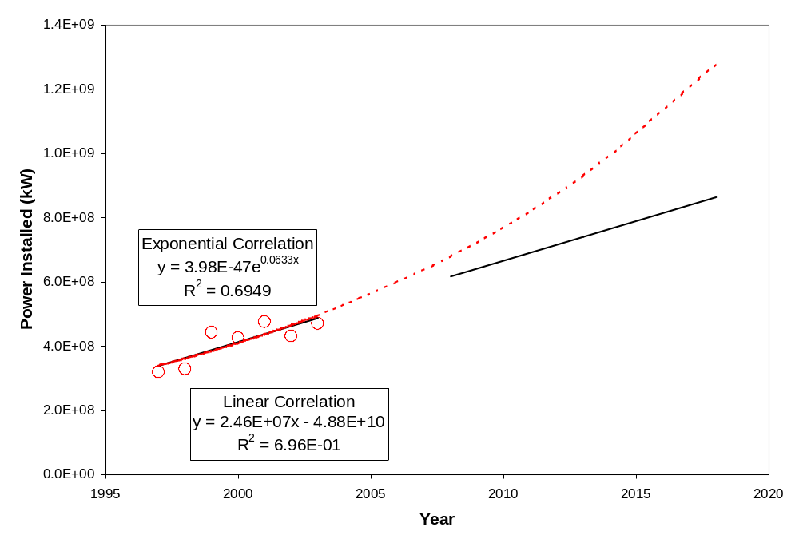

Figure 5. Commercial marine installed power trend and analysis.

Emissions Summaries

Summaries of the gridded off-shore source emissions for the Base02b, Plan02c and Base18b inventories by state and county, annual and seasonal periods, can be found on the TSS at: http://vista.cira.colostate.edu/tss/Results/Emissions.aspx.

