WEIGHTED EMISSIONS POTENTIAL ANALYSIS
(June 2011)

Introduction

The Weighted Emissions Potential (WEP) analysis was developed as a screening tool for states to decide which source regions have the potential to contribute to haze formation at specific Class I areas, based on both the 2002 (Plan02d) and 2018 (Prp18a) emissions inventories. This method does not produce quantitatively accurate results because, unlike the air quality model and associated PSAT analysis, it does not account for chemistry and removal processes. Instead, it relies on an integration of gridded emissions data, back trajectory residence time data, a one-over-distance factor to approximate deposition, and a normalization of the final results. Residence time over an area is indicative of general flow patterns, but does not necessarily imply the area contributed significantly to haze at a given receptor. Therefore, users are cautioned to view the WEP as one piece of a larger, more comprehensive weight of evidence analysis.

Emissions Data

The emissions data used were the annual, 36km grid SMOKE-processed, model-ready emissions inventories provided by the WRAP Regional Modeling Center (RMC). The analysis was performed for six (6) pollutants:

- Sulfur oxides  - Nitrogen oxides  - Organic carbon | - Elemental carbon  - Fine particulate matter  - Coarse particulate matter

The following source categories for each pollutant were identified and preserved through the analysis:

- Point  - Anthropogenic fires  - Natural fire  - Biogenic  - Area  - WRAP area oil and gas | - Off-shore  - On-road mobile  - Off-road mobile  - Road dust  - Fugitive dust  - Windblown dust

Residence Time Data

The back trajectory residence times were provided by Air Resource Specialists, Inc. (ARS), using NOAA’s HYSPLIT model to generate eight back trajectories daily (0000, 0300, … 2100 local standard time) for each WRAP Class I area for the entire five-year baseline period (2000-2004). The major model parameters selected for this analysis are presented in Table 1. From these individual trajectories, residence time fields were generated for one-degree latitude by one-degree longitude grid cells. Residence time analysis computes the amount of time (e.g., number of hours) or percent of time an air parcel is in a horizontal grid cell. Plotted on a map, residence time is shown as percent of total hours in each grid cell across the domain, thus allowing an interpretation of general air flow patterns for a given Class I area. The residence time fields for the 20% worst and best IMPROVE-monitored extinction days (based on the revised IMPROVE extinction algorithm) were selected for the WEP analysis to highlight the potential emissions sources during those specific periods.

Table 1
Back Trajectory Model Parameters Selected for WEP Analysis

Model | Parameter
Trajectory duration | 192 hours (8 days) backward in time
Top of model domain | 14,000 meters
Vertical motion option | used model data
Receptor height | 500 meters
Meteorological field | EDAS

Integration of Emissions and Residence Time Data

ENVIRON performed the WEP analysis, which consisted of weighting the annual gridded emissions (by pollutant and source category) by the worst and best extinction days residence times for the five-year baseline period. To account for deposition along the trajectories, the result was further weighted by a one-over-distance factor, measured as the distance in km between the centroid of each emissions grid cell and the centroid of the grid cell containing the Class I area monitoring site under investigation. (The “home” grid cell of the monitoring site was weighted by one fourth of the 36km grid cell distance, or one-over-9km, to avoid an overly large response in that grid cell.) The resulting weighted emissions field was normalized by the highest grid cell to ease interpretation. In addition, the 2018 results were normalized to the 2002 results so that actual changes in weighted emissions between scenarios are evident.

A series of maps illustrating the WEP analysis is presented in Figure 1. This example shows the annual emissions for NO_{x} across the domain, the specific residence time pattern for the 20% worst monitored days at a Class I area, and the resulting weighted emissions map. Both the 2002 and 2018 cases are presented. Interpretation of the results should focus on which grid cells (or larger regions) have significant potential to affect the Class I area, and on changes between 2002 and 2018.

A bar chart showing the estimated contribution by source category and region is presented in Figure 2. It is important to note that WEP charts show normalized (unitless) values with no direct connection to original emissions values. Interpretation of the results should focus on the relative contributions by each source category and region, and the changes between 2002 and 2018.

Caveats

The WEP is not a rigorous, stand-alone analysis, but a simple, straightforward use of existing data. As such, there are several caveats to keep in mind when using WEP results as part of a comprehensive weight of evidence analysis:

- This analysis does not take into account any emissions chemistry.
- While actual emissions may vary considerably throughout the year, this analysis pairs up annual emissions data with 20% worst/best extinction days residence times – this is likely most problematic for carbon and dust emissions, which can be highly episodic.
- Coarse particle and some fine particle dust emissions tend not to be transported long distances due to their large mass.

The WEP results are unitless numbers, normalized to the largest-valued grid cell. Effective use of these results requires an understanding of actual emissions values and their relative contribution to haze at a given Class I area.

Figure 1. Example series of maps for WEP analysis at Bridger Wilderness, WY. From left to right: single-year annual emissions density map; five-year residence time map; emissions weighted by residence time, by one-over-distance, and normalized to the highest grid cell. Top row presents 2002 results, bottom row presents 2018 results.
Page 4
Weighted Emissions Potential Analysis

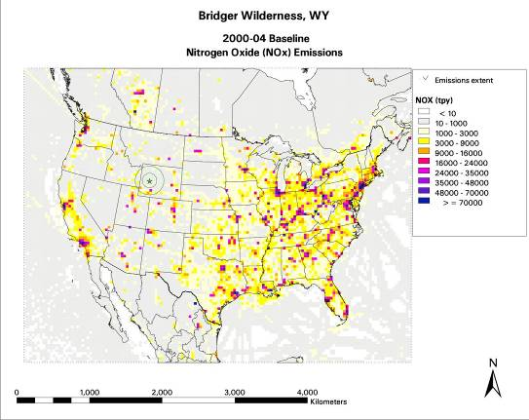 | 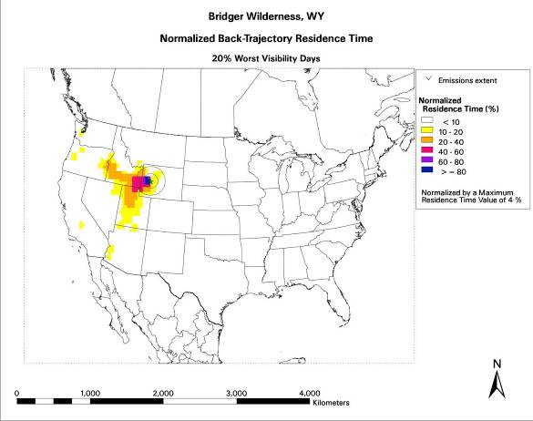 | 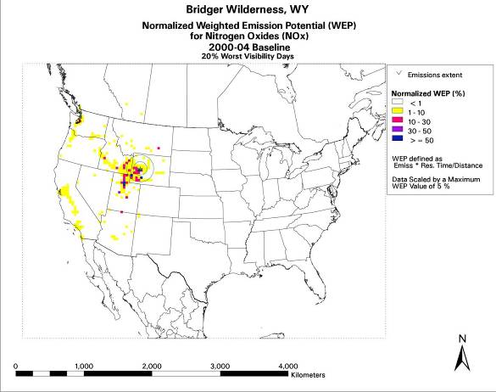
2002 NOx Emissions (TPY) | Residence Time Field, Worst 20% Monitored Days (2000-2005) | 2002 NOx Emissions Weighted by Residence Time and One-Over-Distance
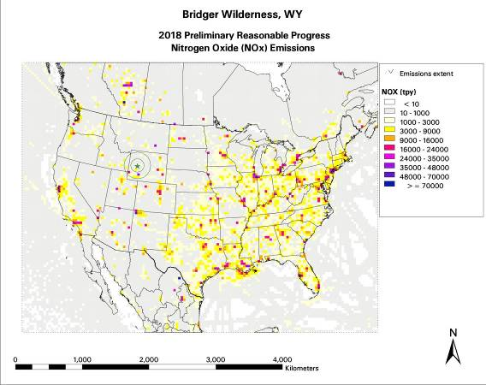 |  | 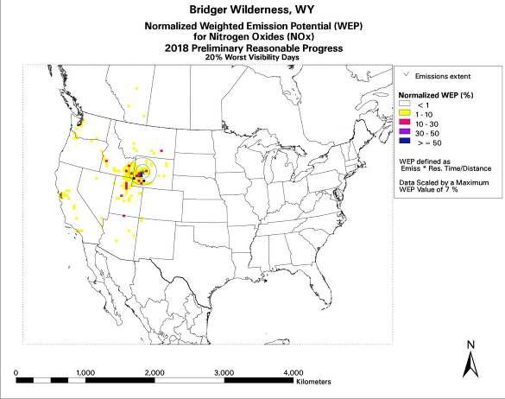
2018 NOx Emissions (TPY) | Residence Time Field, Worst 20% Monitored Days (2000-2005) | 2018 NOx Emissions Weighted by Residence Time, One-Over-Distance, and 2002 Results
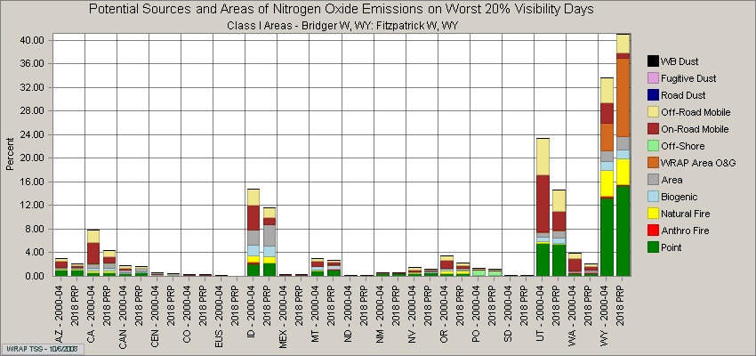
Figure 2. Example source category bar chart based on WEP analysis at Bridger Wilderness, WY. Since 2018 results are normalized to 2002 results, actual changes in weighted emissions between scenarios are evident.

