Comparison of the DRI/OGC and Model 2001 Thermal/Optical Carbon Analyzers

Final Report

Prepared by

Judith C. Chow
John G. Watson
L.-W. Antony Chen
M.-C. Oliver Chang
Guadalupe Paredes-Miranda

Desert Research Institute
2215 Raggio Parkway
Reno, NV 89512

Prepared for

IMPROVE Steering Committee

January 18, 2005
Abstract
The DRI/OGC analyzers used for IMPROVE carbon analysis since 1987 are obsolete. They break down frequently, spare parts are no longer manufactured, and data acquisition and processing software is antiquated and not compatible with current software. The Model 2001 carbon analyzer has been designed and tested as a replacement for future IMPROVE sample analysis
Tests on nine sets of samples from different environments were conducted to determine the comparability between the DRI/OGC and Model 2001 units. Methods to better calibrate the IMPROVE temperature protocol and to measure the oxygen (O₂) content of the helium (He) carrier gas were developed and applied as part of these tests. These tests revealed that:
- TC (total carbon), OC (organic carbon), and EC (elemental carbon) are comparable among different instruments with the same design and between different instrument designs for the IMPROVE thermal optical reflectance (IMPROVE_TOR) protocol and other temperature protocols that use reflectance for pyrolysis charring corrections.
- OC and EC are sensitive to the temperature protocol when a transmittance pyrolysis charring correction is used. The difference depends on the type of sample and can be as high as a factor of 3 or 4 for EC.
- Thermally defined carbon fractions (OC1, OC2, OC3, OC4, EC1, EC2, EC3, and OP) measured with the DRI/OGC units are highly variable due to differences in the sample temperature and O₂ level in the pure He carrier gas. These conditions are much better controlled in the Model 2001.
- DRI/OGC temperature and carrier gas conditions can be simulated in the Model 2001, but the high variability in the DRI/OGC analyses does not define an exact condition to be replicated.
- After temperature calibration, sample temperature in the DRI/OGC analyzers is 20–40 °C higher than the specified protocol. An adjustment can be made in the Model 2001 to represent the actual IMPROVE protocol.
It is recommended that:
- For IMPROVE samples collected in calendar year (CY) 2005, begin analysis with the Model 2001 using the revised IMPROVE protocol (IMPROVE_A) rather than the actual and more variable DRI/OGC temperature and atmosphere conditions. Calibrate thermocouples to obtain stated IMPROVE_A temperatures within ±3 °C. Institute periodic quality control checks of temperature calibration and carrier gas composition. Calibrate reflected and transmitted laser responses among instruments and report initial, minimum, and final values in the data base. Report negative as well as positive TOR and TOT pyrolysis charring corrections.
- In addition to regular replicates measured among the five Model 2001 analyzers, analyze an additional 5% of replicates on two of the DRI/OGC analyzers for at least one year. If discrepancies exceeding 10% in TC, OC, or EC are found between the Model 2001 and DRI/OGC analyzers, an additional 5% of replicates will be analyzed to verify the causes. Operate the DRI/OGC analyzers according to current procedures with periodic audits of their temperatures and carrier gas compositions. Conduct further comparisons of TC, OC, EC, and the carbon fractions.
- Report Model 2001 carbon fractions with new identifiers (OC1A, OC2A, etc.) so they won’t be confused with previous values. Report the 5% DRI/OGC values with their current denomination.
- Analyze additional data to: 1) determine effects of analyzer change on TC, OC, and EC for a wider range of samples than those reported here; 2) determine variability of thermal carbon fractions within and between instrument designs; 3) determine effects of mineral oxidation and catalysts on EC evolution; 4) better identify heavily loaded samples and residual minerals from optical measurements; and 5) estimate different absorption efficiencies of atmospheric and filter pyrolyzed char from reflectance and transmittance measurements.
- Conduct systematic studies of new and archived source samples to define thermal carbon fractions that better represent adsorbed organic vapor and source contributions.

Table of Contents

List of Tables i
List of Figures ii
1 Introduction 1-1
1.1 Background 1-1
1.2 Objectives 1-2
1.3 Overview of Report 1-2
2 Measurement Methods 2-1
2.1 IMPROVE Thermal/Optical Protocol 2-1
2.2 Description of Analyzers 2-1
2.3 Temperature Calibration Method 2-3
2.4 Analysis Atmosphere Measurement Method 2-4
3 Comparability of Thermal/Optical Carbon Measurements 3-1
3.1 IMPROVE OC and EC Comparison 3-2
3.2 Sensitivity of OC and EC by IMPROVE_TOR to Different Temperature and Optical Protocols 3-3
3.3 IMPROVE Thermal Carbon Fractions 3-4
4 Causes of Differences in Carbon Fractions 4-1
4.1 Sensitivity of Carbon Fractions to Temperature and Carrier Gas Composition 4-1
4.2 TC, OC, EC, and Carbon Fraction Uncertainties 4-2
4.3 Statistical Adjustments for Carbon Fractions 4-3
4.4 Analytical Adjustments for Carbon Fractions 4-3
5 Summary, Conclusions, and Recommendations 5-1
5.1 Summary 5-1
5.2 Conclusions 5-1
5.3 Recommendations 5-1
6 References 6-1
Appendix A A-1
Appendix B B-1

List of Tables
Page
Table 2-1. Comparisons between DRI/OGC and Model 2001 thermal/optical carbon analyzers. 2-5
Table 2-2. Temperature differences for five Model 2001 thermal/optical carbon analyzers (#6 — #11). 2-7
Table 2-3. Temperature differences for five DRI/OGC carbon analyzers. 2-8
Table 2-4. Oxygen (O₂) mixing ratios (ppmv) in helium (He) carrier gas for different instruments. 2-9
Table 3-1. Samples used for comparison studies. The batch identifier, type of sampling site, sampling period, and use of the samples in this study are listed. 3-5
Table 3-2. Comparability measures for TC, OC, and EC on DRI/OGC and Model 2001 carbon analyzers. 3-9
Table 3-3. Comparability measures for carbon fractions on DRI/OGC and Model 2001 carbon analyzers. 3-10
Table 4-1. Comparability measures for adjusted carbon fractions on DRI/OGC and Model 2001 carbon analyzers. 4-7
Table 4-2. Comparability measures for carbon fractions on DRI/OGC and Model 2001 with the IMPROVE and revised IMPROVE (IMPROVE_A) protocols. 4-8

List of Figures
Page
Figure 2-1. Example of an IMPROVE_TOR carbon thermogram. Seven carbon fractions are defined by the analysis atmosphere and the sample temperature. OC1, OC2, OC3, and OC4 evolve in a non-oxidizing pure helium (He) atmosphere while EC1, EC2, and EC3 evolve in a 2% oxygen (O₂) and 98% He mixture. Optical charring corrections are determined by both reflectance (R) and transmittance (T) when these achieve their original values after O₂ is added. Only the reflectance correction (OP) is currently reported with the IMPROVE carbon fractions. 2-10
Figure 2-2. Schematic diagram of the: a) DRI/OGC carbon analyzer (Desert Research Institute, Reno, NV) and b) Model 2001 thermal/optical carbon analyzer (Atmoslytic, Inc., Calabasas, CA). In the Model 2001, the sample holder is open on top and bottom to minimize interference with the reflectance and transmittance measurement. The carrier gas flows above and below (not through) the sample. 2-11
Figure 2-3. Schematic diagram of sample holder design in the: (a) DRI/OGC and (b) Model 2001 carbon analyzers. 2-12
Figure 2-4. Temperature ramping during an audit experiment with a Tempilaqº G temperature indicator rated at 184 °C for a Model 2001 carbon analyzer. Also shown in the figure are reflectance (R) and transmittance (T) of the temperature indicator. The dashed line indicates the achievement of the rated temperature. 2-13
Figure 2-5. Reflectance (R) and transmittance (T) measurements and their first and second derivatives over time during an audit experiment with a Tempilaqº G temperature indicator rated at 184 °C. The dashed line indicates the achievement of the rated temperature. 2-14
Figure 2-6. Schematic diagram for measuring composition of the 100% helium (He) carrier gas. 2-15
Figure 2-7. Mass spectrometric detector (MSD) response to known quantities of oxygen (O₂). 2-16
Figure 2-8. Oxygen (O₂) levels in the carrier gas through the analysis oven. 2-17
Figure 3-1. Comparisons of: a) TC, b) OC, and c) EC between the DRI/OGC and Model 2001 carbon analyzers for 243 IMPROVE samples (IMPROVE I and IMPROVE II from Table 3-1) collected at 40 sites between 4/25/2001 and 5/31/2001. 3-11
List of Figures, cont'd
Page
Figure 3-2. Comparisons of: a) TC, b) OC, and c) EC between the DRI/OGC and Model 2001 carbon analyzers for 57 Fresno. Both zero and negative OP (early split) corrections are used. 3-12
Figure 3-3. Comparisons of: a) TC, b) OC, and c) EC between the DRI/OGC and Model 2001 carbon analyzers for 18 Hong Kong samples. Both zero and negative OP (early split) are presented. 3-13
Figure 3-4. Comparisons of STN_TOT and STN_TOR with IMPROVE_TOR implemented on the Model 2001 carbon analyzers for: a) 30 IMPROVE IV samples, b) 57 Fresno samples, c) 18 Hong Kong samples, and d) 22 Montana fire samples. Note that the TOR pyrolysis correction is insensitive to the temperature program applied. The TOT correction shows a large difference for the higher temperature STN protocol. 3-14
Figure 3-5. Comparison of carbon fractions between DRI/OGC and Model 2001 analyses for 243 samples (IMPROVE I and IMPROVE II from Table 3-1) collected at 40 sites from 4/25/2001 to 5/31/2001. 3-15
Figure 4-1. Carbon fractions in total carbon (TC) by IMPROVE_TOR as functions of analytical temperature and atmosphere for a Fresno sample on 7/16/2003. 4-9
Figure 4-2. Carbon fractions by IMPROVE_TOR (a) and IMPROVE_TOT (b) for a Fresno sample on 8/23/2002. 4-10
Figure 4-3. Replicate variation (RV) of total carbon (TC) as a function of mean TC measurements with DRI/OGC analyzers. Replicates were performed on 1,010 IMPROVE samples from more than 150 sites. The sampling period was from 12/1999 to 10/2002, including 224, 381, 236, and 169 samples in spring, summer, fall, and winter, respectively. The curved lines indicate the uncertainty of individual TC measurement at a 95% confidence level. The parameters of this line are minimum detection limit MDL = 1.49 μgC per filter and coefficient of variation (CV) = 8.4%. 4-11
Figure 4-4. Replicate variation (RV) of carbon fractions as a function of mean carbon fraction measurement with DRI/OGC analyzers. 95% confidence lines and number of samples are the same as those shown in Figure 4-3. 4-12
List of Figures, cont'd
Page
Figure 4-5. Replicate variation (RV) of organic carbon (OC) and elemental carbon (EC) as a function of mean OC and EC measurements with DRI/OGC analyzers. 95% confidence lines and samples are the same as those shown in Figure 4-3. 4-13
Figure 4-6. Comparison of: (a) OC1 and (b) EC1 replicates between two DRI/OGC analyzers and between a DRI/OGC and a Model 2001 carbon analyzer. The blue dots indicate replicates of the 1,010 IMPROVE samples by the DRI/OGC analyzer. The red dots indicate replicates of the 243 IMPROVE I and IMPROVE II samples by the Model 2001. The Model 2001 measurements are within the uncertainty of the DRI/OGC measurements. 4-14
Figure 4-7. Comparison between the Model 2001 and DRI/OGC carbon fractions for 154 IMPROVE I samples. The squares result from an empirical conversion of the DRI/OGC analyzer values to equivalence with the Model 2001 carbon analyzer values. 4-15
Figure 4-8. Comparison of Model 2001 and DRI/OGC total carbon (TC), organic carbon (OC), and elemental carbon (EC) using the IMPROVE_A protocol on 160 IMPROVE VI samples collected between 1999 and 2003 (temperature plateaus of 140 °C for OC1, 280 °C for OC2, 480 °C for OC3, 580 °C for OC4, 580 °C for EC1, 740 °C for EC2 and 840 °C for EC3). 4-16
Figure 4-9. Comparison of Model 2001 and DRI/OGC carbon fractions using the IMPROVE_A protocol on 160 IMPROVE VI samples collected between 1999 and 2003 (temperature plateaus of 140 °C for OC1, 280 °C for OC2, 480 °C for OC3, 580 °C for OC4, 580 °C for EC1, 740 °C for EC2 and 840 °C for EC3). 4-17
Figure 4-10. Comparison of Model 2001 and DRI/OGC carbon fractions for 110 IMPROVE III samples with the modified carrier gas (250 ± 50 ppmv O₂ in He for OC analysis) and temperature conditions (temperature plateaus of 142 °C for OC1, 238 °C for OC2, 468 °C for OC3, 579 °C for OC4, 591 °C for EC1, 738 °C for EC2, and 841 °C for EC3). 4-18
Figure 4-11. Total carbon (TC), organic carbon (OC), and elemental carbon (EC) comparisons with the Model 2001 and DRI/OGC analyzers for 110 IMPROVE III samples with the modified Model 2001 carrier gas (250 ± 50 ppmv O₂ in He for OC analysis) and temperature conditions (temperature plateaus of 142 °C for OC1, 238 °C for OC2, 468 °C for OC3, 579 °C for OC4, 591 °C for EC1, 738 °C for EC2, and 841 °C for EC3). 4-19
List of Figures, cont'd
Page
Figure 4-12. Carbon fractions of two Fresno samples (a and b) analyzed by the same DRI/OGC analyzer (CA #2) at nine-month intervals compared with those analyzed by the Model 2001 (CA #10) with IMPROVE_TOR and modified IMPROVE_TOR conditions. (* denotes analysis with modified analytical conditions stated in Figure 4-10.) Red lines indicating the consistent OC/EC split as negative OP are used. 4-20

Introduction

Background
Organic carbon (OC) and elemental carbon (EC) analysis of aerosol samples on quartz-fiber filters was established at the Desert Research Institute (DRI) in 1986 in support of the State of Nevada Air Pollution Study (SNAPS, Chow et al., 1988). The carbon analyzer used for these measurements was designed and constructed by Dr. John Rau of the Oregon Graduate Center (OGC, now called Oregon Graduate Institute, OGI), and was the latest in a series of designs developed at OGI (Huntzicker et al., 1982, Johnson et al., 1981, Rau, 1986, Shah, 1981, Watson, 1979). The thermal evolution protocol was based on that of Rau (1986), with adjustments in temperature plateaus to minimize pyrolysis charring and to lengthen residence times at each temperature to allow most of the carbon at that temperature to evolve before proceeding to the next plateau. This analyzer and protocol were applied to samples from the Winter Haze Intensive Tracer Experiment (Malm et al., 1989) in 1987.
The IMPROVE (Interagency Monitoring of PROtected Visual Environments) network was established in 1988, and four additional DRI/OGC analyzers of identical design were constructed to accommodate the increasing number of samples. The thermal/optical reflectance (TOR) protocol implemented on these analyzers was adopted for IMPROVE OC and EC measurements, and it eventually became known as the IMPROVE_TOR protocol (Chow et al., 1993). TOR refers to the use of reflected laser light to monitor the darkening (charring due to pyrolysis of OC) of sampled OC as the sample is heated in an oxygen (O₂)-starved environment. This contrasts with thermal optical transmittance (TOT) methods that monitor laser light transmitted through, rather than reflected from, the sample.
Other thermal evolution instruments implementing different temperature and optical protocols have been constructed and applied throughout the world (see Appendix A for a partial listing). Numerous comparison studies (see Appendix B for a summary) have shown differences between the OC and EC measured by these different instruments and protocols, although the total carbon (TC = OC + EC) is usually the same when the instruments are similarly calibrated. Since EC is normally the smaller component of TC, its concentration is most sensitive to the method applied. Currie et al. (2002), for example, report a factor of 7 range in EC levels for different measurement methods applied to a standard reference material (SRM 1649a). Differences by factors of 2 or 3 in EC among different methods are common.
Although the knowledge base has increased since 1986, the “best” or “correct” way to measure OC and EC has not been resolved (Richard et al., 2003). It is doubtful that there is a “correct” method, and claims have never been made that the IMPROVE protocol meets that goal. However, great efforts have been expended to assure that application of the IMPROVE protocol is consistent, as is necessary for a long-term trends network. The same protocol on the same instruments has been applied to more than 200,000 samples from IMPROVE and other networks since 1986. Re-analysis of archived sample remnants and replicates verifies that the OC and EC values have been equivalently quantified for the past 18 years.
In the early 1990s, it was noticed that the seven thermally derived carbon fractions measured by IMPROVE_TOR were different for different source emissions (Watson et al., 1994). Since these fractions were a natural outcome of the analysis, it was decided to report them into the IMPROVE data base, along with the optical particle correction that accounts for charred OC (the portion of OC that turns to EC in an inert atmosphere at high temperatures). Recent use of these fractions in receptor models (Kim and Hopke, 2004, Kim et al., 2004a, 2004b, 2004c, Maykut et al., 2004) indicates that they might have some relationship to contributing sources at IMPROVE sites. However, these apportionments have not yet been confirmed by source tests, and the IMPROVE temperature plateaus are not optimized to bracket boiling points of OC compounds that might be distinctive source markers.
By the late 1990s, it was evident that the DRI/OGC analyzers were wearing out. Some components were no longer manufactured and the data acquisition system was antiquated. It was also recognized that a more versatile instrument was needed to better understand the causes of OC and EC differences among different thermal/optical protocols. The Model 2001 (Atmoslytic Inc., Calabasas, CA) was developed and made commercially available for this purpose. The Model 2001 has automatic sample positioning, more rapid temperature response, improved seals and flow control, greater heating capacity, advanced electronics, modern data acquisition, the potential for an automated sample changer, and the ability to simultaneously measure reflectance (R) and transmittance (T). Thirty-five Model 2001 analyzers are currently in use in the U.S., Canada, Mexico, Japan, China, Taiwan, Hong Kong, and France to implement the IMPROVE and other thermal/optical carbon analysis protocols.
Initial comparisons (Chow et al., 2004a) of IMPROVE samples analyzed by the DRI/OGC and Model 2001 implementing the IMPROVE_TOR protocol showed good agreement between the TC, OC, and EC fractions, but sometimes showed large differences between concentrations for the seven thermal carbon fractions. Further testing (Chow et al., 2004b) showed the OC and EC split is the same for widely divergent temperature protocols with the TOR pyrolysis/char correction, although it is very sensitive to temperature for the TOT correction. This was attributed to charring of organic vapors adsorbed within the filter (Chow et al., 2004b, Chen et al., 2004) that dominate the T but have a negligible effect on R. The question remained, however, as to why the thermal sub-fractions were different for the two analyzers, and the answer is the subject of this report.

Objectives
The objectives of this study are to:
- Document physical and operational differences between the DRI/OGC and Model 2001 thermal/optical carbon analyzers.
- Describe methods for determining the sample temperature and composition of analysis atmosphere during thermal analysis.
- Quantify differences between sample temperatures and analysis atmospheres for different instruments.
- Quantify the effects of deviations from the stated IMPROVE_TOR protocol in different instruments on the IMPROVE carbon fractions.

Overview of Report
This introduction has provided the background and stated the objectives for this report. Section 2 describes the DRI/OGC and Model 2001 instruments and their similarities and differences. It reports results of temperature calibration and carrier gas composition experiments. Section 3 examines the comparability among TC, OC, EC, and carbon fractions measured by the two instruments. Section 4 quantifies how fluctuations in sample temperature and carrier gas affect the carbon fraction concentrations. Section 5 recommends an approach for replacing the DRI/OGC analyzers with the Model 2001 analyzers.

Measurement Methods

IMPROVE Thermal/Optical Protocol
Figure 2-1 illustrates the output of a carbon analyzer following the IMPROVE protocol. A 0.5 cm² sample punch taken from a quartz-fiber filter is subjected to different temperature and oxidation environments. Carbonaceous materials are volatilized, pyrolized, and combusted to gas-phase compounds that leave the sample and are converted to carbon dioxide (CO₂) as they pass through an oxidizer (manganese dioxide [MnO₂] at 912 °C). The CO₂ is reduced to methane (CH₄) as the carrier gas passes through granulated firebrick impregnated with a nickel catalyst at ~420 °C. The CH₄ is then quantified by a flame ionization detector (FID). A helium-neon (He-Ne) laser (633 nm, red light) is directed at the deposit side of the sample punch, and the R from—and with the Model 2001, T through—the filter is monitored throughout the analysis.
During heating in the non-oxidizing He atmosphere, some of the OC on the filter pyrolyzes to EC in the absence of O₂, as seen by the decrease of R and T in Figure 2-1. Organic pyrolysis char (OP) is defined as the carbon measured after the introduction of the He/O₂ atmosphere at 550 °C but before R returns to its initial value. If R attains its initial value prior to O₂ introduction (i.e., early split), OP can be reported as either zero (default for the IMPROVE network) or as a negative value. This can occur when EC is mixed with oxidizing minerals (Fung, 1990, Sciare et al., 2003) or catalysts (Lin and Friedlander, 1988a, 1988b, 1988c) in the sampled aerosol, when a heavily loaded sample saturates the optical signal, or when small amounts of O₂ are in the He carrier gas.
The nominal IMPROVE temperature plateaus in pure He are 120 °C, 250 °C, 450 °C, and 550 °C, and the corresponding thermal carbon fractions are called OC1, OC2, OC3 and OC4. Temperature is ramped to the next step when the FID response returns to baseline or remains at a constant value for more than 30 seconds; the residence time at each plateau is longer for more heavily loaded samples. The analysis atmosphere is then switched to 2% O₂/98%He. Temperature plateaus in the 2% O₂/98% He atmosphere are 550 °C (EC1), 700 °C (EC2), and 800 °C (EC3). TC, OC, and EC are calculated from the eight carbon fractions as:
TC = OC + EC (2-1)
OC = OC1 + OC2 + OC3 + OC4 + OP (2-2)
EC = EC1 + EC2 + EC3 – OP (2-3)

Description of Analyzers
Figure 2-2 compares configurations for the DRI/OGC and Model 2001 analyzers. Major differences between the two instruments are summarized in Table 2-1. The location of the thermocouple temperature sensor with respect to the sample is shown in Figure 2-3. The Model 2001 allows both R and T to be measured simultaneously. T was originally added to facilitate comparisons between samples analyzed by the IMPROVE_TOR and Speciation Trends Network (STN_TOT) protocol (Peterson and Richards, 2002). The STN is a counterpart to IMPROVE at urban locations. Comparisons (Chow et al., 2001) for the same samples showed EC by IMPROVE_TOR to be 2 to 4 times EC determined by STN_TOT.
As shown in Figure 2-3, the thermocouple does not come into contact with the sample. Sample temperature may differ from thermocouple temperature owing to: 1) temperature gradients in the sample oven, 2) different thermal properties for the sample and thermocouple, and 3) temperature gradients between the analysis oven and oxidation oven.
The DRI/OGC sample oven consists of a Nichrome heating coil (75 mm long x 18 cm outside diameter) within a large firebrick block (300 mm long x 190 mm wide x 190 mm high). Part of the coil is exposed to ambient air. The temperature gradient in the sample oven ranges from ~20 °C/cm at 1% power output to ~50 °C/cm at 75% power output (>600 °C). The Model 2001 sample oven consists of heavy Nichrome wire (45 mm length x 50 mm height on either side) in a vertical zigzag pattern imbedded in small firebrick blocks (63 cm long x 50 mm wide x 100 mm high) on both sides of the sample. This design reduces the temperature gradient in the oven.
In the DRI/OGC carbon analyzer, the sample punch is 2-4 mm from the tip of the thermocouple (i.e., temperature sensor) and the thermocouple is shielded. The ungrounded type-K thermocouple has a sheath diameter of 0.32 cm (one-eighth inch). It requires ~18 s to equilibrate its response to a given temperature plateau. The standard operating procedure (DRI SOP 2-204.6) specifies that the thermocouple/pushrod is backed up “slightly” after pushing a sample punch into the oven to avoid direct contact between the sample and thermocouple. This manual operation creates some variability in the distance between the sample and thermocouple and the precise location of the sample within the oven.
The Model 2001 minimizes the distance between the sample punch and thermocouple sensor. The sample punch is placed in a quartz holder parallel to the carrier gas stream. The tip of the grounded type-K thermocouple is exposed (i.e., no external shielding, different from the DRI/OGC unit) and located approximately 1 mm under the edge of the filter punch to minimize interference with the R and T measurements. The thermocouple time constant is ~1 s. The temperature sensor is always in the same location relative to the sample within a given analyzer until the thermocouple is replaced. Sample movement is controlled by an electric step motor that ensures a repeatable sample position in the oven.
There is a perpendicular connection (90° crossover area) between the sample and oxidation oven in the DRI/OGC analyzer. This crossover area may be cooler than the area within sample oven. Some of the carbon gases released from the sample may condense on the glass wall in this zone, to be re-volatilized through conduction heating as the high temperature carrier gas from later carbon fractions passes through. This could result in some differences in the carbon fractions. The straight connection in the Model 2001 minimizes the unheated portion between the sample and oxidation ovens so the sample temperature is maintained until conversion to CO₂. CO₂ does not condense on cooler surfaces.
Although both instruments operate under positive pressure in the sample stream, there might still be some diffusion of heavier room air into the oven owing to the lower molecular weight of the He carrier gas. The DRI/OGC analyzers contain several joints and connections sealed with pliable Teflon ferrules. The seal for the manual insertion rod experiences the most wear and tear. The automatic sample loading system on the Model 2001 seals the opening with an O-ring under 20 psi of air pressure. Other joints and connections in the Model 2001 are sealed with high-temperature silicone rings suitable for vacuum systems. The Model 2001 contains a pressure meter that indicates the sample oven pressure continuously, facilitating routine leak checks prior to thermal analysis. For the DRI/OGC analyzer, the leak test is performed indirectly by monitoring the change of flow rate when the oven is isolated (DRI SOP 2-204.6).
Differences between sample temperature and thermocouple temperature and differences between diffusion of outside air into the pure He atmosphere were hypothesized as the main cause of difference among the thermal carbon fractions measured by the DRI/OGC and Model 2001 analyzers. Special methods were developed to quantify these differences.

Temperature Calibration Method
Determining the differences between sample and thermocouple temperatures is complex because they are composed of materials with different thermal properties and cannot be collocated. Initial tests were conducted using pure compounds of known decomposition temperatures, but these did not yield sufficient precision owing to evaporation at temperatures lower than the boiling point and peak broadening as the evolved carbon passed through the oxidation and reduction ovens. However, R and T changes are detected immediately.
Quick-drying temperature indicating liquids (Tempil Inc., South Plainfield, NJ) of different melting points are used as temperature calibration standards. A Tempilaq° G set consists of chemicals that change their appearance at a specific temperature. A thin layer (25 µL) of Tempilaq° G is uniformly applied onto a glass or quartz disk surface with a 0.1 ml Eppendorf Combitip (Brinkman Instruments Inc., Westbury, N.J.) and covered with a sliced quartz-fiber filter punch. This sample is inserted into the carbon analyzer and the temperature is slowly ramped (2 °C/min) across a 50 °C range containing the specified Tempilaq melting point while R and T are monitored. When the specified temperature is reached, the appearance of the sample changes, as evidenced by R and T changes illustrated in Figure 2-4. The maximum or minimum of second derivative (change in the slope) of R or T, respectively, records the inflection point that provides the best indication of when the given temperature is attained, as shown in Figure 2-5. Since the DRI/OGC analyzer measures only R, R is used to determine changes in appearance. The second derivative of T gives the same results. Several tests are made at 121, 184, 253, 510, 704, and 816 °C to obtain an average and standard deviation.
Results for the five Model 2001 analyzers that are intended for future IMPROVE samples and for the five DRI/OGC analyzers currently used for IMPROVE analysis are summarized in Tables 2-2 and 2-3, respectively. The sample temperature is typically higher than the thermocouple reading for all of the analyzers and all of the temperatures tested. For the Model 2001 units, the sample is <10 °C hotter than the sensor reading at lowest two temperatures, increasing to 20 to 30 °C hotter at the higher temperatures. For the DRI/OGC units, the sample is 10 to 50 °C hotter than the sensor readings at all ranges, except for DRI/OGC CA #01, where a ΔT of 57–77 °C is found for the highest temperature (704 °C). The precision of the temperature from repeated measurement is 1 to 3 °C at the lower temperatures and 1 to 7 °C at the higher temperatures for the Model 2001. The temperature measurement is less precise for the DRI/OGC units, for which ΔT of minimum and maximum sample-to-thermocouple distance is determined.
Although this method is used here only to assess temperature differences, it can be used in the future to calibrate the temperature sensor in each unit to the actual sample temperature. This should decrease differences seen among replicates analyzed on different instruments of the same or different designs. The Model 2001 software is being modified to include a temperature calibration mode. It is expected that temperature plateaus with an accuracy of ±5 °C can be obtained by this calibration.

Analysis Atmosphere Measurement Method
The inert atmosphere during which the OC fractions evolve is achieved by using ultrahigh purity He (99.999%) as the carrier gas. An O₂ scrubber removes trace O₂ in the He stream, yielding an O₂ mixing ratio of <1 ppmv (i.e., less than 0.0001% of O₂). The nitrogen (N₂) concentration in ultrahigh purity He is in the level of 1–2 ppmv. The same carrier gas is delivered to each instrument through a laboratory manifold.
To characterize the composition of the carrier gas stream during thermal analysis, a fraction (~10 ml min⁻¹) of the total flow (~50 ml min⁻¹) is taken from the sample oven, upstream of the sample punch location and directed to a six-way Carle Valve with a 1 ml storage loop (Figure 2-6). The pressure and temperature in the storage loop are measured so that the stored gas can be quantified. Once the storage loop is full, the valve is manually switched to inject the gas into a gas chromatographic-mass spectroscopy (GC-MS, 5973N, Agilent Technologies, Palo Alto, California) unit for characterization. The GC separates different compounds based on their differential mobility in the capillary column. These compounds are electron ionized in the MS and detected through their mass-to-charge (m/z) ratio. An m/z ratio of 32 is the primary indicator for O₂. The MS is calibrated with a standard gas of 100 ppmv O₂ in He for quantitative O₂ measurement with an MDL of ~1 ppmv. The linear dynamic range of the GC-MS to O₂ is shown in Figure 2-7.
Table 2-4 summarizes the O₂ mixing ratios at the analyzers' carrier gas inlet, within the sample oven, and after the oxidation (MnO₂) oven. For the Model 2001, the O₂ mixing ratio in the sample oven is typically between 15 and 25 ppmv, compared with 2–6 ppmv at the carrier gas inlet. The N₂/O₂ ratio in the sample oven is higher than 2. This is consistent with the composition of ambient air that might diffuse into the oven from the laboratory air. The oxidation oven is maintained at >900 °C, and the O₂ mixing ratio after the oxidation oven is often lower than that in the sample oven. O₂ is likely consumed in re-oxidizing the catalyst that is reduced during the previous carbon analyses.
For the DRI/OGC analyzers, the O₂ mixing ratio in the sample oven is an order of magnitude higher than that for the Model 2001 analyzers. It varies from 150 ppmv to 350 ppmv, with an average of ~250 ppmv. (An example is shown in Figure 2-8; the actual O₂ level varies by individual runs.) The N₂/O₂ ratio is between 3 and 4, indicative of ambient air diffusion.
Table 2-1. Comparisons between DRI/OGC and Model 2001 thermal/optical carbon analyzers.

Parameters | DRI/OGC Carbon Analyzer | Model 2001 Carbon Analyzer | Benefits of Model 2001
Optical monitoring | Monitor reflectance relative to initial value, which varies with each instrument and sample. | Reflectance (R) calibrated with photographer’s gray scale and Transmittance (T) calibrated with neutral density filters. | Simultaneously monitors reflectance and transmittance. Calibration against common standards allows comparable reflectance and transmittance to be measured among different analyzers. This permits application of optical models (Chen et al., 2004) to independently estimate the amounts of pyrolyzed vs. original EC.
Response time of thermocouples  (Omega Type K Thermocouple) | Approximately 18-second lag time between thermocouple and sample temperatures because of the large thermal mass of the thermocouple and its shielded sensor tip. | Approximately 1-second lag time because of the thinner, fast-response thermocouple with an unshielded tip. | Faster temperature ramping rate, more stable temperature plateaus, and less discrepancy between thermocouple and sample temperatures.
Location and orientation of the thermocouple | Thermocouple is located 2–4 mm behind the center of the filter punch. Uneven heating in the oven may result in differences between thermocouple and sample temperatures. | Thermocouple is located approximately 1 mm below the filter punch and the tip is within 1-2 mm of the center of the filter punch, minimizing temperature gradients. Optically sensitive dyes on quartz filters are used to adjust thermocouple temperatures to sample temperatures. | More closely approximates sample temperature. Calibration allows for more consistency among analyzers, thereby increasing precision of temperature-resolved sub-fractions and allowing for additional sub-fractions that might be more indicative of source contributions.
Orientation of the filter punch | Sample punches are vertical, so carrier gas flows around the edge of the filter. | Sample punches are horizontal, so carrier gas flows over and under the filter. | Loading is easier.
Heater design | Custom-made 650 W Nichrome coiled heater (75 mm length x 18 cm outside diameter) (Marchi Associates, SDH 175), with a large (300 mm length x 190 mm width x 190 mm height) firebrick block, coil partially exposed to the air. | Two heavy Nichrome wire heaters (45 mm length x 50 mm height on each side) in a vertical zigzag pattern imbedded in firebrick blocks (63 cm length x 50 cm width x 100 mm height) on both sides of the oven. A cooling fan is installed under the oven. | Faster sample heating and cooling, better temperature response, and more precise temperature control.

Table 2-1, Cont’d
Parameters | DRI/OGC Carbon Analyzer | Model 2001 Carbon Analyzer | Benefits of Model 2001
Oven design | A perpendicular connection area located between (90º crossover) sample and the oxidation oven. The carrier gas pressure is ~1 psi. | Straight connection between sample and oxidation oven. A flow-limiting orifice installed between the sample punch and oxidation oven minimizes potential oxygen (O₂) backflow from the catalyst. The carrier gas pressure is ~3 psi. | Reduces dead space and analysis time. Increases peak sharpness which should improve signal to noise ratio.  Reduces likelihood of breaking an oven, which slows production.
Sample introduction | Manual sample introduction. Manual closing of the sample port. | Automatic sample introduction by an electric step motor. Automatic closure of the sample port. | Minimizes operator variability. Positioning of sample in same part of sample oven. Facilitates sample autoloading, which reduces operator time.
Seals | Teflon ferrules. | O-ring seal under 20 psi air pressure and high-temperature silicon rings. | Minimizes diffusion points for laboratory air.
Software | DOS-based BASIC. Raw data are stored in a binary format. Hard wired to obsolete data acquisition card. Little flexibility for adaptation to other protocols. | Windows-based Visual-Basic interfaced to Microsoft Access for data storage and processing. Independent of data acquisition hardware. | Improved documentation and flexibility. Can accommodate upgrades for temperature calibration and sample autoloading. Accommodates a broader range of protocols.

Table 2-2. Temperature differences for five Model 2001 thermal/optical carbon analyzers (#6 — #11).
Test Date | Tempilaq° G Indicator Temperature (°C) | 121 ± 2 | 184 ± 2 | 253 ± 3 | 510 ± 6 | 704 ± 8 | 816 ± 9 | 1. Slope (b)  2. Intercept (a)  3. Number of Tests (n)  4. Correlation (r²)
2/11/04 | DRI 2001 CA#06  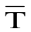ª | 112 | 175 | 246 | 499 | 691 | 817 | b = 0.995±0.004  a = 10.05±1.83  n = 24 (4×6)  r² = 0.996
2/11/04 | 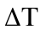^{b} | 9 – 10 | 8 – 10 | 6 – 9 | 11 – 12 | 11 – 16 | -4 – 1 | b = 0.995±0.004  a = 10.05±1.83  n = 24 (4×6)  r² = 0.996
2/11/04 | 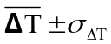^{c} | 9 ± 0.5 | 9 ± 1 | 7 ± 1 | 11 ± 1 | 13 ± 2 | -1 ± 2 | b = 0.995±0.004  a = 10.05±1.83  n = 24 (4×6)  r² = 0.996
11/02/04 | DRI 2001 CA#07  ª | 112 | 174 | 230 | 486 | 679 | 800 | b = 1.012±0.005  a = 12.9±2.63  n = 24 (4×6)  r² = 0.999
11/02/04 | ^{b} | 9 – 10 | 9 – 10 | 18 – 28 | 19 – 30 | 23 – 28 | 10 – 24 | b = 1.012±0.005  a = 12.9±2.63  n = 24 (4×6)  r² = 0.999
11/02/04 | ^{c} | 9 ± 1 | 10 ± 1 | 23 ± 4 | 24 ± 4 | 25 ± 2 | 16 ± 6 | b = 1.012±0.005  a = 12.9±2.63  n = 24 (4×6)  r² = 0.999
04/21/04 | DRI 2001 CA#09  ª | 116 | 175 | 262 | 482 | 676 | 793 | b = 1.040± 0.009  a = -3.00±4.39  n = 18 (3×6)  r² = 0.998
04/21/04 | ^{b} | 4 – 5 | 8 – 9 | -10 – (-9) | 26 – 29 | 26 – 29 | 22 – 24 | b = 1.040± 0.009  a = -3.00±4.39  n = 18 (3×6)  r² = 0.998
04/21/04 | ^{c} | 5 ± 1 | 9 ± 1 | 9 ± 1 | 28 ± 2 | 28 ± 2 | 23 ± 1 | b = 1.040± 0.009  a = -3.00±4.39  n = 18 (3×6)  r² = 0.998
04/19/04 | DRI 2001 CA#10  ª | 113 | 174 | 239 | 495 | 678 | 794 | b = 1.022±0.004  a = 6.55±2.15  n = 18 (3×6)  r² = 0.999
04/19/04 | ^{b} | 7 – 9 | 8 – 14 | 13 – 16 | 12 – 19 | 17 – 34 | 17 – 25 | b = 1.022±0.004  a = 6.55±2.15  n = 18 (3×6)  r² = 0.999
04/19/04 | ^{c} | 8 ± 1 | 10 ± 3 | 14 ± 2 | 15 ± 4 | 26 ± 7 | 22 ± 4 | b = 1.022±0.004  a = 6.55±2.15  n = 18 (3×6)  r² = 0.999
11/15/04 | DRI 2001 CA#11  ª | 116 | 179 | 246 | 490 | 683 | 807 | b = 1.017±0.004  a = 4.28±1.95  n = 30 (5×6)  r² = 0.999
11/15/04 | ^{b} | 4 – 5 | 5 – 6 | 6 – 7 | 18 – 21 | 20 – 24 | 9 – 10 | b = 1.017±0.004  a = 4.28±1.95  n = 30 (5×6)  r² = 0.999
11/15/04 | ^{c} | 5 ± 1 | 5 ± 1 | 7 ± 0.5 | 20 ± 1 | 21 ± 2 | 9 ± 0.5 | b = 1.017±0.004  a = 4.28±1.95  n = 30 (5×6)  r² = 0.999
ª is the average measured temperature.
^{b}is the difference between the measured and rated Tempilaq° G temperatures.
^{c} indicates the average and standard deviation of .

Table 2-3. Temperature differences for five DRI/OGC carbon analyzers.

Test Date | Tempilaq° G Indicator Temperature (°C) | 121 ± 2 | 184 ± 2 | 253 ± 3 | 510 ± 6 | 704 ± 8 | 816 ± 9 | 1. Slope (b)  2. Intercept (a)  3. Number of Tests (n)  4. Correlation (r²)
03/17/04 | DRI/OGC CA#01  ª | 84 | 147 | 209 | 469 | 637 | N/A^{c} | b = 1.044±0.014  a = 31.621±5.449  n = 10 (2×5)  r² = 0.998
03/17/04 | ^{b} | 36 – 37 | 33 – 41 | 37 – 51 | 40 – 43 | 57 – 77 | N/A | b = 1.044±0.014  a = 31.621±5.449  n = 10 (2×5)  r² = 0.998
03/18/04 | DRI/OGC CA#02  ª | 103 | 162 | 230 | 480 | 676 | N/A | b = 1.016±0.005  a = 18.832±2.061  n = 10 (2×5)  r² = 0.999
03/18/04 | ^{b} | 14 – 22 | 22 – 23 | 23 – 25 | 30 – 32 | 26 – 30 | N/A | b = 1.016±0.005  a = 18.832±2.061  n = 10 (2×5)  r² = 0.999
03/22/04 | DRI/OGC CA#03  ª | 110 | 170 | 237 | 482 | 672 | N/A | b = 1.037±0.009  a = 7.743±3.481  n = 10 (2×5)  r² = 0.999
03/22/04 | ^{b} | 9 – 14 | 11 – 18 | 11 – 22 | 22 – 34 | 26 – 38 | N/A | b = 1.037±0.009  a = 7.743±3.481  n = 10 (2×5)  r² = 0.999
03/23/04 | DRI/OGC CA#04  ª | 107 | 166 | 244 | 493 | 682 | N/A | b = 1.012±0.007  a = 13.020±2.907  n = 10 (2×5)  r² = 0.999
03/23/04 | ^{b} | 11 – 17 | 16 – 20 | 8 – 20 | 15 – 20 | 18 – 28 | N/A | b = 1.012±0.007  a = 13.020±2.907  n = 10 (2×5)  r² = 0.999
03/24/04 | DRI/OGC CA#05  ª | 98 | 155 | 219 | 473 | 656 | N/A | b = 1.036±0.010  a = 22.757±4.068  n = 10 (2×5)  r² = 0.999
03/24/04 | ^{b} | 21 – 26 | 27 – 33 | 33 – 36 | 27 – 48 | 43 – 53 | N/A | b = 1.036±0.010  a = 22.757±4.068  n = 10 (2×5)  r² = 0.999

ª is the average measured temperature.
^{b}is the difference between the measured and rated Tempilaq° G temperatures.
^{c} The audit of 816°C was not performed since the sample holder is not stable for temperatures higher than 800°C.
Table 2-4. Oxygen (O₂) mixing ratios (ppmv) in helium (He) carrier gas for different instruments.

Analyzer Type | Analyzer Number | Location of Measurements | Pressure | Flow | Oxygen Mixing Ratio (ppmv) | Relative N₂/O₂ Ratioª
DRI 2001 | CA #10 | Inlet | 2.3 | Regular^{c} | 2.8 ± 1.2 | 2.7
DRI 2001 | CA #10 | Oven | 1.8 | Regular | 21.0 ± 2.7 | 2.1
DRI 2001 | CA #10 | After Oven | 1.3 | Regular | 14.5 ± 1.8 | 2.0
DRI 2001 | CA #08 | Inlet | 0.93 | Regular | 6.6 ± 3.0^{b} | 2.0
DRI 2001 | CA #08 | Oven | 1.05 | Regular | 21.6 ± 1.8 | 2.5
DRI 2001 | CA #08 | Oven | 1.05 | High^{d} | 13.4 ± 1.8 | 2.5
DRI 2001 | CA #09 | Oven | 2.43 | Low^{e} | 29.2 ± 0.7 | 2.4
DRI 2001 | CA #09 | After Oven | 2.69 | Low | 24.1 ± 1.0 | 2.6
DRI/OGC | CA #01 | Inlet | ~ 1 | Regular | 13.6 ± 2.6 | 3.8
DRI/OGC | CA #01 | Oven | ~ 1 | Regular | 121.2 ± 3.3 | 3.7
DRI/OGC | CA #02 | Inlet | ~ 1 | Regular | 10.3 ± 2.6 | 3.7
DRI/OGC | CA #02 | Oven | ~ 1 | Regular | 288.5 ± 4.9 | 3.2
DRI/OGC | CA #03 | Inlet | ~ 1 | Regular | 9.3± 1.8 | 3.7
DRI/OGC | CA #03 | Oven | ~ 1 | Regular | 205.5 ± 2.1 | 2.7
DRI/OGC | CA #04 | Inlet | ~ 1 | Regular | 9.8± 3.7 | 2.5
DRI/OGC | CA #04 | Oven | ~ 1 | Regular | 313.7 ± 1.0 | 3.1
DRI/OGC | CA #05 | Inlet | ~ 1 | Regular | 16.8± 3.0 | 2.3
DRI/OGC | CA #05 | Oven | ~ 1 | Regular | 268.0 ± 4.9 | 2.9
ª The N₂/O₂ ratio is only relative since N₂ is not calibrated.
^{b} Higher background noise.
^{c} Regular flow rate is 50 cc per minute.
^{d} High flow rate is ~60 cc per minute.
^{e} Low flow rate is 40 cc per minute.
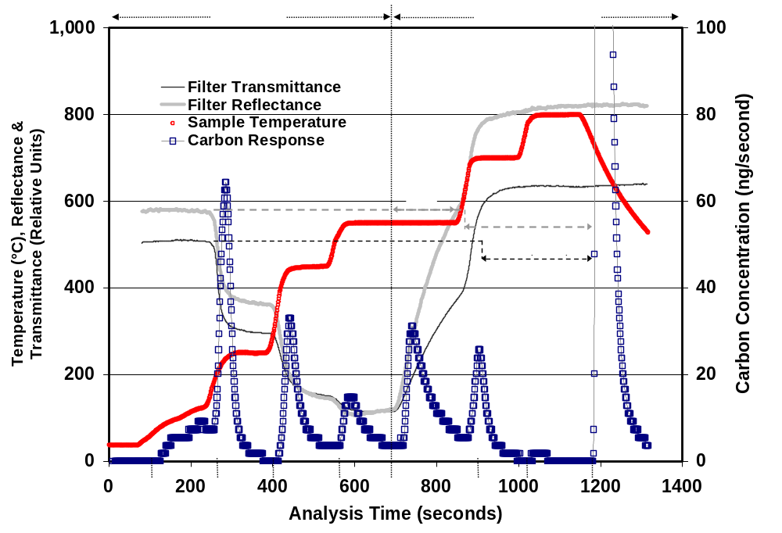
Figure 2-1. Example of an IMPROVE_TOR carbon thermogram. Seven carbon fractions are defined by the analysis atmosphere and the sample temperature. OC1, OC2, OC3, and OC4 evolve in a non-oxidizing pure helium (He) atmosphere while EC1, EC2, and EC3 evolve in a 2% oxygen (O₂) and 98% He mixture. Optical charring corrections are determined by both reflectance (R) and transmittance (T) when these achieve their original values after O₂ is added. Only the reflectance correction (OP) is currently reported with the IMPROVE carbon fractions.
a)
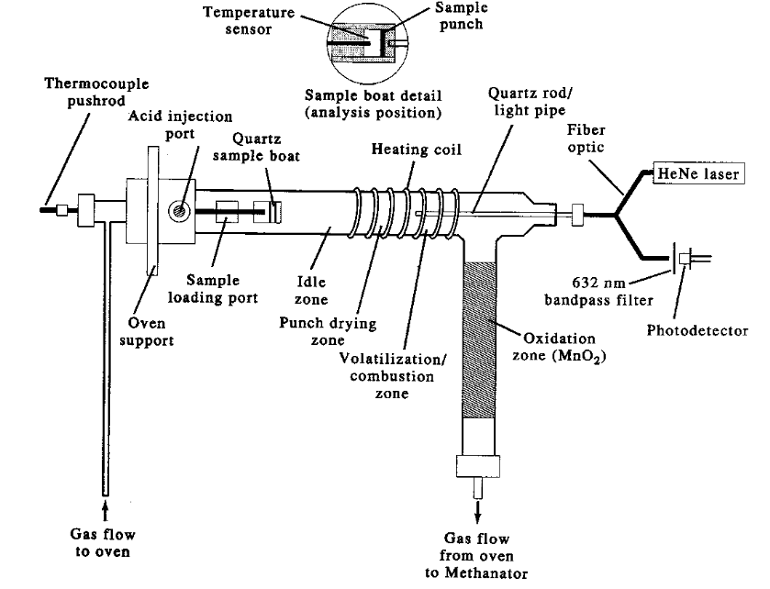
b)
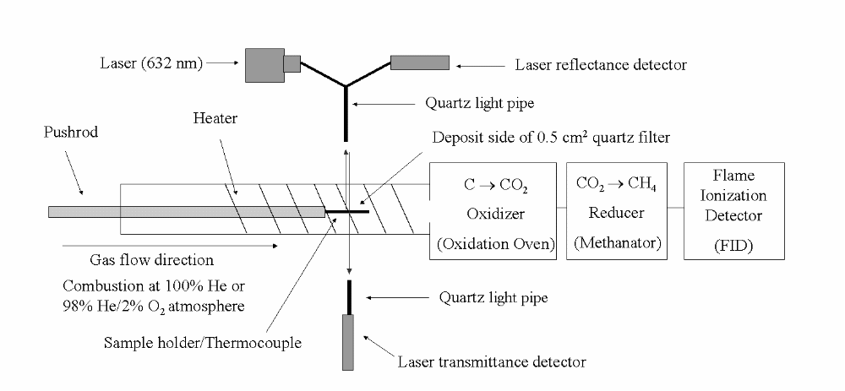
Figure 2-2. Schematic diagram of the: a) DRI/OGC carbon analyzer (Desert Research Institute, Reno, NV) and b) Model 2001 thermal/optical carbon analyzer (Atmoslytic, Inc., Calabasas, CA). In the Model 2001, the sample holder is open on top and bottom to minimize interference with the reflectance and transmittance measurement. The carrier gas flows above and below (not through) the sample.
a)
2-4 mm
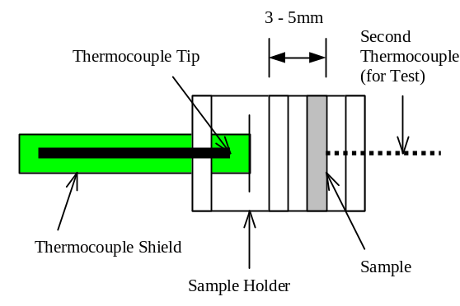
b)

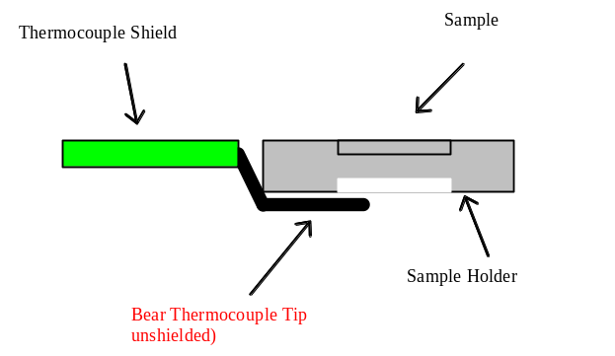
Bare Thermocouple Tip
(unshielded)

Figure 2-3. Schematic diagram of sample holder design in the: (a) DRI/OGC and (b) Model 2001 carbon analyzers.

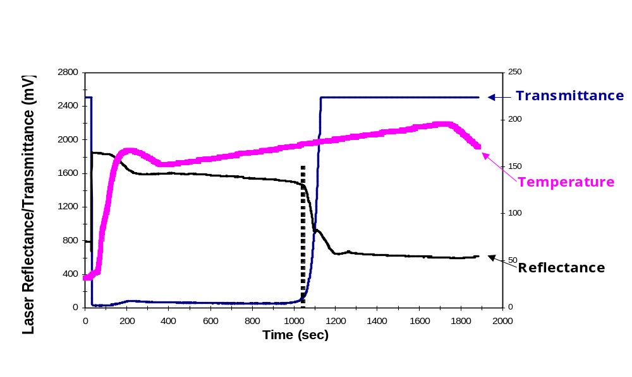
Figure 2-4. Temperature ramping during an audit experiment with a Tempilaqº G temperature indicator rated at 184 °C for a Model 2001 carbon analyzer. Also shown in the figure are reflectance (R) and transmittance (T) of the temperature indicator. The dashed line indicates the achievement of the rated temperature.

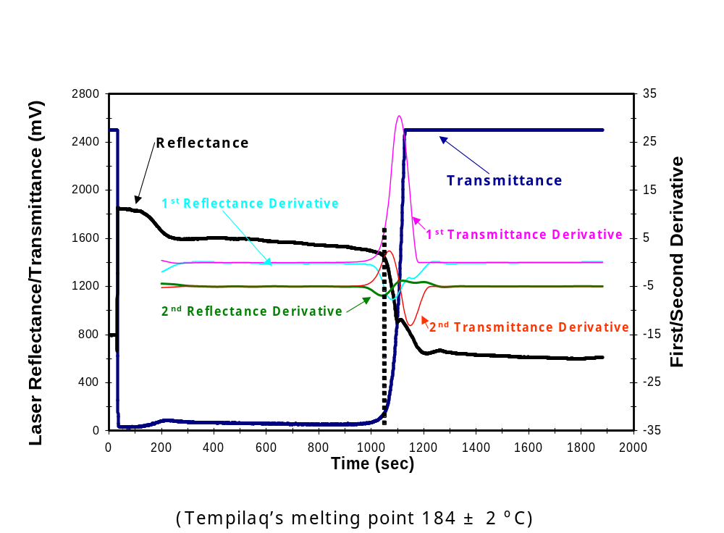

Figure 2-5. Reflectance (R) and transmittance (T) measurements and their first and second derivatives over time during an audit experiment with a Tempilaqº G temperature indicator rated at 184 °C. The dashed line indicates the achievement of the rated temperature.

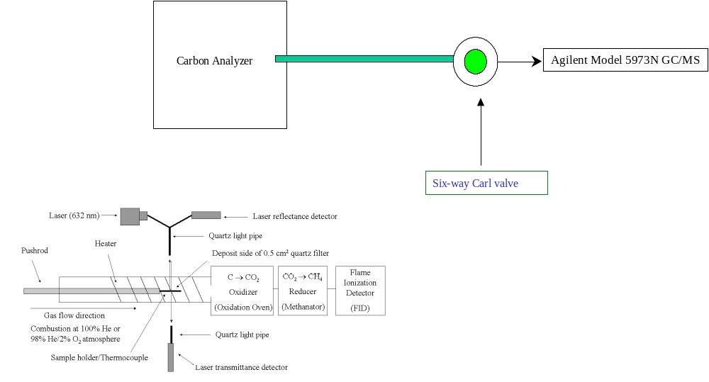
Figure 2-6. Schematic diagram for measuring composition of the 100% helium (He) carrier gas.
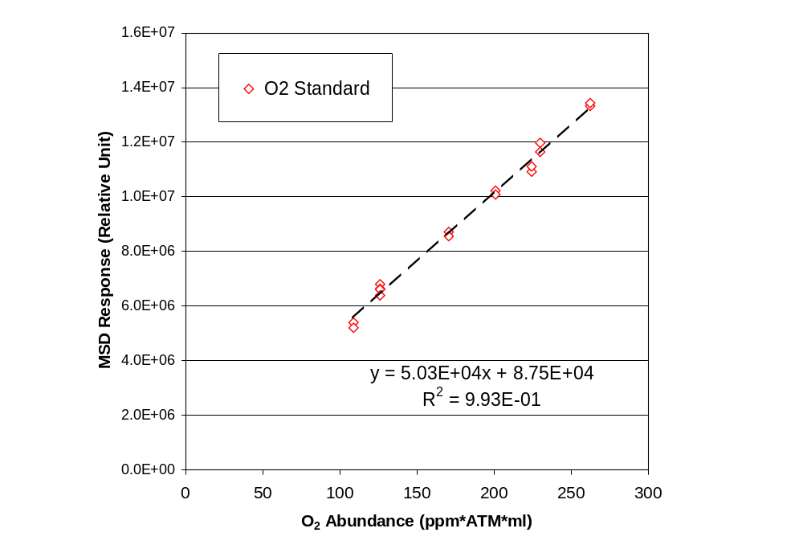
Figure 2-7. Mass spectrometric detector (MSD) response to known quantities of oxygen (O₂).
y = 50,300x + 87,500
R² = 0.99

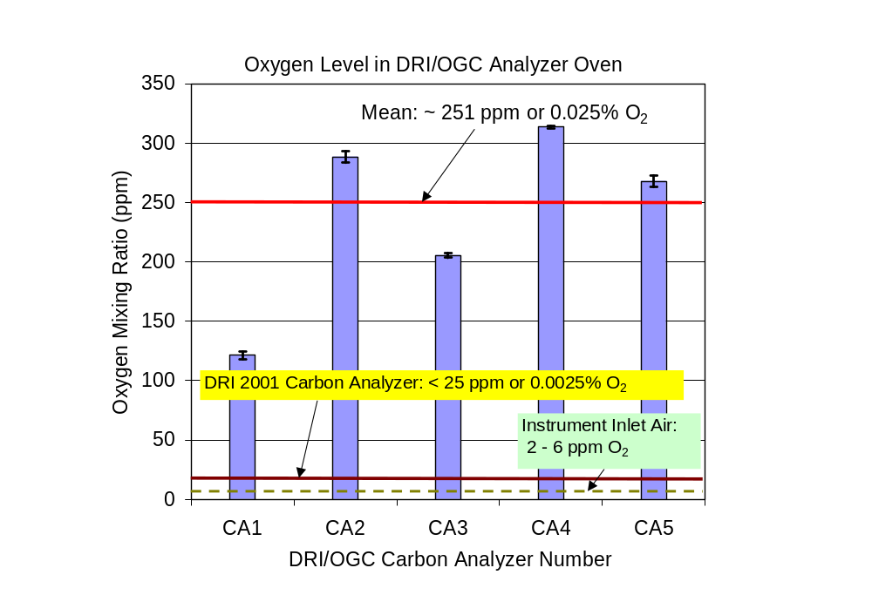
Figure 2-8. Oxygen (O₂) levels in the carrier gas through the analysis oven.

Comparability of Thermal/Optical Carbon Measurements
This section determines how the differences between the DRI/OGC and Model 2001 analyzers might affect the measurement of TC, OC, EC, and the thermal carbon fractions. Table 3-1 describes samples that were used to quantify TC differences. Six batches of IMPROVE sample remnants were used. These cover a wide range of locations, time periods, and source influences. All of these samples are of 24-hour duration.
The IMPROVE 25 mm diameter quartz-fiber filters allow for only three 0.5 cm² punches. One of these has already been used for regular IMPROVE analysis, and a second punch is analyzed to estimate precision or to resolve data validation questions on ~15% of the samples. As a result, only limited testing can be performed with IMPROVE samples. Large 8 x 10 inch quartz-fiber PM_{2.5} samples have been taken over 24-hour periods at the Fresno supersite (Watson et al., 2000, Watson and Chow, 2002), which is affected by a variety of urban sources including gasoline exhaust, diesel exhaust, cooking and wood burning (Poore, 2002, Schauer and Cass, 2000, Watson and Chow, 2002, Watson et al., 2002a, 2002b). Since many punches can be taken from these samples, they were used to systematically evaluate the differences caused by changes in sample temperature and He carrier gas composition. Twenty-four-hour duration 47 mm quartz- fiber filter samples from Hong Kong are highly affected by diesel exhaust (Louie et al., 2004, 2005, Sin et al., 2005) and were used in a carbon intercomparison study (Chow et al., 2005). These samples have a completely different mixture of carbon sources compared to 10-minute duration samples on 47 mm quartz-fiber filters from controlled laboratory burns at the United States Forest Service Fire Science Laboratory (Missoula, MT). Fire samples were included for comparison to the other samples. All of the filter material was Pallflex QAT-UP ultrapure quartz that was conditioned at 900 °C for at least four hours prior to sampling.
IMPROVE sample results from the Model 2001 were measured during 2004 and compared with the original results from samples measured over a period from 1999 to 2003. The remnants were stored at <4 °C in the interim. The Fresno, Hong Kong, and Montana fire laboratory samples were analyzed during the same week for each set during 2004. To evaluate the equivalence of data processing software, the raw FID and R data for these samples from the DRI/OGC analyzer were processed by both the DRI/OGC and Model 2001 software. The results were equivalent within <1% for TC, OC, EC, and eight thermal carbon fractions. The only difference was that the Model 2001 data processing reported negative OP when the reflected laser returned to its initial value before O₂ was added to the carrier gas. The potential causes and implications of this “early split” are discussed further in this section.
Comparison test groupings and performance measures are summarized in Table 3-2 for TC, OC, and EC measurements and in Table 3-3 for the carbon fractions. Comparability measures are based on those used by Mathai et al. (1990) and include the following:
- Average of ratios. Determines the extent to which there might be a bias of one against another. The average ratio should be within three standard error intervals if the values are the same.
- Distribution of differences: This reports the fraction of samples falling within one, two, three, and more than three precision intervals (σ) for the difference between two analyses. If these differences follow a normal distribution, then ~66% of the differences should be within ±1σ, 95% should be within ±2σ, and 99% should be within ±3σ.
- Student’s T-test. This evaluates the probability that the null hypothesis (i.e., the measurements are the same) is invalid.
- Correlation coefficient (r): The degree to which one variable varies in the same way as other variables. The correlation should exceed 0.95 to indicate good comparability.
- Average of the differences: Gives an indication of the absolute values by which concentrations differ.
- Non-weighted linear regression slope: A value between 0.9 and 1.1 is expected, given analytical uncertainties. Outliers in comparison experiments are expected, because some values are a few times the detection limit for IMPROVE samples.

IMPROVE OC and EC Comparison
Figure 3-1 compares TC, OC, and EC measurements from the Model 2001 with the originally reported values quantified by the DRI/OGC analyzers for the IMPROVE I and II groups. Most of the one standard deviation precision intervals overlap the 1:1 line. The highest TC values, which are usually found during special events such as forest fires, show the largest deviations. These are probably due to an inhomogeneous sample deposit (e.g., a cinder may be on one punch but not on another) rather than to analyzer differences. The distribution of differences in Table 3-2 shows a somewhat normal distribution, with most of the values within plus or minus one standard deviation of the difference. Student’s T-test shows no statistically significant differences. All the comparisons show good correlations (r > 0.97) for the entire data set, with values slightly lower for TC concentrations <20 µg cm⁻². Linear regression slopes are within 10% of 1.0, except for EC for all the data which has a 0.89 slope. The T-statistic shows no differences beyond those expected by random errors, given the reported analysis precision. Of the 243 IMPROVE I and II samples, 16 reported a zero pyrolysis (i.e., zero OP) correction. Seven of these were near detection limits for EC (i.e., nearly white filter) and OC and EC for the other nine samples did not differ from the Model 2001 values by more than three precision intervals.
For the 57 Fresno samples, the DRI/OGC analyzers showed zero or negative OP corrections for 31 of the samples. No early splits were observed for the same samples using the Model 2001, but R slowly increased during the OC4 step, in contrast to IMPROVE samples where it is usually at a constant level. Geological material is an important fraction of PM_{2.5} at Fresno, as evidenced by a light red shading of many of the filter punches after thermal analysis. Most IMPROVE filters are completely white after analysis. As previously noted, mineral oxides can oxidize EC in an inert atmosphere. The higher O₂ levels in the DRI/OGC analyzer can also contribute to EC oxidation at the 550 °C temperature plateau, thereby facilitating EC combustion and resulting in an early split that would not be observed in the less oxidizing conditions of the Model 2001. Figure 3-2 shows the extent to which the Fresno samples deviate from the 1:1 line using zero and negative OP corrections. OC and EC comparability measures (Table 3-2) are not good for zero OP, but they reach acceptable agreement when negative OP pyrolysis corrections are used.
A similar situation is found for the Hong Kong samples (Figure 3-3), for which 12 of the 18 samples experienced early splits on the DRI/OGC analyzers. Hong Kong is a coastal city that has a substantial marine aerosol contribution in addition to road dust and Asian dust contributions. As noted above, catalysts such as sodium chloride (NaCl) can lower the temperature at which EC evolves in a non-oxidizing environment. All of the performance measures are within acceptable ranges when the negative OP correction is used except for the OC. With a slope of 0.87, EC is the dominant carbon component in these samples, in contrast to the U.S. samples. OC is therefore more sensitive to the split than EC. For the higher EC loadings, the samples are so dark that a very small change in R is observed. The samples are essentially opaque and no transmitted signal is seen. The OC/EC split is not as accurate for these samples as it is for more moderately loaded samples such as those from IMPROVE.

Sensitivity of OC and EC by IMPROVE_TOR to Different Temperature and Optical Protocols
As shown in Appendix A, the IMPROVE_TOR and STN_TOT have substantially different temperature protocols. IMPROVE_TOR temperatures are generally lower, and a longer analysis time is spent at the lower temperatures than with the STN_TOT. Analysis of the same samples with these two temperature protocols gives a good indication of the maximum differences that might be caused due to differences in analysis temperatures. Any temperature differences among IMPROVE analyzers will be much less than the differences between these protocols. The samples from IMPROVE IV, Fresno, Hong Kong, and the Montana Fire Science Laboratory were used in these tests with both thermal/optical programs implemented on the Model 2001. Since both R and T can be measured, the optical pyrolysis correction was measured both by R (OPR) and by T (OPT). Comparison measures are summarized in the second section of Table 3-2 and illustrated for EC in Figure 3-4.
There are major differences between IMPROVE_TOR and STN_TOT results. This difference appears to be consistent within, but not between sample sets. For the IMPROVE and Fresno samples, IMPROVE_TOR gives 2 to 4 times the EC of STN_TOT. On the other hand, EC from the diesel dominated Hong Kong samples is nearly the same for the two methods, and the Montana fire samples show STN_TOT EC to be about two-thirds of EC from IMPROVE_TOR.
Comparing OC and EC using the TOR correction for the IMPROVE and STN protocols gives comparable results, with distributions of differences following the expected pattern. Chow et al. (2004b) and Chen et al. (2004) attribute the difference between a TOR and TOT correction to a greater attenuation of transmitted light by the pyrolysis of organic vapors adsorbed throughout the filter thickness. These pyrolyzed organic vapors have different absorption efficiencies and come off at different times compared to the original EC in the surface deposit. Owing to a large diesel component, the dark Hong Kong surface deposit probably dominates the T, and may evolve later than the pyrolyzed organic vapors, thereby yielding a better TOR/TOT equivalence. The short duration Montana fire samples probably did not adsorb as much organic vapor as the 24-hour samples from IMPROVE and Fresno.
The implication for IMPROVE analysis is that the TOR pyrolysis correction is not sensitive to temperature programs, and that the minor variations observed in Section 2 will not bias the OC and EC concentrations.

IMPROVE Thermal Carbon Fractions
As shown in Figure 3-5, the carbon fractions do not compare well among the DRI/OGC and Model 2001 analyzers. The comparability measures in Table 3-3 are well outside of acceptable ranges, but the measurements are usually highly correlated. While OC2 and OC4 are within 15–26% of each other, on average the Model 2001 reports ~55% lower OC3, ~60% higher OP, and ~40% higher EC1 than the DRI/OGC analyzers. Although not reported here, similar differences are found for the Fresno and Hong Kong samples. Apparently, the differences between the temperature plateaus and He carrier gas composition affect the carbon fractions, even though they do not affect the TC, OC, and EC concentrations.
Table 3-1. Samples used for comparison studies. The batch identifier, type of sampling site, sampling period, and use of the samples in this study are listed.
Network (Batch) | Type | Site (# of samples) | Period | Purpose of Selection
IMPROVE (I)  (154 samples) | Northeastern Rural | CABA1(1), MOOS1(7), PMRF1(8), PRIS1(8) | 05/10/2001 to 05/31/2001 | Compare TC, OC, EC, and carbon fraction measurements by DRI/OGC and Model 2001 analyzers.  Develop statistical relations between the two measurements for a specific time period.
IMPROVE (I)  (154 samples) | Southern Rural | LIGO1(6), MING1(8), SAMA1(2) | 05/10/2001 to 05/31/2001
IMPROVE (I)  (154 samples) | Midwestern Rural | THRO1(6), VOYA1(6), WICA1(5) | 05/10/2001 to 05/31/2001
IMPROVE (I)  (154 samples) | Northwestern Rural | BLIS1(9), DAVI2(6), LOPE1(7), MOHO1(6), REDW1(6), SAWT1(9), TRIN1(7), YOSE1(10) | 05/10/2001 to 05/31/2001
IMPROVE (I)  (154 samples) | Southwestern Rural | DEVA1(6), GRSA1(8), SAGO1(8), SYCA1(8), TONT1(7) | 05/10/2001 to 05/31/2001
IMPROVE (II)  (89 samples) | Northeastern Rural | ADPI1(5), AREN1(4), CABA1(4) | 04/25/2001 to 05/13/2001 | Compare TC, OC, EC, and carbon fraction measurements by DRI/OGC and Model 2001 analyzers.  Verify statistical relations between the two measurements developed by Batch 1 samples.
IMPROVE (II)  (89 samples) | Southern Rural | CHAS1(3), GRSM2(2) | 04/25/2001 to 05/13/2001
IMPROVE (II)  (89 samples) | Northwestern Rural | BLIS1(4), CABI1(3), CORI1(3), KALM1(1), LOPE1(3), MOHO1(2), MONT1(2), MORA1(3), PASA1(1), REDW1(2), THSI1(4), TRIN1(4), YOSE1(3) | 04/25/2001 to 05/13/2001
IMPROVE (II)  (89 samples) | Southwestern Rural | BOAP1(2), BRCA1(2), CANY1(4), CAPI1(3), CHIR1(4), DEVA1(4), GRSA1(5), MEVE1(3), SAGO1(2), SYCA1(4) | 04/25/2001 to 05/13/2001
IMPROVE (II)  (89 samples) | Marine Influence | HAVO1(3) | 04/25/2001 to 05/13/2001
IMPROVE (III)  (110 samples) | Northeastern Rural | ACAD1(2), AREN1(2), BRIG1(1), COHI1(1), PMRF1(1), QUCI1(1) | 03/05/2001 to 01/03/2003 | Modify the analytical conditions in Model 2001 to simulate DRI/OGC analyzers, based on temperature and oxygen levels.
IMPROVE (III)  (110 samples) | Northeastern Urban | WASH1(4) | 05/26/1999 to 12/31/2002
IMPROVE (III)  (110 samples) | Southern Rural | CHER1(2), GRSM1(1), GUMO1(1), HEGL1(2), LIGO1(1), ROMA1(1), SIPS1(1), UPBU1(1), WIMO1(2) | 05/16/2001 to 05/09/2003
IMPROVE (III)  (110 samples) | Midwestern Rural | BOWA1(4), GRRI1(1), LOST1(2), SENE1(1), VILA1(1), WICA1(1), VOYA1(1) | 06/10/2000 to 01/12/2003

Table 3-1, Cont'd
Network (Batch) | Type | Site (# of samples) | Period | Purpose of Selection
IMPROVE (III)  (cont'd) | Northwestern Rural | BRLA1(1), CABI1(1), CRLA1(1), CRMO1(1), GAMO1(1), GRBA1(2), HECA1(3), JARB1(1), KALM1(3), LABE1(1), MOHO1(1), MONT1(1), MORA1(1), NOCA1(2), OLYM1(1), PASA1(2), PORE1(2), PUSO1(2), REDW1(2), ROMO1(2), SNPA1(2), STAR1(1), SULA1(1), THBA1(1), THSI1(1), WHPA1(1), YOSE1(4) | 12/29/1999 to 09/12/2003 | Modify the analytical conditions in Model 2001 to simulate DRI/OGC analyzers, based on temperature and oxygen levels.
IMPROVE (III)  (cont'd) | Southwestern Rural | BALD1(2), BAND1(1), BOAP1(1), CAPI1(2), CHIR1(1), HANC1(1), INGA1(2), JOSH1(1), PEFO1(3), PINN1(1), RAFA1(4), SAGO1(2), SAPE1(4), SEQU1(1), WEMI1(1), WHRI1(1), ZION1(2) | 04/14/1999 to 10/12/2003
IMPROVE (III)  (cont'd) | Marine Influence | HAVO1(1), VIIS1(1) | 10/14/2002, 07/03/2001
IMPROVE (III)  (cont'd) | Remote | TRCR1(1) | 09/09/2003
IMPROVE (IV)  (30 samples) | Northeastern Winter | MOMO1(1), ACAD1(1) | 01/21/2003, 01/18/2003 | Compare TC, OC, EC, and carbon fraction measurements between IMPROVE and STN protocols with Model 2001 analyzers.
IMPROVE (IV)  (30 samples) | Southern Winter | SIPS1(1), UPBU1(2) | 01/09/2003 to 01/15/2003
IMPROVE (IV)  (30 samples) | Northwestern Winter | HECA1(1), MELA1(2), PUSO1(1), STAR1(1) | 01/12/2003 to 01/27/2003
IMPROVE (IV)  (30 samples) | Southwestern Winter | SAGU1(2), WHIT1(1) | 01/21/2003 to 01/27/2003
IMPROVE (IV)  (30 samples) | Dust Influence (Spring) | GUMO1(2) | 04/15/2000, 04/26/2000
IMPROVE (IV)  (30 samples) | Marine Influence (Spring) | REDW1(2) | 03/29/2000, 04/1/2000
IMPROVE (IV)  (30 samples) | Secondary Organics (Summer) | SEQU1(3) | 06/18/2001 to 08/26/2001
IMPROVE (IV)  (30 samples) | Secondary Inorganics (Winter) | SHEN1(3) | 01/15/2003 to 01/27/2003
IMPROVE (IV)  (30 samples) | Wildfire Influence (Summer) | YOSE1(3) | 07/27/2001 to 08/29/2001
IMPROVE (IV)  (30 samples) | Motor Vehicle Influence (Winter) | WASH1(4) | 12/04/1999 to 02/19/2000

Table 3-1, Cont'd
Network (Batch) | Type | Site (# of samples) | Period | Purpose of Selection
IMPROVE (V)  (1,010 samples) | Winter (169) | A total of 163 randomly selected sampling sites | 12/01/1999 to 02/26/2000 | Examine uncertainties in the historical IMPROVE data measured with DRI/OGC analyzers.
IMPROVE (V)  (1,010 samples) | Spring (224) | A total of 163 randomly selected sampling sites | 03/01/2000 to 05/31/2000
IMPROVE (V)  (1,010 samples) | Summer (381) | A total of 163 randomly selected sampling sites | 06/03/2001 to 08/29/2001  07/18/2002 to 08/30/2002
IMPROVE (V)  (1,010 samples) | Fall (236) | A total of 163 randomly selected sampling sites | 09/02/2002 to 10/20/2002
IMPROVE (VI)  (160 samples) | Northeastern Rural/Urban | ACAD1(2), ADPI1(1), AREN1(4), CABA1(5), CACO1(1), GRGU1(1), MOOS1(3), QURE1(5), WASH1(2) | 10/30/1999 to 12/4/2002 | Modify the protocol in Model 2001 (IMPROVE_A) to simulate DRI/OGC analyzers, based solely on temperature calibration.
IMPROVE (VI)  (160 samples) | Southern Rural | CHAS1(1), COHU1(1), JARI1(4), LASU1(1), MING1(1), SHEN1(2), SIKE1(1), SIPS1(1), UPBU1(1), WIMO1(4) | 4/3/1999 to 8/16/2003
IMPROVE (VI)  (160 samples) | Midwestern Rural | BADL1(2), BOWA1(2), DOSO1(8), ISLE1(4), LOST1(1), THRO1(5) | 6/9/1999 to 3/3/2002
IMPROVE (VI)  (160 samples) | Northwestern Rural | BLSI1(3), BRID1(2), BRLA1(1), CABI1(1), COGO1(2), COHI(1), DAVI2(1), GAMO1(1), GLAC1(1), JARB1(3), KALM1(5), LAVO1(1), LOPE1(1), MELA1(1), MOHO1(1), MONT1(1), MORA1(1), MOZI1(1), NOCA1(2), PASA1(2), REDW1(2), SULA1(1), THBA1(1), THSI1(5), TRIN1(1), WHPA1(2) | 2/17/1999 – 9/30/2003
IMPROVE (VI)  (160 samples) | Southwestern Rural/Urban | BAND1(6), BRCA1(5), CANY1(5), CAPI1(3), CHIR1(1), DEVA1(2), DOME1(4), GRSA1(1), HILL1(1), KAIS1(1), PHOE1(1), RAFA1(3), SYCA1(1), TONT1(1), WEMI1(8), WHRI1(1), YOSE1(2), ZION1(6) | 3/3/1999 – 9/24/2003
IMPROVE (VI)  (160 samples) | Marine Influence | HALE1(1) | 1/7/2001

Table 3-1, Cont'd
Network (Batch) | Type | Site (# of samples) | Period | Purpose of Selection
Fresno, CA  (57 samples) | Urban Mixed | Fresno Supersite (57) | 08/23/2002 to 04/26/2003 | Compare TC, OC, EC, and carbon fraction measurements by DRI/OGC and Model 2001 analyzers with original and revised IMPROVE protocols.  Compare TC, OC, EC, and carbon fraction measurements between IMPROVE and STN protocol with Model 2001 analyzers.
Fresno, CA  (57 samples) | Urban Mixed | Fresno Supersite (2) | 07/16/2003, 08/23/2002 | Determine the influence of temperature and trace oxygen level on TC, OC, EC, and carbon fraction measurements.
Fresno, CA  (57 samples) | Urban Mixed | Fresno Supersite (2) | 11/27/2002, 03/03/2003 | Demonstrate the change of analytical conditions in DRI/OGC analyzers with time.
Hong Kong  (18 samples) | Foreign Roadside | Mong Kok (6) | 05/05/2001 to 10/08/2001 | Compare TC, OC, EC, and carbon fraction measurements by DRI/OGC and Model 2001 analyzers.  Compare TC, OC, EC, and carbon fraction measurements between IMPROVE and STN protocol with Model 2001 analyzers.
Hong Kong  (18 samples) | Foreign Urban | Tsuen Wan (6) | 05/05/2001 to 10/08/2001
Hong Kong  (18 samples) | Foreign Rural | Hok Tsui (6) | 05/05/2001 to 10/08/2001
Montana  (19 samples) | Prescribed Vegetative Burning | U.S. Forest Service Fire Science Laboratory (19) | 11/13/2003 to 11/21/2003 | Compare TC, OC, EC, and carbon fraction measurements between IMPROVE and STN protocol with Model 2001 analyzers.
Table 3-2. Comparability measures for TC, OC, and EC on DRI/OGC and Model 2001 carbon analyzers.

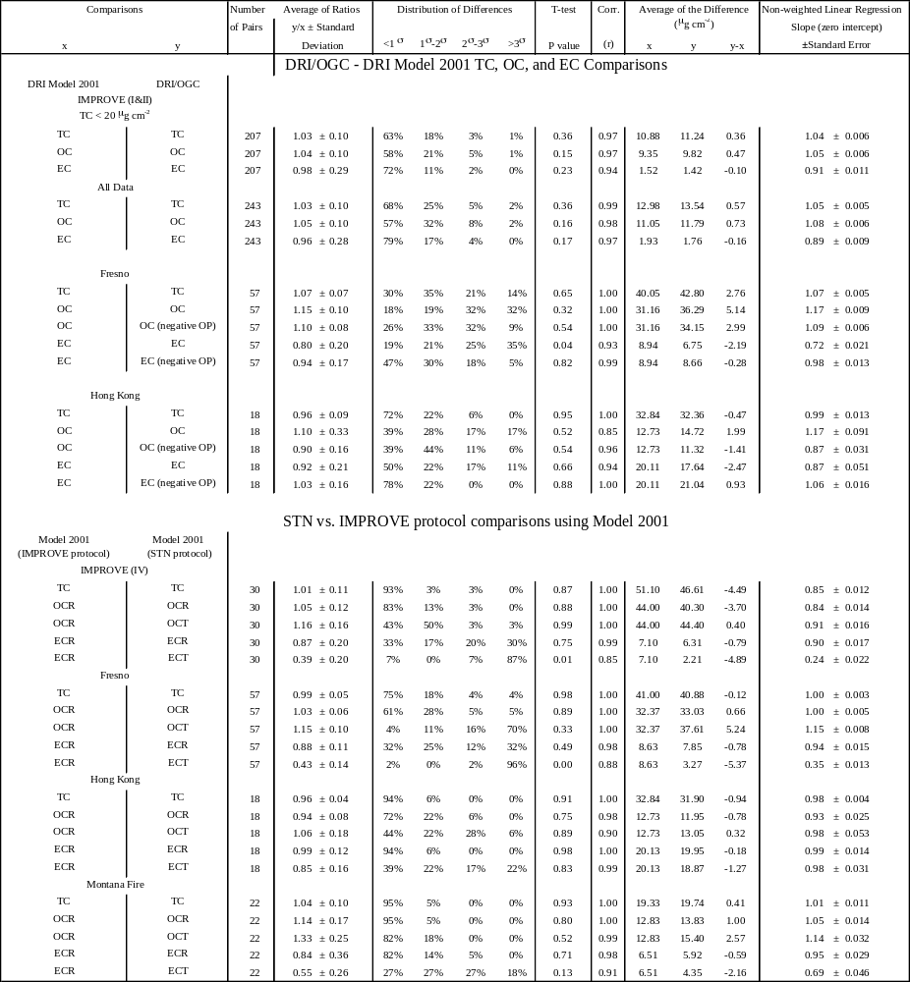
ª 12 samples with zero OP
^{b} 16 samples with zero OP, 7 samples with EC near detection limits
^{c} 31 samples with zero OP
^{d} 12 samples with zero OP
^{e} OC by reflectance pyrolysis correction
^{f} OC by transmission pyrolysis correction
Table 3-3. Comparability measures for carbon fractions on DRI/OGC and Model 2001 carbon analyzers.

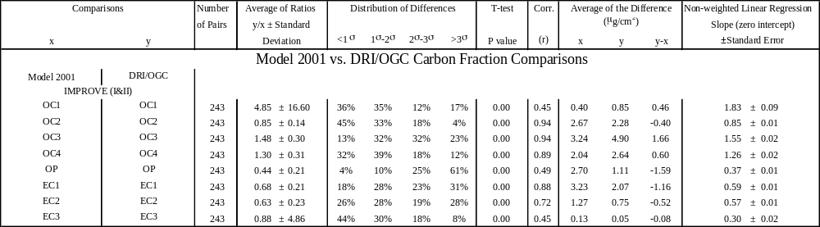

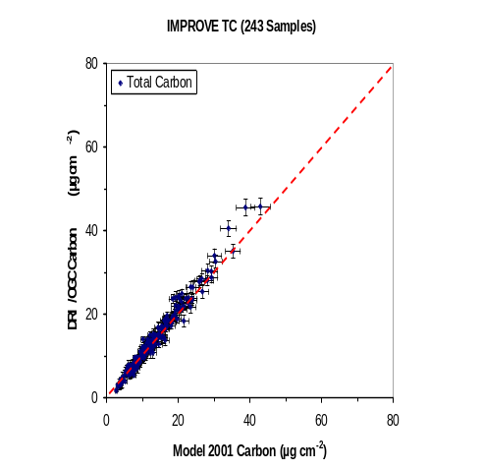
(a)
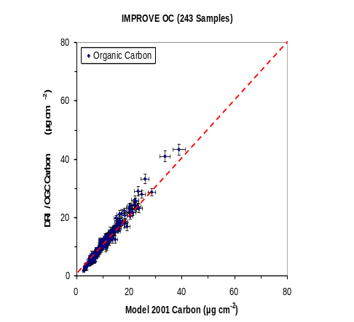
(b)
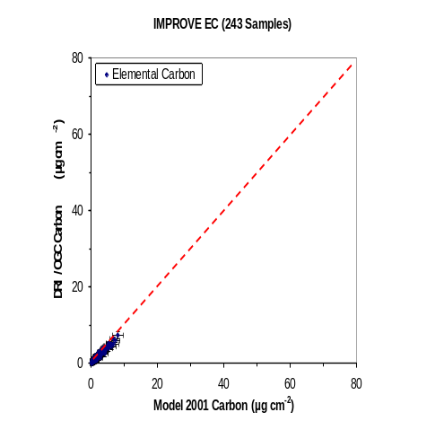
(c)

Figure 3-1. Comparisons of: a) TC, b) OC, and c) EC between the DRI/OGC and Model 2001 carbon analyzers for 243 IMPROVE samples (IMPROVE I and IMPROVE II from Table 3-1) collected at 40 sites between 4/25/2001 and 5/31/2001.

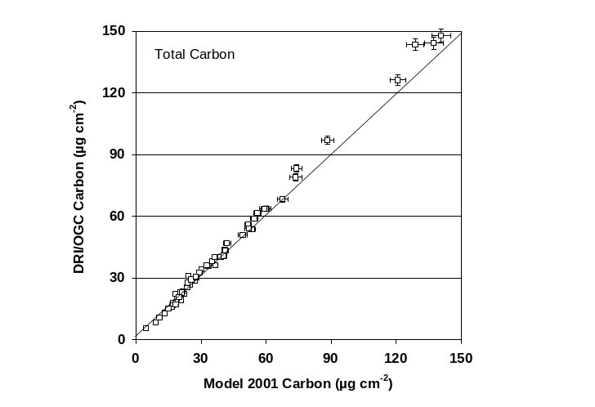
(a)
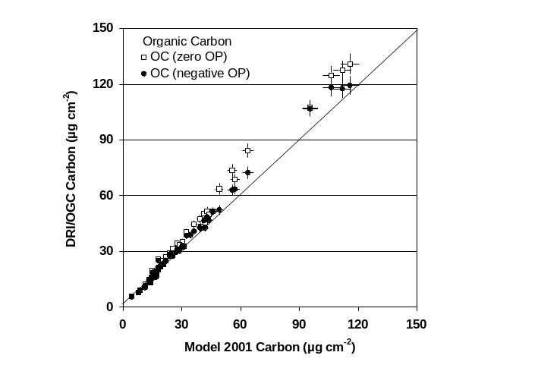
(b)
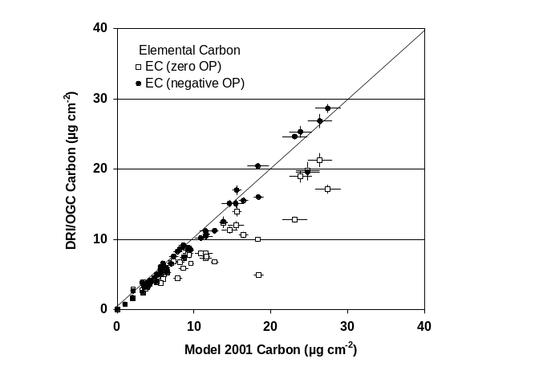
(c)

Figure 3-2. Comparisons of: a) TC, b) OC, and c) EC between the DRI/OGC and Model 2001 carbon analyzers for 57 Fresno. Both zero and negative OP (early split) corrections are used.

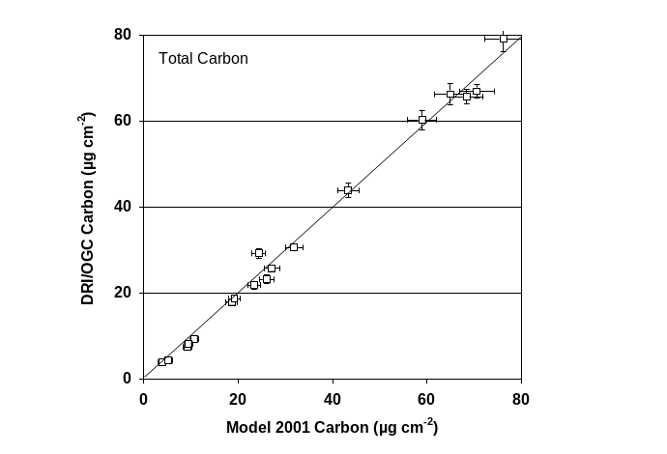
(a)
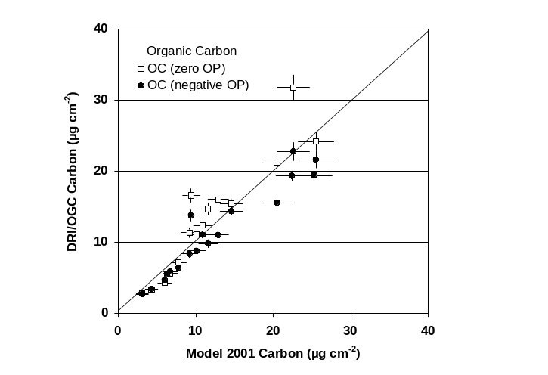
(b)
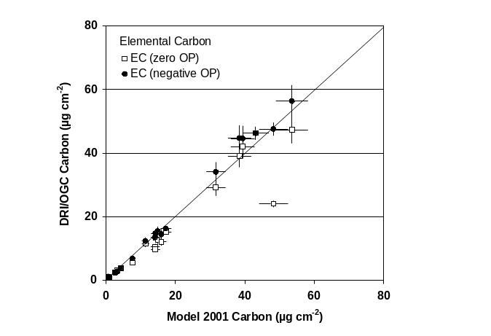
(c)

Figure 3-3. Comparisons of: a) TC, b) OC, and c) EC between the DRI/OGC and Model 2001 carbon analyzers for 18 Hong Kong samples. Both zero and negative OP (early split) are presented.

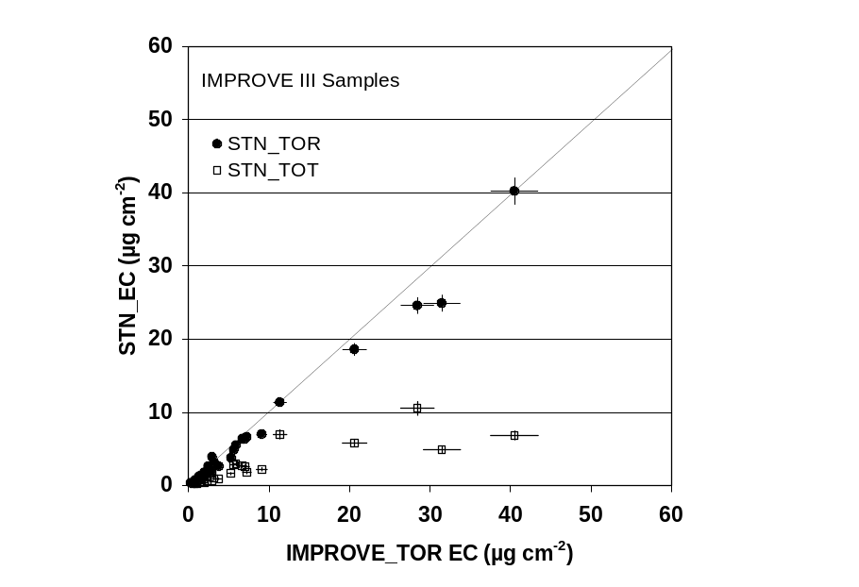  (a) | 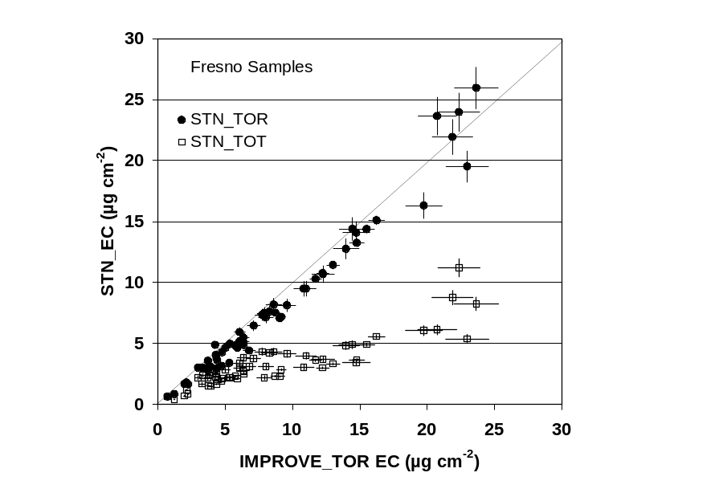  (b)
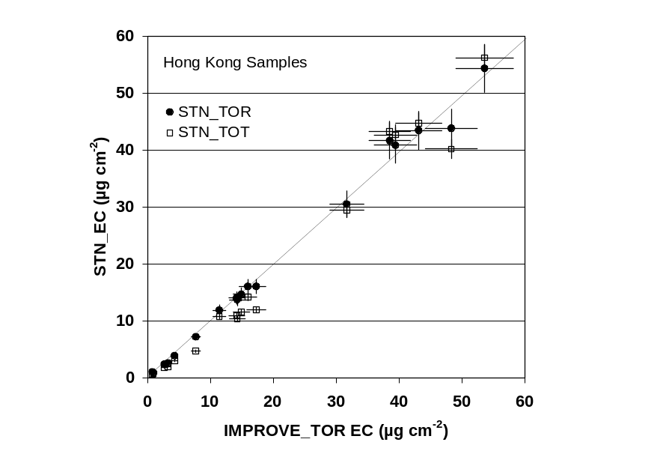  (c) | 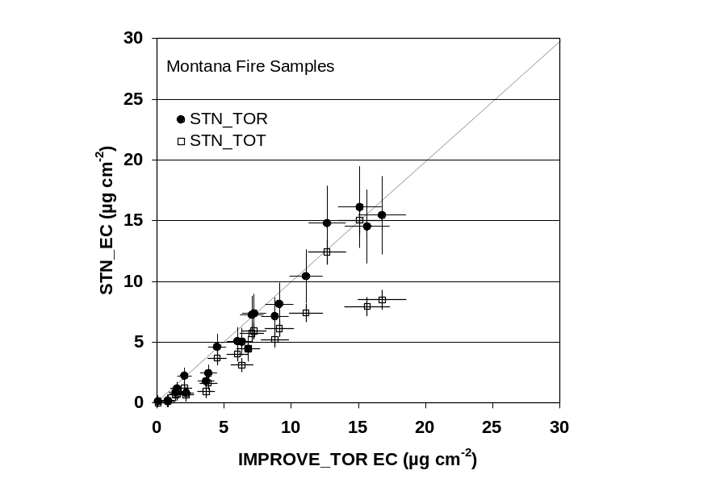  (d)

Figure 3-4. Comparisons of STN_TOT and STN_TOR with IMPROVE_TOR implemented on the Model 2001 carbon analyzers for: a) 30 IMPROVE IV samples, b) 57 Fresno samples, c) 18 Hong Kong samples, and d) 22 Montana fire samples. Note that the TOR pyrolysis correction is insensitive to the temperature program applied. The TOT correction shows a large difference for the higher temperature STN protocol.
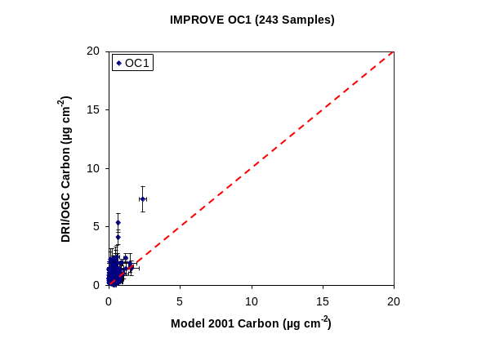 | 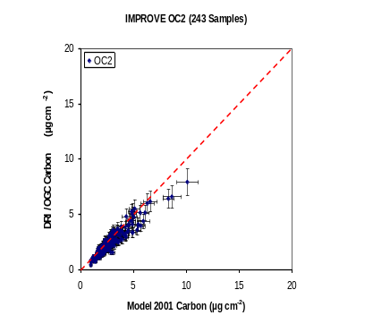
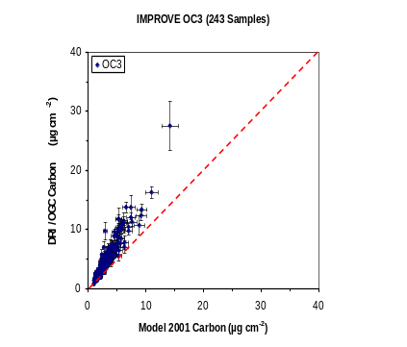 | 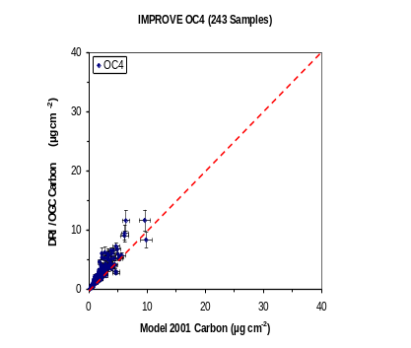
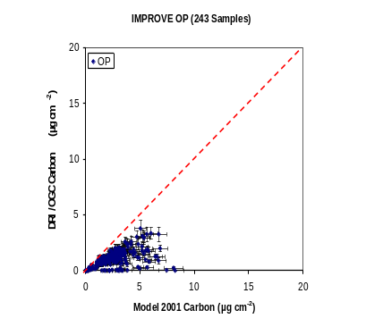 | 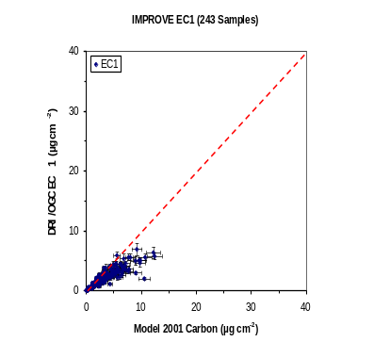
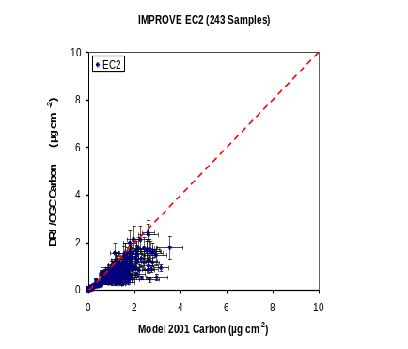 | 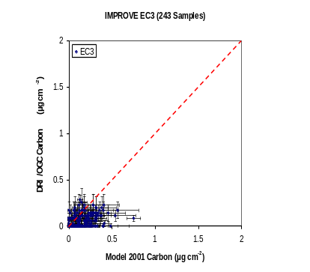

Figure 3-5. Comparison of carbon fractions between DRI/OGC and Model 2001 analyses for 243 samples (IMPROVE I and IMPROVE II from Table 3-1) collected at 40 sites from 4/25/2001 to 5/31/2001.

Causes of Differences in Carbon Fractions

Sensitivity of Carbon Fractions to Temperature and Carrier Gas Composition
Higher O₂ levels in the pure He carrier gas can reduce OC charring and increase the EC oxidation rate. EC also oxidizes more rapidly at higher temperatures, so the effects of fluctuations in temperature and carrier gas composition must be studied together. Multiple punches from the same Fresno sample (FSH0080) were analyzed in the Model 2001 by IMPROVE_TOR after temperature calibration while systematically varying the amount of O₂ in the He carrier gas. The experiment was repeated for IMPROVE temperature plateaus plus 20 °C (IMPROVE + 20) and minus 20 ºC (IMPROVE – 20). This represents the typical range of variability listed in Tables 2-3 and 2-4. O₂ was added to the He carrier gas at levels ranging from 20 to 900 ppmv for the OC fractions. The same 2% O₂/98% He was used for the EC fractions. OP was measured by R. Results are shown in Figure 4-1.
OC1 and OC2 concentrations are independent of the oxidant level, but they are sensitive to temperature. OC1 is reduced from 11% of TC to a negligible amount as the OC1 temperature decreases from 140 to 100 °C. At the same time, OC2 increases from 19% to 27% of TC. The oxidation/decomposition rate of carbonaceous material below 300 °C is so low that higher O₂ levels do not increase the reaction rate. OC3 depends on both temperature and the O₂ level. However, OC4 is relatively constant, regardless of temperature or O₂ level. EC1 and OP are more influenced by O₂ than by temperature. Most of their mass seems to have migrated to the OC3 fraction, where pyrolysis char is evident with a rapid decrease in R. EC2 is not sensitive to the amount of O₂ in the pure He atmosphere, but it is sensitive to temperature, with over a factor of 2 difference between the –20 °C and 20 °C temperatures for this sample. EC3 was negligible in these experiments and is not shown in Figure 4-1. As previously shown, EC by TOR is the same regardless of temperature or O₂ content. The TOR correction appears insensitive to the composition of the analysis atmosphere as well as to the sample temperature.
Appreciable changes in OC3, OP, and EC1 are not observed until O₂ >100 ppmv in the He atmosphere. At 250 ppmv (the average O₂ in DRI/OGC analyzers), the change can be more than 5% for higher temperatures (IMPROVE + 20). O₂ in the analysis atmosphere enhances the carbon output, probably due to EC oxidation (Cachier et al., 1989), while suppressing OC charring in the OC3 region. Its effect is more pronounced when the temperature is increased further. An early TOR split is observed as O₂ approaches 1,000 ppmv (0.1%) for the IMPROVE and IMPROVE + 20 protocols. O₂ in the DRI/OGC He carrier gas is one—but not the only—cause of early splits in some of the Fresno, Hong Kong, and Montana fire laboratory samples.
Figure 4-2 shows similar results for another Fresno sample (FSH0002) using the IMPROVE temperatures with different amounts of O₂ in the He carrier gas. The carbon fractions are fairly stable until the transition from 40 to 160 ppmv, similar to the observation shown in Figure 4-1. OC and EC are invariant to the amount of O₂ for both the TOR and TOT pyrolysis corrections. There is negative OP for O₂ > 1000 ppmv, and this is used for the EC estimate.
Analyses with the Model 2001 can retain temperature plateaus within a few °C after the temperature is calibrated as described in Section 2. It contains lower O₂ levels in a pure He atmosphere; therefore, differences in carbon fractions are not observed for these samples. The O₂ level in the DRI/OGC analyzers is higher and more variable, in the range where OC3, OP, and EC1 are sensitive to changes in temperature and carrier gas composition. The differences in temperature for OC1 and OC2 result in greater variability for these fractions. With a redesigned sample oven and temperature calibration, the Model 2001 has the potential to provide more reproducible carbon fractions than the DRI/OGC analyzers.

TC, OC, EC, and Carbon Fraction Uncertainties Performed in DRI/OGC
Each carbon fraction reported to the IMPROVE data base consists of a value and a precision. The coefficient of variance (CV), defined as the standard deviation of replicates divided by their average (e.g., TC), is a good measure of analysis precision. The uncertainty (Unc) for each individual carbon analysis (e.g., TC_{i} for sample _{i}) can be defined as:

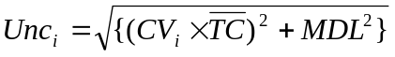 (4-1)
where CV is the coefficient of variance for the replicate analysis and MDL is the minimum detection limit of 1.49 µgC per filter for TC measurements. The carbon SOP (DRI SOP #2-204.6) requires that 10% of the samples from each batch be randomly selected for replicate analysis on a separate analyzer. If the TC difference between two replicates (RD) is considered the lower limit of Unc and the average of the two replicates is TC, then:

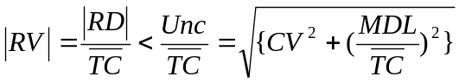 (4-2)

where RV is the replicate variation. A plot of RV versus TC is shown in Figure 4-3 for 1,010 replicates corresponding to more than 10,100 samples from the IMPROVE historical database. Ninety-five percent of the RVs are within the uncertainty interval defined by CV, which is found within ±10% for a replicate analysis for TC concentrations higher than 10 times MDL (Watson et al., 2001). TC is independent of temperatures and carrier gas composition. Precision of the carbon fractions cannot be better than the TC precision.
RVs for the carbon fractions (OC1 to OC4, OP, and EC1 to EC3) from these replicate analyses are plotted in Figure 4-4. The carbon fraction concentrations are often less than 10 times the MDL of TC. The scatter of RV versus carbon fraction measurements suggests a much larger CV and Unc for carbon fraction measurements. The replicate variations are especially high for OC1, OC3, OP, and EC1, while OC2 and EC2 show CVs similar to that of TC. The wide scatter of EC3 is mostly attributed to its low concentration (usually below the MDL). Figure 4-4 reflects the sensitivity of carbon fraction conditions to the variable temperatures and carrier gas compositions in the DRI/OGC analyzers.
RVs for the corresponding OC and EC concentrations are plotted in Figure 4-5. More than 90% of the replicates are within the TC uncertainty intervals. The precision and MDL of IMPROVE OC and EC measurements are similar to those of TC, despite the lower concentrations. EC concentrations are generally lower than OC concentrations and often below 10 times the MDL of TC.
Figure 4-6 illustrates the comparability of two different DRI/OGC analyzers and of one Model 2001 and one DRI/OGC analyzer. The results from the Model 2001 are clearly within the wide scatter of the DRI/OGC results. The carbon fractions reported in the IMPROVE data base are highly variable owing to the differences in temperature and carrier gas composition within and among the DRI/OGC analyzers on which they were measured.

Statistical Adjustments for Carbon Fractions
Since the carbon fraction levels are highly correlated, an algorithm to relate carbon fractions from the DRI/OGC with those of the Model 2001 can be derived by multiple linear regression. This assumes that biases are constant between the two models of analyzers. The following relationships were developed (Chow et al., 2004a) by a linear regression of the Model 2001 values with the DRI/OGC values for the first 154 IMPROVE I samples:
OC´ = OC (4-3)
EC´ = EC (4-4)
OC1´ = 0.29*OC1 + 0.05*OC2 (4-5)
OC2´ = 0.71*OC1 + 0.95*OC2 + 0.01*OC3 (4-6)
OC3´ = 0.67*OC3 (4-7)
OC4´ = 0.32*OC3 + 0.16*OC4 + 0.05*EC1 (4-8)
EC1´ = 0.84*OC4 + 0.66*EC1 (4-9)
EC2´ = 0.30*EC1 + 0.91*EC2 (4-10)
EC3´ = 0.09*EC2 + EC3 (4-11)
OP´ = EC1´ + EC2´ + EC3´ – EC (4-12)
OC1, OC2, OC3, OC4, EC1, EC2, and EC3 are OC and EC fractions measured by the DRI/OGC analyzers. OC´, OC1´, OC2´, OC3´, OC4´, EC´, EC1´, EC2´, and EC3´ are the fractions that would be equivalent to those of the Model 2001. The OP´ in Eq. 4-12 is based on the TOR EC measurement rather than multiple linear regression. This algorithm intends to conserve the TC value and assumes no exchange between two non-adjacent carbon fractions. Figure 4-7 demonstrates that Eqs. 4-5 to 4-12 bring the IMPROVE I carbon fractions into agreement for the IMPROVE I samples from which they were derived.
Comparability measures between adjusted DRI/OGC and Model 2001 fractions are presented in Table 4-1 (OC1_adjusted) for the IMPROVE I samples; for the independent IMPROVE II samples; and for the combined IMPROVE I and IMPROVE II samples. These measures show good agreement, within stated precisions. After the adjustment, a nearly 1-to-1 relationship appears for all carbon fractions except for OC1 and EC3, which are mostly below the MDLs. A reasonable agreement is also achieved when the algorithm is applied to the 89 additional IMPROVE II samples.

Analytical Adjustments for Carbon Fractions
An alternate approach that may bring the measurements into better agreement is to simulate the analytical conditions of the DRI/OGC carbon analyzer using a Model 2001. Two types of simulations are considered. The first is based solely on temperature calibration, thus making the temperature measures in the Model 2001 resemble those in DRI/OGC analyzers. The second simulation includes adding O₂ into the analysis atmosphere of the Model 2001 to fully reproduce the conditions in DRI/OGC analyzers.
According to temperature calibration for the five DRI/OGC carbon analyzers (Table 2-3), the overall least-square regression indicates a relation between the actual and thermocouple temperature:

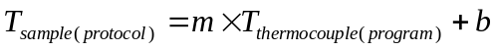

m = 1.024 ± 0.009
b = 19.9 ± 3.4 °C

Therefore, the average temperature in the protocol at each IMPROVE stage should be:

OC1 = 143 °C
OC2 = 276 °C
OC3 = 481 °C
OC4 = 583 °C
EC1 = 583 °C
EC2 = 737 °C
EC3 = 839 °C

Since the precision of temperature measure does not exceed 1% of the designated temperature, these temperatures are rounded to the nearest tens for simplicity. The following temperature protocol is implemented into the Model 2001 analyzers, and referred to as the IMPROVE_A protocol:
OC1 = 140 °C
OC2 = 280 °C
OC3 = 480 °C
OC4 = 580 °C
EC1 = 580 °C
EC2 = 740 °C
EC3 = 840 °C

The IMPROVE_A protocol was first applied to the 57 Fresno samples with the Model 2001 analyzers. Results from the IMPROVE and IMPROVE_A protocols are compared with those from DRI/OGC analyzers in Table 4-2. The precision of TC, OC, and EC measurements holds for either of the comparisons. The distribution of the differences shows that over 96% of the samples are within ±2 σ for TC, OC, and EC using IMPROVE_A, as compared to 59-77% of samples using the original IMPROVE protocol. This confirms that TC, OC, and EC are less influenced by minor fluctuations in the analytical conditions. However, the IMPROVE_A protocol generally produces higher OC2, OC3, OC4, and lower OC1 and OP, due to a higher combustion temperature, which brings the results closer to the DRI/OGC carbon fractions. According to the linear regression slopes (Table 4-2), the IMPROVE_A protocol improves the agreements between DRI/OGC and Model 2001 analyzers for OC3, OC4, and EC2 fractions, with comparable results for OP and EC1. OC3 and OC4 are still lower in the Model 2001, likely due to the lower trace oxygen level in the oven. OC1 and OC2, which mostly represent the organic sampling artifacts, show greater variability.
The same IMPROVE_A protocol was then applied to another 160 samples randomly selected from the IMPROVE network (between 1999 and 2003, IMPROVE VI in Table 3-1) to evaluate its performance on rural samples. Good agreements on TC, OC, and EC measurements were achieved between the DRI/OGC and Model 2001 under the IMPROVE_A protocol (no negative OP was observed on the analyses). The results of these analyses are shown in Table 4-2, with scatter plots shown in Figures 4-8 and 4-9. Compared with the urban Fresno samples run under this protocol, the IMPROVE samples show much better agreements on OC3, OC4, and EC1, with T-test indicating the same means between the DRI/OGC and Model 2001 measurements. One likely explanation is that lower loadings, resulting in shorter analysis time, reduces the influence of trace oxygen in the oven. The OC3 and OC4 from the DRI/OGC, however, are still slightly higher than those from the Model 2001.
When compared with the carbon fraction measurements of the Model 2001 using the original IMPROVE protocol (IMPROVE I and IMPROVE II in Table 3-2 and 3-3), the IMPROVE_A protocol produces robust TC, OC, and EC measurements that differ from the DRI/OGC results by less than 10%. Linear regression slopes are 1.01 to 1.02 for TC, OC, and EC, with the ±15% criteria met by OC3 (1.12), OC4 (1.09), and EC1 (0.95). The T-test shows differences mainly for low temperature OC (i.e., OC1 and OC2) and high temperature EC (i.e., EC3). The distribution of differences shows that 81% of the samples fall within ±2 σ, with the exception of OC2 (Table 4-2). The IMPROVE_A protocol brings the OC3, OC4, OP, EC1 and EC2 fractions closer to the DRI/OGC results than the original IMPROVE protocol. Agreements were lowest for OC1, OC2, and EC3, which are either too variable or too limited on the samples. These observations confirm that temperature is the key factor causing the biases in carbon fraction measurements, and that these biases can be solved by temperature calibration and adjustment.
To fully simulate the average analytical conditions of the five DRI/OGC analyzers, O₂ concentrations of 200 ± 50 ppmv were added to the Model 2001 He carrier gas and monitored with GC/MS. Starting from the IMPROVE_A protocol, several temperature plateaus were programmed and tested with punches from Fresno samples. The best agreement between the DRI/OGC carbon fractions was found with the 250 ppmv atmosphere and temperature plateaus of 142 °C for OC1, 238 °C for OC2, 468 °C for OC3, 579 °C for OC4, 591 °C for EC1, 738 °C for EC2, and 841 °C for EC3. These conditions were then applied to the IMPROVE (IV) sample set (Table 3-1) with comparability measures reported in Table 4-1 (OC1_conditioned, etc.) and scatter plots in Figure 4-10.
Performance measures show good comparability for TC < 20 µg cm⁻², but they degrade when higher concentrations are included. This is evident in Figure 4-10. Figure 4-11 compares TC, OC, and EC. These are equivalent except for the higher EC concentrations. OP in the IMPROVE data base was zero for the higher concentration samples that deviate from the 1-to-1 line. The Model 2001 produced negative OP for most of these outliers with 250 ppmv in He.
These tests show that it is possible to modify the temperature and carrier gas composition analytical conditions in the Model 2001 to simulate those of the DRI/OGC units. However, the instrument characterization reported in Section 2 shows that these conditions vary substantially among the five instruments, which may prevent a full simulation. Section 4.1 shows that the carbon fraction concentrations are sensitive to these variations, although TC, OC, and EC are stable with the TOR pyrolysis correction.
To illustrate this, Figure 4-12 compares carbon fractions from two Fresno samples analyzed nine months apart using the same DRI/OGC instrument (CA2). The substantially different OP indicates that conditions are different. The more recent analyses (5/2004) are closer to the results from a Model 2001 (CA #10) with the intended IMPROVE_TOR protocol. The results in 2003 agree better with the temperature- and O₂-modified IMPROVE_TOR protocol implemented on the Model 2001. Despite all these variations, the OC/EC split reported by the two analyses is the same.
Table 4-1. Comparability measures for adjusted carbon fractions on DRI/OGC and Model 2001 carbon analyzers.

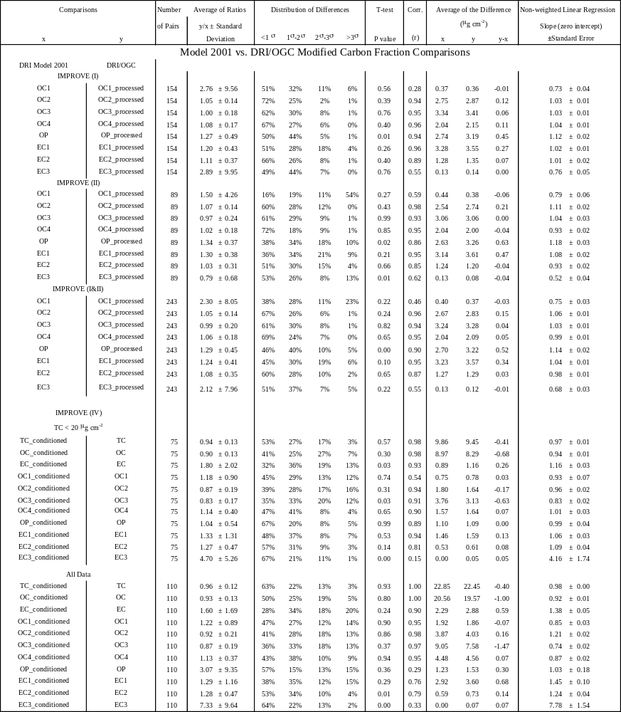
ª Corrected with empirically derived linear regression statistics
^{b} with the 250 ppmv atmosphere and temperature plateaus of 142 °C for OC1, 238 °C for OC2, 468 °C for OC3, 579 °C for OC4, 591 °C for EC1, 738 °C for EC2, and 841 °C for EC3
Table 4-2. Comparability measures for carbon fractions on DRI/OGC and Model 2001 with the IMPROVE and revised IMPROVE (IMPROVE_A) protocols.

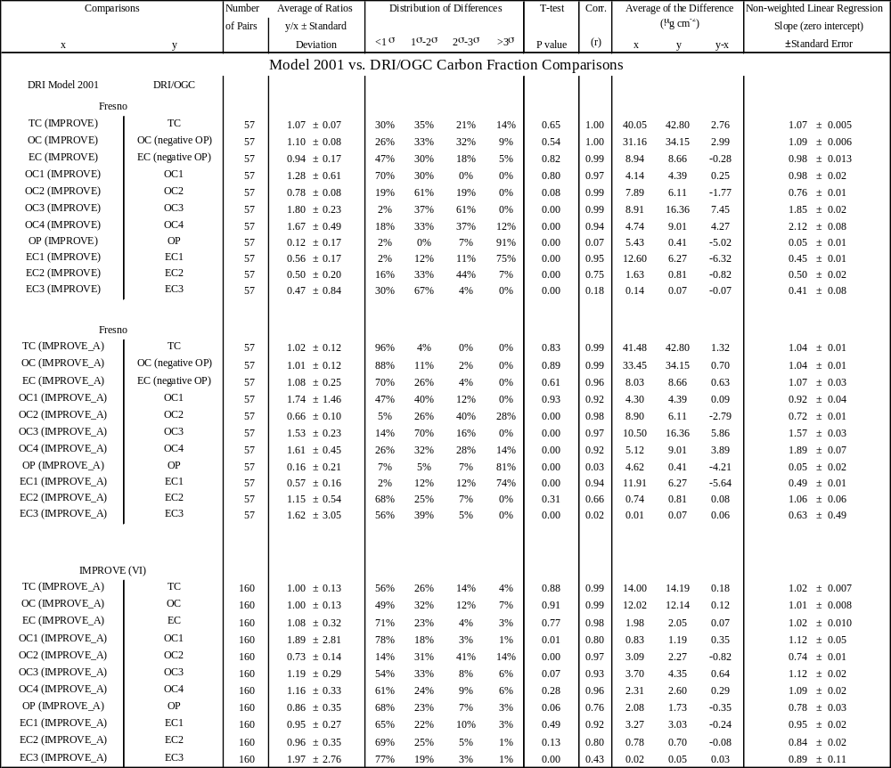

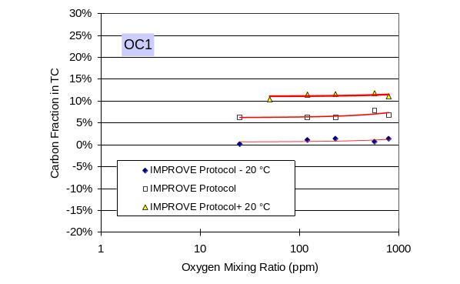 | 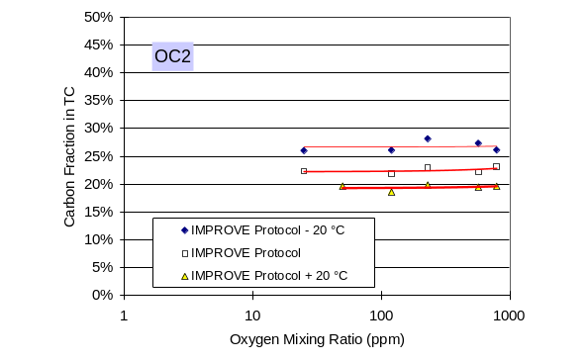
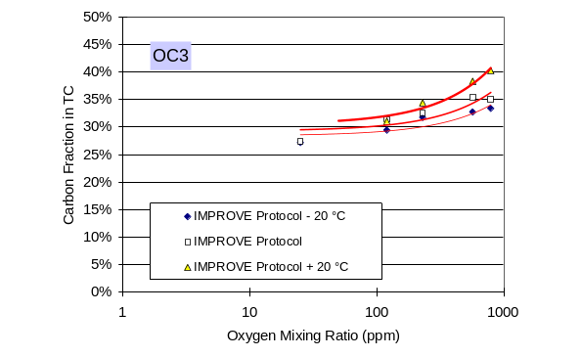 | 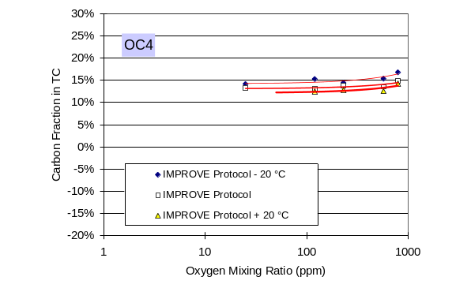
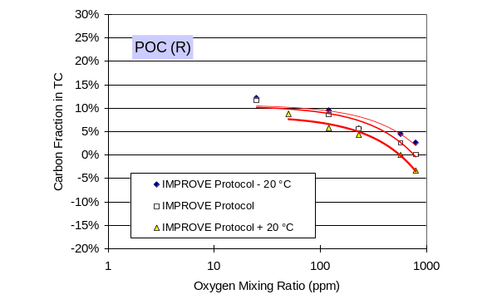  OP | 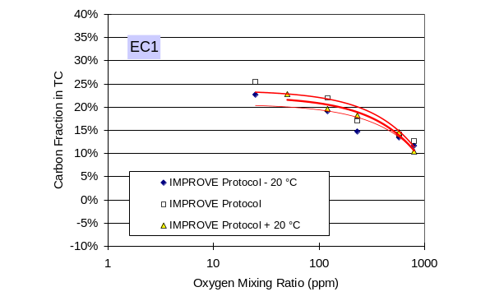
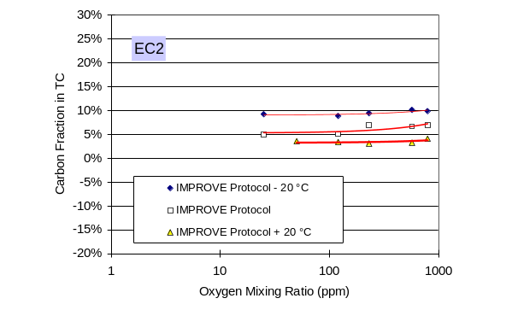 | 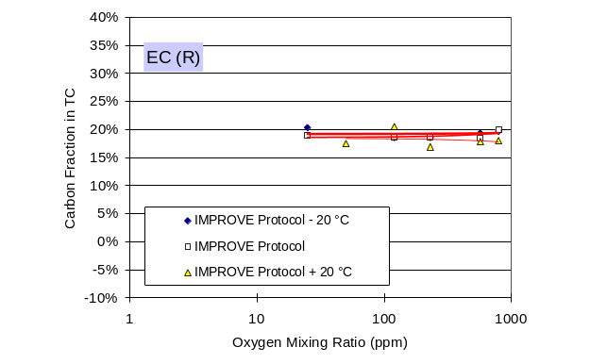
Figure 4-1. Carbon fractions in total carbon (TC) by IMPROVE_TOR as functions of analytical temperature and atmosphere for a Fresno sample on 7/16/2003.

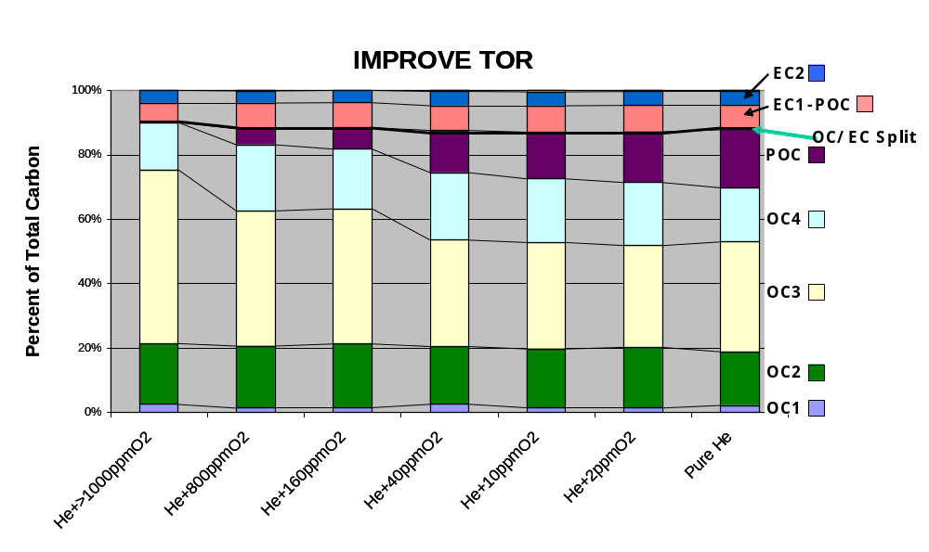
IMPROVE_TOR
(a)

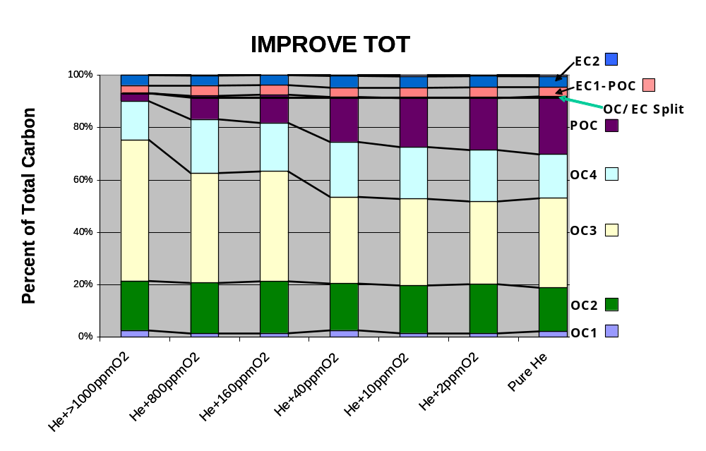
IMPROVE_TOT
(b)

Figure 4-2. Carbon fractions by IMPROVE_TOR (a) and IMPROVE_TOT (b) for a Fresno sample on 8/23/2002.
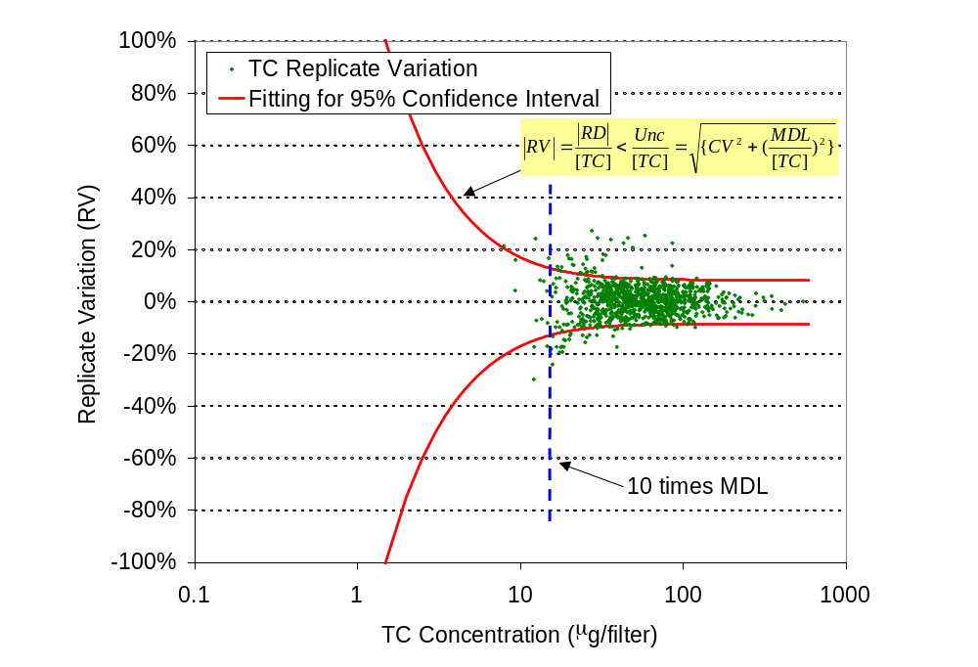
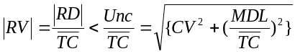
Figure 4-3. Replicate variation (RV) of total carbon (TC) as a function of mean TC measurements with DRI/OGC analyzers. Replicates were performed on 1,010 IMPROVE samples from more than 150 sites. The sampling period was from 12/1999 to 10/2002, including 224, 381, 236, and 169 samples in spring, summer, fall, and winter, respectively. The curved lines indicate the uncertainty of individual TC measurement at a 95% confidence level. The parameters of this line are minimum detection limit MDL = 1.49 μgC per filter and coefficient of variation (CV) = 8.4%.

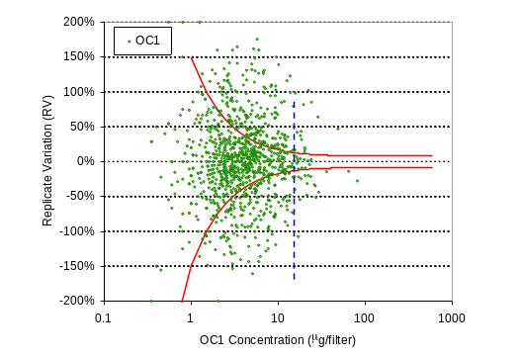 | 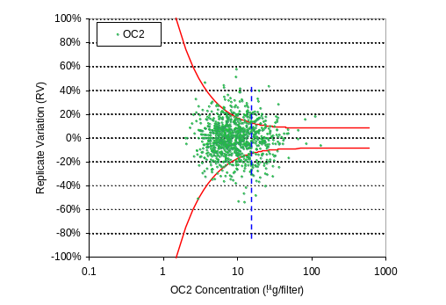
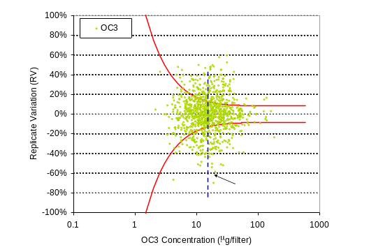 | 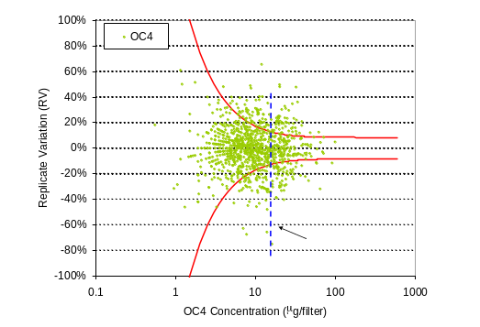
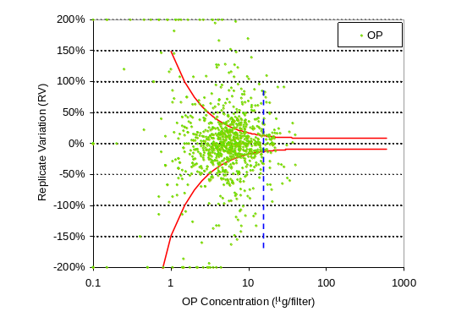 | 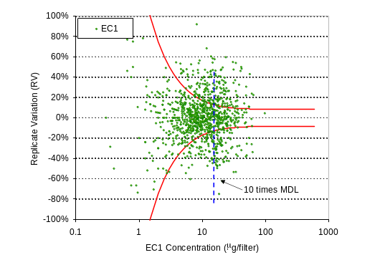
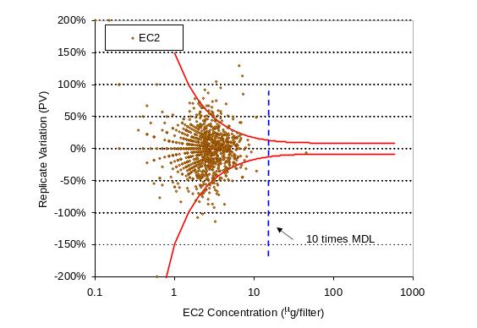 | 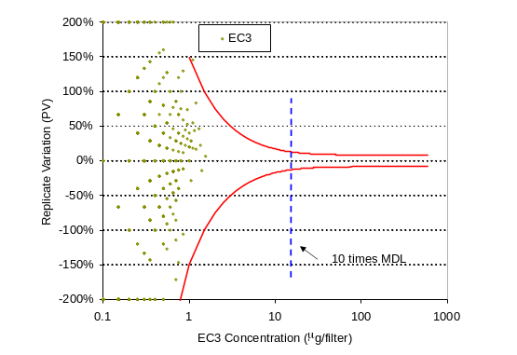
Figure 4-4. Replicate variation (RV) of carbon fractions as a function of mean carbon fraction measurement with DRI/OGC analyzers. 95% confidence lines and number of samples are the same as those shown in Figure 4-3.
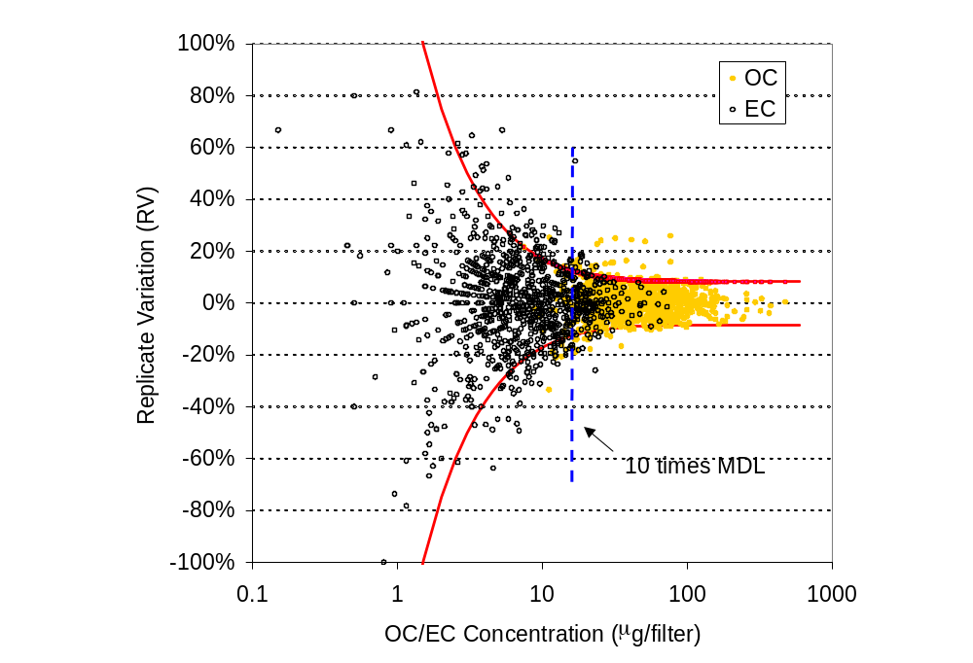
Figure 4-5. Replicate variation (RV) of organic carbon (OC) and elemental carbon (EC) as a function of mean OC and EC measurements with DRI/OGC analyzers. 95% confidence lines and samples are the same as those shown in Figure 4-3.

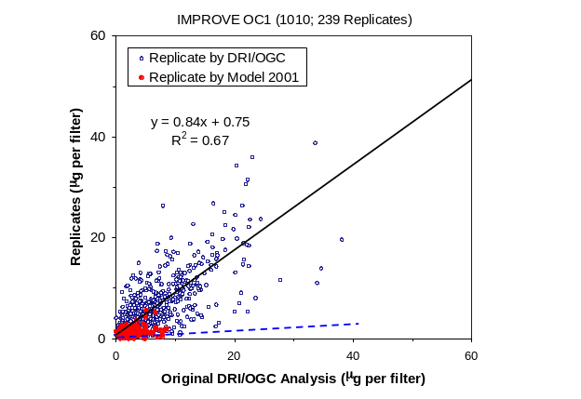  (a) | 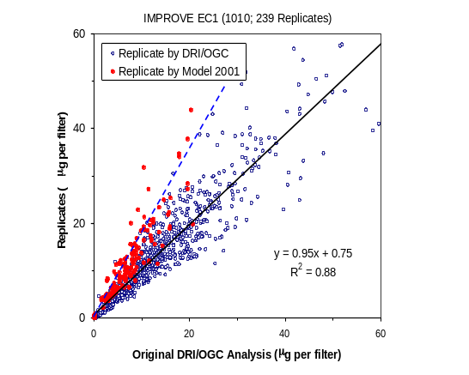  (b)

Figure 4-6. Comparison of: (a) OC1 and (b) EC1 replicates between two DRI/OGC analyzers and between a DRI/OGC and a Model 2001 carbon analyzer. The blue dots indicate replicates of the 1,010 IMPROVE samples by the DRI/OGC analyzer. The red dots indicate replicates of the 243 IMPROVE I and IMPROVE II samples by the Model 2001. The Model 2001 measurements are within the uncertainty of the DRI/OGC measurements.

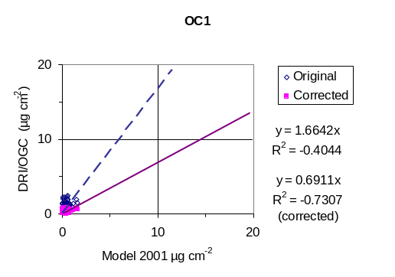 | 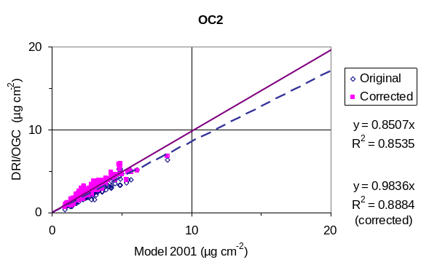
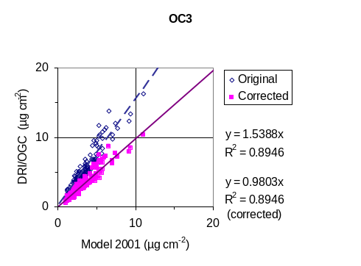 | 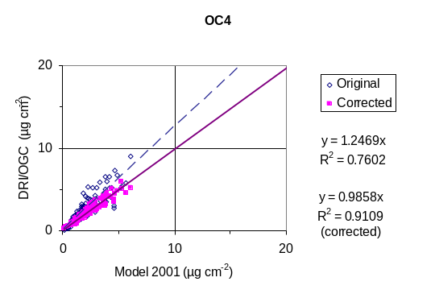
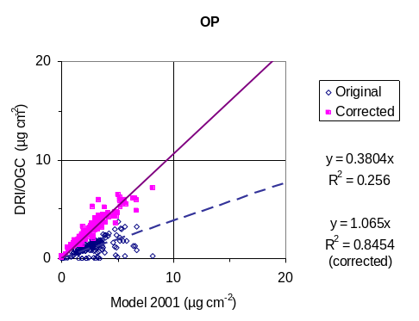 | 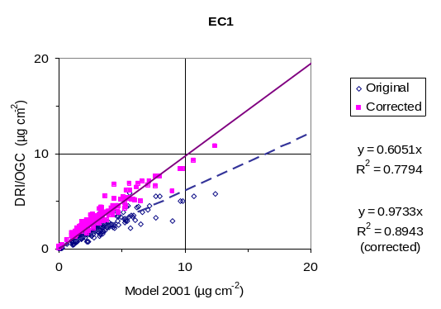
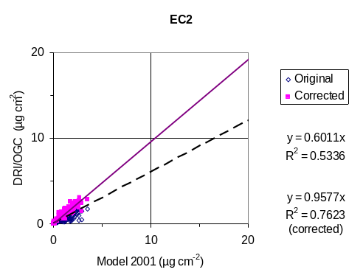 | 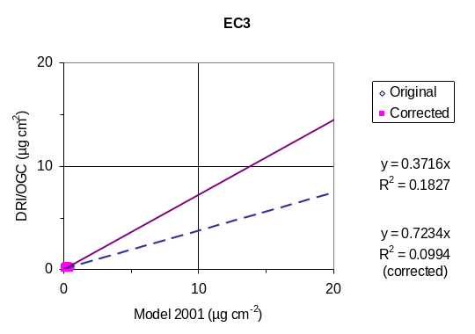

Figure 4-7. Comparison between the Model 2001 and DRI/OGC carbon fractions for 154 IMPROVE I samples. The squares result from an empirical conversion of the DRI/OGC analyzer values to equivalence with the Model 2001 carbon analyzer values.

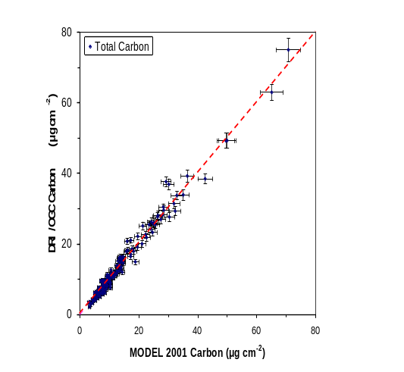
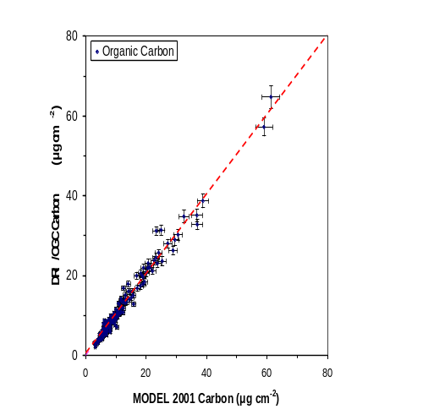
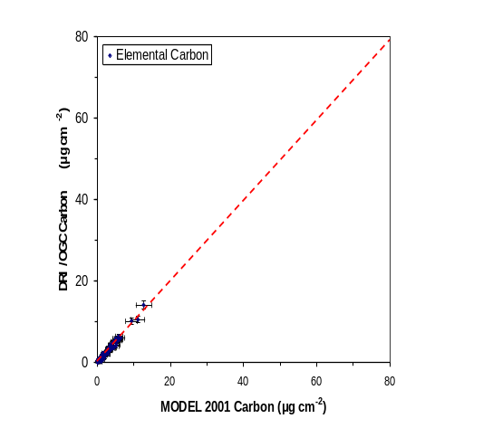
Figure 4-8. Comparison of Model 2001 and DRI/OGC total carbon (TC), organic carbon (OC), and elemental carbon (EC) using the IMPROVE_A protocol on 160 IMPROVE VI samples collected between 1999 and 2003 (temperature plateaus of 140 °C for OC1, 280 °C for OC2, 480 °C for OC3, 580 °C for OC4, 580 °C for EC1, 740 °C for EC2 and 840 °C for EC3).

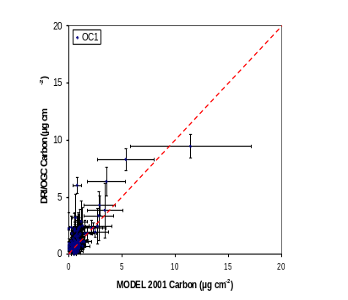 | 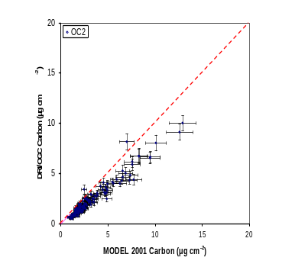
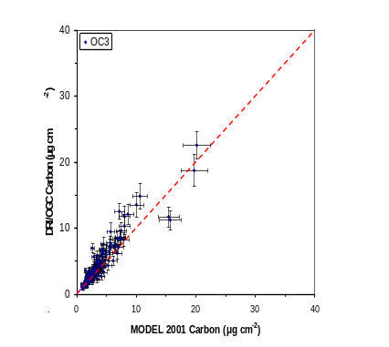 | 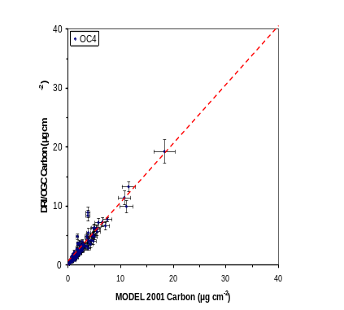
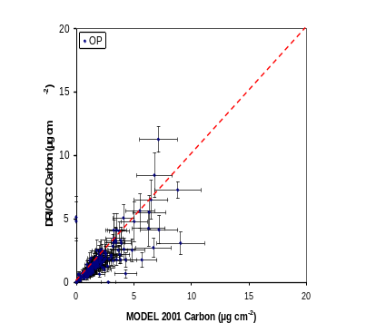 | 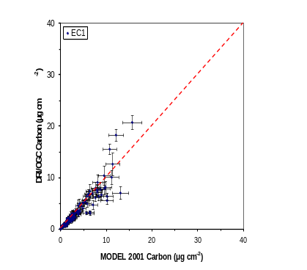
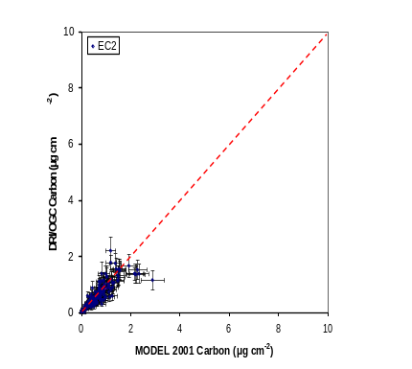 | 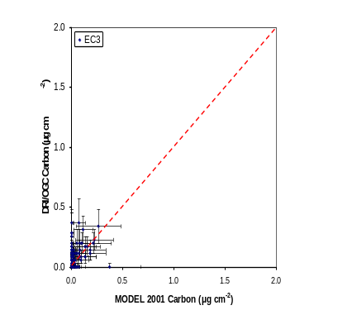
Figure 4-9. Comparison of Model 2001 and DRI/OGC carbon fractions using the IMPROVE_A protocol on 160 IMPROVE VI samples collected between 1999 and 2003 (temperature plateaus of 140 °C for OC1, 280 °C for OC2, 480 °C for OC3, 580 °C for OC4, 580 °C for EC1, 740 °C for EC2 and 840 °C for EC3).

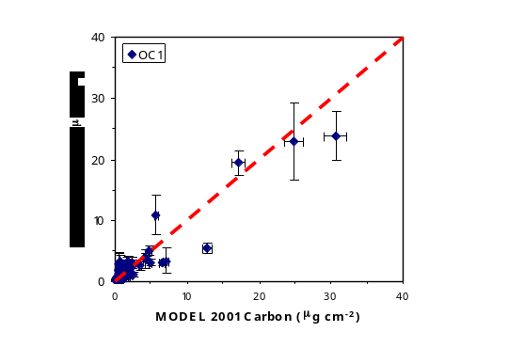 | 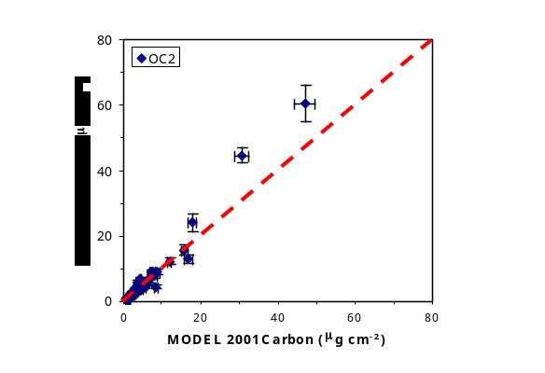
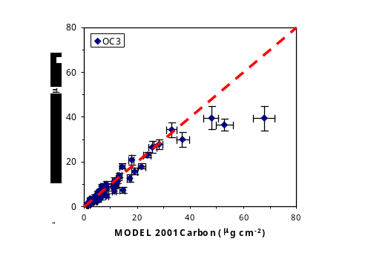 | 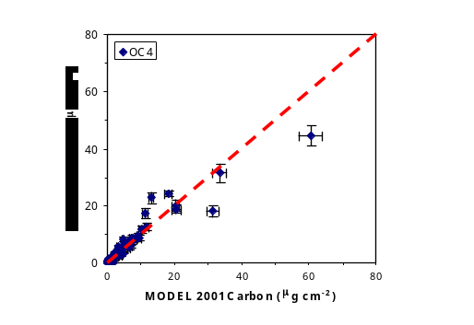
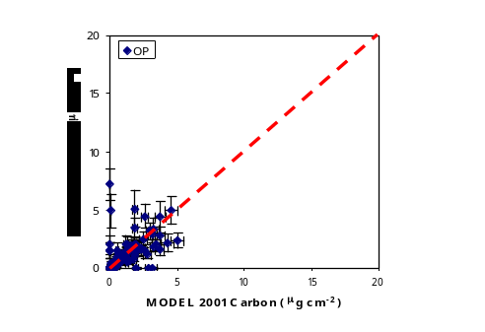 | 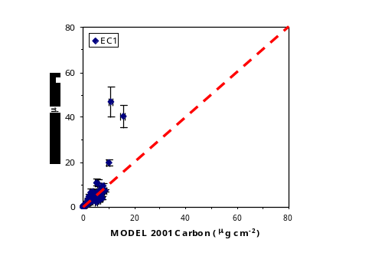
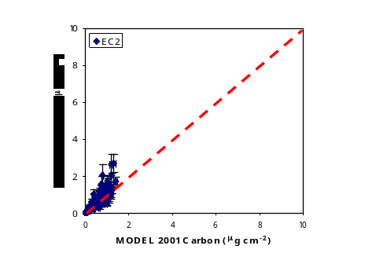 | 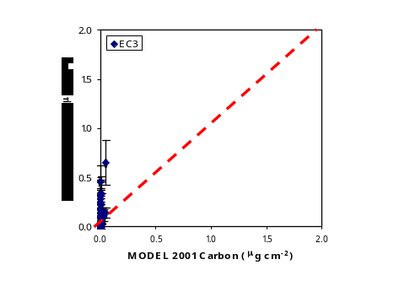
Figure 4-10. Comparison of Model 2001 and DRI/OGC carbon fractions for 110 IMPROVE III samples with the modified carrier gas (250 ± 50 ppmv O₂ in He for OC analysis) and temperature conditions (temperature plateaus of 142 °C for OC1, 238 °C for OC2, 468 °C for OC3, 579 °C for OC4, 591 °C for EC1, 738 °C for EC2, and 841 °C for EC3).

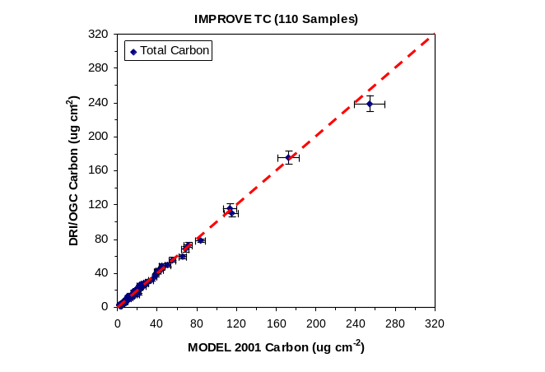
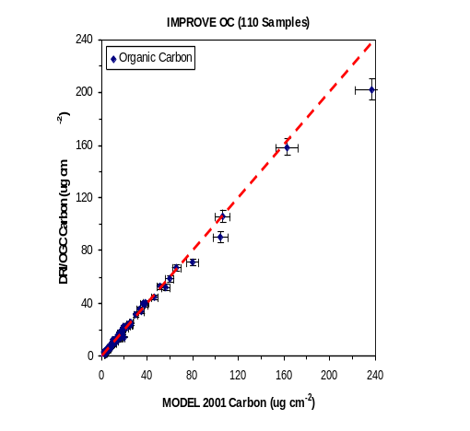
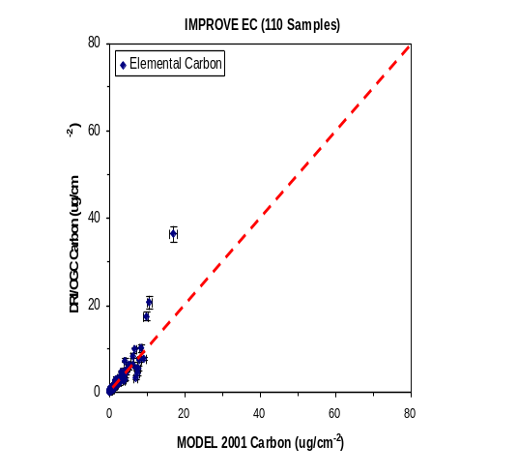

Figure 4-11. Total carbon (TC), organic carbon (OC), and elemental carbon (EC) comparisons with the Model 2001 and DRI/OGC analyzers for 110 IMPROVE III samples with the modified Model 2001 carrier gas (250 ± 50 ppmv O₂ in He for OC analysis) and temperature conditions (temperature plateaus of 142 °C for OC1, 238 °C for OC2, 468 °C for OC3, 579 °C for OC4, 591 °C for EC1, 738 °C for EC2, and 841 °C for EC3).

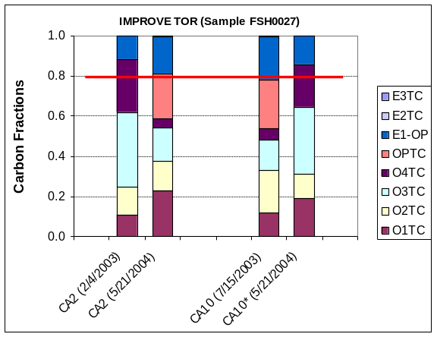  (a) | 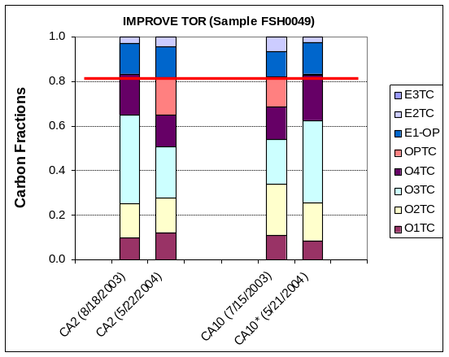  (b)

Figure 4-12. Carbon fractions of two Fresno samples (a and b) analyzed by the same DRI/OGC analyzer (CA #2) at nine-month intervals compared with those analyzed by the Model 2001 (CA #10) with IMPROVE_TOR and modified IMPROVE_TOR conditions. (* denotes analysis with modified analytical conditions stated in Figure 4-10.) Red lines indicating the consistent OC/EC split as negative OP are used.

Summary, Conclusions, and Recommendations

Summary
The DRI/OGC analyzers used for IMPROVE carbon analysis since 1987 are obsolete. They break down frequently, spare parts are no longer manufactured, and their data acquisition and processing software is antiquated. The Model 2001 carbon analyzer has been designed and tested as a replacement for future IMPROVE sample analysis The Model 2001 permits a much lower O₂ diffusion from outside air into the sample heating zone during the pure He stage used to quantify OC fractions. It also allows more accurate and precise monitoring of the sample temperature. Both instruments perform equivalently when implementing the IMPROVE_TOR protocol to measure TC, OC, and EC. They provide different, but highly correlated, results for the seven thermal carbon fractions and optical reflectance pyrolysis corrections reported to the IMPROVE data base. Comparisons of the thermal fractions between the DRI/OGC and Model 2001 for a limited sample set are the same as those found between different DRI/OGC analyzers, or for the same DRI/OGC analyzer used at different times. OC1, OC2, and EC2 are most affected by temperature differences as low as ±20 °C. OP, OC3, and EC1 are most affected when O₂ > 100 ppmv in the pure He carrier gas during the first part of analysis. Nominal conditions for the DRI/OGC analyzers can be simulated by the Model 2001, which gives equivalent thermal carbon fraction concentrations for a given set of DRI/OGC conditions. Consistent relationships can be established via multiple linear regression methods when DRI/OGC conditions do not change.

Conclusions
- TC, OC, and EC are comparable among and between different analyzers with the same design and between different instrument designs for the IMPROVE_TOR protocol and other temperature protocols that use TOR for pyrolysis charring corrections.
- OC and EC are sensitive to the temperature protocol when a TOT pyrolysis charring correction is used. The difference depends on the type of sample and can be as high as a factor of 3 or 4 for EC.
- Carbon fractions measured with the DRI/OGC analyzers are highly variable owing to differences in the sample temperature and O₂ level in the pure He carrier gas.
- DRI/OGC temperature and carrier gas conditions can be simulated in the Model 2001, but the high variability in the DRI/OGC analyses does not define an exact condition to be replicated.
- Analytical conditions such as O₂ level and temperature can be much better controlled in the Model 2001.

Recommendations
- For IMPROVE samples collected in CY2005, begin analysis with the Model 2001 using the revised IMPROVE protocol (IMPROVE_A) rather than the DRI/OGC with more variable temperature and atmosphere conditions. Calibrate thermocouples to obtain stated IMPROVE_A temperatures of 140 ºC for OC1, 280 ºC for OC2, 480 ºC for OC3, 580 ºC for OC4, 580 ºC for EC1, 740 ºC for EC2 and 840 ºC for EC3 within ±5% of the designated temperature. Institute periodic quality control checks of temperature calibration and carrier gas composition. Calibrate reflected and transmitted laser responses among instruments and report initial, minimum, and final values in the data base. Report negative as well as positive TOR and TOT pyrolysis charring corrections.
- In addition to regular replicates measured among the five Model 2001 analyzers, analyze an additional 5% of replicates on two of the DRI/OGC analyzers for at least one year. If discrepancies exceeding 10% in TC, OC, or EC are found between the Model 2001 and DRI/OGC analyzers, an additional 5% of replicates will be analyzed to verify the causes. Operate the DRI/OGC analyzers according to current procedures with periodic audits of their temperatures and carrier gas compositions. Conduct further comparisons of TC, OC, EC, and the carbon fractions.
- Report Model 2001 carbon fractions following the IMPROVE_A protocol with new identifiers (OC1A, OC2A, etc.) so they won’t be confused with previous values. Report the 5% DRI/OGC values with their current denomination.
- Analyze additional data to: 1) determine effects of analyzer change on TC, OC, and EC for a wider range of samples than those reported here; 2) determine variability of thermal carbon fractions within and between instrument designs; 3) determine effects of mineral oxidation and catalysts on EC evolution; 4) better identify heavily loaded samples and residual minerals from optical measurements; and 5) estimate different absorption efficiencies of atmospheric and filter pyrolyzed char from R and transmittance measurements.
- Conduct systematic studies of new and archived source samples to define thermal carbon fractions that better represent adsorbed organic vapor and source contributions.

References

Adams, K.M.; Turpin, B.J.; Huntzicker, J.J. Intercomparison of photoacoustic and thermal-optical methods for the measurement of atmospheric elemental carbon. Presentation at the 82nd Annual Meeting in Anaheim, CA, June 25, 1989. Air & Waste Management Association, Pittsburgh, PA.
Adams, K.M.; Davis, L.I., Jr.; Japar, S.M.; Finley, D.R.; Cary, R.A. Measurement of atmospheric elemental carbon: Real-time data for Los Angeles during summer 1987. Atmos. Environ. 1990, 24A(3):597-604.
Allen, G.A.; Koutrakis, P.; Sioutas, C. Techniques for high quality ambient coarse particulate mass measurements. In Proceedings, PM_{2.5}: A Fine Particle Standard, J.C. Chow and P. Koutrakis, Eds. Air & Waste Management Association, Pittsburgh, PA, 1998, pp. 300-311.
Babich, P.; Davey, M.; Allen, G.; Koutrakis, P. Method comparisons for particulate nitrate, elemental carbon, and PM2.5 mass in seven U.S. cities. J. Air & Waste Manage. Assoc. 2000, 50(7):1095-1105.
Bennett, C.A., Jr.; Patty, R.R. Monitoring particulate carbon collected on Teflon filters: An evaluation of photoacoustic and transmission techniques. Appl. Opt. 1982, 21(3):371-374.
Birch, M.E.; Cary, R.A. Elemental carbon-based method for monitoring occupational exposures to particulate diesel exhaust. Aerosol Sci. Technol. 1996a, 25(3):221-241.
Birch, M.E.; Cary, R.A. Elemental carbon-based method for occupational monitoring of particulate diesel exhaust: Methodology and exposure issues. Analyst 1996b, 121:1183-1190.
Birch, M.E. Analysis of carbonaceous aerosols: Interlaboratory comparison. Analyst 1998, 123 (5):851-857.
Cachier, H.; Bremond, M.P.; Buat-Ménard, P. Thermal separation of soot carbon; Aerosol Sci. Technol. 1989a, 10(2), 358-364.
Cachier, H.; Bremond, M.P.; Buat-Ménard, P. Determination of atmospheric soot carbon with a simple thermal method. Tellus 1989b, 41B(3):379-390.
Cadle, S.H.; Groblicki, P.J. An evaluation of methods for the determination of organic and elemental carbon in particulate samples. In Particulate Carbon: Atmospheric Life Cycles, G.T. Wolff and R.L. Klimisch, Eds. Plenum Press, New York, NY, 1982, pp. 89-109.
Cadle, S.H.; Mulawa, P.A. Atmospheric carbonaceous species measurement methods comparison study: General Motors results. Aerosol Sci. Technol. 1990, 12:128-131.
Cadle, S.H.; Groblicki, P.J.; Stroup, D.P. An automated carbon analyzer for particulate samples. Anal. Chem. 1980, 52(13):2201-2206.
Cadle, S.H.; Groblicki, P.J.; Mulawa, P.A. Problems in the sampling and analysis of carbon particulate. Atmos. Environ. 1983, 17(3):593-600.
Chen, L.W.; Doddridge, B.G.; Dickerson, R.R.; Chow, J.C.; Henry, R.C. Origins of fine aerosol mass in the Baltimore-Washington corridor: Implications from observation, factor analysis, and ensemble air parcel back trajectories. Atmos. Environ. 2002, 36(28):4541-4554.
Chen, L.-W.A.; Chow, J.C.; Watson, J.G.; Moosmüller, H.; Arnott, W.P. Modeling reflectance and transmittance of quartz-fiber filter samples containing elemental carbon particles: Implications for thermal/optical analysis; J. Aerosol Sci. 2004, 35(6), 765-780, doi: 10.1016/j.jaerosci.2003.12.005.
Chow, J.C.; Watson, J.G.; Egami, R.T.; Frazier, C.A.; Goodrich, A.; Ralph, C. PM₁₀ source apportionment in Reno and Sparks, Nevada for state implementation plan development: Chemical mass balance results; DRI 8086.1F2; prepared for State of Nevada, Carson City, NV, by Desert Research Institute: Reno, NV, 1988.
Chow, J.C.; Watson, J.G.; Pritchett, L.C.; Pierson, W.R.; Frazier, C.A.; Purcell, R.G. The DRI Thermal/Optical Reflectance carbon analysis system: Description, evaluation and applications in U.S. air quality studies; Atmos. Environ. 1993, 27A(8), 1185-1201.
Chow, J.C.; Watson, J.G.; Crow, D.; Lowenthal, D.H.; Merrifield, T. Comparison of IMPROVE and NIOSH carbon measurements; Aerosol Sci. Technol. 2001, 34(1), 23-34.
Chow, J.C.; Watson, J.G.; Chen, L.-W.A.; Chang, M.-C.O. Comparison between the DRI/OGC and DRI Model 2001 Thermal/Optical Carbon Analyzers; prepared for IMPROVE Technical Steering Committee, by Desert Research Institute: Reno, NV, 2004a.
Chow, J.C.; Watson, J.G.; Chen, L.-W.A.; Arnott, W.P.; Moosmüller, H.; Fung, K.K. Equivalence of elemental carbon by thermal/optical reflectance and transmittance with different temperature protocols; Environ. Sci. Technol. 2004b, 38(16), 4414-4422.
Chow, J.C.; Watson, J.G.; Crow, D.; Frazier, C.A.; Pritchett, L.C. Thermal carbon analysis procedures for organic carbon, elemental carbon, and carbonate carbon in airborne materials collected on filters, in Methods of Air Sampling and Analysis, 4th ed., Lodge, J.P., Ed.; Air & Waste Management Association: Pittsburgh, PA, 2005, p. in preparation.
Countess, R.J. Interlaboratory analyses of carbonaceous aerosol samples. Aerosol Sci. Technol. 1990, 12:114-121.

Currie, L.A.; Benner, B.A., Jr.; Cachier, H.; Cary, R.; Chow, J.C.; Druffel, E.R.M.; Eglinton, T.I.; Gustafsson, Ö.; Hartmann, P.C.; Hedges, J.I.; Kessler, J.D.; Kirchstetter, T.W.; Klinedinst, D.B.; Klouda, G.A.; Marolf, J.V.; Masiello, C.A.; Novakov, T.; Pearson, A.; Prentice, K.M.; Puxbaum, H.; Quinn, J.G.; Reddy, C.M.; Schmid, H.; Slater, J.F.; Watson, J.G.; Wise, S.A. A critical evaluation of interlaboratory data on total, elemental, and isotopic carbon in the carbonaceous particle reference material, NIST SRM 1649a; J. Res. National Bureau Standards 2002, 107(3), 279-298.
Edwards, J.D.; Ogren, J.A.; Weiss, R.E.; Charlson, R.J. Particulate air pollutants: A comparison of British ‘Smoke’ with optical absorption coefficients and elemental carbon concentration. Atmos. Environ. 1983, 17(11):2337-2341.
Ellis, E.C.; Novakov, T.; Zeldin, M.D. Thermal characterization of organic aerosols. Sci. Total Environ. 1984, 36(Jun.):261-270.
Fung, K.K. Particulate carbon speciation by MnO₂ oxidation; Aerosol Sci. Technol. 1990, 12(1), 122-127.
Fung, K.K.; Chow, J.C.; Watson, J.G. Evaluation of OC/EC speciation by thermal manganese dioxide oxidation and the IMPROVE method. J. Air & Waste Manage. Assoc. 2002, 52(11):1333-1341.
Gaffney, J.S.; Tanner, R.L.; Phillips, M. Separating carbonaceous aerosol source terms using thermal evolution, carbon isotopic measurements, and C/N/S determinations. Sci. Total Environ. 1984, 36:53-60.
Hansen, A.D.A.; Novakov, T. Real-time measurement of aerosol black carbon during the Carbonaceous Species Methods Comparison Study. Aerosol Sci. Technol. 1990, 12:194-199.
Hering, S.V.; Appel, B.R.; Cheng, W.; Salaymeh, F.; Cadle, S.H.; Mulawa, P.A.; Cahill, T.A.; Eldred, R.A.; Surovik, M.; Fitz, D.R.; Howes, J.E.; Knapp, K.T.; Stockburger, L.; Turpin, B.J.; Huntzicker, J.J.; Zhang, X.; McMurry, P.H. Comparison of sampling methods for carbonaceous aerosols in ambient air. Aerosol Sci. Technol. 1990, 12:200-213.
Hitzenberger, R.; Dusek, U.; Berner, A. Black carbon measurements using an integrating sphere technique. J. Geophys. Res. 1996, 101(D14):19601-19606.
Hitzenberger, R.; Jennings, S.G.; Larson, S.M.; Dillner, A.; Cachier, H.; Galambos, Z.; Rouc, A.; Spain, T.G. Intercomparison of measurement methods for black carbon aerosols. Atmos. Environ. 1999, 33(17):2823-2833.
Horvath, H. Atmospheric light absorption - A review. Atmos. Environ. 1993, 27A(3):293-317.
Huffman, H.D. Comparison of the light absorption coefficient and carbon measures for remote aerosols: An independent analysis of data from the IMPROVE NETWORK - I. Atmos. Environ. 1996, 30(1):73-83.
Huntzicker, J.J.; Johnson, R.L.; Shah, J.J.; Cary, R.A. Analysis of organic and elemental carbon in ambient aerosols by a thermal-optical method, in Particulate Carbon: Atmospheric Life Cycle, Wolff, G.T., Klimisch, R.L., Eds.; Plenum Press: New York, NY, 1982, pp. 79-88.
Japar, S.M.; Szkarlat, A.C.; Gorse, R.A., Jr.; Heyerdahl, E.K.; Johnson, R.L.; Rau, J.A.; Huntzicker, J.J. Comparison of solvent extraction and thermal-optical carbon analysis methods: Application to diesel vehicle exhaust aerosol. Environ. Sci. Technol. 1984, 18(4):231-234.
Johnson, R.L. Development and evaluation of a thermal/optical method for the analysis of carbonaceous aerosol; M.S. Thesis; Oregon Graduate Center, Beaverton, OR, 1981.
Kim, E.; Hopke, P.K. Comparison between conditional probability function and nonparametric regression for fine particle source directions; Atmos. Environ. 2004, 38(28), 4667-4673. ISI:000223432500006.
Kim, E.; Hopke, P.K.; Larson, T.V.; Covert, D.S. Analysis of ambient particle size distributions using UNMIX and positive matrix factorization; Environ. Sci. Technol. 2004a, 38(1), 202-209.
Kim, E.; Hopke, P.K.; Edgerton, E.S. Improving source identification of Atlanta aerosol using temperature resolved carbon fractions in positive matrix factorization; Atmos. Environ. 2004b, 38(20), 3349-3362. ISI:000221838500021.
Kim, E.; Hopke, P.K.; Larson, T.V.; Covert, D.S. Analysis of ambient particle size distributions using UNMIX and positive matrix factorization; Environ. Sci. Technol. 2004c, 38(1), 202-209. ISI:000187781800041.
Kirchstetter, T.W.; Corrigan, C.E.; Novakov, T. Laboratory and field investigation of the adsorption of gaseous organic compounds onto quartz filters. Atmos. Environ. 2001, 35(9):1663-1671.
Lavanchy, V.M.H.; Gäggeler, H.W.; Nyeki, S.; Baltensperger, U. Elemental carbon (EC) and black carbon (BC) measurements with a thermal method and an aethalometer at the high-alpine research station Jungfraujoch. Atmos. Environ. 1999, 33(17):2759-2769.
Lawson, D.R.; Hering, S.V. The Carbonaceous Species Methods Comparison Study: An overview. Aerosol Sci. Technol. 1990, 12:1-2.
Lim, H.J.; Turpin, B.J.; Edgerton, E.; Hering, S.V.; Allen, G.; Maring, H.; Solomon, P.A. Semicontinuous aerosol carbon measurements: Comparison of Atlanta Supersite measurements. J. Geophys. Res. 2003, 108(D7):SOS 7-1-SOS 7-12.
Lin, C.; Friedlander, S.K. Soot oxidation in fibrous filters. 1. Deposit structure and reaction mechanisms; Langmuir 1988a, 4(4), 891-898.
Lin, C.; Friedlander, S.K. Soot oxidation in fibrous filters. 2. Effects of temperature, oxygen partial pressure, and sodium additives; Langmuir 1988b, 4(4), 898-903.
Lin, C.I.; Friedlander, S.K. A note on the use of glass fiber filters in the thermal analysis of carbon containing aerosols; Atmos. Environ. 1988c, 22(3), 605-607.
Louie, P.K.K.; Leung, S.P.; Yeung, T.S.; Yu, J.; Lau, A.; Bergin, M.H.; Zheng, M.; Chow, J.C.; Watson, J.G. Twelve-month Particulate Matter Study in Hong Kong; 2002.
Louie, P.K.K.; Chow, J.C.; Chen, L.-W.A.; Watson, J.G.; Gonzi, M.; Leung, G.; Sin, D. PM2.5 chemical composition in Hong Kong: Urban and regional variations; Sci. Total Environ. 2005, in press.
Mader, B.T.; Flagan, R.C.; Seinfield, J.H. Sampling atmospheric carbonaceous aerosols using a particle trap impactor/denuder sampler. Environ. Sci. Technol. 2001, 35(24):4857-4867.
Malm, W.C.; Pitchford, M.L.; Iyer, H.K. Design and implementation of the Winter Haze Intensive Tracer Experiment - WHITEX, in Transactions, Receptor Models in Air Resources Management, Watson, J.G., Ed.; Air & Waste Management Association: Pittsburgh, PA, 1989, pp. 432-458.
Martins, J.V.; Artaxo, P.; Liousse, C.; Reid, J.S.; Hobbs, P.V.; Kaufman, Y.J. Effects of black carbon content, particle size, and mixing on light absorption by aerosols from biomass burning in Brazil. J. Geophys. Res. 1989, 103(D24):32041-32050.
Mathai, C.V.; Watson, J.G.; Rogers, C.F.; Chow, J.C.; Tombach, I.H.; Zwicker, J.O.; Cahill, T.A.; Feeney, P.J.; Eldred, R.A.; Pitchford, M.L.; Mueller, P.K. Intercomparison of ambient aerosol samplers used in western visibility and air quality studies; Enivron. Sci. Technol. 1990, 24(7), 1090-1099.
Maykut, N.N.; Lewtas, J.; Kim, E.; Larson, T.V. Source apportionment of PM2.5 at an urban IMPROVE site in Seattle, Washington; Environ. Sci. Technol. 2003, 37(22), 5135-5142.
McMurry, P.H.; Hansen, A.D.A. An intercomparison of measurements of aerosol elemental carbon during the 1986 Carbonaceous Species Method Comparison Study. J. Air & Waste Manage. Assoc. 1990, 40 (6):894-895.
Mizohata, A.; Ito, N. Analysis of organic and elemental carbon in atmospheric aerosols by thermal method. Annual Report of the Radiation Center of Osaka Prefecture, 1985, 26(0):51-55.
Moosmüller, H. Brewster's angle porro prism: A different use for a pellin-broca prism. Appl. Opt. 1998, 37:8140-8141.
Moosmüller, H.; Arnott, W.P.; Rogers, C.F.; Bowen, J.L.; Gillies, J.A.; Pierson, W.R.; Collins, J.F.; Durbin, T.D.; Norbeck, J.M. Time resolved characterization of diesel particulate emissions 2. Instruments for elemental and organic carbon measurements. Environ. Sci. Technol. 2001, 35(10):1935-1942.
Nejedly, Z.; Campbell, J.L.; Brook, J.R.; Vet, R.; and Eldred, R. Evaluation of elemental and black carbon measurements from the GAViM and IMPROVE networks. Aerosol Sci. Technol. 2003, 37(1):96-108.
NIOSH. Method 5040 Issue 1 (Interim): Elemental carbon (diesel exhaust). In NIOSH Manual of Analytical Methods, 4th ed., National Institute of Occupational Safety and Health, Cincinnati, OH, 1996.
NIOSH. Method 5040 Issue 3 (Interim): Elemental carbon (diesel exhaust). In NIOSH Manual of Analytical Methods, 4th ed., National Institute of Occupational Safety and Health, Cincinnati, OH, 1999.
Novakov, T. Soot in the atmosphere. In Particulate Carbon: Atmospheric Life Cycle, G.T. Wolff and R.L. Klimisch, Eds. Plenum Press, New York, NY, 1982, pp. 19-41.
Peterson, M.R.; Richards, M.H. Thermal-optical-transmittance analysis for organic, elemental, carbonate, total carbon, and OCX2 in PM_{2.5 by the EPA/NIOSH method}, in Proceedings, Symposium on Air Quality Measurement Methods and Technology-2002, Winegar, E.D., Tropp, R.J., Eds.; Air & Waste Management Association: Pittsburgh, PA, 2002, pp. 83-1-83-19.
Petzold, A.; Niessner, R. Intercomparison study on soot-selective methods - Field study results from several polluted areas in Germany. J. Aerosol Sci. 1995, 26(S1):S393-S394.
Poore, M.W. Levoglucosan in PM_{2.5} at the Fresno supersite; JAWMA 2002, 52(1), 3-4.
Rau, J.A. Residential wood combustion aerosol characterization as a function of size and source apportionment using chemical mass balance modeling; Ph.D. Dissertation; Oregon Graduate Center, Beaverton, OR, 1986.
Reid, J.S.; Hobbs, P.V.; Liousse, C.; Martins, J.V.; Weiss, R.E.; Eck, T.F. Comparisons of techniques for measuring shortwave absorption and black carbon content of aerosols from biomass burning in Brazil. J. Geophys. Res. 1998, 103(D24):32031-32040.
Richard, T. Presentation summaries and research recommendations from the Secondary Organic Aerosols Workshop, February 5-7, 2002, Reno, NV; prepared for APACE Workshop Series by Fort Lewis College, US EPA, NPS: Durango, CO, 2004.

Rupprecht, E.G.; Patashnick, H.; Beeson, D.E.; Green, R.E.; Meyer, M.B. A new automated monitor for the measurement of particulate carbon in the atmosphere. In Proceedings, Particulate Matter: Health and Regulatory Issues, J.A. Cooper and L.D. Grant, Eds. Air and Waste Management Association, Pittsburgh, PA, 1995, pp. 262-267.
Ruoss, K.; Dlugi, R.; Weigl, C.; Hänel, G. Intercomparison of different aethalometers with an absorption technique: Laboratory calibrations and field measurements. Atmos. Environ. 1992, 26A(17):3161-3168.
Sadler, M.; Charlson, R.J.; Rosen, H.; Novakov, T. An intercomparison of the integrating plate and the laser transmission methods for determination of aerosol absorption coefficients. Atmos. Environ. 1981, 15(7):1265-1268.
Schauer, J.J.; Cass, G.R. Source apportionment of wintertime gas-phase and particle-phase air pollutants using organic compounds as tracers; Environ. Sci. Technol. 2000, 34(9), 1821-1832.
Schmid, H.P.; Laskus, L.; Abraham, H.J.; Baltensperger, U.; Lavanchy, V.M.H.; Bizjak, M.; Burba, P.; Cachier, H.; Crow, D.J.; Chow, J.C.; Gnauk, T.; Even, A.; ten Brink, H.M.; Giesen, K.P.; Hitzenberger, R.; Hueglin, C.; Maenhaut, W.; Pio, C.A.; Puttock, J.; Putaud, J.P.; Toom-Sauntry, D.; Puxbaum, H. Results of the "Carbon Conference" international aerosol carbon round robin test: Stage 1. Atmos. Environ. 2001, 35(12):2111-2121.
Schmidt, M.W.I.; Skjemstad, J.O.; Czimczik, C.I.; Glaser, B.; Prentice, K.M.; Gelinas, Y.; Kuhlbusch, T.K. Comparative analysis of black carbon in soils. Global Biogeochemical Cycles 2001, 15:163-167.
Sciare, J.; Cachier, H.; Oikonomou, K.; Ausset, P.; Sarda-Esteve, R.; Mihalopoulos, N. Characterization of carbonaceous aerosols during the MINOS campaign in Crete, July-August 2001: A multi-analytical approach; Atmos. Chem. Phys. 2003, 3, 1743-1757. ISI:000185986200002.
Shah, J.J. Measurements of carbonaceous aerosol across the U.S.: Sources and role in visibility degradation; Ph.D. Dissertation; Oregon Graduate Center, Beaverton, OR, 1981.
Sharma, S.; Brook, J.R.; Cachier, H.; Chow, J.C.; Gaudenzi, A.; Lu, G. Light absorption and thermal measurements of black carbon in different regions of Canada. J. Geophys. Res. 2002, 107(D24):4771.
Sheridan, P.J.; Andrews, E.; Jefferson, A.; Ogren, J.A.; Harris, J.M.; Anderson, J.R.; Mertes, S.; Heintzenberg, J. Light absorption efficiency of Indian Ocean aerosols as determined from filter light absorption and graphitic carbon measurements. J. Aerosol Sci. 2004, in preparation.
Sin, D.W.M.; Fung, W.H.; Lam, C.H. (2002). Measurement of carbonaceous aerosols: Validation and comparison of a solvent extraction - gas chromatographic method and a thermal optical transmittance method. Analyst, 127(5):614-622.
Sin, D.W.M.; Fung, W.H.; Choi, Y.Y.; Lam, C.H.; Louie, P.K.K.; Watson, J.G.; Chow, J.C. Seasonal and spatial variation of solvent extractable organic compounds in fine suspended particulate matter in Hong Kong; JAWMA 2005, in press.
Szkarlat, A.C.; Japar, S.M. Optical and chemical properties of particle emissions from on-road vehicles. J. Air Pollution Control Assoc. 1983, 33(6):592-597.
Tanner, R.L. An ambient experimental study of phase equilibrium in the atmospheric system: aerosol H+, NH4+, SO4-2, NO3-, NH3(g), HNO3(g). Atmos. Environ. 1982, 16(12):2935-2942.
Tohno, S.; Hitzenberger, R. Comparison of ambient carbon particulate monitor and filter sampling for black carbon measurement. J. Aerosol Sci. 2000, 31(Suppl. 1):S315-S316.
Turpin, B.J.; Huntzicker, J.J.; Adams, K.M. Intercomparison of photoacoustic and thermal-optical methods for the measurement of atmospheric elemental carbon. Atmos. Environ. 1990, 24A(7):1831-1835.
Turpin, B.J.; Saxena, P.; Allen, G.A.; Koutrakis, P.; McMurry, P.H.; Hildemann, L.M. Characterization of the southwestern desert aerosol, Meadview, AZ. J. Air & Waste Manage. Assoc. 1997, 47(3):344-356.
VDI. Measurement of soot (immission) - Chemical analysis of elemental carbon by extraction and thermal desorption of organic carbon. Report No. 2465 Part 1. Verein Deutscher Ingenieure, Dusseldorf, Germany, 1996.
VDI. Measurement of soot (ambient air) - Thermographic determination of elemental carbon after thermal desorption of organic carbon. Report No. 2465 Part 2. Verein Deutscher Ingenieure, Dusseldorf, Germany, 1999.
Watson, J.G. Chemical element balance receptor model methodology for assessing the sources of fine and total suspended particulate matter in Portland, Oregon; Ph.D. Dissertation; Oregon Graduate Center, Beaverton, OR, 1979.
Watson, J.G.; Chow, J.C. Comparison and evaluation of in-situ and filter carbon measurements at the Fresno Supersite; J. Geophys. Res. 2002, 107(D21), ICC 3-1-ICC 3-15, doi: 10.1029/2001JD000573.
Watson, J.G.; Chow, J.C.; Lu, Z.; Fujita, E.M.; Lowenthal, D.H.; Lawson, D.R. Chemical mass balance source apportionment of PM₁₀ during the Southern California Air Quality Study; Aerosol Sci. Technol. 1994, 21(1), 1-36.
Watson, J.G.; Chow, J.C.; Fitz, D.R. Quality assurance project plan - Fresno Supersite (Revision 0); prepared for U.S. Environmental Protection Agency, Office of Air Quality Planning and Standards, Research Triangle Park, NC, by Desert Research Institute: Reno, NV, 2000.
Watson, J.G.; Turpin, B.J.; Chow, J.C. The measurement process: Precision, accuracy, and validity, in Air Sampling Instruments for Evaluation of Atmospheric Contaminants, Ninth Edition, 9th ed., Cohen, B.S., McCammon, C.S.J., Eds.; American Conference of Governmental Industrial Hygienists: Cincinnati, OH, 2001, pp. 201-216.
Watson, J.G.; Chow, J.C.; Hering, S.V.; Fitz, D.R. Final report for Phase I of Fresno supersite measurements ; prepared for Cooperative Institute for Atmospheric Sciences and Terrestrial Applications, Las Vegas, NV, by Desert Research Institute: Reno, NV, 2002a.
Watson, J.G.; Chow, J.C.; Lowenthal, D.H.; Stolzenburg, M.R.; Kreisberg, N.M.; Hering, S.V. Particle size relationships at the Fresno supersite; JAWMA 2002b, 52(7), 822-827.
Yang, H.; Yu, J.Z. Uncertainties in charring correction in the analysis of elemental and organic carbon in atmospheric particles by thermal/optical methods. Environ. Sci. Technol. 2002, 36(23):5199-5204.
Yu, J.Z.; Xu, J.H.; Yang, H. Charring characteristics of atmospheric organic particulate matter in thermal analysis. Environ. Sci. Technol. 2002, 36(4):754-761.
Appendix A. Summary of organic and elemental carbon thermal analysis protocols.
Protocol | Combustion environment for OC | Combustion environment for EC | Temperature plateau for OC (ºC) | Residence time at each temperature for OC (s) | Temperature plateaus for EC (ºC) | Residence time at each temperature for EC (s) | Optical/charring correction | Converter and detector
IMPROVE^{1,}* | He | 98%He  2%O₂ | 120,250,450,  550 | 150 – 580¹ | 550,700,800 | 150 – 580¹ | Reflectance | Methanator;  FID/CH₄
TMO² | He^{b} | 98%He  2%O₂ | 525 | 300^{c} | 750 | 180 | N/A | Methanator;  FID/CH₄
OGI³ | He^{d} | 98%He  2%O₂ | 600 | Variesª | 400, 500, 600 | 100,120,>200 | Reflectance | Methanator;  FID/CH₄
NIOSH 5040⁴ | He | 98%He  2%O₂ | 250,500,650,  850 | 60,60,60,  90 | 650,750,850,  940 | 30,30,30,  >120 | Transmittance | Methanator;  FID/CH₄
STN^{5,}* | He | 98%He  2%O₂ | 310,480,615,  900 | 60,60,60,  90 | 600,675,750,  825,920 | 45,45,45,  45,120 | Transmittance | Methanator;  FID/CH₄
HKGL⁶  (Hong Kong) | He | 95%He  5%O₂ | 350,550,850 | 70,70,110 | 550,600,700,  750,800,850 | 10,50,40,  30,30,70 | Transmittance | Methanator;  FID/CH₄
HKUST-3⁷  (Hong Kong) | He | 99%He  1%O₂ | 250,500,650,  850 | 150,150,150,  150 | 650,750,850,  890 | 150,150,150,  150 | Transmittance | Methanator;  FID/CH₄
CalTech⁸  (ACE-Asia) | He | 90%N₂  10%O₂ | 310,450,575,  870 | 60,60,60,  90 | 550,625,700,  775,850,900 | 45,45,45,  45,45,120 | Transmittance | Methanator;  FID/CH₄
MSC1⁹  (Canada) | He | 90%He  10%O₂ | 250,450,550,  900 | 150,150,180,  90 | 550,700,800 | 240,210,150 | Transmittance | Methanator;  FID/CH₄
RU/OGI¹⁰  (Atlanta) | He | 90%He  10%O₂ | Stepwise to 700e | N/I | Stepwise to 850 | N/I | Transmittance | Methanator;  FID/CH₄
LBL¹¹ | O₂ | O₂ | Continuous (25 – 825) | 10 ºC per minute | Continuous^{f} (25 – 825) | 10 ºC per minute | Transmittance | NDIR/CO₂
CNRS-CEA  (France 2-Step)^{12,}* | O₂ | O₂ | 340 | 7200 | 1100 | ~600ª | Assume 10% of OC is charred; assume a EC decomposition rate of ~0.22% per min during OC analysis. | Coulometric titration/CO₂
U. Berne  (Switzerland 2-Step)¹³ | O₂ | O₂ | 650^{c},340^{c} | 60, 2520 | 650 | 1920 | N/A | NDIR/CO₂
Appendix A. (continued)
Protocol | Combustion environment for OC | Combustion environment for EC | Temperature plateau for OC (ºC) | Residence time at each temperature for OC (s) | Temperature plateau for EC (ºC) | Residence time at each temperature for EC (s) | Optical/charring correction | Converter and detector
BNL¹⁴ | He | 90%He  10%O₂ | 400 | 300 or 900 ^{g} | 700 | 300 or 900^{g} | N/A | NDIR/CO₂
GM¹⁵ Laboratory | He^{h} | Ambient air | 650 | ~100ª | 650 | ~120ª | N/A | NDIR/CO₂
VDI 2465/1  (Germany)¹⁶ | N/A^{i} | O₂ | N/A | N/A | 200,650,200 | 60,420,120 | N/A | Coulometric titration/CO₂
VDI 2465/2  (Germany)¹⁷ | He | 80%He  20%O₂ | 80,350,620,  400 | 12,72,108,  18 | 300,700^{j} | 30,54 | N/A | Coulometric titration/CO₂
RCOP¹⁸  (Japan) | N₂ | 92%N₂  8%O₂ | 450 | 600^{k} | 850 | 300 | N/A | Methanator;  FID/CH₄
R&P 5400¹⁹ | Ambient air | Ambient air | 340 | ~600^{l} | 750 | ~600 ^{l} | N/A | Low-volume IR CO₂ Meter

- Advance from one temperature to the next when a well-defined carbon peak has evolved.
- Sample is acidified with 30μl of 0.02N HCl and preheated at 120ºC in contact with a bed of granulated MnO₂ in He for 180 s to remove volatile OC and carbonate. The sample remains in contact with MnO₂ throughout analysis.
- Temperature change is accomplished by moving the sample from a lower-temperature oven to a higher-temperature oven.
- Sample is preheated at 350ºC in 2%O₂/98%He environment until all volatile OC is removed.
- Cool to ~ 350 ºC before the introduction of oxygen (Turpin et al., 1990).
- The third of four CO₂ peaks evolving during thermal analysis is assigned to EC; this peak is usually accompanied by an increasing filter transmittance.
- Residence times for loadings < 50μgC and > 50μgC per cm² are 300 s and 900 s each, respectively, for 400° and 700°C.
- Sample is preheated at 350ºC in ambient air for ~ 450 s to remove volatile OC.
- OC on half a filter is extracted with 10 ml of a 50:50 volume %–mixture of toluene and 2-propanol for 24 hr, and the half-filter is dried in pure N₂ before thermal analysis. OC is estimated from the difference between TC and EC acquired from two separated filter halves.
- The sample is cooled to 80ºC from 700ºC. Carbon evolved during cooling is also counted as EC.
- Temperature changes are accomplished by moving the sample through an increasing temperature gradient in the oven.
- The overall analysis time is adjustable but should not be >30 min.
Appendix A. (continued)

References

- Chow et al., 1993; Chow et al., 2001
- Fung, 1990; Fung et al., 2002
- Huntzicker et al., 1982
- Birch 1998; Birch and Cary, 1996a, 1996b; NIOSH 1996, 1999
- Peterson and Richards, 2002
- Sin, 2002
- Yang and Yu, 2002; Yu et al., 2002
- Mader et al., 2001
- Sharma et al., 2002
- Lim et al., 2003
- Novakov, 1982; Ellis et al., 1984; Kirchstetter et al., 2001
- Cachier et al., 1989
- Lavanchy et al., 1999
- Tanner, 1982; Gaffney et al., 1984
- Cadle et al., 1980, 1983
- VDI, 1996
- VDI, 1999
- Mizohata and Ito, 1985
- Rupprecht et al., 1995

Appendix B. Summary of carbon intercomparison studies.
Study/Period/Location/Type | Sampling and Analytical Method | Summary of Major Findings
Atlanta Supersite Experiment  1. Period: 8/3/1999 – 9/1/1999  2. Location: Atlanta Supersite at Jefferson Street, located in a mixed industrial-residential area ~ 4 km northwest of downtown Atlanta, GA.  3. Type: Urban ambient PM_{2.5.}  (Lim et al., 2003) | 1. Rutgers/OGI in situ Thermal/Optical Carbon Analyzer (1-hr average every other hour).  2. R&P 5400 Ambient Carbon Particulate Monitor (hourly).  3. Aethalometer (Magee Scientific) (hourly)  4. PSAP (Radiance) (hourly)  5. ADI Flash Vaporization Carbon Analyzer (10-min cycle; flash temperature unknown)  6. MOUDI Impactor samples (12-hr average; analyzed by TOR)  7. Integrated Filter Samples (Anderson RASS, MetOne SASS, URG MASS, the FRM, R&P Speciation, BYU PC-BOSS, TVA PC-BOSS, ARA PCM, CIT PCM, and URG-VAPS) (24 hr). Filters were analyzed by TOR or TOT methods. | 1. The “inter-sampler precision” with which semicontinuous particulate TC, OC, and EC were measured is 7%, 13%, and 26%, expressed as pooled coefficients of variations of 2, 3, and 4 instruments, respectively.  2. Correlation (R²) between pairs of EC measurements is 74% - 97%, between pairs of OC measurements is 54 – 73%.  3. OC and EC measured by R&P 5400 was 8% lower and 20% higher than RU/OGI OC and EC, respectively.  4. The best correlation of EC measurements is found between the PSAP and aethalometer (R² = 0.97), but PSAP measures only ~ 50% of aethalometer EC.  5. For time-integrated and MOUDI measurements, TC, OC, and EC had pooled coefficients of variation of 25%, 28%, and 66% (9 instruments), respectively.
Fresno Supersite Experiment  1. Time: 1/1/2000 – 12/16/2000  2. Location: Fresno Supersite at 3425 North First Street, ~ 5.5 km north northeast of the downtown Fresno commercial district.  3. Type: Urban ambient PM_{2.5}.  (Watson and Chow, 2002) | 1. Single-channel RAAS-100 FRM (24-hr)  2. Six-channel RAAS-400 (with and without organic gas denuders) (24-hr)  3. Dual-channel sequential filter sampler (SFS) (24-hr)  4. Teflone membrane filters were analyzed for b_{abs} using densitometer.  5. Quartz-fiber filter samples were analyzed for OC, EC, and TC by IMPROVE TOR.  6. R&P 5400 Ambient Carbon Particulate Monitor (hourly).  7. Single- and seven- wavelength aethalometer (AE-14U and AE-30S, Magee Scientific) (hourly).  8. PAS 2000 particle-bound PAH monitor (10-min) | 1. Equivalence was found for PM_{2.5} mass, b_{abs}, TC, OC, and EC among RAAS-100 FRM, RAAS-400, and SFS samplers, and for front filter TC between denuded and non-denuded channels in the RASS-400 samplers.  2. The average positive OC artifact was 1.62 ± 0.5 µg/m³ for the non-denuded Teflone/quartz channel and 1.12 ± 0.91 µg/m³. With preceding denuders, the average negative artifact was 0.61 ± 0.5 µg/m³, ~ 9% of the front filter OC.  3. R&P 5400 total carbon was 40%-60% higher than filter carbon.  4. A high correlation (r>0.9) is found between b_{abs} and EC. The absorption coefficient ranged from 11.4 ± 0.7 to 12.0 ± 0.7 m²/g among FRM, RASS, and SFS.  5. Two aethalometer measurements show a high correlation coefficient of 1, but an average of 0.11 µg/m³ less BC was measured by the 7-wavelength aethalometer for 880 nm channel.  6. TOR EC was consistently 20–25% higher than aethalometer BC. Particle-bound PAH were correlated with BC and EC, but not sufficiently to be considered predictable.

Appendix B. (continued)
Study/Period/Location/Type | Sampling and Analytical Method | Summary of Major Findings
Canada Black Carbon Study  1. Time: Different time periods for 6 sampling sites. The overall study is from 11/1998 to 8/2000  2. Locations: Six sites across Canada: Alert (remote/continental), Egbert (rural), Downsview (suburban), Evans Avenue, Toronto (urban, roadside), Winchester (urban, school yard), and Palmerston (urban, school yard).  3. Type: Remote, rural, suburban, urban ambient PM_{2.5}.  (Sharma et al., 2002) | 1. Ambient PM_{2.5} sampler (averaging time from 12 hrs to 2 weeks)  2. Quartz-fiber filter samples were analyzed by IMPROVE TOR, MSC1 TOT, and France CNRS-CEA 2-Step flash heating thermal protocols.  3. Aethalometer (AE-11, Magee Scientific) (hourly).  4. PSAP (Radiance) (hourly) | 1. EC determined from MSC1 TOT and France 2-Step can be expected to be similar with ~ 10% smaller concentration from IMPROVE TOR.  2. The aethalometer and PSAP instruments agree with each other and underestimate EC, as determined by thermal analysis techniques, by as much as 76% at all sites except for remote Alert, where all measurements agree well.  3. The range of median site-specific absorption efficiency K(s,s) of EC for aethalometer and PSAP was estimated from 6.4 m²/g to 28.3 m²/g and from 3.2 m²/g to 11.6 m²/g, respectively.  4. The highest K(s,s) at the most remote site, Alert, is likely due to the more aged, internally mixed aerosols.
Smoke, Clouds, and Radiation-Brazil (SCAR-B) Experiment  1. Period: 8/17/1995 – 9/20/1995.  2. Location: Samples were obtained from in situ instrumentation or filters collected aboard the University of Washington (UW) Convair C-131A research aircraft (Hobbs, 1996) flying over cerrado and Amazon forest regions of Brazil.  3. Type: Aloft fine aerosol dominated by smoke from biomass burning.  (Reid et al., 1998)  (Martins et al., 1998) | 1. Optical extinction cell (OEC), which is a 6.4 m long transmissometer operated at wavelength 538 nm.  2. Integrating Plate (IP) (Radiance Research), operated at 550 nm.  3. Optical reflectance (OR) (Diffusion Systems), operated in a broadband visible mode. The amount of light reflected is measured to determine the absorption coefficient.  4. PSAP (Radiance Research) at 550 nm (1-min)  5. France pure oxygen/2-Step thermal evolution method (TE).  6. Remote sensing (RS) techniques. Measurements from satellite or Sun photometer combined with irradiance data were used to obtain estimates of the columnar-averaged, single-scattering albedo using SPCTRAL2 (Bird and Riordan, 1986) radiative transfer model. | 1. For in-plume samples, the IP and OR methods produced data that scatter around 1:1 line with the OEC measurements of absorption coefficient σ_{a}; the mean residue for IP and OR were –3% and –0.5%, respectively. The uncertainties in IP and OR methods were estimated at 40% and 17%, respectively.  2. There was a variance of 45% between the PSAP and the OR technique. The uncertainty in PSAP was estimated ~ 40%. This translated into uncertainties of ±0.05 in single scattering albedo for 1-min sample.  3. Combining of the scattering measurements from nephelometer, the OEC produced single scattering albedo for smoke particles that varied from 0.35 – 0.9.  4. The TE method produced data lying well below the 1:1 line with OEC (r = 0.45); the mean residue for TE was –49% relative to OEC, indicating systematic errors. The uncertainty of TE was estimated at 31%. This might lead to significant biases in BC absorption efficiency estimates.  5. SPCTRAL2 model yielded single-scattering albedos slightly higher (by 0.01) than the columnar-averaged values derived from in situ optical measurements on the aircraft.
Northern Front Range Air Quality Study (NFRAQS)  1. Period: 12/17/1996 – 1/9/1997  2. Location: The NFRAQS site at Brighton, Colorado, is located in a semirural environment about 30 km northeast of downtown Denver.  3. Type: Suburban ambient PM_{2.5.}  (Moosmüller et al., 1998) | 1. Aerosol particles were accumulated on for 6- or 12-hour periods on quartz-fiber filters which were analyzed using the IMPROVE TOR protocol at DRI.  2. Aerosol particles were accumulated on for 6- or 12-hour periods on PTFE filters which were analyzed using an integrating plate (Tobias TBX-10 Densitometer).  3. Aethalometer (AE-10IM, Magee Scientific) (10-min).  4. Photoacoustic instrument (532 nm and 685 nm) (10-min average). | 1. The aethalometer BC is well correlated to photoacoustic b_{abs} (r² = 0.87 – 0.92). The comparison resulted in an absorption efficiency for BC of ~ 5 m²/g at 685 nm and ~ 10 m²/g at 532 nm.  2. The TOR EC also shows a good correlation with photoacoustic b_{abs} (r² = 0.85). Large variation occurred when EC concentration was low. The comparison resulted in a absorption efficiency for EC of ~ 3.6 m²/g  3. The correlation of photoacoustic b_{abs} and an integrating plate type filter measurement is fair (r² = 0.74). A correction method (Horvath, 1997) for integrating plate measurement can yield improved agreements.
Big Bend Regional Aerosol and Visibility Observation Study (BRAVO)  1. Period: 9/17/1999 – 10/17/1999  2. Location: Big Bend National Park near the Rio Grande River in South Texas.  3. Type: Rural ambient PM_{2.5.}  (Arnott et al., 2003) | 1. Photoacoustic instrument (532 nm) (hourly).  2. Aethalometer (AE-16, Magee Scientific) (hourly). | 1. The aethalometer BC is weakly correlated to photoacoustic b_{abs} (r² = 0.21 – 0.45) at the low ambient absorption coefficients (<2.1 Mm⁻¹) encountered. The comparison resulted in an absorption efficiency for BC of 8.4 – 9.9 m²/g at 532 nm.  2. The aethalometer BC data never went to zero, suggesting that a small fraction of its response is due to contamination by scattering aerosol.
Maryland Aerosol Research and Characterization (MARCH-Atlantic) Study  1. Period: 7/1999 – 7/2002  2. Location: The sampling site is located at Fort Meade Army base, near the middle of the Baltimore-Washington corridor.  3. Type: Suburban ambient PM_{2.5.}  (Chen et al. 2002) | 1. Samples were collected on quartz-fiber filters (24 hr) by a sequential filter sampler. A tandem filter design was employed. The quartz-fiber filers were analyzed by the IMPROVE TOR thermal/optical protocol for OC, EC, and TC.  2. PSAP (Radiance Research) operated at 550 nm was deployed in 1/2001 for measuring absorption coefficient. (1 min). | 1. The backup filters behind quartz-fiber filter had OC averaged 23 ± 12% of those on the front filters. The backup filters behind Teflon filter had OC averaged 49 ± 19% of those on the front quartz filters.  2. The PSAP absorption coefficient showed a strong correlation with the IMPROVE TOR EC (r² = 0.87). This comparison produced an EC absorption efficiency of 7.1 m²/g at 550 nm.
Southern Great Plains IOP  1. Period: March and April 2000.  2. Location: Department of Energy Cloud and Radiation Testbed site in northern Oklahoma.  3. Type: Rural ambient PM_{2.5.}  (Arnott et al., 2003) | 1. PSAP (Radiance, 550 nm).  2. PSAP (Radiance, 550 nm) downstream of a humidifier.  3. Photoacoustic instrument (532 nm) downstream of a humidifier  4. Humidified nephelometer (TSI Model 3563).  5. 1 hr cycle for humidification was employed. | 1. The photoacoustic data correlated well with the dry PSAP measurements (r² = 0.96), but the slope of the correlation is close to 1.61, meaning that PSAP might overestimate the absorption.  2. The photoacoustic data showed weak dependence of light absorption on relative humidity, a decrease as the relative humidity approaches 95%.  3. The humidified PSAP showed erroneously high light absorption as the RH increases.
Vehicle Emissions Research Laboratory (VERL) Dynamometer Study  1. Vehicles tested: 1996 Dodge Ram 2500 (29509 km), 1999 Ford F250 SD (32401 km).  2. Driving cycle tested: Typical FTP driving cycle including cold start, hot stabilized, and hot start phases.  3. Type: Diesel emission PM_{2.5.}  (Moosmüller et al., 2001) | 1. Time-integration emissions were accumulated on quartz-fiber filters which were subsequently analyzed using the IMPROVE TOR protocol at DRI (1 – 10 min average).  2. TEOM (R&P 1105) (secondly average)  3. Nephelometer (TSI DustTrak 8520) (1 s)  4. Aethalometer (Anderson RTAA-800) (1 s)  5. Photoacoustic Instrument(532 nm) (1 s)  6. Smoke Meter (DRI SM) (633 nm) (1 s) | 1. Aethalometer, photoacoustic, and smoke meter showed the best correlations with the TOR EC (r² = 0.92, 0.92, and 0.91, respectively). The aethalometer overestimated TOR EC by ~ 40%. Photoacoustic estimated an EC absorption efficiency of ~ 8.5 m²/g.  3. TEOM and nephelometer have better correlations with TC (r² = 0.92 and 0.84, respectively).  4. OC can be reasonably estimated by the difference between TEOM/nephelometer total mass measurements and EC estimated from aethalometer, photoacoustic, or smoke meter.
Ford Motor Company Dynamometer Study  1. Vehicle tested: A 1979 2.3 L Opal and a 1980 2.3-L Peugeot were tested. Both of them used diesel engines.  2. Driving cycle tested: Over a series of cruises between 20 mph and 60 mph, as well as over a portion of the FTP driving cycle including cold start, hot stabilized, and hot start phases.  3. Type: Diesel emission fine PM.  (Japar et al., 1984) | Samples were collected on Teflon membrane filter and glass-fiber filters. Total particulate mass was determined by weighing Teflon filter.  1. The organic-soluble fraction of the particulate emission was determined by 20 hr Soxhlet extractions of Teflon filter samples in 1:1 (v/v) mixtures of toluene/1-propanol.  2. The quartz-fiber filters were analyzed for OC, EC, and TC by the OGI TOR protocol (Johnson et al., 1981). | 1. The unextractable mass can be assumed an upper limit to EC. The average ratio of EC to unextractable mass was 1.03 ± 0.06 for all filters. The regression gave a slope of 1.05 ± 0.04 when three outliers were excluded.  2. The outliers were caused by dust components (Al, Si, Ca, Fe, S) in the unextractable mass.  3. The ratio of OC and extractable mass was 0.7 ± 0.05. The regression gave a slope of 0.75.  4. The fraction of solvent extractable mass in total emission mass varied strongly (23 – 63%) with the vehicle operating conditions.
Allegheny Mountain Tunnel Study  1. Period: 7/14/1981 – 7/18/1981.  2. Location: Allegheny Mountain Tunnel on the Pennsylvania Turnpike. The tunnel is located in southwestern Pennsylvania with the closest population center being Somerset, 21 km to the west.  3. Type: Highway traffic emission.  (Szkarlat and Japar, 1983) | Hi-vol samplers (Misco Model 680, 5.5 µm size cutoff) were set up in the east portal of the eastbound tunnel. Particles were collected on glass-fiber and Teflon-fiber filters (4 – 7.5 hrs mean). The vehicle composition was monitored.  1. The organic-soluble fraction of the particulate emission was determined by 16 hr Soxhlet extractions of filter samples in 1:1 (v/v) mixtures of toluene/1-propanol.  2. The carbon content of extracted, nonextracted, and blank filters was determined by combustion (Spang Microanalytical Laboratory, Eagle Harbor, MI).  3. Integrating Plate for measuring absorption at 500 nm.  4. Integrating nephelometer operated at 550 nm.  5. A He-Ne laser (632.8 nm) for total extinction measurements. | 1. The nonextractable carbon was assumed to be EC. Chemical analyses showed that 1) 24% of the vehicle aerosol was extractable material, 2) 75% of the total mass was carbon, 3) 55% of the total mass was EC, and 4) the stoichiometry of extractable fraction of the diesel particle emissions was C_{n}H _{1.7n}N_{0.05n}.  2. The mass absorption efficiency of particulate emission was estimated at 6.0 ± 1.0 m²/g for diesel vehicles and at 6 ± 24 for spark-ignition vehicles.  3. The measurement of mass fraction of EC in particulate emission allowed the calculation of the mass absorption efficiency of EC, and it was determined to average 10.9 ± 1.8 m²/g at 500 nm.  4. In terms of light extinction per km driven, diesel particle emissions were at least one order of magnitude more important than those of spark-ignition vehicles.
Harvard/EPRI Intercomparison Study  1. Periods and Locations:  Riverside CA, 8/15/1997–9/20/1997  Boston, MA, 9/10/1997–9/30/1997  Chicago, IL, 10/10/1997–11/15/1997  Dallas, TX 12/5/1997–1/20/1998  Phoenix, AZ, 12/10/1997–1/25/1998  Bakersfield, CA 2/10/1998–3/25/1998  Philadelphia, PA, 8/1/1998–9/1/1998  Bakersfield, CA, 1/8/1999–1/29/1999  2. Type: Urban ambient PM_{2.5}.  (Babich et al., 2000) | 1. Particles were collected on quartz-fiber filters (24-hr average) and then analyzed by the IMPROVE TOR protocol at DRI.  2. Aethalometer (AE-16U, Magee Scientific) (5-min).  3. Dual channel aethalometer (AE-20UV, Magee Scientific) operated at 880 nm and 325 nm (5-min). | 1. For six cities combined, the EC measured by TOR and BC measured by aethalometer (880 nm) were highly correlated (r² = 0.94; 187 24-hr samples), but the BC values were ~ 24% less than the EC consistently across all six cities.  2. The ratios of BC and EC ranged from 0.62 to 0.81. The lowest ratio was obtained in Dallas, which had the smallest dynamic range of EC concentrations and minimum influence on the overall regression.
Kyoto Intercomparison (Japan)  1. Location: Kyoto University, Uji campus, Kyoto, Japan.  2. Type: Urban ambient PM_{2.5.}  (Tohno and Hitzenberger, 2000) | 1. R&P 5400 ACPM (0.14 - 2.5 µm) (1-hr average)  2. Integrating sphere technique (IS, Hitzenberger et al., 1996). Atmospheric particles were collected on Nuclepore filter (3 hr) downstream of a size-selective Anderson impactor. The exposed filters were dissolved in chloroform, then acetone, to produce liquid suspensions of the collected particles, and the blackness of the suspensions were determined in terms of BC content using the calibration curve of IS. | 1. The direct comparison of EC from ACPM and BC from IS shows very poor agreement.  2. BC mass fraction of particles less than 0.14 µm in diameter ranged from 0.5 to 0.7 in the measurements. Excluding particles below 0.14 µm from IS, the agreements between IS BC and ACPM EC became much better. It was found that ACPM underestimates the real BC concentration without any corrections.
German Intercomparison Study I  1. Locations: Long-term field studies were located at two sites of different pollution levels in Munich and Berlin, respectively. Additional short-term studies were conducted at two rural sites.  2. Type: Urban and rural PM₁₀.  (Petzold and Niessner, 1995) | 1. OC, EC, and TC were determined by the German VDI solvent extraction/thermal oxidation protocol. Volatile organic components were gasified in N₂ atmosphere at 500ºC. This method determined non-extractable carbon (NEC: only solvent extraction), non-volatilizable carbon (NVC: only thermal desorption), and apparent elemental carbon (AEC: thermal desorption and solvent extraction).  2. Aethalometer (AE-9, Magee Scientific) operated at 880 nm.  3. Black smoke method (Christolis et al., 1992).  4. Photoelectric aerosol sensor (PAS, Niessner and Wilbring, 1989). | 1. The method yielded AEC fraction of TC from 9% to 30% at rural sites and from 18% to 53% at urban sites. The NEC fraction of TC was 68–78%. The EC-overestimation by removing OC only with solvent extraction was 35–135%.  2. Aethalometer BC showed a good correlation to AEC at all sites (r = 0.81 – 0.97) with AEC varying from < 2 µg/m³ to > 10 µg/m³. The correlation slope showed strong site dependence, showing a variation of mass absorption efficiency of EC.  3. The black smoke method correlated well with NEC and AEC, but it was not possible to detect a mss concentration of < 5 µg/m³.  4. The PAS was found to be much more sensitive to fresh soot than was aged ambient EC.
German Intercomparison Study II  1. Period: 4/1992 – 4/1993.  2. Location: Two long-term field studies were located in Munich (Site 1: 4/1992 - 10/1992; Site 2: 11/1992 - 4/1993). Site 1 was in a residential district without industrial plants. Site 2 was at a traffic-impacted street crossing with a traffic volume of > 100,000 vehicles per day. Additional short-term studies were conducted at two rural sites.  3. Type: Urban and suburban ambient PM₁₀.  (Petzold and Niessner, 1995) | A tandem filter design was used in this study. Sampling started at 7 a.m. daily (24 hr).  1. OC, EC, and TC were determined by the German VDI solvent extraction/thermal oxidation protocol. Volatile organic components were gasified in N₂ atmosphere at 500ºC. This method determined non-extractable carbon (NEC: only solvent extraction), non-volatilizable carbon (NVC: only thermal desorption), and apparent elemental carbon (AEC: thermal desorption and solvent extraction).  2. Aethalometer (AE-9, Magee Scientific) operated at 880 nm.  3. Smoke shad method (Christolis et al., 1992).  4. Photoelectric aerosol sensor (PAS, Niessner and Wilbring, 1989) that makes use of photoelectron emission from particles when irradiated with UV light. | 1. The method yielded AEC fraction of TC between 40% and 50% and NEC fraction of TC between 75% and 78%.  2. Aethalometer BC and NEC yield site-dependent mass absorption efficiencies (Site 1: 8.4 m²/g; Site 2: 13.7 m²/g) with respect to non-extractable carbon.  3. For the smoke shad method based on reflectometer, a detection limit of 4.2 µg/m³ with respect to EC is determined. Reliable NEC determination is not possible for NEC < 5 µg/m³.  4. The PAS showed complex dependences in its response to a given soot concentration on the age of aerosol. Hence, the PAS was found to be no useful stand-alone technique for soot monitoring. But in combination with an EC measurement, the ratio of PAS signal to EC should allow an estimate of mobile contribution to particulate carbon.
Southwestern Pennsylvania Air Pollution Health Effect Study  1. Period: Summer 1990, 11 weeks.  2. Location: The sampling site is at a school 2 km north of the center of Uniontown in a residential area. Uniontown, PA, is located in Fayette County, 60 km south-southwest of Pittsburgh, PA, and 90 km east of the Ohio River.  3. Type: Rural ambient PM_{2.5}.  (Allen et al., 1998) | 1. Samples of OC/EC were collected (3 hr) using a parallel plate denuder/filter pack system developed by EPRI and AeroVironment, Inc. (Monrovia, CA). Quartz-fiber filters were analyzed by IMPROVE TOR methods at DRI.  2. Aethalometer (AE-9, Magee Scientific Inc.) operated at 880 nm (10 min).  3. Coefficient of Haze (COH; RAC 5000) operated at 400 nm. | 1. Ten-min aethalometer BC data were averaged into 3-hr values matching the 63 EC/OC samples. The two methods were found to be highly correlated (r² = 0.925). The regression equation is BC = (0.95 ± 0.4) EC – (0.2 ± 0.4). The range of EC was 0.6 – 9.4 µg/m³.  2. Collocated COH and aethalometer measurements were conducted in Philadelphia. There was a linear relationship between the two measurements (r = 0.994 with p-value < 0.001). They were very comparable.
Free Troposphere Research Station Jungfraujoch  1. Period: 7/1995 – 6/1997.  2. Location: The Jungfraujoch high-alpine research station in Switzerland (3454 m above surface level).  3. Type: Free troposphere fine PM.  (Lavanchy et al., 1999) | 1. Filter samples were analyzed by the Switzerland pure oxygen/2-Step (340 and 650ºC) thermal protocols with flash heating.  2. Aethalometer (AE-10, Magee Scientific Inc.), operated at 880 nm (19 – 360 hr average).  3. Calibration PM₁₀ samples were acquired from a roadside location in Brene with heavy traffic and from a suburban site at Dübendorf. Standards of OC were obtained by dissolution of starch, tri-sodium citrate 2-hydrate, glucose, and humic acid in pure water, and by pipetting a known volume of these standards onto quartz-fiber filters. EC standards were acquired by using flame soot 101 (Degussa) ultra-sonically suspended in pure water. | 1. The recovery of model organic compounds glucose and starch as OC was ~ 100% while charring was negligible. The recovery of humic acid as OC was 84% on average and artifact formation of EC due to charring was found to be 14%.  2. The correlation of the EC from thermal method and BC from Aethalometer is high (r² = 0.91), exhibiting an average EC absorption efficiency of 9.3 ± 0.4 m²/g.  3. No significant seasonal cycle in absorption efficiency was found at this sampling station. Shorter term variability (days to weeks) was attributed to: 1) the EC/TC composition, and 2) a combination of the Aethalometer filter temporal resolution and the fraction of PBL air mass sampled.
Regional Visibility Experimental Assessment in the Lower Fraser Valley (REVEAL II)  1. Period: 4/1994 – 6/1995.  2. Locations: The monitoring sites were located at Abbotsford Airport in southern British Columbia, Canada, and near the Huntsman Marine Science Center at St. Andrews, New Brunswick, Canada.  3. Type: Rural ambient PM_{2.5}.  (Nejedlý et al., 2003) | The ambient particles are collected by a typical IMPROVE samplers Module A, B, C, and an additional IMPROVE sampler model A.  1. Particles were collected on quartz-fiber filters (24 hr) in the IMPROVE sampler Module C and then analyzed by the IMPROVE TOR protocol at DRI.  2. Particles were collected on Teflon-fiber filters in the additional Model A and then analyzed using laser integrated plate method (LIPM) for BC at the University of Guelph. | 1. A correction factor R for converting b_{abs} measured by LIPM to BC was empirically determined from the known raw values of absorption b_{abs}, concentration of EC, and BC mass absorption efficiency.  2. A polynomial fit of R as a function of areal concentration s yielded the new correction R(s).  3. The correction was retrospectively applied to the LIPM data and compared to the EC. The BC data derived from the LIPM measurements explained about 81% of the variability of the TOR EC.  4. The absolute value of the correction factor R at the two sites agreed for high filter loadings but differed by up to 50% in the case of the low filter loadings, highlighting the influences of aerosol composition.
IMPROVE Network EC/Absorption Comparison  1. Period: 1988 – 1993.  2. Locations: Several rural sites (Pinnacles National Monument, CA; Bandelier National Monument, NM, etc.)  3. Type: Rural ambient PM_{2.5.}  (Huffman, 1996) | 1. Quartz-fiber filters were analyzed using the IMPROVE TOR protocol at DRI.  2. Teflon-fiber filters were analyzed LIPM for absorption _{a} at the University of California, Davis. | 1. The ratio of σ_{a} to EC measured by TOR consistently indicates an absorption efficiency that is twice the accepted value of 10 m²/g. Correlations between σ_{a} and TOR carbon fractions strongly suggest that the discrepancy is due to an underevaluation of light-absorbing carbon rather than an overestimation of µ_{a} or a real, higher value of the absorption efficiency.  2. The potential errors in the current interpretation of TOR analysis included: 1) The pyrolysis correction, based on optical reflectance monitoring, which appeared to be questionable; and 2) the carbon evolving between 450 and 550ºC in a pure He atmosphere, which was well-correlated to _{a} and appeared to be as strongly light absorbing as EC.
Soil BC Content Measurement  1. Location: The eight Australian soils investigated originated from the surface horizons of Vertisols, Mollisols, Alfisols, and Oxisols.  2. Type: Sieved rural soil samples (coarse particles > 2 mm).  (Schmidt et al., 2001) | The sieved soil samples were analyzed for BC using various method:  1. Thermal oxidation method in which OC is removed by thermal oxidation at 375ºC for 24 hours, and EC is determined by C, N-elemental analysis using mass difference.  2. Additional acid extraction (with HF or no HF) before thermal oxidation to remove OC.  3. Chemical oxidation with HNO₃ (65%) at 170ºC for 8 hrs to remove OC. EC is determined by GC/FID using benzenecarboxylic acids as markers. | 1. Thermal oxidation resulted in BC concentrations exhibiting only small differences (41.8 – 58.7 g BC/kg. between samples compared to the other methods. When it was combined with extraction/hydrolysis as a pretreatment, measured values of BC were lower by factors of 8 – 10.  2. Pure chemical oxidation method often resulted in higher BC concentrations (37.2 – 109.0 g BC/kg soil). Differences between samples were also larger.  3. BC concentration generally decreased with increasing intensity of chemical attack.  4. BC measured for individual sample varied over 2 orders of magnitude (up to a factor of 571).
Measurement of Haze and Visual Effects (MOHAVE)  1. Period: 7/15/1992 – 8/30/1992.  2. Location: The sampling site was at Meadview, AZ, located 905 m above sea level on the western edge of Grand Canyon National Park, 95 km east of Las Vegas and 120 km northeast of the MOHAVE coal-fire power plant.  3. Type: Desert ambient PM_{2.5.}  (Turpin et al., 1997) | 1. Size-resolved particulate matter was measured with MOUDIs by the University of Minnesota from 0700 to 1900 using aluminum foil substrates and then analyzed by ERT TMO method, in which samples were heated in He over an MnO₂ catalyst (525ºC for OC and 850 ºC for EC).  2. Particles were collected by a standard IMPROVE four-module sampler and then analyzed by the IMPROVE TOR protocol. | 1. Average MOUDI TC concentrations were 88% greater than IMPROVE filter values, with 95% confidence limits, and the data were uncorrelated (n = 22).  2. OC on backup quartz-fiber filter was 50 ± 20% of the front filter loading. Subtracting the backup filter OC averaged over all sites caused Meadview OC concentrations to be underestimated by 60% on average.  3. The ERT TMO reported an EC mass fraction of < 10% in TC while the IMPROVE TOR reported an EC mass fraction of ~ 17% in TC.
Intercomparison of Black Carbon Measurement  1. Sample: Resuspended carbon black samples and ambient samples from a rural site (Bondville, IL).  2. Type: Artificial BC standards and rural ambient PM_{2.5} far away from source regions.  (Hitzenberger et al., 1999; 1996) | 1. The test aerosol was generated by nebulizing a suspension of carbon black (Elftex 124, Cabot Corp.) in a mixture of 80% ultrapure water and 20% analytic grade isopropanol and sampled by quartz-fiber and polycarbonate capillary pore filter. Ambient samples acquired by MOUDI and dichotomous samplers.  2. BC standards were analyzed by the France pure oxygen/2-step protocol; ambient samples by the NIOSH 5040 protocol.  3. Integrating Sphere (IS) (Hitzenberger et al., 1996).  4. Aethalometer (Magee Scientific) operated at 880 nm. | 1. σ_{a} measured through aethalometer and integrating sphere agreed well (r = 0.943; slope = 0.998; intercept = 0.001 m⁻¹).  2. For standards, the BC mass concentrations determined by aethalometer were only 30% of those from IS. When compared to the thermal method, the IS overestimated BC by only 21%. The instrument factor (19 m²/g) for aethalometer might be too high.  3. For ambient samples, BC determined by thermal/optical method and IS agreed within 5% of the 1:1 slope.  4. For ambient samples, a calibration factor of 6.8 m²/g yielded a slope of aethalometer vs. thermal/optical results of 0.99, very close to the expected 1:1 line, but there was a considerable offset of the data.
Comparison of British Smoke Shade (BSS) with Elemental Carbon Concentration  1. Location: Two sites to sample aerosols: the University of Washington campus provided a typical urban setting while a highway tunnel (U.S. 99) provided a high concentration of vehicle exhaust.  2. Type: Urban ambient fine aerosol and traffic emissions (D_{p} < 1.6 µm).  (Edwards et al., 1983) | 1. Particles were collected on filter, quartz-fiber filter, and Nuclepore polycarbonate membrane filters.  2. EEL Reflectometer (OECD, 1964) for British Smoke Shade (BSS) measurement.  3. Integrating plate method (IPM) operated at 550 nm.  4. Quartz-fiber filters were analyzed by OGI thermal/optical protocol for EC. | 1. The σ_{a} determined by Reflectometer and IPM transmittance were well correlated to each other, but the slope varied with filter medium and face velocity of sampling. This is probably due to penetration of particles into the filters, causing them to be more reflective and transmit less light for a given aerosol loading than they would if the particles were retained on the surface.  2. The transmission of a sample on a fiber filter is always less than for a Nuclepore filter, while the reflectance may be either greater or less than the Nuclepore, likely due to multiple scattering effects.  3. The absorption efficiency of EC ranges from 7 – 12 m²/g in this study.  4. A correction factor of 1.3 was applied to the BC calculated from BSS for a comparison with the EC. The data suggested that BSS might be used to estimate EC within about a factor of two.
Comparison of Filter Absorption and Transmissometric Methods  1. Sample: Pure carbon particles and transparent salt particles were used in this study.  2. Type: Artificial black, white, and mixture fine aerosols (D_{p} < 0.05 µm).  (Horvath, 1993) | 1. An aerosol consisting of pure carbon was produced by a spark discharge between carbon electrodes in an inert atmosphere. This aerosol is mixed with an aerosol consisting of particles produced by spraying a sugar solution in a constant output atomizer. Particles are collected by a Cascade impactor.  2. Long-path transmissometers were used to measure extinction by pure carbon and sugar aerosols separately.  3. Integrating plate (IP) for measuring absorption of particle deposit on Nuclepore filter. | 1. For pure carbon aerosol, when transmission of Nuclepore filter was between 0.4 and 0.95 (the filter has light- to medium-gray appearance), the light absorption coefficient measured with IP was on the average 22% higher than the transmissometric measurements, assuming scattering is negligible. Agreements were obtained for transmission < 0.2.  2. Transparent particle deposit produced limited changes in IP transmission, but the change became significant if the sugar particle was replaced by latex particles. This is due to a stronger backscattering.  3. On a filter which already had carbon particles, an additional deposition of transparent particles onto it always decreased its transmission. Depositing sugar particles that had a scattering coefficient amounting to 50% of the absorption of the carbon particles, the change in IP absorption was 14% on average.
NIST Reference Material Study  1. Sampling Period: Bulk Standard Reference Material (SRM1649a) resulted from atmospheric sampling in 1976-1977.  2. Location: Washington, DC, Navy Yard.  3. Resuspended urban dust PM_{2.5.}  (Currie et al., 2002) | The SRM were resuspended and sampled by quartz-fiber filters using URG filter packs and analyzed by various methods:  1. Aethalometer.  2. 375ºC thermal oxidation method followed flash/combustion/GC to determine residue EC.  3. France 2-Step.  4. LBL pure oxygen/continuous ramping.  5. NIOSH TOT with top temperatures of 900ºC for both EC and OC.  6. IMPROVE TOR.  7. TOT with linear temperature ramping.  8. Thermal kinetic oxidation/intercept method.  9. Thermal oxidation method with various acid pretreatments.  10. Pure chemical oxidation methods (no heating).  11. Isotope carbon (C¹⁴, C¹³) speciation for TC and EC. | 1. A good agreement was shown in the analysis of TC by all laboratories (<1 % variation in TC mass fraction).  2. The EC/TC ratios resulted from all analytical methods varied by about one order of magnitude (7% - 52%). Thermal method results cover the full range of EC/TC values, whereas results from pure chemical oxidation methods are restricted to the upper regions.  3. Particle loss may accompany chemical processing of very small samples.  4. The transmittance measurement for sample of EC > 10µg/cm² are unreliable due to saturation.  5. EC/TC ratio by TOR was significantly higher than that given by TOT.  6. Form isotope study, about 38% of the SRM particulate carbon is derived from biomass burning. The biomass fraction of EC ranges from 2.8% to 11.3 percent. Fossil fuel combustion generally produces a higher EC/TC ratio.
Carbon Conference International Aerosol Carbon Round-Robin Test  1. Sampling Period: 11/7,8,10/1998; the sampling average time is 24 hrs.  2. Location: Frankfurter Allee Street in the city of Berlin. The traffic volume is approximately 58,000 cars per day with a proportion of trucks of ~ 5%.  3. Type: Urban/traffic ambient PM_{10.}  (Schmid et al., 2001) | Particles were collected by a high-volume sampler (Digitel DHA80) with a PM₁₀ inlet and analyzed by various thermal protocols:  1. German VDI 2465 part 1 (solvent extraction, coulometry).  2. German VDI 2465 part 2 (thermal).  3. France CNRS-CEA two-step flash heating.  4. Thermal linear temperature method (20ºC/min) in pure O₂.  5. TOT methods (various temperature programs).  6. IMPROVE TOR.  7. Shimadzu TOC 5000.  8. Elemental Analyzer CE 440; BC: optical transmissometry.  9. Modified integrated sphere, transmission mode. | 1. A good agreement is shown in for the analysis of TC by all laboratories (7 and 9% inter-laboratory relative standard deviation [RSD]).  2. For EC, the within laboratory RSD is ~5% and the inter-laboratory RSD is 37% for the lower load and 46% for the high load samples.  3. Thermal-optical methods (TOR/TOT) obtained, on average, lower EC values than laboratories using only thermal method, likely due to the charring correction. However, a relative high RSD was found for the highest loaded sample with thermal-optical methods.  4. EC in two not pre-extracted/no charring correction samples were highly variable ranging over more than one order of magnitude.  5. Agreements between TOR/TOT and methods that reduce charring (extraction, two-step flash) are better.  6. Optical transmissometry and modified integrated sphere cannot report exact BC since the sample is too dark (off scale).
Carbonaceous Species Methods Comparison Study I (CSMCS)  1. Period: 10 days in August 1986.  2. Location: Sampling site was located in the suburban Los Angeles area.  3. Type: suburban ambient aerosol (PM_{2.5}).  (McMurry and Hansen, 1990)  (Hansen and McMurry, 1990) | 1. Five-stage (2.5, 1.0, 0.6, 0.23, and 0.1 µm) impactor with aluminum foil substrates with quartz-fiber backup filter (University of Minnesota) (12 hr).  2. One-stage (0.1 0.1 µm) impactor with aluminum foil substrates with quartz-fiber backup filter (University of Minnesota) (12 hr).  3. The samples were analyzed for EC by oxidation in He over an MnO₂ catalyst (ERT TMO, 525ºC for OC and 850 ºC for EC.  4. Aethalometer (UC-Berkeley) (1 min). | 1. The aethalometer was calibrated against a chemical determination of EC by solvent extraction pretreatment followed by thermal evolved gas analysis (Gundel et al., 1984).  2. The results of the intercomparison yielded a slope (EC/BC) of 1.02 ± 0.04 and a correlation coefficient of r² = 0.973, within the limits of accuracy of actual determinations.
Carbonaceous Species Methods Comparison Study II (CSMCS)  1. Period: 10 days in August, 1986.  2. Location: Sampling site was located in the suburban Los Angeles area.  3. Type: Reference samples including suburban/urban ambient aerosol, diesel/gasoline source samples, wood smoke samples, a pure secondary organic carbon sample (generated from the photolysis of trimethylbenzene), and a blank (PM₁₀ or less).  (Countess, 1990)  (Lawson and Hering, 1990) | Quartz-fiber samples were analyzed by:  1. IMPROVE TOR protocol.  2. OGI TOR protocol.  3. Sunset TOT method (top temperature 700ºC for OC).  4. Two-Step thermal methods: GGC, USEPA, EMSI, GMR, and Oregon DEQ.  5. LBL pure oxygen/continuous ramping.  6. Optical absorption measurement plus one-step combustion (AIHL).  7. ERT TMO. The samples were analyzed for EC by oxidation in He over an MnO₂ catalyst (TMO, 525ºC for OC and 850 ºC for EC). | 1. All laboratories agreed well on TC analyses with a pooled coefficient of variation for all reference samples of 9%.  2. The coefficient of variation for OC and EC were 25.8% and 52.3%, respectively.  3. The range of EC/TC ratio for the ambient PM₁₀ samples varied by a factor of three from a low of 0.1 (from USEPA) to a high of 0.3 (from GGC) with a mean of 0.22.  4. Overall, USEPA had the lowest average EC/TC ratio while the IMPROVE TOR had the highest EC/TC ratio of 0.5. U.S. EPA’s EC values might be low due to their methodology of switching carrier gases during operation (oxygen contamination).  5. Three of the four laboratories (except Sunset TOT) that attempted to correct for charring gave higher EC values than those did not.
Carbonaceous Species Methods Comparison Study III (CSMCS)  1. Period: 9 days from 8/12/1986 to 8/20/1986.  2. Location: Sampling site was located at Citrus College in Glendora, CA, located in the north-eastern portion of the Los Angeles Basin.  3. Type: Urban ambient fine PM (PM_{1.9} to PM_{2.8}, varied between groups).  (Hering et al., 1990)  (Countess et al., 1990)  (Cadle and Mulawa, 1990)  (Lawson and Hering, 1990) | Ambient samples (4 – 12 hrs average) were collected and analyzed by:  1. OGI TOR protocol with backup-filter correction.  2. Two-step (He and He/O₂) thermal evolution methods without optical charring correction: U.S. EPA, EMSI, GMR  3. Optical absorption measurement for EC plus one-step combustion for TC: AIHL.  4. ERT TMO by AeroVironment and University of Minnesota. The samples were analyzed for EC by oxidation in He over an MnO₂ catalyst (TMO, 525ºC for OC and 850 ºC for EC).  5. Forward alpha scattering technique (FAST, Cahill et al., 1984) by UC Davis. This is a nuclear technique which does not distinguish between organic and nonvolatile carbon. | 1. Consistently higher organic carbon concentrations were reported by the AIHL undenuded quartz-fiber filter and the AV denuded quartz-fiber filter. Lower OC was reported by the adsorption corrected quartz-fiber filter by OGI. The lowest OC were from UM and GMR, both of which used impactors to collect particles.  2. The differences in OC were mostly attributed to sampling methods rather than to analytical methods, but much of the difference in EC was attributed to analytical methods.  3. The TC on Teflon-fiber filters determined by UCD FAST was consistently below (~ 64%) the mean of all other methods.  4. The adsorption of gaseous vapors onto quartz-fiber filters was a significant sampling artifact. For systems employing tandem filters, the TC found on the backup filters was 14% to 53% of the five-sampler mean for TC.
Carbonaceous Species Methods Comparison Study IV (CSMCS)  1. Period: 9 days from 8/12/1986 to 8/20/1986.  2. Location: Sampling site at Citrus College in Glendora, CA, located in the northeastern portion of the Los Angeles Basin.  3. Type: Urban ambient total suspended particulate matter.  (Hansen and Novakov, 1990) | 1. Aethalometer (632 nm, minutely resolution) (6 hr)  2. Integrating plate method was used to calibrate the aethalometer. | 1. The 6-hr average BC concentration ranged from 1.1 to 6.5 µg/m³, with the highest concentration for each day usually shown by the filter collected during period 0800-1400 hour.  2. Examination of minute-by-minute data shows definite events in which individual vehicles in an adjacent property emitted plumes contributing up to 5µg/m³.  3. The aethalometer filters were subsequently analyzed in the laboratory for black carbon content by a integrating plate method that had been calibrated against the solvent extraction/quantitative thermal analysis elemental carbon. The comparison of these analyses confirms the calibration of aethalometer.
Southern California Air Quality Study I (SCAQS)  1. Period: 6/19, 6/24-25, 7/13-15, 8/27-29, 9/2-3 in 1987 (ozone or PM₁₀ episode days).  2. Location: The sampling site was located at Claremont, California.  3. Type: Suburban ambient PM_{2.5.}  (Turpin et al., 1990) | 1. OGI dual-filter/time-resolved thermal-optical carbon analyzer (80-min average followed by 40-min analysis). OC was evolved at 650ºC pure He atmosphere and EC was evolved at 750ºC 98%He/2%O₂ atmosphere.  2. Photoacoustic instrument (Ford Motor Company, 30 s average) operated at 514.5 nm. | 1. The comparison over the concurrent sampling periods indicated good agreements between OGI EC and Ford absorption (b_{abs}).  2. When converting b_{abs} to BC concentration using an absorption efficiency of 10 m²/g, the fit of the two methods exhibited a correlation coefficient of 0.905. The ratio of the mean Ford BC value to the mean OGI EC value was 1.01, and a two-sided t-test showed no significant difference between Ford and OGI values at the 95% confidence level.
Southern California Air Quality Study II (SCAQS)  1. Period: 6/19, 6/24-25, 7/13-15, 8/27-29, 9/2-3 in 1987 (ozone or PM₁₀ episode days).  2. Location: The sampling site was located at Claremont, California.  3. Type: Suburban ambient PM_{2.5.}  (Adams et al., 1990) | 1. A high-volume sampler equipped with a 5 µm pre-separator was used to collected particles on quartz-fiber filters (5 – 6 hr average). The filters were then analyzed at Sunset Laboratory (Forest Grove, OR). Samples were extracted overnight in a 50/50 (v/v) mixture of n-propanol and toluene. The thermal analysis included 250, 385, 580, and 680ºC in He and 600 and 750ºC in 2%O₂/98%He. The split of OC and EC was determined by transmittance.  2. Photoacoustic instrument (Ford Motor Company) operated at 514.5 nm (30 s). | 1. Correlation was good for the optical absorption measured photoacoustically with EC concentration determined by thermal/extraction analysis (r = 0.945). The EC mass absorption efficiency was estimated at 10.06 ± 0.56 m²/g at 514.5 nm.  2. The correlation between photoacoustic measurements and normal thermal technique (no extraction) had greater uncertainty (10%).  3. This study confirmed that EC is the dominant source of aerosol optical absorption in the visible region.
Comparison of IMPROVE and NIOSH temperature protocols at DRI  1. Period and Location: Samples were acquired from a variety of sampling sites during 1997 – 1998. These included 19 source samples and 41 ambient samples. Sampling locations are in Texas; California; Nevada; North Carolina; Virginia; Washington, DC; Colorado; and Mexico.  2. Type: Urban (commercial, residential, and industrial), suburban agriculture, and rural ambient PM_{2.5}; resuspended dry lake soil and road dust; motor vehicle exhaust and chicken rotisserie emission.  (Chow et al., 2001) | Pallflex quartz-fiber filter samples were analyzed by:  1. IMPROVE TOR.  2. NIOSH 5040 TOT. | 1. The IMPROVE and NIOSH thermal evolution protocols are equivalent for TC sampled on quartz-fiber filters.  2. NIOSH EC was typically less than half of IMPROVE EC. The primary difference is the allocation of carbon evolving at the NIOSH (850°C) temperature in He atmosphere to the OC rather than EC fraction. When this portion of NIOSH OC is added to NIOSH EC, the IMPROVE and NIOSH analyses are in good agreement.  3. The pyrolysis adjustment to the EC fraction was always higher for transmittance than reflectance regardless of the protocols used. The difference was most pronounced for very dark samples on which neither reflectance nor transmittance was able to accurately detect further blackening due to pyrolysis.
Comparisons of IMPROVE TOR and TMO Methods  1. Sampling Location: 60 samples from the U.S. IMPROVE Network, 16 from South Korea, 10 from Hong Kong, and 14 synthetic black carbon samples.  2. Type: Urban (industrial and traffic) and rural ambient PM_{2.5}; reference black carbon (Cabot Monarch 120).  (Fung et al., 2002) | Quartz-fiber filter samples were analyzed by:  1. IMPROVE TOR.  2. Thermal Manganese Dioxide Oxidation (TOM) method. | 1. TMO and IMPROVE protocols have been shown to provide equivalent results of TC, OC, and EC values within ± 25% for a wide variety of samples.  2. EC biases were not consistent among different sample sets. EC levels were consistent for simulated soot samples (no OC), higher by TMO in heavily loaded Hong Kong urban samples, and higher by IMPROVE TOR for lightly loaded IMPROVE network and Korea samples.  3. TMO method can effectively reduce charring in pure He environment.
NIOSH Interlaboratory Comparison Study  Location: Samples were collected at a construction site (where diesel-powered compressors were used) near downtown; at a diesel truck loading dock; in the bay of a fire engine house; and from wood smoke. Cigarette smoke was collected in the laboratory on 25 mm diameter portions taken from a field sample.  Type: Various combustion source samples.  (Birch, 1998) | Quartz-fiber filter samples were analyzed by:  1. NIOSH 5040 TOT protocols.  2. TOR (similar to IMPROVE TOR but the residence times were estimates based on scale shown in thermograms).  3. C1: 800ºC, 10 min in N₂ for OC; 800ºC, 7 min in O₂ for EC.  4. C2A: 200ºC (2 min), 400ºC (4 min), and 560ºC (6 min) in N₂ for OC; 800ºC (4.5 min) and 1200ºC (2 min) in O₂ for EC.  5. C2B, C3, C4: 200ºC (2 min), 400ºC (2 min), and 550ºC (4 min) in N₂ for OC; 800ºC (4.5 min) in O₂ for EC.  C1-C4 detect carbon using coulometric methods. | 1. Good agreements (RSD < 15%) between the total carbon (TC) results were reported by all laboratories. Reasonable within-method agreement was seen for EC results.  2. For EC, all coulometric method results were positively biased relative to thermal-optical results. About 52% and 70% of the carbon found in sucrose and EDTA solutions, respectively, were quantified as EC by coulometric method, while thermal-optical method found < 3% of EC for these standards.  3. The NIOSH 5040 TOT method reported only 2% of carbon in cigarette smoke when it was mixed with diesel emissions, while the coulometric method reported an average EC fraction of 40% in cigarette smoke.  4. The coulometric method without charring correction overestimated EC due to inadequate removal of OC in the first part of the analysis.
General Motors Intercomparison Study I  1. Location: Samples were collected from filed studies conducted in Denver, Colorado, and in rural areas near Picas, South Dakota, and Abbeville, Louisiana. Samples of particulate from gasoline and diesel cars were obtained from passenger cars run on a chassis dynamometer. Wood burning particulate was collected from the outlet of residential fireplace.  2. Type: Ambient and source emissions.  (Cadle and Groblicki, 1982) | The particles were collected on a glass-fiber filter or a quartz-fiber filter. The analytical methods for EC included:  1. GMR thermal analysis protocol. OC was removed from the sample by heating at 650ºC under He.  2. Solvent or Fluorinert FC-78 extraction for 8 hrs before thermal analysis.  3. Nitic Acid (6N HNO₃) digestion for 24 hrs before thermal analysis.  4. Vacuum Stripping (1 torr, 180 ºC or 350 ºC) before thermal analysis.  5. Integrating Plate Method (IPM) operated at 550 nm for measuring absorption. | 1. Heating at 180ºC removed only 30% of the carbon compared to 62% at 350ºC in a vacuum. Heating in air at 350ºC removed even more carbon (67%).  2. Both 350ºC oxidation and 2 hr nitric acid extraction removed 67-68% of the carbon compared to a maximum of 54% removal by the most effective solvent. Thus, a maximum of 14% of the organic matter was not extractable.  3. The amount of charring at 650ºC under He depended on the type of organic material present and percent of EC in the samples. Errors will be small in automotive diesel particulate samples where charring is limited. The error can be large in samples susceptible to charring, such as wood burning.  4. The IPM absorption showed a good correlation with EC from thermal method (r = 0.93), resulting in an absorption efficiency of ~ 10 m²/g.
General Motors Intercomparison Study II  1. Location: Samples of atmospheric particulate matter were collected during a field study near Luray, VA. Samples of diesel particulate matter were obtained from passenger cars run on a chassis dynamometer. Wood smoke was collected from a fireplace burning either softwood or hardwood. Additional ambient samples were acquired at Warren, MI, during the winter and spring of 1981.  2. Type: Ambient and source aerosol.  (Cadle et al., 1983) | The particles were collected on quartz-fiber filters. The analytical methods for EC included:  1. GMR thermal analysis protocol. OC was removed from the sample by heating at 650ºC under He. Other heating temperatures were tested.  2. Three digestion methods were used to remove the OC before thermal analysis. In one method, the filters were immersed in a 1.4M H₂SO₄, 0.13 M K₂S₂O₈, 0.6%W/V AgNO₃ solution. In another method, the filters were immersed in a 1:1 solution of ethanol and 4N KOH for ~ 18 hrs. The third method consisted of immersion in a 30% H₂O₂ solution and irradiation with a 200W Xe-Hg arc lamp for 0.75 hr. | 1. The absorption of organic vapor on glass- and quartz-fiber filters and silver membrane filters may be a major problem. With some samples, the amount carbon adsorbed by a backup filter was 30% of that on the front filter.  2. Thermal methods have the advantage of being rapid, but can cause charring of OC, even at 950ºC. The optimum thermal method varies with different samples. A two-step separation procedure employing heating at 350ºC in air followed by a 950ºC pyrolysis under He should be used for samples of unknown compositions.  3. The digestion methods investigated removed some EC and have no advantage over the thermal methods.
DLR Research Center Aethalometer Intercomparison Study  1. Period: Winter 1990-1991.  2. Location: The field station of the Meteorological Institute at Garching, located about 20 km north of Munich, Germany.  3. Type: Artificial black (graphite) and white (salt) aerosol and ambient fine aerosols.  (Ruoss et al., 1992) | 1. Aethalometer (Magee Scientific Inc.).  2. DLR aethalometer. White light is emitted from a source on the downstream side of the filter. Light passing through the filter is detected by four photodiodes, two pf them being sensitive in the green range (550 nm) and two in the infrared range (950 nm). Two of photodiodes measure the reference signals, and the other two detect the measuring signals. | 1. The response of the DLR aethalometer was critical to the ratio of the mass of absorbing and non-absorbing materials as compared with an optical absorption technique (Hänel, 1987; 1988).  2. During the field experiments, the measured soot concentration differed by ~ 50% on average between the DLR aethalometer and the Magee aethalometer. The results of the Magee aethalometer agreed with the absorption technique (Hänel, 1987; 1988) very well.
Colorado State University Aerosol Workshop  1. Sample: Black carbon and white ammonium sulfate particles generated during the Colorado State University Aerosol Workshop.  2. Type: Artificial standard aerosol.  (Bennett and Patty, 1982) | Particles were deposited on the filter substrates at a flow rate of 16.7 L/min. The deposit on Teflon-fiber filters were analyzed by:  1. Integrating plate method (IPM) operated at 633 nm for measuring absorption coefficient through transmission.  2. Photoacoustic detection (PAD) operated at 633 nm for measuring absorption coefficient based on absorptive and thermal properties of the sample. | 1. After a pure carbon deposit was analyzed by IPM and PAD, an overload of (NH₄)₂SO₄ was placed on top of the carbon, and the IPM and PAD measurements were repeated. The perturbation of salt to the IPM measurements was much larger (5 – 10 times) than would be expected, indicating that multiple scattering was apparently taking place within the samples. The perturbation to PAD measurements was much less.  2. IPM tended to overestimate absorption when interfered by scattering particles, but PAD tended to be the opposite.
Ford Photoacoustic Spectroscopy Validation  1. Period: 9/29/1986 – 11/10/1986.  2. Location: The instruments were housed in a mobile office trailer located adjacent to Ford Motor Company’s Scientific Research Laboratory in Dearborn, Michigan.  3. Type: Rural ambient PM₅.  (Adams et al., 1989) | 1. A high-volume sampler equipped with a 5 µm pre-separator was used to collected particles on quartz-fiber filters (5 – 6 hr average). The filters were then analyzed at Sunset Laboratory (Forest Grove, OR). Samples were extracted overnight in a 50/50 (v/v) mixture of n-propanol and toluene. The thermal analysis included 250, 385, 580, and 680ºC in He and 600 and 750ºC in 2%O₂/98%He. The split of OC and EC was determined by transmittance.  2. Photoacoustic instrument (Ford Motor Company) operated at 514.5 nm (secondly average). | 1. A mass absorption efficiency (10 m²/g) was applied to obtain BC concentrations. Agreement between photoacoustic BC and thermal/optical EC were excellent (r = 0.926, slope = 1.10 ± 0.13, intercept = -0.1 ± 0.22 µg/m³).  2. The photoacoustic instrument showed a detection limit ~ 0.3 µgC/m³ (5 – 6 hr average). The instrument signal was sensitive to temperature and humidity, so frequent calibration was necessary as the ambient conditions changed. No influence from atmospheric light scattering species was observed.
A Comparison of Integrating Plate Method and Transmission Method (Early PSAP)  1. Location: Five sampling sites in the western part of Washington state, from a highly congested site in a highway tunnel to a remote site on a western foothill of the Olympic Mountains.  2. Type: Rural ambient aerosol and urban traffic emission aerosol.  (Sadler et al., 1981) | This study incorporated the use of three different sampling substrates (Nuclepore, Millpore, and quartz-fiber).  1. Integrating plate method (IPM) for measuring absorption.  2. Laser transmission method (LTM). The LTM compared the transmission of a 633 nm He-Ne laser beam through a loaded Millipore filter relative to that of a blank filter to calculate the absorption caused by the particle deposit. This was the early development of PSAP.  3. Total carbon on quartz-fiber filters was determined by a total combustion/CO₂ evolution method (Mueller et al., 1971). | 1. A total of 44 filters of each type were used in this comparison. The correlation coefficient between IPM and LTM measurements was 0.95, with the absorption coefficient determined by LTM being greater than that determined by the IPM by a factor of ~ 2.5. This difference was attributed to the filter material.  2. The correlation coefficient found between TC and IPM measurements for the urban data was 0.96. The absorption of urban aerosol was similar to that of a pure graphitic particle of 0.1 µm diameter and 0.66 imaginary refractive index.
Reno Aerosol Optics Study  1. Period: 6/3/2002 – 6/28/2002.  2. Location: Reno, Nevada.  3. Type: Kerosene soot (largely BC) and white (ammonium sulfate) aerosols and mixtures thereof, as well as ambient PM_{2.5.}  (Sheridan et al., 2004) | 1. Cavity Ring-Down Extinction (DRI, NASA, and PSU CRD).  2. Classic extinction cell.  3. Integrating nephelometers.  4. Photoacoustic instrument.  5. Aethalometer.  6. PSAP (Radiance, 550 nm).  7. Multi-Angle Absorption Photometer (MAAP). | 1. Photoacoustic absorption and the difference of extinction and scattering agreed with each other within about 10% for aerosols for scattering albedos ranging from ~ 0.3 – 1, yielding two quasi-equivalent primary standards for aerosol light absorption.  2. The CRD is capable of measuring atmospheric extinction down to below 1 Mm⁻¹.  3. Uncorrected filter-based absorption methods such as aethalometer and PSAP have substantial systematic errors.  4. Filter-based methods corrected for scattering interference (e.g., MAAP) compare (after empirical calibration) generally well with primary standards such as the photoacoustic method. However, their dynamic range is much more limited.

