Chapter 9 - Regional Haze Rule Progress Tracking Metrics

T. Moore and S. Copeland

9.1 REGIONAL HAZE RULE BACKGROUND
The U.S. Environmental Protection Agency (EPA) established the Regional Haze Rule in 1999 (RHR, U.S. EPA, 1999), a major effort to improve air quality in national parks and wilderness areas. The RHR calls for state and federal agencies to collaborate to improve visibility in 156 visibility-protected national parks and wilderness areas (Class I areas, CIA) such as Grand Canyon and Yosemite National Parks, Weminuche Wilderness, and Okefenokee National Wildlife Refuge (see Figure 1.1 in Chapter 1). The rule requires each state, in coordination with the EPA, the National Park Service, U.S. Fish and Wildlife Service, the U.S. Forest Service, and other interested parties, to develop and implement air quality protection plans to reduce the pollution that causes visibility impairment. The first baseline state implementation plans (SIPs) to determine and control emissions that lead to regional haze were due in December 2007, with a progress report due in 2013.

The baseline SIPs were to determine the sources of visibility impairment for the 20% haziest (“worst”) and 20% least hazy (“best”) visibility days derived from IMPROVE aerosol mass samples collected during 2000–2004 at 110 Regional Haze Tracking Sites (RHTS) representing 155 of the 156 CIAs. EPA published default natural conditions to be achieved at each CIA by a nominal date of 2064. The states are required to complete a major regional haze plan update every 10 years (in 2018, 2028, et cetera) until natural conditions are achieved. Regional planning organizations (RPOs) provided technical and planning support to states, EPA, and Federal Land Manager (FLM) efforts to complete the baseline SIPs to reduce emissions by 2018. Reduced emissions should result in changes in visibility on or below the uniform rate of progress slope described in Section 9.2. States were also required to determine Best Available Retrofit Technology (BART) controls on major industrial sources built between 1962 and 1977, as part of the baseline SIPs. Progress to reduce regional haze is determined at the 110 IMPROVE RHTS and reported in 5-year block averages for the worst and best 20% visibility days as monitored by the IMPROVE network. This chapter presents comparisons of visibility estimates from the 2000–2004 baseline time period to the 2005–2009 time period (period 1).
  - Description of RHR Metrics

The RHR specifies a default method to track progress towards the national visibility goal of no anthropogenic visibility impairment. The RHR focuses on reducing pollution on the 20% worst visibility days each year while allowing no degradation of the 20% best visibility days. Haziness is defined by the deciview metric which can be derived from light extinction coefficients (b_{ext}) calculated using the “original” IMPROVE algorithm (RHR1) or the “revised” IMPROVE algorithm (RHR2). Since nearly all states and RPOs used the RHR2 algorithm for SIP development, modeling, and source apportionment, the RHR2 algorithm was applied in this chapter. The daily b_{ext} values were calculated with equation 9.1 (Pitchford et. al. (2007).
b_{ext} = 2.2f_{S}(RH)[small ammonium sulfate] + 4.8f_{L}(RH)[large ammonium sulfate] +
2.4f_{S}(RH)[small ammonium nitrate]+ 5.1f_{L}(RH)[large ammonium nitrate] +
2.8[small particulate organic matter] + 6.1[large particulate organic matter] +
10[light absorbing carbon] + 1[soil] + 1.7f_{SS}(RH)[sea salt]+ 0.6 [coarse mass]+ site-specific Rayleigh scattering 9.1

Recall that in other chapters of this report b_{ext} was computed using a modified RHR1 IMPROVE equation (see Equation 3.4 in Chapter 3) that differs from the RHR2. Species mass concentrations were computed consistently with the previous chapters in the report (see Table 2.1 in Chapter 2). “Small” and “large” refer to a given mode in the bimodal size distribution assumed in this algorithm. Humidification factors (e.g., f_{S}(RH) and f_{L}(RH)) are applied for a specific size mode. Units of b_{ext} and Rayleigh scattering are in inverse megameters (Mm⁻¹). Mass concentrations of aerosol species have units of μg m⁻³, and mass scattering and absorption efficiencies have units of m² g⁻¹. Values of mass scattering efficiencies correspond to the small and large size modes (e.g., 2.2 m² g⁻¹ and 4.8 m² g⁻¹, respectively, for ammonium sulfate).

Deciview values (dv) were calculated from daily b_{ext} values using equation 9.2.
dv = 10ln(b_{ext}/10) 9.2

The RHR guidance requires a given site to have at least 3 “complete” years of data out of each five year period. Some patching of missing aerosol concentration data under certain specific conditions is allowed. The data presented in this chapter have been processed with a patching algorithm described in the guidance report (U.S. EPA, 2003). For the period from 2000–2009 at IMPROVE RHTS, 116,168 valid observations were collected. Of those, 1464 were patched for coarse mass, 421 for ammonium nitrate, 17 for organic carbon and light absorbing carbon, and 6 for fine soil. Eighteen RHTS did not meet the completeness criteria for the 2000–2004 baseline period. For these 18 sites, substitutions were performed for missing data by inserting data from a nearby donor site using a regression analysis technique (Archuleta et al., 2008). Seventeen sites with substituted data are presented in this chapter (i.e., BALD1, BOWA1, CAPI1, CHAS1, COHU1, GLAC1, KAIS1, MING1, NOCA1, RAFA1, SAMA1, SEQU1, SHRO1, SWAN1, THRO1, TONT1, and TRIN1). BRET1 is the 18th substituted site and it is not presented because there were insufficient data from 2005–2009. Of the 110 IMPROVE RHTS, three sites (Zion NP, UT, ZION1, Sierra Ancha WA, AZ, SIAN1, and Breton WA, LA, BRET1) did not have enough data to be considered in this chapter. Data for SIAN1 will be substituted for the 2005–2009 period but the analysis was not completed in time to be included in this chapter. Zion NP was represented by two monitors: ZION1 from 2000 through 2004 and ZICA1 from 2003 through 2009. Evaluating changes across these two sites was beyond the scope of this chapter. The data used in this chapter are not considered regulatory, but are used for evaluation purposes.

Central to the RHR is the concept of the uniform rate of progress (URP). The URP is the yearly rate of change required to achieve natural dv conditions by 2064 in a linear fashion beginning in 2004. The URP provides a reference to evaluate progress made in the context of the change required to reach natural conditions in 60 years. It should be noted that the nature of emissions control programs makes it likely that actual progress will be somewhat erratic and that failure to achieve the URP at any point in the process should be considered in the context of changes to emissions inventories. An example of the URP is shown as the solid black line in Figure 9.2.1. Baseline and period 1 dv values are based on the mean of five yearly values of the best and worst 20% visibility days at each site. Natural conditions are marked with the dashed line.

Figure 9.2.1
The analysis presented in Section 9.3 explores some of the issues with using the total deciview haze index versus b_{ext} from individual aerosol species. Contributions to b_{ext} from biomass burning and windblown dust are highly spatially and temporally variable, and are largely uncontrolled and defined operationally as natural sources. Progress in reducing regional haze, particularly in the western U.S. where 75% of the Class I areas are located, will be strongly affected by variations in fire and dust emissions. In addition, major wildfire events can clog filters or damage IMPROVE sample sites such that those very poor visibility events cannot be characterized. Missing samples can lead to a re-classification of the worst visibility days for a given year and can result in a different source mix.

9.3 Assessment of change in Regional Haze from the baseline (2000–2004) to period 1 (2005–2009).
One assessment of progress during period 1 would be to consider the change in dv values as a fraction of the URP dv change for the 20% worst days. The fraction of URP change corresponds to the change in dv from the baseline to period 1, normalized by the change in dv from the baseline to period 1 along the linear URP glide slope. Higher fractions (100% or greater) suggest considerable improvement in haze levels from baseline to period 1 consistent to or greater than that prescribed by the URP. Attaining the URP is not a regulatory requirement.
Broad improvement in the worst 20% visibility levels is apparent across the eastern U.S. into the Ozark region (see Figure 9.3.1). Degradation in haze was observed in the northern Class I areas (Voyageurs NP, VOYA2, Boundary Waters Canoe Area WA, BOWA1, Isle Royale NP, ISLE1, and Seney WA, SENE1). The western U.S. is characterized by regional improvements in haze especially in the middle and southern Rocky Mountains, Pacific Northwest and southern California. Western IMPROVE sites that experienced large changes in dv on the worst 20% visibility days are often influenced by wildfire impacts. Absolute changes in dv from the baseline to period 1 on the worst 20% visibility days are shown in Figure 9.3.2. The spatial patterns in absolute change in dv are similar to those shown in Figure 9.3.1.
Similarly, Figure 9.3.3 shows the absolute change in dv values on the 20% best visibility days. The goal for these days at all Class I areas is no degradation, which was achieved at a substantial majority of sites across the U.S. Swanquarter WA (SWAN1) in North Carolina was the only IMPROVE RHTS to experience an increase of over 1 dv the 20% best visibility days. The increase was mainly driven by roughly equal increases in b_{ext} from ammonium sulfate and sea salt.
When considering the annual mean of dv values, all but 12 of the IMPROVE RHTS measured at least some improvement (see Figure 9.3.4). While the annual mean values were still influenced by wildfires, the influence was much less pronounced than in the values for the worst 20% visibility days.
Further insights into the changes between the baseline and period 1 can be gained by examining the changes in individual aerosol component's contributions to extinction. While there is no true URP for any given component, a hypothetical URP can be generated by reducing each component of b_{ext} by the same fraction that would be required in total extinction to meet the URP in dv. Maps of hypothetical URP for individual species are shown in Figures 9.3.5-9.3.10. In all of these maps, an asterisk in the place of a site location denotes a site with baseline worst 20% b_{ext} below the estimated natural b_{ext}. This does not mean that the current conditions at that IMPROVE site are cleaner than natural condition for any species. It is an artifact caused by anthropogenic pollutants changing the sample dates that are part of the worst 20% visibility days. As anthropogenic contributions decrease over time, the measured values will converge with the estimated natural values. Note there is no figure for the sea salt fraction of URP since sea salt is assumed to be 100% natural, hence there is no progress to be made.
The fraction of hypothetical URP for ammonium sulfate is shown in Figure 9.3.5. Many sites show improvement in b_{ext} from ammonium sulfate in the Appalachian region and for many sites in New England and Florida. The northern Class I sites and many of the sites in the western U.S. show significant degradation with respect to b_{ext} from ammonium sulfate. Many of the western sites were influenced by wildfires. For example, Hells Canyon WA (HECA1) corresponded to greater than 200% of the URP for b_{ext} due to ammonium sulfate; however this was associated with increases in wildfire impacts in period 1 that resulted in the worst 20% visibility days being associated with organic aerosols rather than ammonium sulfate.
Figure 9.3.6 shows a general improvement in worst 20% visibility days corresponding to ammonium nitrate. Exceptions are three of the northern Class I sites, and the southern Appalachian sites. This is supported by the widespread decreases in annual mean nitrate concentrations (Figure 9.3.x)
Figures 9.3.11-9.3.17 show the absolute changes in each component's extinction contribution to the 20% haziest days. For completeness, individual aerosol component's extinction contributions to clearest 20% days are also provided (Figures 9.3.18-9.3.24).
It can be difficult to discern whether a change in worst 20% visibility days corresponding to a specific species is indicative of decreased emissions, or merely an artifact of a shift to the other aerosol components. Therefore it is especially useful to determine overall changes in b_{ext} from ammonium sulfate and ammonium nitrate by considering the changes in the 5-year annual mean values of b_{ext} from baseline to period 1. Spatial patterns in the differences in the baseline and period 1 annual mean b_{ext} due to ammonium sulfate (Figures 9.3.25) were very similar to differences in the baseline and period 1 worst 20% visibility days. Annual mean b_{ext} due to ammonium nitrate decreased at all but four of the RHTS (see Figure 9.3.26), suggesting that the increases in worst 20% visibility days from ammonium nitrate seen in Figure 9.3.6 are likely to have resulted from changes to the distribution of other extinction components, not an increase in b_{ext} from ammonium nitrate overall.

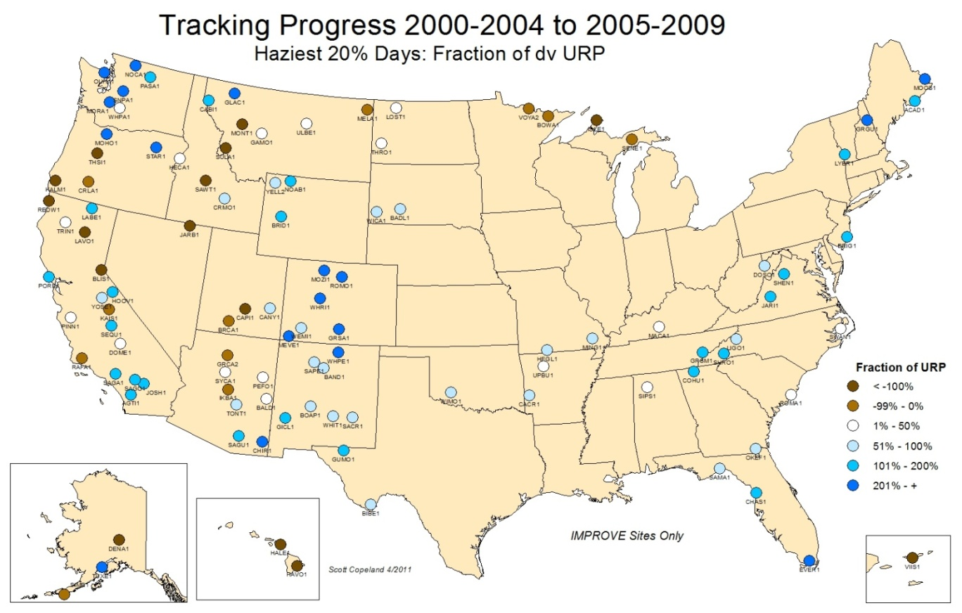
Figure 9.3.1

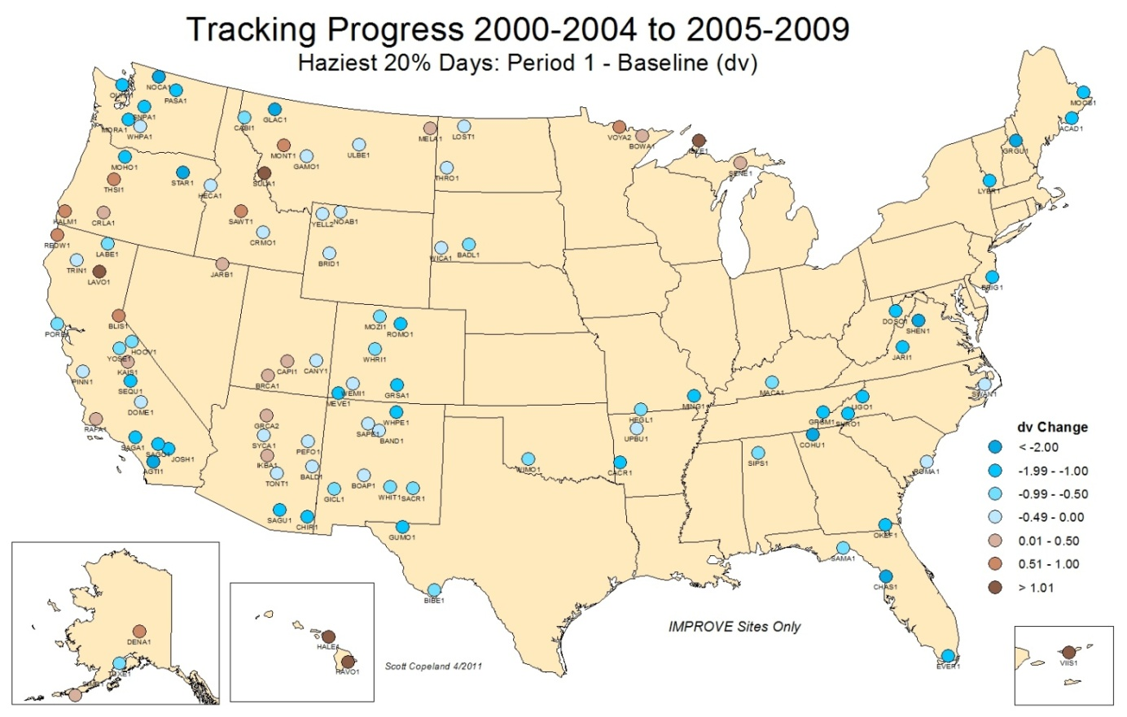
Figure 9.3.2

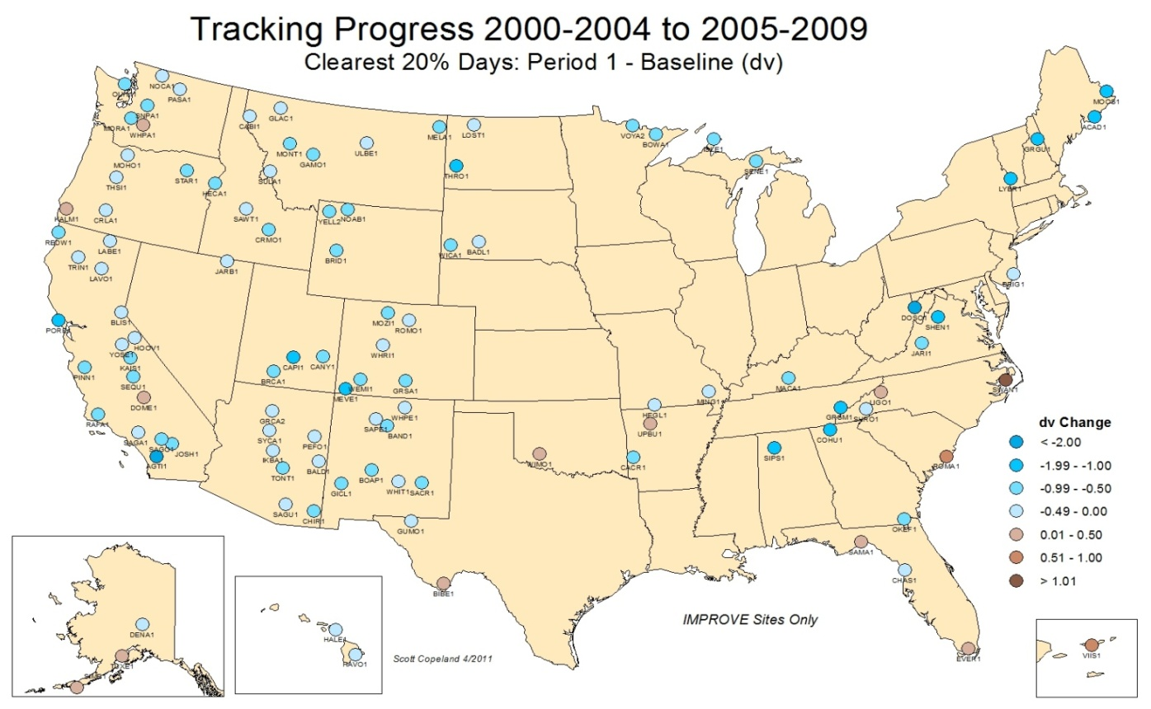
Figure 9.3.3

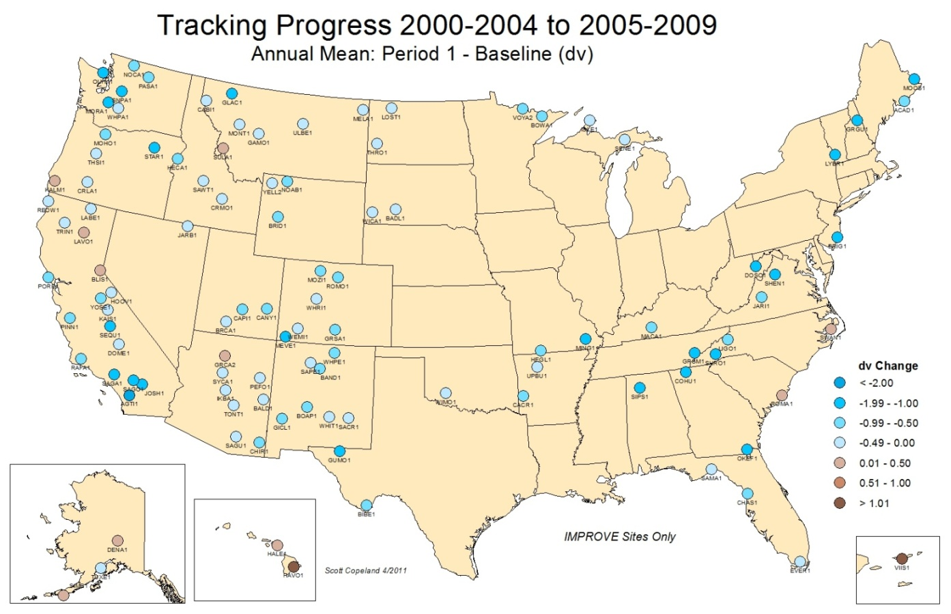
Figure 9.3.4

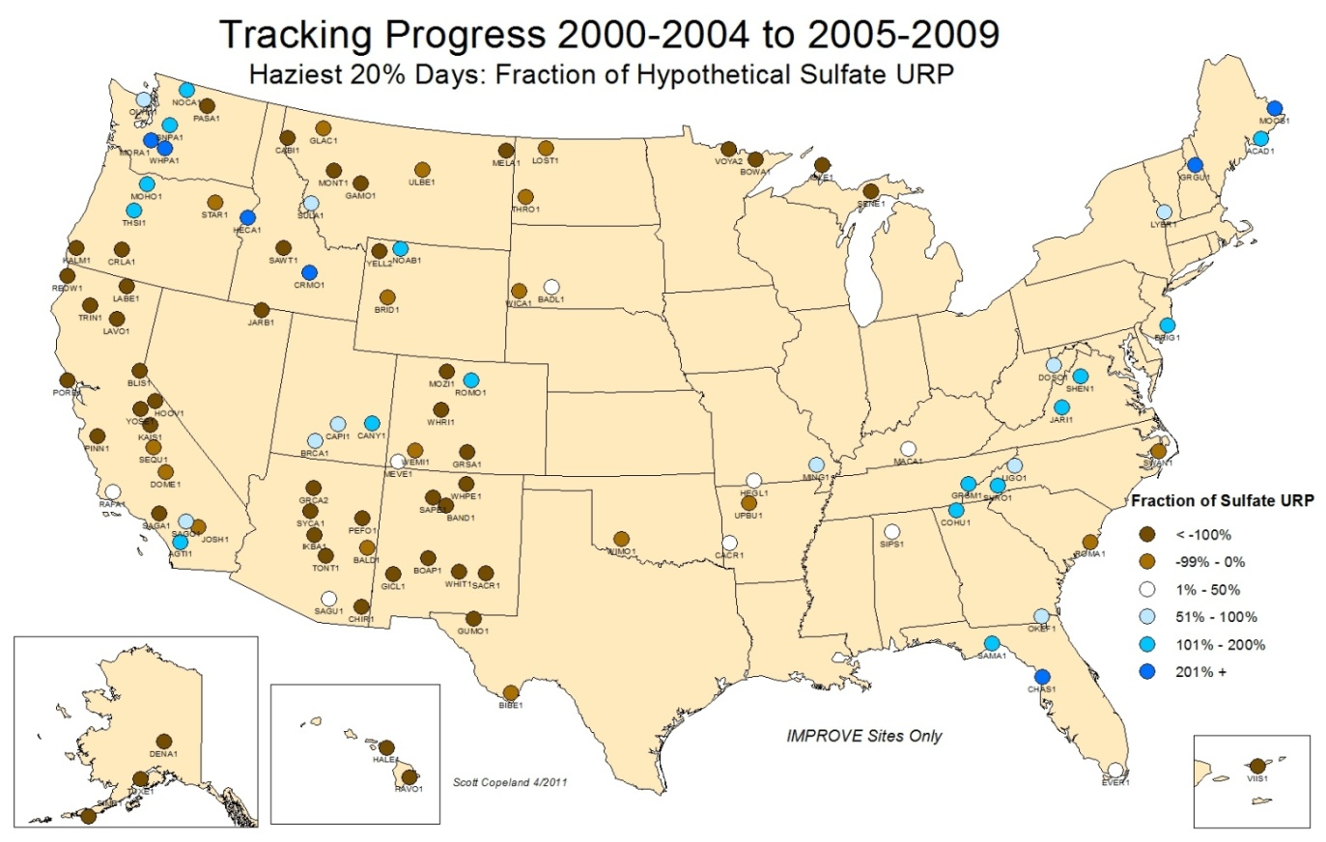
Figure 9.3.5

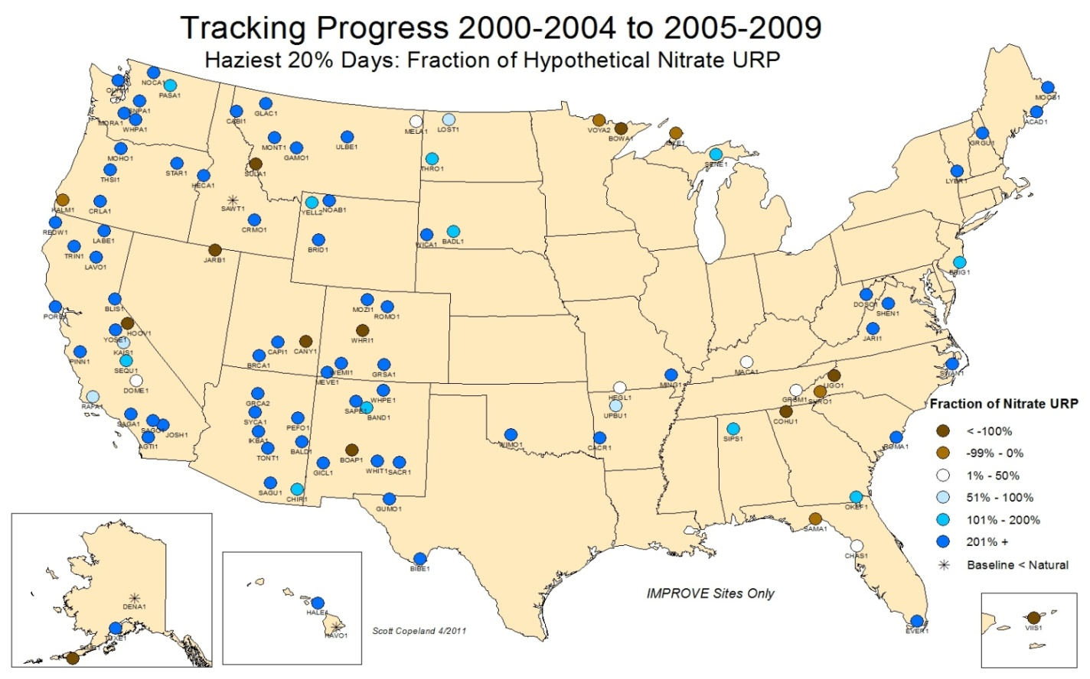
Figure 9.3.6

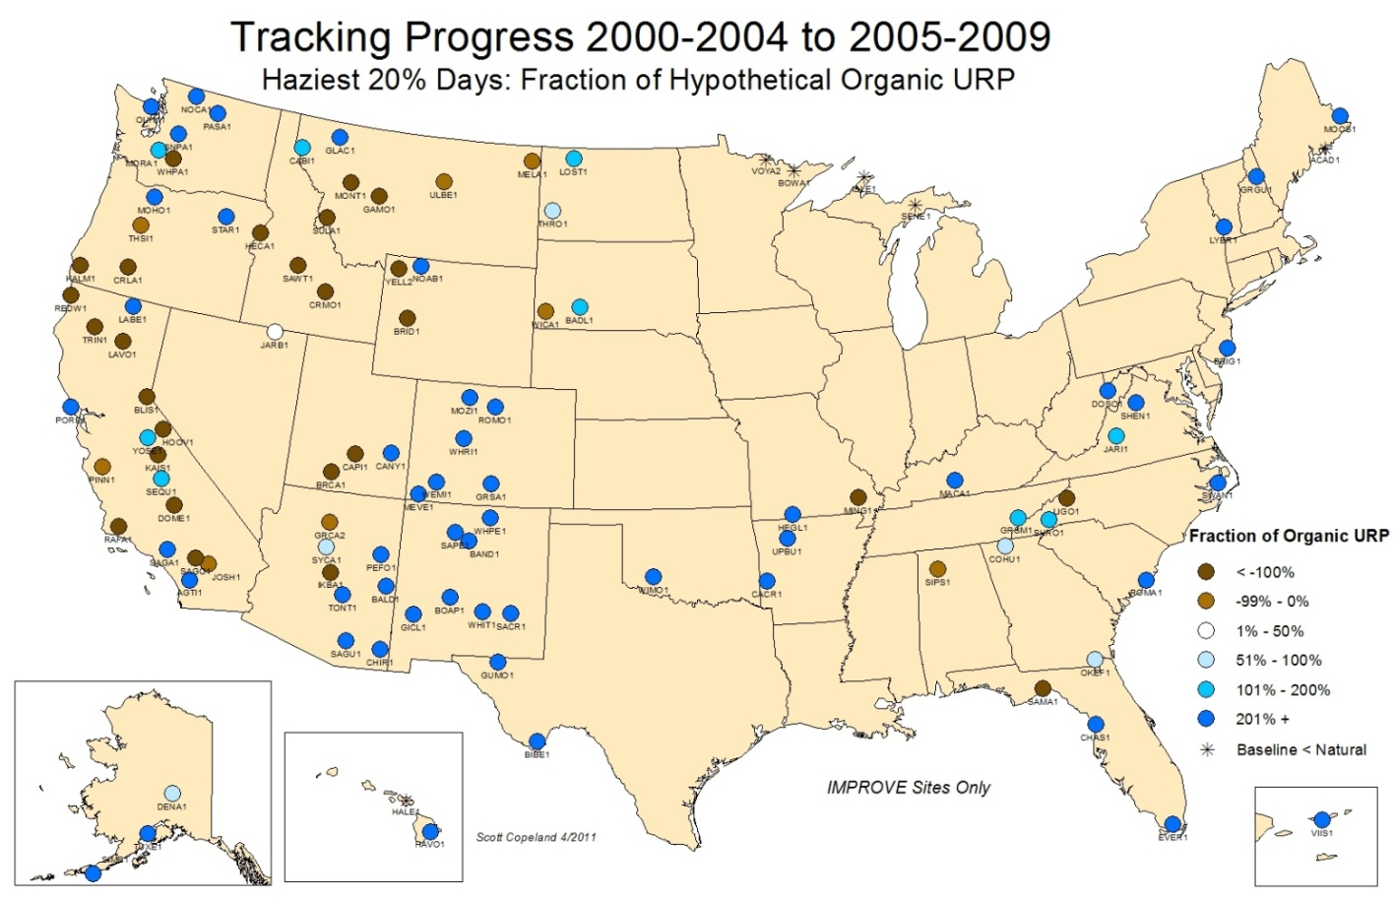
Figure 9.3.7

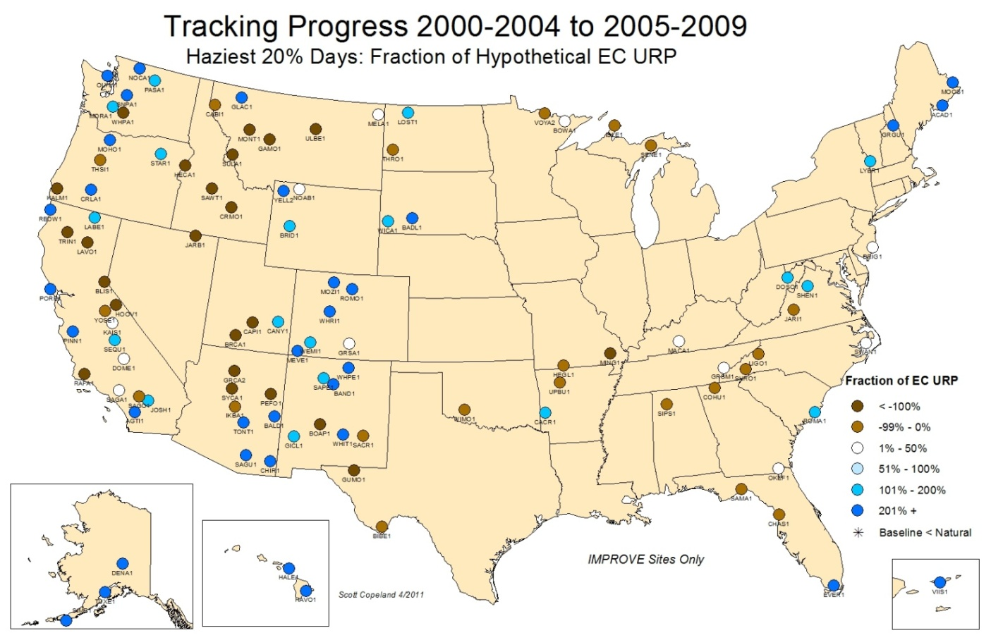
Figure 9.3.8

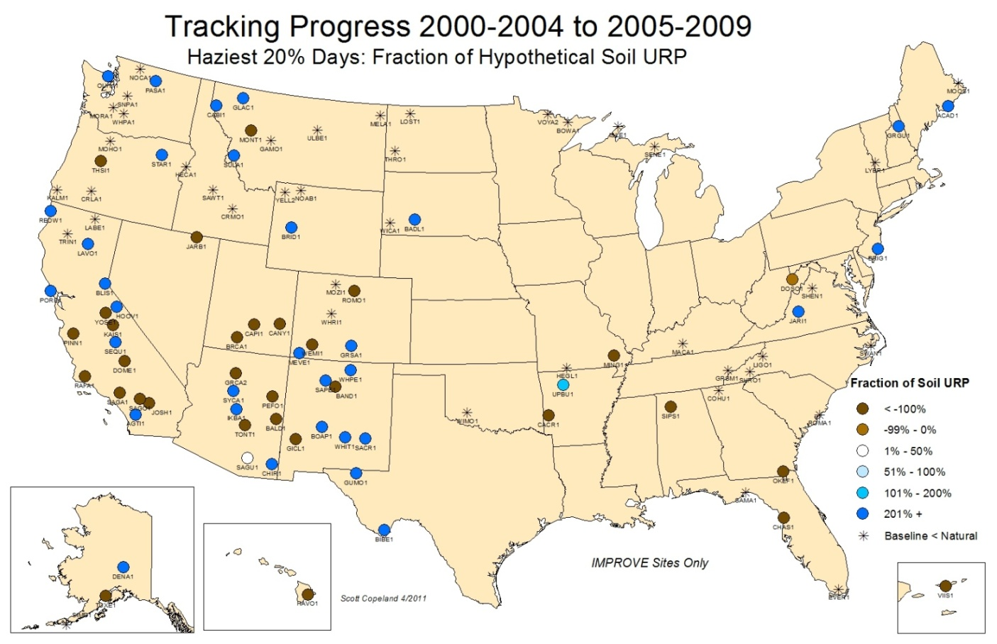
Figure 9.3.9

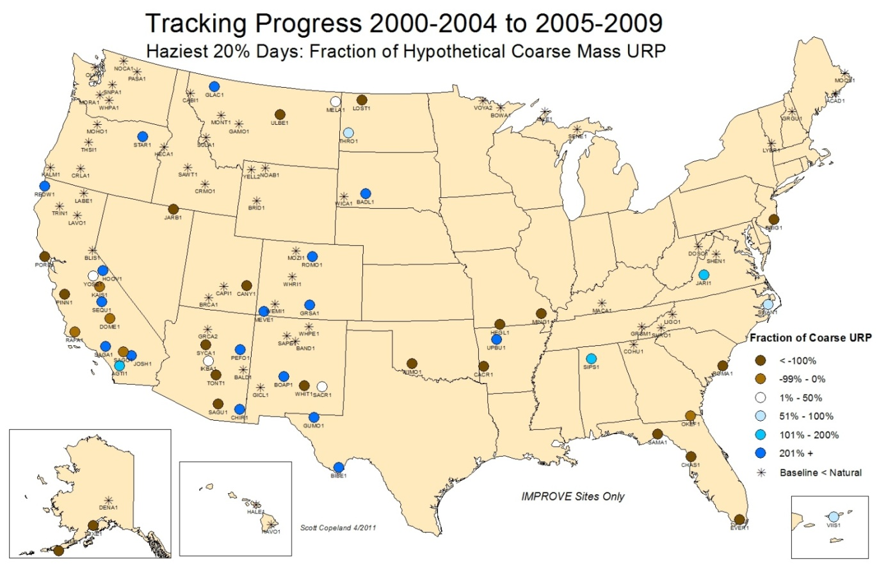
Figure 9.3.10

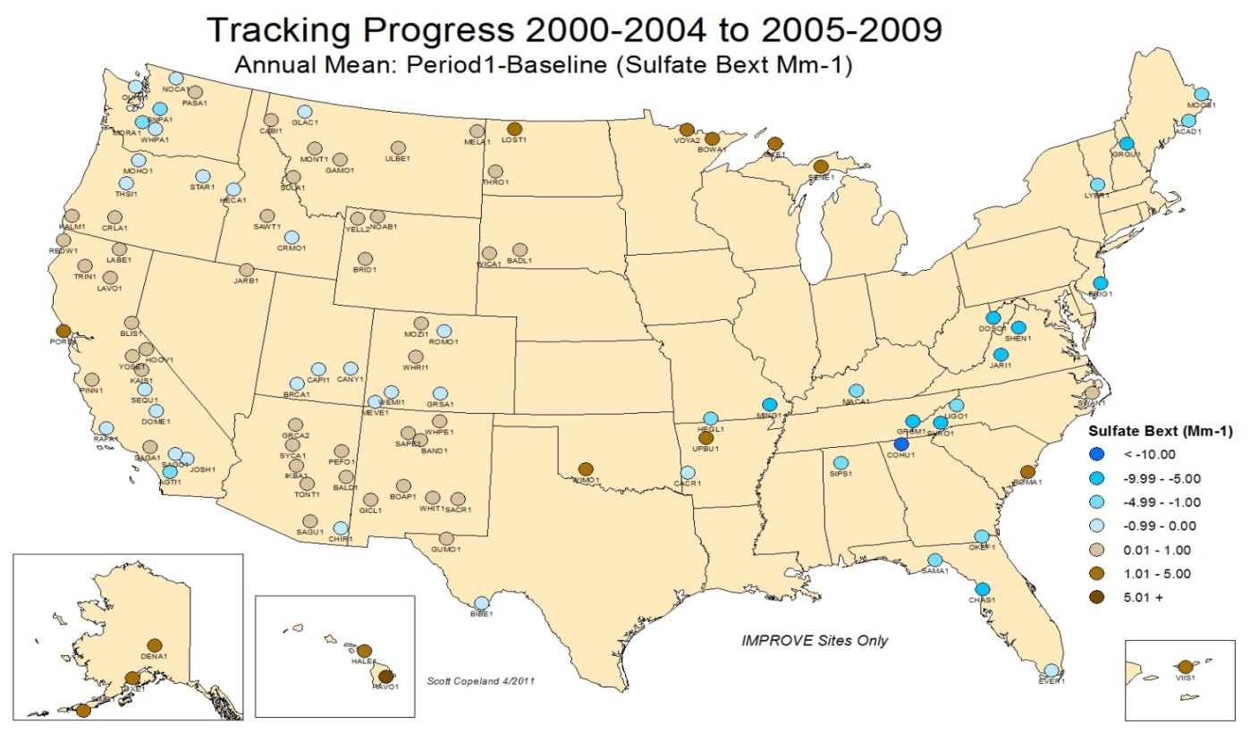
Figure 9.3.25 (or change to reflect moving other figs to appendix)

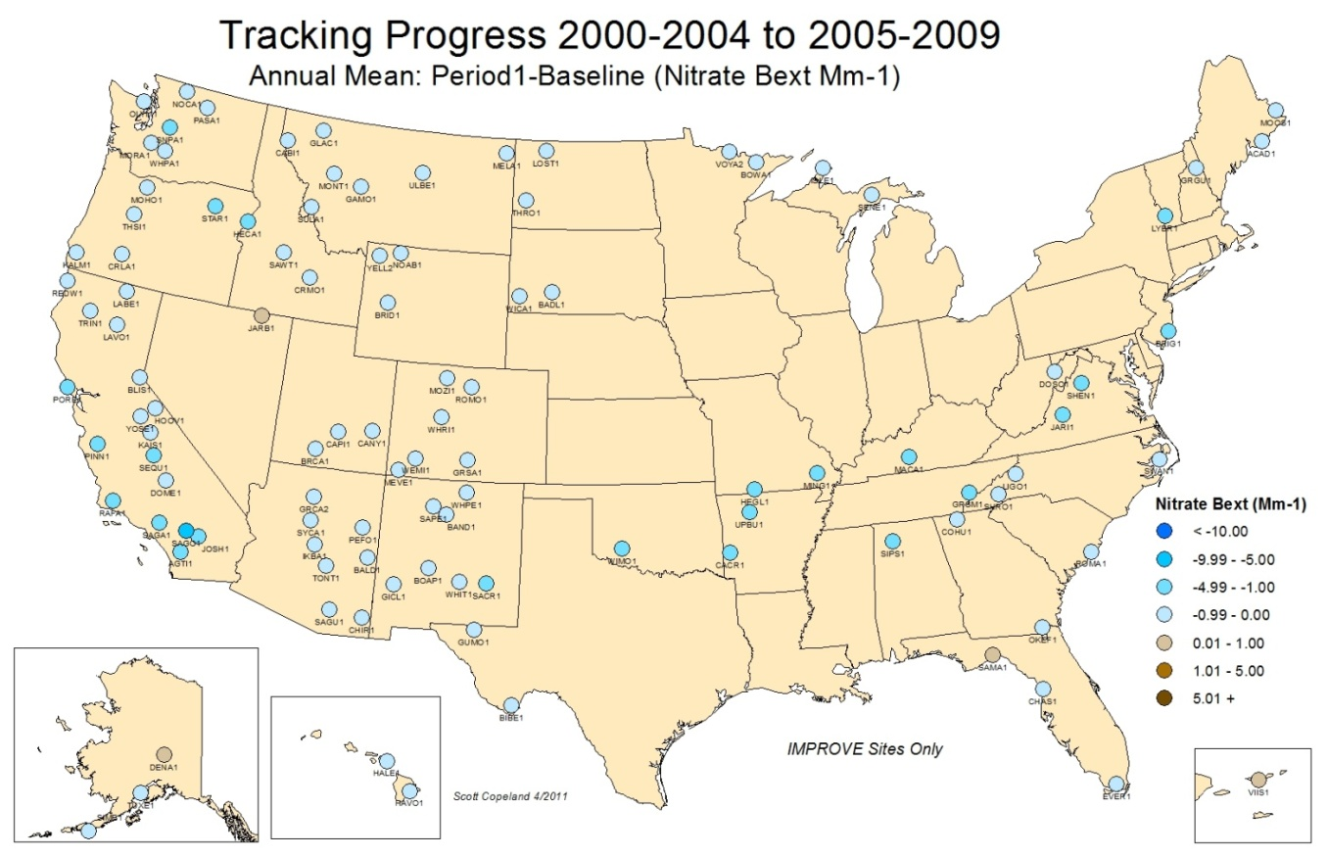

Figure 9.3.26 (or change to reflect moving other figs to appendix)

9.4 Case Studies of Regional Haze Rule Progress

The maps presented in section 9.3 were intended summarize the progress in meeting visibility goals for each site across the U.S. This section provides a more detailed investigation at five IMPROVE RHTS that are representative of the changes observed regionally. For each of the five case studies, daily data for select years from the baseline and period 1 are displayed, and the yearly data for the worst and best 20% visibility days are also presented. In addition, the nominal 2064 default natural conditions visibility targets are shown. Detailed results for all of the 110 RHTS are presented in Appendix G, while detailed composition data for every site can be found on the VIEWS website (http://views.cira.colostate.edu/web/Composition/).

9.4.1 Boundary Waters Canoe Area Wilderness, Minnesota
The Boundary Waters Canoe Area Wilderness (BOWA1) is located on the Canadian border in northern Minnesota. Data from the BOWA1 were largely consistent with the other three nearby Class I areas (Voyageurs NP, VOYA2, Isle Royale NP, ISLE1, and Seney W, SENE1). Light extinction coefficients due to ammonium sulfate increased by roughly 6 Mm⁻¹ (22%) for the worst 20% visibility days (Figure 9.4.1.1a). The increase was due to increase in annual mean sulfate extinction and not by wildfire influences, as particulate organic matter (POM, also referred to as OMC) and light absorbing carbon (LAC, also referred to as EC) contributions remained relatively constant (see bottom panel of Figure 9.4.1.1a). As noted in section 9.3, this is in contrast to most other sites east of 100° longitude. In contrast to the haziest days, the best 20% b_{ext} due to ammonium sulfate and ammonium nitrate decreased at BOWA1 (see Figure 9.4.1.1b). Figure 9.4.1.2a and Figure 9.4.1.2b show the daily derived b_{ext} for each aerosol component from 2001 and 2005, respectively. Note the different vertical axis scales. A number of high summer ammonium sulfate b_{ext} episodes in 2005 could explain the bulk of the increase in the 5 year average worst 20% b_{ext} due to ammonium sulfate. The b_{ext} data from 2006 through 2009 were similar to the b_{ext} during the baseline period at BOWA1, ISLE1, and VOYA2. SENE1 also saw very high ammonium sulfate b_{ext} episodes in 2007; the cause is unknown. Period 1 ammonium nitrate b_{ext} also increased somewhat compared to the baseline, however the annual mean ammonium nitrate b_{ext} was lower at all four northern Class I IMPROVE RHTS.

Figure 9.4.1.1a

Figure 9.4.1.1b
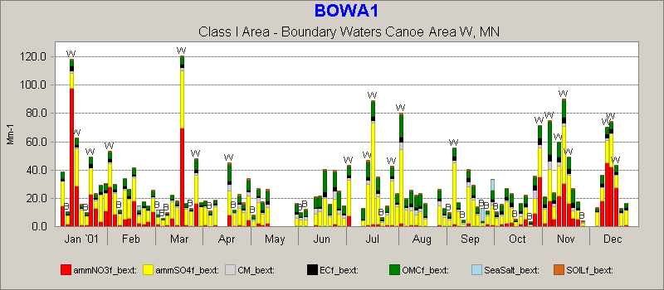
Figure 9.4.1.2a

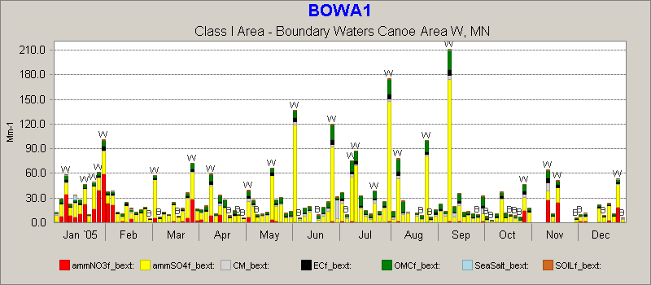
Figure 9.4.1.2b

9.4.2 Great Smoky Mountains National Park, Tennessee/North Carolina

Great Smoky Mountains National Park (GRSM1) straddles the border between Tennessee and North Carolina. Data from GRSM1 were similar to data from other Appalachian region sites and most eastern U.S. sites with respect to significant reductions in the worst 20% b_{ext} due to ammonium sulfate. Data from period 1 show 5 year average decreases of roughly 28 Mm⁻¹ (16%) in the 20% worst ammonium sulfate b_{ext} (Figure 9.4.2.1a). As with haziest days, the best 20% b_{ext} due to ammonium sulfate and ammonium nitrate decreased at GRSM1, although b_{ext} from ammonium nitrate decreased to a much lower degree than that for ammonium sulfate (see Figure 9.4.2.1b). Figure 9.4.2.2a and Figure 9.4.2.2b show the daily derived b_{ext} for each aerosol component from 2001 and 2008, respectively. Note the slightly different vertical axis scales. Light extinction coefficients due to ammonium sulfate are generally lower in 2008 compared to 2001. A likely explanation for the decrease in sulfate b_{ext} is reduced emissions of sulfur dioxide from coal-fired electric generating units across the U.S. by 32% from 2000 to 2008 (U.S. EPA, 2011) as a result of the economic slowdown.
Figure 9.4.2.1a

Figure 9.4.2.1b
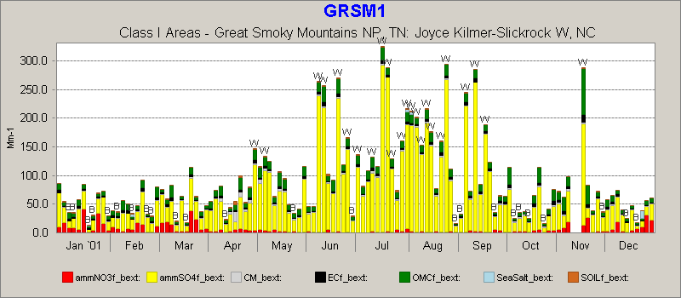
Figure 9.4.2.2a

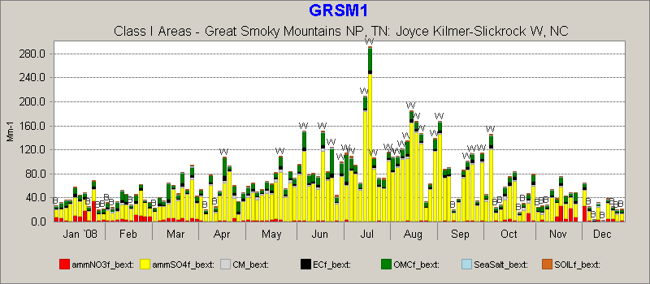
Figure 9.4.2.2b

9.4.3 Mesa Verde National Park, Colorado

Mesa Verde National Park (MEVE1) is located in the Four Corners area of South Western Colorado. Data from MEVE1 is illustrative of one category of Western US IMPROVE site; baseline with relatively high fire activity, followed by period 1 experiencing comparatively little fire activity. As a result, MEVE1 exceeded the URP in dv by a factor of about three, yet most of this change is related to the decreased fire activity. One counterintuitive result at MEVE1 is that during the lower fire activity period 1, contributions to sulfate and nitrate extinction on the 20% haziest days did not increase. An increase would be expected since the fire episodes during the baseline period would tend to have a suppressing effect on haziest extinction from non fire related components. This can in part be attributed to relatively little of the expected seasonality in sulfate and nitrate (Figures 9.4.3.2 a & b).

Class I Area Visibility Summary: Mesa Verde NP, CO Class I area
Visibility Conditions: Worst 20% Days
Model Relative Response Factor Calculation Method: Specific Days (EPA)
Emissions Scenarios for Projected 2018 Emissions & Visibility Changes: WRAP 2000-04 Baseline (plan02d) & 2018 PRPb (prp18b)
 |  | Monitored |  | Estimated |  | Projected
 |  | 2000-04  Baseline  Conditions  (Mm-1) | 2005-09  1st Progress  Period Conditions (Mm-1) | 2064  Natural  Conditions  (Mm-1) | 2018  Uniform Rate  of Progress Target  (Mm-1)¹ | 2018  Projected Visibility Conditions  (Mm-1) | Baseline to 2018  Change in Statewide Emissions  (tons / %) | Baseline to 2018  Change in Upwind Weighted Emissions²  (%) | Baseline to 2018  Change in Anthropogenic  Upwind Weighted  Emissions²  (%)
Sulfate |  | 6.46 |  | 0.73 | 4.90 | 5.09 | -58,907  -51% | -30% | -30%
Nitrate |  | 2.3 |  | 0.83 | 1.94 | 2.18 | -123,497  -30% | -27% | -28%
Organic Carbon |  | 12.28 |  | 4.19 | 10.06 | 12.13 | -439  -1% | 0% | -1%
Elemental Carbon |  | 2.37 |  | 0.36 | 1.87 | 1.84 | -2,833  -23% | -20% | -40%
Fine Soil |  | 2.51 |  | 1.16 | 2.18 | 2.76 | -1,232  -6% | 7% | 10%
Coarse Material³ |  | 6.52 |  | 4.3 | 5.97 | Not Applicable | 9,024  9% | 7% | 12%
Sea Salt³ |  | 0.04 |  | 0.04 | 0.04 | Not Applicable | Not Applicable
Total Light Extinction |  | 41.48 |  | 20.63 | 35.29 | 39.57
Deciview |  | 13.03 |  | 6.81 | 11.58 | 12.5

Class I Area Visibility Summary: Mesa Verde NP, CO Class I area
Visibility Conditions: Best 20% Days
Model Relative Response Factor Calculation Method: Specific Days (EPA)
Emissions Scenarios for Projected 2018 Emissions & Visibility Changes: WRAP 2000-04 Baseline (plan02d) & 2018 PRPb (prp18b)
 | Monitored |  | Estimated |  | Projected
 | 2000-04  Baseline  Conditions  (Mm-1) | 2005-09  1st Progress  Period  Conditions  (Mm-1) | 2064  Natural  Conditions  (Mm-1) | 2018  Uniform Rate  of Progress Target  (Mm-1)¹ | 2018  Projected Visibility  Conditions  (Mm-1) | Baseline to 2018  Change in Statewide  Emissions  (tons / %) | Baseline to 2018  Change in Upwind Weighted Emissions²  (%) | Baseline to 2018  Change in Anthropogenic  Upwind Weighted  Emissions²  (%)
Sulfate | 2.37 |  | 0.36 | Not Applicable | 2.13 | -58,907  -51% | -30% | -30%
Nitrate | 0.84 |  | 0.36 | Not Applicable | 0.84 | -123,497  -30% | -30% | -31%
Organic Carbon | 1.49 |  | 0.68 | Not Applicable | 1.5 | -439  -1% | -1% | -3%
Elemental Carbon | 0.6 |  | 0.11 | Not Applicable | 0.44 | -2,833  -23% | -19% | -41%
Fine Soil | 0.4 |  | 0.17 | Not Applicable | 0.45 | -1,232  -6% | 8% | 11%
Coarse Material³ | 0.74 |  | 0.4 | Not Applicable | Not Applicable | 9,024  9% | 8% | 15%
Sea Salt³ | 0.01 |  | 0 | Not Applicable | Not Applicable | Not Applicable
Total Light Extinction | 15.46 |  | 11.08 | Not Applicable | 15.13
Deciview | 4.32 |  | 1.01 | Not Applicable | 4.1
1) 2018 Uniform Rate of Progress Target for Best 20% Days is not defined. WRAP TSS - 4/21/2011
2) Results based on Weighted Emissions Potential analysis using the 2000-04 Baseline (plan02d) & 2018 PRPb (prp18b) emissions scenarios.
3) Visibility projections not available due to model performance issues.

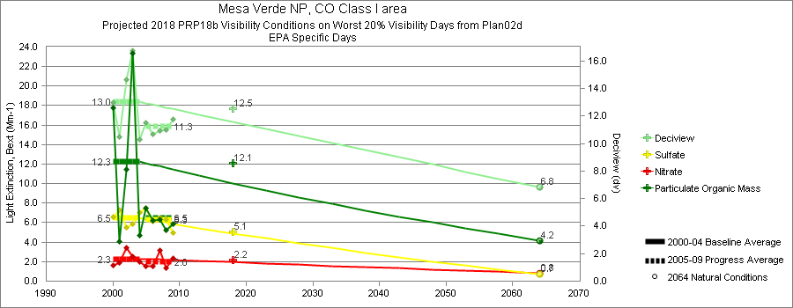

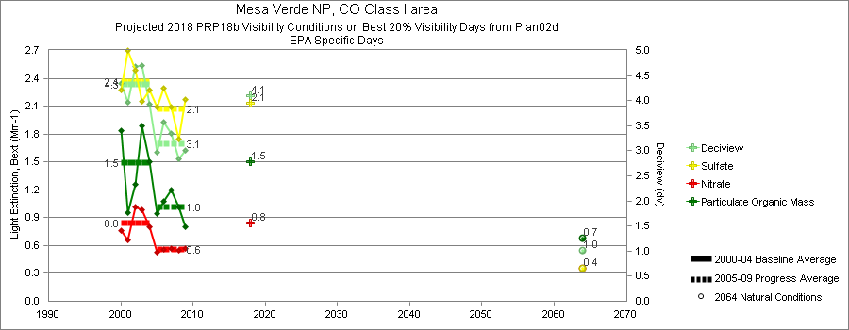
No Figure #s on previous 4 graphics – this is Scott’s numbering: Figures 9.4.3.2 a & b

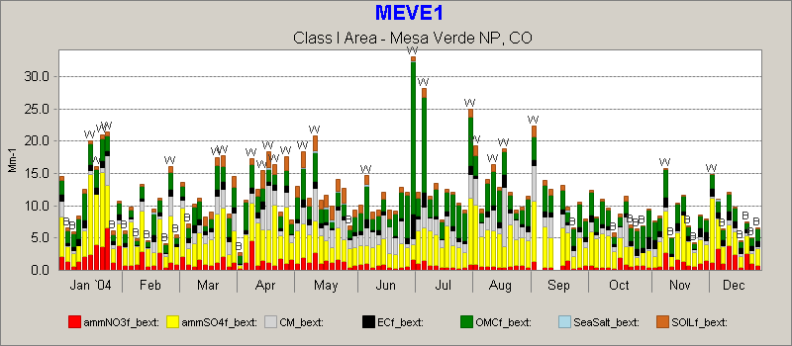

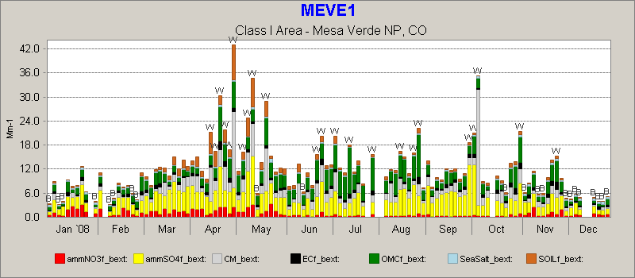

9.4.4 Hell’s Canyon Wilderness, Oregon/Idaho
(this analysis is good, but numbering of cited graphs has not been aligned with graphics) Hells Canyon Wilderness is on both sides of the Snake River Canyon along the border of Oregon and Idaho. Data from HECA1 has the opposite pattern (Figures 9.4.1.1 a & b) to that seen at MEVE1; low fire activity in the baseline period followed by a period 1 with high fire activity. HECA1 exhibits the expected behavior where haziest 20% day sulfate and nitrate extinctions are reduced during the high fire activity period. Figures 9.4.4.2 a & b clearly show the change in seasonality of the worst days from winter, summer and fall of 2004 to mostly summer in 2006 (note the significantly different scales). HECA1 however also experienced a measured reduction in annual mean nitrate extinction, which can be seen for example by comparing the first quarter of 2006 compared to the first quarter of 2004. This measured reduction in nitrate extinction coupled with a reduction in sulfate extinction actually more than offset the increased fire related haziest day extinction, resulting in a net 0.5 dv improvement in haze. This is slightly less improvement than the URP for dv, but presumably without the increased fire activity would have been much greater than URP. The reason for the significant reductions in first quarter nitrate extinction is unknown.
Class I Area Visibility Summary: Hells Canyon W, ID Class I area
Visibility Conditions: Worst 20% Days
Model Relative Response Factor Calculation Method: Specific Days (EPA)
Emissions Scenarios for Projected 2018 Emissions & Visibility Changes: WRAP 2000-04 Baseline (plan02d_rev) & 2018 PRPb (prp18b)
 | Monitored |  | Estimated |  | Projected
 | 2000-04  Baseline Conditions  (Mm-1) | 2005-09  1st Progress  Period Conditions  (Mm-1) | 2064  Natural  Conditions  (Mm-1) | 2018  Uniform Rate  of Progress  Target  (Mm-1)¹ | 2018  Projected Visibility Conditions  (Mm-1) | Baseline to 2018 Change In Statewide Emissions  (tons / %) | Baseline to 2018  Change in Upwind Weighted Emissions²  (%) | Baseline to 2018  Change in Anthropogenic  Upwind Weighted  Emissions²  (%)
Sulfate | 8.37 |  | 1.14 | 6.35 | 7.89 | -20,912  -40% | -29% | -38%
Nitrate | 28.47 |  | 2.67 | 19.69 | 20.34 | -96,079  -37% | -22% | -30%
Organic Carbon | 15.6 |  | 3.69 | 12.12 | 14.01 | -3,120  -3% | -12% | -31%
Elemental Carbon | 3.06 |  | 0.37 | 2.37 | 2.18 | -3,043  -11% | -21% | -44%
Fine Soil | 0.66 |  | 0.92 | 0.72 | 0.73 | -909  -3% | 10% | 15%
Coarse Material³ | 1.93 |  | 3.4 | 2.26 | Not Applicable | 31,039  47% | 12% | 27%
Sea Salt³ | 0.05 |  | 0.05 | 0.05 | Not Applicable | Not Applicable
Total Light Extinction | 69.14 |  | 23.24 | 53.48 | 58.13
Deciview | 18.55 |  | 8.32 | 16.17 | 16.99

Class I Area Visibility Summary: Hells Canyon W, ID Class I area
Visibility Conditions: Best 20% Days
Model Relative Response Factor Calculation Method: Specific Days (EPA)
Emissions Scenarios for Projected 2018 Emissions & Visibility Changes: WRAP 2000-04 Baseline (plan02d_rev) & 2018 PRPb (prp18b)
 |  | Monitored |  | Estimated |  | Projected
 |  | 2000-04  Baseline  Conditions  (Mm-1) | 2005-09  1st Progress  Period  Conditions  (Mm-1) | 2064  Natural  Conditions  (Mm-1) | 2018  Uniform Rate  of Progress Target  (Mm-1)¹ | 2018  Projected Visibility  Conditions  (Mm-1) | Baseline to 2018  Change in Statewide  Emissions  (tons / %) | Baseline to 2018  Change in Upwind Weighted Emissions²  (%) | Baseline to 2018  Change in Anthropogenic  Upwind Weighted  Emissions²  (%)
Sulfate |  | 1.93 |  | 0.38 | Not Applicable | 1.65 | -20,912  -40% | -36% | -42%
Nitrate |  | 0.78 |  | 0.17 | Not Applicable | 0.55 | -96,079  -37% | -28% | -35%
Organic Carbon |  | 2.01 |  | 0.54 | Not Applicable | 1.86 | -3,120  -3% | -12% | -25%
Elemental Carbon |  | 0.58 |  | 0.08 | Not Applicable | 0.43 | -3,043  -11% | -23% | -41%
Fine Soil |  | 0.25 |  | 0.14 | Not Applicable | 0.24 | -909  -3% | 3% | 4%
Coarse Material³ |  | 0.8 |  | 0.48 | Not Applicable | Not Applicable | 31,039  47% | 10% | 25%
Sea Salt³ |  | 0.08 |  | 0.07 | Not Applicable | Not Applicable | Not Applicable
Total Light Extinction |  | 17.45 |  | 12.87 | Not Applicable | 16.62
Deciview |  | 5.52 |  | 2.52 | Not Applicable | 5.04
1) 2018 Uniform Rate of Progress Target for Best 20% Days is not defined.
2) Results based on Weighted Emissions Potential analysis using the 2000-04 Baseline (plan02d_rev) & 2018 PRPb (prp18b) emissions scenarios.
3) Visibility projections not available due to model performance issues.
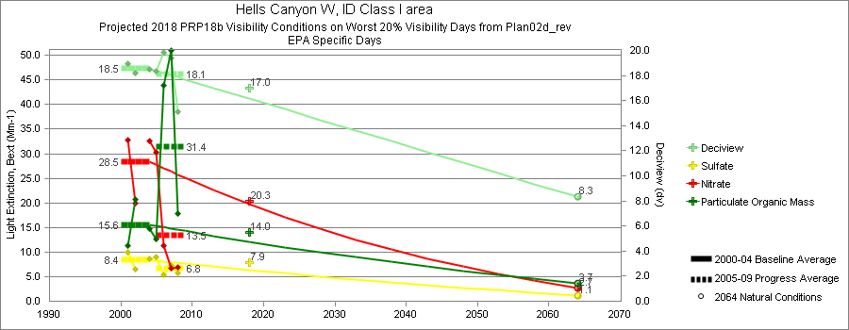

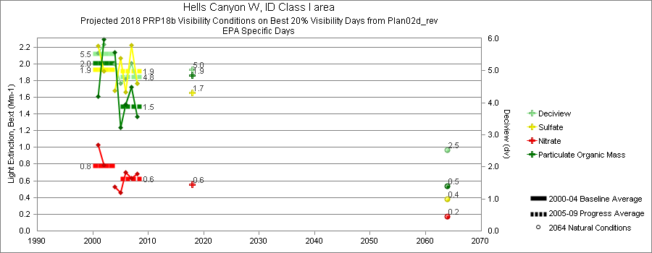

No Figure #s on previous 4 graphics – this is Scott’s numbering: Figures 9.4.4.2 a & b
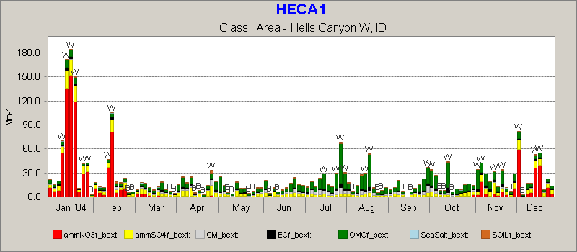

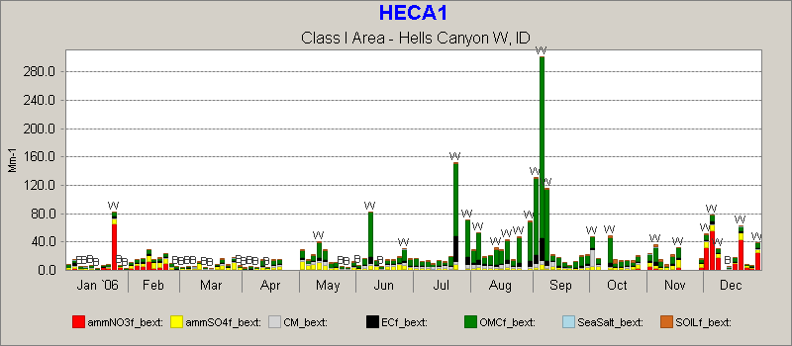

9.4.5 Agua Tibia Wilderness, California
(this analysis is good, but numbering of cited graphs has not been aligned with graphics) Agua Tibia Wilderness is southeast of Los Angeles, and is one of 7 Class I areas in southern California. Data from AGTI1 represent an apparent success story as virtually all haze components show improvement beyond the URP in period 1. AGTI1 is generally representative of data from the other Southern California IMPROVE sites, and does not appear to have been significantly affected by fire related activity.
Class I Area Visibility Summary: Agua Tibia W, CA Class I area
Visibility Conditions: Worst 20% Days
Model Relative Response Factor Calculation Method: Specific Days (EPA)
Emissions Scenarios for Projected 2018 Emissions & Visibility Changes: WRAP 2000-04 Baseline (plan02d) & 2018 PRPb (prp18b)
 |  | Monitored |  | Estimated |  | Projected
 |  | 2000-04  Baseline  Conditions  (Mm-1) | 2005-09  1st Progress  Period  Conditions  (Mm-1) | 2064  Natural  Conditions  (Mm-1) | 2018  Uniform Rate  of Progress Target  (Mm-1)¹ | 2018  Projected Visibility  Conditions  (Mm-1) | Baseline to 2018  Change in Statewide  Emissions  (tons / %) | Baseline to 2018  Change in Upwind Weighted Emissions²  (%) |  | Baseline to 2018  Change in Anthropogenic  Upwind Weighted  Emissions²  (%)
Sulfate |  | 31.82 |  | 0.99 | 20.62 | 24.64 | -6,243  -8% | -26% |  | -30%
Nitrate |  | 29.91 |  | 0.94 | 19.50 | 11.98 | -591,119  -45% | -49% |  | -51%
Organic Carbon |  | 17.55 |  | 2.98 | 13.11 | 16.22 | -10,792  -7% | -5% |  | -14%
Elemental Carbon |  | 6.37 |  | 0.26 | 4.68 | 3.57 | -12,961  -28% | -28% |  | -49%
Fine Soil |  | 1.25 |  | 0.83 | 1.15 | 1.28 | 250  0% | 3% |  | 3%
Coarse Material³ |  | 8.64 |  | 2.98 | 7.13 | Not Applicable | 29,666  13% | 13% |  | 16%
Sea Salt³ |  | 0.82 |  | 1.68 | 1.01 | Not Applicable | Not Applicable
Total Light Extinction |  | 107.36 |  | 21.66 | 73.56 | 78.15
Deciview |  | 23.5 |  | 7.64 | 19.80 | 20.3

Class I Area Visibility Summary: Agua Tibia W, CA Class I area
Visibility Conditions: Best 20% Days
Model Relative Response Factor Calculation Method: Specific Days (EPA)
Emissions Scenarios for Projected 2018 Emissions & Visibility Changes: WRAP 2000-04 Baseline (plan02d) & 2018 PRPb (prp18b)
 |  | Monitored |  | Estimated |  | Projected
 |  | 2000-04 Baseline Conditions  (Mm-1) | 2005-09 1st Progress Period Conditions  (Mm-1) | 2064 Natural Conditions  (Mm-1) | 2018 Uniform Rate of Progress Target  (Mm-1)¹ | 2018 Projected Visibility Conditions  (Mm-1) | Baseline to 2018 Change In Statewide Emissions  (tons / %) | Baseline to 2018 Change In Upwind Weighted Emissions²  (%) | Baseline to 2018 Change In Anthropogenic Upwind Weighted Emissions²  (%)
Sulfate |  | 3.9 |  | 0.17 | Not Applicable | 3.3 | -6,243  -8% | -32% | -36%
Nitrate |  | 3.27 |  | 0.22 | Not Applicable | 1.57 | -591,119  -45% | -48% | -50%
Organic Carbon |  | 2.99 |  | 0.74 | Not Applicable | 2.95 | -10,792  -7% | -4% | -12%
Elemental Carbon |  | 1.87 |  | 0.11 | Not Applicable | 1.01 | -12,961  -28% | -27% | -48%
Fine Soil |  | 0.47 |  | 0.26 | Not Applicable | 0.5 | 250  0% | 4% | 5%
Coarse Material³ |  | 2.41 |  | 0.72 | Not Applicable | Not Applicable | 29,666  13% | 14% | 17%
Sea Salt³ |  | 0.79 |  | 0.2 | Not Applicable | Not Applicable | Not Applicable
Total Light Extinction |  | 26.70 |  | 13.42 | Not Applicable | 23.51
Deciview |  | 9.58 |  | 2.92 | Not Applicable | 8.37
1) 2018 Uniform Rate of Progress Target for Best 20% Days is not defined.
2) Results based on Weighted Emissions Potential analysis using the 2000-04 Baseline (plan02d) & 2018 PRPb (prp18b) emissions scenarios.
3) Visibility projections not available due to model performance issues.
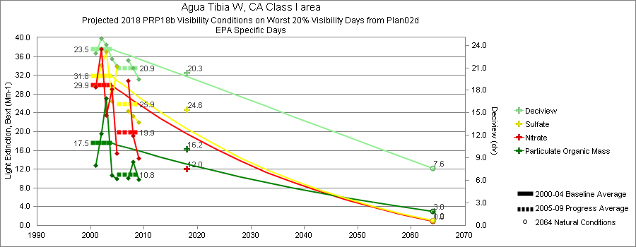

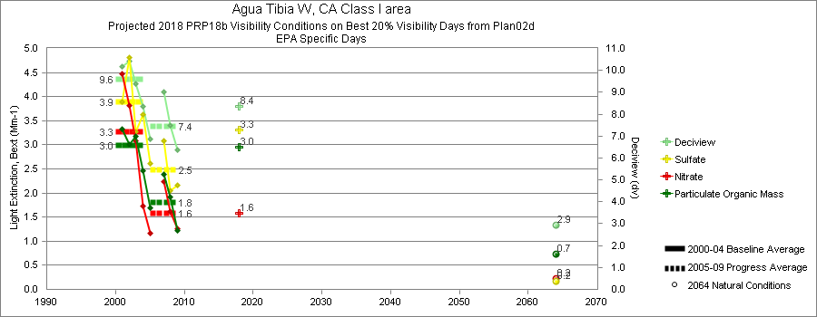

No Figure #s on previous 4 graphics – this is Scott’s numbering: Figures 9.4.5.2 a & b
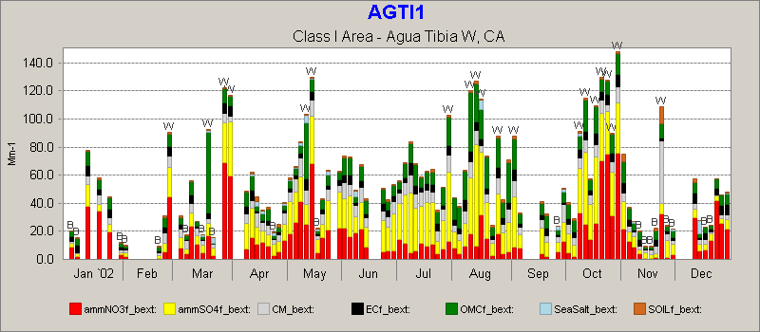

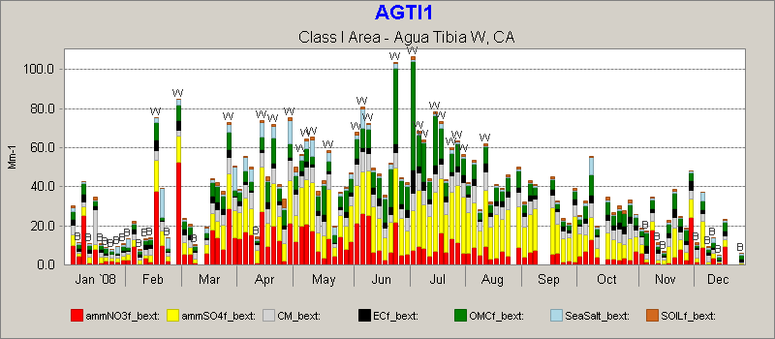

  - Tracking and Reporting of Progress toward upcoming RHR Planning Milestones

    - Activities for 2013 mid-course check-in on emissions control implementation

    - 2018 full RHR planning update to set 2028 visibility improvement goals

References
U.S. EPA (1999), Regional Haze Regulations; Final Rule, 40 CFR 51, Federal Register, 64, 35714-35774.
U.S. EPA (2003), Guidance for tracking progress under the Regional Haze Rule, EPA-454/B-03-004, Contract No. 68-D-02-0261, Work Order No. 1-06.
U.S. EPA (2011), Acid Rain Program Emissions, Emission Rates, and Heat Input Changes at National Levels (All Units), http://www.epa.gov/airmarkets/images/ARP1990to2010.pdf

Appendix of Extra Maps
Species Bext Change Annual Mean for Organic, EC, Fine Soil, Coarse Material, and Sea Salt (next 5 maps)
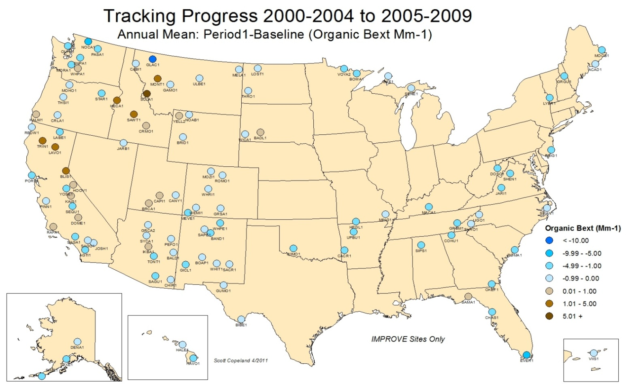
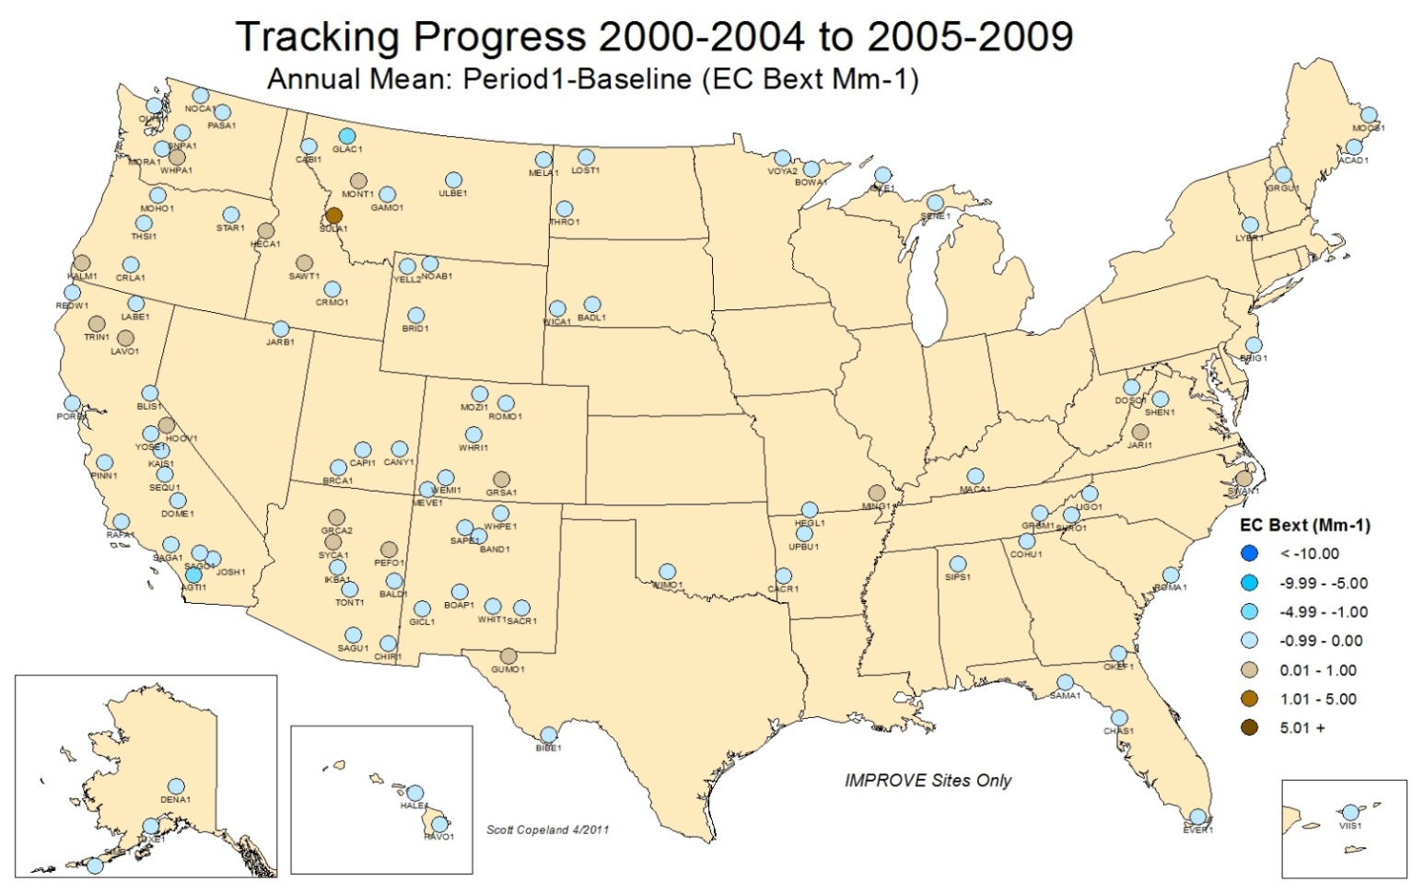

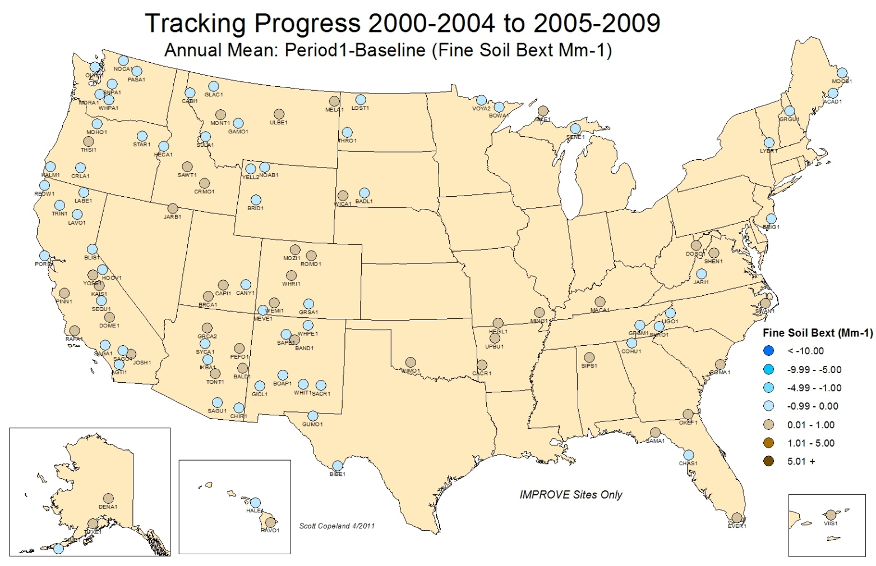
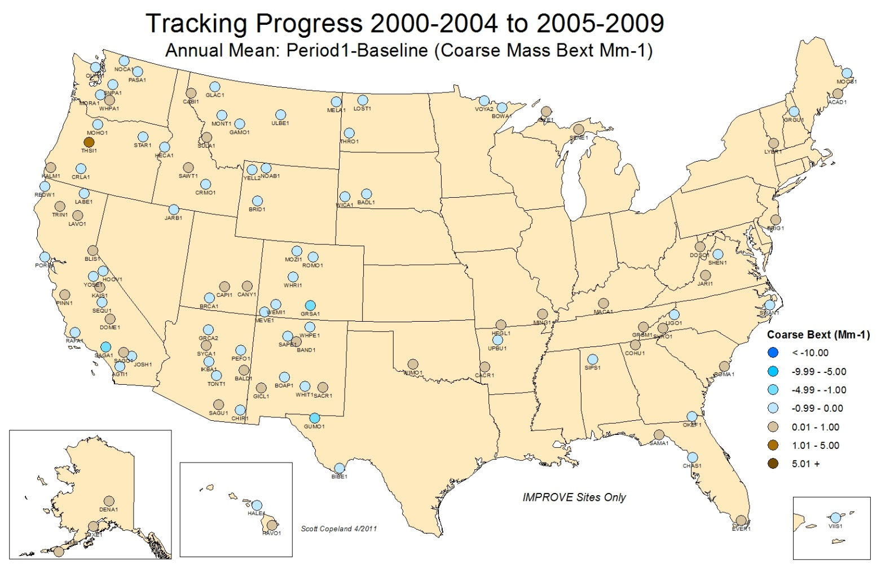

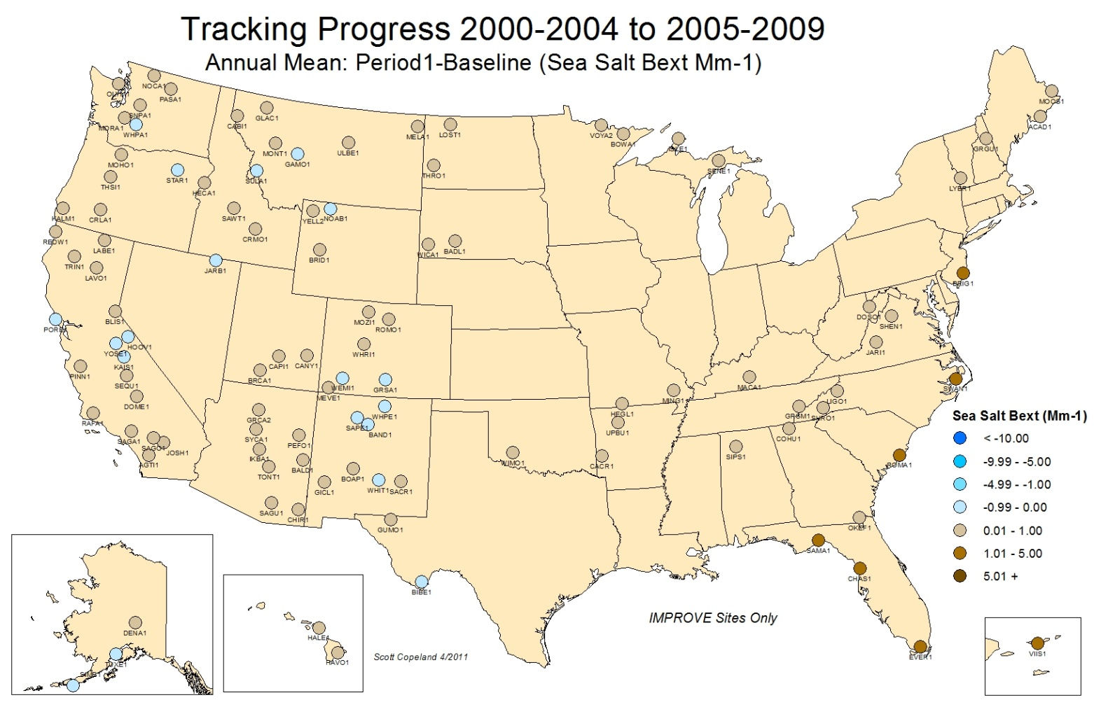
Figures 9.3.11-9.3.17 Species Bext Change Haziest 20% Days (next 7 maps)
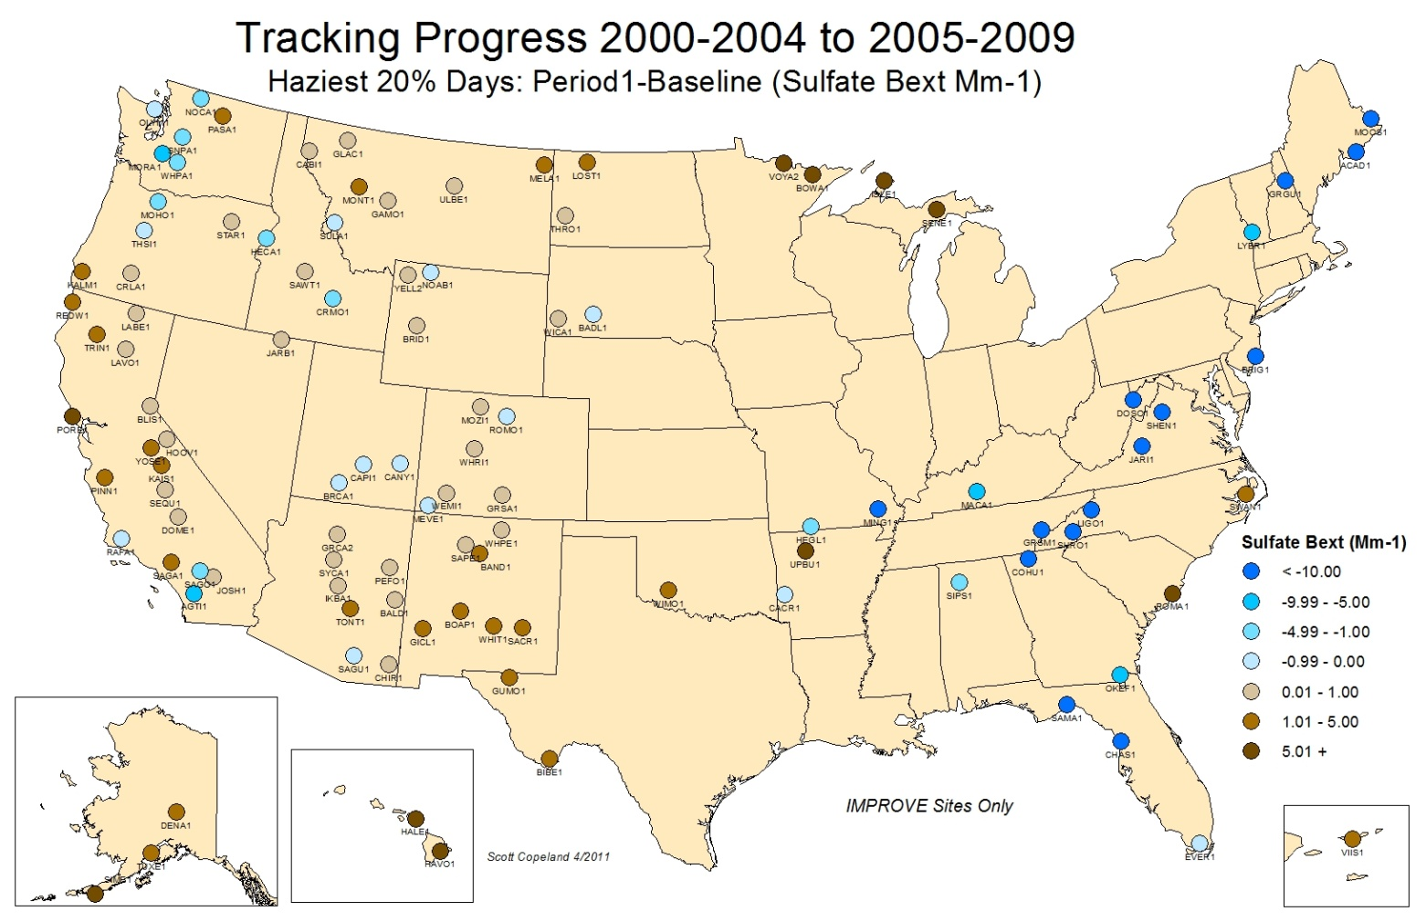

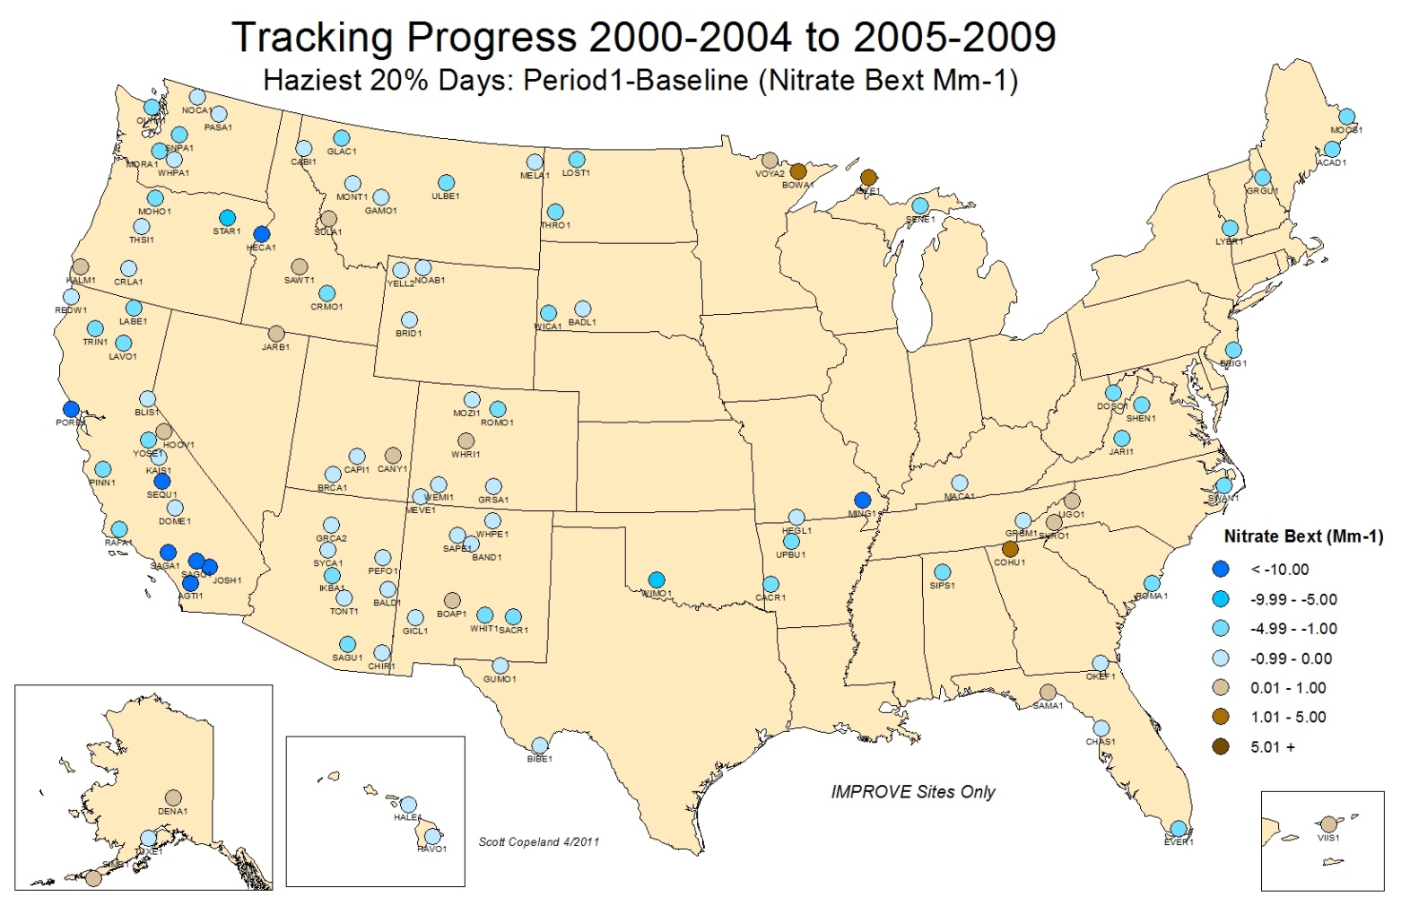

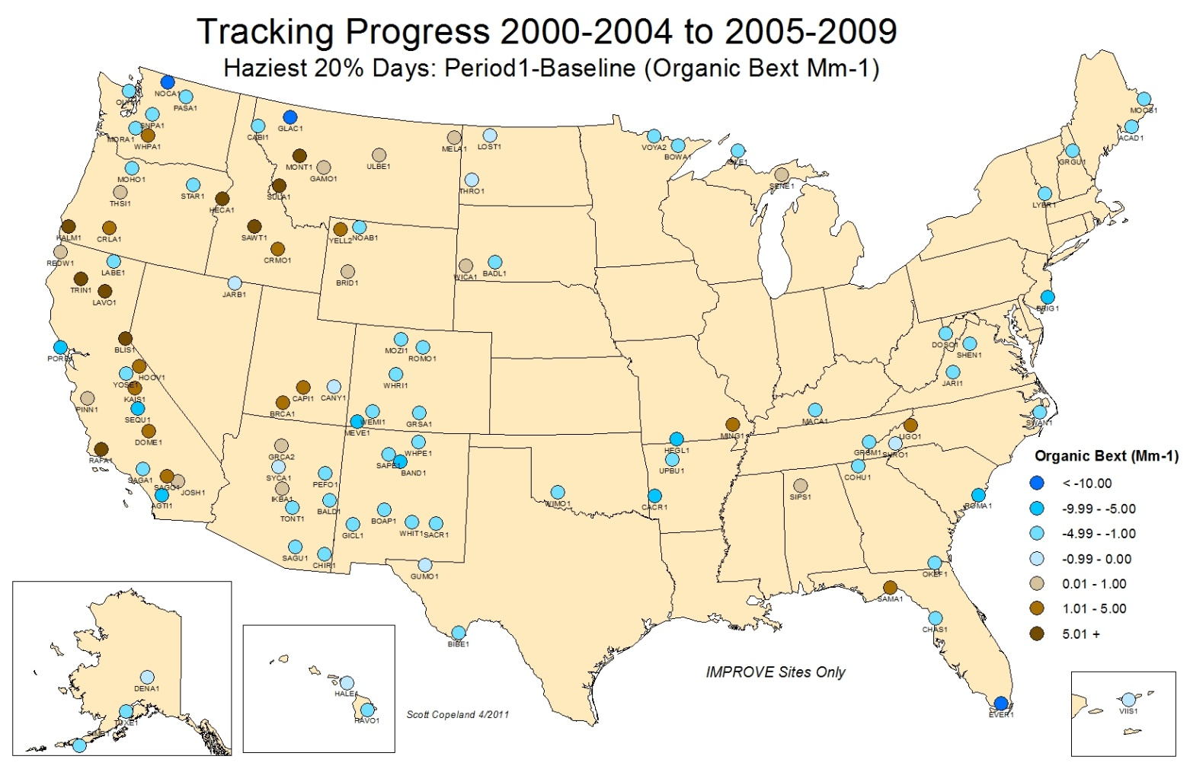

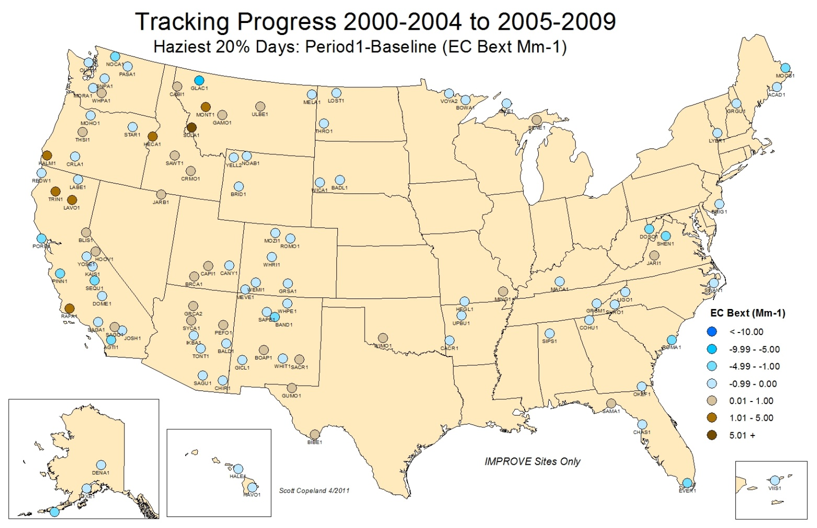

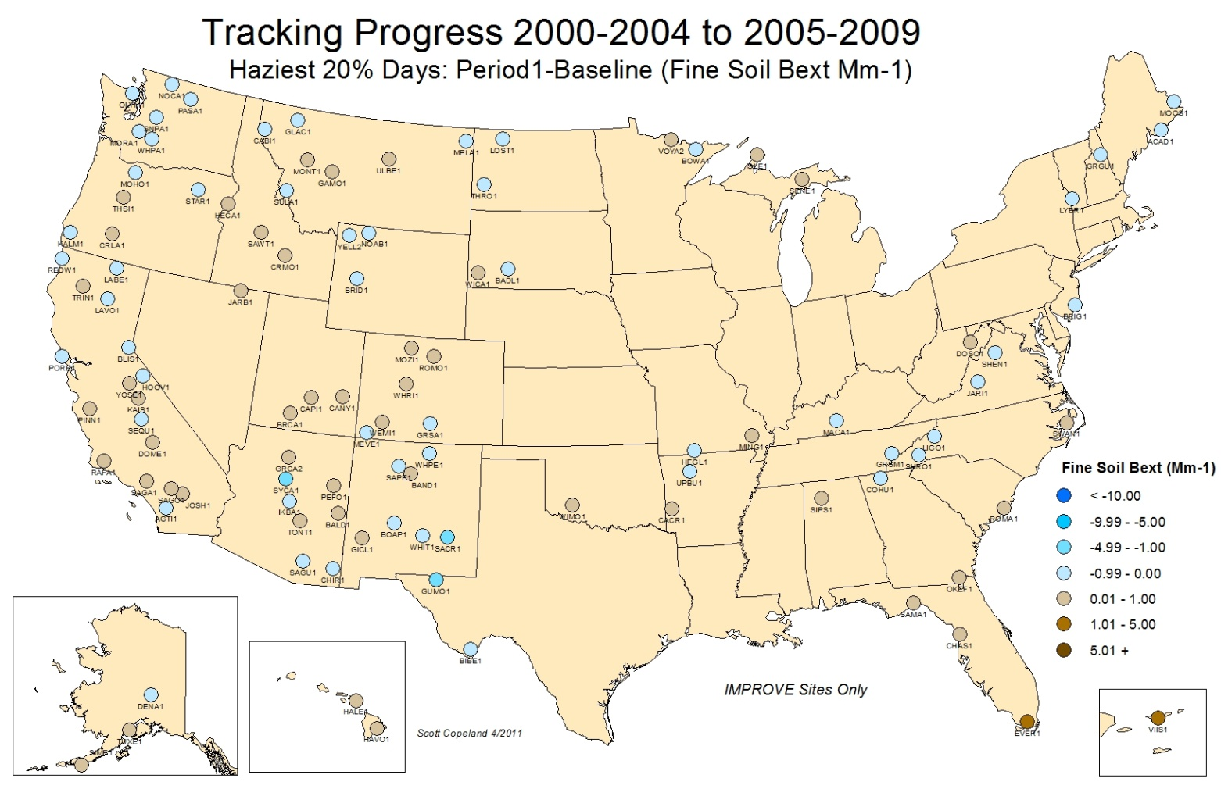

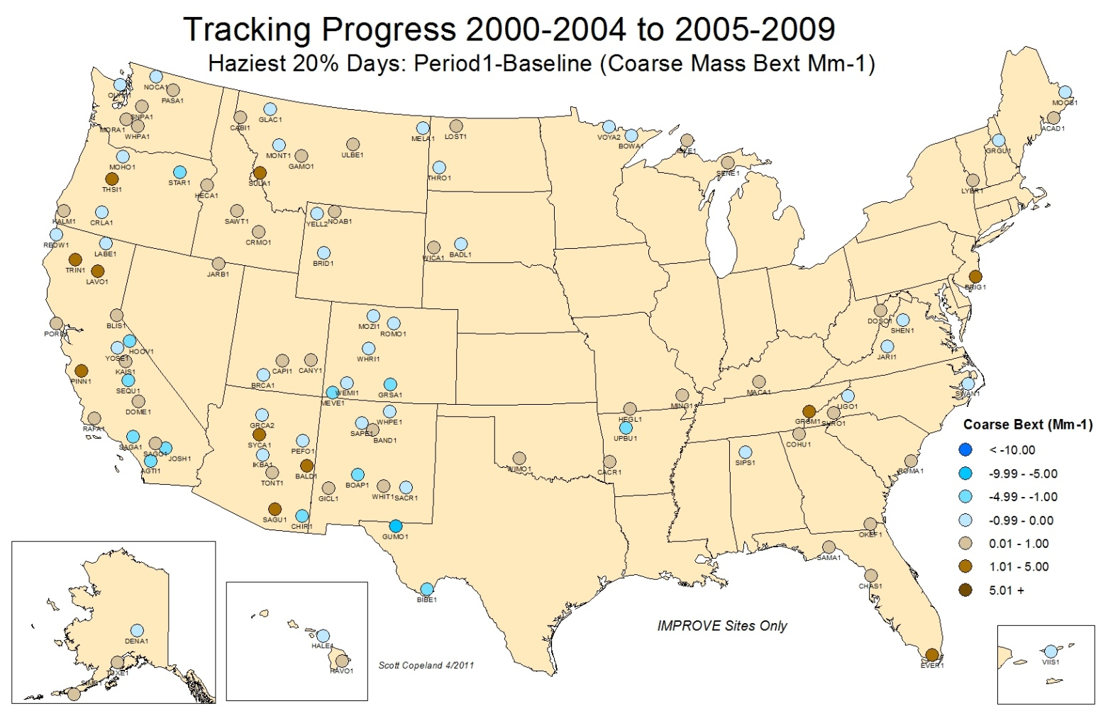

Figures 9.3.18-9.3.24 -Species Bext Change Clearest 20% Days (next 7 maps)

