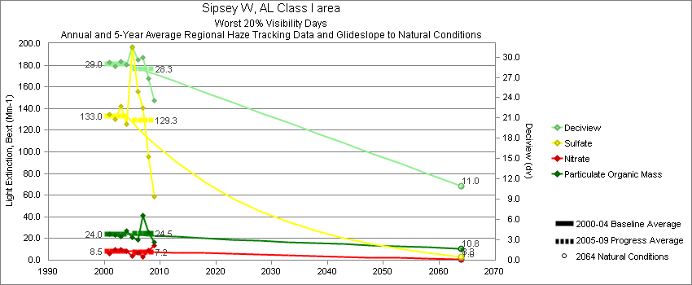
Sipsey - Worst 20% Visibility Days – 5-Year Average, Natural Conditions and Annual Data
Parameter | 2000-2004 | 2005-2009 | 2064 NC | 2000 | 2001 | 2002 | 2003 | 2004 | 2005 | 2006 | 2007 | 2008 | 2009
Deciview (dv) | 29.0 | 28.3 | 11.0 |  | 29.2 | 28.7 | 29.4 | 28.8 | 31.5 | 29.7 | 30.0 | 26.8 | 23.6
Sulfate Bext | 133.0 | 129.3 | 3.3 |  | 134.5 | 130.0 | 142.2 | 125.5 | 196.1 | 155.5 | 140.3 | 95.6 | 58.8
Nitrate Bext | 8.5 | 7.2 | 1.0 |  | 6.2 | 10.1 | 9.6 | 8.3 | 3.9 | 6.6 | 3.2 | 9.0 | 13.5
POM Bext | 24.0 | 24.5 | 10.8 |  | 23.7 | 23.3 | 21.5 | 27.4 | 20.8 | 18.7 | 41.1 | 25.4 | 16.7
EC Bext | 6.5 | 6.4 | 0.3 |  | 6.7 | 5.9 | 6.2 | 7.1 | 8.1 | 5.7 | 7.1 | 5.8 | 5.2
Soil Bext | 0.8 | 0.8 | 0.8 |  | 0.6 | 1.0 | 0.8 | 0.9 | 0.7 | 1.0 | 1.0 | 0.9 | 0.7
Coarse Mass Bext | 3.2 | 3.1 | 2.4 |  | 4.6 | 3.1 | 2.4 | 2.7 | 3.1 | 3.0 | 3.8 | 2.9 | 2.5
Sea Salt Bext | 0.3 | 0.2 | 0.7 |  | 0.0 | 0.0 | 0.3 | 0.9 | 0.1 | 0.2 | 0.2 | 0.1 | 0.1

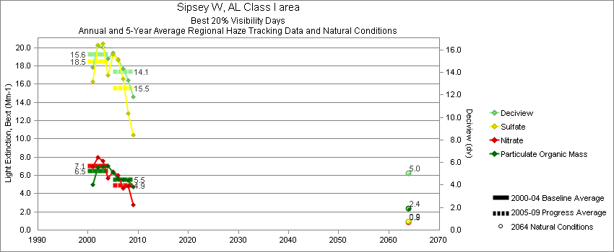
Sipsey - Best 20% Visibility Days – 5-Year Average, Natural Conditions and Annual Data
Parameter | 2000-2004 | 2005-2009 | 2064 NC | 2000 | 2001 | 2002 | 2003 | 2004 | 2005 | 2006 | 2007 | 2008 | 2009
Deciview (dv) | 15.6 | 14.1 | 5.0 |  | 14.4 | 16.4 | 16.3 | 15.2 | 15.7 | 15.1 | 14.3 | 13.3 | 11.8
Sulfate Bext | 18.5 | 15.5 | 0.9 |  | 16.3 | 20.3 | 20.4 | 17.0 | 19.2 | 18.6 | 16.5 | 12.8 | 10.4
Nitrate Bext | 7.1 | 4.9 | 0.9 |  | 6.9 | 8.0 | 7.6 | 5.7 | 6.5 | 5.9 | 4.5 | 4.9 | 2.8
POM Bext | 6.5 | 5.5 | 2.4 |  | 5.0 | 6.9 | 6.9 | 7.0 | 6.3 | 5.6 | 5.6 | 5.5 | 4.7
EC Bext | 2.6 | 2.4 | 0.1 |  | 2.3 | 2.7 | 2.6 | 2.8 | 3.4 | 2.5 | 2.3 | 2.1 | 1.7
Soil Bext | 0.4 | 0.3 | 0.2 |  | 0.3 | 0.5 | 0.5 | 0.4 | 0.4 | 0.2 | 0.3 | 0.3 | 0.3
Coarse Mass Bext | 2.1 | 1.8 | 1.0 |  | 1.8 | 2.3 | 2.3 | 2.1 | 1.8 | 1.7 | 2.2 | 1.6 | 1.7
Sea Salt Bext | 0.1 | 0.3 | 0.1 |  | 0.0 | 0.0 | 0.0 | 0.4 | 0.2 | 0.2 | 0.4 | 0.3 | 0.1

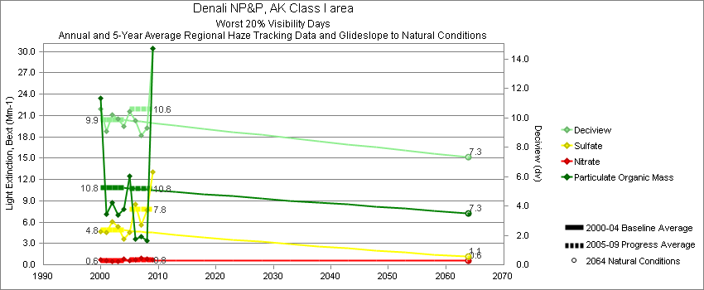
Denali - Worst 20% Visibility Days – 5-Year Average, Natural Conditions and Annual Data
Parameter | 2000-2004 | 2005-2009 | 2064 NC | 2000 | 2001 | 2002 | 2003 | 2004 | 2005 | 2006 | 2007 | 2008 | 2009
Deciview (dv) | 9.9 | 10.6 | 7.3 | 10.6 | 9.1 | 10.2 | 9.9 | 9.4 | 10.4 | 9.8 | 8.8 | 9.3 | 14.7
Sulfate Bext | 4.9 | 7.8 | 1.1 | 4.6 | 4.6 | 6.0 | 5.4 | 3.6 | 4.5 | 8.5 | 5.6 | 7.6 | 13.1
Nitrate Bext | 0.6 | 0.7 | 0.6 | 0.7 | 0.6 | 0.4 | 0.5 | 0.8 | 0.6 | 0.7 | 0.9 | 0.8 | 0.7
POM Bext | 10.8 | 10.7 | 7.3 | 23.5 | 7.1 | 8.7 | 7.0 | 7.9 | 12.5 | 3.6 | 3.9 | 3.3 | 30.4
EC Bext | 1.6 | 1.3 | 0.5 | 2.3 | 1.3 | 1.4 | 1.6 | 1.3 | 1.7 | 0.9 | 1.1 | 0.8 | 2.1
Soil Bext | 0.3 | 0.3 | 0.3 | 0.2 | 0.5 | 0.5 | 0.2 | 0.2 | 0.2 | 0.4 | 0.2 | 0.3 | 0.4
Coarse Mass Bext | 1.4 | 1.2 | 1.4 | 1.2 | 1.8 | 1.6 | 1.0 | 1.3 | 1.2 | 1.2 | 0.9 | 1.3 | 1.3
Sea Salt Bext | 0.4 | 0.8 | 0.6 | 0.5 | 0.3 | 0.0 | 0.5 | 0.9 | 0.7 | 1.0 | 0.8 | 1.0 | 0.6

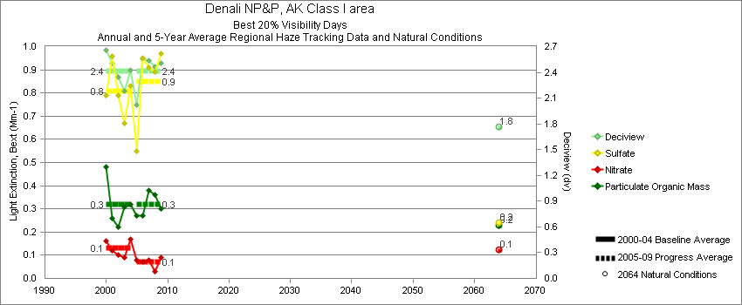
Denali - Best 20% Visibility Days – 5-Year Average, Natural Conditions and Annual Data
Parameter | 2000-2004 | 2005-2009 | 2064 NC | 2000 | 2001 | 2002 | 2003 | 2004 | 2005 | 2006 | 2007 | 2008 | 2009
Deciview (dv) | 2.4 | 2.4 | 1.8 | 2.7 | 2.5 | 2.3 | 2.2 | 2.4 | 2.1 | 2.5 | 2.5 | 2.5 | 2.5
Sulfate Bext | 0.8 | 0.9 | 0.2 | 0.8 | 1.0 | 0.8 | 0.7 | 0.8 | 0.5 | 1.0 | 0.9 | 0.9 | 1.0
Nitrate Bext | 0.1 | 0.1 | 0.1 | 0.2 | 0.1 | 0.1 | 0.1 | 0.2 | 0.1 | 0.1 | 0.1 | 0.0 | 0.1
POM Bext | 0.3 | 0.3 | 0.2 | 0.5 | 0.3 | 0.2 | 0.3 | 0.3 | 0.3 | 0.3 | 0.4 | 0.4 | 0.3
EC Bext | 0.2 | 0.1 | 0.1 | 0.2 | 0.2 | 0.2 | 0.1 | 0.1 | 0.1 | 0.2 | 0.1 | 0.1 | 0.1
Soil Bext | 0.0 | 0.0 | 0.0 | 0.1 | 0.1 | 0.0 | 0.0 | 0.0 | 0.0 | 0.0 | 0.1 | 0.1 | 0.1
Coarse Mass Bext | 0.2 | 0.3 | 0.2 | 0.3 | 0.2 | 0.2 | 0.2 | 0.2 | 0.2 | 0.3 | 0.3 | 0.3 | 0.2
Sea Salt Bext | 0.1 | 0.1 | 0.0 | 0.1 | 0.1 | 0.1 | 0.0 | 0.1 | 0.1 | 0.1 | 0.1 | 0.1 | 0.1

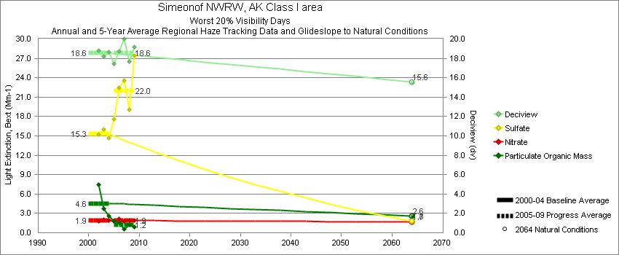
Simeonof - Worst 20% Visibility Days – 5-Year Average, Natural Conditions and Annual Data
Parameter | 2000-2004 | 2005-2009 | 2064 NC | 2000 | 2001 | 2002 | 2003 | 2004 | 2005 | 2006 | 2007 | 2008 | 2009
Deciview (dv) | 18.6 | 18.6 | 15.6 |  |  | 18.8 | 18.2 | 18.6 | 17.4 | 18.7 | 20.0 | 17.7 | 19.2
Sulfate Bext | 15.3 | 22.0 | 1.8 |  |  | 15.2 | 16.0 | 14.7 | 17.5 | 22.5 | 23.5 | 19.0 | 27.4
Nitrate Bext | 1.9 | 1.9 | 1.7 |  |  | 1.8 | 2.1 | 1.9 | 1.8 | 2.2 | 1.8 | 1.9 | 2.0
POM Bext | 4.6 | 1.2 | 2.6 |  |  | 7.5 | 3.7 | 2.5 | 1.8 | 1.7 | 0.5 | 1.3 | 0.9
EC Bext | 1.9 | 0.8 | 0.2 |  |  | 3.8 | 0.9 | 1.1 | 0.9 | 1.5 | 0.4 | 0.4 | 0.8
Soil Bext | 0.2 | 0.2 | 0.2 |  |  | 0.2 | 0.2 | 0.2 | 0.1 | 0.4 | 0.2 | 0.1 | 0.2
Coarse Mass Bext | 4.4 | 5.2 | 3.2 |  |  | 4.4 | 4.3 | 4.5 | 4.5 | 6.2 | 6.4 | 4.4 | 4.4
Sea Salt Bext | 25.2 | 23.7 | 27.5 |  |  | 22.3 | 24.1 | 29.0 | 20.3 | 21.8 | 31.6 | 21.1 | 23.9

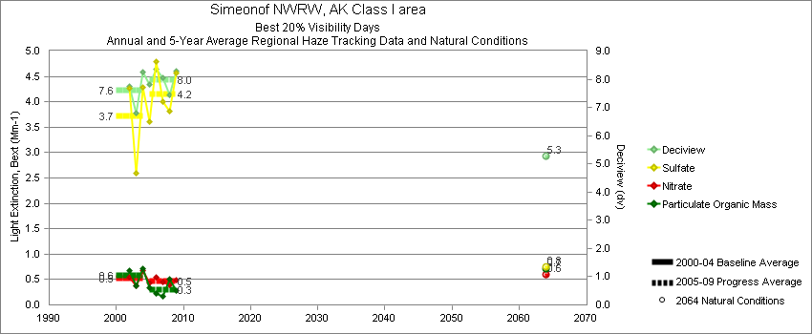
Simeonof - Best 20% Visibility Days – 5-Year Average, Natural Conditions and Annual Data
Parameter | 2000-2004 | 2005-2009 | 2064 NC | 2000 | 2001 | 2002 | 2003 | 2004 | 2005 | 2006 | 2007 | 2008 | 2009
Deciview (dv) | 7.6 | 8.0 | 5.3 |  |  | 7.8 | 6.8 | 8.3 | 7.8 | 8.3 | 8.1 | 7.5 | 8.3
Sulfate Bext | 3.7 | 4.2 | 0.8 |  |  | 4.3 | 2.6 | 4.3 | 3.6 | 4.8 | 4.0 | 3.8 | 4.6
Nitrate Bext | 0.5 | 0.5 | 0.6 |  |  | 0.5 | 0.4 | 0.7 | 0.5 | 0.6 | 0.5 | 0.4 | 0.5
POM Bext | 0.6 | 0.3 | 0.7 |  |  | 0.7 | 0.4 | 0.7 | 0.3 | 0.2 | 0.2 | 0.5 | 0.3
EC Bext | 0.4 | 0.5 | 0.2 |  |  | 0.4 | 0.5 | 0.4 | 0.4 | 0.7 | 0.6 | 0.4 | 0.6
Soil Bext | 0.0 | 0.0 | 0.0 |  |  | 0.0 | 0.0 | 0.0 | 0.0 | 0.0 | 0.0 | 0.0 | 0.0
Coarse Mass Bext | 1.1 | 1.2 | 0.7 |  |  | 1.1 | 1.1 | 1.1 | 1.1 | 1.3 | 1.2 | 1.1 | 1.1
Sea Salt Bext | 3.2 | 3.7 | 2.0 |  |  | 2.9 | 2.9 | 3.8 | 4.1 | 3.5 | 4.0 | 2.9 | 4.1

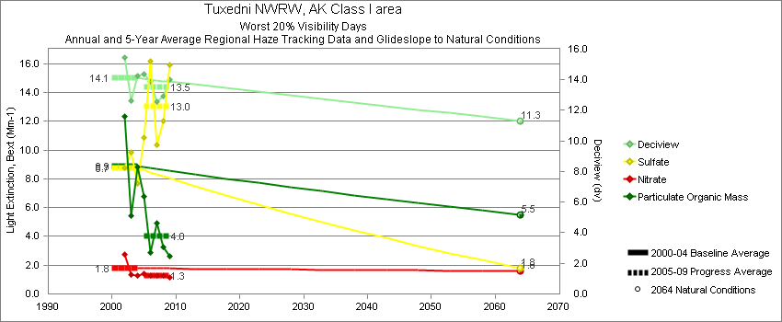
Tuxedni - Worst 20% Visibility Days – 5-Year Average, Natural Conditions and Annual Data
Parameter | 2000-2004 | 2005-2009 | 2064 NC | 2000 | 2001 | 2002 | 2003 | 2004 | 2005 | 2006 | 2007 | 2008 | 2009
Deciview (dv) | 14.1 | 13.5 | 11.3 |  |  | 15.5 | 12.6 | 14.2 | 14.2 | 13.9 | 12.6 | 12.9 | 14.0
Sulfate Bext | 8.7 | 13.0 | 1.8 |  |  | 8.7 | 9.8 | 7.7 | 10.7 | 16.2 | 10.3 | 12.0 | 15.9
Nitrate Bext | 1.8 | 1.3 | 1.6 |  |  | 2.7 | 1.3 | 1.3 | 1.4 | 1.3 | 1.3 | 1.3 | 1.1
POM Bext | 8.9 | 4.0 | 5.5 |  |  | 12.3 | 5.5 | 8.8 | 6.5 | 2.9 | 4.9 | 3.3 | 2.6
EC Bext | 1.2 | 0.9 | 0.3 |  |  | 1.1 | 1.0 | 1.4 | 1.4 | 1.0 | 0.9 | 0.6 | 0.5
Soil Bext | 0.1 | 0.4 | 0.1 |  |  | 0.2 | 0.1 | 0.1 | 0.1 | 1.5 | 0.2 | 0.2 | 0.3
Coarse Mass Bext | 2.5 | 2.9 | 2.5 |  |  | 2.9 | 2.4 | 2.2 | 2.8 | 3.6 | 2.3 | 1.7 | 3.9
Sea Salt Bext | 8.2 | 5.9 | 8.9 |  |  | 11.3 | 4.0 | 9.4 | 8.7 | 3.7 | 5.1 | 7.0 | 5.1

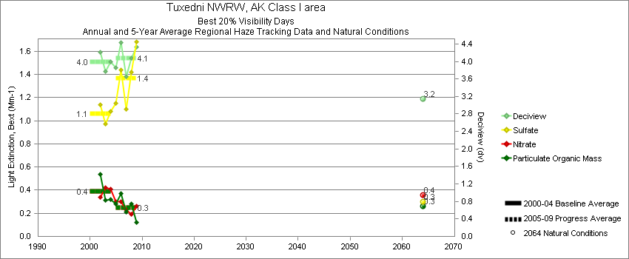
Tuxedni - Best 20% Visibility Days – 5-Year Average, Natural Conditions and Annual Data
Parameter | 2000-2004 | 2005-2009 | 2064 NC | 2000 | 2001 | 2002 | 2003 | 2004 | 2005 | 2006 | 2007 | 2008 | 2009
Deciview (dv) | 4.0 | 4.1 | 3.1 |  |  | 4.2 | 3.8 | 4.0 | 3.9 | 4.4 | 3.6 | 4.1 | 4.3
Sulfate Bext | 1.1 | 1.4 | 0.3 |  |  | 1.1 | 1.0 | 1.1 | 1.2 | 1.4 | 1.1 | 1.4 | 1.7
Nitrate Bext | 0.4 | 0.3 | 0.4 |  |  | 0.3 | 0.4 | 0.4 | 0.3 | 0.3 | 0.2 | 0.2 | 0.3
POM Bext | 0.4 | 0.3 | 0.3 |  |  | 0.5 | 0.3 | 0.3 | 0.3 | 0.4 | 0.2 | 0.3 | 0.1
EC Bext | 0.2 | 0.1 | 0.1 |  |  | 0.1 | 0.2 | 0.3 | 0.1 | 0.1 | 0.0 | 0.1 | 0.1
Soil Bext | 0.0 | 0.0 | 0.0 |  |  | 0.0 | 0.0 | 0.0 | 0.0 | 0.0 | 0.0 | 0.0 | 0.0
Coarse Mass Bext | 0.3 | 0.5 | 0.3 |  |  | 0.4 | 0.3 | 0.3 | 0.4 | 0.6 | 0.3 | 0.4 | 0.5
Sea Salt Bext | 0.5 | 0.6 | 0.4 |  |  | 0.7 | 0.4 | 0.5 | 0.5 | 0.7 | 0.5 | 0.7 | 0.8

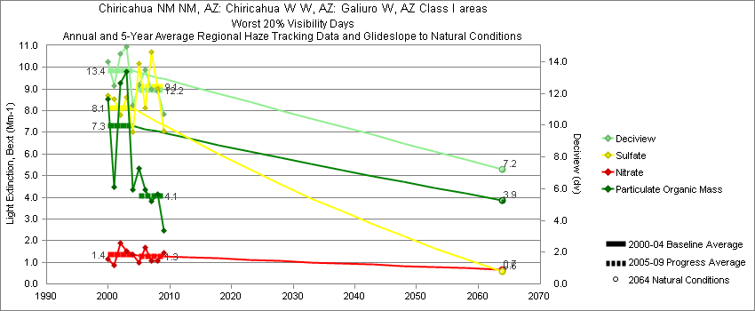
Chiricahua - Worst 20% Visibility Days – 5-Year Average, Natural Conditions and Annual Data
Parameter | 2000-2004 | 2005-2009 | 2064 NC | 2000 | 2001 | 2002 | 2003 | 2004 | 2005 | 2006 | 2007 | 2008 | 2009
Deciview (dv) | 13.4 | 12.2 | 7.2 | 14.0 | 12.5 | 14.5 | 14.9 | 11.2 | 12.6 | 13.4 | 12.3 | 12.1 | 10.7
Sulfate Bext | 8.1 | 9.1 | 0.6 | 8.7 | 8.5 | 7.8 | 8.6 | 7.0 | 10.6 | 8.3 | 10.7 | 9.0 | 7.0
Nitrate Bext | 1.3 | 1.3 | 0.7 | 1.1 | 0.9 | 1.9 | 1.5 | 1.4 | 1.0 | 1.7 | 1.1 | 1.1 | 1.4
POM Bext | 7.3 | 4.0 | 3.9 | 8.5 | 4.5 | 9.3 | 9.8 | 4.3 | 5.4 | 4.5 | 3.8 | 4.1 | 2.5
EC Bext | 1.7 | 1.2 | 0.3 | 2.2 | 1.2 | 1.8 | 2.2 | 1.0 | 1.9 | 1.3 | 1.1 | 0.9 | 0.8
Soil Bext | 2.7 | 2.4 | 1.2 | 2.8 | 2.5 | 2.4 | 3.8 | 1.9 | 1.4 | 3.6 | 2.4 | 2.6 | 2.0
Coarse Mass Bext | 8.6 | 6.8 | 4.3 | 8.8 | 8.8 | 9.9 | 10.4 | 5.3 | 4.9 | 11.4 | 5.8 | 6.4 | 5.3
Sea Salt Bext | 0.1 | 0.3 | 0.2 | 0.0 | 0.1 | 0.3 | 0.0 | 0.2 | 0.2 | 0.4 | 0.2 | 0.3 | 0.2

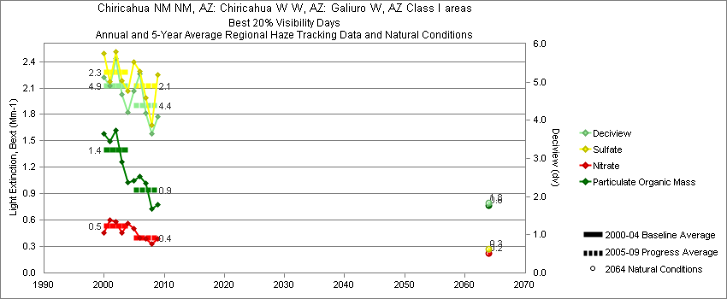
Chiricahua - Best 20% Visibility Days – 5-Year Average, Natural Conditions and Annual Data
Parameter | 2000-2004 | 2005-2009 | 2064 NC | 2000 | 2001 | 2002 | 2003 | 2004 | 2005 | 2006 | 2007 | 2008 | 2009
Deciview (dv) | 4.9 | 4.4 | 1.8 | 5.1 | 4.9 | 5.6 | 4.7 | 4.2 | 4.8 | 5.2 | 4.2 | 3.6 | 4.1
Sulfate Bext | 2.3 | 2.1 | 0.3 | 2.5 | 2.2 | 2.5 | 2.2 | 2.1 | 2.4 | 2.3 | 2.0 | 1.7 | 2.3
Nitrate Bext | 0.5 | 0.4 | 0.2 | 0.5 | 0.6 | 0.6 | 0.5 | 0.6 | 0.5 | 0.4 | 0.4 | 0.3 | 0.4
POM Bext | 1.4 | 0.9 | 0.8 | 1.6 | 1.5 | 1.6 | 1.3 | 1.0 | 1.1 | 1.1 | 1.0 | 0.7 | 0.8
EC Bext | 0.7 | 0.6 | 0.1 | 0.7 | 0.7 | 0.9 | 0.6 | 0.5 | 0.7 | 0.8 | 0.6 | 0.4 | 0.4
Soil Bext | 0.3 | 0.3 | 0.1 | 0.4 | 0.2 | 0.5 | 0.3 | 0.2 | 0.3 | 0.5 | 0.3 | 0.3 | 0.4
Coarse Mass Bext | 1.2 | 1.2 | 0.5 | 1.2 | 1.2 | 1.6 | 1.3 | 0.9 | 1.2 | 1.8 | 1.0 | 1.0 | 1.0
Sea Salt Bext | 0.0 | 0.0 | 0.0 | 0.0 | 0.0 | 0.0 | 0.0 | 0.1 | 0.1 | 0.1 | 0.0 | 0.0 | 0.0

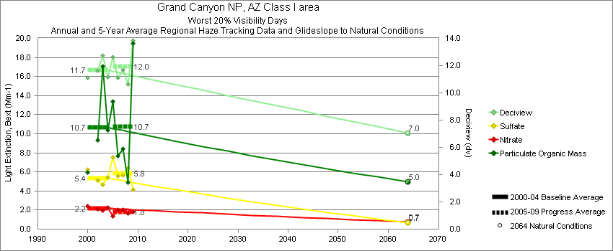
Hance Camp at Grand Canyon - Worst 20% Visibility Days – 5-Year Average, Natural Conditions and Annual Data
Parameter | 2000-2004 | 2005-2009 | 2064 NC | 2000 | 2001 | 2002 | 2003 | 2004 | 2005 | 2006 | 2007 | 2008 | 2009
Deciview (dv) | 11.7 | 12.0 | 7.0 | 11.1 |  | 11.6 | 12.7 | 11.2 | 12.6 | 11.1 | 11.7 | 10.6 | 13.8
Sulfate Bext | 5.4 | 5.8 | 0.7 | 6.3 |  | 5.1 | 4.7 | 5.4 | 7.4 | 5.6 | 5.7 | 6.4 | 4.1
Nitrate Bext | 2.2 | 1.8 | 0.7 | 2.4 |  | 2.1 | 2.0 | 2.3 | 1.3 | 2.1 | 2.0 | 1.6 | 1.8
POM Bext | 10.7 | 10.7 | 5.0 | 5.9 |  | 9.3 | 17.1 | 10.4 | 13.3 | 7.7 | 8.4 | 4.9 | 19.5
EC Bext | 2.4 | 2.9 | 0.4 | 1.6 |  | 2.1 | 3.1 | 2.8 | 3.7 | 2.4 | 2.1 | 1.3 | 5.3
Soil Bext | 1.3 | 1.5 | 1.1 | 1.4 |  | 1.7 | 1.3 | 1.0 | 1.0 | 1.1 | 2.3 | 2.1 | 0.9
Coarse Mass Bext | 3.5 | 3.2 | 3.9 | 3.7 |  | 3.8 | 3.7 | 2.8 | 2.5 | 2.8 | 3.5 | 3.9 | 3.3
Sea Salt Bext | 0.1 | 0.1 | 0.2 | 0.4 |  | 0.0 | 0.0 | 0.1 | 0.1 | 0.1 | 0.1 | 0.1 | 0.2

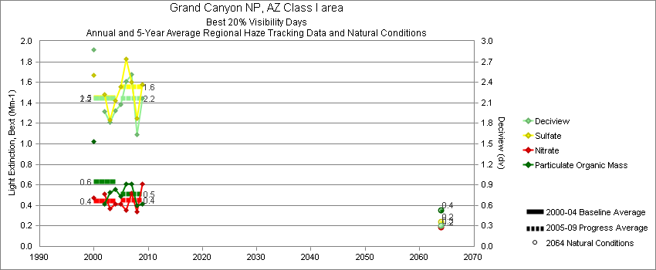
Hance Camp at Grand Canyon - Best 20% Visibility Days – 5-Year Average, Natural Conditions and Annual Data
Parameter | 2000-2004 | 2005-2009 | 2064 NC | 2000 | 2001 | 2002 | 2003 | 2004 | 2005 | 2006 | 2007 | 2008 | 2009
Deciview (dv) | 2.2 | 2.2 | 0.3 | 2.9 |  | 2.0 | 1.8 | 2.0 | 2.1 | 2.4 | 2.5 | 1.6 | 2.2
Sulfate Bext | 1.5 | 1.6 | 0.2 | 1.7 |  | 1.5 | 1.2 | 1.4 | 1.6 | 1.8 | 1.6 | 1.2 | 1.6
Nitrate Bext | 0.4 | 0.4 | 0.2 | 0.5 |  | 0.5 | 0.4 | 0.4 | 0.4 | 0.3 | 0.5 | 0.3 | 0.6
POM Bext | 0.6 | 0.5 | 0.3 | 1.0 |  | 0.4 | 0.5 | 0.6 | 0.5 | 0.6 | 0.6 | 0.4 | 0.4
EC Bext | 0.3 | 0.3 | 0.1 | 0.4 |  | 0.3 | 0.4 | 0.3 | 0.3 | 0.4 | 0.4 | 0.2 | 0.2
Soil Bext | 0.1 | 0.2 | 0.1 | 0.2 |  | 0.2 | 0.1 | 0.1 | 0.1 | 0.1 | 0.2 | 0.1 | 0.2
Coarse Mass Bext | 0.4 | 0.5 | 0.4 | 0.6 |  | 0.4 | 0.4 | 0.4 | 0.4 | 0.5 | 0.6 | 0.4 | 0.4
Sea Salt Bext | 0.0 | 0.0 | 0.0 | 0.0 |  | 0.0 | 0.0 | 0.0 | 0.0 | 0.0 | 0.0 | 0.1 | 0.0

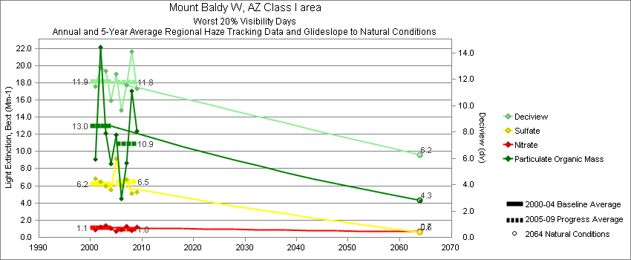
Mount Baldy - Worst 20% Visibility Days – 5-Year Average, Natural Conditions and Annual Data
Parameter | 2000-2004 | 2005-2009 | 2064 NC | 2000 | 2001 | 2002 | 2003 | 2004 | 2005 | 2006 | 2007 | 2008 | 2009
Deciview (dv) | 11.8 | 11.8 | 6.2 |  | 11.4 | 12.9 | 12.6 | 10.4 | 12.4 | 9.7 | 11.5 | 14.1 | 11.3
Sulfate Bext | 6.2 | 6.5 | 0.6 |  | 6.8 | 6.5 | 5.9 | 5.5 | 9.2 | 6.0 | 6.8 | 5.1 | 5.3
Nitrate Bext | 1.1 | 1.0 | 0.6 |  | 0.9 | 1.2 | 1.4 | 1.0 | 0.7 | 0.9 | 1.3 | 0.8 | 1.2
POM Bext | 13.0 | 10.9 | 4.3 |  | 9.1 | 22.2 | 12.1 | 8.5 | 11.9 | 4.5 | 8.6 | 17.0 | 12.3
EC Bext | 2.8 | 2.1 | 0.4 |  | 2.4 | 4.3 | 2.6 | 1.9 | 2.8 | 1.3 | 1.7 | 2.5 | 2.2
Soil Bext | 1.1 | 1.5 | 1.1 |  | 1.1 | 1.1 | 1.6 | 0.8 | 0.8 | 1.3 | 1.3 | 2.4 | 1.8
Coarse Mass Bext | 2.8 | 4.1 | 3.6 |  | 2.7 | 2.8 | 3.8 | 2.1 | 2.4 | 3.3 | 4.0 | 6.2 | 4.5
Sea Salt Bext | 0.0 | 0.1 | 0.1 |  | 0.0 | 0.0 | 0.1 | 0.0 | 0.0 | 0.1 | 0.2 | 0.1 | 0.1

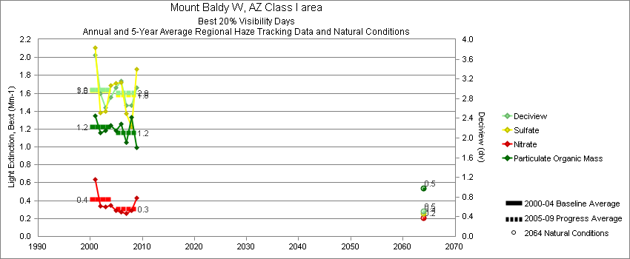
Mount Baldy - Best 20% Visibility Days – 5-Year Average, Natural Conditions and Annual Data
Parameter | 2000-2004 | 2005-2009 | 2064 NC | 2000 | 2001 | 2002 | 2003 | 2004 | 2005 | 2006 | 2007 | 2008 | 2009
Deciview (dv) | 3.0 | 2.9 | 0.5 |  | 3.6 | 2.8 | 2.6 | 2.8 | 3.0 | 3.2 | 2.7 | 2.7 | 3.0
Sulfate Bext | 1.6 | 1.6 | 0.3 |  | 2.1 | 1.4 | 1.4 | 1.7 | 1.7 | 1.7 | 1.4 | 1.2 | 1.9
Nitrate Bext | 0.4 | 0.3 | 0.2 |  | 0.6 | 0.3 | 0.3 | 0.3 | 0.3 | 0.3 | 0.3 | 0.3 | 0.4
POM Bext | 1.2 | 1.2 | 0.5 |  | 1.3 | 1.1 | 1.2 | 1.2 | 1.2 | 1.3 | 1.0 | 1.3 | 1.0
EC Bext | 0.6 | 0.6 | 0.1 |  | 0.6 | 0.7 | 0.6 | 0.5 | 0.7 | 0.7 | 0.6 | 0.5 | 0.5
Soil Bext | 0.2 | 0.2 | 0.1 |  | 0.2 | 0.3 | 0.1 | 0.1 | 0.2 | 0.2 | 0.2 | 0.2 | 0.3
Coarse Mass Bext | 0.5 | 0.6 | 0.3 |  | 0.6 | 0.6 | 0.4 | 0.3 | 0.6 | 0.6 | 0.7 | 0.6 | 0.6
Sea Salt Bext | 0.0 | 0.0 | 0.0 |  | 0.0 | 0.0 | 0.0 | 0.0 | 0.0 | 0.0 | 0.0 | 0.0 | 0.0

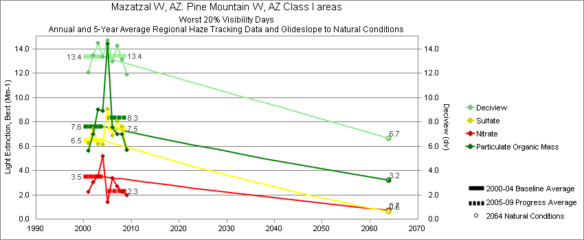
Ike’s Backbone - Worst 20% Visibility Days – 5-Year Average, Natural Conditions and Annual Data
Parameter | 2000-2004 | 2005-2009 | 2064 NC | 2000 | 2001 | 2002 | 2003 | 2004 | 2005 | 2006 | 2007 | 2008 | 2009
Deciview (dv) | 13.3 | 13.4 | 6.7 |  | 12.1 | 13.5 | 14.5 | 13.3 | 14.7 | 13.0 | 14.3 | 13.2 | 11.9
Sulfate Bext | 6.5 | 7.5 | 0.6 |  | 6.3 | 7.4 | 6.2 | 6.1 | 9.1 | 6.9 | 8.1 | 7.6 | 5.7
Nitrate Bext | 3.5 | 2.3 | 0.7 |  | 2.2 | 3.1 | 3.6 | 5.2 | 1.4 | 3.4 | 2.7 | 2.2 | 2.0
POM Bext | 7.6 | 8.3 | 3.2 |  | 5.6 | 7.0 | 9.0 | 8.9 | 14.4 | 7.6 | 7.0 | 7.0 | 5.7
EC Bext | 2.3 | 2.3 | 0.3 |  | 2.0 | 2.0 | 2.4 | 3.0 | 3.5 | 2.3 | 1.9 | 1.9 | 1.8
Soil Bext | 2.6 | 2.3 | 1.1 |  | 2.0 | 3.5 | 3.7 | 1.4 | 1.2 | 1.7 | 3.5 | 2.9 | 2.4
Coarse Mass Bext | 6.2 | 6.2 | 3.8 |  | 5.5 | 6.0 | 9.0 | 4.3 | 5.5 | 4.9 | 9.4 | 5.9 | 5.4
Sea Salt Bext | 0.1 | 0.2 | 0.1 |  | 0.0 | 0.0 | 0.0 | 0.3 | 0.2 | 0.1 | 0.2 | 0.2 | 0.3

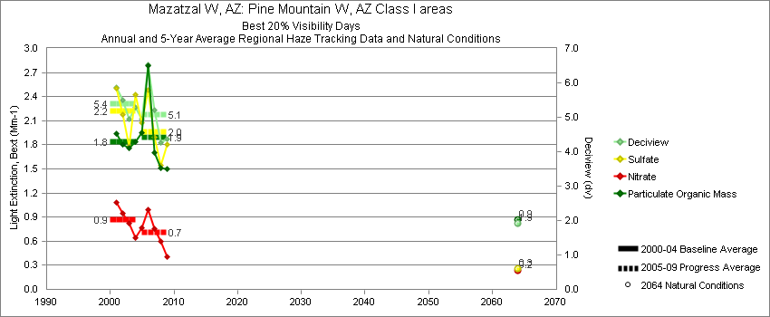
Ike’s Backbone - Best 20% Visibility Days – 5-Year Average, Natural Conditions and Annual Data
Parameter | 2000-2004 | 2005-2009 | 2064 NC | 2000 | 2001 | 2002 | 2003 | 2004 | 2005 | 2006 | 2007 | 2008 | 2009
Deciview (dv) | 5.4 | 5.1 | 1.9 |  | 5.9 | 5.5 | 4.9 | 5.3 | 5.0 | 6.5 | 5.2 | 4.3 | 4.4
Sulfate Bext | 2.2 | 2.0 | 0.3 |  | 2.5 | 2.2 | 1.8 | 2.4 | 2.1 | 2.5 | 1.9 | 1.5 | 1.8
Nitrate Bext | 0.9 | 0.7 | 0.2 |  | 1.1 | 0.9 | 0.8 | 0.6 | 0.8 | 1.0 | 0.8 | 0.6 | 0.4
POM Bext | 1.8 | 1.9 | 0.9 |  | 1.9 | 1.8 | 1.8 | 1.8 | 1.9 | 2.8 | 1.7 | 1.5 | 1.5
EC Bext | 0.9 | 0.8 | 0.1 |  | 1.0 | 0.9 | 0.9 | 0.8 | 0.8 | 1.2 | 0.8 | 0.6 | 0.7
Soil Bext | 0.4 | 0.3 | 0.1 |  | 0.3 | 0.5 | 0.4 | 0.4 | 0.2 | 0.4 | 0.4 | 0.3 | 0.3
Coarse Mass Bext | 1.0 | 1.0 | 0.5 |  | 1.2 | 1.2 | 0.8 | 1.0 | 0.7 | 1.3 | 1.3 | 0.8 | 0.8
Sea Salt Bext | 0.0 | 0.1 | 0.0 |  | 0.0 | 0.0 | 0.0 | 0.1 | 0.0 | 0.1 | 0.1 | 0.1 | 0.0

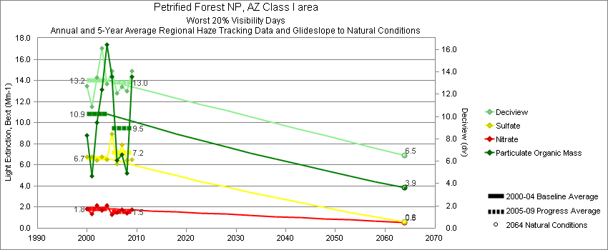
Petrified Forest - Worst 20% Visibility Days – 5-Year Average, Natural Conditions and Annual Data
Parameter | 2000-2004 | 2005-2009 | 2064 NC | 2000 | 2001 | 2002 | 2003 | 2004 | 2005 | 2006 | 2007 | 2008 | 2009
Deciview (dv) | 13.2 | 13.0 | 6.5 | 12.7 | 10.8 | 13.5 | 16.1 | 12.9 | 14.0 | 12.1 | 12.7 | 12.3 | 14.0
Sulfate Bext | 6.6 | 7.2 | 0.6 | 6.8 | 6.8 | 6.4 | 6.8 | 6.5 | 8.9 | 6.1 | 7.9 | 6.4 | 6.5
Nitrate Bext | 1.8 | 1.5 | 0.6 | 1.8 | 1.3 | 2.2 | 1.7 | 2.2 | 1.3 | 1.5 | 1.7 | 1.4 | 1.7
POM Bext | 10.9 | 9.5 | 3.9 | 8.8 | 5.0 | 10.0 | 13.2 | 17.4 | 14.3 | 6.4 | 7.0 | 5.2 | 14.3
EC Bext | 2.9 | 3.4 | 0.3 | 2.9 | 2.4 | 2.7 | 3.3 | 3.4 | 5.0 | 2.8 | 3.2 | 2.2 | 3.9
Soil Bext | 2.0 | 2.6 | 1.1 | 1.7 | 1.6 | 2.5 | 3.0 | 1.3 | 2.7 | 2.2 | 2.1 | 3.0 | 2.9
Coarse Mass Bext | 7.3 | 6.3 | 4.3 | 5.0 | 3.8 | 7.6 | 15.5 | 4.6 | 5.7 | 5.7 | 4.8 | 7.1 | 8.4
Sea Salt Bext | 0.0 | 0.2 | 0.1 | 0.0 | 0.0 | 0.0 | 0.0 | 0.1 | 0.2 | 0.1 | 0.2 | 0.2 | 0.1

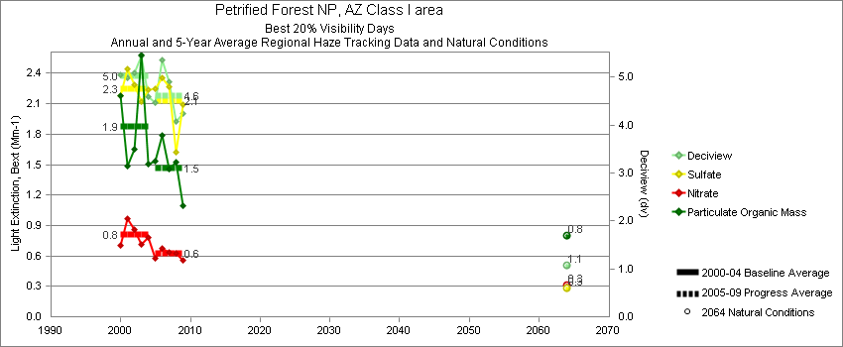
Petrified Forest - Best 20% Visibility Days – 5-Year Average, Natural Conditions and Annual Data
Parameter | 2000-2004 | 2005-2009 | 2064 NC | 2000 | 2001 | 2002 | 2003 | 2004 | 2005 | 2006 | 2007 | 2008 | 2009
Deciview (dv) | 5.0 | 4.6 | 1.1 | 5.0 | 5.0 | 5.1 | 5.4 | 4.6 | 4.5 | 5.4 | 4.9 | 4.1 | 4.2
Sulfate Bext | 2.3 | 2.1 | 0.3 | 2.2 | 2.4 | 2.3 | 2.1 | 2.2 | 2.3 | 2.4 | 2.3 | 1.6 | 2.1
Nitrate Bext | 0.8 | 0.6 | 0.3 | 0.7 | 1.0 | 0.9 | 0.7 | 0.8 | 0.6 | 0.7 | 0.6 | 0.6 | 0.6
POM Bext | 1.9 | 1.5 | 0.8 | 2.2 | 1.5 | 1.7 | 2.6 | 1.5 | 1.5 | 1.8 | 1.5 | 1.5 | 1.1
EC Bext | 1.3 | 1.3 | 0.1 | 1.4 | 1.1 | 1.4 | 1.5 | 1.2 | 1.3 | 1.7 | 1.4 | 1.1 | 0.9
Soil Bext | 0.4 | 0.4 | 0.2 | 0.3 | 0.5 | 0.5 | 0.3 | 0.3 | 0.4 | 0.6 | 0.4 | 0.3 | 0.4
Coarse Mass Bext | 1.0 | 1.0 | 0.5 | 0.8 | 1.1 | 1.0 | 1.0 | 0.8 | 0.6 | 1.0 | 1.2 | 0.8 | 1.2
Sea Salt Bext | 0.0 | 0.0 | 0.0 | 0.0 | 0.0 | 0.0 | 0.0 | 0.0 | 0.0 | 0.0 | 0.0 | 0.1 | 0.0

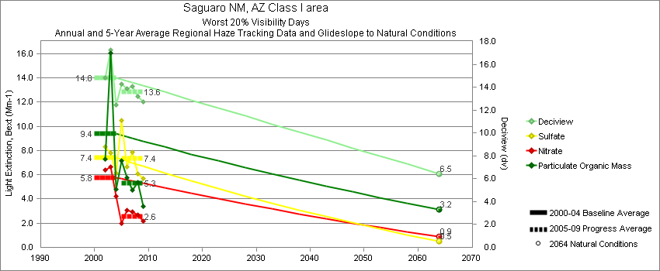
Saguaro - Worst 20% Visibility Days – 5-Year Average, Natural Conditions and Annual Data
Parameter | 2000-2004 | 2005-2009 | 2064 NC | 2000 | 2001 | 2002 | 2003 | 2004 | 2005 | 2006 | 2007 | 2008 | 2009
Deciview (dv) | 14.8 | 13.6 | 6.5 |  |  | 14.8 | 17.2 | 12.5 | 14.3 | 13.9 | 14.1 | 13.2 | 12.7
Sulfate Bext | 7.4 | 7.4 | 0.5 |  |  | 8.3 | 7.8 | 6.1 | 10.6 | 6.6 | 7.9 | 6.1 | 5.7
Nitrate Bext | 5.8 | 2.6 | 0.9 |  |  | 6.4 | 6.7 | 4.2 | 2.0 | 3.1 | 3.0 | 2.7 | 2.2
POM Bext | 9.4 | 5.3 | 3.2 |  |  | 7.3 | 16.0 | 4.8 | 7.2 | 5.8 | 4.7 | 5.4 | 3.4
EC Bext | 3.1 | 2.2 | 0.3 |  |  | 2.8 | 3.9 | 2.7 | 3.3 | 2.9 | 1.8 | 1.8 | 1.5
Soil Bext | 3.4 | 3.3 | 0.9 |  |  | 4.4 | 3.7 | 2.0 | 2.2 | 2.7 | 4.8 | 3.4 | 3.4
Coarse Mass Bext | 7.1 | 8.3 | 3.3 |  |  | 6.2 | 10.1 | 4.9 | 6.8 | 8.9 | 8.4 | 7.8 | 9.6
Sea Salt Bext | 0.2 | 0.4 | 0.3 |  |  | 0.1 | 0.1 | 0.3 | 0.2 | 0.4 | 0.6 | 0.6 | 0.3

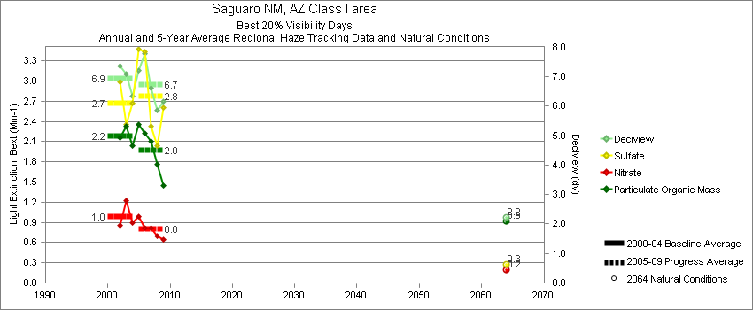
Saguaro - Best 20% Visibility Days – 5-Year Average, Natural Conditions and Annual Data
Parameter | 2000-2004 | 2005-2009 | 2064 NC | 2000 | 2001 | 2002 | 2003 | 2004 | 2005 | 2006 | 2007 | 2008 | 2009
Deciview (dv) | 6.9 | 6.7 | 2.2 |  |  | 7.4 | 7.1 | 6.4 | 7.2 | 7.8 | 6.6 | 5.9 | 6.2
Sulfate Bext | 2.7 | 2.8 | 0.3 |  |  | 3.0 | 2.3 | 2.7 | 3.5 | 3.4 | 2.3 | 2.0 | 2.6
Nitrate Bext | 1.0 | 0.8 | 0.2 |  |  | 0.8 | 1.2 | 0.9 | 1.0 | 0.8 | 0.8 | 0.7 | 0.6
POM Bext | 2.2 | 2.0 | 0.9 |  |  | 2.2 | 2.3 | 2.0 | 2.4 | 2.2 | 2.1 | 1.8 | 1.5
EC Bext | 1.3 | 1.2 | 0.1 |  |  | 1.3 | 1.3 | 1.2 | 1.4 | 1.4 | 1.3 | 0.8 | 0.8
Soil Bext | 1.1 | 0.8 | 0.2 |  |  | 1.7 | 1.0 | 0.6 | 0.6 | 0.9 | 1.1 | 0.8 | 0.8
Coarse Mass Bext | 1.8 | 2.1 | 0.7 |  |  | 2.0 | 2.0 | 1.5 | 1.8 | 2.9 | 1.8 | 1.7 | 2.3
Sea Salt Bext | 0.1 | 0.2 | 0.1 |  |  | 0.0 | 0.1 | 0.2 | 0.2 | 0.2 | 0.2 | 0.2 | 0.1

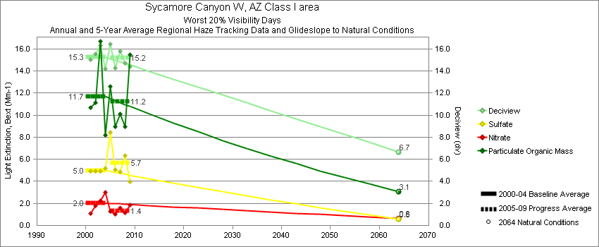
Sycamore Canyon - Worst 20% Visibility Days – 5-Year Average, Natural Conditions and Annual Data
Parameter | 2000-2004 | 2005-2009 | 2064 NC | 2000 | 2001 | 2002 | 2003 | 2004 | 2005 | 2006 | 2007 | 2008 | 2009
Deciview (dv) | 15.3 | 15.2 | 6.7 |  | 15.0 | 15.5 | 16.3 | 14.2 | 16.7 | 14.3 | 15.8 | 14.7 | 14.4
Sulfate Bext | 5.0 | 5.7 | 0.6 |  | 4.9 | 4.9 | 4.9 | 5.2 | 8.2 | 5.0 | 4.9 | 6.3 | 4.0
Nitrate Bext | 2.0 | 1.4 | 0.6 |  | 1.1 | 1.8 | 2.2 | 3.0 | 1.2 | 1.0 | 1.6 | 1.1 | 1.9
POM Bext | 11.7 | 11.2 | 3.1 |  | 10.7 | 11.1 | 16.7 | 8.2 | 12.6 | 8.9 | 10.1 | 9.0 | 15.5
EC Bext | 3.2 | 3.5 | 0.2 |  | 2.3 | 3.0 | 4.2 | 3.2 | 3.3 | 3.4 | 2.8 | 3.3 | 4.8
Soil Bext | 6.8 | 5.8 | 1.2 |  | 7.1 | 9.3 | 5.5 | 5.2 | 6.2 | 5.2 | 8.1 | 5.3 | 4.1
Coarse Mass Bext | 9.4 | 10.8 | 4.8 |  | 11.2 | 8.7 | 9.7 | 7.9 | 14.5 | 9.9 | 12.8 | 9.7 | 6.9
Sea Salt Bext | 0.1 | 0.1 | 0.2 |  | 0.2 | 0.1 | 0.0 | 0.1 | 0.1 | 0.1 | 0.2 | 0.1 | 0.1

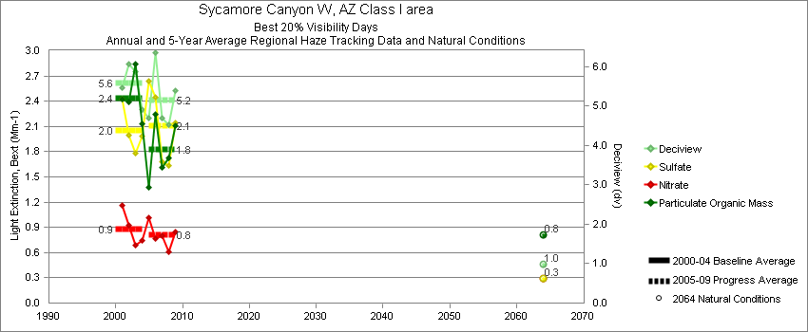
Sycamore Canyon - Best 20% Visibility Days – 5-Year Average, Natural Conditions and Annual Data
Parameter | 2000-2004 | 2005-2009 | 2064 NC | 2000 | 2001 | 2002 | 2003 | 2004 | 2005 | 2006 | 2007 | 2008 | 2009
Deciview (dv) | 5.6 | 5.1 | 1.0 |  | 5.5 | 6.1 | 5.9 | 4.9 | 4.8 | 6.3 | 4.7 | 4.5 | 5.4
Sulfate Bext | 2.0 | 2.1 | 0.3 |  | 2.4 | 2.0 | 1.8 | 2.0 | 2.6 | 2.4 | 1.7 | 1.6 | 2.1
Nitrate Bext | 0.9 | 0.8 | 0.3 |  | 1.2 | 0.9 | 0.7 | 0.7 | 1.0 | 0.8 | 0.8 | 0.6 | 0.9
POM Bext | 2.4 | 1.8 | 0.8 |  | 2.4 | 2.4 | 2.8 | 2.1 | 1.5 | 2.2 | 1.6 | 1.7 | 2.1
EC Bext | 1.6 | 1.4 | 0.1 |  | 1.4 | 1.5 | 1.8 | 1.5 | 0.9 | 1.9 | 1.2 | 1.4 | 1.4
Soil Bext | 0.7 | 0.6 | 0.1 |  | 0.4 | 1.0 | 1.0 | 0.3 | 0.5 | 0.8 | 0.5 | 0.5 | 0.6
Coarse Mass Bext | 1.0 | 1.2 | 0.4 |  | 0.6 | 1.7 | 1.1 | 0.7 | 0.8 | 1.7 | 1.2 | 0.9 | 1.2
Sea Salt Bext | 0.0 | 0.1 | 0.0 |  | 0.0 | 0.0 | 0.0 | 0.1 | 0.1 | 0.1 | 0.1 | 0.1 | 0.0
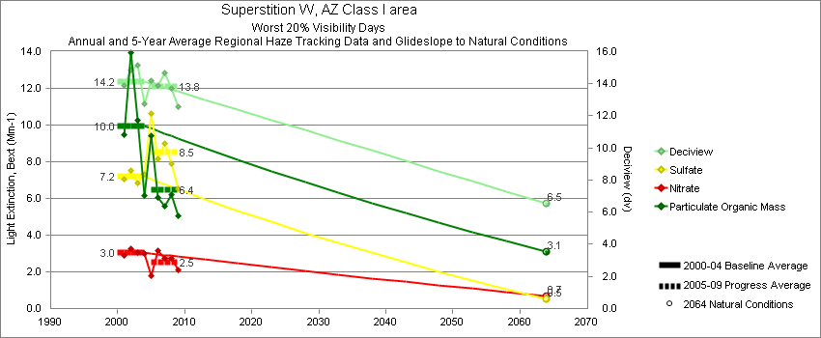
Tonto - Worst 20% Visibility Days – 5-Year Average, Natural Conditions and Annual Data
Parameter | 2000-2004 | 2005-2009 | 2064 NC | 2000 | 2001 | 2002 | 2003 | 2004 | 2005 | 2006 | 2007 | 2008 | 2009
Deciview (dv) | 14.2 | 13.8 | 6.5 |  | 13.9 | 14.8 | 15.2 | 12.8 | 14.3 | 13.9 | 14.7 | 13.7 | 12.6
Sulfate Bext | 7.2 | 8.5 | 0.5 |  | 7.0 | 7.5 | 6.9 | 7.3 | 11.0 | 8.1 | 9.0 | 7.9 | 6.5
Nitrate Bext | 3.0 | 2.5 | 0.7 |  | 2.9 | 3.2 | 3.1 | 3.0 | 1.8 | 3.2 | 2.7 | 2.7 | 2.1
POM Bext | 10.0 | 6.4 | 3.1 |  | 9.5 | 13.9 | 10.3 | 6.2 | 9.4 | 6.1 | 5.6 | 6.2 | 5.0
EC Bext | 2.7 | 2.1 | 0.3 |  | 3.1 | 3.2 | 2.8 | 1.8 | 3.4 | 2.1 | 1.6 | 1.8 | 1.6
Soil Bext | 2.4 | 2.8 | 1.1 |  | 1.8 | 2.6 | 3.7 | 1.5 | 1.4 | 2.8 | 3.9 | 3.2 | 2.5
Coarse Mass Bext | 7.4 | 7.9 | 3.7 |  | 7.4 | 6.6 | 9.7 | 6.0 | 5.3 | 8.3 | 11.0 | 7.5 | 7.3
Sea Salt Bext | 0.1 | 0.3 | 0.1 |  | 0.0 | 0.1 | 0.0 | 0.3 | 0.2 | 0.3 | 0.4 | 0.4 | 0.4

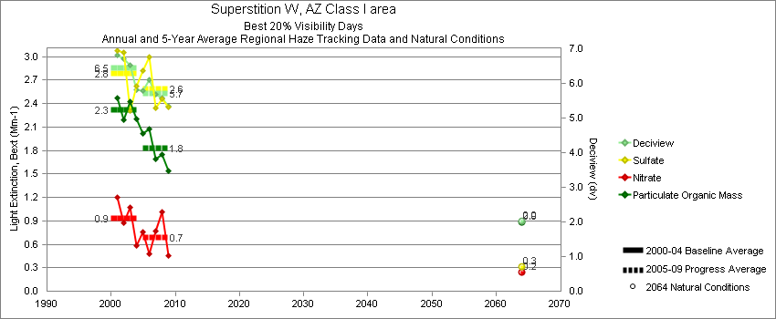
Tonto - Best 20% Visibility Days – 5-Year Average, Natural Conditions and Annual Data
Parameter | 2000-2004 | 2005-2009 | 2064 NC | 2000 | 2001 | 2002 | 2003 | 2004 | 2005 | 2006 | 2007 | 2008 | 2009
Deciview (dv) | 6.5 | 5.7 | 2.0 |  | 6.8 | 6.7 | 6.5 | 5.8 | 5.8 | 6.1 | 5.7 | 5.6 | 5.3
Sulfate Bext | 2.8 | 2.6 | 0.3 |  | 3.1 | 3.1 | 2.3 | 2.6 | 2.8 | 3.0 | 2.3 | 2.5 | 2.3
Nitrate Bext | 0.9 | 0.7 | 0.2 |  | 1.2 | 0.9 | 1.1 | 0.6 | 0.7 | 0.5 | 0.8 | 1.0 | 0.5
POM Bext | 2.3 | 1.8 | 0.9 |  | 2.5 | 2.2 | 2.4 | 2.2 | 2.1 | 2.1 | 1.7 | 1.8 | 1.5
EC Bext | 1.1 | 0.9 | 0.1 |  | 1.1 | 1.2 | 1.1 | 0.9 | 1.0 | 1.1 | 0.9 | 0.8 | 0.8
Soil Bext | 0.5 | 0.5 | 0.2 |  | 0.4 | 0.6 | 0.6 | 0.5 | 0.3 | 0.4 | 0.5 | 0.6 | 0.5
Coarse Mass Bext | 1.5 | 1.3 | 0.5 |  | 1.4 | 1.6 | 1.7 | 1.2 | 1.1 | 1.5 | 1.4 | 0.9 | 1.4
Sea Salt Bext | 0.0 | 0.1 | 0.0 |  | 0.0 | 0.0 | 0.0 | 0.1 | 0.1 | 0.1 | 0.1 | 0.2 | 0.1

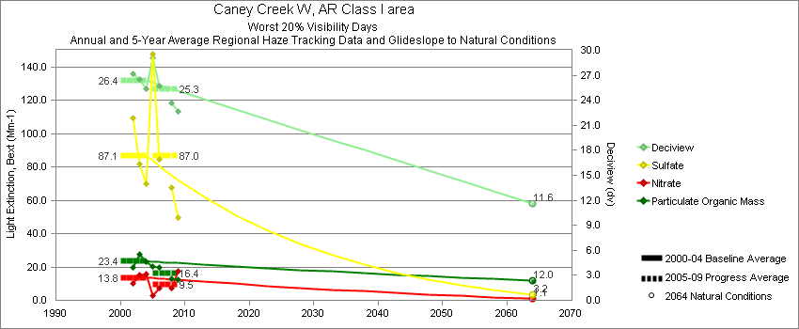
Caney Creek - Worst 20% Visibility Days – 5-Year Average, Natural Conditions and Annual Data
Parameter | 2000-2004 | 2005-2009 | 2064 NC | 2000 | 2001 | 2002 | 2003 | 2004 | 2005 | 2006 | 2007 | 2008 | 2009
Deciview (dv) | 26.4 | 25.3 | 11.6 |  |  | 27.2 | 26.5 | 25.3 | 29.2 | 25.7 |  | 23.7 | 22.7
Sulfate Bext | 87.1 | 87.0 | 3.2 |  |  | 109.5 | 81.7 | 70.0 | 145.8 | 84.7 |  | 67.8 | 49.7
Nitrate Bext | 13.8 | 9.5 | 1.1 |  |  | 10.2 | 15.1 | 16.0 | 6.2 | 7.2 |  | 7.2 | 17.3
POM Bext | 23.4 | 16.4 | 12.0 |  |  | 19.6 | 27.4 | 23.3 | 20.1 | 20.0 |  | 12.8 | 12.6
EC Bext | 4.8 | 4.2 | 0.3 |  |  | 4.4 | 5.8 | 4.3 | 5.8 | 4.8 |  | 3.2 | 3.1
Soil Bext | 1.1 | 1.2 | 1.1 |  |  | 1.4 | 1.1 | 0.9 | 0.7 | 1.6 |  | 1.9 | 0.8
Coarse Mass Bext | 3.7 | 4.0 | 3.1 |  |  | 4.3 | 4.1 | 2.8 | 4.1 | 4.4 |  | 4.1 | 3.5
Sea Salt Bext | 0.2 | 0.3 | 0.3 |  |  | 0.1 | 0.0 | 0.5 | 0.2 | 0.6 |  | 0.3 | 0.3

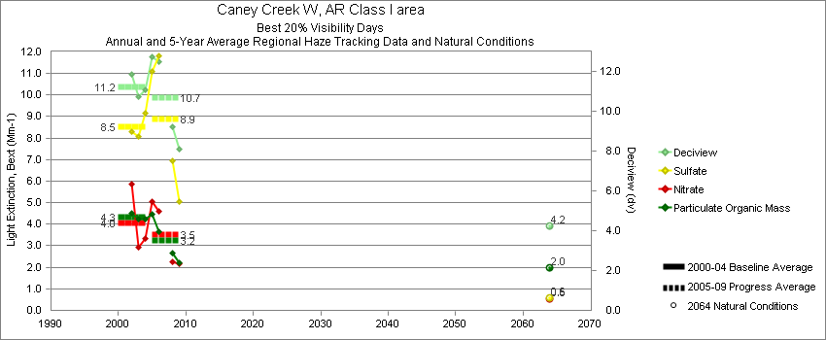
Caney Creek - Best 20% Visibility Days – 5-Year Average, Natural Conditions and Annual Data
Parameter | 2000-2004 | 2005-2009 | 2064 NC | 2000 | 2001 | 2002 | 2003 | 2004 | 2005 | 2006 | 2007 | 2008 | 2009
Deciview (dv) | 11.2 | 10.7 | 4.2 |  |  | 11.9 | 10.7 | 11.1 | 12.9 | 12.5 |  | 9.2 | 8.1
Sulfate Bext | 8.5 | 8.9 | 0.6 |  |  | 8.3 | 8.1 | 9.2 | 11.7 | 11.8 |  | 7.0 | 5.1
Nitrate Bext | 4.0 | 3.5 | 0.5 |  |  | 5.9 | 2.9 | 3.3 | 5.1 | 4.6 |  | 2.3 | 2.2
POM Bext | 4.3 | 3.2 | 2.0 |  |  | 4.5 | 4.2 | 4.3 | 4.5 | 3.6 |  | 2.6 | 2.2
EC Bext | 1.5 | 1.4 | 0.1 |  |  | 1.7 | 1.4 | 1.4 | 2.0 | 1.7 |  | 1.0 | 0.9
Soil Bext | 0.2 | 0.3 | 0.1 |  |  | 0.3 | 0.2 | 0.2 | 0.3 | 0.3 |  | 0.2 | 0.2
Coarse Mass Bext | 1.8 | 1.9 | 0.9 |  |  | 2.0 | 1.8 | 1.6 | 2.4 | 2.4 |  | 1.3 | 1.4
Sea Salt Bext | 0.2 | 0.2 | 0.1 |  |  | 0.1 | 0.0 | 0.4 | 0.2 | 0.2 |  | 0.3 | 0.2

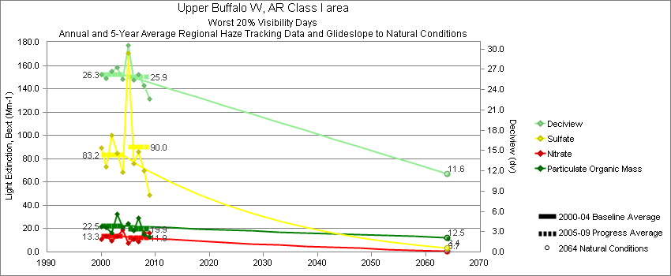
Upper Buffalo - Worst 20% Visibility Days – 5-Year Average, Natural Conditions and Annual Data
Parameter | 2000-2004 | 2005-2009 | 2064 NC | 2000 | 2001 | 2002 | 2003 | 2004 | 2005 | 2006 | 2007 | 2008 | 2009
Deciview (dv) | 26.3 | 25.9 | 11.6 | 26.2 | 25.6 | 26.7 | 27.2 | 25.6 | 30.5 | 25.4 | 26.2 | 24.6 | 22.6
Sulfate Bext | 83.2 | 90.0 | 3.4 | 89.2 | 73.1 | 100.4 | 84.8 | 68.3 | 169.8 | 75.9 | 85.8 | 69.5 | 48.8
Nitrate Bext | 13.3 | 11.9 | 0.7 | 10.6 | 13.8 | 9.7 | 13.3 | 19.1 | 7.7 | 11.0 | 8.7 | 16.0 | 16.2
POM Bext | 22.5 | 19.8 | 12.5 | 21.5 | 21.0 | 16.5 | 32.8 | 20.9 | 24.3 | 18.1 | 28.8 | 15.1 | 12.9
EC Bext | 4.7 | 4.7 | 0.3 | 4.9 | 4.2 | 4.2 | 5.8 | 4.5 | 6.8 | 4.2 | 5.4 | 3.6 | 3.4
Soil Bext | 1.2 | 1.2 | 1.1 | 1.9 | 1.2 | 1.2 | 0.9 | 0.9 | 0.9 | 1.5 | 1.0 | 1.6 | 0.9
Coarse Mass Bext | 6.8 | 4.9 | 3.4 | 3.4 | 6.7 | 8.9 | 8.0 | 7.2 | 2.7 | 9.1 | 5.3 | 3.6 | 3.8
Sea Salt Bext | 0.2 | 0.4 | 0.3 | 0.1 | 0.0 | 0.0 | 0.0 | 0.7 | 0.3 | 0.6 | 0.6 | 0.3 | 0.2

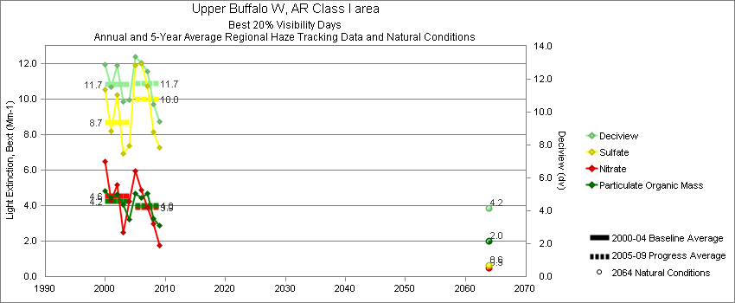
Upper Buffalo - Best 20% Visibility Days – 5-Year Average, Natural Conditions and Annual Data
Parameter | 2000-2004 | 2005-2009 | 2064 NC | 2000 | 2001 | 2002 | 2003 | 2004 | 2005 | 2006 | 2007 | 2008 | 2009
Deciview (dv) | 11.7 | 11.7 | 4.2 | 12.9 | 11.5 | 12.8 | 10.6 | 10.7 | 13.3 | 13.0 | 12.4 | 10.5 | 9.4
Sulfate Bext | 8.7 | 10.0 | 0.6 | 10.6 | 8.2 | 10.3 | 6.9 | 7.4 | 11.9 | 12.0 | 10.8 | 8.2 | 7.3
Nitrate Bext | 4.6 | 3.9 | 0.5 | 6.5 | 4.3 | 5.2 | 2.5 | 4.2 | 6.0 | 4.9 | 3.9 | 3.0 | 1.8
POM Bext | 4.2 | 4.0 | 2.0 | 4.8 | 4.5 | 4.6 | 4.1 | 3.2 | 4.7 | 4.4 | 4.7 | 3.3 | 2.9
EC Bext | 1.5 | 1.5 | 0.1 | 1.8 | 1.5 | 1.7 | 1.2 | 1.3 | 2.1 | 1.8 | 1.7 | 1.0 | 1.0
Soil Bext | 0.3 | 0.3 | 0.2 | 0.4 | 0.4 | 0.4 | 0.3 | 0.2 | 0.3 | 0.3 | 0.3 | 0.3 | 0.3
Coarse Mass Bext | 2.8 | 2.3 | 0.8 | 2.3 | 2.5 | 3.4 | 3.5 | 2.4 | 2.4 | 2.5 | 2.7 | 1.9 | 1.9
Sea Salt Bext | 0.1 | 0.2 | 0.1 | 0.0 | 0.0 | 0.0 | 0.1 | 0.2 | 0.3 | 0.1 | 0.3 | 0.2 | 0.2

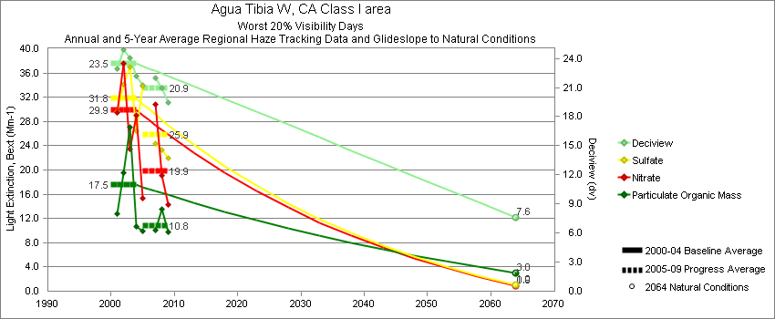
Agua Tibia - Worst 20% Visibility Days – 5-Year Average, Natural Conditions and Annual Data
Parameter | 2000-2004 | 2005-2009 | 2064 NC | 2000 | 2001 | 2002 | 2003 | 2004 | 2005 | 2006 | 2007 | 2008 | 2009
Deciview (dv) | 23.5 | 20.9 | 7.6 |  | 22.9 | 24.9 | 24.0 | 22.2 | 21.2 |  | 22.0 | 21.0 | 19.4
Sulfate Bext | 31.8 | 25.8 | 1.0 |  | 29.7 | 34.2 | 36.9 | 26.5 | 33.8 |  | 24.3 | 23.3 | 22.0
Nitrate Bext | 29.9 | 19.9 | 0.9 |  | 29.5 | 37.6 | 23.5 | 29.1 | 15.2 |  | 30.8 | 19.1 | 14.3
POM Bext | 17.5 | 10.8 | 3.0 |  | 12.8 | 19.6 | 27.1 | 10.7 | 9.9 |  | 10.1 | 13.5 | 9.8
EC Bext | 6.4 | 4.6 | 0.3 |  | 6.5 | 6.6 | 7.9 | 4.5 | 6.2 |  | 4.9 | 3.5 | 3.8
Soil Bext | 1.3 | 0.9 | 0.8 |  | 1.3 | 1.7 | 1.0 | 1.0 | 0.8 |  | 0.9 | 0.9 | 1.0
Coarse Mass Bext | 8.6 | 7.5 | 3.0 |  | 8.6 | 10.4 | 7.2 | 8.3 | 6.7 |  | 8.7 | 8.0 | 6.8
Sea Salt Bext | 0.8 | 1.8 | 1.7 |  | 0.4 | 0.8 | 0.0 | 2.0 | 0.8 |  | 1.9 | 3.1 | 1.4

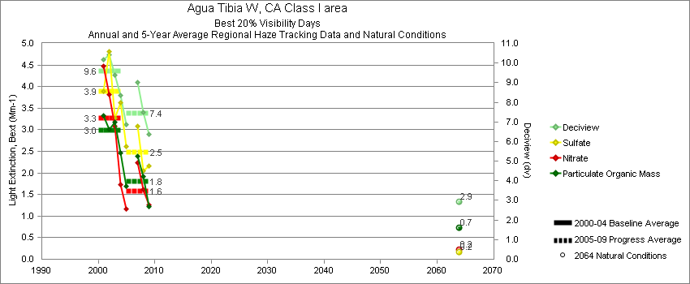
Agua Tibia - Best 20% Visibility Days – 5-Year Average, Natural Conditions and Annual Data
Parameter | 2000-2004 | 2005-2009 | 2064 NC | 2000 | 2001 | 2002 | 2003 | 2004 | 2005 | 2006 | 2007 | 2008 | 2009
Deciview (dv) | 9.6 | 7.4 | 2.9 |  | 10.2 | 10.4 | 9.4 | 8.4 | 6.9 |  | 9.0 | 7.5 | 6.3
Sulfate Bext | 3.9 | 2.5 | 0.2 |  | 3.9 | 4.8 | 3.3 | 3.6 | 2.6 |  | 3.1 | 2.1 | 2.2
Nitrate Bext | 3.3 | 1.6 | 0.2 |  | 4.5 | 3.8 | 3.1 | 1.7 | 1.2 |  | 2.2 | 1.6 | 1.3
POM Bext | 3.0 | 1.8 | 0.7 |  | 3.3 | 3.0 | 3.2 | 2.5 | 1.7 |  | 2.4 | 1.9 | 1.2
EC Bext | 1.9 | 1.2 | 0.1 |  | 2.0 | 2.1 | 2.1 | 1.3 | 1.3 |  | 1.6 | 1.3 | 0.8
Soil Bext | 0.5 | 0.4 | 0.3 |  | 0.3 | 0.6 | 0.5 | 0.4 | 0.2 |  | 0.6 | 0.4 | 0.3
Coarse Mass Bext | 2.4 | 2.4 | 0.7 |  | 2.4 | 2.8 | 2.1 | 2.3 | 1.8 |  | 3.7 | 2.3 | 1.9
Sea Salt Bext | 0.8 | 0.6 | 0.2 |  | 0.8 | 0.7 | 0.9 | 0.7 | 0.4 |  | 0.5 | 0.9 | 0.4

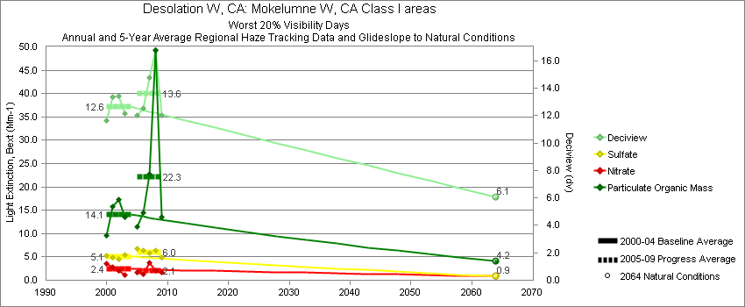
Bliss SP - Worst 20% Visibility Days – 5-Year Average, Natural Conditions and Annual Data
Parameter | 2000-2004 | 2005-2009 | 2064 NC | 2000 | 2001 | 2002 | 2003 | 2004 | 2005 | 2006 | 2007 | 2008 | 2009
Deciview (dv) | 12.6 | 13.6 | 6.1 | 11.6 | 13.4 | 13.4 | 12.2 |  | 12.0 | 12.5 | 14.8 | 16.8 | 12.0
Sulfate Bext | 5.1 | 6.0 | 0.9 | 5.3 | 4.9 | 4.6 | 5.5 |  | 6.9 | 6.3 | 5.8 | 6.3 | 4.9
Nitrate Bext | 2.4 | 2.1 | 0.9 | 3.6 | 2.7 | 2.2 | 1.1 |  | 1.8 | 1.4 | 3.7 | 2.1 | 1.7
POM Bext | 14.1 | 22.3 | 4.1 | 9.5 | 15.8 | 17.4 | 13.6 |  | 11.3 | 14.4 | 22.7 | 49.2 | 13.5
EC Bext | 3.0 | 3.7 | 0.4 | 2.8 | 3.5 | 3.3 | 2.4 |  | 3.1 | 2.8 | 3.9 | 6.3 | 2.4
Soil Bext | 1.0 | 0.8 | 1.0 | 0.5 | 1.9 | 1.0 | 0.6 |  | 0.5 | 0.9 | 0.8 | 0.9 | 0.7
Coarse Mass Bext | 2.1 | 2.1 | 2.3 | 1.5 | 3.2 | 1.9 | 1.8 |  | 1.9 | 2.4 | 2.2 | 2.3 | 2.0
Sea Salt Bext | 0.0 | 0.1 | 0.1 | 0.0 | 0.0 | 0.0 | 0.1 |  | 0.0 | 0.1 | 0.1 | 0.1 | 0.1

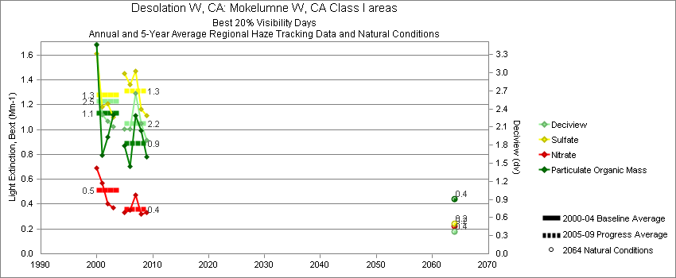
Bliss SP - Best 20% Visibility Days – 5-Year Average, Natural Conditions and Annual Data
Parameter | 2000-2004 | 2005-2009 | 2064 NC | 2000 | 2001 | 2002 | 2003 | 2004 | 2005 | 2006 | 2007 | 2008 | 2009
Deciview (dv) | 2.5 | 2.2 | 0.4 | 3.5 | 2.3 | 2.2 | 2.1 |  | 2.1 | 2.0 | 2.7 | 2.2 | 1.9
Sulfate Bext | 1.3 | 1.3 | 0.2 | 1.6 | 1.2 | 1.2 | 1.1 |  | 1.4 | 1.4 | 1.5 | 1.2 | 1.1
Nitrate Bext | 0.5 | 0.4 | 0.2 | 0.7 | 0.6 | 0.4 | 0.4 |  | 0.4 | 0.3 | 0.5 | 0.3 | 0.3
POM Bext | 1.1 | 0.9 | 0.4 | 1.7 | 0.8 | 0.9 | 1.1 |  | 0.9 | 0.7 | 1.1 | 1.0 | 0.8
EC Bext | 0.5 | 0.3 | 0.1 | 0.6 | 0.5 | 0.4 | 0.4 |  | 0.3 | 0.3 | 0.3 | 0.2 | 0.3
Soil Bext | 0.1 | 0.1 | 0.1 | 0.1 | 0.1 | 0.1 | 0.1 |  | 0.1 | 0.1 | 0.1 | 0.1 | 0.1
Coarse Mass Bext | 0.4 | 0.4 | 0.3 | 0.4 | 0.3 | 0.4 | 0.3 |  | 0.3 | 0.4 | 0.5 | 0.5 | 0.4
Sea Salt Bext | 0.1 | 0.1 | 0.0 | 0.2 | 0.2 | 0.1 | 0.0 |  | 0.1 | 0.1 | 0.1 | 0.1 | 0.1

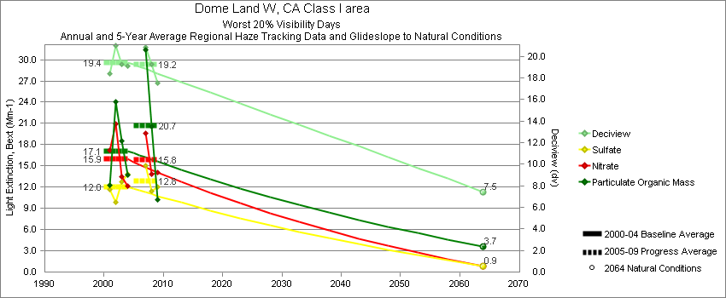
Dome Land - Worst 20% Visibility Days – 5-Year Average, Natural Conditions and Annual Data
Parameter | 2000-2004 | 2005-2009 | 2064 NC | 2000 | 2001 | 2002 | 2003 | 2004 | 2005 | 2006 | 2007 | 2008 | 2009
Deciview (dv) | 19.4 | 19.2 | 7.5 |  | 18.4 | 21.0 | 19.3 | 19.1 |  |  | 20.9 | 19.3 | 17.6
Sulfate Bext | 12.0 | 12.8 | 0.9 |  | 11.7 | 9.8 | 12.8 | 13.8 |  |  | 15.0 | 11.4 | 12.0
Nitrate Bext | 15.9 | 15.8 | 0.9 |  | 17.2 | 20.9 | 13.5 | 12.1 |  |  | 19.6 | 13.9 | 14.1
POM Bext | 17.1 | 20.7 | 3.7 |  | 12.3 | 24.0 | 18.5 | 13.7 |  |  | 31.4 | 20.5 | 10.2
EC Bext | 3.9 | 3.7 | 0.4 |  | 3.5 | 4.7 | 4.1 | 3.4 |  |  | 5.4 | 3.3 | 2.4
Soil Bext | 1.5 | 1.7 | 1.0 |  | 1.7 | 1.9 | 1.1 | 1.3 |  |  | 1.9 | 1.7 | 1.4
Coarse Mass Bext | 11.0 | 11.7 | 4.2 |  | 7.5 | 13.1 | 9.8 | 13.6 |  |  | 13.3 | 12.0 | 9.8
Sea Salt Bext | 0.2 | 0.2 | 0.2 |  | 0.4 | 0.0 | 0.1 | 0.2 |  |  | 0.1 | 0.2 | 0.4

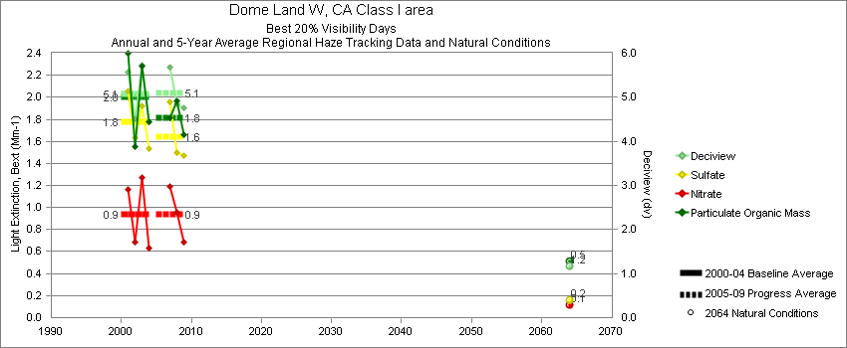
Dome Land - Best 20% Visibility Days – 5-Year Average, Natural Conditions and Annual Data
Parameter | 2000-2004 | 2005-2009 | 2064 NC | 2000 | 2001 | 2002 | 2003 | 2004 | 2005 | 2006 | 2007 | 2008 | 2009
Deciview (dv) | 5.1 | 5.1 | 1.2 |  | 5.6 | 4.5 | 5.7 | 4.4 |  |  | 5.7 | 4.9 | 4.8
Sulfate Bext | 1.8 | 1.6 | 0.2 |  | 2.1 | 1.6 | 1.9 | 1.5 |  |  | 2.0 | 1.5 | 1.5
Nitrate Bext | 0.9 | 0.9 | 0.1 |  | 1.2 | 0.7 | 1.3 | 0.6 |  |  | 1.2 | 1.0 | 0.7
POM Bext | 2.0 | 1.8 | 0.5 |  | 2.4 | 1.5 | 2.3 | 1.8 |  |  | 1.8 | 2.0 | 1.7
EC Bext | 0.8 | 0.7 | 0.1 |  | 1.0 | 0.9 | 0.9 | 0.6 |  |  | 0.7 | 0.7 | 0.8
Soil Bext | 0.1 | 0.2 | 0.1 |  | 0.1 | 0.2 | 0.2 | 0.1 |  |  | 0.3 | 0.1 | 0.2
Coarse Mass Bext | 0.9 | 1.2 | 0.3 |  | 0.7 | 0.8 | 1.3 | 0.9 |  |  | 1.6 | 0.8 | 1.3
Sea Salt Bext | 0.1 | 0.2 | 0.1 |  | 0.1 | 0.1 | 0.0 | 0.1 |  |  | 0.2 | 0.3 | 0.1

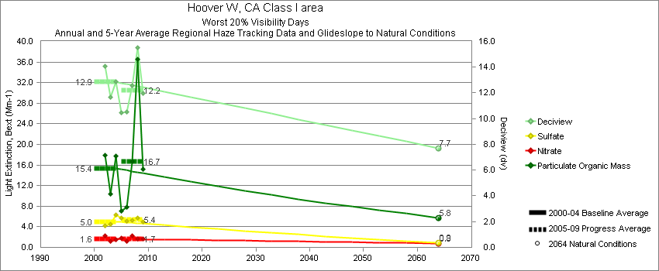
Hoover - Worst 20% Visibility Days – 5-Year Average, Natural Conditions and Annual Data
Parameter | 2000-2004 | 2005-2009 | 2064 NC | 2000 | 2001 | 2002 | 2003 | 2004 | 2005 | 2006 | 2007 | 2008 | 2009
Deciview (dv) | 12.9 | 12.2 | 7.7 |  |  | 14.1 | 11.7 | 12.9 | 10.4 | 10.5 | 12.6 | 15.5 | 12.0
Sulfate Bext | 5.0 | 5.4 | 0.9 |  |  | 4.2 | 4.5 | 6.3 | 5.7 | 5.1 | 5.2 | 5.8 | 4.9
Nitrate Bext | 1.6 | 1.7 | 0.8 |  |  | 2.2 | 1.2 | 1.5 | 1.7 | 1.1 | 2.3 | 1.7 | 1.7
POM Bext | 15.4 | 16.7 | 5.8 |  |  | 17.9 | 10.4 | 17.8 | 7.1 | 7.9 | 16.6 | 36.6 | 15.2
EC Bext | 2.4 | 3.2 | 0.5 |  |  | 2.7 | 2.2 | 2.4 | 1.8 | 2.3 | 4.2 | 5.4 | 2.3
Soil Bext | 1.6 | 1.0 | 1.1 |  |  | 2.4 | 1.0 | 1.3 | 0.8 | 1.0 | 1.1 | 1.4 | 1.0
Coarse Mass Bext | 4.7 | 2.4 | 4.7 |  |  | 5.6 | 4.7 | 4.0 | 2.3 | 2.7 | 2.1 | 2.8 | 2.2
Sea Salt Bext | 0.1 | 0.0 | 0.1 |  |  | 0.3 | 0.0 | 0.1 | 0.0 | 0.0 | 0.0 | 0.0 | 0.0

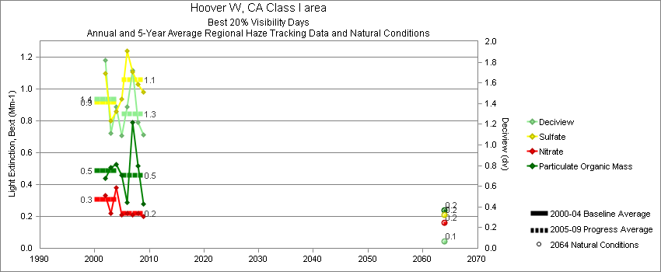
Hoover - Best 20% Visibility Days – 5-Year Average, Natural Conditions and Annual Data
Parameter | 2000-2004 | 2005-2009 | 2064 NC | 2000 | 2001 | 2002 | 2003 | 2004 | 2005 | 2006 | 2007 | 2008 | 2009
Deciview (dv) | 1.4 | 1.3 | 0.1 |  |  | 1.8 | 1.1 | 1.4 | 1.1 | 1.3 | 1.7 | 1.2 | 1.1
Sulfate Bext | 0.9 | 1.1 | 0.2 |  |  | 1.1 | 0.8 | 0.9 | 0.9 | 1.2 | 1.1 | 1.0 | 1.0
Nitrate Bext | 0.3 | 0.2 | 0.2 |  |  | 0.3 | 0.2 | 0.4 | 0.2 | 0.2 | 0.2 | 0.2 | 0.2
POM Bext | 0.5 | 0.5 | 0.2 |  |  | 0.4 | 0.5 | 0.5 | 0.5 | 0.3 | 0.8 | 0.5 | 0.3
EC Bext | 0.2 | 0.2 | 0.1 |  |  | 0.3 | 0.2 | 0.2 | 0.2 | 0.2 | 0.2 | 0.2 | 0.1
Soil Bext | 0.1 | 0.1 | 0.1 |  |  | 0.1 | 0.1 | 0.1 | 0.1 | 0.1 | 0.2 | 0.1 | 0.1
Coarse Mass Bext | 0.5 | 0.3 | 0.3 |  |  | 0.7 | 0.3 | 0.4 | 0.3 | 0.4 | 0.4 | 0.2 | 0.4
Sea Salt Bext | 0.0 | 0.0 | 0.0 |  |  | 0.0 | 0.0 | 0.0 | 0.0 | 0.0 | 0.0 | 0.0 | 0.0

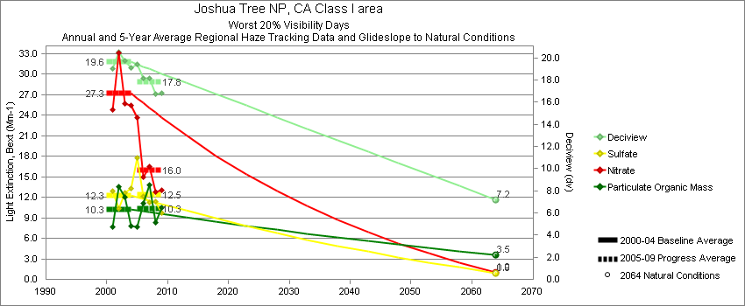
Joshua Tree - Worst 20% Visibility Days – 5-Year Average, Natural Conditions and Annual Data
Parameter | 2000-2004 | 2005-2009 | 2064 NC | 2000 | 2001 | 2002 | 2003 | 2004 | 2005 | 2006 | 2007 | 2008 | 2009
Deciview (dv) | 19.6 | 17.8 | 7.2 |  | 19.1 | 20.5 | 19.8 | 19.1 | 19.4 | 18.1 | 18.1 | 16.7 | 16.8
Sulfate Bext | 12.3 | 12.5 | 0.9 |  | 12.9 | 10.4 | 12.6 | 13.3 | 17.8 | 12.2 | 11.3 | 11.3 | 9.8
Nitrate Bext | 27.3 | 16.0 | 1.0 |  | 24.8 | 33.1 | 25.6 | 25.5 | 22.8 | 15.0 | 16.5 | 12.8 | 13.1
POM Bext | 10.3 | 10.3 | 3.5 |  | 7.6 | 13.6 | 12.0 | 7.8 | 7.7 | 11.1 | 13.8 | 8.4 | 10.5
EC Bext | 4.1 | 3.6 | 0.4 |  | 3.5 | 4.6 | 4.6 | 3.8 | 4.4 | 4.3 | 3.6 | 2.7 | 3.1
Soil Bext | 1.6 | 1.8 | 1.0 |  | 2.4 | 1.5 | 1.2 | 1.2 | 1.2 | 1.9 | 1.8 | 2.1 | 1.9
Coarse Mass Bext | 7.8 | 6.8 | 3.7 |  | 9.2 | 7.9 | 7.1 | 7.1 | 6.2 | 7.9 | 7.2 | 6.4 | 6.1
Sea Salt Bext | 0.2 | 0.4 | 0.2 |  | 0.0 | 0.2 | 0.1 | 0.5 | 0.4 | 0.2 | 0.5 | 0.4 | 0.4

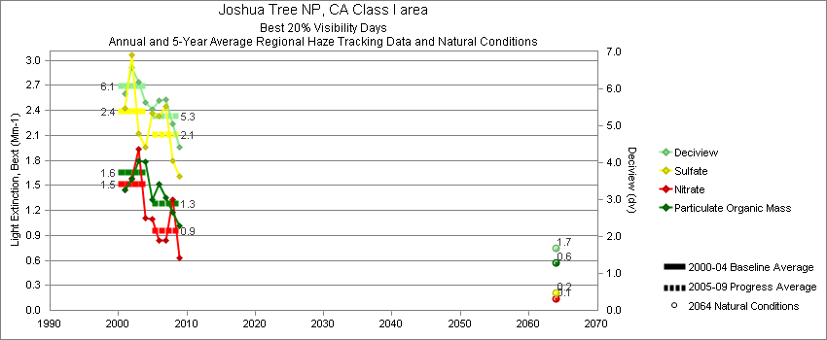
Joshua Tree - Best 20% Visibility Days – 5-Year Average, Natural Conditions and Annual Data
Parameter | 2000-2004 | 2005-2009 | 2064 NC | 2000 | 2001 | 2002 | 2003 | 2004 | 2005 | 2006 | 2007 | 2008 | 2009
Deciview (dv) | 6.1 | 5.3 | 1.7 |  | 5.9 | 6.6 | 6.2 | 5.6 | 5.5 | 5.7 | 5.7 | 5.1 | 4.4
Sulfate Bext | 2.4 | 2.1 | 0.2 |  | 2.4 | 3.1 | 2.1 | 2.0 | 2.4 | 2.3 | 2.4 | 1.8 | 1.6
Nitrate Bext | 1.5 | 0.9 | 0.1 |  | 1.4 | 1.6 | 1.9 | 1.1 | 1.1 | 0.8 | 0.8 | 1.3 | 0.6
POM Bext | 1.6 | 1.3 | 0.6 |  | 1.4 | 1.6 | 1.8 | 1.8 | 1.3 | 1.5 | 1.4 | 1.2 | 1.0
EC Bext | 0.9 | 0.7 | 0.1 |  | 0.9 | 0.8 | 1.0 | 0.9 | 0.8 | 0.8 | 0.7 | 0.6 | 0.6
Soil Bext | 0.4 | 0.4 | 0.2 |  | 0.4 | 0.5 | 0.3 | 0.4 | 0.3 | 0.4 | 0.5 | 0.3 | 0.4
Coarse Mass Bext | 1.6 | 1.5 | 0.6 |  | 1.6 | 1.9 | 1.5 | 1.4 | 1.4 | 1.7 | 1.9 | 1.4 | 1.3
Sea Salt Bext | 0.1 | 0.1 | 0.1 |  | 0.1 | 0.0 | 0.1 | 0.2 | 0.1 | 0.2 | 0.1 | 0.2 | 0.1

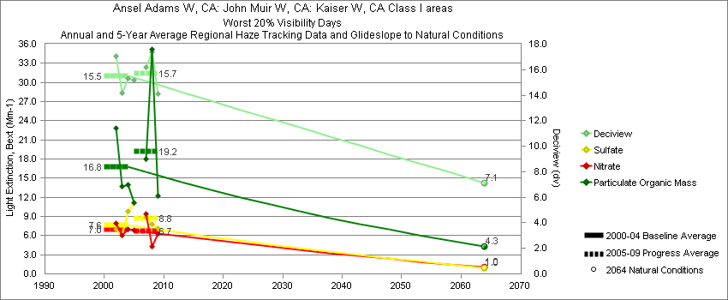
Kaiser - Worst 20% Visibility Days – 5-Year Average, Natural Conditions and Annual Data
Parameter | 2000-2004 | 2005-2009 | 2064 NC | 2000 | 2001 | 2002 | 2003 | 2004 | 2005 | 2006 | 2007 | 2008 | 2009
Deciview (dv) | 15.5 | 15.7 | 7.1 |  |  | 17.1 | 14.2 | 15.3 | 15.3 |  | 16.2 | 17.4 | 14.1
Sulfate Bext | 7.6 | 8.8 | 1.0 |  |  | 7.0 | 6.1 | 9.8 | 11.3 |  | 8.9 | 7.8 | 7.1
Nitrate Bext | 7.0 | 6.7 | 1.0 |  |  | 7.9 | 6.1 | 6.9 | 6.8 |  | 9.4 | 4.3 | 6.2
POM Bext | 16.8 | 19.2 | 4.3 |  |  | 22.8 | 13.7 | 14.0 | 11.4 |  | 17.9 | 35.1 | 12.2
EC Bext | 3.4 | 3.2 | 0.4 |  |  | 5.2 | 2.9 | 2.3 | 2.9 |  | 3.5 | 4.3 | 2.2
Soil Bext | 1.1 | 1.1 | 0.9 |  |  | 1.4 | 0.7 | 1.3 | 0.8 |  | 1.3 | 1.3 | 1.1
Coarse Mass Bext | 4.3 | 4.3 | 3.8 |  |  | 4.9 | 3.1 | 4.9 | 4.4 |  | 4.5 | 4.4 | 3.9
Sea Salt Bext | 0.1 | 0.1 | 0.2 |  |  | 0.0 | 0.2 | 0.2 | 0.1 |  | 0.1 | 0.1 | 0.2

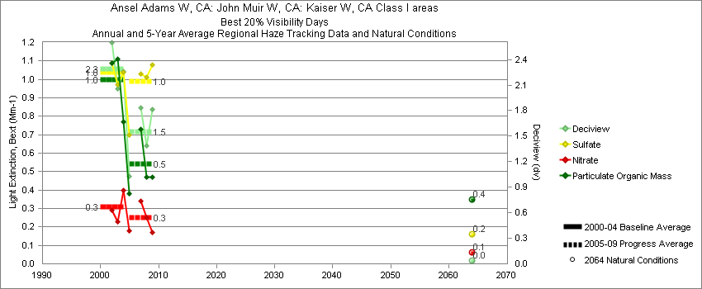
Kaiser - Best 20% Visibility Days – 5-Year Average, Natural Conditions and Annual Data
Parameter | 2000-2004 | 2005-2009 | 2064 NC | 2000 | 2001 | 2002 | 2003 | 2004 | 2005 | 2006 | 2007 | 2008 | 2009
Deciview (dv) | 2.3 | 1.6 | 0.0 |  |  | 2.6 | 2.1 | 2.3 | 1.2 |  | 1.8 | 1.4 | 1.8
Sulfate Bext | 1.0 | 1.0 | 0.2 |  |  | 1.1 | 1.0 | 1.0 | 0.8 |  | 1.0 | 1.0 | 1.1
Nitrate Bext | 0.3 | 0.2 | 0.1 |  |  | 0.3 | 0.2 | 0.4 | 0.2 |  | 0.3 | 0.2 | 0.2
POM Bext | 1.0 | 0.5 | 0.3 |  |  | 1.1 | 1.1 | 0.8 | 0.5 |  | 0.7 | 0.5 | 0.5
EC Bext | 0.7 | 0.4 | 0.1 |  |  | 0.7 | 0.6 | 0.8 | 0.4 |  | 0.4 | 0.2 | 0.5
Soil Bext | 0.1 | 0.1 | 0.1 |  |  | 0.1 | 0.1 | 0.1 | 0.1 |  | 0.1 | 0.1 | 0.1
Coarse Mass Bext | 0.4 | 0.4 | 0.3 |  |  | 0.5 | 0.3 | 0.3 | 0.2 |  | 0.4 | 0.4 | 0.7
Sea Salt Bext | 0.1 | 0.1 | 0.0 |  |  | 0.1 | 0.0 | 0.1 | 0.1 |  | 0.0 | 0.1 | 0.0

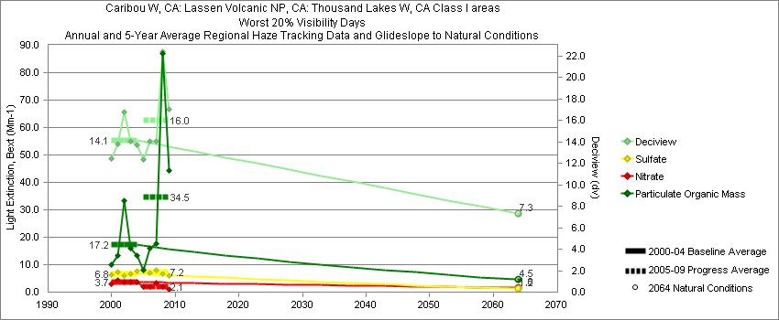
Lassen Volcanic - Worst 20% Visibility Days – 5-Year Average, Natural Conditions and Annual Data
Parameter | 2000-2004 | 2005-2009 | 2064 NC | 2000 | 2001 | 2002 | 2003 | 2004 | 2005 | 2006 | 2007 | 2008 | 2009
Deciview (dv) | 14.1 | 16.0 | 7.3 | 12.5 | 13.8 | 16.8 | 14.0 | 13.7 | 12.4 | 14.1 | 14.1 | 22.4 | 17.1
Sulfate Bext | 6.8 | 7.2 | 1.2 | 6.3 | 7.3 | 6.1 | 6.6 | 7.5 | 8.4 | 7.1 | 7.9 | 6.6 | 5.9
Nitrate Bext | 3.7 | 2.1 | 1.6 | 3.1 | 4.5 | 3.5 | 3.6 | 3.6 | 2.0 | 2.1 | 3.4 | 2.0 | 0.9
POM Bext | 17.2 | 34.5 | 4.5 | 10.0 | 13.4 | 33.3 | 15.9 | 13.3 | 7.9 | 15.9 | 17.8 | 86.9 | 44.2
EC Bext | 3.1 | 5.2 | 0.4 | 3.2 | 2.9 | 3.6 | 3.2 | 2.6 | 2.5 | 3.5 | 3.3 | 12.1 | 4.5
Soil Bext | 1.0 | 0.9 | 0.9 | 0.6 | 1.4 | 1.3 | 0.7 | 0.9 | 0.8 | 1.0 | 0.9 | 1.4 | 0.5
Coarse Mass Bext | 2.0 | 3.2 | 2.4 | 2.0 | 2.1 | 2.9 | 1.3 | 1.8 | 3.2 | 3.6 | 2.4 | 4.4 | 2.3
Sea Salt Bext | 0.0 | 0.1 | 0.1 | 0.0 | 0.2 | 0.0 | 0.0 | 0.0 | 0.1 | 0.1 | 0.1 | 0.0 | 0.1

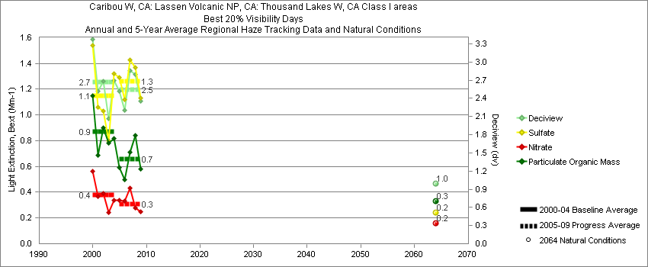
Lassen Volcanic - Best 20% Visibility Days – 5-Year Average, Natural Conditions and Annual Data
Parameter | 2000-2004 | 2005-2009 | 2064 NC | 2000 | 2001 | 2002 | 2003 | 2004 | 2005 | 2006 | 2007 | 2008 | 2009
Deciview (dv) | 2.7 | 2.5 | 1.0 | 3.4 | 2.5 | 2.7 | 2.1 | 2.7 | 2.5 | 2.2 | 2.9 | 2.8 | 2.4
Sulfate Bext | 1.2 | 1.3 | 0.2 | 1.5 | 1.1 | 1.0 | 0.8 | 1.3 | 1.3 | 1.1 | 1.4 | 1.4 | 1.1
Nitrate Bext | 0.4 | 0.3 | 0.2 | 0.6 | 0.4 | 0.4 | 0.2 | 0.3 | 0.4 | 0.2 | 0.4 | 0.3 | 0.2
POM Bext | 0.9 | 0.7 | 0.3 | 1.2 | 0.7 | 0.9 | 0.8 | 0.8 | 0.6 | 0.6 | 0.7 | 0.8 | 0.6
EC Bext | 0.4 | 0.2 | 0.1 | 0.4 | 0.4 | 0.4 | 0.3 | 0.3 | 0.3 | 0.2 | 0.2 | 0.2 | 0.3
Soil Bext | 0.1 | 0.1 | 0.1 | 0.1 | 0.1 | 0.1 | 0.1 | 0.1 | 0.1 | 0.0 | 0.1 | 0.1 | 0.1
Coarse Mass Bext | 0.2 | 0.3 | 0.1 | 0.2 | 0.2 | 0.2 | 0.1 | 0.1 | 0.2 | 0.2 | 0.3 | 0.4 | 0.3
Sea Salt Bext | 0.1 | 0.1 | 0.1 | 0.1 | 0.0 | 0.1 | 0.0 | 0.1 | 0.2 | 0.1 | 0.2 | 0.1 | 0.0

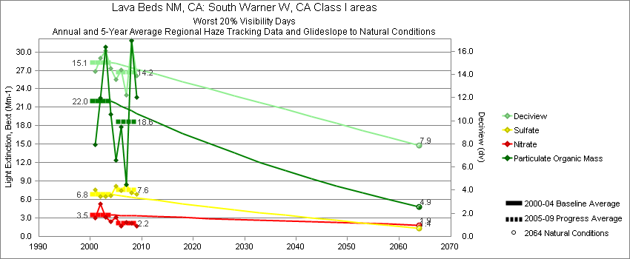
Lava Beds - Worst 20% Visibility Days – 5-Year Average, Natural Conditions and Annual Data
Parameter | 2000-2004 | 2005-2009 | 2064 NC | 2000 | 2001 | 2002 | 2003 | 2004 | 2005 | 2006 | 2007 | 2008 | 2009
Deciview (dv) | 15.1 | 14.2 | 7.9 |  | 14.3 | 15.4 | 16.0 | 14.5 | 13.5 | 14.4 | 12.2 | 16.9 | 13.9
Sulfate Bext | 6.8 | 7.6 | 1.4 |  | 7.6 | 6.5 | 6.5 | 6.6 | 8.2 | 7.4 | 8.5 | 7.1 | 6.8
Nitrate Bext | 3.5 | 2.2 | 1.9 |  | 3.0 | 5.3 | 3.1 | 2.4 | 3.2 | 1.7 | 2.3 | 2.2 | 1.7
POM Bext | 22.0 | 18.6 | 4.9 |  | 15.0 | 22.5 | 30.8 | 19.8 | 12.3 | 17.8 | 8.4 | 31.8 | 22.7
EC Bext | 3.3 | 3.1 | 0.5 |  | 2.8 | 3.3 | 4.2 | 3.1 | 3.2 | 3.2 | 2.2 | 3.9 | 3.1
Soil Bext | 1.0 | 0.8 | 1.0 |  | 1.6 | 0.9 | 0.7 | 0.8 | 0.5 | 0.9 | 0.8 | 0.7 | 1.0
Coarse Mass Bext | 2.6 | 2.3 | 2.8 |  | 2.9 | 2.3 | 2.5 | 2.9 | 1.9 | 2.7 | 1.9 | 2.5 | 2.4
Sea Salt Bext | 0.1 | 0.1 | 0.1 |  | 0.0 | 0.0 | 0.0 | 0.1 | 0.2 | 0.0 | 0.2 | 0.0 | 0.2

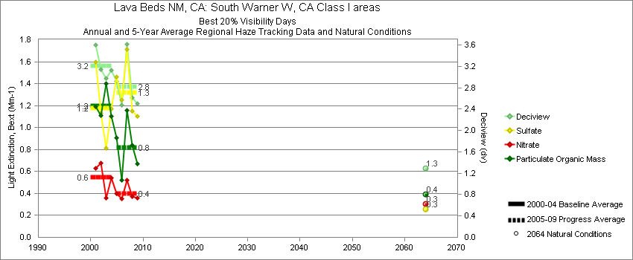
Lava Beds - Best 20% Visibility Days – 5-Year Average, Natural Conditions and Annual Data
Parameter | 2000-2004 | 2005-2009 | 2064 NC | 2000 | 2001 | 2002 | 2003 | 2004 | 2005 | 2006 | 2007 | 2008 | 2009
Deciview (dv) | 3.2 | 2.8 | 1.3 |  | 3.6 | 3.1 | 3.0 | 3.1 | 2.9 | 2.4 | 3.6 | 2.6 | 2.5
Sulfate Bext | 1.2 | 1.3 | 0.3 |  | 1.6 | 1.1 | 0.8 | 1.2 | 1.5 | 1.2 | 1.7 | 1.2 | 1.1
Nitrate Bext | 0.6 | 0.4 | 0.3 |  | 0.6 | 0.7 | 0.4 | 0.5 | 0.4 | 0.3 | 0.5 | 0.4 | 0.4
POM Bext | 1.2 | 0.8 | 0.4 |  | 1.2 | 1.1 | 1.4 | 1.1 | 0.9 | 0.5 | 1.2 | 0.8 | 0.7
EC Bext | 0.4 | 0.3 | 0.1 |  | 0.3 | 0.4 | 0.5 | 0.3 | 0.3 | 0.3 | 0.3 | 0.2 | 0.3
Soil Bext | 0.1 | 0.1 | 0.1 |  | 0.1 | 0.1 | 0.1 | 0.1 | 0.0 | 0.1 | 0.1 | 0.1 | 0.1
Coarse Mass Bext | 0.4 | 0.2 | 0.3 |  | 0.4 | 0.4 | 0.3 | 0.3 | 0.2 | 0.2 | 0.4 | 0.3 | 0.2
Sea Salt Bext | 0.1 | 0.2 | 0.0 |  | 0.1 | 0.0 | 0.0 | 0.2 | 0.2 | 0.2 | 0.2 | 0.2 | 0.2

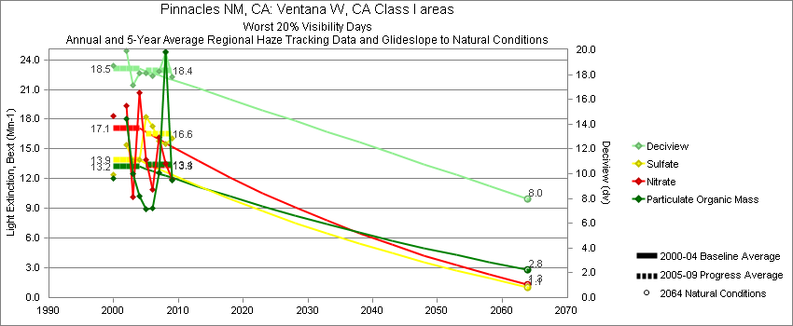
Pinnacles - Worst 20% Visibility Days – 5-Year Average, Natural Conditions and Annual Data
Parameter | 2000-2004 | 2005-2009 | 2064 NC | 2000 | 2001 | 2002 | 2003 | 2004 | 2005 | 2006 | 2007 | 2008 | 2009
Deciview (dv) | 18.5 | 18.4 | 8.0 | 18.7 |  | 19.9 | 17.1 | 18.1 | 18.1 | 17.9 | 18.3 | 19.8 | 17.8
Sulfate Bext | 13.9 | 16.6 | 1.0 | 12.4 |  | 15.4 | 13.8 | 13.9 | 18.2 | 17.3 | 15.7 | 15.5 | 16.1
Nitrate Bext | 17.1 | 13.3 | 1.3 | 18.3 |  | 19.3 | 10.1 | 20.7 | 13.9 | 10.9 | 16.2 | 13.5 | 12.0
POM Bext | 13.2 | 13.4 | 2.8 | 12.1 |  | 18.1 | 12.5 | 10.2 | 8.9 | 9.0 | 12.6 | 24.8 | 11.8
EC Bext | 4.6 | 3.5 | 0.3 | 6.4 |  | 4.7 | 3.5 | 3.6 | 4.2 | 3.4 | 3.4 | 3.9 | 2.5
Soil Bext | 0.6 | 0.6 | 0.6 | 0.6 |  | 0.6 | 0.5 | 0.6 | 0.4 | 0.8 | 0.5 | 0.6 | 0.6
Coarse Mass Bext | 3.8 | 4.9 | 2.7 | 3.8 |  | 4.3 | 4.0 | 3.0 | 4.2 | 6.0 | 4.7 | 5.1 | 4.4
Sea Salt Bext | 0.9 | 2.5 | 2.7 | 0.9 |  | 1.3 | 0.6 | 0.9 | 1.5 | 2.0 | 2.0 | 3.5 | 3.4

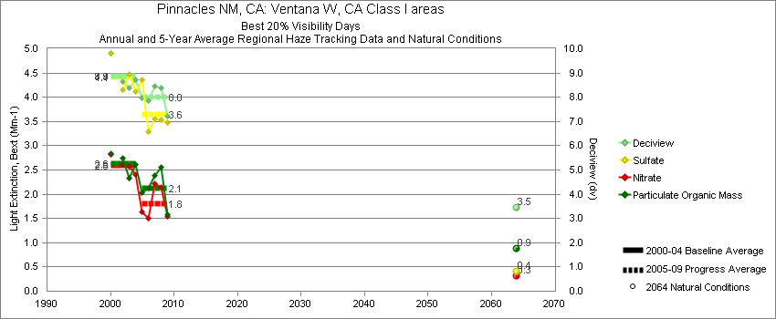
Pinnacles - Best 20% Visibility Days – 5-Year Average, Natural Conditions and Annual Data
Parameter | 2000-2004 | 2005-2009 | 2064 NC | 2000 | 2001 | 2002 | 2003 | 2004 | 2005 | 2006 | 2007 | 2008 | 2009
Deciview (dv) | 8.9 | 8.0 | 3.5 | 9.8 |  | 8.6 | 8.4 | 8.7 | 8.0 | 7.9 | 8.5 | 8.4 | 7.2
Sulfate Bext | 4.4 | 3.6 | 0.4 | 4.9 |  | 4.2 | 4.5 | 4.1 | 4.4 | 3.3 | 3.5 | 3.5 | 3.5
Nitrate Bext | 2.6 | 1.8 | 0.3 | 2.8 |  | 2.6 | 2.6 | 2.4 | 1.7 | 1.5 | 2.2 | 2.1 | 1.5
POM Bext | 2.6 | 2.1 | 0.9 | 2.8 |  | 2.7 | 2.3 | 2.6 | 2.0 | 2.1 | 2.4 | 2.6 | 1.6
EC Bext | 1.2 | 1.0 | 0.1 | 1.5 |  | 1.2 | 1.1 | 1.2 | 1.1 | 1.1 | 1.1 | 0.8 | 0.7
Soil Bext | 0.2 | 0.2 | 0.2 | 0.2 |  | 0.2 | 0.1 | 0.2 | 0.1 | 0.1 | 0.2 | 0.1 | 0.2
Coarse Mass Bext | 1.7 | 1.7 | 0.9 | 1.9 |  | 1.7 | 1.4 | 1.7 | 1.7 | 1.3 | 2.1 | 1.7 | 1.5
Sea Salt Bext | 0.9 | 1.1 | 0.3 | 1.7 |  | 0.4 | 0.4 | 1.1 | 0.6 | 1.6 | 1.0 | 1.6 | 0.8

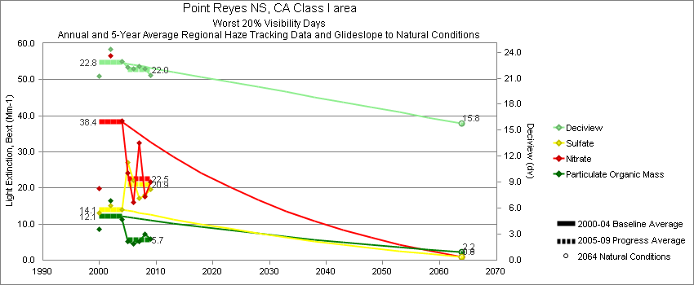
Point Reyes - Worst 20% Visibility Days – 5-Year Average, Natural Conditions and Annual Data
Parameter | 2000-2004 | 2005-2009 | 2064 NC | 2000 | 2001 | 2002 | 2003 | 2004 | 2005 | 2006 | 2007 | 2008 | 2009
Deciview (dv) | 22.8 | 22.0 | 15.8 | 21.2 |  | 24.3 |  | 22.9 | 22.3 | 22.0 | 22.4 | 22.1 | 21.3
Sulfate Bext | 14.1 | 20.9 | 0.8 | 13.1 |  | 15.2 |  | 13.9 | 27.6 | 22.2 | 17.1 | 17.9 | 19.7
Nitrate Bext | 38.4 | 22.5 | 0.9 | 19.9 |  | 56.6 |  | 38.7 | 24.8 | 16.0 | 32.4 | 17.7 | 21.7
POM Bext | 12.1 | 5.7 | 2.2 | 8.6 |  | 16.4 |  | 11.2 | 5.4 | 4.6 | 5.3 | 7.2 | 5.8
EC Bext | 3.3 | 2.0 | 0.2 | 3.9 |  | 3.1 |  | 2.8 | 2.6 | 1.9 | 2.2 | 1.5 | 1.6
Soil Bext | 0.4 | 0.3 | 0.4 | 0.4 |  | 0.5 |  | 0.3 | 0.2 | 0.3 | 0.2 | 0.4 | 0.3
Coarse Mass Bext | 7.5 | 7.8 | 3.3 | 7.6 |  | 7.7 |  | 7.1 | 5.8 | 9.6 | 8.6 | 9.8 | 5.4
Sea Salt Bext | 21.2 | 23.4 | 29.7 | 19.8 |  | 23.2 |  | 20.6 | 18.5 | 26.0 | 24.0 | 27.6 | 21.2

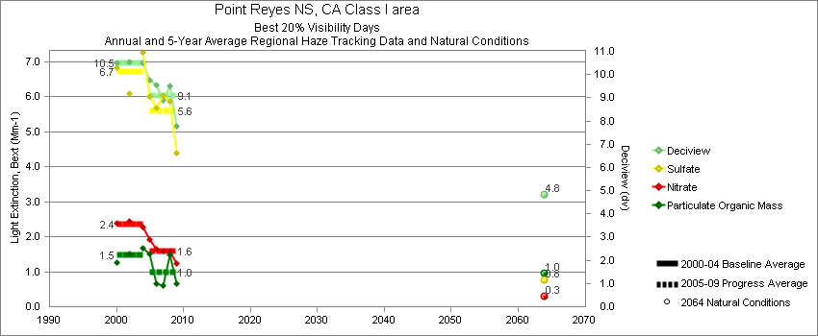
Point Reyes - Best 20% Visibility Days – 5-Year Average, Natural Conditions and Annual Data
Parameter | 2000-2004 | 2005-2009 | 2064 NC | 2000 | 2001 | 2002 | 2003 | 2004 | 2005 | 2006 | 2007 | 2008 | 2009
Deciview (dv) | 10.5 | 9.1 | 4.8 | 10.5 |  | 10.5 |  | 10.5 | 9.8 | 9.6 | 8.9 | 9.5 | 7.8
Sulfate Bext | 6.7 | 5.6 | 0.8 | 6.8 |  | 6.1 |  | 7.3 | 6.0 | 5.7 | 6.0 | 5.9 | 4.4
Nitrate Bext | 2.4 | 1.6 | 0.3 | 2.4 |  | 2.4 |  | 2.3 | 1.9 | 1.6 | 1.6 | 1.6 | 1.2
POM Bext | 1.5 | 1.0 | 1.0 | 1.3 |  | 1.5 |  | 1.7 | 1.5 | 0.7 | 0.6 | 1.5 | 0.6
EC Bext | 0.6 | 0.3 | 0.1 | 0.5 |  | 0.6 |  | 0.6 | 0.5 | 0.3 | 0.3 | 0.4 | 0.2
Soil Bext | 0.1 | 0.1 | 0.1 | 0.1 |  | 0.1 |  | 0.1 | 0.1 | 0.1 | 0.1 | 0.1 | 0.1
Coarse Mass Bext | 2.3 | 1.6 | 0.6 | 2.6 |  | 2.5 |  | 1.8 | 1.6 | 2.1 | 1.6 | 1.5 | 1.1
Sea Salt Bext | 3.4 | 3.2 | 1.4 | 3.2 |  | 3.7 |  | 3.4 | 3.3 | 4.0 | 2.7 | 3.5 | 2.4

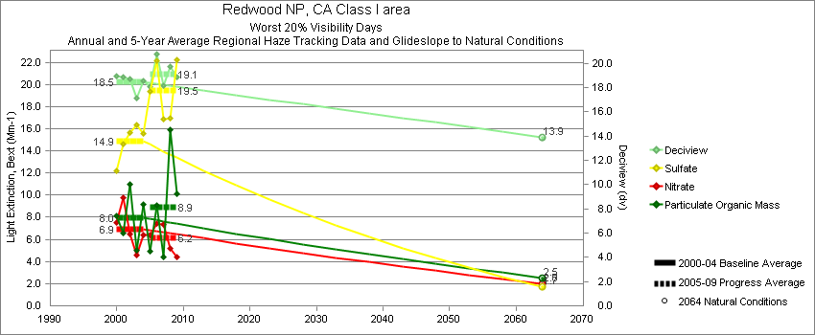
Redwood - Worst 20% Visibility Days – 5-Year Average, Natural Conditions and Annual Data
Parameter | 2000-2004 | 2005-2009 | 2064 NC | 2000 | 2001 | 2002 | 2003 | 2004 | 2005 | 2006 | 2007 | 2008 | 2009
Deciview (dv) | 18.5 | 19.1 | 13.9 | 19.0 | 18.9 | 18.7 | 17.2 | 18.6 | 18.1 | 20.8 | 18.2 | 19.8 | 18.9
Sulfate Bext | 14.9 | 19.5 | 1.7 | 12.2 | 14.6 | 15.7 | 16.4 | 15.6 | 19.3 | 22.1 | 16.8 | 17.0 | 22.2
Nitrate Bext | 7.0 | 6.2 | 2.0 | 7.5 | 9.8 | 6.5 | 4.5 | 6.4 | 6.5 | 7.5 | 7.4 | 5.1 | 4.4
POM Bext | 8.0 | 8.9 | 2.5 | 8.2 | 6.6 | 11.0 | 5.0 | 9.1 | 4.9 | 9.0 | 4.4 | 15.9 | 10.2
EC Bext | 1.5 | 1.2 | 0.2 | 1.9 | 1.4 | 1.8 | 0.7 | 1.5 | 0.9 | 1.5 | 0.9 | 1.4 | 1.2
Soil Bext | 0.3 | 0.2 | 0.3 | 0.2 | 0.4 | 0.4 | 0.2 | 0.3 | 0.2 | 0.3 | 0.2 | 0.2 | 0.3
Coarse Mass Bext | 4.1 | 3.9 | 3.4 | 4.8 | 3.4 | 4.0 | 3.8 | 4.3 | 3.3 | 5.4 | 3.3 | 4.0 | 3.5
Sea Salt Bext | 17.6 | 20.4 | 20.0 | 22.0 | 19.5 | 15.2 | 14.8 | 16.7 | 16.4 | 27.6 | 18.9 | 21.7 | 17.6

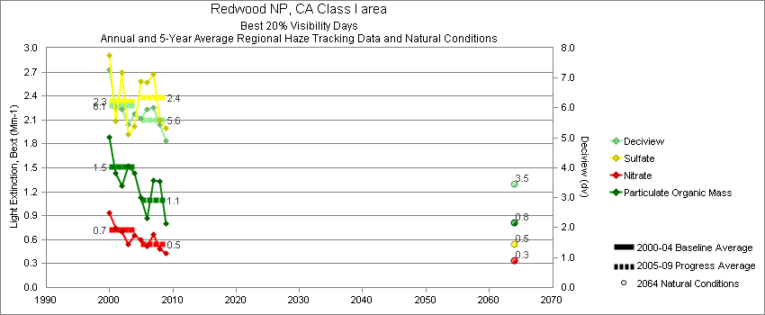
Redwood - Best 20% Visibility Days – 5-Year Average, Natural Conditions and Annual Data
Parameter | 2000-2004 | 2005-2009 | 2064 NC | 2000 | 2001 | 2002 | 2003 | 2004 | 2005 | 2006 | 2007 | 2008 | 2009
Deciview (dv) | 6.1 | 5.6 | 3.5 | 7.3 | 6.0 | 5.9 | 5.4 | 5.8 | 5.7 | 5.9 | 6.0 | 5.4 | 4.9
Sulfate Bext | 2.3 | 2.4 | 0.5 | 2.9 | 2.1 | 2.7 | 1.9 | 2.0 | 2.6 | 2.6 | 2.7 | 2.1 | 2.0
Nitrate Bext | 0.7 | 0.5 | 0.3 | 0.9 | 0.7 | 0.7 | 0.5 | 0.6 | 0.6 | 0.5 | 0.7 | 0.5 | 0.4
POM Bext | 1.5 | 1.1 | 0.8 | 1.9 | 1.4 | 1.3 | 1.5 | 1.4 | 1.1 | 0.9 | 1.3 | 1.3 | 0.8
EC Bext | 0.5 | 0.3 | 0.1 | 0.8 | 0.5 | 0.4 | 0.3 | 0.5 | 0.4 | 0.2 | 0.3 | 0.3 | 0.2
Soil Bext | 0.1 | 0.0 | 0.1 | 0.1 | 0.0 | 0.0 | 0.1 | 0.0 | 0.0 | 0.0 | 0.1 | 0.0 | 0.0
Coarse Mass Bext | 0.9 | 0.8 | 0.6 | 1.2 | 0.8 | 0.8 | 0.9 | 0.8 | 0.7 | 0.9 | 0.8 | 0.8 | 0.7
Sea Salt Bext | 1.7 | 1.6 | 0.7 | 2.2 | 1.7 | 1.5 | 1.2 | 1.8 | 1.4 | 2.2 | 1.6 | 1.4 | 1.2

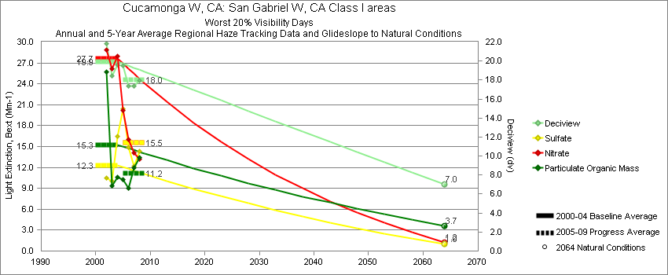
San Gabriel - Worst 20% Visibility Days – 5-Year Average, Natural Conditions and Annual Data
Parameter | 2000-2004 | 2005-2009 | 2064 NC | 2000 | 2001 | 2002 | 2003 | 2004 | 2005 | 2006 | 2007 | 2008 | 2009
Deciview (dv) | 19.9 | 18.0 | 7.0 |  |  | 21.8 | 18.4 | 19.6 | 19.4 | 17.4 | 17.4 | 17.9
Sulfate Bext | 12.3 | 15.5 | 1.0 |  |  | 10.5 | 10.1 | 16.5 | 20.4 | 15.2 | 12.2 | 14.3
Nitrate Bext | 27.7 | 15.5 | 1.2 |  |  | 28.9 | 26.1 | 28.0 | 19.7 | 15.3 | 14.0 | 13.2
POM Bext | 15.3 | 11.2 | 3.7 |  |  | 25.7 | 9.4 | 10.6 | 10.2 | 9.1 | 12.0 | 13.4
EC Bext | 4.3 | 4.1 | 0.3 |  |  | 5.3 | 3.8 | 3.8 | 5.2 | 4.1 | 3.8 | 3.2
Soil Bext | 0.9 | 1.1 | 0.8 |  |  | 0.8 | 0.8 | 1.0 | 0.9 | 0.9 | 1.0 | 1.4
Coarse Mass Bext | 8.3 | 5.2 | 4.2 |  |  | 15.5 | 4.8 | 4.5 | 4.6 | 3.8 | 5.5 | 7.0
Sea Salt Bext | 0.4 | 0.4 | 0.5 |  |  | 0.3 | 0.4 | 0.6 | 0.6 | 0.3 | 0.3 | 0.6

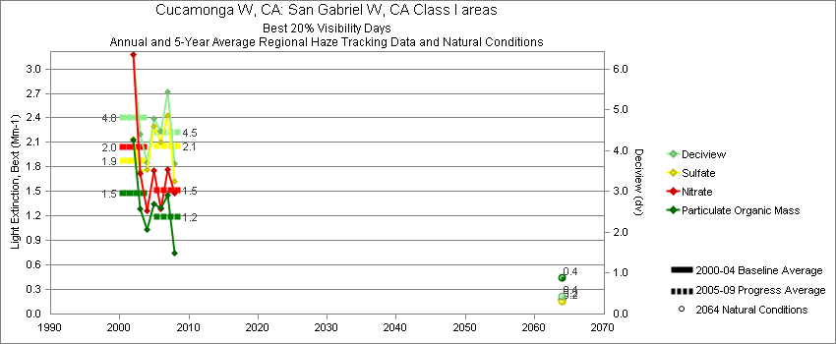
San Gabriel - Best 20% Visibility Days – 5-Year Average, Natural Conditions and Annual Data
Parameter | 2000-2004 | 2005-2009 | 2064 NC | 2000 | 2001 | 2002 | 2003 | 2004 | 2005 | 2006 | 2007 | 2008 | 2009
Deciview (dv) | 4.8 | 4.5 | 0.4 |  |  | 6.4 | 4.4 | 3.7 | 4.3 | 4.4 | 5.4 | 3.7
Sulfate Bext | 1.9 | 2.1 | 0.2 |  |  | 2.1 | 1.7 | 1.8 | 2.1 | 2.1 | 2.4 | 1.6
Nitrate Bext | 2.1 | 1.5 | 0.2 |  |  | 3.2 | 1.7 | 1.3 | 1.5 | 1.3 | 1.8 | 1.5
POM Bext | 1.5 | 1.2 | 0.4 |  |  | 2.1 | 1.3 | 1.0 | 1.3 | 1.3 | 1.4 | 0.8
EC Bext | 0.7 | 0.6 | 0.1 |  |  | 1.0 | 0.7 | 0.4 | 0.7 | 0.7 | 0.6 | 0.3
Soil Bext | 0.3 | 0.3 | 0.1 |  |  | 0.4 | 0.2 | 0.1 | 0.2 | 0.3 | 0.3 | 0.2
Coarse Mass Bext | 1.2 | 1.1 | 0.4 |  |  | 1.4 | 1.3 | 0.9 | 0.8 | 0.9 | 1.7 | 1.1
Sea Salt Bext | 0.1 | 0.2 | 0.1 |  |  | 0.1 | 0.0 | 0.1 | 0.1 | 0.2 | 0.2 | 0.3

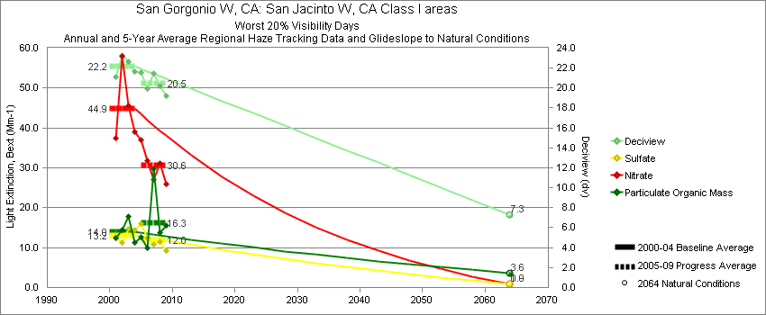
San Gorgonio - Worst 20% Visibility Days – 5-Year Average, Natural Conditions and Annual Data
Parameter | 2000-2004 | 2005-2009 | 2064 NC | 2000 | 2001 | 2002 | 2003 | 2004 | 2005 | 2006 | 2007 | 2008 | 2009
Deciview (dv) | 22.2 | 20.5 | 7.3 |  | 21.2 | 23.3 | 22.6 | 21.6 | 21.5 | 19.9 | 21.5 | 20.2 | 19.2
Sulfate Bext | 13.2 | 12.0 | 1.0 |  | 12.5 | 11.2 | 14.6 | 14.5 | 16.0 | 12.4 | 10.8 | 11.5 | 9.3
Nitrate Bext | 44.9 | 30.6 | 0.9 |  | 37.4 | 58.0 | 45.5 | 39.0 | 37.0 | 31.8 | 27.0 | 31.0 | 26.0
POM Bext | 14.0 | 16.3 | 3.6 |  | 12.4 | 14.5 | 17.9 | 11.3 | 12.6 | 9.9 | 29.8 | 13.7 | 15.5
EC Bext | 5.2 | 5.2 | 0.3 |  | 4.9 | 5.8 | 5.4 | 4.6 | 6.5 | 5.3 | 6.3 | 3.8 | 4.1
Soil Bext | 1.1 | 1.2 | 0.9 |  | 1.2 | 1.1 | 0.9 | 1.2 | 0.9 | 0.9 | 1.5 | 1.4 | 1.0
Coarse Mass Bext | 6.1 | 6.2 | 3.9 |  | 6.2 | 5.4 | 6.4 | 6.6 | 5.4 | 4.5 | 10.4 | 6.3 | 4.4
Sea Salt Bext | 0.2 | 0.6 | 0.2 |  | 0.1 | 0.1 | 0.1 | 0.6 | 0.6 | 0.4 | 0.5 | 0.8 | 0.6

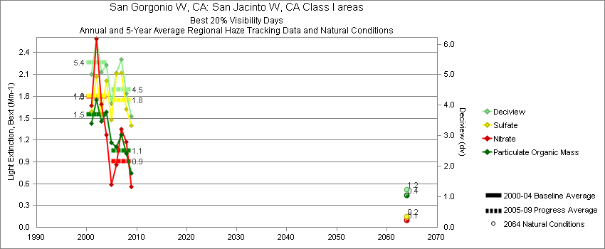
San Gorgonio - Best 20% Visibility Days – 5-Year Average, Natural Conditions and Annual Data
Parameter | 2000-2004 | 2005-2009 | 2064 NC | 2000 | 2001 | 2002 | 2003 | 2004 | 2005 | 2006 | 2007 | 2008 | 2009
Deciview (dv) | 5.4 | 4.5 | 1.2 |  | 5.0 | 6.2 | 5.1 | 5.3 | 4.1 | 5.0 | 5.5 | 4.4 | 3.6
Sulfate Bext | 1.8 | 1.7 | 0.2 |  | 1.6 | 2.1 | 1.6 | 2.0 | 1.5 | 2.1 | 2.1 | 1.6 | 1.4
Nitrate Bext | 1.8 | 0.9 | 0.1 |  | 1.7 | 2.6 | 1.7 | 1.3 | 0.6 | 0.8 | 1.3 | 1.2 | 0.6
POM Bext | 1.6 | 1.1 | 0.4 |  | 1.4 | 1.7 | 1.5 | 1.6 | 1.2 | 1.1 | 1.3 | 1.0 | 0.7
EC Bext | 1.0 | 0.6 | 0.1 |  | 1.1 | 1.2 | 0.9 | 0.8 | 0.7 | 0.8 | 0.7 | 0.4 | 0.3
Soil Bext | 0.2 | 0.2 | 0.1 |  | 0.1 | 0.4 | 0.2 | 0.2 | 0.1 | 0.3 | 0.3 | 0.2 | 0.2
Coarse Mass Bext | 0.8 | 1.2 | 0.4 |  | 0.5 | 0.9 | 0.9 | 1.1 | 1.0 | 1.5 | 1.6 | 0.9 | 1.1
Sea Salt Bext | 0.2 | 0.1 | 0.1 |  | 0.3 | 0.0 | 0.2 | 0.2 | 0.1 | 0.1 | 0.1 | 0.3 | 0.1

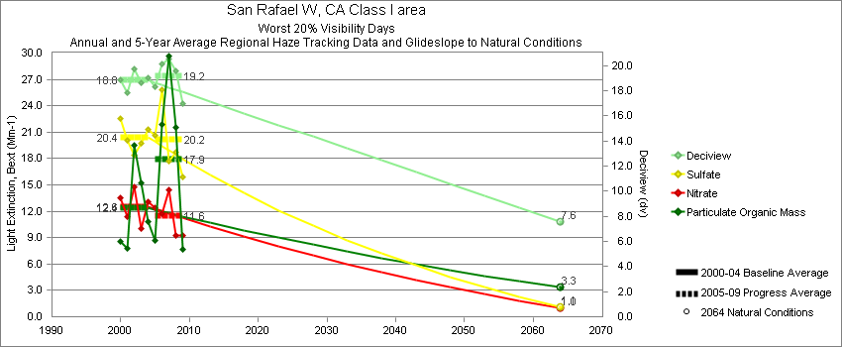
San Rafael - Worst 20% Visibility Days – 5-Year Average, Natural Conditions and Annual Data
Parameter | 2000-2004 | 2005-2009 | 2064 NC | 2000 | 2001 | 2002 | 2003 | 2004 | 2005 | 2006 | 2007 | 2008 | 2009
Deciview (dv) | 18.8 | 19.2 | 7.6 | 18.9 | 17.9 | 19.7 | 18.7 | 19.0 | 18.7 | 20.2 | 20.6 | 19.6 | 17.0
Sulfate Bext | 20.4 | 20.2 | 1.1 | 22.6 | 20.0 | 18.4 | 19.8 | 21.3 | 22.7 | 25.9 | 17.7 | 18.8 | 15.9
Nitrate Bext | 12.6 | 11.6 | 1.0 | 13.6 | 11.4 | 14.8 | 10.0 | 13.1 | 13.1 | 11.8 | 14.5 | 9.2 | 9.2
POM Bext | 12.4 | 17.9 | 3.3 | 8.6 | 7.8 | 19.5 | 15.2 | 10.8 | 8.9 | 21.8 | 29.7 | 21.5 | 7.7
EC Bext | 3.0 | 4.5 | 0.3 | 3.6 | 2.6 | 3.3 | 3.2 | 2.4 | 3.0 | 9.6 | 5.4 | 3.0 | 1.7
Soil Bext | 1.0 | 1.1 | 1.0 | 0.9 | 1.4 | 0.9 | 1.1 | 1.0 | 0.7 | 1.1 | 0.9 | 1.5 | 1.1
Coarse Mass Bext | 6.9 | 7.0 | 3.2 | 6.5 | 7.3 | 6.1 | 6.8 | 7.7 | 6.0 | 7.5 | 7.1 | 7.2 | 7.2
Sea Salt Bext | 0.8 | 1.8 | 1.5 | 0.8 | 0.1 | 0.8 | 0.5 | 1.5 | 1.1 | 1.8 | 1.0 | 2.1 | 3.0

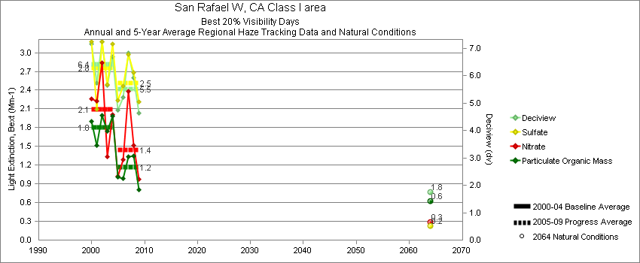
San Rafael - Best 20% Visibility Days – 5-Year Average, Natural Conditions and Annual Data
Parameter | 2000-2004 | 2005-2009 | 2064 NC | 2000 | 2001 | 2002 | 2003 | 2004 | 2005 | 2006 | 2007 | 2008 | 2009
Deciview (dv) | 6.4 | 5.5 | 1.8 | 7.1 | 5.5 | 7.1 | 5.7 | 6.7 | 5.0 | 5.2 | 6.8 | 5.9 | 4.6
Sulfate Bext | 2.8 | 2.5 | 0.2 | 3.2 | 2.0 | 3.0 | 2.5 | 3.1 | 2.3 | 2.5 | 3.0 | 2.7 | 2.2
Nitrate Bext | 2.1 | 1.4 | 0.3 | 2.3 | 2.1 | 2.7 | 1.3 | 2.0 | 1.1 | 1.3 | 2.4 | 1.5 | 1.0
POM Bext | 1.8 | 1.2 | 0.6 | 1.9 | 1.4 | 2.0 | 1.8 | 2.0 | 1.4 | 1.0 | 1.3 | 1.3 | 0.8
EC Bext | 0.7 | 0.5 | 0.1 | 0.9 | 0.6 | 0.8 | 0.6 | 0.7 | 0.6 | 0.4 | 0.5 | 0.5 | 0.3
Soil Bext | 0.1 | 0.2 | 0.1 | 0.2 | 0.1 | 0.2 | 0.1 | 0.1 | 0.1 | 0.1 | 0.2 | 0.2 | 0.2
Coarse Mass Bext | 1.3 | 1.2 | 0.5 | 1.6 | 1.2 | 1.4 | 1.2 | 1.1 | 0.8 | 0.9 | 1.9 | 1.1 | 1.0
Sea Salt Bext | 0.5 | 0.7 | 0.1 | 0.7 | 0.3 | 0.6 | 0.3 | 0.9 | 0.6 | 0.7 | 0.8 | 1.1 | 0.5

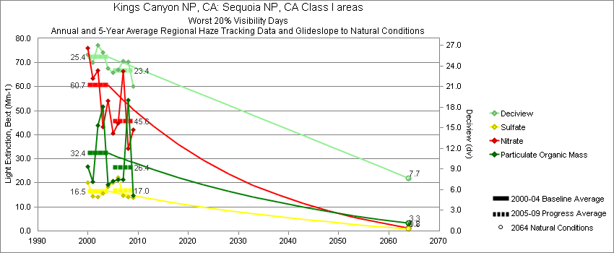
Sequoia - Worst 20% Visibility Days – 5-Year Average, Natural Conditions and Annual Data
Parameter | 2000-2004 | 2005-2009 | 2064 NC | 2000 | 2001 | 2002 | 2003 | 2004 | 2005 | 2006 | 2007 | 2008 | 2009
Deciview (dv) | 25.4 | 23.4 | 7.7 | 25.7 | 24.5 | 27.0 | 26.0 | 23.7 | 23.1 | 23.4 | 24.7 | 24.7 | 21.0
Sulfate Bext | 16.5 | 17.0 | 0.8 | 20.1 | 14.5 | 14.2 | 15.7 | 18.2 | 20.0 | 22.3 | 14.8 | 14.2 | 13.7
Nitrate Bext | 60.7 | 45.6 | 1.2 | 76.1 | 63.5 | 66.7 | 43.3 | 54.0 | 40.5 | 44.9 | 66.5 | 34.2 | 42.0
POM Bext | 32.4 | 26.4 | 3.3 | 26.8 | 20.6 | 43.9 | 51.6 | 19.2 | 20.6 | 21.3 | 21.2 | 54.3 | 14.7
EC Bext | 7.0 | 5.7 | 0.3 | 7.9 | 5.8 | 7.7 | 8.9 | 4.7 | 5.9 | 5.6 | 6.0 | 7.5 | 3.7
Soil Bext | 1.1 | 1.0 | 1.0 | 0.8 | 0.8 | 1.1 | 1.4 | 1.2 | 0.6 | 1.1 | 0.9 | 1.3 | 1.1
Coarse Mass Bext | 7.7 | 5.8 | 3.5 | 5.6 | 7.0 | 9.4 | 9.2 | 7.1 | 5.5 | 5.1 | 6.1 | 6.4 | 5.8
Sea Salt Bext | 0.2 | 0.3 | 0.6 | 0.1 | 0.3 | 0.3 | 0.1 | 0.5 | 0.2 | 0.4 | 0.3 | 0.2 | 0.5

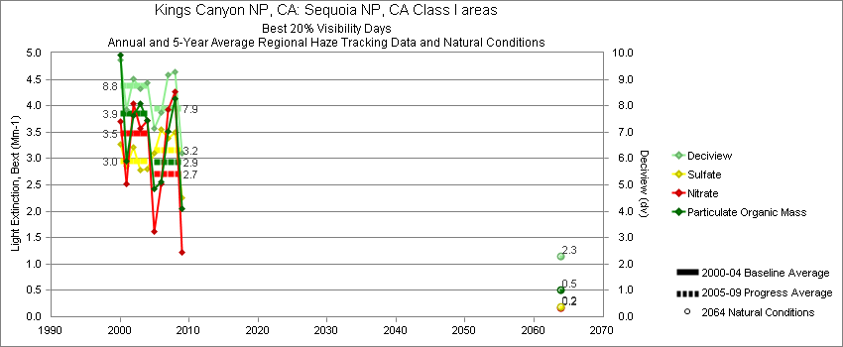
Sequoia - Best 20% Visibility Days – 5-Year Average, Natural Conditions and Annual Data
Parameter | 2000-2004 | 2005-2009 | 2064 NC | 2000 | 2001 | 2002 | 2003 | 2004 | 2005 | 2006 | 2007 | 2008 | 2009
Deciview (dv) | 8.8 | 7.9 | 2.3 | 9.7 | 7.8 | 8.9 | 8.5 | 8.9 | 7.2 | 7.7 | 9.2 | 9.3 | 6.2
Sulfate Bext | 3.0 | 3.2 | 0.2 | 3.3 | 2.8 | 3.2 | 2.7 | 2.8 | 3.1 | 3.6 | 3.4 | 3.5 | 2.2
Nitrate Bext | 3.5 | 2.7 | 0.2 | 3.7 | 2.5 | 3.9 | 3.5 | 3.7 | 1.6 | 2.5 | 3.9 | 4.3 | 1.2
POM Bext | 3.9 | 2.9 | 0.5 | 5.0 | 2.9 | 3.7 | 4.0 | 3.7 | 2.4 | 2.6 | 3.5 | 4.1 | 2.0
EC Bext | 1.5 | 1.0 | 0.1 | 2.0 | 1.1 | 1.3 | 1.5 | 1.4 | 1.1 | 0.9 | 1.3 | 1.1 | 0.7
Soil Bext | 0.2 | 0.2 | 0.1 | 0.2 | 0.2 | 0.2 | 0.1 | 0.2 | 0.1 | 0.2 | 0.3 | 0.3 | 0.2
Coarse Mass Bext | 1.6 | 1.4 | 0.4 | 1.9 | 1.5 | 1.5 | 1.4 | 1.7 | 1.3 | 1.1 | 1.9 | 1.7 | 1.3
Sea Salt Bext | 0.2 | 0.3 | 0.1 | 0.2 | 0.3 | 0.1 | 0.0 | 0.2 | 0.2 | 0.3 | 0.3 | 0.4 | 0.1

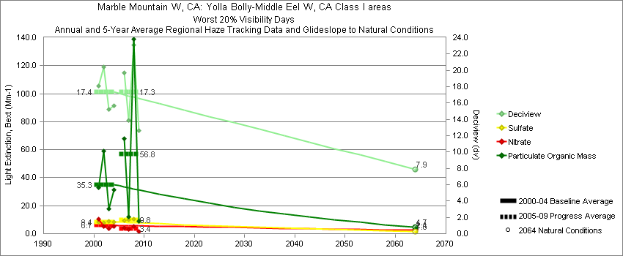
Trinity - Worst 20% Visibility Days – 5-Year Average, Natural Conditions and Annual Data
Parameter | 2000-2004 | 2005-2009 | 2064 NC | 2000 | 2001 | 2002 | 2003 | 2004 | 2005 | 2006 | 2007 | 2008 | 2009
Deciview (dv) | 17.3 | 17.3 | 7.9 |  | 18.1 | 20.5 | 15.2 | 15.7 |  | 19.7 | 13.9 | 23.1 | 12.7
Sulfate Bext | 8.4 | 9.8 | 1.6 |  | 8.6 | 7.8 | 9.0 | 8.1 |  | 9.6 | 9.7 | 10.6 | 9.4
Nitrate Bext | 6.1 | 3.4 | 2.4 |  | 10.3 | 5.0 | 3.5 | 5.4 |  | 4.3 | 3.0 | 5.0 | 1.4
POM Bext | 35.3 | 56.8 | 4.7 |  | 32.8 | 59.0 | 18.0 | 31.2 |  | 67.8 | 11.8 | 139.0 | 8.8
EC Bext | 4.6 | 6.9 | 0.5 |  | 5.3 | 5.5 | 3.2 | 4.5 |  | 9.9 | 2.7 | 13.3 | 1.5
Soil Bext | 0.8 | 0.9 | 0.9 |  | 1.1 | 0.7 | 0.6 | 1.0 |  | 1.0 | 0.8 | 1.0 | 0.7
Coarse Mass Bext | 2.5 | 3.6 | 2.7 |  | 3.3 | 3.1 | 2.5 | 1.3 |  | 3.4 | 3.8 | 3.7 | 3.5
Sea Salt Bext | 0.3 | 0.3 | 0.4 |  | 0.0 | 0.3 | 0.7 | 0.2 |  | 0.1 | 0.2 | 0.5 | 0.4

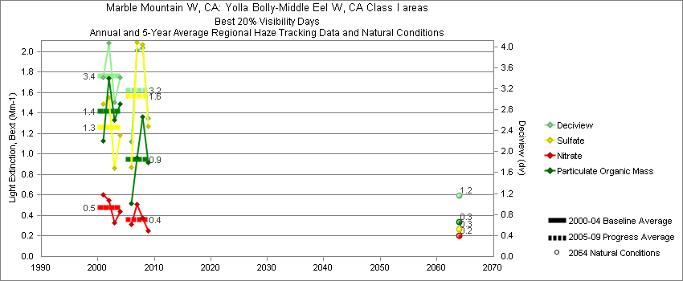
Trinity - Best 20% Visibility Days – 5-Year Average, Natural Conditions and Annual Data
Parameter | 2000-2004 | 2005-2009 | 2064 NC | 2000 | 2001 | 2002 | 2003 | 2004 | 2005 | 2006 | 2007 | 2008 | 2009
Deciview (dv) | 3.4 | 3.2 | 1.2 |  | 3.4 | 4.0 | 2.9 | 3.4 |  | 2.1 | 3.9 | 4.0 | 2.6
Sulfate Bext | 1.3 | 1.6 | 0.3 |  | 1.5 | 1.5 | 0.9 | 1.2 |  | 0.8 | 2.1 | 2.1 | 1.3
Nitrate Bext | 0.5 | 0.4 | 0.2 |  | 0.6 | 0.6 | 0.3 | 0.4 |  | 0.3 | 0.5 | 0.4 | 0.3
POM Bext | 1.4 | 0.9 | 0.3 |  | 1.1 | 1.7 | 1.3 | 1.5 |  | 0.6 | 1.0 | 1.4 | 0.9
EC Bext | 0.5 | 0.3 | 0.1 |  | 0.4 | 0.5 | 0.5 | 0.4 |  | 0.2 | 0.3 | 0.3 | 0.2
Soil Bext | 0.1 | 0.1 | 0.1 |  | 0.1 | 0.1 | 0.0 | 0.1 |  | 0.0 | 0.1 | 0.1 | 0.1
Coarse Mass Bext | 0.3 | 0.3 | 0.2 |  | 0.3 | 0.3 | 0.2 | 0.2 |  | 0.1 | 0.4 | 0.3 | 0.2
Sea Salt Bext | 0.2 | 0.4 | 0.1 |  | 0.1 | 0.3 | 0.2 | 0.4 |  | 0.4 | 0.5 | 0.6 | 0.1

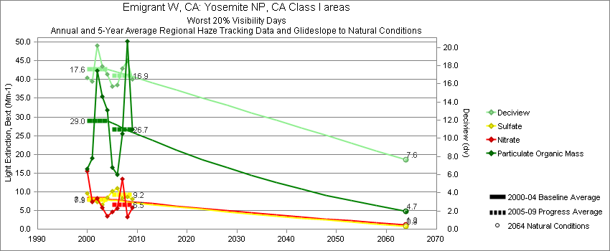
Yosemite - Worst 20% Visibility Days – 5-Year Average, Natural Conditions and Annual Data
Parameter | 2000-2004 | 2005-2009 | 2064 NC | 2000 | 2001 | 2002 | 2003 | 2004 | 2005 | 2006 | 2007 | 2008 | 2009
Deciview (dv) | 17.6 | 16.9 | 7.6 | 16.6 | 16.3 | 20.2 | 18.0 | 17.1 | 15.7 | 15.9 | 17.7 | 18.6 | 16.5
Sulfate Bext | 7.9 | 9.2 | 0.9 | 9.5 | 7.7 | 7.4 | 6.4 | 8.5 | 10.2 | 10.9 | 8.2 | 8.7 | 8.0
Nitrate Bext | 8.1 | 6.5 | 1.2 | 15.6 | 7.4 | 8.3 | 5.7 | 3.5 | 4.6 | 5.5 | 13.4 | 3.2 | 5.8
POM Bext | 29.0 | 26.7 | 4.7 | 16.1 | 19.0 | 42.4 | 35.5 | 31.8 | 16.4 | 14.5 | 25.5 | 50.2 | 26.6
EC Bext | 4.8 | 4.6 | 0.5 | 4.6 | 4.0 | 5.5 | 5.2 | 4.6 | 3.8 | 3.6 | 5.0 | 6.7 | 4.2
Soil Bext | 0.9 | 0.9 | 0.9 | 0.8 | 1.2 | 0.8 | 0.6 | 1.1 | 0.5 | 1.3 | 0.8 | 1.1 | 0.9
Coarse Mass Bext | 4.0 | 4.0 | 3.7 | 4.5 | 3.6 | 4.0 | 3.4 | 4.4 | 3.5 | 3.6 | 4.2 | 4.5 | 4.0
Sea Salt Bext | 0.1 | 0.1 | 0.1 | 0.0 | 0.0 | 0.1 | 0.3 | 0.1 | 0.1 | 0.2 | 0.1 | 0.1 | 0.3

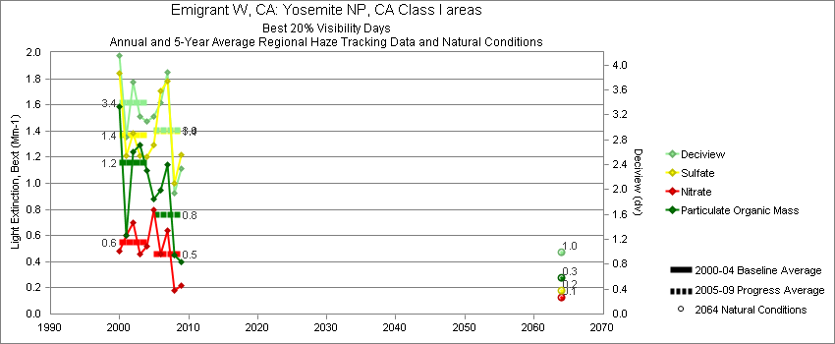
Yosemite - Best 20% Visibility Days – 5-Year Average, Natural Conditions and Annual Data
Parameter | 2000-2004 | 2005-2009 | 2064 NC | 2000 | 2001 | 2002 | 2003 | 2004 | 2005 | 2006 | 2007 | 2008 | 2009
Deciview (dv) | 3.4 | 2.9 | 1.0 | 4.2 | 2.8 | 3.7 | 3.2 | 3.1 | 3.2 | 3.4 | 3.9 | 2.0 | 2.3
Sulfate Bext | 1.4 | 1.4 | 0.2 | 1.8 | 1.2 | 1.4 | 1.2 | 1.2 | 1.3 | 1.7 | 1.8 | 1.0 | 1.2
Nitrate Bext | 0.6 | 0.5 | 0.1 | 0.5 | 0.6 | 0.7 | 0.5 | 0.5 | 0.8 | 0.4 | 0.6 | 0.2 | 0.2
POM Bext | 1.2 | 0.8 | 0.3 | 1.6 | 0.6 | 1.2 | 1.3 | 1.1 | 0.9 | 0.9 | 1.1 | 0.4 | 0.4
EC Bext | 0.4 | 0.3 | 0.0 | 0.5 | 0.2 | 0.4 | 0.3 | 0.4 | 0.4 | 0.4 | 0.4 | 0.1 | 0.2
Soil Bext | 0.1 | 0.1 | 0.1 | 0.1 | 0.1 | 0.1 | 0.1 | 0.1 | 0.1 | 0.1 | 0.2 | 0.1 | 0.1
Coarse Mass Bext | 0.5 | 0.4 | 0.3 | 0.5 | 0.5 | 0.5 | 0.4 | 0.4 | 0.2 | 0.3 | 0.7 | 0.3 | 0.5
Sea Salt Bext | 0.1 | 0.1 | 0.0 | 0.2 | 0.1 | 0.2 | 0.1 | 0.1 | 0.2 | 0.1 | 0.1 | 0.1 | 0.0

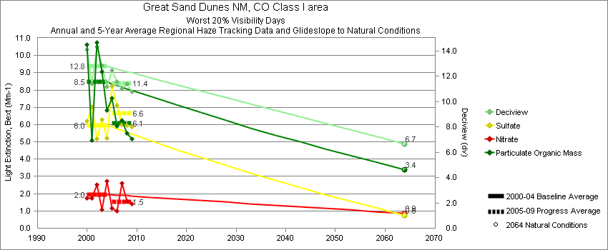
Great Sand Dunes - Worst 20% Visibility Days – 5-Year Average, Natural Conditions and Annual Data
Parameter | 2000-2004 | 2005-2009 | 2064 NC | 2000 | 2001 | 2002 | 2003 | 2004 | 2005 | 2006 | 2007 | 2008 | 2009
Deciview (dv) | 12.8 | 11.4 | 6.7 | 14.1 | 11.4 | 14.3 | 12.9 | 11.2 | 12.5 | 11.6 | 11.0 | 11.4 | 10.8
Sulfate Bext | 6.0 | 6.6 | 0.7 | 6.2 | 7.0 | 5.1 | 6.3 | 5.2 | 8.2 | 7.1 | 6.0 | 6.0 | 5.9
Nitrate Bext | 2.0 | 1.5 | 0.9 | 1.7 | 1.8 | 2.5 | 1.1 | 2.7 | 1.2 | 1.0 | 2.6 | 1.6 | 1.4
POM Bext | 8.5 | 6.1 | 3.4 | 10.6 | 5.1 | 10.8 | 9.1 | 6.8 | 7.5 | 5.9 | 6.3 | 5.5 | 5.2
EC Bext | 1.7 | 1.7 | 0.3 | 2.2 | 1.2 | 2.0 | 1.9 | 1.3 | 2.1 | 2.0 | 1.5 | 1.6 | 1.3
Soil Bext | 2.8 | 1.9 | 1.2 | 2.8 | 2.3 | 4.1 | 2.8 | 2.1 | 1.9 | 1.8 | 0.9 | 2.5 | 2.5
Coarse Mass Bext | 7.2 | 5.1 | 4.2 | 9.5 | 5.8 | 10.8 | 6.5 | 3.7 | 5.9 | 5.6 | 4.0 | 5.8 | 4.4
Sea Salt Bext | 0.1 | 0.1 | 0.1 | 0.0 | 0.0 | 0.0 | 0.1 | 0.2 | 0.0 | 0.2 | 0.1 | 0.1 | 0.1

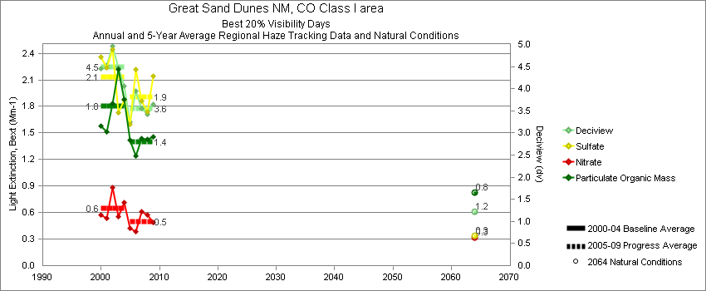
Great Sand Dunes - Best 20% Visibility Days – 5-Year Average, Natural Conditions and Annual Data
Parameter | 2000-2004 | 2005-2009 | 2064 NC | 2000 | 2001 | 2002 | 2003 | 2004 | 2005 | 2006 | 2007 | 2008 | 2009
Deciview (dv) | 4.5 | 3.6 | 1.2 | 4.5 | 4.5 | 5.0 | 4.5 | 4.1 | 3.3 | 3.9 | 3.6 | 3.4 | 3.6
Sulfate Bext | 2.1 | 1.9 | 0.3 | 2.4 | 2.2 | 2.4 | 1.7 | 1.9 | 1.6 | 2.2 | 1.9 | 1.7 | 2.1
Nitrate Bext | 0.7 | 0.5 | 0.3 | 0.6 | 0.5 | 0.9 | 0.6 | 0.7 | 0.4 | 0.4 | 0.6 | 0.6 | 0.5
POM Bext | 1.8 | 1.4 | 0.8 | 1.6 | 1.5 | 1.8 | 2.2 | 1.9 | 1.4 | 1.2 | 1.4 | 1.4 | 1.5
EC Bext | 0.6 | 0.5 | 0.1 | 0.6 | 0.6 | 0.7 | 0.5 | 0.6 | 0.5 | 0.7 | 0.5 | 0.5 | 0.6
Soil Bext | 0.4 | 0.3 | 0.2 | 0.3 | 0.5 | 0.4 | 0.4 | 0.3 | 0.2 | 0.4 | 0.3 | 0.2 | 0.3
Coarse Mass Bext | 1.1 | 0.7 | 0.5 | 1.1 | 1.3 | 1.3 | 1.2 | 0.6 | 0.7 | 0.9 | 0.7 | 0.7 | 0.5
Sea Salt Bext | 0.0 | 0.0 | 0.0 | 0.1 | 0.0 | 0.0 | 0.0 | 0.0 | 0.0 | 0.0 | 0.0 | 0.0 | 0.0

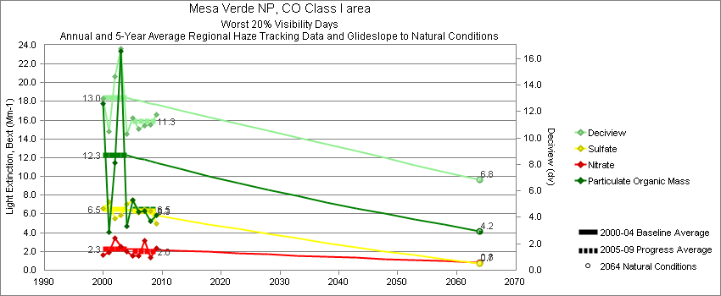
Mesa Verde - Worst 20% Visibility Days – 5-Year Average, Natural Conditions and Annual Data
Parameter | 2000-2004 | 2005-2009 | 2064 NC | 2000 | 2001 | 2002 | 2003 | 2004 | 2005 | 2006 | 2007 | 2008 | 2009
Deciview (dv) | 13.0 | 11.3 | 6.8 | 13.0 | 10.5 | 14.7 | 16.8 | 10.3 | 12.0 | 10.7 | 10.9 | 11.0 | 11.7
Sulfate Bext | 6.5 | 6.3 | 0.7 | 6.6 | 7.3 | 5.5 | 5.9 | 7.0 | 7.6 | 6.2 | 6.5 | 6.3 | 4.9
Nitrate Bext | 2.3 | 2.0 | 0.8 | 1.7 | 1.9 | 3.5 | 2.5 | 2.0 | 1.5 | 1.6 | 3.1 | 1.3 | 2.4
POM Bext | 12.3 | 6.5 | 4.2 | 17.8 | 4.1 | 11.5 | 23.4 | 4.7 | 8.9 | 6.2 | 6.3 | 5.2 | 5.9
EC Bext | 2.4 | 1.6 | 0.4 | 3.6 | 1.3 | 2.2 | 3.5 | 1.2 | 2.6 | 1.7 | 1.6 | 1.0 | 1.3
Soil Bext | 2.5 | 2.0 | 1.2 | 1.9 | 1.6 | 3.9 | 3.9 | 1.3 | 1.5 | 1.9 | 1.1 | 2.3 | 3.2
Coarse Mass Bext | 6.5 | 4.6 | 4.3 | 3.8 | 3.5 | 9.5 | 12.8 | 3.0 | 4.0 | 3.2 | 2.4 | 5.6 | 7.5
Sea Salt Bext | 0.0 | 0.1 | 0.0 | 0.0 | 0.0 | 0.0 | 0.1 | 0.1 | 0.1 | 0.0 | 0.1 | 0.1 | 0.0

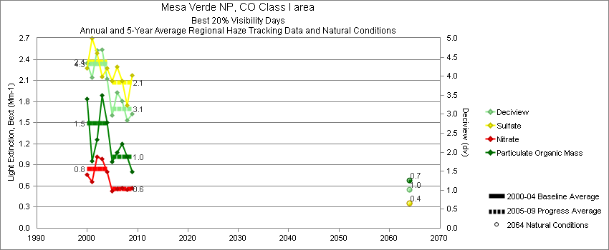
Mesa Verde - Best 20% Visibility Days – 5-Year Average, Natural Conditions and Annual Data
Parameter | 2000-2004 | 2005-2009 | 2064 NC | 2000 | 2001 | 2002 | 2003 | 2004 | 2005 | 2006 | 2007 | 2008 | 2009
Deciview (dv) | 4.3 | 3.1 | 1.0 | 4.3 | 4.0 | 4.7 | 4.7 | 3.9 | 3.0 | 3.6 | 3.3 | 2.8 | 3.0
Sulfate Bext | 2.4 | 2.1 | 0.4 | 2.3 | 2.7 | 2.5 | 2.1 | 2.3 | 2.0 | 2.3 | 2.1 | 1.8 | 2.2
Nitrate Bext | 0.8 | 0.6 | 0.4 | 0.8 | 0.7 | 1.0 | 1.0 | 0.8 | 0.6 | 0.6 | 0.6 | 0.6 | 0.6
POM Bext | 1.5 | 1.0 | 0.7 | 1.8 | 1.0 | 1.3 | 1.9 | 1.5 | 1.0 | 1.1 | 1.2 | 1.0 | 0.8
EC Bext | 0.6 | 0.4 | 0.1 | 0.8 | 0.4 | 0.6 | 0.7 | 0.6 | 0.4 | 0.6 | 0.4 | 0.3 | 0.3
Soil Bext | 0.4 | 0.2 | 0.2 | 0.2 | 0.4 | 0.6 | 0.5 | 0.3 | 0.3 | 0.3 | 0.2 | 0.2 | 0.2
Coarse Mass Bext | 0.7 | 0.4 | 0.4 | 0.6 | 0.9 | 1.1 | 0.9 | 0.4 | 0.3 | 0.4 | 0.5 | 0.5 | 0.5
Sea Salt Bext | 0.0 | 0.0 | 0.0 | 0.1 | 0.0 | 0.0 | 0.0 | 0.0 | 0.0 | 0.0 | 0.0 | 0.0 | 0.0

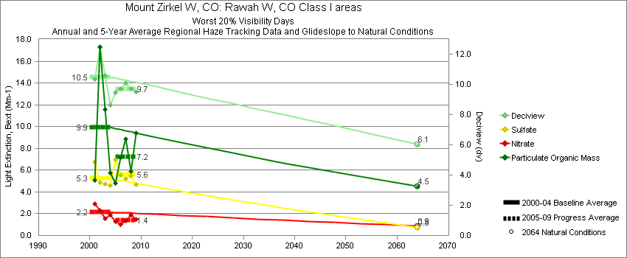
Mount Zirkel - Worst 20% Visibility Days – 5-Year Average, Natural Conditions and Annual Data
Parameter | 2000-2004 | 2005-2009 | 2064 NC | 2000 | 2001 | 2002 | 2003 | 2004 | 2005 | 2006 | 2007 | 2008 | 2009
Deciview (dv) | 10.5 | 9.7 | 6.1 |  | 10.3 | 12.5 | 10.6 | 8.7 | 9.4 | 9.7 | 10.1 | 9.7 | 9.5
Sulfate Bext | 5.2 | 5.6 | 0.7 |  | 6.8 | 4.9 | 4.7 | 4.6 | 7.0 | 5.6 | 5.2 | 5.5 | 4.7
Nitrate Bext | 2.2 | 1.4 | 0.9 |  | 2.9 | 2.3 | 1.5 | 1.9 | 1.3 | 1.0 | 1.4 | 1.9 | 1.5
POM Bext | 9.9 | 7.2 | 4.5 |  | 5.1 | 17.3 | 11.6 | 5.8 | 4.8 | 7.2 | 8.9 | 5.9 | 9.4
EC Bext | 1.8 | 1.5 | 0.4 |  | 1.4 | 2.6 | 2.0 | 1.0 | 1.5 | 1.7 | 1.7 | 1.0 | 1.7
Soil Bext | 1.0 | 1.1 | 1.0 |  | 1.2 | 1.2 | 0.6 | 1.0 | 0.9 | 0.7 | 1.0 | 1.4 | 1.8
Coarse Mass Bext | 3.1 | 2.9 | 3.6 |  | 3.2 | 3.8 | 3.8 | 1.8 | 2.4 | 2.6 | 2.1 | 3.5 | 3.9
Sea Salt Bext | 0.0 | 0.1 | 0.0 |  | 0.0 | 0.0 | 0.1 | 0.0 | 0.0 | 0.0 | 0.0 | 0.1 | 0.1

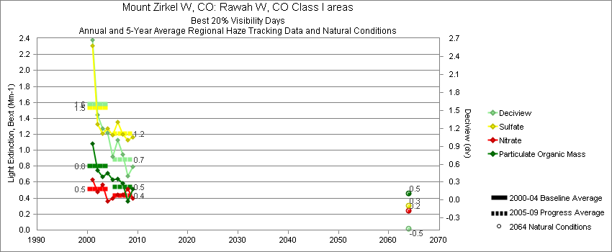
Mount Zirkel - Best 20% Visibility Days – 5-Year Average, Natural Conditions and Annual Data
Parameter | 2000-2004 | 2005-2009 | 2064 NC | 2000 | 2001 | 2002 | 2003 | 2004 | 2005 | 2006 | 2007 | 2008 | 2009
Deciview (dv) | 1.6 | 0.7 | -0.5 |  | 2.7 | 1.4 | 1.2 | 1.1 | 0.7 | 1.0 | 0.8 | 0.4 | 0.6
Sulfate Bext | 1.5 | 1.2 | 0.3 |  | 2.3 | 1.3 | 1.2 | 1.3 | 1.2 | 1.4 | 1.2 | 1.1 | 1.2
Nitrate Bext | 0.5 | 0.4 | 0.2 |  | 0.6 | 0.5 | 0.6 | 0.4 | 0.4 | 0.4 | 0.4 | 0.5 | 0.4
POM Bext | 0.8 | 0.5 | 0.5 |  | 1.1 | 0.8 | 0.7 | 0.7 | 0.6 | 0.6 | 0.6 | 0.4 | 0.5
EC Bext | 0.3 | 0.2 | 0.1 |  | 0.4 | 0.4 | 0.3 | 0.3 | 0.2 | 0.3 | 0.3 | 0.1 | 0.2
Soil Bext | 0.1 | 0.1 | 0.1 |  | 0.2 | 0.1 | 0.1 | 0.1 | 0.1 | 0.1 | 0.1 | 0.1 | 0.1
Coarse Mass Bext | 0.5 | 0.2 | 0.4 |  | 0.6 | 0.5 | 0.5 | 0.5 | 0.2 | 0.3 | 0.2 | 0.2 | 0.2
Sea Salt Bext | 0.0 | 0.0 | 0.0 |  | 0.0 | 0.1 | 0.0 | 0.0 | 0.0 | 0.0 | 0.0 | 0.0 | 0.0

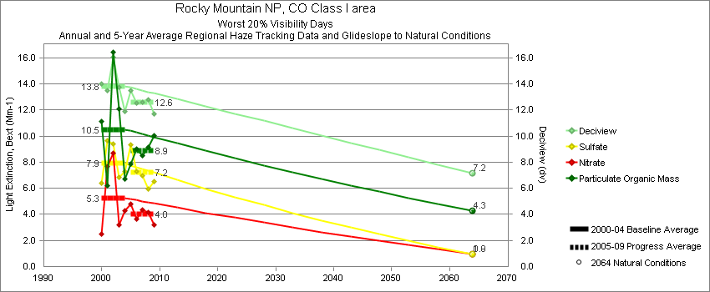
Rocky Mountain National Park - Worst 20% Visibility Days – 5-Year Average, Natural Conditions and Annual Data
Parameter | 2000-2004 | 2005-2009 | 2064 NC | 2000 | 2001 | 2002 | 2003 | 2004 | 2005 | 2006 | 2007 | 2008 | 2009
Deciview (dv) | 13.8 | 12.6 | 7.2 | 14.0 | 13.5 | 16.0 | 13.7 | 11.9 | 13.5 | 12.5 | 12.6 | 12.8 | 11.7
Sulfate Bext | 7.9 | 7.2 | 0.9 | 6.4 | 9.7 | 9.4 | 6.8 | 7.3 | 9.3 | 7.3 | 6.9 | 5.9 | 6.5
Nitrate Bext | 5.3 | 4.0 | 1.0 | 2.5 | 7.6 | 8.7 | 3.2 | 4.3 | 4.8 | 3.7 | 4.3 | 4.1 | 3.2
POM Bext | 10.5 | 8.9 | 4.3 | 11.1 | 6.2 | 16.5 | 12.1 | 6.7 | 7.8 | 9.0 | 8.5 | 9.1 | 10.1
EC Bext | 2.6 | 2.2 | 0.4 | 2.9 | 2.0 | 3.4 | 2.5 | 2.0 | 2.5 | 2.4 | 1.9 | 1.7 | 2.3
Soil Bext | 1.4 | 1.5 | 1.1 | 1.3 | 1.4 | 1.9 | 1.2 | 1.1 | 1.5 | 0.9 | 1.3 | 2.3 | 1.5
Coarse Mass Bext | 4.9 | 3.9 | 4.1 | 8.7 | 3.2 | 4.6 | 5.1 | 2.9 | 4.1 | 3.2 | 3.8 | 5.1 | 3.2
Sea Salt Bext | 0.0 | 0.1 | 0.0 | 0.0 | 0.0 | 0.0 | 0.0 | 0.0 | 0.0 | 0.0 | 0.0 | 0.1 | 0.1

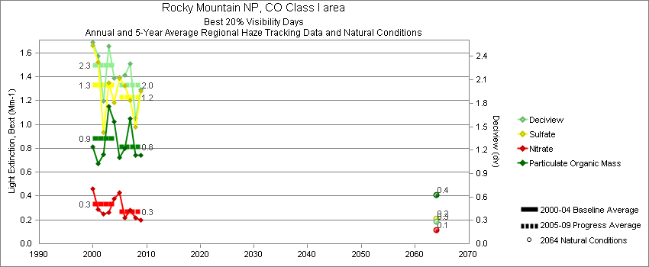
Rocky Mountain National Park - Best 20% Visibility Days – 5-Year Average, Natural Conditions and Annual Data
Parameter | 2000-2004 | 2005-2009 | 2064 NC | 2000 | 2001 | 2002 | 2003 | 2004 | 2005 | 2006 | 2007 | 2008 | 2009
Deciview (dv) | 2.3 | 2.0 | 0.3 | 2.6 | 2.4 | 1.8 | 2.5 | 2.1 | 2.1 | 2.1 | 2.3 | 1.6 | 2.0
Sulfate Bext | 1.3 | 1.2 | 0.2 | 1.7 | 1.5 | 0.9 | 1.3 | 1.2 | 1.4 | 1.3 | 1.2 | 1.0 | 1.3
Nitrate Bext | 0.3 | 0.3 | 0.1 | 0.5 | 0.3 | 0.2 | 0.3 | 0.4 | 0.4 | 0.2 | 0.3 | 0.2 | 0.2
POM Bext | 0.9 | 0.8 | 0.4 | 0.8 | 0.7 | 0.8 | 1.1 | 1.0 | 0.7 | 0.8 | 1.0 | 0.7 | 0.7
EC Bext | 0.3 | 0.3 | 0.1 | 0.3 | 0.3 | 0.3 | 0.3 | 0.3 | 0.3 | 0.3 | 0.3 | 0.2 | 0.2
Soil Bext | 0.1 | 0.2 | 0.1 | 0.1 | 0.2 | 0.1 | 0.1 | 0.1 | 0.1 | 0.2 | 0.2 | 0.2 | 0.3
Coarse Mass Bext | 0.6 | 0.6 | 0.4 | 0.6 | 0.8 | 0.6 | 0.8 | 0.4 | 0.5 | 0.6 | 0.7 | 0.5 | 0.5
Sea Salt Bext | 0.0 | 0.0 | 0.0 | 0.0 | 0.0 | 0.1 | 0.0 | 0.0 | 0.0 | 0.0 | 0.0 | 0.0 | 0.0

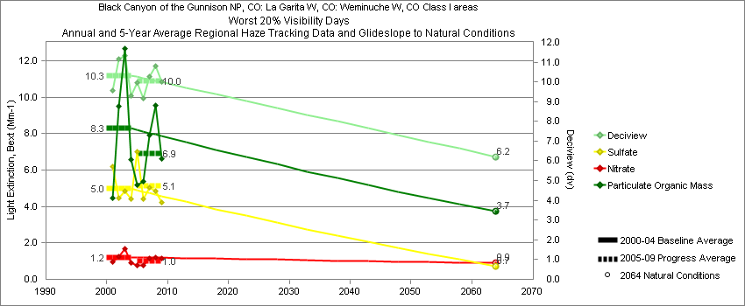
Weminuche - Worst 20% Visibility Days – 5-Year Average, Natural Conditions and Annual Data
Parameter | 2000-2004 | 2005-2009 | 2064 NC | 2000 | 2001 | 2002 | 2003 | 2004 | 2005 | 2006 | 2007 | 2008 | 2009
Deciview (dv) | 10.3 | 10.0 | 6.2 |  | 9.6 | 11.2 | 11.3 | 9.3 | 10.0 | 9.2 | 10.3 | 10.8 | 10.0
Sulfate Bext | 5.0 | 5.1 | 0.7 |  | 6.2 | 4.5 | 4.9 | 4.4 | 7.0 | 4.4 | 5.1 | 4.9 | 4.2
Nitrate Bext | 1.2 | 1.0 | 0.9 |  | 1.0 | 1.3 | 1.7 | 0.9 | 0.8 | 0.8 | 1.1 | 1.2 | 1.2
POM Bext | 8.3 | 6.9 | 3.7 |  | 4.5 | 9.5 | 12.7 | 6.6 | 5.1 | 5.4 | 7.9 | 9.6 | 6.6
EC Bext | 2.0 | 1.8 | 0.3 |  | 2.0 | 1.9 | 2.2 | 2.0 | 2.1 | 1.8 | 2.0 | 1.8 | 1.5
Soil Bext | 1.3 | 1.3 | 1.2 |  | 1.2 | 1.5 | 1.4 | 0.8 | 0.9 | 1.1 | 0.9 | 1.5 | 2.1
Coarse Mass Bext | 3.0 | 3.0 | 3.3 |  | 2.1 | 4.1 | 3.6 | 2.2 | 2.2 | 2.7 | 2.8 | 3.6 | 3.6
Sea Salt Bext | 0.1 | 0.0 | 0.1 |  | 0.3 | 0.0 | 0.1 | 0.0 | 0.0 | 0.0 | 0.1 | 0.1 | 0.0

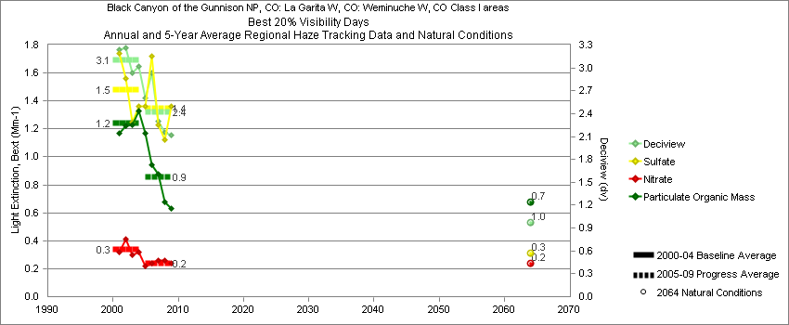
Weminuche - Best 20% Visibility Days – 5-Year Average, Natural Conditions and Annual Data
Parameter | 2000-2004 | 2005-2009 | 2064 NC | 2000 | 2001 | 2002 | 2003 | 2004 | 2005 | 2006 | 2007 | 2008 | 2009
Deciview (dv) | 3.1 | 2.4 | 1.0 |  | 3.2 | 3.3 | 2.9 | 3.0 | 2.6 | 2.9 | 2.3 | 2.2 | 2.1
Sulfate Bext | 1.5 | 1.3 | 0.3 |  | 1.7 | 1.6 | 1.2 | 1.4 | 1.4 | 1.7 | 1.2 | 1.1 | 1.4
Nitrate Bext | 0.3 | 0.2 | 0.2 |  | 0.3 | 0.4 | 0.3 | 0.3 | 0.2 | 0.2 | 0.3 | 0.3 | 0.2
POM Bext | 1.2 | 0.9 | 0.7 |  | 1.2 | 1.2 | 1.2 | 1.3 | 1.2 | 1.0 | 0.9 | 0.7 | 0.6
EC Bext | 0.8 | 0.5 | 0.1 |  | 0.8 | 0.7 | 0.8 | 0.9 | 0.7 | 0.8 | 0.5 | 0.5 | 0.3
Soil Bext | 0.2 | 0.2 | 0.1 |  | 0.2 | 0.2 | 0.2 | 0.1 | 0.1 | 0.1 | 0.2 | 0.1 | 0.2
Coarse Mass Bext | 0.7 | 0.6 | 0.5 |  | 0.6 | 0.7 | 0.7 | 0.5 | 0.4 | 0.6 | 0.6 | 0.6 | 0.6
Sea Salt Bext | 0.0 | 0.0 | 0.0 |  | 0.0 | 0.1 | 0.0 | 0.0 | 0.0 | 0.1 | 0.0 | 0.1 | 0.0

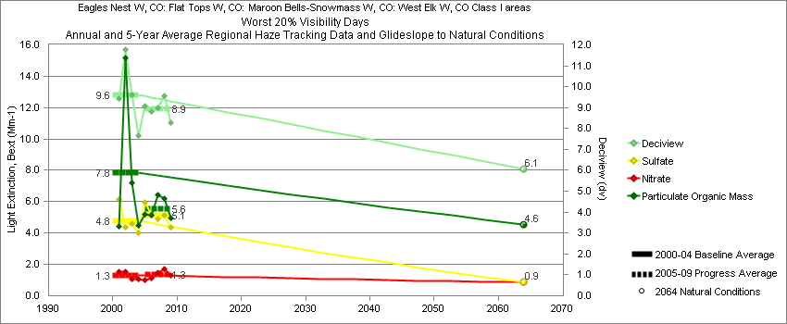
White River - Worst 20% Visibility Days – 5-Year Average, Natural Conditions and Annual Data
Parameter | 2000-2004 | 2005-2009 | 2064 NC | 2000 | 2001 | 2002 | 2003 | 2004 | 2005 | 2006 | 2007 | 2008 | 2009
Deciview (dv) | 9.6 | 8.9 | 6.1 |  | 9.4 | 11.8 | 9.6 | 7.6 | 9.1 | 8.8 | 9.0 | 9.6 | 8.3
Sulfate Bext | 4.8 | 5.1 | 0.9 |  | 6.1 | 4.3 | 4.6 | 4.0 | 6.0 | 5.1 | 4.9 | 5.1 | 4.4
Nitrate Bext | 1.3 | 1.3 | 0.9 |  | 1.5 | 1.5 | 1.1 | 1.1 | 1.0 | 1.2 | 1.5 | 1.7 | 1.3
POM Bext | 7.8 | 5.6 | 4.6 |  | 4.4 | 15.2 | 7.2 | 4.5 | 5.2 | 5.1 | 6.4 | 6.2 | 5.0
EC Bext | 1.8 | 1.4 | 0.4 |  | 1.6 | 2.5 | 1.5 | 1.4 | 1.8 | 1.5 | 1.4 | 1.2 | 1.2
Soil Bext | 1.2 | 1.3 | 1.2 |  | 1.6 | 1.3 | 0.9 | 0.9 | 1.0 | 1.1 | 1.0 | 1.6 | 1.6
Coarse Mass Bext | 2.8 | 2.3 | 3.0 |  | 2.8 | 3.5 | 3.1 | 1.8 | 2.1 | 2.3 | 1.9 | 2.9 | 2.2
Sea Salt Bext | 0.0 | 0.1 | 0.0 |  | 0.0 | 0.0 | 0.1 | 0.0 | 0.0 | 0.0 | 0.0 | 0.1 | 0.1

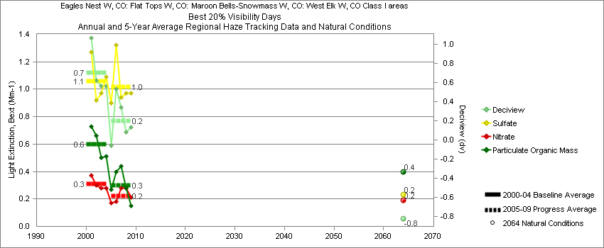
White River - Best 20% Visibility Days – 5-Year Average, Natural Conditions and Annual Data
Parameter | 2000-2004 | 2005-2009 | 2064 NC | 2000 | 2001 | 2002 | 2003 | 2004 | 2005 | 2006 | 2007 | 2008 | 2009
Deciview (dv) | 0.7 | 0.2 | -0.8 |  | 1.1 | 0.6 | 0.6 | 0.6 | -0.1 | 0.5 | 0.3 | 0.1 | 0.1
Sulfate Bext | 1.1 | 1.0 | 0.2 |  | 1.3 | 0.9 | 1.0 | 1.1 | 0.9 | 1.3 | 0.9 | 1.0 | 1.0
Nitrate Bext | 0.3 | 0.2 | 0.2 |  | 0.4 | 0.3 | 0.3 | 0.3 | 0.2 | 0.2 | 0.3 | 0.3 | 0.2
POM Bext | 0.6 | 0.3 | 0.4 |  | 0.7 | 0.7 | 0.5 | 0.5 | 0.3 | 0.4 | 0.4 | 0.3 | 0.1
EC Bext | 0.5 | 0.3 | 0.1 |  | 0.4 | 0.5 | 0.5 | 0.4 | 0.4 | 0.4 | 0.3 | 0.3 | 0.3
Soil Bext | 0.1 | 0.1 | 0.1 |  | 0.1 | 0.1 | 0.1 | 0.1 | 0.1 | 0.1 | 0.1 | 0.1 | 0.1
Coarse Mass Bext | 0.2 | 0.3 | 0.2 |  | 0.3 | 0.2 | 0.3 | 0.2 | 0.2 | 0.2 | 0.3 | 0.2 | 0.4
Sea Salt Bext | 0.0 | 0.0 | 0.0 |  | 0.0 | 0.0 | 0.0 | 0.0 | 0.0 | 0.0 | 0.0 | 0.0 | 0.0

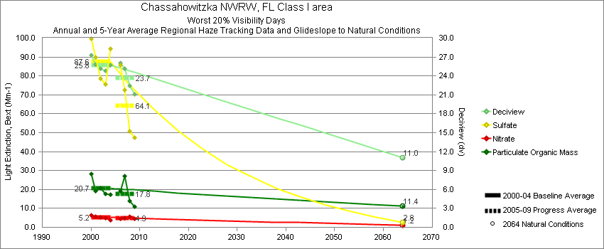
Chassahowitzka - Worst 20% Visibility Days – 5-Year Average, Natural Conditions and Annual Data
Parameter | 2000-2004 | 2005-2009 | 2064 NC | 2000 | 2001 | 2002 | 2003 | 2004 | 2005 | 2006 | 2007 | 2008 | 2009
Deciview (dv) | 25.8 | 23.7 | 11.0 | 27.3 | 25.8 | 25.2 | 24.8 | 25.7 |  | 26.0 | 25.1 | 22.5 | 21.1
Sulfate Bext | 87.6 | 64.1 | 2.8 | 99.7 | 90.0 | 78.6 | 75.4 | 94.3 |  | 85.9 | 72.4 | 50.8 | 47.4
Nitrate Bext | 5.2 | 4.9 | 1.2 | 6.4 | 5.6 | 5.3 | 4.7 | 3.7 |  | 4.4 | 5.0 | 5.6 | 4.7
POM Bext | 20.7 | 17.8 | 11.4 | 28.2 | 19.3 | 20.6 | 17.8 | 17.4 |  | 19.3 | 27.2 | 13.8 | 11.0
EC Bext | 6.7 | 6.4 | 0.3 | 8.7 | 5.8 | 6.2 | 7.0 | 5.9 |  | 8.9 | 7.3 | 4.8 | 4.7
Soil Bext | 0.9 | 1.3 | 0.8 | 0.7 | 1.4 | 0.7 | 0.9 | 0.8 |  | 1.4 | 0.9 | 2.0 | 0.7
Coarse Mass Bext | 3.0 | 3.6 | 2.0 | 3.0 | 3.1 | 2.7 | 3.4 | 2.7 |  | 4.4 | 3.0 | 4.4 | 2.7
Sea Salt Bext | 0.2 | 1.5 | 1.1 | 0.2 | 0.4 | 0.0 | 0.1 | 0.4 |  | 0.6 | 0.8 | 3.1 | 1.7

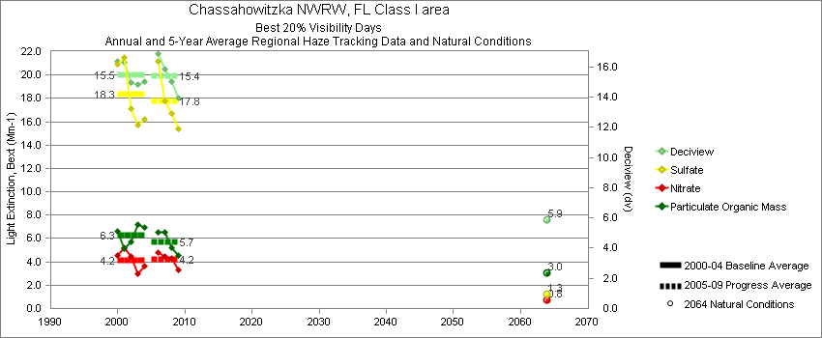
Chassahowitzka - Best 20% Visibility Days – 5-Year Average, Natural Conditions and Annual Data
Parameter | 2000-2004 | 2005-2009 | 2064 NC | 2000 | 2001 | 2002 | 2003 | 2004 | 2005 | 2006 | 2007 | 2008 | 2009
Deciview (dv) | 15.5 | 15.4 | 5.9 | 16.4 | 16.3 | 15.0 | 14.8 | 15.0 |  | 16.9 | 15.8 | 15.0 | 14.0
Sulfate Bext | 18.3 | 17.7 | 1.3 | 20.9 | 21.5 | 17.2 | 15.8 | 16.2 |  | 21.2 | 17.8 | 16.7 | 15.4
Nitrate Bext | 4.2 | 4.2 | 0.8 | 4.5 | 5.2 | 4.4 | 3.0 | 3.7 |  | 4.8 | 4.5 | 4.3 | 3.3
POM Bext | 6.3 | 5.7 | 3.0 | 6.6 | 5.2 | 5.7 | 7.2 | 6.9 |  | 6.5 | 6.5 | 5.2 | 4.6
EC Bext | 2.9 | 2.5 | 0.1 | 3.5 | 2.6 | 2.4 | 3.5 | 2.6 |  | 3.5 | 2.5 | 2.1 | 1.7
Soil Bext | 0.6 | 0.5 | 0.3 | 0.4 | 0.9 | 0.3 | 0.4 | 0.7 |  | 0.4 | 0.5 | 0.4 | 0.5
Coarse Mass Bext | 3.3 | 3.0 | 1.5 | 3.1 | 3.6 | 3.6 | 3.2 | 3.3 |  | 3.8 | 3.3 | 2.7 | 2.2
Sea Salt Bext | 1.0 | 3.0 | 0.2 | 1.6 | 1.5 | 0.6 | 0.6 | 0.8 |  | 3.4 | 3.1 | 3.1 | 2.3
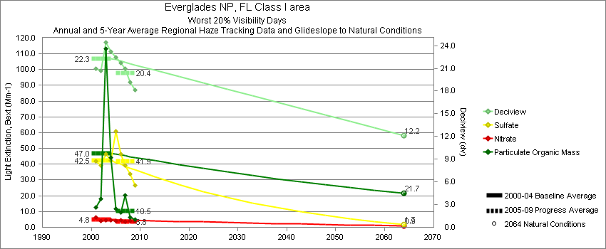
Everglades - Worst 20% Visibility Days – 5-Year Average, Natural Conditions and Annual Data
Parameter | 2000-2004 | 2005-2009 | 2064 NC | 2000 | 2001 | 2002 | 2003 | 2004 | 2005 | 2006 | 2007 | 2008 | 2009
Deciview (dv) | 22.3 | 20.4 | 12.1 |  | 20.9 | 20.6 | 24.4 | 23.2 | 22.3 | 21.4 | 21.0 | 19.2 | 18.1
Sulfate Bext | 42.5 | 41.9 | 1.7 |  | 42.2 | 39.1 | 46.5 | 42.2 | 60.0 | 49.8 | 39.2 | 33.9 | 26.6
Nitrate Bext | 4.8 | 3.8 | 0.9 |  | 6.4 | 3.8 | 4.7 | 4.4 | 4.1 | 3.6 | 3.5 | 4.0 | 3.7
POM Bext | 47.1 | 10.5 | 21.7 |  | 12.8 | 18.1 | 113.1 | 44.2 | 11.8 | 9.8 | 20.1 | 6.1 | 4.8
EC Bext | 5.9 | 3.4 | 0.3 |  | 4.9 | 4.7 | 9.6 | 4.4 | 4.5 | 4.1 | 4.7 | 1.9 | 1.6
Soil Bext | 0.9 | 2.3 | 1.1 |  | 0.8 | 1.3 | 0.9 | 0.8 | 0.6 | 2.8 | 1.5 | 2.7 | 3.7
Coarse Mass Bext | 3.0 | 5.2 | 2.5 |  | 3.6 | 3.2 | 2.6 | 2.5 | 3.1 | 6.0 | 5.0 | 5.8 | 5.9
Sea Salt Bext | 1.2 | 2.5 | 3.8 |  | 0.7 | 0.7 | 0.2 | 3.2 | 1.4 | 1.1 | 1.6 | 4.3 | 4.1

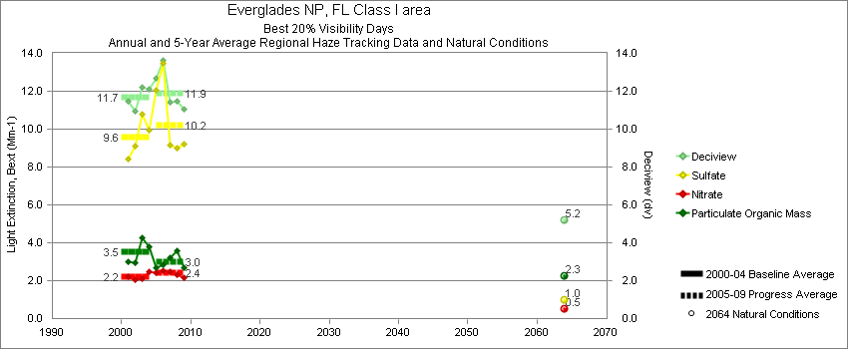
Everglades - Best 20% Visibility Days – 5-Year Average, Natural Conditions and Annual Data
Parameter | 2000-2004 | 2005-2009 | 2064 NC | 2000 | 2001 | 2002 | 2003 | 2004 | 2005 | 2006 | 2007 | 2008 | 2009
Deciview (dv) | 11.7 | 11.9 | 5.2 |  | 11.4 | 11.0 | 12.2 | 12.1 | 12.6 | 13.1 | 11.4 | 11.5 | 11.0
Sulfate Bext | 9.6 | 10.2 | 1.0 |  | 8.4 | 9.1 | 10.8 | 10.0 | 11.8 | 11.8 | 9.2 | 9.0 | 9.2
Nitrate Bext | 2.2 | 2.4 | 0.5 |  | 2.2 | 2.0 | 2.1 | 2.5 | 2.4 | 2.6 | 2.5 | 2.3 | 2.2
POM Bext | 3.5 | 3.0 | 2.3 |  | 3.0 | 3.0 | 4.3 | 3.8 | 2.6 | 2.8 | 3.2 | 3.6 | 2.7
EC Bext | 1.1 | 1.1 | 0.1 |  | 1.3 | 1.0 | 1.3 | 1.0 | 1.1 | 1.3 | 1.1 | 0.9 | 0.9
Soil Bext | 0.4 | 0.4 | 0.2 |  | 0.4 | 0.4 | 0.4 | 0.4 | 0.3 | 0.8 | 0.3 | 0.5 | 0.3
Coarse Mass Bext | 2.7 | 2.8 | 1.1 |  | 3.2 | 2.3 | 2.7 | 2.5 | 2.9 | 4.2 | 2.9 | 2.3 | 1.9
Sea Salt Bext | 1.9 | 2.3 | 0.7 |  | 2.0 | 1.3 | 1.6 | 2.6 | 3.1 | 2.7 | 1.4 | 2.1 | 2.2

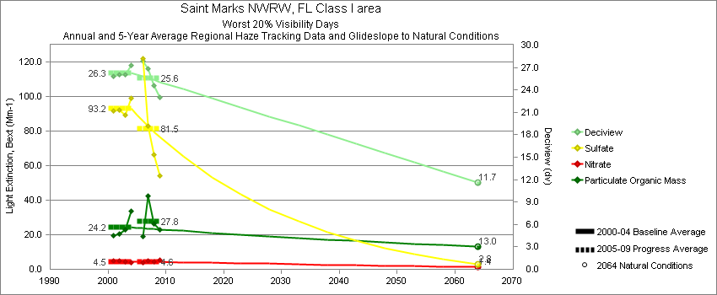
Saint Marks - Worst 20% Visibility Days – 5-Year Average, Natural Conditions and Annual Data
Parameter | 2000-2004 | 2005-2009 | 2064 NC | 2000 | 2001 | 2002 | 2003 | 2004 | 2005 | 2006 | 2007 | 2008 | 2009
Deciview (dv) | 26.3 | 25.6 | 11.7 |  | 25.9 | 26.1 | 26.0 | 27.3 |  | 27.9 | 26.8 | 24.6 | 23.0
Sulfate Bext | 93.1 | 81.5 | 2.8 |  | 91.7 | 92.1 | 89.4 | 99.3 |  | 122.0 | 83.2 | 66.7 | 54.3
Nitrate Bext | 4.5 | 4.6 | 1.4 |  | 4.9 | 4.8 | 4.2 | 4.1 |  | 3.8 | 4.8 | 4.5 | 5.4
POM Bext | 24.2 | 27.8 | 13.0 |  | 19.7 | 20.6 | 22.7 | 33.9 |  | 19.3 | 42.5 | 26.6 | 22.7
EC Bext | 5.6 | 5.9 | 0.3 |  | 5.0 | 6.0 | 6.0 | 5.6 |  | 6.7 | 6.1 | 4.8 | 5.8
Soil Bext | 0.8 | 1.0 | 0.8 |  | 0.7 | 0.9 | 0.8 | 0.7 |  | 0.7 | 1.6 | 0.8 | 1.0
Coarse Mass Bext | 2.6 | 3.4 | 2.3 |  | 2.9 | 3.1 | 2.9 | 1.5 |  | 2.6 | 5.2 | 3.9 | 2.1
Sea Salt Bext | 0.2 | 1.4 | 1.4 |  | 0.3 | 0.0 | 0.0 | 0.7 |  | 1.0 | 0.8 | 2.7 | 1.1

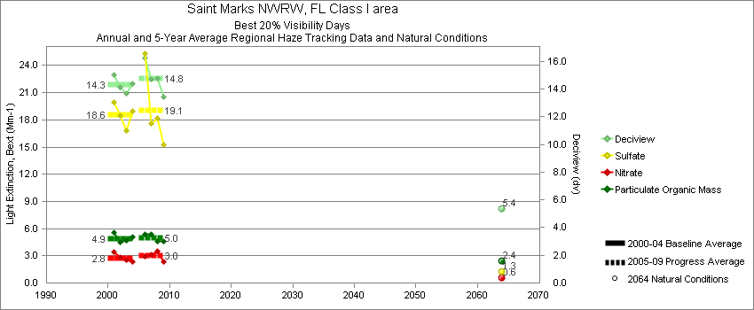
Saint Marks - Best 20% Visibility Days – 5-Year Average, Natural Conditions and Annual Data
Parameter | 2000-2004 | 2005-2009 | 2064 NC | 2000 | 2001 | 2002 | 2003 | 2004 | 2005 | 2006 | 2007 | 2008 | 2009
Deciview (dv) | 14.3 | 14.8 | 5.4 |  | 15.0 | 14.1 | 13.7 | 14.4 |  | 16.2 | 14.7 | 14.8 | 13.4
Sulfate Bext | 18.6 | 19.1 | 1.2 |  | 19.9 | 18.5 | 16.9 | 19.0 |  | 25.4 | 17.6 | 18.2 | 15.2
Nitrate Bext | 2.8 | 3.0 | 0.6 |  | 3.4 | 2.8 | 2.5 | 2.3 |  | 3.0 | 3.1 | 3.6 | 2.4
POM Bext | 4.9 | 5.0 | 2.4 |  | 5.5 | 4.4 | 4.7 | 5.1 |  | 5.4 | 5.4 | 4.6 | 4.6
EC Bext | 1.7 | 1.7 | 0.1 |  | 2.2 | 1.6 | 1.5 | 1.7 |  | 2.0 | 1.9 | 1.4 | 1.4
Soil Bext | 0.5 | 0.5 | 0.2 |  | 0.5 | 0.5 | 0.4 | 0.8 |  | 0.3 | 0.5 | 0.7 | 0.4
Coarse Mass Bext | 2.3 | 2.0 | 1.3 |  | 2.3 | 2.5 | 2.4 | 2.0 |  | 1.9 | 2.3 | 2.1 | 1.7
Sea Salt Bext | 0.6 | 2.4 | 0.3 |  | 0.7 | 0.2 | 0.5 | 1.0 |  | 2.7 | 2.2 | 2.6 | 2.2

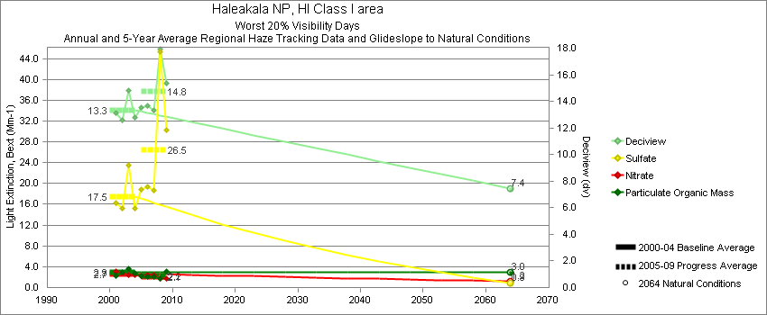
Haleakala - Worst 20% Visibility Days – 5-Year Average, Natural Conditions and Annual Data
Parameter | 2000-2004 | 2005-2009 | 2064 NC | 2000 | 2001 | 2002 | 2003 | 2004 | 2005 | 2006 | 2007 | 2008 | 2009
Deciview (dv) | 13.3 | 14.8 | 7.4 |  | 13.1 | 12.6 | 14.8 | 12.8 | 13.5 | 13.7 | 13.3 | 17.9 | 15.4
Sulfate Bext | 17.5 | 26.5 | 0.9 |  | 16.2 | 15.2 | 23.5 | 15.3 | 18.8 | 19.4 | 18.6 | 45.3 | 30.3
Nitrate Bext | 2.7 | 2.1 | 1.2 |  | 3.1 | 2.8 | 2.4 | 2.4 | 2.3 | 2.4 | 2.4 | 1.7 | 1.8
POM Bext | 2.9 | 2.2 | 3.0 |  | 2.2 | 3.0 | 3.6 | 2.8 | 2.3 | 2.0 | 2.0 | 1.7 | 3.0
EC Bext | 1.4 | 1.2 | 0.4 |  | 1.2 | 1.3 | 1.7 | 1.3 | 1.3 | 1.0 | 1.0 | 1.1 | 1.3
Soil Bext | 0.3 | 0.4 | 0.4 |  | 0.4 | 0.4 | 0.3 | 0.3 | 0.3 | 0.3 | 0.4 | 0.4 | 0.4
Coarse Mass Bext | 2.6 | 1.9 | 2.7 |  | 3.2 | 2.7 | 2.4 | 2.2 | 1.9 | 2.3 | 2.0 | 1.6 | 1.9
Sea Salt Bext | 1.3 | 2.0 | 2.7 |  | 1.4 | 0.7 | 1.3 | 1.7 | 2.1 | 2.5 | 2.5 | 1.3 | 1.5

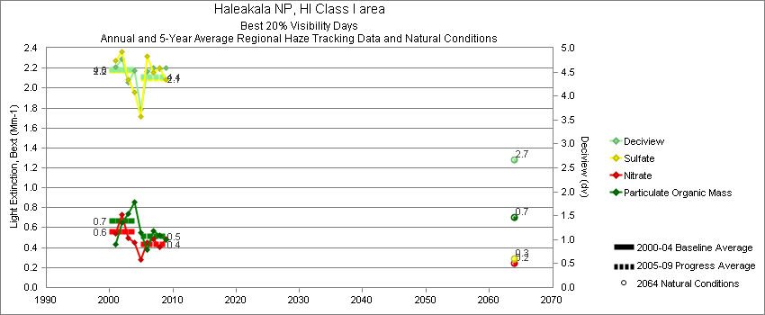
Haleakala - Best 20% Visibility Days – 5-Year Average, Natural Conditions and Annual Data
Parameter | 2000-2004 | 2005-2009 | 2064 NC | 2000 | 2001 | 2002 | 2003 | 2004 | 2005 | 2006 | 2007 | 2008 | 2009
Deciview (dv) | 4.5 | 4.4 | 2.7 |  | 4.6 | 4.8 | 4.3 | 4.5 | 3.7 | 4.5 | 4.6 | 4.6 | 4.6
Sulfate Bext | 2.2 | 2.1 | 0.3 |  | 2.3 | 2.4 | 2.1 | 2.0 | 1.7 | 2.3 | 2.2 | 2.2 | 2.1
Nitrate Bext | 0.6 | 0.4 | 0.2 |  | 0.5 | 0.7 | 0.5 | 0.5 | 0.3 | 0.4 | 0.5 | 0.4 | 0.5
POM Bext | 0.7 | 0.5 | 0.7 |  | 0.4 | 0.7 | 0.7 | 0.9 | 0.6 | 0.4 | 0.6 | 0.5 | 0.5
EC Bext | 0.2 | 0.2 | 0.1 |  | 0.2 | 0.2 | 0.2 | 0.2 | 0.2 | 0.2 | 0.1 | 0.1 | 0.2
Soil Bext | 0.1 | 0.1 | 0.1 |  | 0.1 | 0.1 | 0.1 | 0.1 | 0.0 | 0.1 | 0.1 | 0.1 | 0.1
Coarse Mass Bext | 1.0 | 0.9 | 1.0 |  | 1.2 | 1.1 | 1.0 | 0.9 | 0.8 | 0.8 | 0.9 | 0.9 | 1.0
Sea Salt Bext | 1.1 | 1.5 | 0.7 |  | 1.1 | 1.0 | 0.9 | 1.3 | 1.1 | 1.4 | 1.6 | 1.7 | 1.7
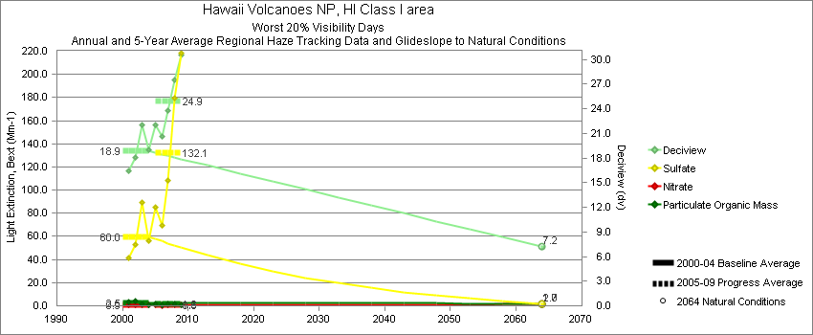
Hawaii Volcanoes - Worst 20% Visibility Days – 5-Year Average, Natural Conditions and Annual Data
Parameter | 2000-2004 | 2005-2009 | 2064 NC | 2000 | 2001 | 2002 | 2003 | 2004 | 2005 | 2006 | 2007 | 2008 | 2009
Deciview (dv) | 18.9 | 24.9 | 7.2 |  | 16.4 | 18.0 | 22.0 | 19.0 | 22.1 | 20.6 | 23.8 | 27.5 | 30.5
Sulfate Bext | 60.0 | 132.1 | 1.7 |  | 41.7 | 53.0 | 89.3 | 56.2 | 85.2 | 69.2 | 108.6 | 179.5 | 218.1
Nitrate Bext | 0.9 | 0.6 | 1.3 |  | 1.0 | 1.0 | 0.8 | 0.6 | 0.6 | 0.3 | 0.7 | 0.7 | 0.5
POM Bext | 2.5 | 1.3 | 2.0 |  | 3.6 | 3.9 | 1.3 | 1.2 | 1.4 | 1.0 | 1.5 | 1.7 | 0.9
EC Bext | 1.0 | 0.8 | 0.3 |  | 0.9 | 0.9 | 1.2 | 1.0 | 0.9 | 0.8 | 0.9 | 0.9 | 0.6
Soil Bext | 0.3 | 0.5 | 0.3 |  | 0.2 | 0.2 | 0.4 | 0.3 | 0.3 | 0.2 | 0.3 | 0.7 | 1.2
Coarse Mass Bext | 0.8 | 1.1 | 1.3 |  | 1.1 | 0.4 | 0.7 | 0.9 | 1.0 | 0.4 | 0.8 | 2.5 | 0.8
Sea Salt Bext | 1.2 | 1.3 | 3.7 |  | 2.3 | 0.4 | 0.1 | 1.4 | 1.5 | 1.5 | 1.2 | 1.5 | 0.8

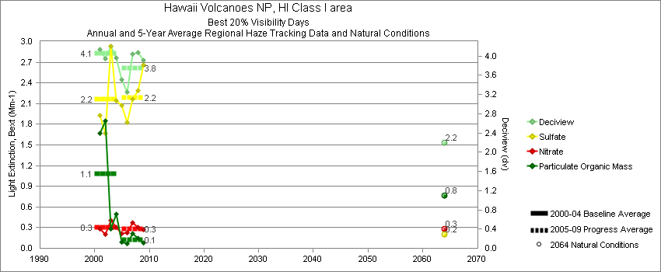
Hawaii Volcanoes - Best 20% Visibility Days – 5-Year Average, Natural Conditions and Annual Data
Parameter | 2000-2004 | 2005-2009 | 2064 NC | 2000 | 2001 | 2002 | 2003 | 2004 | 2005 | 2006 | 2007 | 2008 | 2009
Deciview (dv) | 4.1 | 3.8 | 2.2 |  | 4.1 | 3.9 | 4.2 | 4.0 | 3.5 | 3.2 | 4.0 | 4.1 | 3.9
Sulfate Bext | 2.2 | 2.2 | 0.2 |  | 1.9 | 1.7 | 2.9 | 2.1 | 2.1 | 1.8 | 2.2 | 2.3 | 2.7
Nitrate Bext | 0.3 | 0.3 | 0.3 |  | 0.3 | 0.2 | 0.4 | 0.3 | 0.2 | 0.2 | 0.4 | 0.3 | 0.3
POM Bext | 1.1 | 0.1 | 0.8 |  | 1.7 | 1.9 | 0.3 | 0.5 | 0.1 | 0.1 | 0.2 | 0.1 | 0.1
EC Bext | 0.2 | 0.1 | 0.1 |  | 0.2 | 0.2 | 0.1 | 0.2 | 0.1 | 0.1 | 0.1 | 0.1 | 0.1
Soil Bext | 0.1 | 0.0 | 0.1 |  | 0.1 | 0.0 | 0.1 | 0.0 | 0.0 | 0.0 | 0.0 | 0.0 | 0.0
Coarse Mass Bext | 0.4 | 0.4 | 0.4 |  | 0.4 | 0.2 | 0.5 | 0.5 | 0.4 | 0.3 | 0.5 | 0.4 | 0.3
Sea Salt Bext | 0.9 | 1.6 | 0.7 |  | 0.7 | 0.7 | 1.0 | 1.3 | 1.4 | 1.4 | 1.7 | 1.8 | 1.4

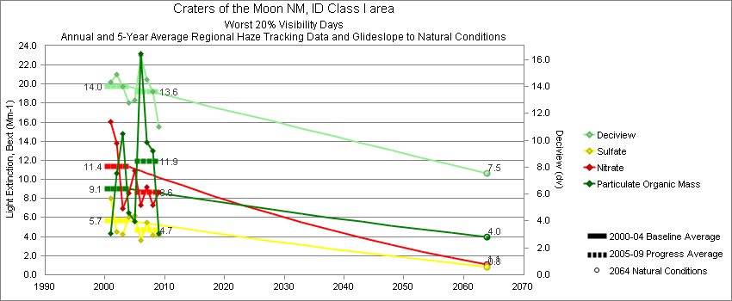
Craters of the Moon - Worst 20% Visibility Days – 5-Year Average, Natural Conditions and Annual Data
Parameter | 2000-2004 | 2005-2009 | 2064 NC | 2000 | 2001 | 2002 | 2003 | 2004 | 2005 | 2006 | 2007 | 2008 | 2009
Deciview (dv) | 14.0 | 13.6 | 7.5 |  | 14.3 | 14.9 | 14.0 | 12.8 | 12.8 | 16.2 | 14.5 | 13.6 | 11.0
Sulfate Bext | 5.7 | 4.7 | 0.8 |  | 8.0 | 4.5 | 4.2 | 6.1 | 6.1 | 3.6 | 5.5 | 4.2 | 4.1
Nitrate Bext | 11.3 | 8.6 | 1.0 |  | 16.0 | 13.8 | 6.9 | 8.6 | 10.3 | 7.6 | 9.2 | 7.3 | 8.6
POM Bext | 9.1 | 11.9 | 4.0 |  | 4.3 | 10.7 | 14.8 | 6.5 | 5.4 | 22.9 | 13.9 | 13.0 | 4.3
EC Bext | 1.9 | 2.1 | 0.4 |  | 1.4 | 2.1 | 2.5 | 1.7 | 1.8 | 3.3 | 2.7 | 1.9 | 1.0
Soil Bext | 1.0 | 1.1 | 1.2 |  | 1.4 | 1.1 | 0.9 | 0.9 | 0.6 | 2.2 | 0.8 | 0.9 | 0.7
Coarse Mass Bext | 2.9 | 3.4 | 4.0 |  | 2.8 | 2.7 | 3.5 | 2.9 | 2.8 | 7.1 | 2.3 | 3.0 | 1.8
Sea Salt Bext | 0.0 | 0.1 | 0.1 |  | 0.0 | 0.0 | 0.0 | 0.1 | 0.1 | 0.2 | 0.1 | 0.1 | 0.0

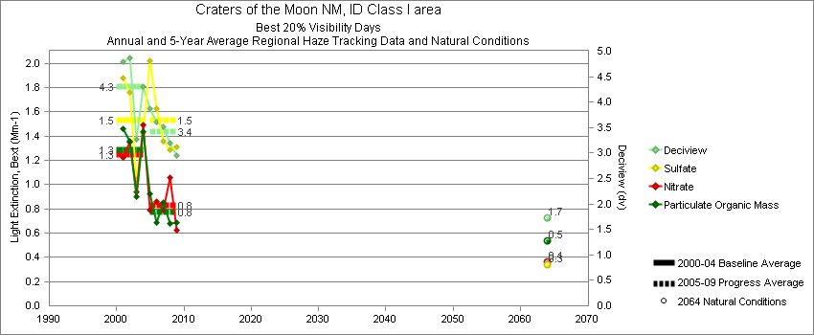
Craters of the Moon - Best 20% Visibility Days – 5-Year Average, Natural Conditions and Annual Data
Parameter | 2000-2004 | 2005-2009 | 2064 NC | 2000 | 2001 | 2002 | 2003 | 2004 | 2005 | 2006 | 2007 | 2008 | 2009
Deciview (dv) | 4.3 | 3.4 | 1.7 |  | 4.8 | 4.9 | 3.3 | 4.3 | 3.9 | 3.6 | 3.5 | 3.2 | 3.0
Sulfate Bext | 1.5 | 1.5 | 0.3 |  | 1.9 | 1.8 | 1.0 | 1.4 | 2.0 | 1.6 | 1.4 | 1.3 | 1.3
Nitrate Bext | 1.2 | 0.8 | 0.4 |  | 1.1 | 1.3 | 0.9 | 1.5 | 0.9 | 0.8 | 0.8 | 1.1 | 0.6
POM Bext | 1.3 | 0.8 | 0.5 |  | 1.5 | 1.4 | 0.9 | 1.4 | 0.9 | 0.7 | 0.8 | 0.7 | 0.7
EC Bext | 0.4 | 0.3 | 0.1 |  | 0.5 | 0.4 | 0.2 | 0.4 | 0.3 | 0.4 | 0.3 | 0.2 | 0.2
Soil Bext | 0.2 | 0.2 | 0.1 |  | 0.3 | 0.3 | 0.1 | 0.2 | 0.2 | 0.1 | 0.2 | 0.1 | 0.2
Coarse Mass Bext | 0.8 | 0.5 | 0.4 |  | 0.9 | 1.1 | 0.7 | 0.5 | 0.5 | 0.5 | 0.6 | 0.4 | 0.5
Sea Salt Bext | 0.0 | 0.0 | 0.0 |  | 0.0 | 0.1 | 0.0 | 0.1 | 0.0 | 0.1 | 0.1 | 0.0 | 0.0

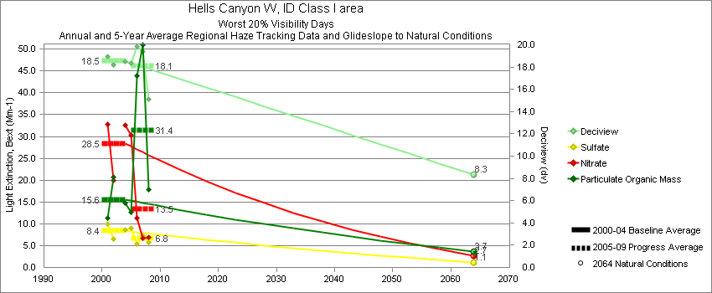
Hells Canyon - Worst 20% Visibility Days – 5-Year Average, Natural Conditions and Annual Data
Parameter | 2000-2004 | 2005-2009 | 2064 NC | 2000 | 2001 | 2002 | 2003 | 2004 | 2005 | 2006 | 2007 | 2008 | 2009
Deciview (dv) | 18.6 | 18.1 | 8.3 |  | 19.0 | 18.2 |  | 18.5 | 18.3 | 19.8 | 19.4 | 15.1
Sulfate Bext | 8.4 | 6.8 | 1.1 |  | 9.9 | 6.6 |  | 8.6 | 8.8 | 5.4 | 7.3 | 5.7
Nitrate Bext | 28.5 | 13.5 | 2.7 |  | 32.9 | 20.0 |  | 32.5 | 29.1 | 11.2 | 6.8 | 6.9
POM Bext | 15.6 | 31.4 | 3.7 |  | 11.4 | 20.7 |  | 14.7 | 13.1 | 43.9 | 51.0 | 17.8
EC Bext | 3.1 | 5.3 | 0.4 |  | 2.9 | 3.7 |  | 2.5 | 4.3 | 7.6 | 6.6 | 2.5
Soil Bext | 0.7 | 0.8 | 0.9 |  | 0.7 | 0.7 |  | 0.6 | 0.4 | 1.1 | 1.2 | 0.7
Coarse Mass Bext | 1.9 | 2.9 | 3.4 |  | 1.4 | 2.0 |  | 2.5 | 1.8 | 3.8 | 3.6 | 2.6
Sea Salt Bext | 0.0 | 0.1 | 0.0 |  | 0.0 | 0.0 |  | 0.1 | 0.2 | 0.2 | 0.1 | 0.0

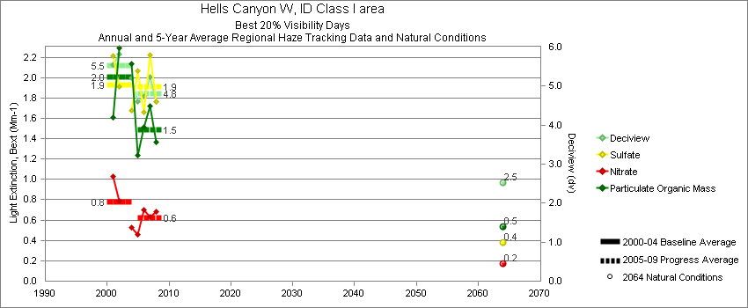
Hells Canyon - Best 20% Visibility Days – 5-Year Average, Natural Conditions and Annual Data
Parameter | 2000-2004 | 2005-2009 | 2064 NC | 2000 | 2001 | 2002 | 2003 | 2004 | 2005 | 2006 | 2007 | 2008 | 2009
Deciview (dv) | 5.5 | 4.8 | 2.5 |  | 5.5 | 5.8 |  | 5.2 | 4.7 | 4.7 | 5.2 | 4.6
Sulfate Bext | 1.9 | 1.9 | 0.4 |  | 2.2 | 1.9 |  | 1.7 | 2.0 | 1.7 | 2.2 | 1.8
Nitrate Bext | 0.8 | 0.6 | 0.2 |  | 1.0 | 0.8 |  | 0.5 | 0.5 | 0.7 | 0.6 | 0.7
POM Bext | 2.0 | 1.5 | 0.5 |  | 1.6 | 2.3 |  | 2.1 | 1.4 | 1.5 | 1.7 | 1.4
EC Bext | 0.6 | 0.4 | 0.1 |  | 0.6 | 0.7 |  | 0.5 | 0.5 | 0.4 | 0.5 | 0.3
Soil Bext | 0.3 | 0.2 | 0.1 |  | 0.2 | 0.3 |  | 0.2 | 0.1 | 0.2 | 0.2 | 0.2
Coarse Mass Bext | 0.8 | 0.5 | 0.5 |  | 0.7 | 0.9 |  | 0.8 | 0.5 | 0.4 | 0.6 | 0.5
Sea Salt Bext | 0.1 | 0.1 | 0.1 |  | 0.1 | 0.0 |  | 0.1 | 0.1 | 0.2 | 0.1 | 0.1

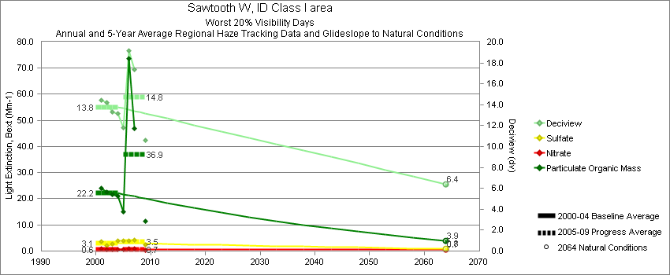
Sawtooth - Worst 20% Visibility Days – 5-Year Average, Natural Conditions and Annual Data
Parameter | 2000-2004 | 2005-2009 | 2064 NC | 2000 | 2001 | 2002 | 2003 | 2004 | 2005 | 2006 | 2007 | 2008 | 2009
Deciview (dv) | 13.8 | 14.8 | 6.4 |  | 14.5 | 14.2 | 13.3 | 13.1 | 11.9 | 19.2 | 17.4 |  | 10.6
Sulfate Bext | 3.1 | 3.5 | 0.8 |  | 3.5 | 2.1 | 2.6 | 4.0 | 3.8 | 3.8 | 4.1 |  | 2.5
Nitrate Bext | 0.6 | 0.7 | 0.7 |  | 0.8 | 0.6 | 0.5 | 0.6 | 0.6 | 1.0 | 0.9 |  | 0.4
POM Bext | 22.2 | 36.9 | 3.9 |  | 23.9 | 22.5 | 21.6 | 20.9 | 15.3 | 73.8 | 47.0 |  | 11.3
EC Bext | 4.2 | 4.9 | 0.4 |  | 5.6 | 4.9 | 2.8 | 3.4 | 3.2 | 7.9 | 6.6 |  | 1.7
Soil Bext | 0.8 | 1.0 | 0.9 |  | 1.1 | 0.8 | 0.5 | 0.8 | 0.7 | 1.1 | 1.4 |  | 0.8
Coarse Mass Bext | 1.7 | 2.5 | 2.4 |  | 2.3 | 1.6 | 1.6 | 1.5 | 2.4 | 2.9 | 2.8 |  | 2.0
Sea Salt Bext | 0.1 | 0.2 | 0.1 |  | 0.3 | 0.0 | 0.2 | 0.0 | 0.0 | 0.0 | 0.0 |  | 0.6

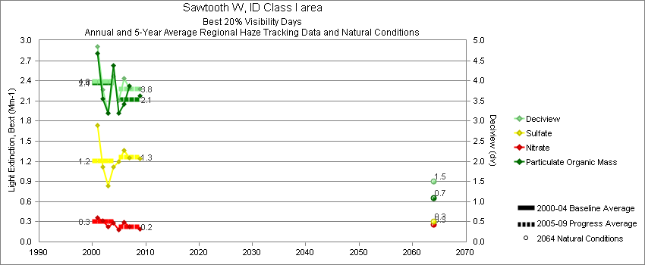
Sawtooth - Best 20% Visibility Days – 5-Year Average, Natural Conditions and Annual Data
Parameter | 2000-2004 | 2005-2009 | 2064 NC | 2000 | 2001 | 2002 | 2003 | 2004 | 2005 | 2006 | 2007 | 2008 | 2009
Deciview (dv) | 4.0 | 3.8 | 1.5 |  | 4.9 | 3.8 | 3.2 | 4.1 | 3.5 | 4.0 | 3.8 |  | 3.8
Sulfate Bext | 1.2 | 1.3 | 0.3 |  | 1.7 | 1.1 | 0.8 | 1.1 | 1.2 | 1.4 | 1.3 |  | 1.2
Nitrate Bext | 0.3 | 0.2 | 0.3 |  | 0.4 | 0.3 | 0.2 | 0.3 | 0.2 | 0.3 | 0.2 |  | 0.2
POM Bext | 2.4 | 2.1 | 0.6 |  | 2.8 | 2.1 | 1.9 | 2.6 | 1.9 | 2.1 | 2.3 |  | 2.2
EC Bext | 0.6 | 0.5 | 0.1 |  | 0.9 | 0.6 | 0.5 | 0.6 | 0.5 | 0.7 | 0.5 |  | 0.4
Soil Bext | 0.1 | 0.1 | 0.1 |  | 0.1 | 0.2 | 0.1 | 0.2 | 0.1 | 0.1 | 0.1 |  | 0.2
Coarse Mass Bext | 0.3 | 0.3 | 0.2 |  | 0.3 | 0.3 | 0.3 | 0.3 | 0.3 | 0.4 | 0.2 |  | 0.3
Sea Salt Bext | 0.0 | 0.0 | 0.0 |  | 0.0 | 0.0 | 0.0 | 0.0 | 0.0 | 0.1 | 0.0 |  | 0.0

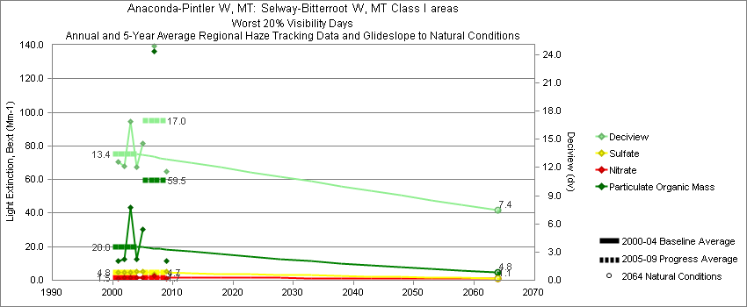
Sula Peak - Worst 20% Visibility Days – 5-Year Average, Natural Conditions and Annual Data
Parameter | 2000-2004 | 2005-2009 | 2064 NC | 2000 | 2001 | 2002 | 2003 | 2004 | 2005 | 2006 | 2007 | 2008 | 2009
Deciview (dv) | 13.4 | 17.0 | 7.4 |  | 12.6 | 12.1 | 16.9 | 12.0 | 14.6 |  | 24.9 |  | 11.6
Sulfate Bext | 4.8 | 4.7 | 1.1 |  | 4.8 | 4.6 | 4.8 | 5.1 | 5.2 |  | 3.8 |  | 5.1
Nitrate Bext | 1.5 | 1.7 | 1.1 |  | 1.3 | 1.6 | 1.6 | 1.4 | 1.4 |  | 2.7 |  | 1.0
POM Bext | 20.0 | 59.5 | 4.8 |  | 11.5 | 12.6 | 43.3 | 12.7 | 30.6 |  | 136.5 |  | 11.3
EC Bext | 2.5 | 8.8 | 0.4 |  | 2.0 | 2.1 | 4.3 | 1.7 | 4.9 |  | 19.8 |  | 1.7
Soil Bext | 0.9 | 0.6 | 0.9 |  | 1.6 | 0.9 | 0.6 | 0.7 | 0.5 |  | 0.7 |  | 0.6
Coarse Mass Bext | 2.5 | 3.6 | 2.7 |  | 3.7 | 2.4 | 1.7 | 2.1 | 2.8 |  | 5.2 |  | 2.8
Sea Salt Bext | 0.3 | 0.0 | 0.3 |  | 1.0 | 0.0 | 0.0 | 0.0 | 0.0 |  | 0.1 |  | 0.0

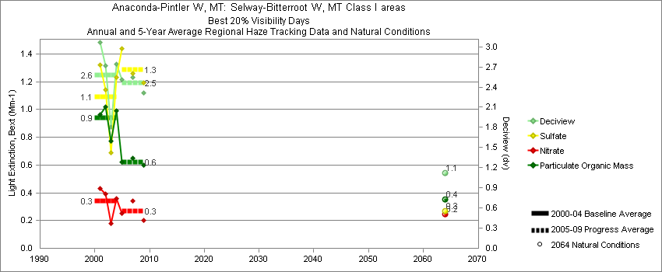
Sula Peak - Best 20% Visibility Days – 5-Year Average, Natural Conditions and Annual Data
Parameter | 2000-2004 | 2005-2009 | 2064 NC | 2000 | 2001 | 2002 | 2003 | 2004 | 2005 | 2006 | 2007 | 2008 | 2009
Deciview (dv) | 2.6 | 2.5 | 1.1 |  | 3.1 | 2.7 | 1.8 | 2.7 | 2.5 |  | 2.5 |  | 2.3
Sulfate Bext | 1.1 | 1.3 | 0.3 |  | 1.3 | 1.1 | 0.7 | 1.2 | 1.4 |  | 1.3 |  | 1.2
Nitrate Bext | 0.3 | 0.3 | 0.2 |  | 0.4 | 0.4 | 0.2 | 0.4 | 0.3 |  | 0.3 |  | 0.2
POM Bext | 0.9 | 0.6 | 0.4 |  | 1.0 | 1.0 | 0.8 | 1.0 | 0.6 |  | 0.7 |  | 0.6
EC Bext | 0.3 | 0.2 | 0.1 |  | 0.3 | 0.3 | 0.2 | 0.3 | 0.2 |  | 0.2 |  | 0.1
Soil Bext | 0.1 | 0.1 | 0.1 |  | 0.2 | 0.1 | 0.0 | 0.1 | 0.1 |  | 0.1 |  | 0.1
Coarse Mass Bext | 0.2 | 0.3 | 0.2 |  | 0.3 | 0.2 | 0.1 | 0.2 | 0.3 |  | 0.4 |  | 0.4
Sea Salt Bext | 0.0 | 0.0 | 0.0 |  | 0.1 | 0.0 | 0.0 | 0.0 | 0.0 |  | 0.1 |  | 0.0

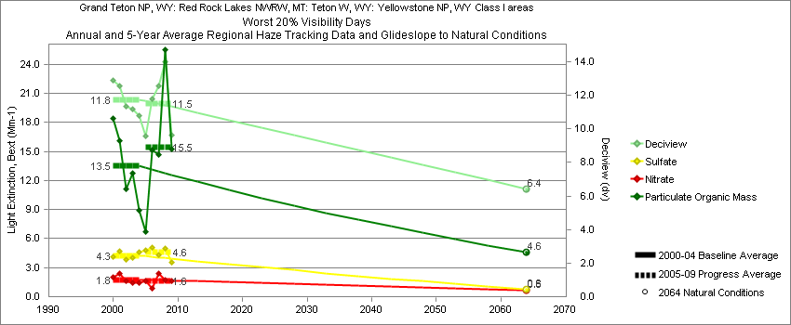
Yellowstone - Worst 20% Visibility Days – 5-Year Average, Natural Conditions and Annual Data
Parameter | 2000-2004 | 2005-2009 | 2064 NC | 2000 | 2001 | 2002 | 2003 | 2004 | 2005 | 2006 | 2007 | 2008 | 2009
Deciview (dv) | 11.8 | 11.5 | 6.4 | 12.9 | 12.6 | 11.4 | 11.2 | 10.8 | 9.6 | 11.8 | 12.6 | 14.0 | 9.6
Sulfate Bext | 4.3 | 4.6 | 0.8 | 4.2 | 4.7 | 3.8 | 4.1 | 4.6 | 4.8 | 5.1 | 4.3 | 5.0 | 3.5
Nitrate Bext | 1.8 | 1.6 | 0.6 | 2.0 | 2.4 | 1.6 | 1.4 | 1.5 | 1.6 | 0.9 | 2.4 | 1.7 | 1.6
POM Bext | 13.5 | 15.5 | 4.6 | 18.4 | 16.1 | 11.2 | 12.8 | 8.9 | 6.7 | 15.1 | 14.7 | 25.6 | 15.2
EC Bext | 2.5 | 2.2 | 0.4 | 3.7 | 2.6 | 1.9 | 2.3 | 1.9 | 1.8 | 2.3 | 2.4 | 2.6 | 1.7
Soil Bext | 1.0 | 0.8 | 1.0 | 0.8 | 1.4 | 1.2 | 0.4 | 0.9 | 0.6 | 1.1 | 0.8 | 1.0 | 0.6
Coarse Mass Bext | 2.6 | 2.4 | 3.0 | 2.8 | 2.7 | 3.1 | 1.3 | 2.9 | 1.8 | 2.6 | 2.6 | 2.6 | 2.3
Sea Salt Bext | 0.0 | 0.1 | 0.0 | 0.0 | 0.0 | 0.0 | 0.0 | 0.1 | 0.1 | 0.0 | 0.0 | 0.1 | 0.1

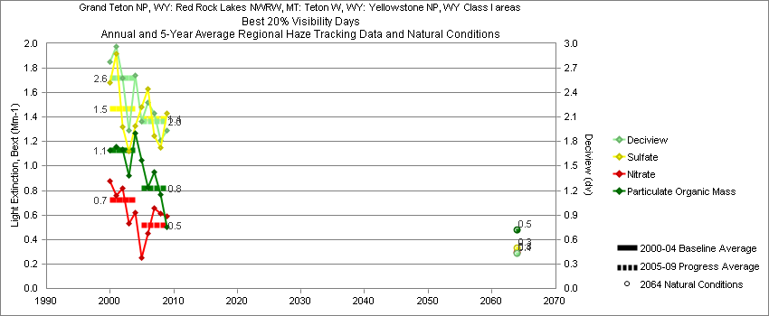
Yellowstone - Best 20% Visibility Days – 5-Year Average, Natural Conditions and Annual Data
Parameter | 2000-2004 | 2005-2009 | 2064 NC | 2000 | 2001 | 2002 | 2003 | 2004 | 2005 | 2006 | 2007 | 2008 | 2009
Deciview (dv) | 2.6 | 2.0 | 0.4 | 2.8 | 3.0 | 2.6 | 1.9 | 2.6 | 2.1 | 2.3 | 2.2 | 1.8 | 1.9
Sulfate Bext | 1.5 | 1.4 | 0.3 | 1.7 | 1.9 | 1.3 | 1.1 | 1.3 | 1.5 | 1.6 | 1.2 | 1.1 | 1.4
Nitrate Bext | 0.7 | 0.5 | 0.3 | 0.9 | 0.8 | 0.8 | 0.5 | 0.6 | 0.3 | 0.4 | 0.7 | 0.6 | 0.6
POM Bext | 1.1 | 0.8 | 0.5 | 1.1 | 1.2 | 1.1 | 0.9 | 1.3 | 1.1 | 0.8 | 1.0 | 0.8 | 0.5
EC Bext | 0.3 | 0.3 | 0.1 | 0.2 | 0.4 | 0.3 | 0.2 | 0.5 | 0.3 | 0.4 | 0.3 | 0.1 | 0.2
Soil Bext | 0.1 | 0.1 | 0.1 | 0.1 | 0.1 | 0.1 | 0.1 | 0.1 | 0.1 | 0.1 | 0.1 | 0.1 | 0.1
Coarse Mass Bext | 0.2 | 0.2 | 0.2 | 0.3 | 0.2 | 0.3 | 0.2 | 0.3 | 0.1 | 0.2 | 0.2 | 0.3 | 0.3
Sea Salt Bext | 0.0 | 0.0 | 0.0 | 0.1 | 0.0 | 0.0 | 0.0 | 0.0 | 0.0 | 0.0 | 0.0 | 0.0 | 0.0

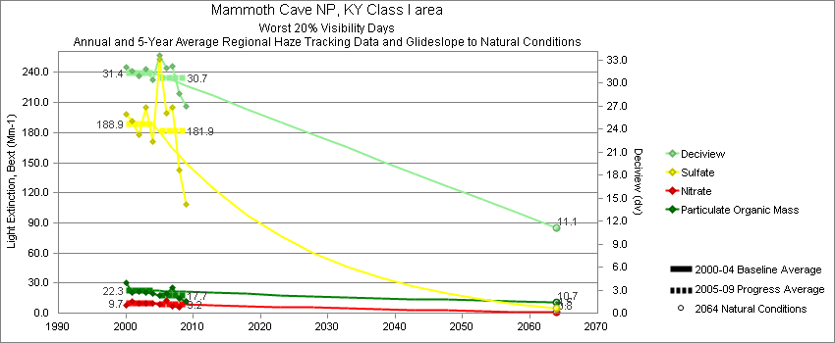
Mammoth Cave - Worst 20% Visibility Days – 5-Year Average, Natural Conditions and Annual Data
Parameter | 2000-2004 | 2005-2009 | 2064 NC | 2000 | 2001 | 2002 | 2003 | 2004 | 2005 | 2006 | 2007 | 2008 | 2009
Deciview (dv) | 31.4 | 30.7 | 11.1 | 32.1 | 31.5 | 31.0 | 31.8 | 30.4 | 33.7 | 31.9 | 32.2 | 28.7 | 26.9
Sulfate Bext | 188.9 | 181.9 | 4.5 | 198.3 | 191.3 | 178.4 | 205.6 | 171.0 | 252.7 | 199.7 | 205.1 | 143.0 | 108.9
Nitrate Bext | 9.7 | 9.2 | 0.8 | 7.8 | 11.6 | 10.1 | 9.7 | 9.5 | 8.5 | 12.5 | 7.2 | 6.2 | 11.8
POM Bext | 22.3 | 17.7 | 10.7 | 30.3 | 20.1 | 21.6 | 20.1 | 19.2 | 17.5 | 19.1 | 25.9 | 14.4 | 11.7
EC Bext | 6.2 | 5.7 | 0.3 | 8.7 | 5.5 | 5.6 | 6.1 | 5.2 | 7.6 | 6.5 | 6.0 | 4.4 | 4.0
Soil Bext | 0.9 | 0.8 | 1.0 | 0.6 | 0.9 | 1.3 | 0.8 | 1.1 | 0.6 | 0.8 | 0.9 | 1.0 | 0.7
Coarse Mass Bext | 2.2 | 3.0 | 2.3 | 3.6 | 2.3 | 1.1 | 2.1 | 1.8 | 2.6 | 3.1 | 3.9 | 3.0 | 2.4
Sea Salt Bext | 0.1 | 0.2 | 0.2 | 0.2 | 0.0 | 0.0 | 0.0 | 0.3 | 0.2 | 0.3 | 0.2 | 0.0 | 0.1

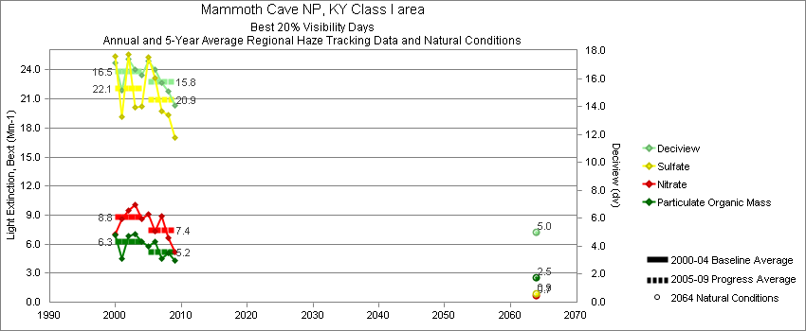
Mammoth Cave - Best 20% Visibility Days – 5-Year Average, Natural Conditions and Annual Data
Parameter | 2000-2004 | 2005-2009 | 2064 NC | 2000 | 2001 | 2002 | 2003 | 2004 | 2005 | 2006 | 2007 | 2008 | 2009
Deciview (dv) | 16.5 | 15.8 | 5.0 | 17.1 | 15.2 | 17.4 | 16.7 | 16.2 | 17.3 | 16.6 | 15.7 | 15.1 | 14.1
Sulfate Bext | 22.1 | 20.9 | 0.9 | 25.4 | 19.2 | 25.6 | 20.1 | 20.3 | 25.3 | 23.2 | 19.8 | 19.3 | 17.0
Nitrate Bext | 8.8 | 7.4 | 0.7 | 7.1 | 8.6 | 9.5 | 10.1 | 8.6 | 9.1 | 7.3 | 8.9 | 6.7 | 5.2
POM Bext | 6.3 | 5.2 | 2.5 | 6.9 | 4.5 | 6.8 | 7.1 | 6.2 | 5.8 | 6.3 | 4.5 | 5.1 | 4.3
EC Bext | 3.0 | 2.7 | 0.1 | 3.7 | 2.4 | 3.0 | 3.1 | 2.9 | 3.5 | 3.3 | 2.3 | 2.3 | 1.9
Soil Bext | 0.3 | 0.3 | 0.2 | 0.3 | 0.3 | 0.4 | 0.3 | 0.3 | 0.3 | 0.3 | 0.3 | 0.3 | 0.3
Coarse Mass Bext | 1.4 | 1.7 | 0.9 | 1.5 | 0.9 | 1.1 | 1.8 | 1.5 | 1.9 | 1.9 | 2.1 | 1.4 | 1.5
Sea Salt Bext | 0.1 | 0.3 | 0.1 | 0.0 | 0.0 | 0.0 | 0.0 | 0.4 | 0.2 | 0.4 | 0.4 | 0.3 | 0.1

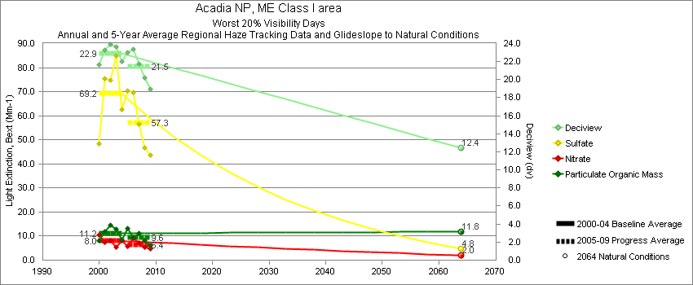
Acadia - Worst 20% Visibility Days – 5-Year Average, Natural Conditions and Annual Data
Parameter | 2000-2004 | 2005-2009 | 2064 NC | 2000 | 2001 | 2002 | 2003 | 2004 | 2005 | 2006 | 2007 | 2008 | 2009
Deciview (dv) | 22.9 | 21.5 | 12.4 | 21.6 | 23.3 | 23.9 | 23.6 | 22.0 | 23.0 | 23.4 | 21.7 | 20.2 | 18.9
Sulfate Bext | 69.2 | 57.2 | 4.8 | 48.4 | 75.5 | 74.8 | 84.9 | 62.5 | 70.1 | 69.6 | 56.4 | 46.7 | 43.5
Nitrate Bext | 8.0 | 6.4 | 2.0 | 10.6 | 7.5 | 8.2 | 5.6 | 8.3 | 5.7 | 9.2 | 7.0 | 5.5 | 4.8
POM Bext | 11.2 | 9.6 | 11.8 | 8.2 | 11.9 | 14.6 | 12.8 | 8.3 | 13.0 | 9.5 | 11.1 | 8.2 | 6.1
EC Bext | 4.3 | 3.5 | 0.4 | 4.6 | 4.5 | 4.0 | 4.9 | 3.6 | 4.6 | 4.1 | 3.9 | 2.8 | 2.4
Soil Bext | 0.5 | 0.3 | 0.5 | 0.3 | 0.6 | 0.8 | 0.5 | 0.4 | 0.3 | 0.4 | 0.4 | 0.3 | 0.4
Coarse Mass Bext | 1.9 | 2.3 | 2.2 | 2.5 | 1.6 | 1.9 | 1.7 | 1.8 | 2.0 | 2.8 | 2.7 | 2.1 | 2.0
Sea Salt Bext | 1.3 | 1.6 | 2.1 | 3.1 | 0.0 | 0.8 | 0.6 | 1.9 | 1.3 | 1.3 | 1.9 | 1.3 | 2.0

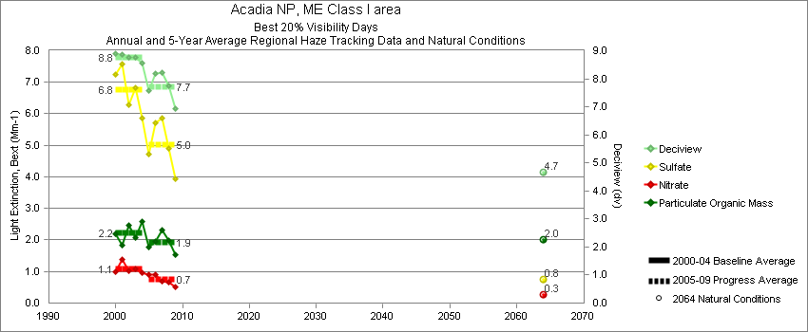
Acadia - Best 20% Visibility Days – 5-Year Average, Natural Conditions and Annual Data
Parameter | 2000-2004 | 2005-2009 | 2064 NC | 2000 | 2001 | 2002 | 2003 | 2004 | 2005 | 2006 | 2007 | 2008 | 2009
Deciview (dv) | 8.8 | 7.7 | 4.7 | 8.9 | 8.9 | 8.8 | 8.8 | 8.6 | 7.6 | 8.2 | 8.2 | 7.8 | 6.9
Sulfate Bext | 6.8 | 5.0 | 0.8 | 7.2 | 7.6 | 6.3 | 6.8 | 5.9 | 4.7 | 5.7 | 5.9 | 4.9 | 3.9
Nitrate Bext | 1.1 | 0.7 | 0.3 | 1.0 | 1.4 | 1.0 | 1.1 | 0.9 | 0.9 | 0.9 | 0.7 | 0.7 | 0.5
POM Bext | 2.2 | 1.9 | 2.0 | 2.2 | 1.8 | 2.5 | 2.1 | 2.6 | 1.8 | 1.9 | 2.3 | 2.0 | 1.5
EC Bext | 0.9 | 0.7 | 0.1 | 1.1 | 0.9 | 0.9 | 0.8 | 0.8 | 0.8 | 0.9 | 0.7 | 0.6 | 0.5
Soil Bext | 0.1 | 0.1 | 0.1 | 0.1 | 0.1 | 0.1 | 0.1 | 0.1 | 0.1 | 0.1 | 0.1 | 0.1 | 0.1
Coarse Mass Bext | 0.7 | 0.8 | 0.6 | 0.7 | 0.6 | 0.8 | 0.6 | 0.9 | 0.7 | 0.8 | 0.7 | 0.9 | 1.0
Sea Salt Bext | 0.4 | 0.6 | 0.2 | 0.3 | 0.1 | 0.6 | 0.7 | 0.5 | 0.8 | 0.6 | 0.4 | 0.8 | 0.6
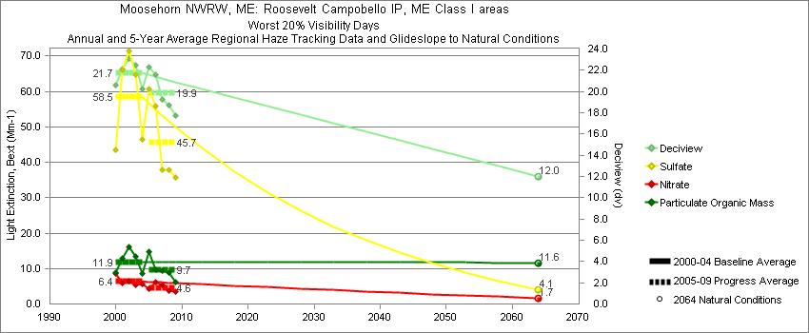
Moosehorn - Worst 20% Visibility Days – 5-Year Average, Natural Conditions and Annual Data
Parameter | 2000-2004 | 2005-2009 | 2064 NC | 2000 | 2001 | 2002 | 2003 | 2004 | 2005 | 2006 | 2007 | 2008 | 2009
Deciview (dv) | 21.7 | 19.9 | 12.0 | 20.6 | 22.1 | 23.1 | 22.5 | 20.3 | 22.4 | 21.6 | 19.2 | 18.7 | 17.7
Sulfate Bext | 58.5 | 45.7 | 4.0 | 43.5 | 66.1 | 71.5 | 64.7 | 46.5 | 61.2 | 55.8 | 37.9 | 37.8 | 35.8
Nitrate Bext | 6.4 | 4.6 | 1.7 | 8.5 | 5.9 | 6.4 | 5.5 | 5.7 | 4.3 | 6.1 | 5.2 | 3.9 | 3.5
POM Bext | 11.9 | 9.7 | 11.6 | 8.8 | 12.8 | 16.0 | 13.5 | 8.7 | 14.5 | 9.6 | 9.3 | 8.7 | 6.3
EC Bext | 4.4 | 3.1 | 0.4 | 3.6 | 4.0 | 4.0 | 7.3 | 3.2 | 3.9 | 3.3 | 3.1 | 2.5 | 2.9
Soil Bext | 0.4 | 0.3 | 0.4 | 0.3 | 0.5 | 0.4 | 0.4 | 0.4 | 0.3 | 0.3 | 0.3 | 0.4 | 0.4
Coarse Mass Bext | 2.1 | 1.7 | 2.3 | 2.7 | 2.1 | 1.7 | 2.3 | 1.8 | 1.6 | 1.6 | 1.9 | 1.9 | 1.5
Sea Salt Bext | 0.9 | 1.8 | 1.5 | 2.1 | 0.0 | 0.5 | 0.4 | 1.8 | 2.6 | 1.4 | 1.4 | 1.2 | 2.3

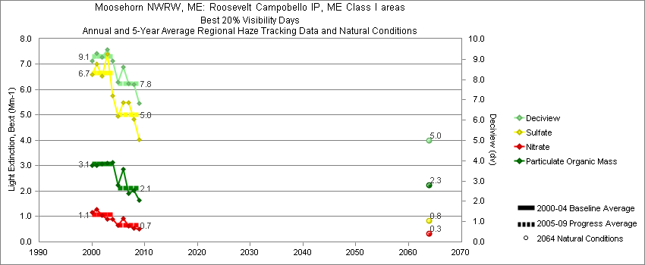
Moosehorn - Best 20% Visibility Days – 5-Year Average, Natural Conditions and Annual Data
Parameter | 2000-2004 | 2005-2009 | 2064 NC | 2000 | 2001 | 2002 | 2003 | 2004 | 2005 | 2006 | 2007 | 2008 | 2009
Deciview (dv) | 9.2 | 7.8 | 5.0 | 8.9 | 9.3 | 9.1 | 9.5 | 8.9 | 8.0 | 8.6 | 7.8 | 7.8 | 6.8
Sulfate Bext | 6.7 | 5.0 | 0.8 | 6.6 | 7.0 | 6.6 | 7.4 | 5.8 | 5.1 | 5.5 | 5.5 | 4.8 | 4.0
Nitrate Bext | 1.1 | 0.7 | 0.3 | 1.2 | 1.3 | 1.0 | 0.9 | 0.9 | 0.7 | 0.9 | 0.6 | 0.6 | 0.5
POM Bext | 3.1 | 2.1 | 2.2 | 3.0 | 3.0 | 3.1 | 3.1 | 3.1 | 2.2 | 2.9 | 1.9 | 2.0 | 1.6
EC Bext | 1.0 | 0.7 | 0.1 | 1.2 | 1.0 | 1.0 | 0.9 | 0.9 | 0.9 | 1.1 | 0.6 | 0.6 | 0.4
Soil Bext | 0.1 | 0.1 | 0.1 | 0.1 | 0.1 | 0.1 | 0.1 | 0.1 | 0.1 | 0.1 | 0.1 | 0.1 | 0.1
Coarse Mass Bext | 1.1 | 0.8 | 0.8 | 1.0 | 0.9 | 1.1 | 1.2 | 1.1 | 0.7 | 0.7 | 0.8 | 1.0 | 0.6
Sea Salt Bext | 0.3 | 0.6 | 0.2 | 0.0 | 0.1 | 0.3 | 0.3 | 0.7 | 0.8 | 0.7 | 0.3 | 0.7 | 0.6

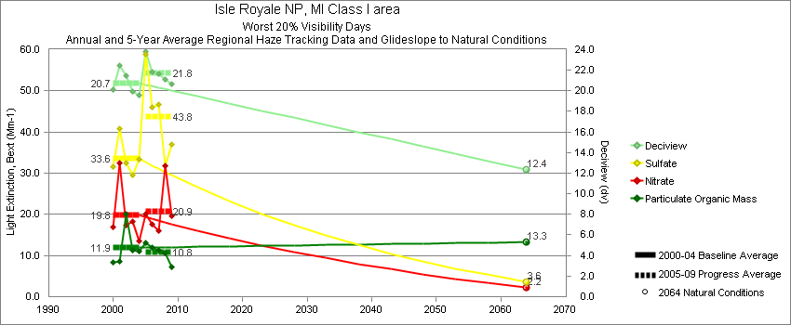
Isle Royale - Worst 20% Visibility Days – 5-Year Average, Natural Conditions and Annual Data
Parameter | 2000-2004 | 2005-2009 | 2064 NC | 2000 | 2001 | 2002 | 2003 | 2004 | 2005 | 2006 | 2007 | 2008 | 2009
Deciview (dv) | 20.7 | 21.8 | 12.4 | 20.2 | 22.5 | 21.5 | 19.9 | 19.6 | 23.5 | 21.8 | 21.7 | 21.1 | 20.6
Sulfate Bext | 33.6 | 43.8 | 3.6 | 31.5 | 40.8 | 32.5 | 29.5 | 33.4 | 57.6 | 45.9 | 46.7 | 31.7 | 37.1
Nitrate Bext | 19.8 | 20.9 | 2.2 | 16.9 | 32.6 | 17.4 | 18.3 | 13.6 | 19.3 | 17.6 | 15.9 | 31.8 | 19.7
POM Bext | 11.9 | 10.8 | 13.3 | 8.4 | 8.5 | 20.0 | 11.4 | 11.0 | 12.9 | 12.0 | 11.2 | 10.6 | 7.3
EC Bext | 3.6 | 3.5 | 0.4 | 3.9 | 3.9 | 4.2 | 3.4 | 2.9 | 4.7 | 3.8 | 3.4 | 3.0 | 2.7
Soil Bext | 0.4 | 0.5 | 0.4 | 0.4 | 0.4 | 0.5 | 0.4 | 0.5 | 0.5 | 0.5 | 0.6 | 0.4 | 0.5
Coarse Mass Bext | 3.4 | 3.5 | 3.5 | 4.9 | 2.1 | 3.9 | 2.7 | 3.5 | 3.6 | 4.1 | 3.9 | 2.8 | 3.4
Sea Salt Bext | 0.2 | 0.2 | 0.4 | 0.0 | 0.5 | 0.0 | 0.0 | 0.3 | 0.3 | 0.3 | 0.2 | 0.2 | 0.1

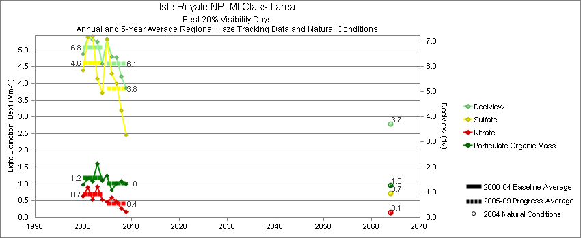
Isle Royale - Best 20% Visibility Days – 5-Year Average, Natural Conditions and Annual Data
Parameter | 2000-2004 | 2005-2009 | 2064 NC | 2000 | 2001 | 2002 | 2003 | 2004 | 2005 | 2006 | 2007 | 2008 | 2009
Deciview (dv) | 6.8 | 6.1 | 3.7 | 6.5 | 7.2 | 7.1 | 7.0 | 6.1 | 7.1 | 6.4 | 6.4 | 5.6 | 5.1
Sulfate Bext | 4.6 | 3.8 | 0.7 | 4.4 | 5.4 | 5.4 | 4.2 | 3.7 | 5.2 | 4.3 | 4.0 | 3.2 | 2.5
Nitrate Bext | 0.7 | 0.4 | 0.1 | 0.6 | 0.9 | 0.5 | 0.9 | 0.5 | 0.5 | 0.6 | 0.5 | 0.3 | 0.2
POM Bext | 1.2 | 1.0 | 1.0 | 1.0 | 1.2 | 1.1 | 1.6 | 1.1 | 1.2 | 0.8 | 1.0 | 1.1 | 1.0
EC Bext | 0.4 | 0.3 | 0.1 | 0.4 | 0.3 | 0.4 | 0.6 | 0.3 | 0.4 | 0.3 | 0.4 | 0.2 | 0.3
Soil Bext | 0.1 | 0.1 | 0.1 | 0.1 | 0.1 | 0.1 | 0.1 | 0.1 | 0.1 | 0.1 | 0.1 | 0.1 | 0.1
Coarse Mass Bext | 0.7 | 0.7 | 0.5 | 0.6 | 0.6 | 0.8 | 0.8 | 0.7 | 0.8 | 0.7 | 0.8 | 0.6 | 0.7
Sea Salt Bext | 0.1 | 0.2 | 0.1 | 0.2 | 0.2 | 0.1 | 0.1 | 0.1 | 0.2 | 0.3 | 0.2 | 0.1 | 0.1
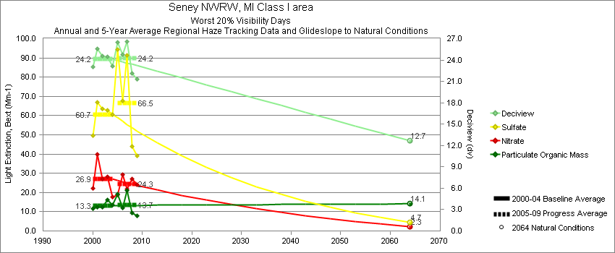
Seney - Worst 20% Visibility Days – 5-Year Average, Natural Conditions and Annual Data
Parameter | 2000-2004 | 2005-2009 | 2064 NC | 2000 | 2001 | 2002 | 2003 | 2004 | 2005 | 2006 | 2007 | 2008 | 2009
Deciview (dv) | 24.2 | 24.2 | 12.7 | 23.0 | 25.6 | 24.6 | 24.5 | 23.2 | 26.2 | 24.8 | 26.6 | 22.2 | 21.3
Sulfate Bext | 60.7 | 66.5 | 4.7 | 49.6 | 66.8 | 63.6 | 62.9 | 60.6 | 90.6 | 67.5 | 91.3 | 43.8 | 39.2
Nitrate Bext | 26.9 | 24.3 | 2.3 | 22.0 | 40.0 | 27.0 | 28.1 | 17.5 | 19.1 | 29.5 | 21.7 | 27.1 | 24.2
POM Bext | 13.3 | 13.7 | 14.1 | 11.8 | 12.5 | 12.5 | 16.0 | 13.4 | 18.2 | 12.0 | 21.0 | 9.2 | 8.1
EC Bext | 4.3 | 4.4 | 0.5 | 4.8 | 4.6 | 3.9 | 4.7 | 3.5 | 5.9 | 5.1 | 4.7 | 3.3 | 2.8
Soil Bext | 0.5 | 0.5 | 0.5 | 0.4 | 0.5 | 0.6 | 0.4 | 0.6 | 0.5 | 0.6 | 0.7 | 0.5 | 0.4
Coarse Mass Bext | 1.9 | 2.1 | 2.2 | 1.8 | 1.5 | 2.6 | 2.1 | 1.5 | 2.4 | 2.5 | 2.3 | 1.7 | 1.4
Sea Salt Bext | 0.0 | 0.2 | 0.0 | 0.0 | 0.0 | 0.0 | 0.0 | 0.2 | 0.2 | 0.3 | 0.2 | 0.1 | 0.1

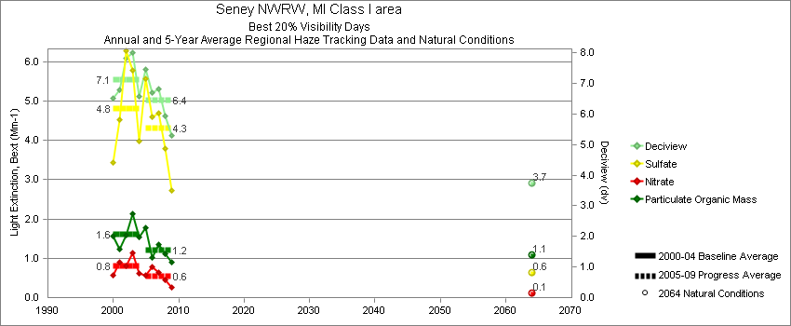
Seney - Best 20% Visibility Days – 5-Year Average, Natural Conditions and Annual Data
Parameter | 2000-2004 | 2005-2009 | 2064 NC | 2000 | 2001 | 2002 | 2003 | 2004 | 2005 | 2006 | 2007 | 2008 | 2009
Deciview (dv) | 7.1 | 6.5 | 3.7 | 6.5 | 6.8 | 7.8 | 8.0 | 6.6 | 7.5 | 6.7 | 6.8 | 5.9 | 5.3
Sulfate Bext | 4.8 | 4.3 | 0.6 | 3.4 | 4.5 | 6.3 | 5.8 | 4.0 | 5.7 | 4.6 | 4.7 | 3.8 | 2.7
Nitrate Bext | 0.8 | 0.5 | 0.1 | 0.6 | 0.9 | 0.8 | 1.1 | 0.6 | 0.6 | 0.8 | 0.6 | 0.4 | 0.3
POM Bext | 1.6 | 1.2 | 1.1 | 1.6 | 1.2 | 1.6 | 2.1 | 1.5 | 1.7 | 1.0 | 1.3 | 1.1 | 0.9
EC Bext | 0.5 | 0.4 | 0.1 | 0.5 | 0.4 | 0.5 | 0.6 | 0.4 | 0.6 | 0.4 | 0.4 | 0.2 | 0.3
Soil Bext | 0.1 | 0.1 | 0.1 | 0.1 | 0.1 | 0.1 | 0.1 | 0.1 | 0.1 | 0.1 | 0.1 | 0.1 | 0.1
Coarse Mass Bext | 0.7 | 0.6 | 0.5 | 1.1 | 0.5 | 0.6 | 0.5 | 0.6 | 0.6 | 0.5 | 0.6 | 0.5 | 0.7
Sea Salt Bext | 0.1 | 0.2 | 0.1 | 0.0 | 0.1 | 0.1 | 0.2 | 0.2 | 0.2 | 0.3 | 0.3 | 0.2 | 0.2

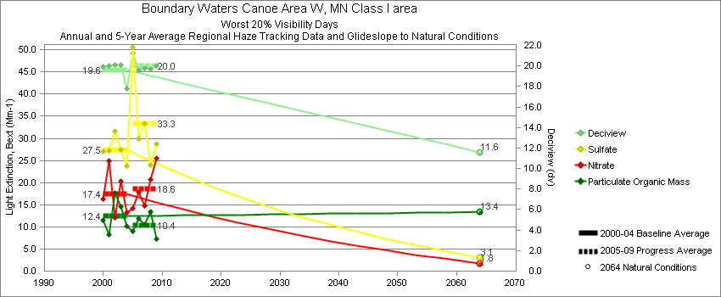
Boundary Waters - Worst 20% Visibility Days – 5-Year Average, Natural Conditions and Annual Data
Parameter | 2000-2004 | 2005-2009 | 2064 NC | 2000 | 2001 | 2002 | 2003 | 2004 | 2005 | 2006 | 2007 | 2008 | 2009
Deciview (dv) | 19.6 | 20.1 | 11.6 | 19.9 | 20.0 | 20.1 | 20.1 | 17.8 | 21.3 | 19.6 | 19.8 | 19.7 | 20.0
Sulfate Bext | 27.4 | 33.3 | 3.1 | 27.0 | 27.3 | 31.7 | 27.4 | 23.8 | 50.4 | 30.0 | 33.4 | 24.1 | 28.7
Nitrate Bext | 17.4 | 18.6 | 1.8 | 16.4 | 25.0 | 12.1 | 20.3 | 13.3 | 14.3 | 17.8 | 14.8 | 20.6 | 25.5
POM Bext | 12.4 | 10.4 | 13.4 | 11.5 | 8.3 | 17.6 | 14.6 | 10.1 | 8.9 | 11.9 | 10.4 | 13.4 | 7.4
EC Bext | 3.1 | 2.9 | 0.4 | 4.4 | 3.0 | 3.3 | 2.6 | 2.2 | 3.5 | 3.2 | 3.0 | 2.7 | 2.3
Soil Bext | 0.5 | 0.5 | 0.6 | 0.8 | 0.4 | 0.6 | 0.4 | 0.4 | 0.5 | 0.4 | 0.6 | 0.5 | 0.5
Coarse Mass Bext | 2.6 | 2.1 | 3.1 | 3.7 | 2.1 | 2.5 | 2.2 | 2.2 | 2.5 | 1.9 | 1.5 | 1.7 | 2.8
Sea Salt Bext | 0.1 | 0.2 | 0.1 | 0.0 | 0.0 | 0.0 | 0.0 | 0.2 | 0.2 | 0.2 | 0.2 | 0.6 | 0.1

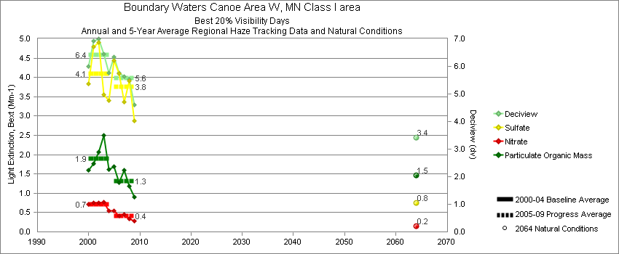
Boundary Waters - Best 20% Visibility Days – 5-Year Average, Natural Conditions and Annual Data
Parameter | 2000-2004 | 2005-2009 | 2064 NC | 2000 | 2001 | 2002 | 2003 | 2004 | 2005 | 2006 | 2007 | 2008 | 2009
Deciview (dv) | 6.4 | 5.6 | 3.4 | 6.0 | 6.9 | 7.0 | 6.5 | 5.8 | 6.3 | 5.7 | 5.6 | 5.5 | 4.6
Sulfate Bext | 4.1 | 3.8 | 0.7 | 3.8 | 4.8 | 4.9 | 3.6 | 3.4 | 4.6 | 4.1 | 3.4 | 3.9 | 2.9
Nitrate Bext | 0.7 | 0.4 | 0.2 | 0.7 | 0.8 | 0.7 | 0.8 | 0.5 | 0.6 | 0.4 | 0.4 | 0.3 | 0.3
POM Bext | 1.9 | 1.3 | 1.5 | 1.6 | 1.8 | 2.1 | 2.5 | 1.6 | 1.6 | 1.3 | 1.6 | 1.2 | 0.9
EC Bext | 0.6 | 0.4 | 0.1 | 0.6 | 0.4 | 0.7 | 0.7 | 0.4 | 0.4 | 0.5 | 0.4 | 0.3 | 0.3
Soil Bext | 0.1 | 0.1 | 0.1 | 0.1 | 0.1 | 0.2 | 0.1 | 0.1 | 0.1 | 0.1 | 0.1 | 0.1 | 0.1
Coarse Mass Bext | 0.7 | 0.5 | 0.5 | 0.5 | 0.7 | 0.6 | 0.8 | 0.7 | 0.5 | 0.5 | 0.5 | 0.6 | 0.5
Sea Salt Bext | 0.2 | 0.1 | 0.1 | 0.0 | 0.6 | 0.0 | 0.0 | 0.1 | 0.1 | 0.1 | 0.3 | 0.1 | 0.1
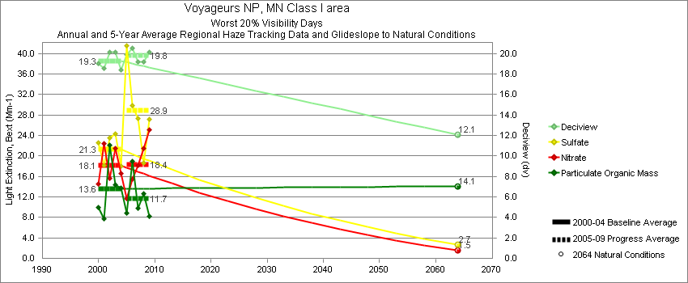
Voyaguers - Worst 20% Visibility Days – 5-Year Average, Natural Conditions and Annual Data
Parameter | 2000-2004 | 2005-2009 | 2064 NC | 2000 | 2001 | 2002 | 2003 | 2004 | 2005 | 2006 | 2007 | 2008 | 2009
Deciview (dv) | 19.3 | 19.8 | 12.1 | 19.1 | 18.6 | 20.1 | 20.2 | 18.4 | 19.9 | 20.5 | 19.2 | 19.2 | 20.2
Sulfate Bext | 21.3 | 28.9 | 2.7 | 22.5 | 18.2 | 23.6 | 24.4 | 18.0 | 41.6 | 29.8 | 27.4 | 18.6 | 27.1
Nitrate Bext | 18.2 | 18.4 | 1.5 | 14.6 | 22.5 | 15.7 | 21.5 | 16.5 | 11.8 | 15.4 | 18.2 | 21.4 | 25.1
POM Bext | 13.6 | 11.7 | 14.1 | 10.0 | 7.7 | 22.1 | 14.3 | 13.8 | 8.9 | 18.9 | 9.8 | 12.7 | 8.3
EC Bext | 3.2 | 3.2 | 0.4 | 3.7 | 2.8 | 3.7 | 3.3 | 2.6 | 3.5 | 3.9 | 2.9 | 2.9 | 2.7
Soil Bext | 0.4 | 0.5 | 0.5 | 0.5 | 0.3 | 0.5 | 0.5 | 0.4 | 0.4 | 0.6 | 0.5 | 0.4 | 0.5
Coarse Mass Bext | 2.8 | 2.5 | 3.5 | 3.8 | 2.1 | 2.9 | 2.6 | 2.6 | 2.5 | 3.5 | 1.7 | 2.1 | 2.7
Sea Salt Bext | 0.5 | 0.3 | 0.6 | 1.6 | 0.3 | 0.2 | 0.1 | 0.3 | 0.2 | 0.3 | 0.3 | 0.7 | 0.2

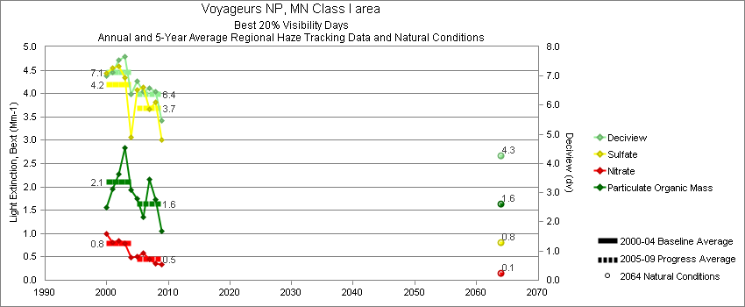
Voyaguers - Best 20% Visibility Days – 5-Year Average, Natural Conditions and Annual Data
Parameter | 2000-2004 | 2005-2009 | 2064 NC | 2000 | 2001 | 2002 | 2003 | 2004 | 2005 | 2006 | 2007 | 2008 | 2009
Deciview (dv) | 7.1 | 6.4 | 4.3 | 7.0 | 7.1 | 7.5 | 7.7 | 6.4 | 6.8 | 6.5 | 6.6 | 6.5 | 5.5
Sulfate Bext | 4.2 | 3.7 | 0.8 | 4.4 | 4.5 | 4.6 | 4.4 | 3.1 | 4.1 | 3.9 | 3.7 | 3.8 | 3.0
Nitrate Bext | 0.8 | 0.5 | 0.1 | 1.0 | 0.8 | 0.8 | 0.8 | 0.5 | 0.5 | 0.6 | 0.5 | 0.4 | 0.3
POM Bext | 2.1 | 1.6 | 1.6 | 1.6 | 2.0 | 2.3 | 2.8 | 1.9 | 1.8 | 1.5 | 2.2 | 1.7 | 1.1
EC Bext | 0.6 | 0.4 | 0.1 | 0.7 | 0.4 | 0.6 | 0.7 | 0.5 | 0.5 | 0.6 | 0.4 | 0.3 | 0.3
Soil Bext | 0.1 | 0.1 | 0.1 | 0.1 | 0.1 | 0.1 | 0.1 | 0.1 | 0.1 | 0.1 | 0.1 | 0.1 | 0.1
Coarse Mass Bext | 0.7 | 0.6 | 0.5 | 0.4 | 0.7 | 0.7 | 0.9 | 0.8 | 0.8 | 0.5 | 0.5 | 0.8 | 0.5
Sea Salt Bext | 0.1 | 0.1 | 0.1 | 0.1 | 0.1 | 0.2 | 0.0 | 0.2 | 0.2 | 0.1 | 0.3 | 0.1 | 0.1

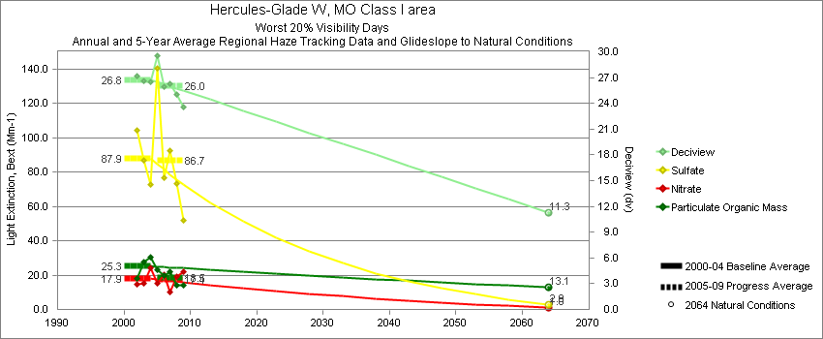
Hercules-Glade - Worst 20% Visibility Days – 5-Year Average, Natural Conditions and Annual Data
Parameter | 2000-2004 | 2005-2009 | 2064 NC | 2000 | 2001 | 2002 | 2003 | 2004 | 2005 | 2006 | 2007 | 2008 | 2009
Deciview (dv) | 26.7 | 26.0 | 11.3 |  |  | 27.2 | 26.6 | 26.5 | 29.5 | 25.9 | 26.2 | 25.0 | 23.6
Sulfate Bext | 87.9 | 86.7 | 2.9 |  |  | 104.2 | 87.0 | 72.6 | 139.2 | 76.8 | 92.6 | 73.0 | 51.9
Nitrate Bext | 17.9 | 17.4 | 1.0 |  |  | 14.6 | 15.0 | 24.1 | 15.3 | 20.3 | 10.0 | 19.4 | 22.0
POM Bext | 25.3 | 18.5 | 13.1 |  |  | 18.2 | 27.4 | 30.3 | 22.8 | 19.5 | 21.9 | 13.8 | 14.3
EC Bext | 5.2 | 5.1 | 0.3 |  |  | 5.0 | 5.6 | 5.1 | 6.7 | 5.6 | 5.6 | 3.6 | 4.0
Soil Bext | 0.9 | 0.9 | 1.0 |  |  | 1.0 | 0.8 | 0.9 | 0.7 | 1.5 | 0.8 | 0.8 | 0.7
Coarse Mass Bext | 2.8 | 3.5 | 2.7 |  |  | 2.9 | 2.5 | 2.9 | 4.1 | 3.3 | 3.9 | 3.1 | 3.2
Sea Salt Bext | 0.2 | 0.5 | 0.2 |  |  | 0.0 | 0.0 | 0.6 | 0.8 | 0.6 | 0.4 | 0.2 | 0.3

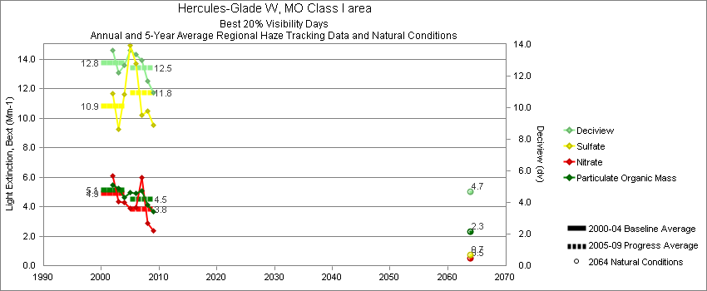
Hercules-Glade - Best 20% Visibility Days – 5-Year Average, Natural Conditions and Annual Data
Parameter | 2000-2004 | 2005-2009 | 2064 NC | 2000 | 2001 | 2002 | 2003 | 2004 | 2005 | 2006 | 2007 | 2008 | 2009
Deciview (dv) | 12.8 | 12.5 | 4.7 |  |  | 13.6 | 12.2 | 12.7 | 13.6 | 13.3 | 13.0 | 11.7 | 11.0
Sulfate Bext | 10.8 | 11.8 | 0.7 |  |  | 11.7 | 9.3 | 11.6 | 14.8 | 13.7 | 10.2 | 10.5 | 9.5
Nitrate Bext | 4.9 | 3.9 | 0.5 |  |  | 6.1 | 4.3 | 4.3 | 4.2 | 3.9 | 6.0 | 2.8 | 2.4
POM Bext | 5.1 | 4.5 | 2.3 |  |  | 5.5 | 5.3 | 4.6 | 4.8 | 4.9 | 5.1 | 4.1 | 3.7
EC Bext | 2.0 | 1.9 | 0.1 |  |  | 2.4 | 1.8 | 1.8 | 2.2 | 2.5 | 1.9 | 1.4 | 1.4
Soil Bext | 0.3 | 0.3 | 0.2 |  |  | 0.3 | 0.3 | 0.3 | 0.4 | 0.3 | 0.3 | 0.3 | 0.3
Coarse Mass Bext | 2.3 | 2.3 | 1.1 |  |  | 2.4 | 2.3 | 2.1 | 2.8 | 1.8 | 2.5 | 2.5 | 2.0
Sea Salt Bext | 0.2 | 0.1 | 0.1 |  |  | 0.0 | 0.2 | 0.3 | 0.1 | 0.2 | 0.2 | 0.1 | 0.2
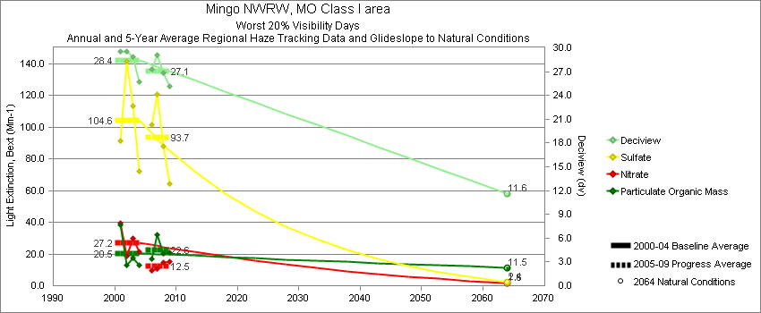
Mingo - Worst 20% Visibility Days – 5-Year Average, Natural Conditions and Annual Data
Parameter | 2000-2004 | 2005-2009 | 2064 NC | 2000 | 2001 | 2002 | 2003 | 2004 | 2005 | 2006 | 2007 | 2008 | 2009
Deciview (dv) | 28.4 | 27.1 | 11.6 |  | 29.5 | 29.6 | 28.9 | 25.7 |  | 27.3 | 29.1 | 26.8 | 25.1
Sulfate Bext | 104.6 | 93.7 | 2.4 |  | 91.6 | 141.3 | 113.3 | 72.1 |  | 101.8 | 120.9 | 87.9 | 64.0
Nitrate Bext | 27.2 | 12.5 | 1.6 |  | 39.3 | 18.4 | 29.7 | 21.5 |  | 9.4 | 10.7 | 14.4 | 15.3
POM Bext | 20.5 | 22.6 | 11.5 |  | 38.5 | 13.0 | 17.5 | 13.2 |  | 17.0 | 32.3 | 20.1 | 20.7
EC Bext | 5.5 | 6.4 | 0.4 |  | 9.0 | 3.8 | 5.2 | 4.1 |  | 6.2 | 8.1 | 5.6 | 5.8
Soil Bext | 1.4 | 2.0 | 0.9 |  | 1.6 | 1.7 | 1.1 | 1.2 |  | 2.7 | 2.1 | 1.7 | 1.4
Coarse Mass Bext | 6.5 | 7.4 | 3.2 |  | 8.4 | 5.1 | 4.5 | 7.8 |  | 9.2 | 8.4 | 5.2 | 6.7
Sea Salt Bext | 0.2 | 0.3 | 0.5 |  | 0.0 | 0.1 | 0.0 | 0.7 |  | 0.4 | 0.4 | 0.3 | 0.3

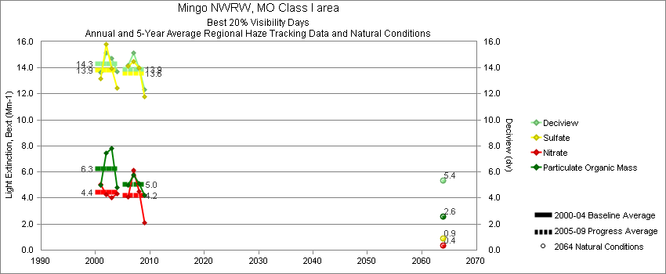
Mingo - Best 20% Visibility Days – 5-Year Average, Natural Conditions and Annual Data
Parameter | 2000-2004 | 2005-2009 | 2064 NC | 2000 | 2001 | 2002 | 2003 | 2004 | 2005 | 2006 | 2007 | 2008 | 2009
Deciview (dv) | 14.3 | 13.9 | 5.4 |  | 13.7 | 15.2 | 14.7 | 13.7 |  | 14.2 | 15.1 | 13.9 | 12.3
Sulfate Bext | 13.8 | 13.6 | 0.9 |  | 13.2 | 15.8 | 14.0 | 12.5 |  | 14.1 | 14.5 | 14.0 | 11.8
Nitrate Bext | 4.4 | 4.2 | 0.4 |  | 5.1 | 4.3 | 4.0 | 4.4 |  | 4.1 | 6.1 | 4.5 | 2.1
POM Bext | 6.3 | 5.0 | 2.6 |  | 5.0 | 7.5 | 7.8 | 4.8 |  | 5.0 | 5.8 | 5.1 | 4.2
EC Bext | 2.3 | 2.1 | 0.1 |  | 2.1 | 2.6 | 2.7 | 1.7 |  | 2.4 | 2.6 | 1.8 | 1.6
Soil Bext | 0.4 | 0.5 | 0.2 |  | 0.4 | 0.6 | 0.5 | 0.3 |  | 0.6 | 0.7 | 0.5 | 0.3
Coarse Mass Bext | 3.2 | 3.2 | 0.9 |  | 2.1 | 3.2 | 3.2 | 4.1 |  | 3.5 | 4.1 | 3.0 | 2.4
Sea Salt Bext | 0.1 | 0.2 | 0.1 |  | 0.0 | 0.0 | 0.0 | 0.3 |  | 0.4 | 0.3 | 0.2 | 0.1

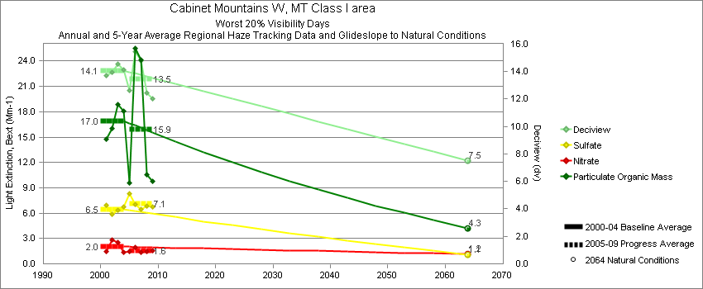
Cabinet Mountains - Worst 20% Visibility Days – 5-Year Average, Natural Conditions and Annual Data
Parameter | 2000-2004 | 2005-2009 | 2064 NC | 2000 | 2001 | 2002 | 2003 | 2004 | 2005 | 2006 | 2007 | 2008 | 2009
Deciview (dv) | 14.1 | 13.5 | 7.5 |  | 13.7 | 13.9 | 14.6 | 14.2 | 12.6 | 15.4 | 14.8 | 12.5 | 12.0
Sulfate Bext | 6.5 | 7.1 | 1.1 |  | 7.0 | 5.9 | 6.3 | 6.7 | 8.4 | 7.0 | 6.5 | 6.9 | 6.8
Nitrate Bext | 2.0 | 1.6 | 1.1 |  | 1.4 | 2.8 | 2.5 | 1.3 | 1.5 | 2.0 | 1.4 | 1.4 | 1.6
POM Bext | 16.9 | 15.9 | 4.3 |  | 14.8 | 16.0 | 18.9 | 18.1 | 9.6 | 25.5 | 24.2 | 10.6 | 9.8
EC Bext | 2.8 | 2.8 | 0.4 |  | 2.5 | 3.0 | 3.0 | 2.7 | 2.7 | 4.1 | 3.7 | 2.0 | 1.7
Soil Bext | 1.0 | 1.0 | 1.0 |  | 1.7 | 1.1 | 0.6 | 0.7 | 0.8 | 1.0 | 0.9 | 1.3 | 1.0
Coarse Mass Bext | 2.8 | 2.9 | 3.4 |  | 4.3 | 2.5 | 2.2 | 2.3 | 2.5 | 2.5 | 3.0 | 3.5 | 2.8
Sea Salt Bext | 0.1 | 0.1 | 0.2 |  | 0.3 | 0.0 | 0.0 | 0.0 | 0.0 | 0.1 | 0.1 | 0.0 | 0.0

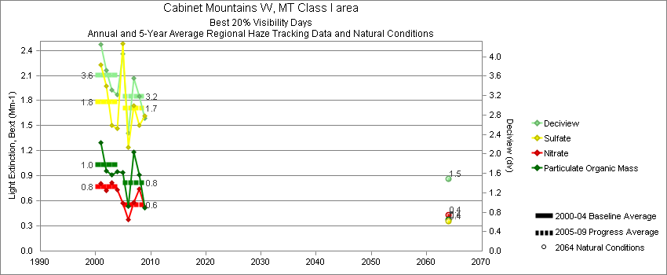
Cabinet Mountains - Best 20% Visibility Days – 5-Year Average, Natural Conditions and Annual Data
Parameter | 2000-2004 | 2005-2009 | 2064 NC | 2000 | 2001 | 2002 | 2003 | 2004 | 2005 | 2006 | 2007 | 2008 | 2009
Deciview (dv) | 3.6 | 3.2 | 1.5 |  | 4.3 | 3.7 | 3.3 | 3.2 | 4.0 | 2.4 | 3.6 | 3.2 | 2.7
Sulfate Bext | 1.8 | 1.7 | 0.4 |  | 2.2 | 2.0 | 1.5 | 1.5 | 2.5 | 1.2 | 1.7 | 1.5 | 1.6
Nitrate Bext | 0.8 | 0.6 | 0.4 |  | 0.8 | 0.7 | 0.8 | 0.7 | 0.6 | 0.4 | 0.6 | 0.7 | 0.5
POM Bext | 1.0 | 0.8 | 0.4 |  | 1.3 | 1.0 | 0.9 | 0.9 | 0.9 | 0.5 | 1.2 | 0.9 | 0.5
EC Bext | 0.3 | 0.3 | 0.1 |  | 0.4 | 0.3 | 0.3 | 0.3 | 0.3 | 0.2 | 0.3 | 0.3 | 0.2
Soil Bext | 0.1 | 0.1 | 0.1 |  | 0.2 | 0.1 | 0.1 | 0.1 | 0.1 | 0.1 | 0.1 | 0.1 | 0.1
Coarse Mass Bext | 0.3 | 0.3 | 0.2 |  | 0.4 | 0.4 | 0.2 | 0.3 | 0.4 | 0.2 | 0.3 | 0.2 | 0.2
Sea Salt Bext | 0.1 | 0.1 | 0.0 |  | 0.1 | 0.2 | 0.2 | 0.1 | 0.3 | 0.1 | 0.1 | 0.1 | 0.1

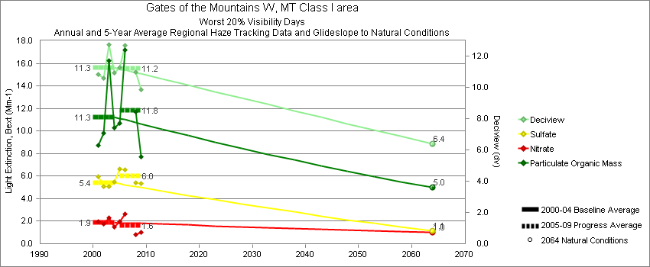
Gates of the Mountains - Worst 20% Visibility Days – 5-Year Average, Natural Conditions and Annual Data
Parameter | 2000-2004 | 2005-2009 | 2064 NC | 2000 | 2001 | 2002 | 2003 | 2004 | 2005 | 2006 | 2007 | 2008 | 2009
Deciview (dv) | 11.3 | 11.2 | 6.4 |  | 10.8 | 10.6 | 12.8 | 10.9 | 11.3 | 12.7 |  | 11.0 | 9.9
Sulfate Bext | 5.4 | 6.0 | 1.1 |  | 6.0 | 5.1 | 5.1 | 5.5 | 6.6 | 6.6 |  | 5.4 | 5.4
Nitrate Bext | 1.9 | 1.6 | 1.0 |  | 1.9 | 1.8 | 2.3 | 1.5 | 2.0 | 2.7 |  | 0.8 | 1.0
POM Bext | 11.3 | 11.8 | 5.0 |  | 8.7 | 9.8 | 16.2 | 10.3 | 10.7 | 17.2 |  | 11.7 | 7.7
EC Bext | 1.8 | 1.9 | 0.5 |  | 1.6 | 1.6 | 2.5 | 1.6 | 2.1 | 2.7 |  | 1.6 | 1.2
Soil Bext | 0.7 | 0.8 | 0.8 |  | 1.1 | 0.6 | 0.5 | 0.8 | 0.6 | 1.0 |  | 0.8 | 0.7
Coarse Mass Bext | 1.7 | 1.8 | 1.8 |  | 1.9 | 1.4 | 1.6 | 1.8 | 1.4 | 1.8 |  | 1.9 | 2.0
Sea Salt Bext | 0.1 | 0.0 | 0.1 |  | 0.0 | 0.0 | 0.0 | 0.2 | 0.0 | 0.0 |  | 0.0 | 0.0

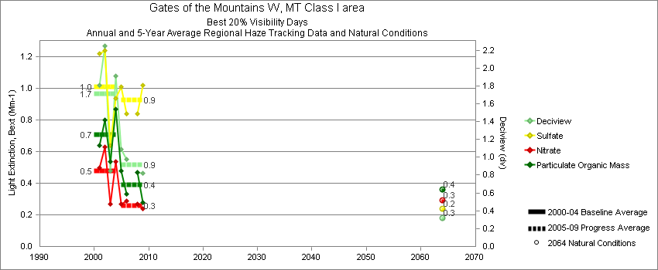
Gates of the Mountains - Best 20% Visibility Days – 5-Year Average, Natural Conditions and Annual Data
Parameter | 2000-2004 | 2005-2009 | 2064 NC | 2000 | 2001 | 2002 | 2003 | 2004 | 2005 | 2006 | 2007 | 2008 | 2009
Deciview (dv) | 1.7 | 0.9 | 0.3 |  | 1.8 | 2.2 | 0.9 | 1.9 | 1.1 | 0.9 |  | 0.8 | 0.8
Sulfate Bext | 1.0 | 0.9 | 0.2 |  | 1.2 | 1.2 | 0.6 | 0.9 | 1.0 | 0.8 |  | 0.8 | 1.0
Nitrate Bext | 0.5 | 0.3 | 0.3 |  | 0.5 | 0.6 | 0.3 | 0.5 | 0.3 | 0.3 |  | 0.3 | 0.2
POM Bext | 0.7 | 0.4 | 0.4 |  | 0.6 | 0.8 | 0.5 | 0.9 | 0.5 | 0.3 |  | 0.5 | 0.3
EC Bext | 0.2 | 0.1 | 0.1 |  | 0.2 | 0.2 | 0.1 | 0.2 | 0.2 | 0.2 |  | 0.1 | 0.1
Soil Bext | 0.1 | 0.1 | 0.1 |  | 0.1 | 0.1 | 0.1 | 0.1 | 0.1 | 0.1 |  | 0.1 | 0.1
Coarse Mass Bext | 0.4 | 0.2 | 0.3 |  | 0.4 | 0.5 | 0.3 | 0.4 | 0.2 | 0.2 |  | 0.2 | 0.2
Sea Salt Bext | 0.0 | 0.0 | 0.0 |  | 0.0 | 0.1 | 0.0 | 0.0 | 0.0 | 0.1 |  | 0.0 | 0.0

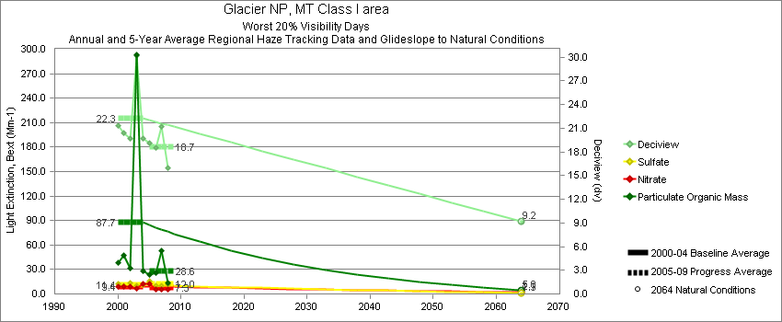
Glacier - Worst 20% Visibility Days – 5-Year Average, Natural Conditions and Annual Data
Parameter | 2000-2004 | 2005-2009 | 2064 NC | 2000 | 2001 | 2002 | 2003 | 2004 | 2005 | 2006 | 2007 | 2008 | 2009
Deciview (dv) | 22.3 | 18.7 | 9.2 | 21.3 | 20.4 | 19.7 | 30.2 | 19.7 | 19.1 | 18.6 | 21.2 | 16.0
Sulfate Bext | 11.4 | 12.0 | 1.3 | 12.7 | 9.9 | 13.4 | 9.7 | 11.2 | 16.3 | 10.3 | 10.2 | 11.2
Nitrate Bext | 9.4 | 7.3 | 2.1 | 9.5 | 9.1 | 8.9 | 7.3 | 12.1 | 11.9 | 6.0 | 6.2 | 5.2
POM Bext | 87.7 | 28.6 | 5.0 | 38.6 | 46.9 | 32.0 | 292.8 | 28.1 | 22.2 | 25.8 | 52.5 | 14.1
EC Bext | 11.2 | 5.7 | 0.4 | 7.5 | 7.4 | 6.6 | 29.2 | 5.3 | 6.5 | 6.1 | 6.7 | 3.7
Soil Bext | 1.4 | 1.1 | 1.3 | 1.9 | 1.3 | 1.2 | 1.4 | 1.0 | 0.6 | 1.3 | 1.5 | 1.0
Coarse Mass Bext | 5.2 | 4.6 | 4.6 | 7.4 | 5.2 | 2.5 | 6.5 | 4.6 | 2.2 | 5.3 | 6.9 | 3.9
Sea Salt Bext | 0.3 | 0.2 | 0.3 | 0.2 | 0.8 | 0.0 | 0.1 | 0.2 | 0.1 | 0.2 | 0.2 | 0.2

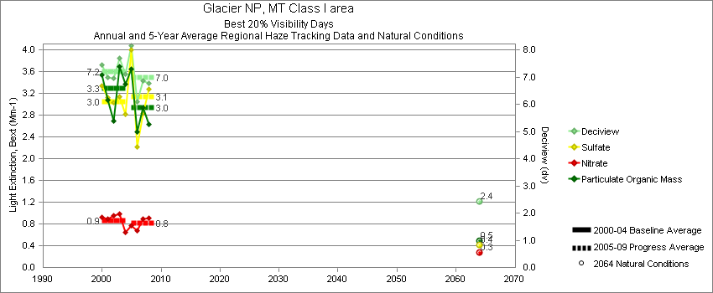
Glacier - Best 20% Visibility Days – 5-Year Average, Natural Conditions and Annual Data
Parameter | 2000-2004 | 2005-2009 | 2064 NC | 2000 | 2001 | 2002 | 2003 | 2004 | 2005 | 2006 | 2007 | 2008 | 2009
Deciview (dv) | 7.2 | 7.0 | 2.4 | 7.5 | 7.0 | 6.9 | 7.6 | 7.1 | 8.3 | 6.1 | 6.9 | 6.8
Sulfate Bext | 3.0 | 3.1 | 0.4 | 3.4 | 3.1 | 3.0 | 2.9 | 2.8 | 4.2 | 2.2 | 2.8 | 3.3
Nitrate Bext | 0.9 | 0.8 | 0.3 | 0.9 | 0.9 | 0.8 | 1.0 | 0.7 | 0.8 | 0.7 | 0.9 | 0.9
POM Bext | 3.3 | 2.9 | 0.5 | 3.5 | 3.1 | 2.7 | 3.8 | 3.4 | 3.7 | 2.5 | 2.9 | 2.6
EC Bext | 1.4 | 1.5 | 0.1 | 1.4 | 1.2 | 1.3 | 1.9 | 1.3 | 1.9 | 1.3 | 1.5 | 1.1
Soil Bext | 0.2 | 0.2 | 0.1 | 0.1 | 0.2 | 0.3 | 0.2 | 0.2 | 0.2 | 0.1 | 0.2 | 0.2
Coarse Mass Bext | 0.8 | 0.8 | 0.3 | 0.8 | 0.7 | 0.9 | 0.6 | 1.2 | 1.2 | 0.5 | 0.7 | 0.6
Sea Salt Bext | 0.1 | 0.1 | 0.0 | 0.0 | 0.0 | 0.1 | 0.1 | 0.1 | 0.0 | 0.2 | 0.1 | 0.1

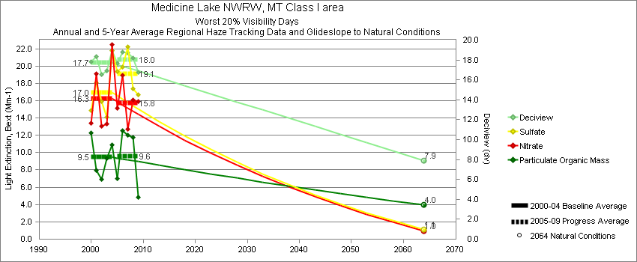
Medicine Lake - Worst 20% Visibility Days – 5-Year Average, Natural Conditions and Annual Data
Parameter | 2000-2004 | 2005-2009 | 2064 NC | 2000 | 2001 | 2002 | 2003 | 2004 | 2005 | 2006 | 2007 | 2008 | 2009
Deciview (dv) | 17.7 | 18.0 | 7.9 | 17.8 | 18.3 | 16.6 | 16.9 | 19.0 | 17.7 | 18.8 | 18.7 | 18.2 | 16.7
Sulfate Bext | 17.0 | 19.1 | 1.1 | 14.9 | 18.1 | 15.9 | 14.1 | 21.8 | 19.4 | 19.9 | 22.2 | 17.4 | 16.7
Nitrate Bext | 16.3 | 15.8 | 1.0 | 13.4 | 19.1 | 13.0 | 13.3 | 22.5 | 15.2 | 18.9 | 12.7 | 16.1 | 15.9
POM Bext | 9.5 | 9.6 | 4.0 | 12.3 | 8.0 | 6.9 | 9.4 | 10.9 | 7.0 | 12.5 | 12.1 | 11.7 | 4.8
EC Bext | 2.3 | 2.2 | 0.4 | 3.4 | 2.2 | 2.0 | 2.2 | 1.9 | 2.5 | 2.5 | 2.4 | 1.9 | 1.5
Soil Bext | 0.8 | 0.7 | 1.0 | 1.1 | 1.0 | 0.7 | 0.5 | 0.5 | 0.6 | 0.7 | 0.9 | 0.8 | 0.7
Coarse Mass Bext | 4.5 | 4.4 | 3.9 | 6.2 | 5.5 | 3.8 | 4.2 | 2.5 | 4.3 | 3.7 | 7.1 | 4.0 | 3.0
Sea Salt Bext | 0.0 | 0.6 | 0.0 | 0.0 | 0.0 | 0.0 | 0.0 | 0.2 | 0.1 | 0.1 | 0.1 | 1.9 | 0.8

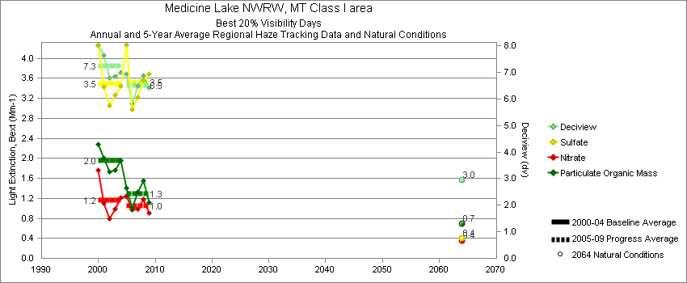
Medicine Lake - Best 20% Visibility Days – 5-Year Average, Natural Conditions and Annual Data
Parameter | 2000-2004 | 2005-2009 | 2064 NC | 2000 | 2001 | 2002 | 2003 | 2004 | 2005 | 2006 | 2007 | 2008 | 2009
Deciview (dv) | 7.3 | 6.5 | 3.0 | 8.0 | 7.6 | 6.8 | 6.9 | 7.0 | 7.0 | 5.8 | 6.5 | 6.9 | 6.4
Sulfate Bext | 3.5 | 3.5 | 0.4 | 4.3 | 3.4 | 3.1 | 3.3 | 3.4 | 4.2 | 3.0 | 3.2 | 3.6 | 3.7
Nitrate Bext | 1.2 | 1.1 | 0.4 | 1.8 | 1.1 | 0.8 | 1.0 | 1.2 | 1.2 | 1.0 | 1.0 | 1.2 | 0.9
POM Bext | 1.9 | 1.3 | 0.7 | 2.3 | 2.0 | 1.7 | 1.8 | 2.0 | 1.5 | 1.0 | 1.3 | 1.5 | 1.1
EC Bext | 0.6 | 0.5 | 0.1 | 0.8 | 0.7 | 0.6 | 0.5 | 0.5 | 0.7 | 0.5 | 0.6 | 0.5 | 0.4
Soil Bext | 0.4 | 0.3 | 0.2 | 0.3 | 0.5 | 0.4 | 0.3 | 0.3 | 0.3 | 0.2 | 0.3 | 0.5 | 0.3
Coarse Mass Bext | 2.2 | 1.6 | 0.7 | 1.8 | 2.9 | 2.2 | 2.1 | 1.8 | 1.4 | 1.3 | 1.8 | 1.8 | 1.8
Sea Salt Bext | 0.0 | 0.0 | 0.0 | 0.1 | 0.0 | 0.0 | 0.0 | 0.1 | 0.0 | 0.1 | 0.0 | 0.0 | 0.0

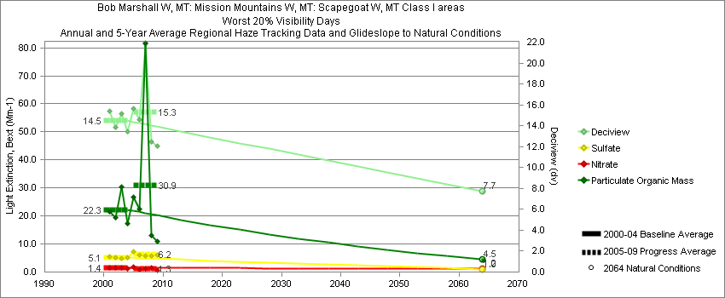
Monture - Worst 20% Visibility Days – 5-Year Average, Natural Conditions and Annual Data
Parameter | 2000-2004 | 2005-2009 | 2064 NC | 2000 | 2001 | 2002 | 2003 | 2004 | 2005 | 2006 | 2007 | 2008 | 2009
Deciview (dv) | 14.5 | 15.3 | 7.7 |  | 15.4 | 13.9 | 15.2 | 13.4 | 15.6 | 14.6 | 21.9 | 12.5 | 12.0
Sulfate Bext | 5.1 | 6.2 | 1.0 |  | 5.3 | 5.1 | 4.8 | 5.3 | 7.3 | 6.2 | 5.8 | 5.7 | 6.1
Nitrate Bext | 1.4 | 1.3 | 1.2 |  | 1.4 | 1.6 | 1.6 | 1.1 | 2.0 | 1.0 | 1.3 | 1.5 | 0.7
POM Bext | 22.3 | 30.9 | 4.5 |  | 21.7 | 19.6 | 30.5 | 17.4 | 26.5 | 22.4 | 81.6 | 13.1 | 10.9
EC Bext | 2.8 | 4.0 | 0.4 |  | 3.0 | 2.6 | 3.3 | 2.3 | 5.0 | 3.6 | 8.2 | 1.7 | 1.6
Soil Bext | 1.3 | 1.5 | 1.2 |  | 2.0 | 1.5 | 0.8 | 0.8 | 1.1 | 1.4 | 2.4 | 1.1 | 1.4
Coarse Mass Bext | 3.6 | 2.8 | 3.9 |  | 5.6 | 4.0 | 2.4 | 2.4 | 2.6 | 2.7 | 3.8 | 1.7 | 3.1
Sea Salt Bext | 0.0 | 0.2 | 0.0 |  | 0.0 | 0.0 | 0.1 | 0.0 | 0.0 | 0.0 | 0.1 | 0.6 | 0.0

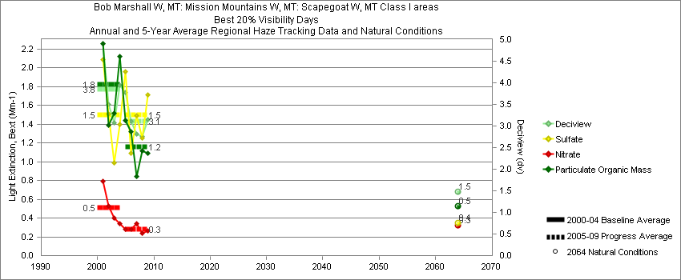
Monture - Best 20% Visibility Days – 5-Year Average, Natural Conditions and Annual Data
Parameter | 2000-2004 | 2005-2009 | 2064 NC | 2000 | 2001 | 2002 | 2003 | 2004 | 2005 | 2006 | 2007 | 2008 | 2009
Deciview (dv) | 3.9 | 3.1 | 1.5 |  | 4.9 | 3.5 | 3.1 | 3.9 | 3.8 | 3.1 | 2.8 | 2.8 | 3.1
Sulfate Bext | 1.5 | 1.5 | 0.3 |  | 2.1 | 1.5 | 1.0 | 1.4 | 2.0 | 1.1 | 1.5 | 1.2 | 1.7
Nitrate Bext | 0.5 | 0.3 | 0.3 |  | 0.8 | 0.5 | 0.4 | 0.3 | 0.3 | 0.3 | 0.3 | 0.2 | 0.3
POM Bext | 1.8 | 1.2 | 0.5 |  | 2.3 | 1.4 | 1.5 | 2.1 | 1.4 | 1.3 | 0.8 | 1.1 | 1.1
EC Bext | 0.5 | 0.4 | 0.1 |  | 0.6 | 0.5 | 0.5 | 0.5 | 0.5 | 0.5 | 0.3 | 0.3 | 0.3
Soil Bext | 0.1 | 0.1 | 0.1 |  | 0.1 | 0.1 | 0.1 | 0.1 | 0.1 | 0.1 | 0.1 | 0.1 | 0.1
Coarse Mass Bext | 0.3 | 0.2 | 0.2 |  | 0.5 | 0.3 | 0.1 | 0.3 | 0.3 | 0.2 | 0.2 | 0.2 | 0.2
Sea Salt Bext | 0.0 | 0.1 | 0.0 |  | 0.1 | 0.0 | 0.0 | 0.1 | 0.0 | 0.2 | 0.1 | 0.1 | 0.0

Sula Peak - Worst 20% Visibility Days – 5-Year Average, Natural Conditions and Annual Data
Parameter | 2000-2004 | 2005-2009 | 2064 NC | 2000 | 2001 | 2002 | 2003 | 2004 | 2005 | 2006 | 2007 | 2008 | 2009
Deciview (dv) | 13.4 | 17.0 | 7.4 |  | 12.6 | 12.1 | 16.9 | 12.0 | 14.6 |  | 24.9 |  | 11.6
Sulfate Bext | 4.8 | 4.7 | 1.1 |  | 4.8 | 4.6 | 4.8 | 5.1 | 5.2 |  | 3.8 |  | 5.1
Nitrate Bext | 1.5 | 1.7 | 1.1 |  | 1.3 | 1.6 | 1.6 | 1.4 | 1.4 |  | 2.7 |  | 1.0
POM Bext | 20.0 | 59.5 | 4.8 |  | 11.5 | 12.6 | 43.3 | 12.7 | 30.6 |  | 136.5 |  | 11.3
EC Bext | 2.5 | 8.8 | 0.4 |  | 2.0 | 2.1 | 4.3 | 1.7 | 4.9 |  | 19.8 |  | 1.7
Soil Bext | 0.9 | 0.6 | 0.9 |  | 1.6 | 0.9 | 0.6 | 0.7 | 0.5 |  | 0.7 |  | 0.6
Coarse Mass Bext | 2.5 | 3.6 | 2.7 |  | 3.7 | 2.4 | 1.7 | 2.1 | 2.8 |  | 5.2 |  | 2.8
Sea Salt Bext | 0.3 | 0.0 | 0.3 |  | 1.0 | 0.0 | 0.0 | 0.0 | 0.0 |  | 0.1 |  | 0.0

Sula Peak - Best 20% Visibility Days – 5-Year Average, Natural Conditions and Annual Data
Parameter | 2000-2004 | 2005-2009 | 2064 NC | 2000 | 2001 | 2002 | 2003 | 2004 | 2005 | 2006 | 2007 | 2008 | 2009
Deciview (dv) | 2.6 | 2.5 | 1.1 |  | 3.1 | 2.7 | 1.8 | 2.7 | 2.5 |  | 2.5 |  | 2.3
Sulfate Bext | 1.1 | 1.3 | 0.3 |  | 1.3 | 1.1 | 0.7 | 1.2 | 1.4 |  | 1.3 |  | 1.2
Nitrate Bext | 0.3 | 0.3 | 0.2 |  | 0.4 | 0.4 | 0.2 | 0.4 | 0.3 |  | 0.3 |  | 0.2
POM Bext | 0.9 | 0.6 | 0.4 |  | 1.0 | 1.0 | 0.8 | 1.0 | 0.6 |  | 0.7 |  | 0.6
EC Bext | 0.3 | 0.2 | 0.1 |  | 0.3 | 0.3 | 0.2 | 0.3 | 0.2 |  | 0.2 |  | 0.1
Soil Bext | 0.1 | 0.1 | 0.1 |  | 0.2 | 0.1 | 0.0 | 0.1 | 0.1 |  | 0.1 |  | 0.1
Coarse Mass Bext | 0.2 | 0.3 | 0.2 |  | 0.3 | 0.2 | 0.1 | 0.2 | 0.3 |  | 0.4 |  | 0.4
Sea Salt Bext | 0.0 | 0.0 | 0.0 |  | 0.1 | 0.0 | 0.0 | 0.0 | 0.0 |  | 0.1 |  | 0.0

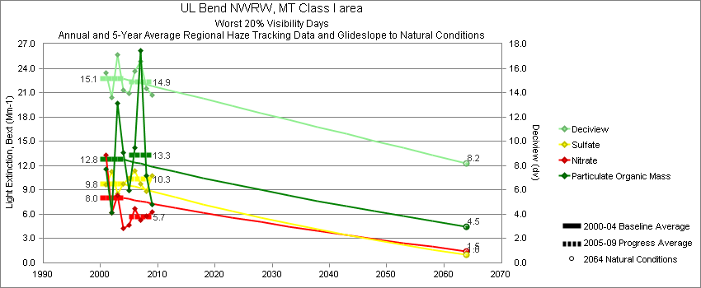
UL Bend - Worst 20% Visibility Days – 5-Year Average, Natural Conditions and Annual Data
Parameter | 2000-2004 | 2005-2009 | 2064 NC | 2000 | 2001 | 2002 | 2003 | 2004 | 2005 | 2006 | 2007 | 2008 | 2009
Deciview (dv) | 15.1 | 14.9 | 8.2 |  | 15.6 | 13.6 | 17.1 | 14.2 | 13.9 | 15.6 | 16.6 | 14.4 | 13.8
Sulfate Bext | 9.8 | 10.3 | 1.0 |  | 9.6 | 11.2 | 8.5 | 9.8 | 10.9 | 11.2 | 9.8 | 8.8 | 10.8
Nitrate Bext | 8.0 | 5.7 | 1.5 |  | 13.3 | 6.1 | 8.3 | 4.3 | 4.7 | 6.4 | 5.3 | 5.8 | 6.3
POM Bext | 12.8 | 13.3 | 4.5 |  | 11.6 | 6.2 | 19.7 | 13.6 | 8.6 | 13.9 | 26.2 | 10.7 | 7.2
EC Bext | 2.1 | 2.3 | 0.4 |  | 2.0 | 1.5 | 3.1 | 1.7 | 2.7 | 2.4 | 3.7 | 1.5 | 1.2
Soil Bext | 0.8 | 0.9 | 1.0 |  | 0.8 | 0.5 | 1.1 | 0.7 | 0.6 | 1.1 | 0.9 | 0.9 | 0.8
Coarse Mass Bext | 4.0 | 4.0 | 3.9 |  | 3.7 | 2.9 | 5.9 | 3.4 | 3.7 | 4.7 | 4.5 | 3.7 | 3.6
Sea Salt Bext | 0.0 | 0.5 | 0.0 |  | 0.0 | 0.0 | 0.0 | 0.0 | 0.0 | 0.0 | 0.0 | 2.2 | 0.1

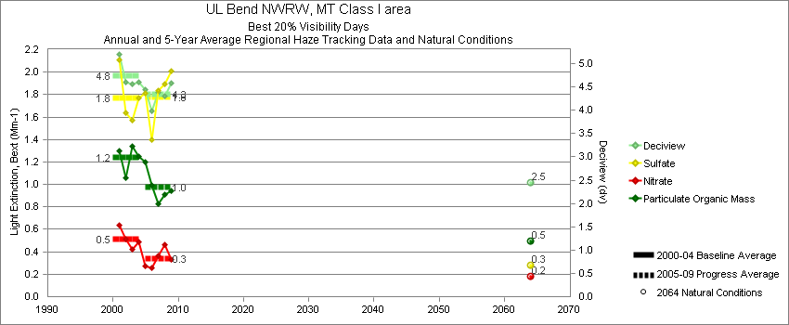
UL Bend - Best 20% Visibility Days – 5-Year Average, Natural Conditions and Annual Data
Parameter | 2000-2004 | 2005-2009 | 2064 NC | 2000 | 2001 | 2002 | 2003 | 2004 | 2005 | 2006 | 2007 | 2008 | 2009
Deciview (dv) | 4.7 | 4.3 | 2.5 |  | 5.2 | 4.6 | 4.6 | 4.6 | 4.4 | 4.0 | 4.4 | 4.3 | 4.6
Sulfate Bext | 1.8 | 1.8 | 0.3 |  | 2.1 | 1.6 | 1.6 | 1.8 | 1.8 | 1.4 | 1.8 | 1.9 | 2.0
Nitrate Bext | 0.5 | 0.3 | 0.2 |  | 0.6 | 0.5 | 0.4 | 0.5 | 0.3 | 0.2 | 0.4 | 0.5 | 0.3
POM Bext | 1.2 | 1.0 | 0.5 |  | 1.3 | 1.1 | 1.3 | 1.2 | 1.2 | 1.0 | 0.8 | 0.9 | 0.9
EC Bext | 0.5 | 0.3 | 0.1 |  | 0.6 | 0.5 | 0.5 | 0.4 | 0.4 | 0.5 | 0.3 | 0.3 | 0.3
Soil Bext | 0.2 | 0.2 | 0.2 |  | 0.2 | 0.1 | 0.2 | 0.2 | 0.2 | 0.1 | 0.2 | 0.2 | 0.2
Coarse Mass Bext | 0.9 | 0.9 | 0.6 |  | 1.1 | 1.0 | 0.8 | 0.8 | 0.8 | 0.7 | 1.1 | 0.7 | 1.0
Sea Salt Bext | 0.0 | 0.0 | 0.0 |  | 0.0 | 0.1 | 0.0 | 0.0 | 0.0 | 0.0 | 0.0 | 0.0 | 0.0

Yellowstone - Worst 20% Visibility Days – 5-Year Average, Natural Conditions and Annual Data
Parameter | 2000-2004 | 2005-2009 | 2064 NC | 2000 | 2001 | 2002 | 2003 | 2004 | 2005 | 2006 | 2007 | 2008 | 2009
Deciview (dv) | 11.8 | 11.5 | 6.4 | 12.9 | 12.6 | 11.4 | 11.2 | 10.8 | 9.6 | 11.8 | 12.6 | 14.0 | 9.6
Sulfate Bext | 4.3 | 4.6 | 0.8 | 4.2 | 4.7 | 3.8 | 4.1 | 4.6 | 4.8 | 5.1 | 4.3 | 5.0 | 3.5
Nitrate Bext | 1.8 | 1.6 | 0.6 | 2.0 | 2.4 | 1.6 | 1.4 | 1.5 | 1.6 | 0.9 | 2.4 | 1.7 | 1.6
POM Bext | 13.5 | 15.5 | 4.6 | 18.4 | 16.1 | 11.2 | 12.8 | 8.9 | 6.7 | 15.1 | 14.7 | 25.6 | 15.2
EC Bext | 2.5 | 2.2 | 0.4 | 3.7 | 2.6 | 1.9 | 2.3 | 1.9 | 1.8 | 2.3 | 2.4 | 2.6 | 1.7
Soil Bext | 1.0 | 0.8 | 1.0 | 0.8 | 1.4 | 1.2 | 0.4 | 0.9 | 0.6 | 1.1 | 0.8 | 1.0 | 0.6
Coarse Mass Bext | 2.6 | 2.4 | 3.0 | 2.8 | 2.7 | 3.1 | 1.3 | 2.9 | 1.8 | 2.6 | 2.6 | 2.6 | 2.3
Sea Salt Bext | 0.0 | 0.1 | 0.0 | 0.0 | 0.0 | 0.0 | 0.0 | 0.1 | 0.1 | 0.0 | 0.0 | 0.1 | 0.1

Yellowstone - Best 20% Visibility Days – 5-Year Average, Natural Conditions and Annual Data
Parameter | 2000-2004 | 2005-2009 | 2064 NC | 2000 | 2001 | 2002 | 2003 | 2004 | 2005 | 2006 | 2007 | 2008 | 2009
Deciview (dv) | 2.6 | 2.0 | 0.4 | 2.8 | 3.0 | 2.6 | 1.9 | 2.6 | 2.1 | 2.3 | 2.2 | 1.8 | 1.9
Sulfate Bext | 1.5 | 1.4 | 0.3 | 1.7 | 1.9 | 1.3 | 1.1 | 1.3 | 1.5 | 1.6 | 1.2 | 1.1 | 1.4
Nitrate Bext | 0.7 | 0.5 | 0.3 | 0.9 | 0.8 | 0.8 | 0.5 | 0.6 | 0.3 | 0.4 | 0.7 | 0.6 | 0.6
POM Bext | 1.1 | 0.8 | 0.5 | 1.1 | 1.2 | 1.1 | 0.9 | 1.3 | 1.1 | 0.8 | 1.0 | 0.8 | 0.5
EC Bext | 0.3 | 0.3 | 0.1 | 0.2 | 0.4 | 0.3 | 0.2 | 0.5 | 0.3 | 0.4 | 0.3 | 0.1 | 0.2
Soil Bext | 0.1 | 0.1 | 0.1 | 0.1 | 0.1 | 0.1 | 0.1 | 0.1 | 0.1 | 0.1 | 0.1 | 0.1 | 0.1
Coarse Mass Bext | 0.2 | 0.2 | 0.2 | 0.3 | 0.2 | 0.3 | 0.2 | 0.3 | 0.1 | 0.2 | 0.2 | 0.3 | 0.3
Sea Salt Bext | 0.0 | 0.0 | 0.0 | 0.1 | 0.0 | 0.0 | 0.0 | 0.0 | 0.0 | 0.0 | 0.0 | 0.0 | 0.0

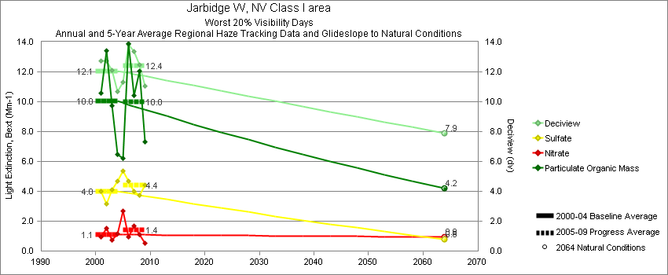
Worst 20% Visibility Days – 5-Year Average, Natural Conditions and Annual Data
Parameter | 2000-2004 | 2005-2009 | 2064 NC | 2000 | 2001 | 2002 | 2003 | 2004 | 2005 | 2006 | 2007 | 2008 | 2009
Deciview (dv) | 12.1 | 12.4 | 7.9 |  | 12.7 | 12.8 | 12.1 | 10.7 | 11.3 | 13.8 | 13.4 | 12.5 | 11.1
Sulfate Bext | 4.0 | 4.4 | 0.8 |  | 4.0 | 3.2 | 4.1 | 4.7 | 5.4 | 4.7 | 4.0 | 3.7 | 4.4
Nitrate Bext | 1.1 | 1.4 | 0.9 |  | 1.0 | 1.5 | 0.7 | 1.1 | 2.7 | 1.0 | 1.7 | 1.1 | 0.5
POM Bext | 10.0 | 10.0 | 4.2 |  | 10.6 | 13.4 | 9.7 | 6.5 | 6.3 | 13.9 | 10.4 | 12.1 | 7.3
EC Bext | 1.6 | 1.7 | 0.4 |  | 2.3 | 1.8 | 1.5 | 1.0 | 1.2 | 3.2 | 1.6 | 1.5 | 1.1
Soil Bext | 2.4 | 2.6 | 1.3 |  | 2.8 | 3.0 | 1.8 | 1.9 | 1.6 | 2.5 | 3.7 | 2.6 | 2.3
Coarse Mass Bext | 5.5 | 5.9 | 4.3 |  | 6.6 | 4.7 | 5.9 | 4.6 | 4.6 | 6.5 | 7.8 | 4.8 | 5.7
Sea Salt Bext | 0.1 | 0.2 | 0.4 |  | 0.1 | 0.0 | 0.0 | 0.1 | 0.3 | 0.0 | 0.1 | 0.0 | 0.3

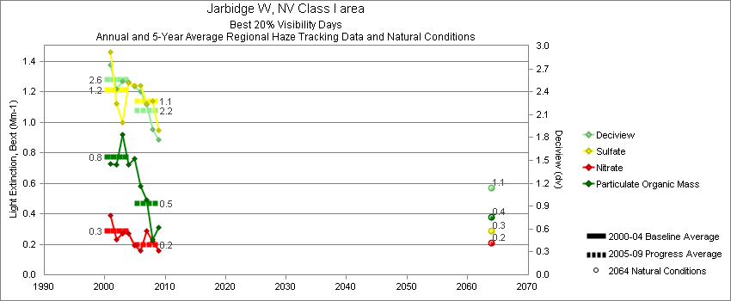
Best 20% Visibility Days – 5-Year Average, Natural Conditions and Annual Data
Parameter | 2000-2004 | 2005-2009 | 2064 NC | 2000 | 2001 | 2002 | 2003 | 2004 | 2005 | 2006 | 2007 | 2008 | 2009
Deciview (dv) | 2.6 | 2.2 | 1.1 |  | 2.7 | 2.4 | 2.5 | 2.5 | 2.5 | 2.4 | 2.2 | 1.9 | 1.8
Sulfate Bext | 1.2 | 1.1 | 0.3 |  | 1.5 | 1.1 | 1.0 | 1.3 | 1.3 | 1.2 | 1.1 | 1.1 | 1.0
Nitrate Bext | 0.3 | 0.2 | 0.2 |  | 0.4 | 0.2 | 0.3 | 0.3 | 0.2 | 0.1 | 0.3 | 0.2 | 0.2
POM Bext | 0.8 | 0.5 | 0.4 |  | 0.7 | 0.7 | 0.9 | 0.7 | 0.8 | 0.6 | 0.5 | 0.2 | 0.3
EC Bext | 0.3 | 0.2 | 0.1 |  | 0.3 | 0.3 | 0.3 | 0.3 | 0.2 | 0.2 | 0.2 | 0.1 | 0.1
Soil Bext | 0.1 | 0.1 | 0.0 |  | 0.1 | 0.1 | 0.1 | 0.1 | 0.1 | 0.1 | 0.1 | 0.1 | 0.1
Coarse Mass Bext | 0.3 | 0.3 | 0.2 |  | 0.2 | 0.3 | 0.3 | 0.2 | 0.3 | 0.4 | 0.3 | 0.3 | 0.3
Sea Salt Bext | 0.0 | 0.0 | 0.0 |  | 0.0 | 0.0 | 0.0 | 0.1 | 0.0 | 0.1 | 0.0 | 0.1 | 0.0

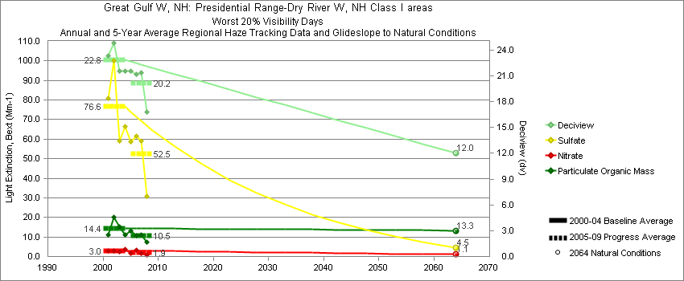
Great Gulf - Worst 20% Visibility Days – 5-Year Average, Natural Conditions and Annual Data
Parameter | 2000-2004 | 2005-2009 | 2064 NC | 2000 | 2001 | 2002 | 2003 | 2004 | 2005 | 2006 | 2007 | 2008 | 2009
Deciview (dv) | 22.8 | 20.2 | 12.0 |  | 23.3 | 24.8 | 21.6 | 21.6 | 21.5 | 21.1 | 21.3 | 16.8
Sulfate Bext | 76.6 | 52.5 | 4.5 |  | 80.9 | 100.1 | 59.0 | 66.4 | 58.7 | 61.5 | 59.2 | 30.8
Nitrate Bext | 3.0 | 1.8 | 1.1 |  | 3.0 | 2.9 | 2.5 | 3.6 | 1.5 | 3.3 | 1.7 | 0.9
POM Bext | 14.4 | 10.5 | 13.3 |  | 11.0 | 20.1 | 15.2 | 11.2 | 13.0 | 10.6 | 11.0 | 7.3
EC Bext | 3.9 | 3.2 | 0.4 |  | 3.9 | 4.4 | 4.0 | 3.4 | 4.0 | 3.5 | 3.5 | 1.9
Soil Bext | 0.6 | 0.4 | 0.5 |  | 0.6 | 0.7 | 0.4 | 0.5 | 0.2 | 0.4 | 0.5 | 0.3
Coarse Mass Bext | 3.0 | 2.6 | 3.3 |  | 3.0 | 2.7 | 2.8 | 3.4 | 2.2 | 3.0 | 2.8 | 2.2
Sea Salt Bext | 0.1 | 0.2 | 0.1 |  | 0.0 | 0.2 | 0.0 | 0.3 | 0.2 | 0.1 | 0.3 | 0.0

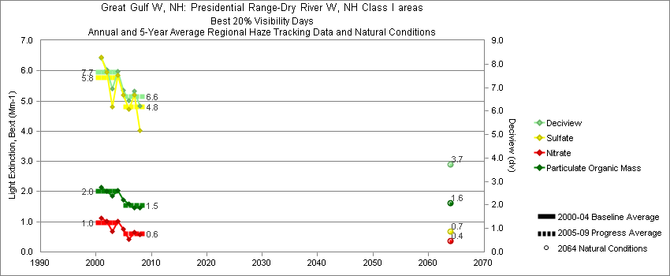
Great Gulf - Best 20% Visibility Days – 5-Year Average, Natural Conditions and Annual Data
Parameter | 2000-2004 | 2005-2009 | 2064 NC | 2000 | 2001 | 2002 | 2003 | 2004 | 2005 | 2006 | 2007 | 2008 | 2009
Deciview (dv) | 7.7 | 6.6 | 3.7 |  | 8.3 | 7.8 | 6.9 | 7.7 | 6.9 | 6.4 | 6.9 | 6.2
Sulfate Bext | 5.8 | 4.8 | 0.7 |  | 6.5 | 6.0 | 4.8 | 5.9 | 5.3 | 4.7 | 5.2 | 4.0
Nitrate Bext | 1.0 | 0.6 | 0.4 |  | 1.1 | 1.0 | 0.7 | 1.0 | 0.8 | 0.4 | 0.6 | 0.6
POM Bext | 2.0 | 1.5 | 1.6 |  | 2.1 | 2.0 | 1.9 | 2.0 | 1.7 | 1.6 | 1.5 | 1.5
EC Bext | 0.8 | 0.7 | 0.1 |  | 0.9 | 0.8 | 0.8 | 0.8 | 0.8 | 0.7 | 0.7 | 0.5
Soil Bext | 0.1 | 0.1 | 0.1 |  | 0.2 | 0.1 | 0.1 | 0.1 | 0.1 | 0.1 | 0.1 | 0.1
Coarse Mass Bext | 0.9 | 0.7 | 0.6 |  | 1.1 | 0.7 | 1.0 | 0.7 | 0.6 | 0.7 | 0.7 | 0.8
Sea Salt Bext | 0.2 | 0.2 | 0.1 |  | 0.0 | 0.4 | 0.0 | 0.2 | 0.1 | 0.1 | 0.2 | 0.3

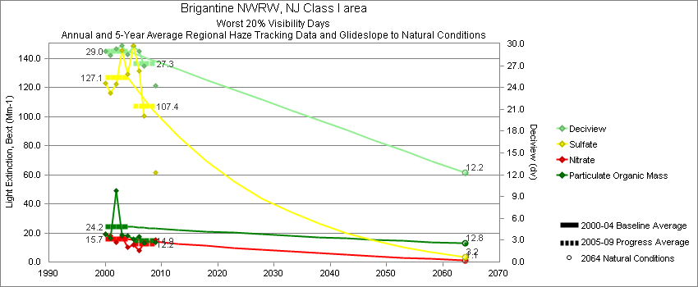
Brigantine - Worst 20% Visibility Days – 5-Year Average, Natural Conditions and Annual Data
Parameter | 2000-2004 | 2005-2009 | 2064 NC | 2000 | 2001 | 2002 | 2003 | 2004 | 2005 | 2006 | 2007 | 2008 | 2009
Deciview (dv) | 29.0 | 27.3 | 12.2 | 29.0 | 28.4 | 29.3 | 29.8 | 28.6 | 29.6 | 28.5 | 26.9 |  | 24.3
Sulfate Bext | 127.1 | 107.4 | 3.2 | 122.7 | 116.2 | 122.1 | 145.3 | 129.3 | 148.5 | 119.3 | 100.4 |  | 61.3
Nitrate Bext | 15.7 | 12.2 | 1.1 | 19.2 | 18.1 | 13.4 | 17.8 | 10.0 | 12.0 | 8.2 | 13.3 |  | 15.3
POM Bext | 24.2 | 14.9 | 12.8 | 19.2 | 16.1 | 48.9 | 18.8 | 18.1 | 16.0 | 16.9 | 13.2 |  | 13.7
EC Bext | 7.0 | 6.1 | 0.3 | 8.1 | 6.7 | 7.9 | 7.0 | 5.1 | 6.8 | 6.4 | 5.9 |  | 5.4
Soil Bext | 1.0 | 0.7 | 0.8 | 0.6 | 1.1 | 1.1 | 0.8 | 1.2 | 0.6 | 0.8 | 0.7 |  | 0.7
Coarse Mass Bext | 5.4 | 7.3 | 2.6 | 5.5 | 8.9 | 4.3 | 3.5 | 4.7 | 6.5 | 12.9 | 4.3 |  | 5.3
Sea Salt Bext | 0.4 | 1.2 | 3.6 | 0.5 | 0.1 | 0.1 | 0.4 | 0.9 | 0.9 | 0.8 | 1.6 |  | 1.3

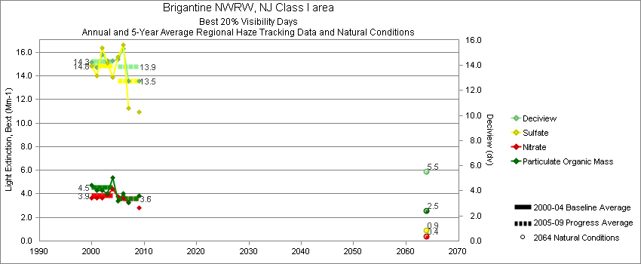
Brigantine - Best 20% Visibility Days – 5-Year Average, Natural Conditions and Annual Data
Parameter | 2000-2004 | 2005-2009 | 2064 NC | 2000 | 2001 | 2002 | 2003 | 2004 | 2005 | 2006 | 2007 | 2008 | 2009
Deciview (dv) | 14.3 | 13.9 | 5.5 | 14.3 | 13.8 | 14.8 | 14.4 | 14.4 | 14.6 | 15.3 | 12.7 |  | 12.8
Sulfate Bext | 14.8 | 13.5 | 0.9 | 14.8 | 14.0 | 16.3 | 15.1 | 13.9 | 15.8 | 16.2 | 11.3 |  | 10.9
Nitrate Bext | 3.9 | 3.6 | 0.4 | 3.7 | 3.7 | 3.6 | 3.9 | 4.4 | 3.9 | 4.2 | 3.3 |  | 2.8
POM Bext | 4.5 | 3.6 | 2.5 | 4.7 | 4.3 | 4.3 | 4.0 | 5.4 | 3.3 | 4.0 | 3.3 |  | 3.8
EC Bext | 2.4 | 1.9 | 0.1 | 3.0 | 2.4 | 2.1 | 1.9 | 2.8 | 2.2 | 2.0 | 1.6 |  | 1.7
Soil Bext | 0.2 | 0.2 | 0.2 | 0.2 | 0.2 | 0.2 | 0.2 | 0.3 | 0.2 | 0.3 | 0.2 |  | 0.3
Coarse Mass Bext | 3.2 | 3.3 | 1.0 | 3.4 | 3.6 | 3.9 | 2.8 | 2.2 | 2.9 | 5.3 | 2.4 |  | 2.5
Sea Salt Bext | 1.4 | 2.5 | 0.2 | 0.7 | 0.2 | 2.0 | 2.6 | 1.3 | 3.5 | 2.6 | 2.0 |  | 2.1

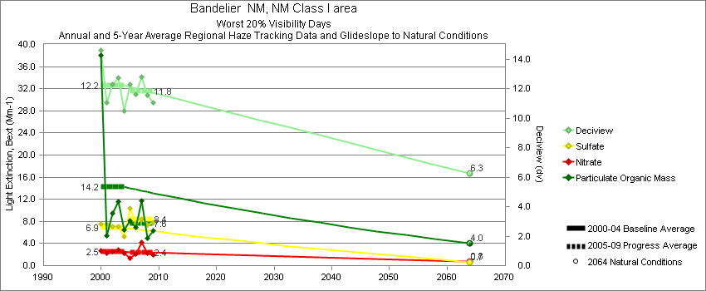
Bandelier - Worst 20% Visibility Days – 5-Year Average, Natural Conditions and Annual Data
Parameter | 2000-2004 | 2005-2009 | 2064 NC | 2000 | 2001 | 2002 | 2003 | 2004 | 2005 | 2006 | 2007 | 2008 | 2009
Deciview (dv) | 12.2 | 11.8 | 6.3 | 14.6 | 11.1 | 12.3 | 12.7 | 10.5 | 12.3 | 11.6 | 12.8 | 11.5 | 11.0
Sulfate Bext | 6.9 | 8.4 | 0.6 | 7.6 | 7.5 | 7.1 | 7.1 | 5.4 | 10.6 | 7.7 | 8.4 | 7.3 | 7.9
Nitrate Bext | 2.5 | 2.4 | 0.8 | 2.8 | 2.2 | 2.6 | 2.8 | 2.2 | 1.4 | 2.1 | 4.1 | 2.3 | 2.0
POM Bext | 14.2 | 7.6 | 4.0 | 38.1 | 5.4 | 9.5 | 11.6 | 6.5 | 8.0 | 6.9 | 11.8 | 5.0 | 6.3
EC Bext | 3.1 | 2.1 | 0.3 | 6.8 | 2.0 | 2.5 | 2.5 | 1.9 | 2.2 | 2.1 | 2.8 | 1.5 | 1.9
Soil Bext | 1.1 | 1.2 | 1.1 | 0.9 | 1.1 | 1.4 | 1.2 | 0.9 | 0.7 | 1.0 | 0.5 | 2.3 | 1.5
Coarse Mass Bext | 2.9 | 3.2 | 3.6 | 2.4 | 2.6 | 3.5 | 3.4 | 2.7 | 2.7 | 3.4 | 1.9 | 4.4 | 3.5
Sea Salt Bext | 0.2 | 0.1 | 0.2 | 0.1 | 0.7 | 0.3 | 0.1 | 0.1 | 0.1 | 0.0 | 0.0 | 0.1 | 0.1

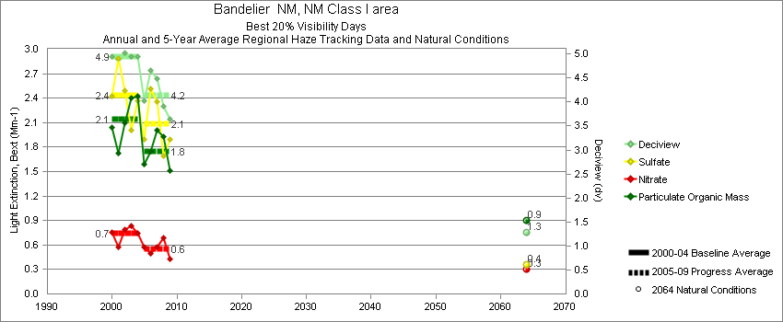
Bandelier - Best 20% Visibility Days – 5-Year Average, Natural Conditions and Annual Data
Parameter | 2000-2004 | 2005-2009 | 2064 NC | 2000 | 2001 | 2002 | 2003 | 2004 | 2005 | 2006 | 2007 | 2008 | 2009
Deciview (dv) | 5.0 | 4.2 | 1.3 | 5.0 | 4.9 | 5.0 | 4.9 | 4.9 | 4.1 | 4.6 | 4.5 | 3.9 | 3.6
Sulfate Bext | 2.4 | 2.1 | 0.4 | 2.4 | 2.9 | 2.5 | 2.0 | 2.4 | 2.0 | 2.5 | 2.4 | 1.7 | 1.9
Nitrate Bext | 0.7 | 0.6 | 0.3 | 0.8 | 0.6 | 0.8 | 0.8 | 0.7 | 0.6 | 0.5 | 0.6 | 0.7 | 0.4
POM Bext | 2.1 | 1.8 | 0.9 | 2.0 | 1.7 | 2.1 | 2.4 | 2.4 | 1.6 | 1.7 | 2.0 | 1.9 | 1.5
EC Bext | 0.9 | 0.8 | 0.1 | 0.9 | 0.8 | 0.9 | 1.0 | 0.9 | 0.9 | 1.0 | 0.8 | 0.7 | 0.6
Soil Bext | 0.3 | 0.2 | 0.2 | 0.3 | 0.4 | 0.4 | 0.2 | 0.3 | 0.2 | 0.3 | 0.2 | 0.2 | 0.3
Coarse Mass Bext | 0.9 | 0.8 | 0.5 | 1.0 | 1.0 | 1.0 | 1.0 | 0.7 | 0.9 | 1.0 | 0.8 | 0.6 | 0.7
Sea Salt Bext | 0.0 | 0.0 | 0.0 | 0.0 | 0.0 | 0.0 | 0.0 | 0.1 | 0.0 | 0.0 | 0.1 | 0.0 | 0.0
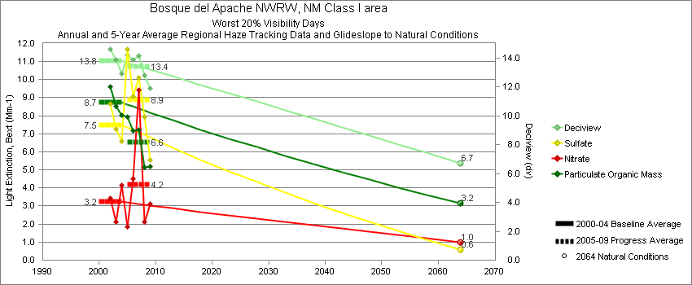
Bosque del Apache - Worst 20% Visibility Days – 5-Year Average, Natural Conditions and Annual Data
Parameter | 2000-2004 | 2005-2009 | 2064 NC | 2000 | 2001 | 2002 | 2003 | 2004 | 2005 | 2006 | 2007 | 2008 | 2009
Deciview (dv) | 13.8 | 13.4 | 6.7 |  |  | 14.6 | 13.9 | 12.9 | 14.3 | 13.9 | 14.2 | 12.8 | 11.9
Sulfate Bext | 7.5 | 8.9 | 0.6 |  |  | 8.7 | 7.3 | 6.6 | 11.8 | 9.1 | 10.1 | 8.0 | 5.5
Nitrate Bext | 3.2 | 4.2 | 1.0 |  |  | 3.4 | 2.1 | 4.1 | 1.9 | 4.5 | 9.4 | 2.1 | 3.1
POM Bext | 8.7 | 6.5 | 3.1 |  |  | 9.6 | 8.5 | 8.0 | 8.0 | 7.2 | 7.2 | 5.2 | 5.2
EC Bext | 2.6 | 2.8 | 0.3 |  |  | 2.5 | 2.5 | 2.9 | 3.4 | 3.2 | 3.2 | 1.8 | 2.6
Soil Bext | 1.9 | 1.6 | 1.1 |  |  | 2.8 | 1.7 | 1.4 | 1.5 | 1.7 | 1.1 | 2.3 | 1.4
Coarse Mass Bext | 6.7 | 5.5 | 3.6 |  |  | 7.6 | 8.3 | 4.2 | 5.3 | 5.9 | 4.4 | 7.0 | 4.9
Sea Salt Bext | 0.2 | 0.2 | 0.2 |  |  | 0.1 | 0.2 | 0.3 | 0.2 | 0.3 | 0.2 | 0.1 | 0.1

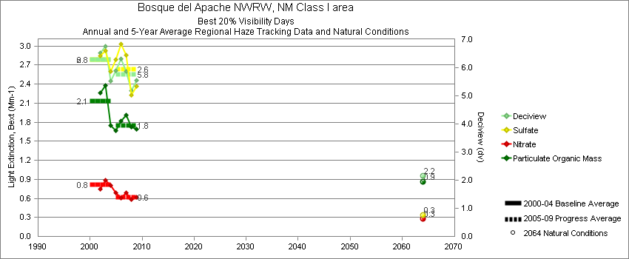
Bosque del Apache - Best 20% Visibility Days – 5-Year Average, Natural Conditions and Annual Data
Parameter | 2000-2004 | 2005-2009 | 2064 NC | 2000 | 2001 | 2002 | 2003 | 2004 | 2005 | 2006 | 2007 | 2008 | 2009
Deciview (dv) | 6.3 | 5.8 | 2.2 |  |  | 6.5 | 6.8 | 5.5 | 5.9 | 6.3 | 5.9 | 5.2 | 5.5
Sulfate Bext | 2.8 | 2.6 | 0.3 |  |  | 2.8 | 2.9 | 2.6 | 2.8 | 2.9 | 2.9 | 2.2 | 2.4
Nitrate Bext | 0.8 | 0.6 | 0.3 |  |  | 0.8 | 0.9 | 0.8 | 0.6 | 0.6 | 0.7 | 0.6 | 0.6
POM Bext | 2.1 | 1.8 | 0.9 |  |  | 2.3 | 2.4 | 1.8 | 1.7 | 1.8 | 1.9 | 1.7 | 1.7
EC Bext | 1.1 | 0.9 | 0.1 |  |  | 1.2 | 1.2 | 0.9 | 1.0 | 1.1 | 0.9 | 0.8 | 0.9
Soil Bext | 0.3 | 0.4 | 0.2 |  |  | 0.4 | 0.4 | 0.3 | 0.3 | 0.5 | 0.3 | 0.3 | 0.4
Coarse Mass Bext | 1.6 | 1.4 | 0.6 |  |  | 1.9 | 1.9 | 0.9 | 1.6 | 1.8 | 1.2 | 1.1 | 1.5
Sea Salt Bext | 0.1 | 0.1 | 0.1 |  |  | 0.0 | 0.2 | 0.2 | 0.1 | 0.2 | 0.1 | 0.1 | 0.0

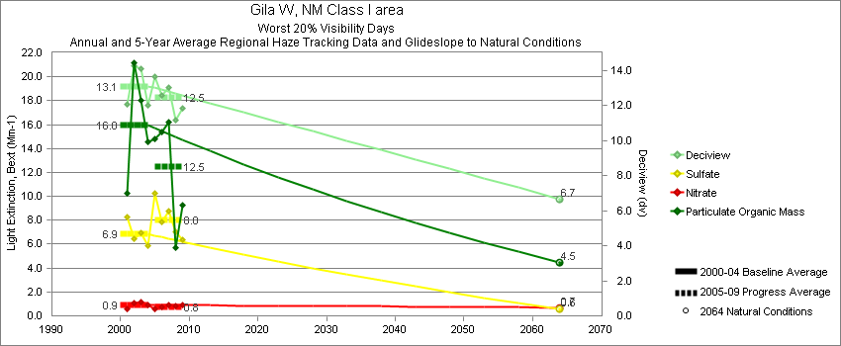
Gila - Worst 20% Visibility Days – 5-Year Average, Natural Conditions and Annual Data
Parameter | 2000-2004 | 2005-2009 | 2064 NC | 2000 | 2001 | 2002 | 2003 | 2004 | 2005 | 2006 | 2007 | 2008 | 2009
Deciview (dv) | 13.1 | 12.5 | 6.7 |  | 12.1 | 14.2 | 14.1 | 12.0 | 13.9 | 12.6 | 13.0 | 11.1 | 11.8
Sulfate Bext | 6.9 | 8.0 | 0.6 |  | 8.3 | 6.4 | 6.9 | 5.8 | 10.1 | 7.9 | 8.8 | 7.0 | 6.4
Nitrate Bext | 0.9 | 0.8 | 0.7 |  | 0.6 | 1.0 | 1.1 | 0.9 | 0.6 | 0.7 | 0.9 | 0.8 | 0.9
POM Bext | 16.0 | 12.5 | 4.5 |  | 10.2 | 21.2 | 18.0 | 14.5 | 15.7 | 15.4 | 16.2 | 5.7 | 9.3
EC Bext | 3.2 | 2.9 | 0.4 |  | 2.3 | 3.5 | 3.9 | 2.9 | 4.6 | 3.0 | 3.3 | 1.2 | 2.4
Soil Bext | 1.5 | 1.5 | 1.2 |  | 1.4 | 1.7 | 1.5 | 1.2 | 0.6 | 1.6 | 1.4 | 2.4 | 1.4
Coarse Mass Bext | 2.8 | 3.6 | 3.5 |  | 2.9 | 3.4 | 2.8 | 2.3 | 2.0 | 3.1 | 4.4 | 4.5 | 4.0
Sea Salt Bext | 0.1 | 0.1 | 0.2 |  | 0.0 | 0.0 | 0.2 | 0.1 | 0.1 | 0.1 | 0.1 | 0.1 | 0.1

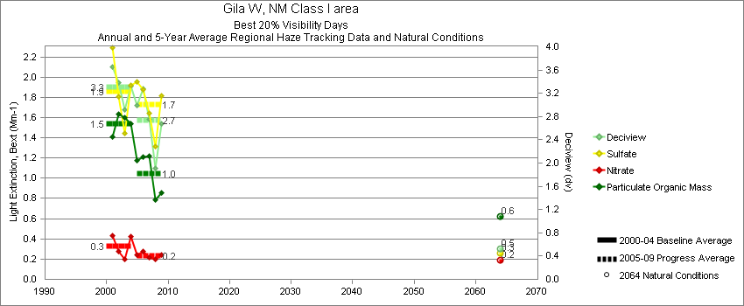
Gila - Best 20% Visibility Days – 5-Year Average, Natural Conditions and Annual Data
Parameter | 2000-2004 | 2005-2009 | 2064 NC | 2000 | 2001 | 2002 | 2003 | 2004 | 2005 | 2006 | 2007 | 2008 | 2009
Deciview (dv) | 3.3 | 2.7 | 0.5 |  | 3.7 | 3.4 | 2.9 | 3.3 | 3.1 | 3.3 | 2.7 | 1.9 | 2.7
Sulfate Bext | 1.9 | 1.7 | 0.3 |  | 2.3 | 1.8 | 1.4 | 1.9 | 2.0 | 1.9 | 1.6 | 1.3 | 1.8
Nitrate Bext | 0.3 | 0.2 | 0.2 |  | 0.4 | 0.3 | 0.2 | 0.4 | 0.3 | 0.3 | 0.2 | 0.2 | 0.2
POM Bext | 1.5 | 1.1 | 0.6 |  | 1.4 | 1.6 | 1.6 | 1.5 | 1.2 | 1.2 | 1.2 | 0.8 | 0.9
EC Bext | 0.6 | 0.4 | 0.1 |  | 0.6 | 0.8 | 0.6 | 0.6 | 0.5 | 0.6 | 0.4 | 0.3 | 0.4
Soil Bext | 0.2 | 0.2 | 0.1 |  | 0.2 | 0.2 | 0.2 | 0.1 | 0.2 | 0.3 | 0.2 | 0.2 | 0.2
Coarse Mass Bext | 0.4 | 0.5 | 0.3 |  | 0.6 | 0.4 | 0.4 | 0.3 | 0.4 | 0.7 | 0.5 | 0.4 | 0.6
Sea Salt Bext | 0.0 | 0.0 | 0.0 |  | 0.0 | 0.0 | 0.0 | 0.0 | 0.0 | 0.0 | 0.0 | 0.0 | 0.0
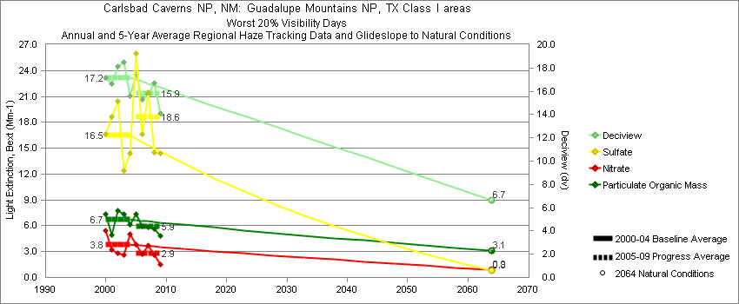
Guadalupe Mountains - Worst 20% Visibility Days – 5-Year Average, Natural Conditions and Annual Data
Parameter | 2000-2004 | 2005-2009 | 2064 NC | 2000 | 2001 | 2002 | 2003 | 2004 | 2005 | 2006 | 2007 | 2008 | 2009
Deciview (dv) | 17.2 | 15.9 | 6.7 | 17.1 | 16.6 | 18.1 | 18.5 | 15.6 | 17.5 | 15.3 | 15.7 | 16.8 | 14.1
Sulfate Bext | 16.5 | 18.6 | 0.8 | 16.6 | 18.6 | 20.5 | 12.4 | 14.4 | 26.0 | 16.6 | 21.5 | 14.5 | 14.4
Nitrate Bext | 3.8 | 2.9 | 0.9 | 5.4 | 3.2 | 2.8 | 2.6 | 5.1 | 3.8 | 2.7 | 3.7 | 2.6 | 1.5
POM Bext | 6.7 | 5.9 | 3.1 | 7.4 | 5.0 | 7.8 | 7.4 | 6.2 | 7.4 | 5.9 | 5.8 | 5.6 | 4.9
EC Bext | 1.3 | 1.5 | 0.2 | 2.0 | 1.0 | 1.3 | 1.0 | 1.3 | 2.2 | 1.6 | 1.5 | 1.0 | 1.2
Soil Bext | 4.4 | 2.7 | 1.3 | 2.4 | 4.1 | 5.1 | 7.5 | 2.9 | 2.1 | 2.0 | 2.0 | 4.8 | 2.7
Coarse Mass Bext | 16.0 | 9.9 | 4.4 | 13.2 | 12.7 | 16.0 | 28.1 | 10.1 | 8.3 | 8.6 | 6.0 | 18.8 | 7.7
Sea Salt Bext | 0.1 | 0.1 | 0.1 | 0.1 | 0.0 | 0.1 | 0.2 | 0.2 | 0.2 | 0.1 | 0.1 | 0.1 | 0.1

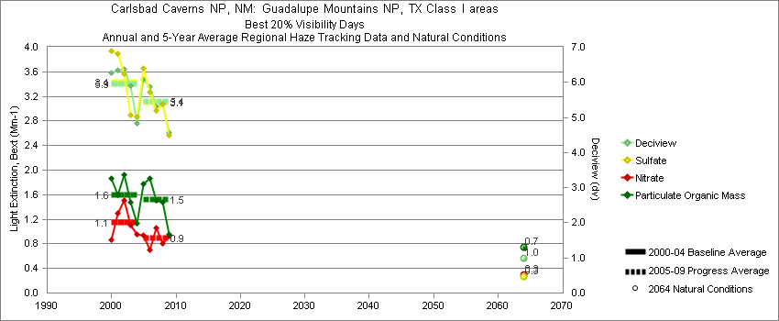
Guadalupe Mountains - Best 20% Visibility Days – 5-Year Average, Natural Conditions and Annual Data
Parameter | 2000-2004 | 2005-2009 | 2064 NC | 2000 | 2001 | 2002 | 2003 | 2004 | 2005 | 2006 | 2007 | 2008 | 2009
Deciview (dv) | 5.9 | 5.4 | 1.0 | 6.3 | 6.3 | 6.4 | 5.9 | 4.8 | 6.1 | 5.9 | 5.3 | 5.4 | 4.6
Sulfate Bext | 3.4 | 3.1 | 0.3 | 3.9 | 3.9 | 3.6 | 2.9 | 2.9 | 3.7 | 3.3 | 3.0 | 3.1 | 2.6
Nitrate Bext | 1.1 | 0.9 | 0.3 | 0.9 | 1.3 | 1.5 | 1.1 | 1.0 | 1.0 | 0.7 | 1.1 | 0.8 | 0.9
POM Bext | 1.6 | 1.5 | 0.7 | 1.9 | 1.6 | 1.9 | 1.5 | 1.1 | 1.8 | 1.9 | 1.5 | 1.5 | 1.0
EC Bext | 0.7 | 0.7 | 0.1 | 0.9 | 0.7 | 0.7 | 0.6 | 0.6 | 0.9 | 0.9 | 0.7 | 0.6 | 0.4
Soil Bext | 0.4 | 0.5 | 0.1 | 0.5 | 0.5 | 0.4 | 0.4 | 0.3 | 0.4 | 0.4 | 0.4 | 0.5 | 0.6
Coarse Mass Bext | 2.0 | 1.7 | 0.5 | 1.6 | 2.0 | 2.3 | 2.7 | 1.5 | 1.9 | 2.0 | 1.4 | 1.9 | 1.5
Sea Salt Bext | 0.1 | 0.0 | 0.0 | 0.1 | 0.0 | 0.0 | 0.1 | 0.0 | 0.0 | 0.0 | 0.0 | 0.0 | 0.1

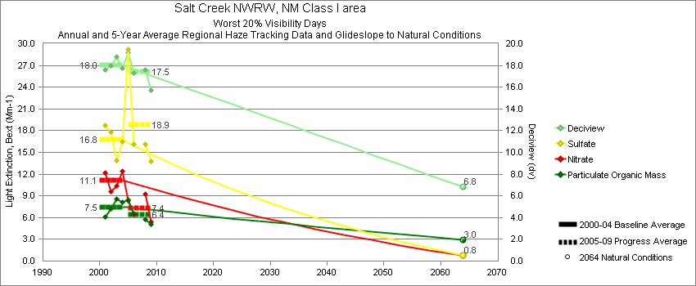
Salt Creek - Worst 20% Visibility Days – 5-Year Average, Natural Conditions and Annual Data
Parameter | 2000-2004 | 2005-2009 | 2064 NC | 2000 | 2001 | 2002 | 2003 | 2004 | 2005 | 2006 | 2007 | 2008 | 2009
Deciview (dv) | 18.0 | 17.5 | 6.8 |  | 17.6 | 18.0 | 18.8 | 17.7 | 19.2 | 17.3 |  | 17.6 | 15.7
Sulfate Bext | 16.7 | 18.9 | 0.8 |  | 18.7 | 17.9 | 13.9 | 16.5 | 29.3 | 16.2 |  | 16.1 | 13.7
Nitrate Bext | 11.1 | 7.4 | 0.8 |  | 12.2 | 9.5 | 10.4 | 12.4 | 8.4 | 6.4 |  | 9.3 | 5.4
POM Bext | 7.5 | 6.4 | 3.0 |  | 6.1 | 7.3 | 8.5 | 8.1 | 8.4 | 6.5 |  | 5.8 | 5.0
EC Bext | 2.3 | 2.3 | 0.3 |  | 2.5 | 2.2 | 2.3 | 2.3 | 3.3 | 2.4 |  | 1.6 | 2.1
Soil Bext | 3.3 | 2.3 | 1.0 |  | 2.1 | 2.1 | 4.9 | 4.2 | 1.4 | 2.3 |  | 3.6 | 2.0
Coarse Mass Bext | 11.5 | 11.4 | 4.1 |  | 10.3 | 12.4 | 16.8 | 6.4 | 7.5 | 13.1 |  | 13.8 | 11.0
Sea Salt Bext | 0.2 | 0.5 | 0.2 |  | 0.3 | 0.1 | 0.1 | 0.3 | 1.0 | 0.3 |  | 0.3 | 0.3

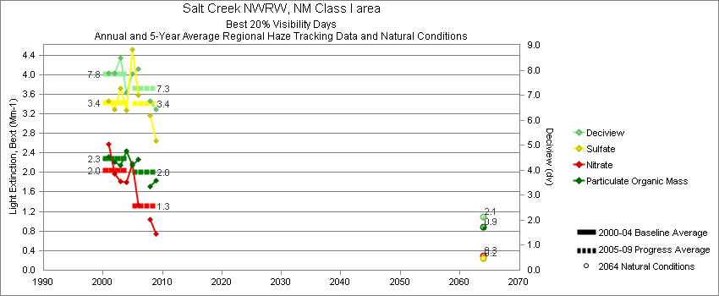
Salt Creek - Best 20% Visibility Days – 5-Year Average, Natural Conditions and Annual Data
Parameter | 2000-2004 | 2005-2009 | 2064 NC | 2000 | 2001 | 2002 | 2003 | 2004 | 2005 | 2006 | 2007 | 2008 | 2009
Deciview (dv) | 7.8 | 7.3 | 2.1 |  | 7.9 | 7.9 | 8.5 | 7.1 | 7.9 | 8.0 |  | 6.8 | 6.4
Sulfate Bext | 3.4 | 3.4 | 0.2 |  | 3.5 | 3.3 | 3.7 | 3.3 | 4.2 | 3.6 |  | 3.2 | 2.6
Nitrate Bext | 2.0 | 1.3 | 0.3 |  | 2.6 | 2.0 | 1.8 | 1.8 | 2.2 | 1.3 |  | 1.0 | 0.7
POM Bext | 2.3 | 2.0 | 0.9 |  | 2.3 | 2.2 | 2.1 | 2.4 | 2.2 | 2.3 |  | 1.7 | 1.8
EC Bext | 1.1 | 0.9 | 0.1 |  | 1.2 | 1.1 | 1.1 | 1.0 | 1.1 | 1.2 |  | 0.7 | 0.7
Soil Bext | 0.7 | 0.5 | 0.2 |  | 0.4 | 0.5 | 1.4 | 0.5 | 0.4 | 0.6 |  | 0.5 | 0.5
Coarse Mass Bext | 2.5 | 2.7 | 0.6 |  | 2.4 | 3.1 | 3.4 | 1.3 | 2.0 | 3.5 |  | 2.7 | 2.7
Sea Salt Bext | 0.1 | 0.1 | 0.1 |  | 0.0 | 0.1 | 0.1 | 0.1 | 0.1 | 0.1 |  | 0.0 | 0.0

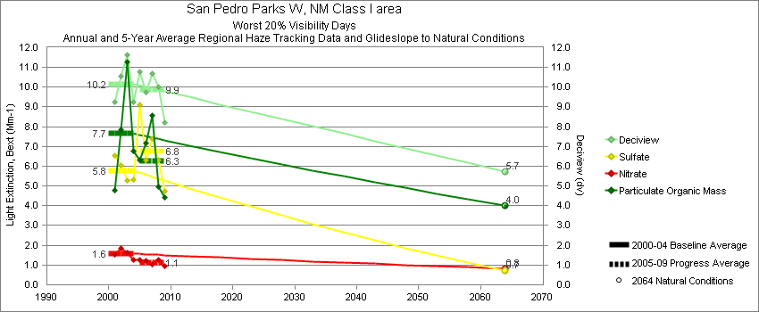
San Pedro Parks - Worst 20% Visibility Days – 5-Year Average, Natural Conditions and Annual Data
Parameter | 2000-2004 | 2005-2009 | 2064 NC | 2000 | 2001 | 2002 | 2003 | 2004 | 2005 | 2006 | 2007 | 2008 | 2009
Deciview (dv) | 10.2 | 9.9 | 5.7 |  | 9.3 | 10.6 | 11.6 | 9.3 | 10.8 | 9.7 | 10.7 | 10.0 | 8.2
Sulfate Bext | 5.8 | 6.8 | 0.7 |  | 6.5 | 6.0 | 5.3 | 5.3 | 9.1 | 6.3 | 7.4 | 6.3 | 4.7
Nitrate Bext | 1.6 | 1.2 | 0.8 |  | 1.5 | 1.8 | 1.6 | 1.3 | 1.3 | 1.3 | 1.0 | 1.3 | 1.0
POM Bext | 7.7 | 6.3 | 4.0 |  | 4.8 | 7.8 | 11.3 | 6.8 | 6.3 | 7.2 | 8.6 | 5.0 | 4.4
EC Bext | 1.6 | 1.6 | 0.3 |  | 1.1 | 1.6 | 2.6 | 1.1 | 2.2 | 1.6 | 1.7 | 1.2 | 1.1
Soil Bext | 1.5 | 1.3 | 1.2 |  | 1.6 | 1.7 | 1.5 | 1.0 | 1.1 | 0.9 | 1.0 | 2.3 | 1.3
Coarse Mass Bext | 2.7 | 2.5 | 3.0 |  | 2.0 | 2.6 | 4.2 | 2.1 | 2.1 | 2.3 | 2.5 | 3.2 | 2.3
Sea Salt Bext | 0.1 | 0.1 | 0.1 |  | 0.0 | 0.3 | 0.1 | 0.0 | 0.1 | 0.0 | 0.0 | 0.1 | 0.0

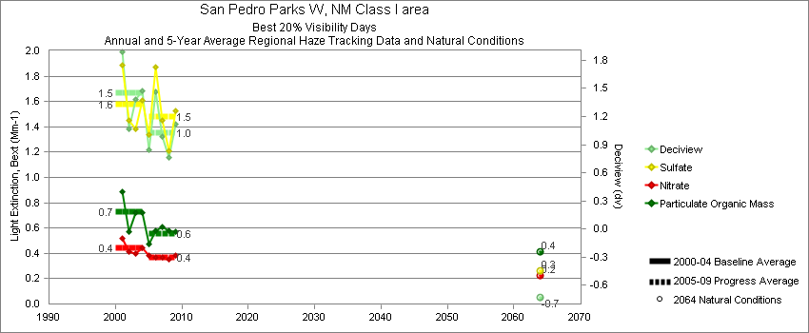
San Pedro Parks - Best 20% Visibility Days – 5-Year Average, Natural Conditions and Annual Data
Parameter | 2000-2004 | 2005-2009 | 2064 NC | 2000 | 2001 | 2002 | 2003 | 2004 | 2005 | 2006 | 2007 | 2008 | 2009
Deciview (dv) | 1.5 | 1.0 | -0.7 |  | 1.9 | 1.1 | 1.4 | 1.5 | 0.9 | 1.4 | 1.0 | 0.8 | 1.1
Sulfate Bext | 1.6 | 1.5 | 0.3 |  | 1.9 | 1.4 | 1.4 | 1.6 | 1.3 | 1.9 | 1.4 | 1.2 | 1.5
Nitrate Bext | 0.4 | 0.4 | 0.2 |  | 0.5 | 0.4 | 0.4 | 0.4 | 0.4 | 0.3 | 0.4 | 0.4 | 0.4
POM Bext | 0.7 | 0.6 | 0.4 |  | 0.9 | 0.6 | 0.7 | 0.7 | 0.5 | 0.6 | 0.6 | 0.6 | 0.6
EC Bext | 0.4 | 0.2 | 0.1 |  | 0.4 | 0.3 | 0.4 | 0.5 | 0.2 | 0.3 | 0.2 | 0.2 | 0.3
Soil Bext | 0.2 | 0.1 | 0.1 |  | 0.2 | 0.1 | 0.2 | 0.1 | 0.1 | 0.1 | 0.2 | 0.2 | 0.2
Coarse Mass Bext | 0.3 | 0.3 | 0.2 |  | 0.3 | 0.3 | 0.4 | 0.2 | 0.3 | 0.3 | 0.3 | 0.3 | 0.3
Sea Salt Bext | 0.0 | 0.0 | 0.0 |  | 0.0 | 0.0 | 0.1 | 0.0 | 0.1 | 0.0 | 0.0 | 0.0 | 0.0

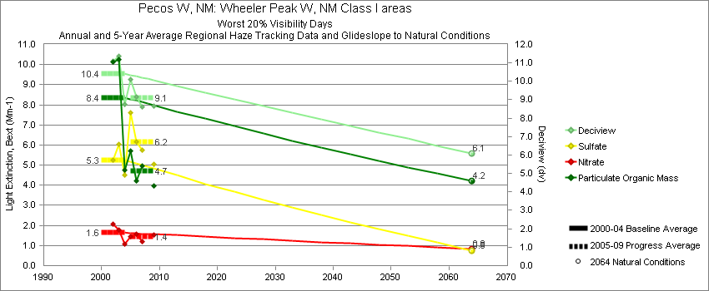
Wheeler Peak - Worst 20% Visibility Days – 5-Year Average, Natural Conditions and Annual Data
Parameter | 2000-2004 | 2005-2009 | 2064 NC | 2000 | 2001 | 2002 | 2003 | 2004 | 2005 | 2006 | 2007 | 2008 | 2009
Deciview (dv) | 10.4 | 9.1 | 6.1 |  |  | 11.1 | 11.4 | 8.7 | 10.1 | 9.2 | 8.6 |  | 8.6
Sulfate Bext | 5.3 | 6.2 | 0.8 |  |  | 5.3 | 6.1 | 4.5 | 7.6 | 6.3 | 5.7 |  | 5.1
Nitrate Bext | 1.6 | 1.4 | 0.8 |  |  | 2.1 | 1.8 | 1.1 | 1.4 | 1.6 | 1.2 |  | 1.5
POM Bext | 8.4 | 4.7 | 4.2 |  |  | 10.1 | 10.2 | 4.7 | 5.7 | 4.3 | 5.0 |  | 3.9
EC Bext | 2.2 | 1.6 | 0.4 |  |  | 2.2 | 2.4 | 2.0 | 2.0 | 1.2 | 1.4 |  | 1.8
Soil Bext | 1.7 | 1.1 | 1.2 |  |  | 1.6 | 2.1 | 1.6 | 1.3 | 1.2 | 0.7 |  | 1.3
Coarse Mass Bext | 2.8 | 2.1 | 3.2 |  |  | 3.3 | 3.8 | 1.2 | 1.9 | 2.5 | 1.9 |  | 2.3
Sea Salt Bext | 0.5 | 0.1 | 0.5 |  |  | 0.3 | 0.1 | 1.0 | 0.1 | 0.0 | 0.1 |  | 0.1

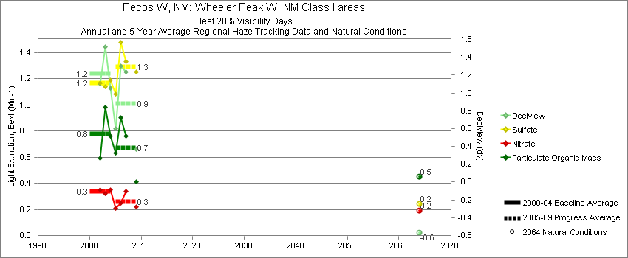
Wheeler Peak - Best 20% Visibility Days – 5-Year Average, Natural Conditions and Annual Data
Parameter | 2000-2004 | 2005-2009 | 2064 NC | 2000 | 2001 | 2002 | 2003 | 2004 | 2005 | 2006 | 2007 | 2008 | 2009
Deciview (dv) | 1.2 | 0.9 | -0.6 |  |  | 1.1 | 1.5 | 1.0 | 0.6 | 1.3 | 1.2 |  | 0.4
Sulfate Bext | 1.2 | 1.3 | 0.2 |  |  | 1.2 | 1.1 | 1.2 | 1.1 | 1.5 | 1.3 |  | 1.3
Nitrate Bext | 0.3 | 0.3 | 0.2 |  |  | 0.4 | 0.3 | 0.4 | 0.2 | 0.2 | 0.3 |  | 0.2
POM Bext | 0.8 | 0.7 | 0.5 |  |  | 0.6 | 1.0 | 0.8 | 0.6 | 0.9 | 0.8 |  | 0.4
EC Bext | 0.4 | 0.3 | 0.1 |  |  | 0.4 | 0.4 | 0.3 | 0.2 | 0.4 | 0.3 |  | 0.2
Soil Bext | 0.1 | 0.1 | 0.1 |  |  | 0.1 | 0.1 | 0.1 | 0.1 | 0.1 | 0.1 |  | 0.1
Coarse Mass Bext | 0.5 | 0.3 | 0.4 |  |  | 0.5 | 0.6 | 0.4 | 0.4 | 0.3 | 0.5 |  | 0.2
Sea Salt Bext | 0.1 | 0.0 | 0.0 |  |  | 0.1 | 0.0 | 0.0 | 0.0 | 0.0 | 0.0 |  | 0.0
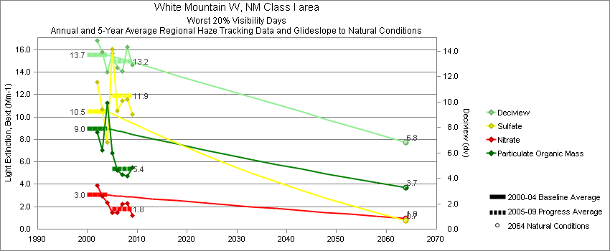
White Mountain - Worst 20% Visibility Days – 5-Year Average, Natural Conditions and Annual Data
Parameter | 2000-2004 | 2005-2009 | 2064 NC | 2000 | 2001 | 2002 | 2003 | 2004 | 2005 | 2006 | 2007 | 2008 | 2009
Deciview (dv) | 13.7 | 13.2 | 6.8 |  |  | 14.8 | 13.9 | 12.4 | 13.7 | 12.7 | 12.4 | 14.3 | 12.9
Sulfate Bext | 10.5 | 11.9 | 0.7 |  |  | 13.1 | 10.7 | 7.8 | 15.5 | 10.5 | 11.4 | 11.6 | 10.2
Nitrate Bext | 3.0 | 1.8 | 1.0 |  |  | 3.9 | 2.9 | 2.3 | 1.9 | 1.4 | 2.2 | 2.3 | 1.2
POM Bext | 9.0 | 5.4 | 3.7 |  |  | 8.6 | 7.0 | 11.3 | 6.6 | 5.2 | 4.8 | 4.7 | 5.5
EC Bext | 1.8 | 1.4 | 0.3 |  |  | 1.9 | 1.5 | 2.1 | 2.2 | 1.7 | 1.3 | 1.0 | 1.0
Soil Bext | 1.9 | 1.8 | 1.2 |  |  | 2.0 | 2.1 | 1.6 | 1.1 | 1.8 | 1.3 | 2.7 | 1.9
Coarse Mass Bext | 6.7 | 7.4 | 4.3 |  |  | 7.4 | 8.9 | 3.8 | 3.9 | 7.3 | 4.7 | 12.1 | 9.2
Sea Salt Bext | 0.2 | 0.3 | 0.2 |  |  | 0.1 | 0.2 | 0.2 | 0.1 | 0.3 | 0.1 | 0.6 | 0.4

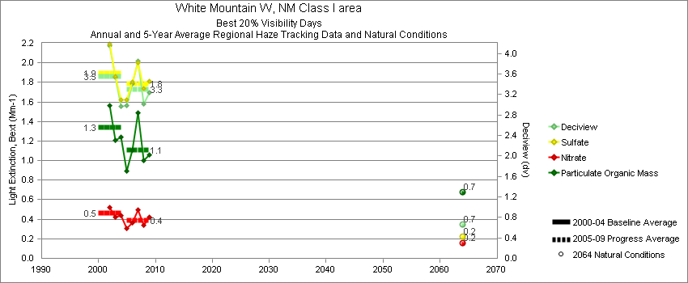
White Mountain - Best 20% Visibility Days – 5-Year Average, Natural Conditions and Annual Data
Parameter | 2000-2004 | 2005-2009 | 2064 NC | 2000 | 2001 | 2002 | 2003 | 2004 | 2005 | 2006 | 2007 | 2008 | 2009
Deciview (dv) | 3.6 | 3.3 | 0.7 |  |  | 4.1 | 3.5 | 3.0 | 3.0 | 3.4 | 3.9 | 3.0 | 3.2
Sulfate Bext | 1.9 | 1.8 | 0.2 |  |  | 2.2 | 1.9 | 1.6 | 1.6 | 1.8 | 2.0 | 1.7 | 1.8
Nitrate Bext | 0.5 | 0.4 | 0.2 |  |  | 0.5 | 0.4 | 0.4 | 0.3 | 0.3 | 0.5 | 0.3 | 0.4
POM Bext | 1.3 | 1.1 | 0.7 |  |  | 1.6 | 1.2 | 1.2 | 0.9 | 1.1 | 1.5 | 1.0 | 1.1
EC Bext | 0.6 | 0.4 | 0.1 |  |  | 0.7 | 0.6 | 0.5 | 0.6 | 0.5 | 0.5 | 0.4 | 0.3
Soil Bext | 0.2 | 0.2 | 0.1 |  |  | 0.2 | 0.2 | 0.1 | 0.2 | 0.3 | 0.2 | 0.2 | 0.3
Coarse Mass Bext | 0.9 | 1.0 | 0.4 |  |  | 1.0 | 1.1 | 0.5 | 0.9 | 1.0 | 1.0 | 0.9 | 1.0
Sea Salt Bext | 0.0 | 0.0 | 0.0 |  |  | 0.1 | 0.0 | 0.0 | 0.0 | 0.0 | 0.0 | 0.0 | 0.0
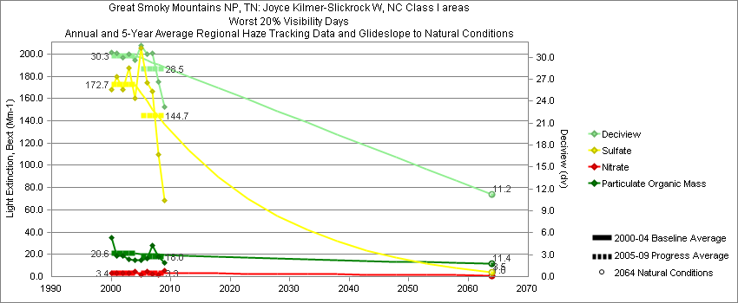
Great Smoky Mountains - Worst 20% Visibility Days – 5-Year Average, Natural Conditions and Annual Data
Parameter | 2000-2004 | 2005-2009 | 2064 NC | 2000 | 2001 | 2002 | 2003 | 2004 | 2005 | 2006 | 2007 | 2008 | 2009
Deciview (dv) | 30.3 | 28.5 | 11.2 | 30.7 | 30.6 | 29.9 | 30.5 | 29.6 | 31.6 | 30.5 | 30.6 | 26.7 | 23.2
Sulfate Bext | 172.7 | 144.7 | 3.5 | 167.8 | 179.9 | 168.3 | 187.3 | 160.3 | 205.1 | 174.2 | 166.3 | 109.6 | 68.6
Nitrate Bext | 3.4 | 3.3 | 1.0 | 3.5 | 3.0 | 2.7 | 3.2 | 4.6 | 1.8 | 5.0 | 2.7 | 1.7 | 5.4
POM Bext | 20.6 | 18.0 | 11.4 | 35.1 | 18.9 | 18.8 | 15.7 | 14.6 | 14.5 | 16.3 | 28.3 | 18.1 | 12.6
EC Bext | 5.7 | 5.1 | 0.3 | 8.1 | 5.0 | 4.8 | 5.8 | 4.7 | 6.1 | 5.6 | 5.9 | 4.2 | 3.9
Soil Bext | 0.8 | 0.8 | 0.9 | 0.6 | 0.8 | 1.0 | 0.7 | 1.0 | 0.6 | 0.9 | 0.9 | 0.9 | 0.6
Coarse Mass Bext | 1.9 | 3.7 | 2.9 | 2.6 | 2.4 | 2.0 | 1.5 | 1.2 | 4.9 | 4.6 | 4.2 | 2.6 | 2.1
Sea Salt Bext | 0.2 | 0.3 | 0.4 | 0.0 | 0.5 | 0.0 | 0.0 | 0.3 | 0.1 | 0.3 | 0.3 | 0.2 | 0.3

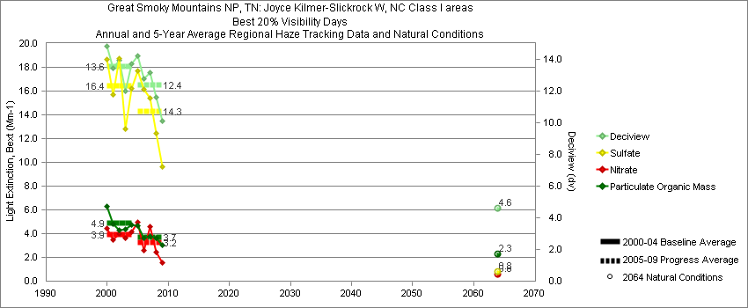
Great Smoky Mountains - Best 20% Visibility Days – 5-Year Average, Natural Conditions and Annual Data
Parameter | 2000-2004 | 2005-2009 | 2064 NC | 2000 | 2001 | 2002 | 2003 | 2004 | 2005 | 2006 | 2007 | 2008 | 2009
Deciview (dv) | 13.6 | 12.4 | 4.6 | 14.8 | 13.4 | 13.9 | 12.0 | 13.7 | 14.3 | 12.7 | 13.2 | 11.6 | 10.1
Sulfate Bext | 16.4 | 14.3 | 0.8 | 18.7 | 15.7 | 18.7 | 12.8 | 16.2 | 17.7 | 16.2 | 15.4 | 12.4 | 9.6
Nitrate Bext | 3.9 | 3.2 | 0.6 | 4.5 | 3.5 | 4.0 | 3.6 | 4.1 | 5.0 | 2.6 | 4.6 | 2.5 | 1.6
POM Bext | 4.9 | 3.7 | 2.3 | 6.3 | 4.8 | 4.3 | 4.4 | 4.7 | 4.6 | 3.6 | 3.8 | 3.6 | 3.0
EC Bext | 2.2 | 1.8 | 0.1 | 3.0 | 2.0 | 2.0 | 2.0 | 2.1 | 2.3 | 2.0 | 1.8 | 1.6 | 1.2
Soil Bext | 0.2 | 0.2 | 0.2 | 0.2 | 0.2 | 0.2 | 0.2 | 0.2 | 0.2 | 0.2 | 0.2 | 0.3 | 0.2
Coarse Mass Bext | 1.3 | 1.4 | 0.9 | 1.5 | 1.5 | 1.1 | 1.0 | 1.5 | 1.7 | 1.2 | 1.1 | 1.4 | 1.5
Sea Salt Bext | 0.2 | 0.2 | 0.1 | 0.1 | 0.3 | 0.2 | 0.0 | 0.4 | 0.2 | 0.2 | 0.3 | 0.2 | 0.1

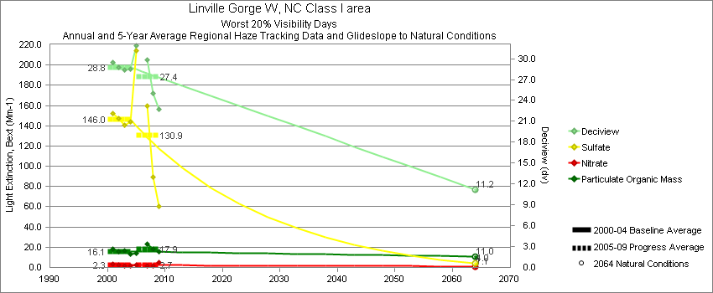
Linville Gorge - Worst 20% Visibility Days – 5-Year Average, Natural Conditions and Annual Data
Parameter | 2000-2004 | 2005-2009 | 2064 NC | 2000 | 2001 | 2002 | 2003 | 2004 | 2005 | 2006 | 2007 | 2008 | 2009
Deciview (dv) | 28.8 | 27.4 | 11.2 |  | 29.4 | 28.8 | 28.4 | 28.5 | 31.9 |  | 29.9 | 25.1 | 22.7
Sulfate Bext | 146.0 | 130.9 | 4.0 |  | 152.3 | 147.2 | 140.3 | 144.3 | 213.9 |  | 159.9 | 89.6 | 60.1
Nitrate Bext | 2.3 | 2.7 | 1.1 |  | 3.5 | 2.3 | 1.7 | 1.6 | 2.7 |  | 1.6 | 1.8 | 4.7
POM Bext | 16.1 | 17.9 | 11.0 |  | 18.5 | 15.8 | 16.9 | 13.1 | 13.7 |  | 23.5 | 18.3 | 15.9
EC Bext | 5.2 | 5.0 | 0.3 |  | 5.9 | 4.5 | 5.4 | 4.8 | 6.2 |  | 5.3 | 4.3 | 4.4
Soil Bext | 0.8 | 0.6 | 0.8 |  | 0.8 | 0.8 | 0.5 | 0.9 | 0.4 |  | 0.7 | 0.7 | 0.5
Coarse Mass Bext | 2.2 | 1.9 | 2.5 |  | 2.8 | 2.4 | 2.1 | 1.5 | 1.7 |  | 2.2 | 1.9 | 1.8
Sea Salt Bext | 0.1 | 0.4 | 0.3 |  | 0.0 | 0.1 | 0.0 | 0.4 | 0.4 |  | 0.3 | 0.5 | 0.4

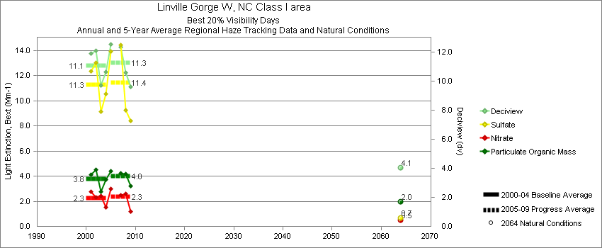
Linville Gorge - Best 20% Visibility Days – 5-Year Average, Natural Conditions and Annual Data
Parameter | 2000-2004 | 2005-2009 | 2064 NC | 2000 | 2001 | 2002 | 2003 | 2004 | 2005 | 2006 | 2007 | 2008 | 2009
Deciview (dv) | 11.1 | 11.3 | 4.1 |  | 11.9 | 12.1 | 9.7 | 10.7 | 12.6 |  | 12.4 | 10.6 | 9.6
Sulfate Bext | 11.3 | 11.5 | 0.6 |  | 12.4 | 13.1 | 9.2 | 10.6 | 13.7 |  | 14.4 | 9.3 | 8.4
Nitrate Bext | 2.2 | 2.4 | 0.5 |  | 2.8 | 2.3 | 2.4 | 1.5 | 3.2 |  | 2.5 | 2.6 | 1.2
POM Bext | 3.8 | 4.0 | 2.0 |  | 4.1 | 4.5 | 2.8 | 3.7 | 4.5 |  | 4.2 | 4.1 | 3.2
EC Bext | 1.8 | 1.7 | 0.1 |  | 2.0 | 2.2 | 1.3 | 1.7 | 2.2 |  | 1.8 | 1.5 | 1.2
Soil Bext | 0.2 | 0.2 | 0.1 |  | 0.2 | 0.2 | 0.1 | 0.1 | 0.2 |  | 0.2 | 0.2 | 0.2
Coarse Mass Bext | 0.8 | 1.0 | 0.6 |  | 1.0 | 0.9 | 0.8 | 0.6 | 1.0 |  | 1.0 | 1.0 | 1.0
Sea Salt Bext | 0.1 | 0.2 | 0.1 |  | 0.1 | 0.1 | 0.0 | 0.3 | 0.2 |  | 0.2 | 0.1 | 0.1
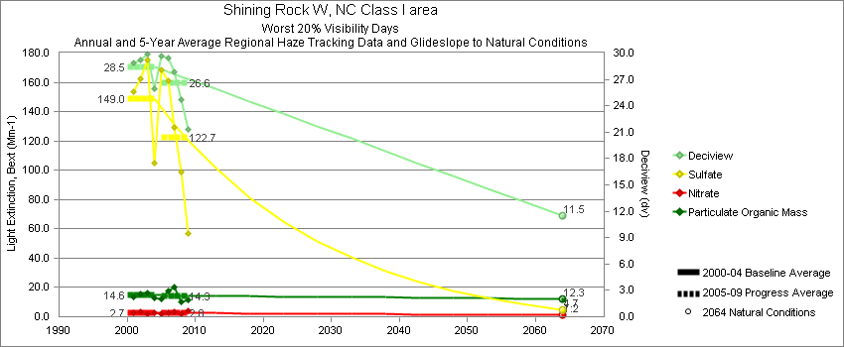
Shining Rock - Worst 20% Visibility Days – 5-Year Average, Natural Conditions and Annual Data
Parameter | 2000-2004 | 2005-2009 | 2064 NC | 2000 | 2001 | 2002 | 2003 | 2004 | 2005 | 2006 | 2007 | 2008 | 2009
Deciview (dv) | 28.5 | 26.6 | 11.5 |  | 28.9 | 29.2 | 29.8 | 25.9 | 29.7 | 29.4 | 27.9 | 24.7 | 21.3
Sulfate Bext | 149.0 | 122.7 | 4.7 |  | 153.6 | 162.2 | 175.3 | 105.1 | 167.8 | 160.9 | 129.6 | 98.8 | 56.5
Nitrate Bext | 2.7 | 2.8 | 1.2 |  | 3.0 | 3.1 | 2.2 | 2.4 | 2.4 | 2.4 | 3.7 | 1.9 | 3.8
POM Bext | 14.6 | 14.3 | 12.3 |  | 13.7 | 15.7 | 16.4 | 12.7 | 12.2 | 17.6 | 20.0 | 10.2 | 11.3
EC Bext | 3.6 | 3.5 | 0.3 |  | 4.0 | 2.5 | 4.6 | 3.5 | 4.9 | 4.4 | 4.2 | 1.3 | 2.5
Soil Bext | 0.9 | 0.7 | 1.0 |  | 0.7 | 1.1 | 0.8 | 0.9 | 0.5 | 0.9 | 0.8 | 0.7 | 0.7
Coarse Mass Bext | 1.3 | 1.8 | 2.1 |  | 1.3 | 1.8 | 0.6 | 1.3 | 1.2 | 2.2 | 2.3 | 1.6 | 1.9
Sea Salt Bext | 0.1 | 0.2 | 0.2 |  | 0.0 | 0.0 | 0.0 | 0.4 | 0.1 | 0.3 | 0.3 | 0.2 | 0.2

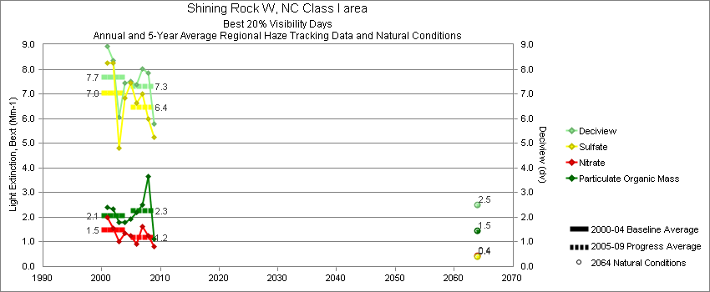
Shining Rock - Best 20% Visibility Days – 5-Year Average, Natural Conditions and Annual Data
Parameter | 2000-2004 | 2005-2009 | 2064 NC | 2000 | 2001 | 2002 | 2003 | 2004 | 2005 | 2006 | 2007 | 2008 | 2009
Deciview (dv) | 7.7 | 7.3 | 2.5 |  | 8.9 | 8.4 | 6.1 | 7.4 | 7.5 | 7.3 | 8.0 | 7.8 | 5.8
Sulfate Bext | 7.0 | 6.5 | 0.4 |  | 8.3 | 8.2 | 4.8 | 6.8 | 7.4 | 6.6 | 7.0 | 6.0 | 5.2
Nitrate Bext | 1.5 | 1.2 | 0.4 |  | 2.0 | 1.5 | 1.0 | 1.4 | 1.3 | 0.9 | 1.6 | 1.3 | 0.8
POM Bext | 2.1 | 2.3 | 1.5 |  | 2.4 | 2.3 | 1.8 | 1.8 | 1.9 | 2.2 | 2.5 | 3.7 | 1.1
EC Bext | 0.9 | 0.7 | 0.1 |  | 1.0 | 1.1 | 0.7 | 0.8 | 0.8 | 0.9 | 0.9 | 0.6 | 0.5
Soil Bext | 0.2 | 0.1 | 0.1 |  | 0.2 | 0.1 | 0.2 | 0.2 | 0.1 | 0.1 | 0.1 | 0.1 | 0.1
Coarse Mass Bext | 0.4 | 0.4 | 0.3 |  | 0.7 | 0.5 | 0.2 | 0.3 | 0.4 | 0.4 | 0.4 | 0.5 | 0.4
Sea Salt Bext | 0.1 | 0.1 | 0.0 |  | 0.2 | 0.0 | 0.0 | 0.1 | 0.1 | 0.1 | 0.2 | 0.1 | 0.1

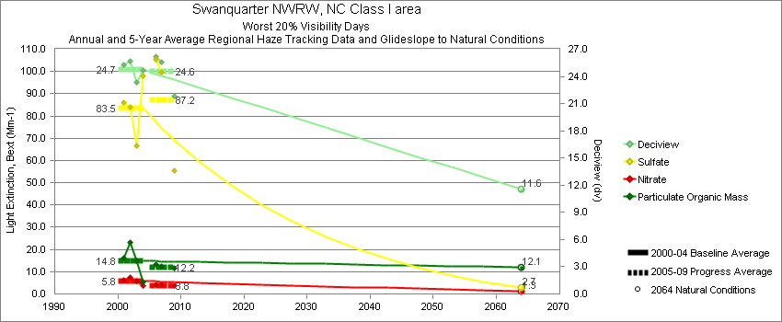
Swanquarter - Worst 20% Visibility Days – 5-Year Average, Natural Conditions and Annual Data
Parameter | 2000-2004 | 2005-2009 | 2064 NC | 2000 | 2001 | 2002 | 2003 | 2004 | 2005 | 2006 | 2007 | 2008 | 2009
Deciview (dv) | 24.7 | 24.6 | 11.5 |  | 25.3 | 25.7 | 23.4 | 24.6 |  | 26.2 | 25.6 |  | 21.9
Sulfate Bext | 83.5 | 87.2 | 2.7 |  | 86.0 | 83.8 | 66.4 | 97.8 |  | 106.6 | 99.6 |  | 55.3
Nitrate Bext | 5.8 | 3.8 | 1.3 |  | 6.2 | 7.4 | 5.7 | 3.9 |  | 3.5 | 4.1 |  | 3.8
POM Bext | 14.8 | 12.2 | 12.1 |  | 16.0 | 23.2 | 14.8 | 5.2 |  | 12.8 | 12.4 |  | 11.4
EC Bext | 3.7 | 3.4 | 0.3 |  | 4.5 | 4.8 | 4.0 | 1.6 |  | 4.0 | 3.8 |  | 2.6
Soil Bext | 0.6 | 0.8 | 0.7 |  | 0.6 | 0.6 | 0.5 | 0.8 |  | 0.7 | 0.6 |  | 1.1
Coarse Mass Bext | 3.5 | 3.4 | 2.1 |  | 2.8 | 3.7 | 4.3 | 3.2 |  | 3.8 | 3.1 |  | 3.3
Sea Salt Bext | 0.2 | 1.2 | 1.4 |  | 0.0 | 0.1 | 0.1 | 0.6 |  | 0.5 | 0.6 |  | 2.4

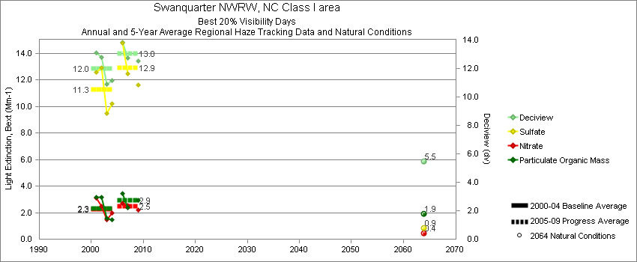
Swanquarter - Best 20% Visibility Days – 5-Year Average, Natural Conditions and Annual Data
Parameter | 2000-2004 | 2005-2009 | 2064 NC | 2000 | 2001 | 2002 | 2003 | 2004 | 2005 | 2006 | 2007 | 2008 | 2009
Deciview (dv) | 12.0 | 13.0 | 5.5 |  | 13.1 | 12.8 | 10.9 | 11.2 |  | 13.8 | 12.7 |  | 12.6
Sulfate Bext | 11.3 | 12.9 | 0.8 |  | 12.5 | 12.9 | 9.5 | 10.2 |  | 14.8 | 12.5 |  | 11.6
Nitrate Bext | 2.3 | 2.5 | 0.4 |  | 3.1 | 2.5 | 1.5 | 2.0 |  | 2.7 | 2.6 |  | 2.2
POM Bext | 2.3 | 2.9 | 1.9 |  | 3.1 | 3.1 | 1.6 | 1.4 |  | 3.5 | 2.4 |  | 2.9
EC Bext | 0.8 | 1.0 | 0.1 |  | 1.1 | 1.0 | 0.6 | 0.5 |  | 1.3 | 0.8 |  | 0.9
Soil Bext | 0.2 | 0.2 | 0.2 |  | 0.2 | 0.2 | 0.2 | 0.3 |  | 0.3 | 0.2 |  | 0.3
Coarse Mass Bext | 3.2 | 2.6 | 1.4 |  | 3.1 | 3.0 | 3.6 | 3.0 |  | 2.8 | 2.5 |  | 2.4
Sea Salt Bext | 1.5 | 3.0 | 0.3 |  | 2.0 | 1.4 | 1.3 | 1.4 |  | 2.9 | 3.2 |  | 3.1

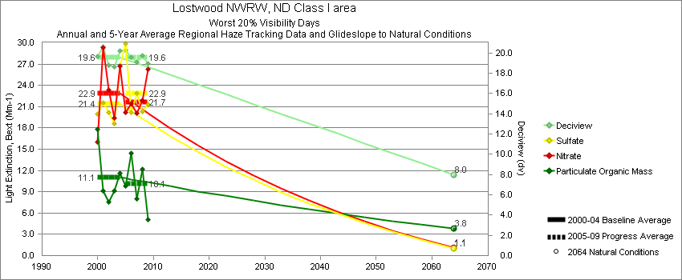
Lostwood - Worst 20% Visibility Days – 5-Year Average, Natural Conditions and Annual Data
Parameter | 2000-2004 | 2005-2009 | 2064 NC | 2000 | 2001 | 2002 | 2003 | 2004 | 2005 | 2006 | 2007 | 2008 | 2009
Deciview (dv) | 19.6 | 19.6 | 8.0 | 19.7 | 20.6 | 18.8 | 18.6 | 20.2 | 20.5 | 19.6 | 19.1 | 19.7 | 18.9
Sulfate Bext | 21.4 | 22.9 | 1.1 | 20.0 | 21.5 | 20.1 | 18.6 | 26.8 | 29.9 | 20.2 | 22.9 | 20.3 | 21.3
Nitrate Bext | 22.9 | 21.7 | 1.1 | 16.0 | 29.3 | 23.3 | 19.4 | 26.7 | 19.0 | 21.4 | 20.0 | 21.9 | 26.3
POM Bext | 11.1 | 10.1 | 3.8 | 17.8 | 9.2 | 7.6 | 9.1 | 11.6 | 11.0 | 14.5 | 8.0 | 12.2 | 5.0
EC Bext | 2.8 | 2.5 | 0.4 | 4.5 | 2.8 | 2.3 | 2.4 | 2.2 | 3.2 | 2.8 | 2.1 | 2.5 | 2.0
Soil Bext | 0.6 | 0.6 | 0.9 | 0.9 | 0.7 | 0.5 | 0.6 | 0.4 | 0.5 | 0.6 | 0.6 | 0.7 | 0.7
Coarse Mass Bext | 3.9 | 4.0 | 3.7 | 5.2 | 4.7 | 2.6 | 4.3 | 2.7 | 4.1 | 4.2 | 4.4 | 3.9 | 3.5
Sea Salt Bext | 0.3 | 0.6 | 0.5 | 0.0 | 0.9 | 0.1 | 0.0 | 0.3 | 0.2 | 0.2 | 0.2 | 2.1 | 0.1

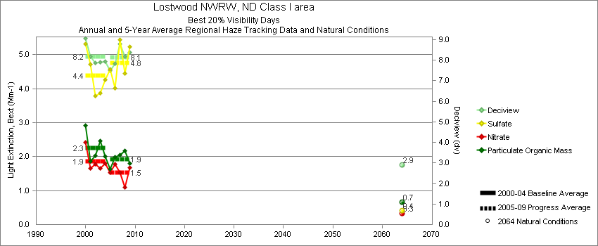
Lostwood - Best 20% Visibility Days – 5-Year Average, Natural Conditions and Annual Data
Parameter | 2000-2004 | 2005-2009 | 2064 NC | 2000 | 2001 | 2002 | 2003 | 2004 | 2005 | 2006 | 2007 | 2008 | 2009
Deciview (dv) | 8.2 | 8.1 | 2.9 | 9.1 | 8.2 | 7.9 | 7.9 | 7.9 | 7.6 | 7.8 | 8.8 | 8.2 | 8.4
Sulfate Bext | 4.4 | 4.8 | 0.4 | 5.3 | 4.7 | 3.8 | 3.9 | 4.3 | 4.7 | 4.0 | 5.4 | 4.4 | 5.2
Nitrate Bext | 1.9 | 1.5 | 0.3 | 2.4 | 1.6 | 1.8 | 1.7 | 1.8 | 1.7 | 1.8 | 1.5 | 1.1 | 1.7
POM Bext | 2.3 | 1.9 | 0.7 | 2.9 | 1.9 | 2.0 | 2.5 | 2.0 | 1.6 | 2.0 | 2.1 | 2.2 | 1.8
EC Bext | 0.7 | 0.7 | 0.1 | 0.8 | 0.7 | 0.7 | 0.7 | 0.5 | 0.7 | 0.9 | 0.7 | 0.7 | 0.7
Soil Bext | 0.3 | 0.3 | 0.2 | 0.3 | 0.4 | 0.4 | 0.3 | 0.3 | 0.2 | 0.3 | 0.4 | 0.3 | 0.4
Coarse Mass Bext | 2.3 | 2.5 | 0.6 | 2.2 | 2.5 | 2.4 | 2.2 | 2.2 | 1.6 | 2.1 | 3.1 | 3.1 | 2.5
Sea Salt Bext | 0.0 | 0.1 | 0.0 | 0.0 | 0.0 | 0.0 | 0.0 | 0.1 | 0.1 | 0.1 | 0.1 | 0.0 | 0.1
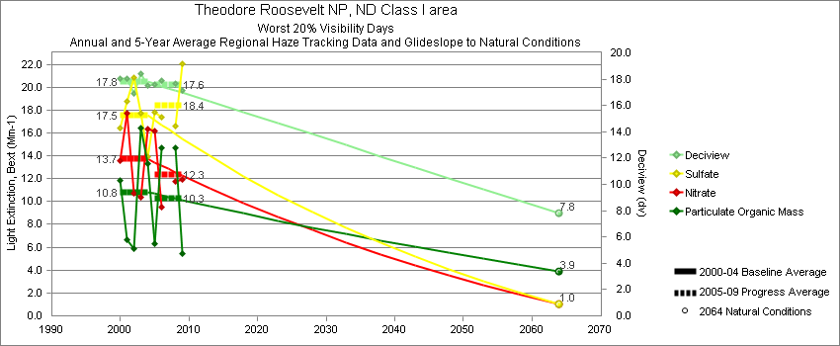
Theodore Roosevelt - Worst 20% Visibility Days – 5-Year Average, Natural Conditions and Annual Data
Parameter | 2000-2004 | 2005-2009 | 2064 NC | 2000 | 2001 | 2002 | 2003 | 2004 | 2005 | 2006 | 2007 | 2008 | 2009
Deciview (dv) | 17.8 | 17.6 | 7.8 | 18.1 | 18.0 | 17.0 | 18.4 | 17.5 | 17.6 | 17.9 |  | 17.6 | 17.2
Sulfate Bext | 17.5 | 18.4 | 1.0 | 16.4 | 18.8 | 20.8 | 17.7 | 14.0 | 17.7 | 17.3 |  | 16.6 | 22.0
Nitrate Bext | 13.7 | 12.3 | 1.0 | 13.6 | 17.7 | 10.7 | 10.3 | 16.4 | 16.1 | 9.5 |  | 11.8 | 11.9
POM Bext | 10.8 | 10.3 | 3.9 | 11.8 | 6.7 | 5.9 | 16.4 | 13.4 | 6.3 | 14.7 |  | 14.7 | 5.4
EC Bext | 2.7 | 2.6 | 0.3 | 3.3 | 2.7 | 1.9 | 3.4 | 2.5 | 2.8 | 3.3 |  | 2.5 | 1.9
Soil Bext | 0.9 | 0.8 | 1.0 | 0.8 | 1.0 | 1.2 | 1.0 | 0.5 | 0.9 | 1.0 |  | 0.8 | 0.7
Coarse Mass Bext | 4.8 | 4.7 | 3.7 | 5.6 | 4.5 | 5.6 | 5.4 | 3.0 | 5.1 | 5.3 |  | 4.1 | 4.4
Sea Salt Bext | 0.1 | 0.6 | 0.2 | 0.0 | 0.0 | 0.0 | 0.0 | 0.3 | 0.2 | 0.1 |  | 2.0 | 0.1

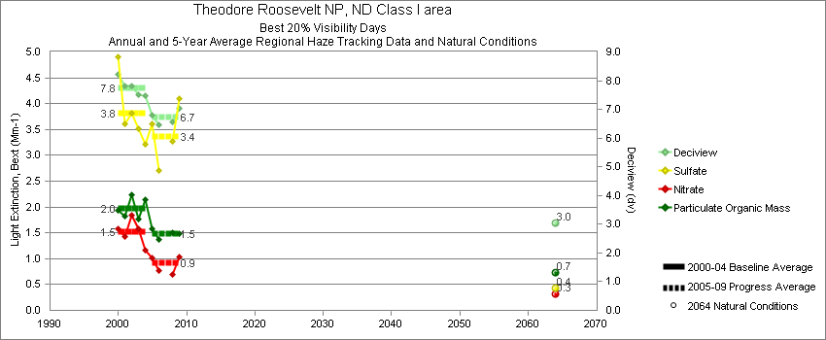
Theodore Roosevelt - Best 20% Visibility Days – 5-Year Average, Natural Conditions and Annual Data
Parameter | 2000-2004 | 2005-2009 | 2064 NC | 2000 | 2001 | 2002 | 2003 | 2004 | 2005 | 2006 | 2007 | 2008 | 2009
Deciview (dv) | 7.8 | 6.7 | 3.0 | 8.2 | 7.8 | 7.8 | 7.5 | 7.5 | 6.8 | 6.5 |  | 6.6 | 7.0
Sulfate Bext | 3.8 | 3.4 | 0.4 | 4.9 | 3.6 | 3.8 | 3.5 | 3.2 | 3.6 | 2.5 |  | 3.3 | 4.1
Nitrate Bext | 1.5 | 0.9 | 0.3 | 1.6 | 1.4 | 1.9 | 1.6 | 1.2 | 1.0 | 0.9 |  | 0.7 | 1.0
POM Bext | 2.0 | 1.5 | 0.7 | 1.9 | 1.8 | 2.2 | 1.8 | 2.1 | 1.6 | 1.4 |  | 1.5 | 1.5
EC Bext | 0.9 | 0.9 | 0.1 | 1.2 | 0.8 | 0.8 | 0.9 | 0.9 | 1.0 | 1.1 |  | 0.7 | 0.6
Soil Bext | 0.4 | 0.3 | 0.2 | 0.3 | 0.5 | 0.4 | 0.3 | 0.4 | 0.3 | 0.3 |  | 0.3 | 0.3
Coarse Mass Bext | 2.2 | 1.7 | 0.7 | 2.1 | 2.7 | 1.7 | 2.1 | 2.4 | 1.3 | 1.9 |  | 1.8 | 1.8
Sea Salt Bext | 0.0 | 0.1 | 0.0 | 0.0 | 0.1 | 0.0 | 0.1 | 0.1 | 0.1 | 0.1 |  | 0.1 | 0.0

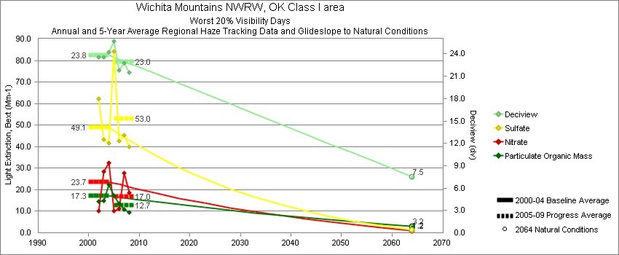
Wichita Mountains - Worst 20% Visibility Days – 5-Year Average, Natural Conditions and Annual Data
Parameter | 2000-2004 | 2005-2009 | 2064 NC | 2000 | 2001 | 2002 | 2003 | 2004 | 2005 | 2006 | 2007 | 2008 | 2009
Deciview (dv) | 23.8 | 23.0 | 7.5 |  |  | 23.6 | 23.6 | 24.2 | 25.7 | 21.8 | 22.8 | 21.6
Sulfate Bext | 49.1 | 53.0 | 1.2 |  |  | 62.2 | 43.5 | 41.7 | 83.9 | 42.6 | 45.5 | 40.1
Nitrate Bext | 23.7 | 17.0 | 1.2 |  |  | 10.3 | 28.5 | 32.3 | 10.3 | 11.2 | 27.9 | 18.7
POM Bext | 17.3 | 12.7 | 3.2 |  |  | 14.5 | 14.8 | 22.5 | 17.3 | 13.4 | 10.9 | 9.4
EC Bext | 4.5 | 4.6 | 0.3 |  |  | 4.2 | 4.5 | 4.7 | 5.9 | 5.1 | 4.1 | 3.0
Soil Bext | 0.8 | 1.2 | 1.1 |  |  | 0.8 | 0.9 | 0.7 | 0.7 | 1.5 | 1.1 | 1.3
Coarse Mass Bext | 4.6 | 5.4 | 3.1 |  |  | 5.5 | 4.2 | 4.3 | 5.4 | 7.3 | 4.4 | 4.7
Sea Salt Bext | 0.2 | 0.4 | 0.2 |  |  | 0.0 | 0.0 | 0.4 | 0.2 | 0.4 | 0.6 | 0.4

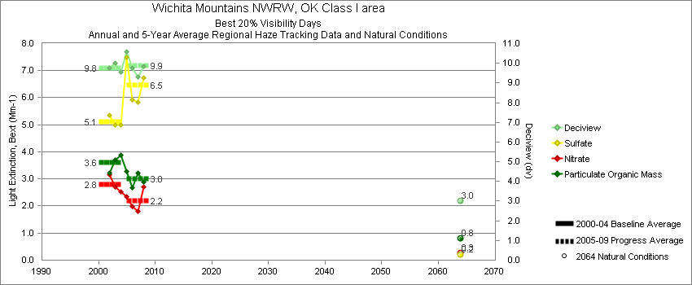
Wichita Mountains - Best 20% Visibility Days – 5-Year Average, Natural Conditions and Annual Data
Parameter | 2000-2004 | 2005-2009 | 2064 NC | 2000 | 2001 | 2002 | 2003 | 2004 | 2005 | 2006 | 2007 | 2008 | 2009
Deciview (dv) | 9.8 | 9.9 | 3.0 |  |  | 9.8 | 10.0 | 9.6 | 10.6 | 9.7 | 9.3 | 9.8
Sulfate Bext | 5.1 | 6.5 | 0.2 |  |  | 5.4 | 5.0 | 5.0 | 7.5 | 5.9 | 5.8 | 6.7
Nitrate Bext | 2.8 | 2.2 | 0.3 |  |  | 3.2 | 2.7 | 2.5 | 2.4 | 2.0 | 1.8 | 2.7
POM Bext | 3.6 | 3.0 | 0.8 |  |  | 3.2 | 3.7 | 3.9 | 3.3 | 2.7 | 3.2 | 2.9
EC Bext | 1.3 | 1.2 | 0.1 |  |  | 1.2 | 1.3 | 1.3 | 1.5 | 1.1 | 1.2 | 1.0
Soil Bext | 0.3 | 0.4 | 0.2 |  |  | 0.3 | 0.4 | 0.3 | 0.4 | 0.5 | 0.3 | 0.4
Coarse Mass Bext | 2.7 | 2.9 | 0.9 |  |  | 2.5 | 3.3 | 2.2 | 3.5 | 3.5 | 2.3 | 2.3
Sea Salt Bext | 0.1 | 0.1 | 0.1 |  |  | 0.0 | 0.1 | 0.2 | 0.1 | 0.1 | 0.2 | 0.1

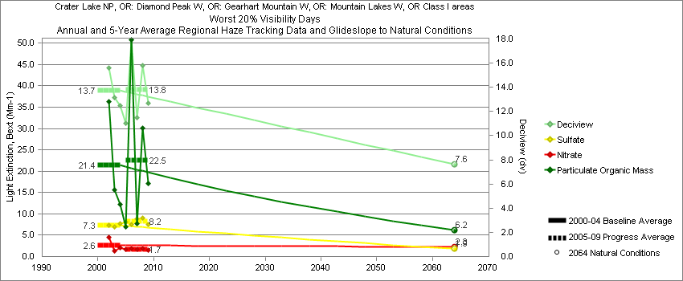
Crater Lake - Worst 20% Visibility Days – 5-Year Average, Natural Conditions and Annual Data
Parameter | 2000-2004 | 2005-2009 | 2064 NC | 2000 | 2001 | 2002 | 2003 | 2004 | 2005 | 2006 | 2007 | 2008 | 2009
Deciview (dv) | 13.7 | 13.8 | 7.6 |  |  | 15.6 | 13.1 | 12.5 | 11.1 | 17.9 | 11.5 | 15.8 | 12.7
Sulfate Bext | 7.3 | 8.2 | 1.9 |  |  | 7.3 | 7.0 | 7.8 | 8.1 | 7.6 | 8.9 | 9.1 | 7.5
Nitrate Bext | 2.6 | 1.7 | 2.3 |  |  | 4.5 | 1.3 | 2.0 | 1.7 | 1.9 | 1.8 | 1.8 | 1.4
POM Bext | 21.4 | 22.5 | 6.2 |  |  | 36.3 | 15.7 | 12.3 | 6.9 | 50.9 | 7.8 | 30.1 | 17.0
EC Bext | 4.3 | 3.4 | 0.5 |  |  | 6.7 | 3.7 | 2.6 | 2.4 | 6.4 | 2.0 | 3.6 | 2.5
Soil Bext | 0.8 | 0.9 | 0.9 |  |  | 1.0 | 0.7 | 0.8 | 0.6 | 0.8 | 0.8 | 0.7 | 1.3
Coarse Mass Bext | 2.3 | 1.8 | 2.5 |  |  | 3.6 | 1.9 | 1.4 | 1.8 | 1.9 | 1.7 | 1.5 | 2.2
Sea Salt Bext | 0.1 | 0.1 | 0.2 |  |  | 0.1 | 0.0 | 0.0 | 0.1 | 0.1 | 0.2 | 0.1 | 0.2

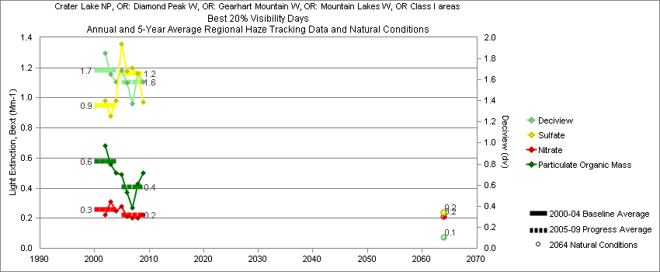
Crater Lake - Best 20% Visibility Days – 5-Year Average, Natural Conditions and Annual Data
Parameter | 2000-2004 | 2005-2009 | 2064 NC | 2000 | 2001 | 2002 | 2003 | 2004 | 2005 | 2006 | 2007 | 2008 | 2009
Deciview (dv) | 1.7 | 1.6 | 0.1 |  |  | 1.8 | 1.7 | 1.6 | 1.7 | 1.5 | 1.4 | 1.7 | 1.6
Sulfate Bext | 0.9 | 1.2 | 0.2 |  |  | 1.0 | 0.9 | 1.0 | 1.3 | 1.2 | 1.2 | 1.2 | 1.0
Nitrate Bext | 0.3 | 0.2 | 0.2 |  |  | 0.2 | 0.3 | 0.3 | 0.3 | 0.2 | 0.2 | 0.2 | 0.2
POM Bext | 0.6 | 0.4 | 0.2 |  |  | 0.7 | 0.6 | 0.5 | 0.6 | 0.3 | 0.3 | 0.4 | 0.5
EC Bext | 0.7 | 0.5 | 0.1 |  |  | 0.7 | 0.7 | 0.5 | 0.4 | 0.6 | 0.3 | 0.5 | 0.5
Soil Bext | 0.1 | 0.1 | 0.1 |  |  | 0.1 | 0.1 | 0.1 | 0.1 | 0.1 | 0.1 | 0.1 | 0.1
Coarse Mass Bext | 0.2 | 0.2 | 0.1 |  |  | 0.2 | 0.2 | 0.2 | 0.1 | 0.1 | 0.2 | 0.3 | 0.2
Sea Salt Bext | 0.2 | 0.2 | 0.1 |  |  | 0.3 | 0.1 | 0.2 | 0.2 | 0.3 | 0.2 | 0.2 | 0.3

Hells Canyon - Worst 20% Visibility Days – 5-Year Average, Natural Conditions and Annual Data
Parameter | 2000-2004 | 2005-2009 | 2064 NC | 2000 | 2001 | 2002 | 2003 | 2004 | 2005 | 2006 | 2007 | 2008 | 2009
Deciview (dv) | 18.6 | 18.1 | 8.3 |  | 19.0 | 18.2 |  | 18.5 | 18.3 | 19.8 | 19.4 | 15.1
Sulfate Bext | 8.4 | 6.8 | 1.1 |  | 9.9 | 6.6 |  | 8.6 | 8.8 | 5.4 | 7.3 | 5.7
Nitrate Bext | 28.5 | 13.5 | 2.7 |  | 32.9 | 20.0 |  | 32.5 | 29.1 | 11.2 | 6.8 | 6.9
POM Bext | 15.6 | 31.4 | 3.7 |  | 11.4 | 20.7 |  | 14.7 | 13.1 | 43.9 | 51.0 | 17.8
EC Bext | 3.1 | 5.3 | 0.4 |  | 2.9 | 3.7 |  | 2.5 | 4.3 | 7.6 | 6.6 | 2.5
Soil Bext | 0.7 | 0.8 | 0.9 |  | 0.7 | 0.7 |  | 0.6 | 0.4 | 1.1 | 1.2 | 0.7
Coarse Mass Bext | 1.9 | 2.9 | 3.4 |  | 1.4 | 2.0 |  | 2.5 | 1.8 | 3.8 | 3.6 | 2.6
Sea Salt Bext | 0.0 | 0.1 | 0.0 |  | 0.0 | 0.0 |  | 0.1 | 0.2 | 0.2 | 0.1 | 0.0

Hells Canyon - Best 20% Visibility Days – 5-Year Average, Natural Conditions and Annual Data
Parameter | 2000-2004 | 2005-2009 | 2064 NC | 2000 | 2001 | 2002 | 2003 | 2004 | 2005 | 2006 | 2007 | 2008 | 2009
Deciview (dv) | 5.5 | 4.8 | 2.5 |  | 5.5 | 5.8 |  | 5.2 | 4.7 | 4.7 | 5.2 | 4.6
Sulfate Bext | 1.9 | 1.9 | 0.4 |  | 2.2 | 1.9 |  | 1.7 | 2.0 | 1.7 | 2.2 | 1.8
Nitrate Bext | 0.8 | 0.6 | 0.2 |  | 1.0 | 0.8 |  | 0.5 | 0.5 | 0.7 | 0.6 | 0.7
POM Bext | 2.0 | 1.5 | 0.5 |  | 1.6 | 2.3 |  | 2.1 | 1.4 | 1.5 | 1.7 | 1.4
EC Bext | 0.6 | 0.4 | 0.1 |  | 0.6 | 0.7 |  | 0.5 | 0.5 | 0.4 | 0.5 | 0.3
Soil Bext | 0.3 | 0.2 | 0.1 |  | 0.2 | 0.3 |  | 0.2 | 0.1 | 0.2 | 0.2 | 0.2
Coarse Mass Bext | 0.8 | 0.5 | 0.5 |  | 0.7 | 0.9 |  | 0.8 | 0.5 | 0.4 | 0.6 | 0.5
Sea Salt Bext | 0.1 | 0.1 | 0.1 |  | 0.1 | 0.0 |  | 0.1 | 0.1 | 0.2 | 0.1 | 0.1

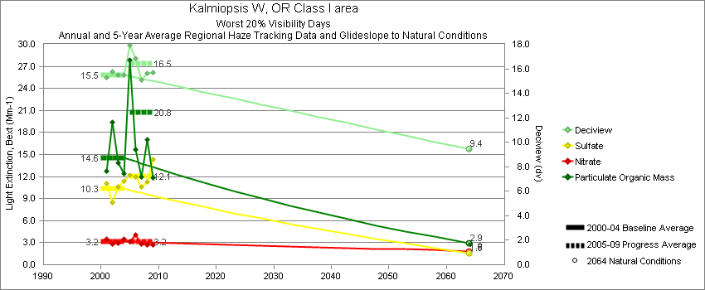
Kalmiopsis - Worst 20% Visibility Days – 5-Year Average, Natural Conditions and Annual Data
Parameter | 2000-2004 | 2005-2009 | 2064 NC | 2000 | 2001 | 2002 | 2003 | 2004 | 2005 | 2006 | 2007 | 2008 | 2009
Deciview (dv) | 15.5 | 16.4 | 9.4 |  | 15.3 | 15.8 | 15.5 | 15.5 | 19.0 | 16.9 | 15.1 | 15.6 | 15.7
Sulfate Bext | 10.3 | 12.1 | 1.6 |  | 11.0 | 8.4 | 10.6 | 11.3 | 12.1 | 12.0 | 10.6 | 11.2 | 14.4
Nitrate Bext | 3.2 | 3.2 | 1.9 |  | 3.4 | 2.9 | 2.9 | 3.5 | 3.5 | 4.1 | 2.8 | 2.7 | 2.7
POM Bext | 14.6 | 20.8 | 2.9 |  | 12.7 | 19.4 | 13.8 | 12.4 | 47.4 | 15.7 | 12.0 | 17.0 | 11.8
EC Bext | 2.5 | 3.5 | 0.2 |  | 2.3 | 3.5 | 2.4 | 1.8 | 7.3 | 2.9 | 3.2 | 2.4 | 1.7
Soil Bext | 0.4 | 0.3 | 0.4 |  | 0.5 | 0.4 | 0.3 | 0.3 | 0.4 | 0.4 | 0.2 | 0.4 | 0.4
Coarse Mass Bext | 2.1 | 2.4 | 2.2 |  | 2.3 | 1.9 | 2.2 | 2.2 | 3.0 | 2.5 | 2.0 | 2.0 | 2.3
Sea Salt Bext | 2.9 | 3.6 | 4.7 |  | 3.2 | 1.3 | 3.5 | 3.8 | 2.8 | 5.3 | 3.2 | 2.4 | 4.3

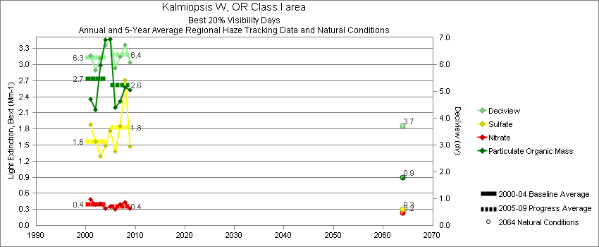
Kalmiopsis - Best 20% Visibility Days – 5-Year Average, Natural Conditions and Annual Data
Parameter | 2000-2004 | 2005-2009 | 2064 NC | 2000 | 2001 | 2002 | 2003 | 2004 | 2005 | 2006 | 2007 | 2008 | 2009
Deciview (dv) | 6.3 | 6.4 | 3.7 |  | 6.3 | 5.8 | 6.2 | 6.7 | 6.9 | 5.8 | 6.3 | 6.7 | 6.1
Sulfate Bext | 1.6 | 1.8 | 0.3 |  | 1.9 | 1.6 | 1.3 | 1.5 | 1.7 | 1.4 | 1.9 | 2.7 | 1.5
Nitrate Bext | 0.4 | 0.4 | 0.2 |  | 0.5 | 0.4 | 0.4 | 0.3 | 0.4 | 0.3 | 0.4 | 0.4 | 0.3
POM Bext | 2.7 | 2.6 | 0.9 |  | 2.4 | 2.2 | 3.0 | 3.5 | 3.5 | 2.2 | 2.3 | 2.6 | 2.5
EC Bext | 0.8 | 0.8 | 0.1 |  | 0.8 | 0.6 | 0.9 | 1.1 | 1.1 | 0.7 | 0.7 | 0.6 | 0.7
Soil Bext | 0.0 | 0.0 | 0.1 |  | 0.1 | 0.0 | 0.0 | 0.0 | 0.0 | 0.0 | 0.0 | 0.1 | 0.1
Coarse Mass Bext | 0.6 | 0.6 | 0.6 |  | 0.7 | 0.5 | 0.5 | 0.5 | 0.6 | 0.5 | 0.6 | 0.5 | 0.5
Sea Salt Bext | 0.7 | 0.8 | 0.3 |  | 0.6 | 0.7 | 0.6 | 0.9 | 0.7 | 0.9 | 0.9 | 0.9 | 0.8

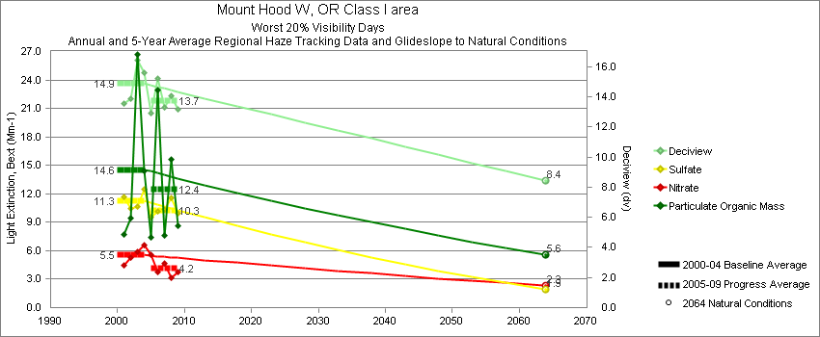
Mount Hood - Worst 20% Visibility Days – 5-Year Average, Natural Conditions and Annual Data
Parameter | 2000-2004 | 2005-2009 | 2064 NC | 2000 | 2001 | 2002 | 2003 | 2004 | 2005 | 2006 | 2007 | 2008 | 2009
Deciview (dv) | 14.9 | 13.7 | 8.4 |  | 13.6 | 13.9 | 16.4 | 15.6 | 12.9 | 15.2 | 13.3 | 14.0 | 13.2
Sulfate Bext | 11.3 | 10.3 | 1.9 |  | 11.6 | 10.4 | 10.7 | 12.5 | 9.5 | 10.1 | 10.3 | 11.6 | 9.9
Nitrate Bext | 5.5 | 4.2 | 2.3 |  | 4.5 | 5.2 | 5.8 | 6.6 | 5.7 | 3.8 | 4.6 | 3.1 | 3.8
POM Bext | 14.6 | 12.4 | 5.6 |  | 7.7 | 9.5 | 26.7 | 14.4 | 7.5 | 22.9 | 7.6 | 15.6 | 8.6
EC Bext | 2.9 | 2.3 | 0.5 |  | 2.2 | 2.3 | 4.3 | 2.8 | 2.3 | 3.2 | 2.2 | 2.3 | 1.8
Soil Bext | 0.7 | 0.6 | 0.8 |  | 1.2 | 0.6 | 0.5 | 0.6 | 0.3 | 0.7 | 0.6 | 0.7 | 0.7
Coarse Mass Bext | 2.5 | 2.3 | 2.7 |  | 2.4 | 2.8 | 2.7 | 2.0 | 1.3 | 2.6 | 2.6 | 2.0 | 2.9
Sea Salt Bext | 0.1 | 0.7 | 0.2 |  | 0.0 | 0.0 | 0.0 | 0.3 | 0.6 | 2.0 | 0.2 | 0.1 | 0.4

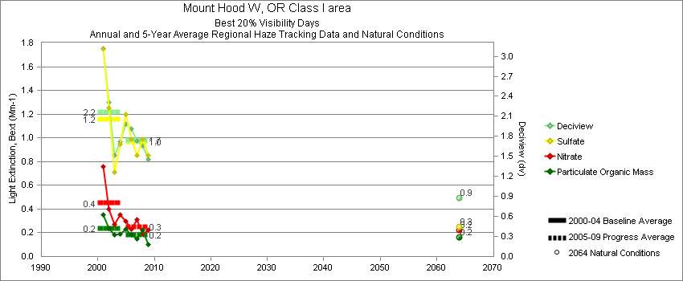
Mount Hood - Best 20% Visibility Days – 5-Year Average, Natural Conditions and Annual Data
Parameter | 2000-2004 | 2005-2009 | 2064 NC | 2000 | 2001 | 2002 | 2003 | 2004 | 2005 | 2006 | 2007 | 2008 | 2009
Deciview (dv) | 2.2 | 1.7 | 0.9 |  | 3.1 | 2.3 | 1.5 | 1.7 | 2.0 | 1.8 | 1.7 | 1.7 | 1.5
Sulfate Bext | 1.2 | 1.0 | 0.3 |  | 1.8 | 1.2 | 0.7 | 0.9 | 1.2 | 1.0 | 0.8 | 1.0 | 0.8
Nitrate Bext | 0.4 | 0.3 | 0.2 |  | 0.8 | 0.4 | 0.3 | 0.4 | 0.3 | 0.2 | 0.3 | 0.2 | 0.2
POM Bext | 0.2 | 0.2 | 0.2 |  | 0.3 | 0.2 | 0.2 | 0.2 | 0.2 | 0.2 | 0.1 | 0.2 | 0.1
EC Bext | 0.2 | 0.1 | 0.0 |  | 0.3 | 0.2 | 0.2 | 0.2 | 0.1 | 0.1 | 0.1 | 0.1 | 0.1
Soil Bext | 0.1 | 0.0 | 0.1 |  | 0.1 | 0.0 | 0.1 | 0.0 | 0.0 | 0.0 | 0.0 | 0.0 | 0.1
Coarse Mass Bext | 0.1 | 0.1 | 0.1 |  | 0.1 | 0.2 | 0.1 | 0.0 | 0.1 | 0.1 | 0.2 | 0.1 | 0.1
Sea Salt Bext | 0.3 | 0.3 | 0.1 |  | 0.4 | 0.4 | 0.2 | 0.2 | 0.3 | 0.4 | 0.3 | 0.2 | 0.2

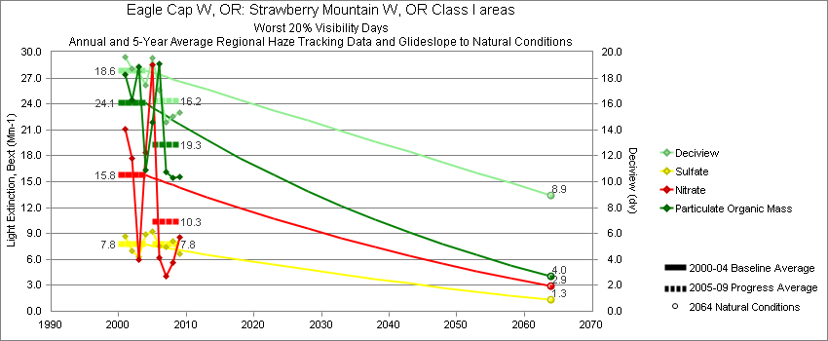
Starkey - Worst 20% Visibility Days – 5-Year Average, Natural Conditions and Annual Data
Parameter | 2000-2004 | 2005-2009 | 2064 NC | 2000 | 2001 | 2002 | 2003 | 2004 | 2005 | 2006 | 2007 | 2008 | 2009
Deciview (dv) | 18.6 | 16.2 | 8.9 |  | 19.7 | 18.7 | 18.5 | 17.4 | 19.1 | 17.1 | 14.6 | 15.0 | 15.3
Sulfate Bext | 7.7 | 7.8 | 1.3 |  | 8.7 | 7.0 | 6.4 | 8.9 | 9.0 | 7.5 | 7.5 | 8.1 | 6.6
Nitrate Bext | 15.8 | 10.3 | 2.9 |  | 21.1 | 17.7 | 5.9 | 18.4 | 27.1 | 6.2 | 4.1 | 5.7 | 8.5
POM Bext | 24.1 | 19.3 | 4.0 |  | 27.4 | 24.5 | 28.3 | 16.3 | 20.7 | 28.7 | 16.1 | 15.4 | 15.5
EC Bext | 4.2 | 3.6 | 0.4 |  | 4.8 | 5.2 | 3.8 | 3.0 | 4.8 | 4.5 | 3.2 | 2.6 | 2.8
Soil Bext | 1.3 | 0.9 | 1.2 |  | 1.0 | 0.7 | 2.3 | 1.1 | 0.5 | 1.5 | 0.9 | 0.8 | 1.0
Coarse Mass Bext | 4.8 | 3.3 | 4.3 |  | 2.6 | 3.3 | 9.4 | 3.8 | 1.8 | 5.0 | 3.5 | 2.9 | 3.5
Sea Salt Bext | 0.1 | 0.1 | 0.6 |  | 0.0 | 0.0 | 0.4 | 0.2 | 0.3 | 0.1 | 0.1 | 0.0 | 0.1

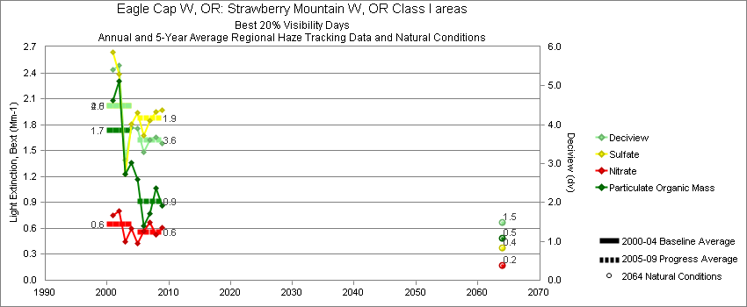
Starkey - Best 20% Visibility Days – 5-Year Average, Natural Conditions and Annual Data
Parameter | 2000-2004 | 2005-2009 | 2064 NC | 2000 | 2001 | 2002 | 2003 | 2004 | 2005 | 2006 | 2007 | 2008 | 2009
Deciview (dv) | 4.5 | 3.6 | 1.5 |  | 5.4 | 5.5 | 3.1 | 3.9 | 4.0 | 3.2 | 3.6 | 3.7 | 3.5
Sulfate Bext | 2.0 | 1.9 | 0.4 |  | 2.6 | 2.4 | 1.2 | 1.8 | 2.0 | 1.7 | 1.9 | 1.9 | 2.0
Nitrate Bext | 0.7 | 0.6 | 0.2 |  | 0.8 | 0.8 | 0.5 | 0.6 | 0.4 | 0.5 | 0.7 | 0.5 | 0.6
POM Bext | 1.7 | 0.9 | 0.5 |  | 2.1 | 2.3 | 1.2 | 1.4 | 1.2 | 0.6 | 0.8 | 1.1 | 0.9
EC Bext | 0.5 | 0.3 | 0.1 |  | 0.8 | 0.8 | 0.3 | 0.4 | 0.4 | 0.3 | 0.3 | 0.3 | 0.2
Soil Bext | 0.1 | 0.1 | 0.1 |  | 0.2 | 0.2 | 0.1 | 0.1 | 0.1 | 0.1 | 0.1 | 0.1 | 0.1
Coarse Mass Bext | 0.5 | 0.4 | 0.3 |  | 0.7 | 0.8 | 0.3 | 0.4 | 0.6 | 0.3 | 0.3 | 0.4 | 0.3
Sea Salt Bext | 0.2 | 0.3 | 0.1 |  | 0.3 | 0.2 | 0.1 | 0.3 | 0.2 | 0.4 | 0.4 | 0.2 | 0.3

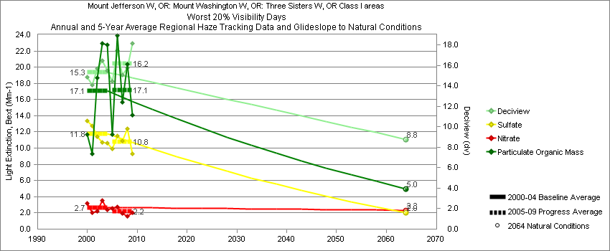
Three Sisters - Worst 20% Visibility Days – 5-Year Average, Natural Conditions and Annual Data
Parameter | 2000-2004 | 2005-2009 | 2064 NC | 2000 | 2001 | 2002 | 2003 | 2004 | 2005 | 2006 | 2007 | 2008 | 2009
Deciview (dv) | 15.3 | 16.2 | 8.8 | 14.9 | 14.1 | 15.7 | 16.5 | 15.5 | 14.5 | 17.5 | 15.1 | 15.8 | 18.1
Sulfate Bext | 11.8 | 10.8 | 2.0 | 13.4 | 12.8 | 11.4 | 10.7 | 10.6 | 10.0 | 11.5 | 10.9 | 12.4 | 9.3
Nitrate Bext | 2.7 | 2.2 | 2.3 | 3.2 | 2.1 | 2.2 | 3.6 | 2.4 | 2.6 | 2.7 | 1.9 | 1.6 | 2.0
POM Bext | 17.1 | 17.1 | 5.0 | 11.7 | 9.3 | 18.7 | 23.0 | 22.8 | 11.7 | 23.9 | 15.7 | 20.4 | 14.0
EC Bext | 3.2 | 3.3 | 0.4 | 3.2 | 2.4 | 3.7 | 3.6 | 3.1 | 3.5 | 4.5 | 2.9 | 3.2 | 2.6
Soil Bext | 0.6 | 1.4 | 0.6 | 0.4 | 0.9 | 0.7 | 0.6 | 0.5 | 0.7 | 1.1 | 0.7 | 0.7 | 3.9
Coarse Mass Bext | 2.7 | 7.6 | 2.8 | 2.2 | 2.3 | 2.8 | 3.5 | 2.8 | 3.8 | 6.3 | 4.8 | 2.8 | 20.3
Sea Salt Bext | 0.2 | 0.4 | 0.5 | 0.0 | 0.5 | 0.0 | 0.3 | 0.2 | 0.1 | 0.9 | 0.2 | 0.2 | 0.5

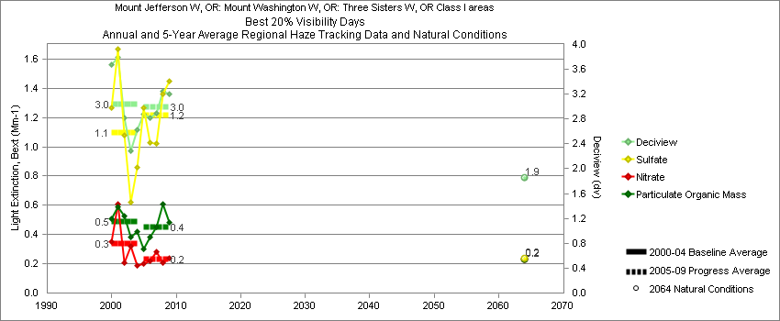
Three Sisters - Best 20% Visibility Days – 5-Year Average, Natural Conditions and Annual Data
Parameter | 2000-2004 | 2005-2009 | 2064 NC | 2000 | 2001 | 2002 | 2003 | 2004 | 2005 | 2006 | 2007 | 2008 | 2009
Deciview (dv) | 3.0 | 3.0 | 1.9 | 3.7 | 3.8 | 2.8 | 2.3 | 2.6 | 2.9 | 2.8 | 2.9 | 3.3 | 3.2
Sulfate Bext | 1.1 | 1.2 | 0.2 | 1.3 | 1.7 | 1.1 | 0.6 | 0.9 | 1.2 | 1.0 | 1.0 | 1.4 | 1.4
Nitrate Bext | 0.3 | 0.2 | 0.2 | 0.4 | 0.6 | 0.2 | 0.3 | 0.2 | 0.2 | 0.2 | 0.3 | 0.2 | 0.2
POM Bext | 0.5 | 0.4 | 0.2 | 0.5 | 0.6 | 0.5 | 0.4 | 0.4 | 0.3 | 0.4 | 0.5 | 0.6 | 0.5
EC Bext | 0.2 | 0.2 | 0.0 | 0.4 | 0.2 | 0.2 | 0.1 | 0.1 | 0.2 | 0.2 | 0.1 | 0.2 | 0.2
Soil Bext | 0.0 | 0.0 | 0.0 | 0.0 | 0.0 | 0.0 | 0.0 | 0.0 | 0.0 | 0.0 | 0.0 | 0.0 | 0.0
Coarse Mass Bext | 0.2 | 0.2 | 0.2 | 0.5 | 0.3 | 0.1 | 0.1 | 0.1 | 0.2 | 0.1 | 0.2 | 0.2 | 0.1
Sea Salt Bext | 0.2 | 0.3 | 0.1 | 0.4 | 0.3 | 0.2 | 0.0 | 0.3 | 0.3 | 0.3 | 0.3 | 0.3 | 0.3

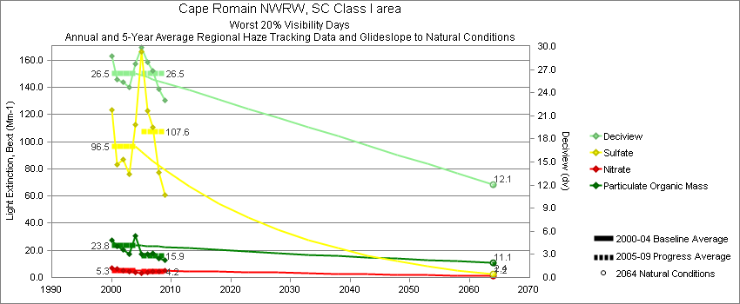
Cape Romain - Worst 20% Visibility Days – 5-Year Average, Natural Conditions and Annual Data
Parameter | 2000-2004 | 2005-2009 | 2064 NC | 2000 | 2001 | 2002 | 2003 | 2004 | 2005 | 2006 | 2007 | 2008 | 2009
Deciview (dv) | 26.5 | 26.5 | 12.1 | 28.8 | 25.7 | 25.4 | 24.7 | 27.8 | 29.9 | 27.9 | 26.9 | 24.5 | 23.0
Sulfate Bext | 96.5 | 107.6 | 2.4 | 123.4 | 83.3 | 86.9 | 76.4 | 112.7 | 165.8 | 122.9 | 110.8 | 77.5 | 61.0
Nitrate Bext | 5.3 | 4.2 | 1.2 | 6.8 | 6.4 | 5.2 | 4.2 | 4.0 | 3.3 | 3.9 | 4.4 | 4.3 | 5.0
POM Bext | 23.8 | 15.9 | 11.1 | 27.6 | 23.1 | 20.2 | 17.3 | 30.7 | 17.4 | 17.5 | 17.9 | 14.0 | 12.5
EC Bext | 5.7 | 4.7 | 0.3 | 8.1 | 5.2 | 5.5 | 4.8 | 5.1 | 5.3 | 5.9 | 4.9 | 4.0 | 3.2
Soil Bext | 0.6 | 0.8 | 0.7 | 0.5 | 0.5 | 0.7 | 0.4 | 0.8 | 0.6 | 0.9 | 0.8 | 0.8 | 0.7
Coarse Mass Bext | 3.2 | 3.5 | 2.6 | 3.7 | 2.6 | 2.6 | 4.9 | 2.4 | 2.9 | 3.2 | 3.9 | 3.6 | 3.9
Sea Salt Bext | 0.2 | 1.3 | 4.0 | 0.2 | 0.2 | 0.0 | 0.0 | 0.4 | 0.5 | 0.3 | 1.0 | 2.2 | 2.7

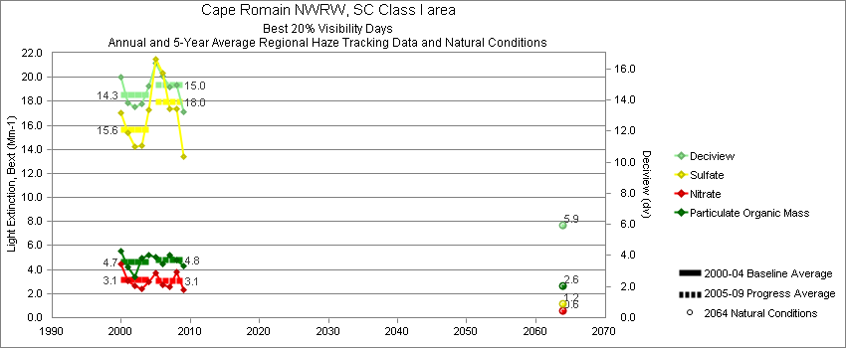
Cape Romain - Best 20% Visibility Days – 5-Year Average, Natural Conditions and Annual Data
Parameter | 2000-2004 | 2005-2009 | 2064 NC | 2000 | 2001 | 2002 | 2003 | 2004 | 2005 | 2006 | 2007 | 2008 | 2009
Deciview (dv) | 14.3 | 15.0 | 5.9 | 15.5 | 13.8 | 13.6 | 13.7 | 14.9 | 16.3 | 15.5 | 14.8 | 15.0 | 13.3
Sulfate Bext | 15.7 | 18.0 | 1.2 | 17.1 | 15.4 | 14.2 | 14.3 | 17.3 | 21.3 | 20.4 | 17.3 | 17.3 | 13.4
Nitrate Bext | 3.1 | 3.1 | 0.6 | 4.5 | 3.1 | 2.7 | 2.4 | 3.0 | 3.8 | 2.8 | 2.6 | 3.8 | 2.4
POM Bext | 4.7 | 4.8 | 2.6 | 5.5 | 4.2 | 3.4 | 4.9 | 5.2 | 5.0 | 4.4 | 5.2 | 4.8 | 4.3
EC Bext | 1.7 | 1.8 | 0.1 | 2.0 | 1.8 | 1.1 | 1.6 | 1.8 | 2.2 | 2.2 | 1.7 | 1.5 | 1.4
Soil Bext | 0.3 | 0.4 | 0.2 | 0.4 | 0.3 | 0.2 | 0.2 | 0.3 | 0.6 | 0.5 | 0.4 | 0.3 | 0.3
Coarse Mass Bext | 2.9 | 2.6 | 1.2 | 3.5 | 2.4 | 2.7 | 3.4 | 2.5 | 3.0 | 2.6 | 2.6 | 2.4 | 2.3
Sea Salt Bext | 2.2 | 2.9 | 0.3 | 2.7 | 1.2 | 3.3 | 1.0 | 2.5 | 3.6 | 2.9 | 2.7 | 2.9 | 2.2

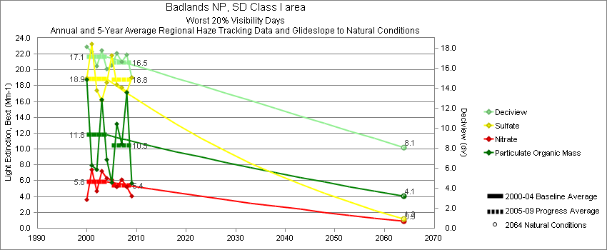
Badlands - Worst 20% Visibility Days – 5-Year Average, Natural Conditions and Annual Data
Parameter | 2000-2004 | 2005-2009 | 2064 NC | 2000 | 2001 | 2002 | 2003 | 2004 | 2005 | 2006 | 2007 | 2008 | 2009
Deciview (dv) | 17.1 | 16.6 | 8.1 | 18.1 | 17.6 | 16.2 | 17.8 | 15.9 | 16.3 | 17.5 | 16.6 | 17.3 | 15.1
Sulfate Bext | 18.9 | 18.8 | 1.2 | 19.0 | 23.3 | 17.4 | 16.2 | 18.4 | 21.8 | 18.2 | 17.8 | 17.2 | 19.1
Nitrate Bext | 5.8 | 5.4 | 0.9 | 3.6 | 7.4 | 4.7 | 7.2 | 6.3 | 6.1 | 5.3 | 6.2 | 5.3 | 4.0
POM Bext | 11.8 | 10.5 | 4.1 | 18.7 | 7.9 | 7.4 | 16.2 | 8.6 | 5.8 | 13.2 | 10.6 | 17.2 | 5.7
EC Bext | 2.6 | 1.9 | 0.3 | 4.0 | 2.6 | 1.9 | 2.9 | 1.6 | 2.1 | 2.7 | 2.0 | 1.6 | 1.2
Soil Bext | 1.0 | 1.0 | 1.0 | 1.0 | 1.3 | 1.1 | 0.7 | 0.7 | 0.8 | 1.2 | 0.9 | 1.2 | 0.7
Coarse Mass Bext | 5.9 | 5.1 | 4.0 | 6.1 | 5.9 | 7.3 | 7.0 | 3.5 | 3.9 | 6.8 | 4.7 | 6.3 | 4.0
Sea Salt Bext | 0.2 | 0.5 | 0.2 | 0.0 | 0.0 | 0.5 | 0.3 | 0.1 | 0.1 | 0.1 | 0.2 | 2.2 | 0.2

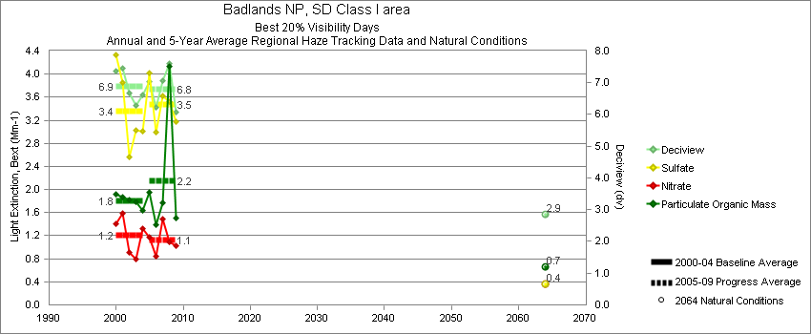
Badlands - Best 20% Visibility Days – 5-Year Average, Natural Conditions and Annual Data
Parameter | 2000-2004 | 2005-2009 | 2064 NC | 2000 | 2001 | 2002 | 2003 | 2004 | 2005 | 2006 | 2007 | 2008 | 2009
Deciview (dv) | 6.9 | 6.8 | 2.9 | 7.4 | 7.5 | 6.7 | 6.3 | 6.6 | 7.0 | 6.2 | 7.1 | 7.6 | 6.1
Sulfate Bext | 3.4 | 3.5 | 0.4 | 4.3 | 3.9 | 2.6 | 3.0 | 3.0 | 4.0 | 3.0 | 3.6 | 3.5 | 3.2
Nitrate Bext | 1.2 | 1.1 | 0.4 | 1.4 | 1.6 | 0.9 | 0.8 | 1.3 | 1.2 | 0.8 | 1.5 | 1.1 | 1.0
POM Bext | 1.8 | 2.2 | 0.7 | 1.9 | 1.9 | 1.8 | 1.8 | 1.6 | 2.0 | 1.4 | 1.8 | 4.1 | 1.5
EC Bext | 0.8 | 0.6 | 0.1 | 0.8 | 0.9 | 0.9 | 0.6 | 0.7 | 0.8 | 0.6 | 0.6 | 0.3 | 0.5
Soil Bext | 0.3 | 0.3 | 0.2 | 0.3 | 0.4 | 0.4 | 0.2 | 0.3 | 0.3 | 0.4 | 0.4 | 0.3 | 0.3
Coarse Mass Bext | 1.5 | 1.2 | 0.6 | 1.3 | 1.6 | 1.9 | 1.3 | 1.4 | 1.1 | 1.4 | 1.5 | 1.1 | 1.0
Sea Salt Bext | 0.0 | 0.0 | 0.0 | 0.1 | 0.0 | 0.0 | 0.0 | 0.1 | 0.0 | 0.0 | 0.0 | 0.0 | 0.0
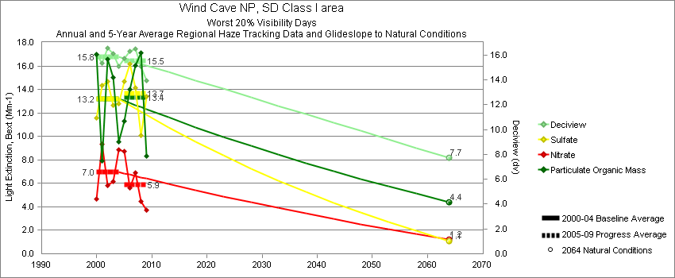
Wind Cave - Worst 20% Visibility Days – 5-Year Average, Natural Conditions and Annual Data
Parameter | 2000-2004 | 2005-2009 | 2064 NC | 2000 | 2001 | 2002 | 2003 | 2004 | 2005 | 2006 | 2007 | 2008 | 2009
Deciview (dv) | 15.8 | 15.5 | 7.7 | 16.1 | 15.3 | 16.6 | 16.1 | 15.1 | 15.7 | 16.3 | 16.5 | 15.1 | 13.9
Sulfate Bext | 13.2 | 13.7 | 1.1 | 11.6 | 14.3 | 14.7 | 12.7 | 12.8 | 14.6 | 16.2 | 14.2 | 10.1 | 13.4
Nitrate Bext | 7.0 | 5.9 | 1.2 | 4.7 | 9.3 | 5.9 | 6.2 | 8.9 | 8.7 | 5.6 | 6.9 | 4.5 | 3.7
POM Bext | 13.2 | 13.4 | 4.4 | 17.0 | 7.9 | 16.6 | 15.1 | 9.5 | 11.2 | 14.0 | 16.1 | 17.1 | 8.4
EC Bext | 2.9 | 2.6 | 0.4 | 3.7 | 2.2 | 3.1 | 2.4 | 3.2 | 2.8 | 3.3 | 2.8 | 2.5 | 1.6
Soil Bext | 0.9 | 1.0 | 1.0 | 1.0 | 0.8 | 1.0 | 0.7 | 0.8 | 0.8 | 1.0 | 1.0 | 1.0 | 1.2
Coarse Mass Bext | 3.5 | 3.8 | 3.8 | 3.9 | 3.5 | 4.1 | 4.0 | 2.1 | 3.1 | 4.3 | 3.6 | 4.4 | 3.4
Sea Salt Bext | 0.0 | 0.3 | 0.0 | 0.0 | 0.0 | 0.0 | 0.0 | 0.1 | 0.1 | 0.1 | 0.0 | 1.0 | 0.2

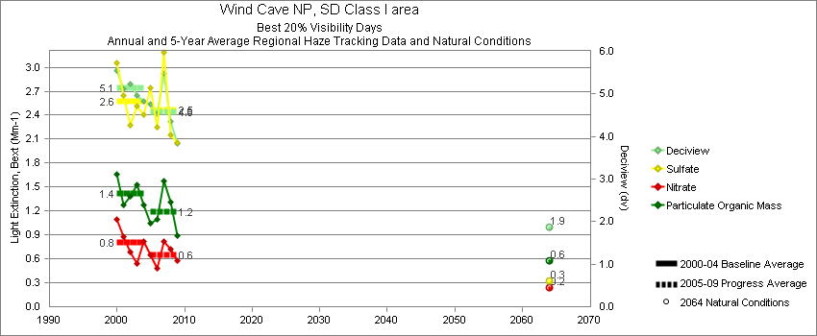
Wind Cave - Best 20% Visibility Days – 5-Year Average, Natural Conditions and Annual Data
Parameter | 2000-2004 | 2005-2009 | 2064 NC | 2000 | 2001 | 2002 | 2003 | 2004 | 2005 | 2006 | 2007 | 2008 | 2009
Deciview (dv) | 5.1 | 4.6 | 1.9 | 5.6 | 5.1 | 5.2 | 5.0 | 4.8 | 4.7 | 4.5 | 5.5 | 4.3 | 3.8
Sulfate Bext | 2.6 | 2.5 | 0.3 | 3.1 | 2.6 | 2.3 | 2.5 | 2.4 | 2.7 | 2.3 | 3.2 | 2.1 | 2.1
Nitrate Bext | 0.8 | 0.6 | 0.2 | 1.1 | 0.9 | 0.7 | 0.5 | 0.8 | 0.7 | 0.5 | 0.8 | 0.7 | 0.6
POM Bext | 1.4 | 1.2 | 0.6 | 1.7 | 1.3 | 1.4 | 1.5 | 1.3 | 1.1 | 1.1 | 1.6 | 1.3 | 0.9
EC Bext | 0.7 | 0.5 | 0.1 | 0.9 | 0.6 | 0.7 | 0.6 | 0.7 | 0.7 | 0.6 | 0.6 | 0.4 | 0.4
Soil Bext | 0.2 | 0.2 | 0.2 | 0.2 | 0.3 | 0.3 | 0.2 | 0.2 | 0.2 | 0.2 | 0.2 | 0.2 | 0.2
Coarse Mass Bext | 1.1 | 0.8 | 0.6 | 0.7 | 1.0 | 1.5 | 1.1 | 0.9 | 0.8 | 1.1 | 0.9 | 0.8 | 0.6
Sea Salt Bext | 0.0 | 0.0 | 0.0 | 0.0 | 0.0 | 0.0 | 0.0 | 0.0 | 0.0 | 0.0 | 0.0 | 0.0 | 0.0

Great Smoky Mountains - Worst 20% Visibility Days – 5-Year Average, Natural Conditions and Annual Data
Parameter | 2000-2004 | 2005-2009 | 2064 NC | 2000 | 2001 | 2002 | 2003 | 2004 | 2005 | 2006 | 2007 | 2008 | 2009
Deciview (dv) | 30.3 | 28.5 | 11.2 | 30.7 | 30.6 | 29.9 | 30.5 | 29.6 | 31.6 | 30.5 | 30.6 | 26.7 | 23.2
Sulfate Bext | 172.7 | 144.7 | 3.5 | 167.8 | 179.9 | 168.3 | 187.3 | 160.3 | 205.1 | 174.2 | 166.3 | 109.6 | 68.6
Nitrate Bext | 3.4 | 3.3 | 1.0 | 3.5 | 3.0 | 2.7 | 3.2 | 4.6 | 1.8 | 5.0 | 2.7 | 1.7 | 5.4
POM Bext | 20.6 | 18.0 | 11.4 | 35.1 | 18.9 | 18.8 | 15.7 | 14.6 | 14.5 | 16.3 | 28.3 | 18.1 | 12.6
EC Bext | 5.7 | 5.1 | 0.3 | 8.1 | 5.0 | 4.8 | 5.8 | 4.7 | 6.1 | 5.6 | 5.9 | 4.2 | 3.9
Soil Bext | 0.8 | 0.8 | 0.9 | 0.6 | 0.8 | 1.0 | 0.7 | 1.0 | 0.6 | 0.9 | 0.9 | 0.9 | 0.6
Coarse Mass Bext | 1.9 | 3.7 | 2.9 | 2.6 | 2.4 | 2.0 | 1.5 | 1.2 | 4.9 | 4.6 | 4.2 | 2.6 | 2.1
Sea Salt Bext | 0.2 | 0.3 | 0.4 | 0.0 | 0.5 | 0.0 | 0.0 | 0.3 | 0.1 | 0.3 | 0.3 | 0.2 | 0.3

Great Smoky Mountains - Best 20% Visibility Days – 5-Year Average, Natural Conditions and Annual Data
Parameter | 2000-2004 | 2005-2009 | 2064 NC | 2000 | 2001 | 2002 | 2003 | 2004 | 2005 | 2006 | 2007 | 2008 | 2009
Deciview (dv) | 13.6 | 12.4 | 4.6 | 14.8 | 13.4 | 13.9 | 12.0 | 13.7 | 14.3 | 12.7 | 13.2 | 11.6 | 10.1
Sulfate Bext | 16.4 | 14.3 | 0.8 | 18.7 | 15.7 | 18.7 | 12.8 | 16.2 | 17.7 | 16.2 | 15.4 | 12.4 | 9.6
Nitrate Bext | 3.9 | 3.2 | 0.6 | 4.5 | 3.5 | 4.0 | 3.6 | 4.1 | 5.0 | 2.6 | 4.6 | 2.5 | 1.6
POM Bext | 4.9 | 3.7 | 2.3 | 6.3 | 4.8 | 4.3 | 4.4 | 4.7 | 4.6 | 3.6 | 3.8 | 3.6 | 3.0
EC Bext | 2.2 | 1.8 | 0.1 | 3.0 | 2.0 | 2.0 | 2.0 | 2.1 | 2.3 | 2.0 | 1.8 | 1.6 | 1.2
Soil Bext | 0.2 | 0.2 | 0.2 | 0.2 | 0.2 | 0.2 | 0.2 | 0.2 | 0.2 | 0.2 | 0.2 | 0.3 | 0.2
Coarse Mass Bext | 1.3 | 1.4 | 0.9 | 1.5 | 1.5 | 1.1 | 1.0 | 1.5 | 1.7 | 1.2 | 1.1 | 1.4 | 1.5
Sea Salt Bext | 0.2 | 0.2 | 0.1 | 0.1 | 0.3 | 0.2 | 0.0 | 0.4 | 0.2 | 0.2 | 0.3 | 0.2 | 0.1

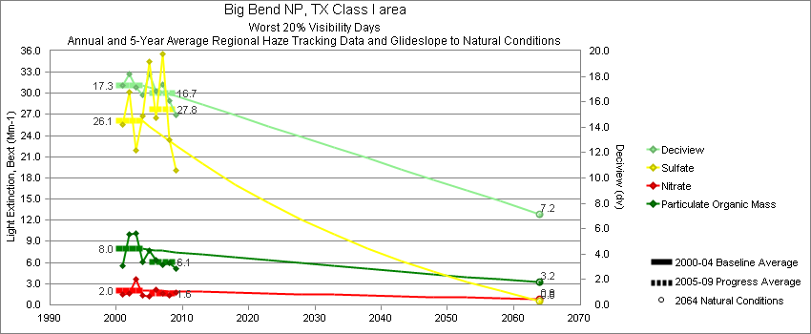
Big Bend - Worst 20% Visibility Days – 5-Year Average, Natural Conditions and Annual Data
Parameter | 2000-2004 | 2005-2009 | 2064 NC | 2000 | 2001 | 2002 | 2003 | 2004 | 2005 | 2006 | 2007 | 2008 | 2009
Deciview (dv) | 17.3 | 16.7 | 7.2 |  | 17.3 | 18.2 | 17.2 | 16.5 | 18.2 | 16.9 | 17.4 | 16.1 | 15.0
Sulfate Bext | 26.1 | 27.8 | 0.6 |  | 25.5 | 30.2 | 21.9 | 26.8 | 34.4 | 26.5 | 35.6 | 23.4 | 19.1
Nitrate Bext | 2.0 | 1.6 | 0.8 |  | 1.6 | 1.6 | 3.6 | 1.4 | 1.3 | 2.2 | 1.6 | 1.4 | 1.8
POM Bext | 8.0 | 6.1 | 3.2 |  | 5.6 | 10.1 | 10.2 | 6.1 | 7.6 | 6.3 | 5.7 | 5.9 | 5.1
EC Bext | 2.1 | 2.2 | 0.3 |  | 2.1 | 2.3 | 2.3 | 1.8 | 2.9 | 2.6 | 2.1 | 1.7 | 1.5
Soil Bext | 2.5 | 1.8 | 1.2 |  | 2.8 | 2.7 | 2.5 | 2.2 | 2.0 | 1.2 | 1.5 | 2.3 | 2.1
Coarse Mass Bext | 7.0 | 5.3 | 4.2 |  | 9.5 | 7.7 | 6.5 | 4.4 | 4.9 | 5.7 | 3.9 | 6.3 | 5.5
Sea Salt Bext | 0.1 | 0.1 | 0.4 |  | 0.2 | 0.0 | 0.0 | 0.2 | 0.1 | 0.1 | 0.1 | 0.1 | 0.0

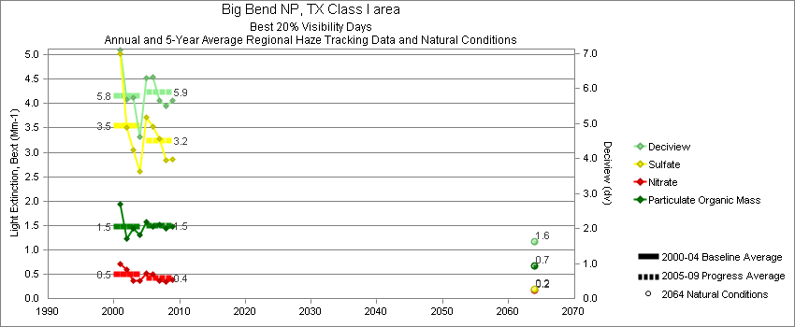
Big Bend - Best 20% Visibility Days – 5-Year Average, Natural Conditions and Annual Data
Parameter | 2000-2004 | 2005-2009 | 2064 NC | 2000 | 2001 | 2002 | 2003 | 2004 | 2005 | 2006 | 2007 | 2008 | 2009
Deciview (dv) | 5.8 | 5.9 | 1.6 |  | 7.1 | 5.7 | 5.7 | 4.6 | 6.3 | 6.3 | 5.7 | 5.5 | 5.7
Sulfate Bext | 3.5 | 3.2 | 0.2 |  | 5.0 | 3.5 | 3.0 | 2.6 | 3.7 | 3.5 | 3.3 | 2.8 | 2.8
Nitrate Bext | 0.5 | 0.4 | 0.2 |  | 0.7 | 0.6 | 0.4 | 0.4 | 0.5 | 0.5 | 0.4 | 0.3 | 0.4
POM Bext | 1.5 | 1.5 | 0.7 |  | 1.9 | 1.2 | 1.4 | 1.3 | 1.6 | 1.5 | 1.5 | 1.4 | 1.5
EC Bext | 0.7 | 0.6 | 0.1 |  | 0.9 | 0.6 | 0.6 | 0.5 | 0.7 | 0.8 | 0.7 | 0.5 | 0.5
Soil Bext | 0.4 | 0.5 | 0.1 |  | 0.4 | 0.5 | 0.5 | 0.2 | 0.5 | 0.5 | 0.3 | 0.4 | 0.6
Coarse Mass Bext | 1.4 | 1.9 | 0.5 |  | 1.6 | 1.4 | 1.6 | 0.9 | 1.9 | 2.1 | 1.5 | 2.0 | 1.9
Sea Salt Bext | 0.1 | 0.0 | 0.0 |  | 0.0 | 0.0 | 0.4 | 0.1 | 0.1 | 0.0 | 0.1 | 0.0 | 0.0

Guadalupe Mountains - Worst 20% Visibility Days – 5-Year Average, Natural Conditions and Annual Data
Parameter | 2000-2004 | 2005-2009 | 2064 NC | 2000 | 2001 | 2002 | 2003 | 2004 | 2005 | 2006 | 2007 | 2008 | 2009
Deciview (dv) | 17.2 | 15.9 | 6.7 | 17.1 | 16.6 | 18.1 | 18.5 | 15.6 | 17.5 | 15.3 | 15.7 | 16.8 | 14.1
Sulfate Bext | 16.5 | 18.6 | 0.8 | 16.6 | 18.6 | 20.5 | 12.4 | 14.4 | 26.0 | 16.6 | 21.5 | 14.5 | 14.4
Nitrate Bext | 3.8 | 2.9 | 0.9 | 5.4 | 3.2 | 2.8 | 2.6 | 5.1 | 3.8 | 2.7 | 3.7 | 2.6 | 1.5
POM Bext | 6.7 | 5.9 | 3.1 | 7.4 | 5.0 | 7.8 | 7.4 | 6.2 | 7.4 | 5.9 | 5.8 | 5.6 | 4.9
EC Bext | 1.3 | 1.5 | 0.2 | 2.0 | 1.0 | 1.3 | 1.0 | 1.3 | 2.2 | 1.6 | 1.5 | 1.0 | 1.2
Soil Bext | 4.4 | 2.7 | 1.3 | 2.4 | 4.1 | 5.1 | 7.5 | 2.9 | 2.1 | 2.0 | 2.0 | 4.8 | 2.7
Coarse Mass Bext | 16.0 | 9.9 | 4.4 | 13.2 | 12.7 | 16.0 | 28.1 | 10.1 | 8.3 | 8.6 | 6.0 | 18.8 | 7.7
Sea Salt Bext | 0.1 | 0.1 | 0.1 | 0.1 | 0.0 | 0.1 | 0.2 | 0.2 | 0.2 | 0.1 | 0.1 | 0.1 | 0.1

Guadalupe Mountains - Best 20% Visibility Days – 5-Year Average, Natural Conditions and Annual Data
Parameter | 2000-2004 | 2005-2009 | 2064 NC | 2000 | 2001 | 2002 | 2003 | 2004 | 2005 | 2006 | 2007 | 2008 | 2009
Deciview (dv) | 5.9 | 5.4 | 1.0 | 6.3 | 6.3 | 6.4 | 5.9 | 4.8 | 6.1 | 5.9 | 5.3 | 5.4 | 4.6
Sulfate Bext | 3.4 | 3.1 | 0.3 | 3.9 | 3.9 | 3.6 | 2.9 | 2.9 | 3.7 | 3.3 | 3.0 | 3.1 | 2.6
Nitrate Bext | 1.1 | 0.9 | 0.3 | 0.9 | 1.3 | 1.5 | 1.1 | 1.0 | 1.0 | 0.7 | 1.1 | 0.8 | 0.9
POM Bext | 1.6 | 1.5 | 0.7 | 1.9 | 1.6 | 1.9 | 1.5 | 1.1 | 1.8 | 1.9 | 1.5 | 1.5 | 1.0
EC Bext | 0.7 | 0.7 | 0.1 | 0.9 | 0.7 | 0.7 | 0.6 | 0.6 | 0.9 | 0.9 | 0.7 | 0.6 | 0.4
Soil Bext | 0.4 | 0.5 | 0.1 | 0.5 | 0.5 | 0.4 | 0.4 | 0.3 | 0.4 | 0.4 | 0.4 | 0.5 | 0.6
Coarse Mass Bext | 2.0 | 1.7 | 0.5 | 1.6 | 2.0 | 2.3 | 2.7 | 1.5 | 1.9 | 2.0 | 1.4 | 1.9 | 1.5
Sea Salt Bext | 0.1 | 0.0 | 0.0 | 0.1 | 0.0 | 0.0 | 0.1 | 0.0 | 0.0 | 0.0 | 0.0 | 0.0 | 0.1

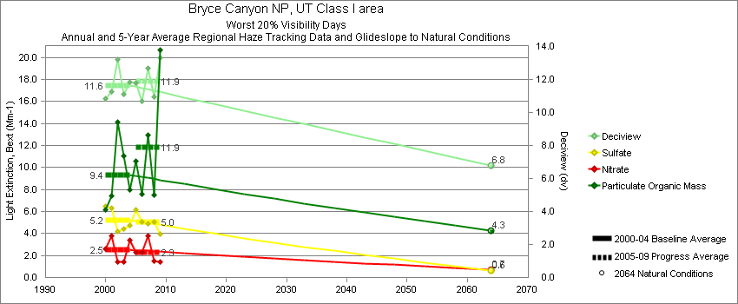
Bryce Canyon - Worst 20% Visibility Days – 5-Year Average, Natural Conditions and Annual Data
Parameter | 2000-2004 | 2005-2009 | 2064 NC | 2000 | 2001 | 2002 | 2003 | 2004 | 2005 | 2006 | 2007 | 2008 | 2009
Deciview (dv) | 11.6 | 11.9 | 6.8 | 10.8 | 11.3 | 13.2 | 11.1 | 11.8 | 11.8 | 10.7 | 12.7 | 11.0 | 13.3
Sulfate Bext | 5.2 | 5.0 | 0.6 | 6.5 | 6.3 | 4.2 | 4.4 | 4.8 | 6.2 | 5.1 | 4.9 | 5.0 | 4.0
Nitrate Bext | 2.5 | 2.2 | 0.7 | 2.6 | 3.8 | 1.4 | 1.4 | 3.4 | 2.3 | 2.3 | 3.8 | 1.5 | 1.4
POM Bext | 9.4 | 11.8 | 4.3 | 6.1 | 7.5 | 14.1 | 11.1 | 8.0 | 10.5 | 7.5 | 13.0 | 7.5 | 20.7
EC Bext | 2.4 | 2.5 | 0.4 | 2.1 | 1.9 | 2.3 | 2.4 | 3.2 | 2.6 | 2.1 | 3.0 | 1.5 | 3.5
Soil Bext | 1.2 | 1.3 | 1.2 | 1.0 | 1.4 | 1.5 | 1.1 | 1.2 | 0.8 | 0.8 | 1.2 | 2.4 | 1.3
Coarse Mass Bext | 4.0 | 3.1 | 4.1 | 2.6 | 3.1 | 6.1 | 4.3 | 3.9 | 2.5 | 2.6 | 2.9 | 3.7 | 3.7
Sea Salt Bext | 0.1 | 0.1 | 0.1 | 0.0 | 0.0 | 0.3 | 0.0 | 0.1 | 0.0 | 0.0 | 0.1 | 0.2 | 0.1

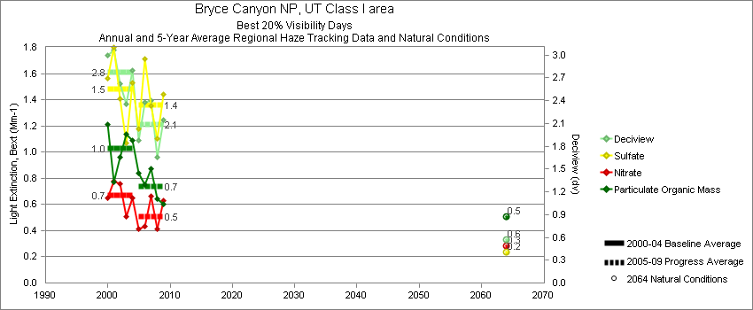
Bryce Canyon - Best 20% Visibility Days – 5-Year Average, Natural Conditions and Annual Data
Parameter | 2000-2004 | 2005-2009 | 2064 NC | 2000 | 2001 | 2002 | 2003 | 2004 | 2005 | 2006 | 2007 | 2008 | 2009
Deciview (dv) | 2.8 | 2.1 | 0.6 | 3.0 | 3.1 | 2.6 | 2.4 | 2.8 | 1.9 | 2.4 | 2.4 | 1.7 | 2.1
Sulfate Bext | 1.5 | 1.4 | 0.2 | 1.6 | 1.8 | 1.4 | 1.1 | 1.5 | 1.2 | 1.7 | 1.3 | 1.1 | 1.4
Nitrate Bext | 0.7 | 0.5 | 0.3 | 0.7 | 0.8 | 0.8 | 0.5 | 0.7 | 0.4 | 0.4 | 0.7 | 0.4 | 0.6
POM Bext | 1.0 | 0.7 | 0.5 | 1.2 | 0.8 | 1.0 | 1.1 | 1.1 | 0.8 | 0.7 | 0.9 | 0.6 | 0.6
EC Bext | 0.4 | 0.2 | 0.1 | 0.4 | 0.4 | 0.4 | 0.3 | 0.5 | 0.3 | 0.3 | 0.2 | 0.2 | 0.2
Soil Bext | 0.1 | 0.1 | 0.1 | 0.2 | 0.2 | 0.1 | 0.1 | 0.2 | 0.1 | 0.1 | 0.2 | 0.1 | 0.2
Coarse Mass Bext | 0.5 | 0.4 | 0.4 | 0.5 | 0.7 | 0.4 | 0.5 | 0.3 | 0.3 | 0.4 | 0.4 | 0.4 | 0.4
Sea Salt Bext | 0.0 | 0.0 | 0.0 | 0.0 | 0.0 | 0.0 | 0.0 | 0.0 | 0.0 | 0.0 | 0.1 | 0.1 | 0.0
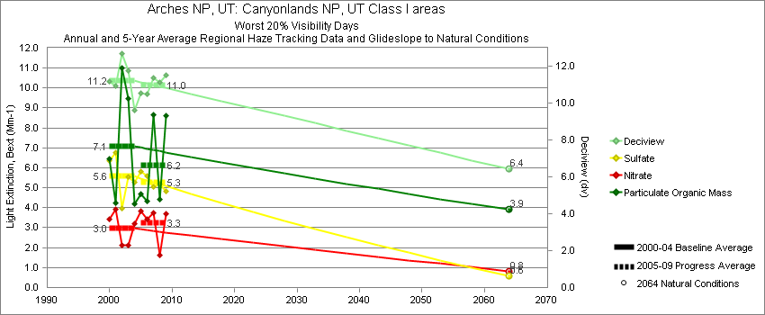
Canyonlands - Worst 20% Visibility Days – 5-Year Average, Natural Conditions and Annual Data
Parameter | 2000-2004 | 2005-2009 | 2064 NC | 2000 | 2001 | 2002 | 2003 | 2004 | 2005 | 2006 | 2007 | 2008 | 2009
Deciview (dv) | 11.2 | 11.0 | 6.4 | 11.2 | 10.9 | 12.7 | 11.8 | 9.6 | 10.6 | 10.5 | 11.4 | 11.1 | 11.5
Sulfate Bext | 5.6 | 5.3 | 0.6 | 6.3 | 6.8 | 4.0 | 5.5 | 5.3 | 5.8 | 5.6 | 5.0 | 5.2 | 4.8
Nitrate Bext | 3.0 | 3.3 | 0.8 | 3.4 | 3.9 | 2.1 | 2.1 | 3.2 | 3.9 | 3.4 | 3.7 | 1.6 | 3.7
POM Bext | 7.1 | 6.2 | 3.9 | 6.4 | 4.2 | 11.0 | 9.5 | 4.2 | 4.7 | 4.3 | 8.7 | 4.4 | 8.6
EC Bext | 1.7 | 1.6 | 0.3 | 2.1 | 1.4 | 2.0 | 1.9 | 1.3 | 1.8 | 1.7 | 2.1 | 0.9 | 1.7
Soil Bext | 1.5 | 1.5 | 1.0 | 0.8 | 1.8 | 2.8 | 1.0 | 0.9 | 0.9 | 1.4 | 0.9 | 2.6 | 1.8
Coarse Mass Bext | 3.8 | 4.6 | 3.6 | 3.4 | 3.1 | 6.0 | 4.1 | 2.4 | 3.0 | 3.5 | 3.3 | 7.8 | 5.4
Sea Salt Bext | 0.1 | 0.1 | 0.1 | 0.0 | 0.1 | 0.0 | 0.0 | 0.1 | 0.1 | 0.1 | 0.1 | 0.2 | 0.1

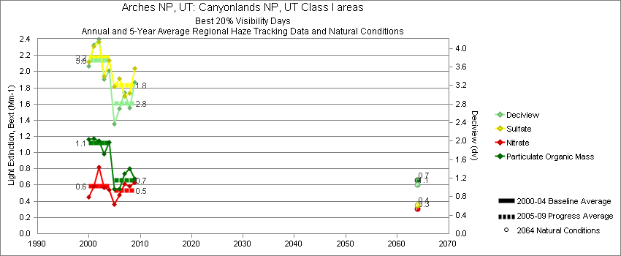
Canyonlands - Best 20% Visibility Days – 5-Year Average, Natural Conditions and Annual Data
Parameter | 2000-2004 | 2005-2009 | 2064 NC | 2000 | 2001 | 2002 | 2003 | 2004 | 2005 | 2006 | 2007 | 2008 | 2009
Deciview (dv) | 3.7 | 2.8 | 1.0 | 3.6 | 4.1 | 4.2 | 3.3 | 3.5 | 2.3 | 2.7 | 3.0 | 2.7 | 3.3
Sulfate Bext | 2.2 | 1.8 | 0.4 | 2.1 | 2.3 | 2.4 | 1.9 | 2.1 | 1.8 | 1.9 | 1.7 | 1.7 | 2.0
Nitrate Bext | 0.6 | 0.5 | 0.3 | 0.4 | 0.6 | 0.8 | 0.6 | 0.5 | 0.4 | 0.5 | 0.6 | 0.6 | 0.6
POM Bext | 1.1 | 0.7 | 0.7 | 1.2 | 1.2 | 1.2 | 1.0 | 1.1 | 0.5 | 0.5 | 0.7 | 0.8 | 0.7
EC Bext | 0.4 | 0.3 | 0.1 | 0.4 | 0.5 | 0.5 | 0.4 | 0.4 | 0.2 | 0.4 | 0.3 | 0.3 | 0.3
Soil Bext | 0.3 | 0.2 | 0.1 | 0.2 | 0.4 | 0.4 | 0.2 | 0.3 | 0.1 | 0.2 | 0.3 | 0.2 | 0.3
Coarse Mass Bext | 1.0 | 0.7 | 0.5 | 1.0 | 1.1 | 1.1 | 0.9 | 0.7 | 0.6 | 0.6 | 0.9 | 0.6 | 0.9
Sea Salt Bext | 0.0 | 0.0 | 0.0 | 0.0 | 0.0 | 0.0 | 0.0 | 0.0 | 0.0 | 0.0 | 0.1 | 0.0 | 0.0

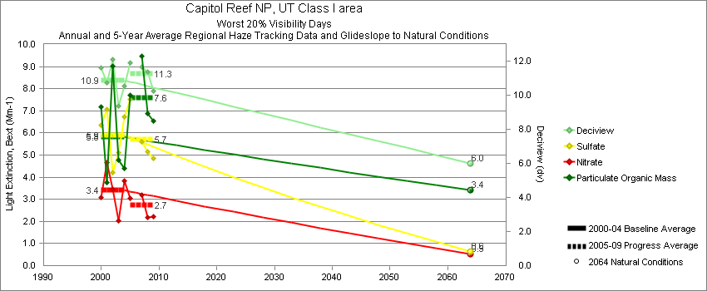
Capitol Reef - Worst 20% Visibility Days – 5-Year Average, Natural Conditions and Annual Data
Parameter | 2000-2004 | 2005-2009 | 2064 NC | 2000 | 2001 | 2002 | 2003 | 2004 | 2005 | 2006 | 2007 | 2008 | 2009
Deciview (dv) | 10.9 | 11.3 | 6.0 | 11.6 | 10.8 | 12.1 | 9.4 | 10.6 | 11.8 |  | 11.7 | 11.4 | 10.3
Sulfate Bext | 5.9 | 5.7 | 0.6 | 6.3 | 7.1 | 4.2 | 5.1 | 6.7 | 7.3 |  | 5.6 | 5.1 | 4.8
Nitrate Bext | 3.4 | 2.7 | 0.5 | 3.1 | 4.7 | 3.5 | 2.0 | 3.8 | 3.3 |  | 3.2 | 2.2 | 2.2
POM Bext | 5.8 | 7.6 | 3.4 | 7.2 | 3.8 | 9.0 | 4.8 | 4.4 | 7.4 |  | 9.5 | 6.9 | 6.6
EC Bext | 1.6 | 1.8 | 0.3 | 2.0 | 1.4 | 2.0 | 1.3 | 1.4 | 2.5 |  | 2.2 | 1.3 | 1.1
Soil Bext | 1.3 | 1.6 | 1.1 | 1.0 | 1.4 | 1.5 | 0.8 | 1.5 | 0.8 |  | 1.3 | 2.4 | 1.9
Coarse Mass Bext | 3.4 | 4.1 | 3.6 | 4.6 | 2.5 | 4.9 | 2.7 | 2.1 | 3.0 |  | 3.8 | 5.1 | 4.3
Sea Salt Bext | 0.0 | 0.1 | 0.0 | 0.0 | 0.0 | 0.0 | 0.0 | 0.0 | 0.0 |  | 0.1 | 0.2 | 0.1

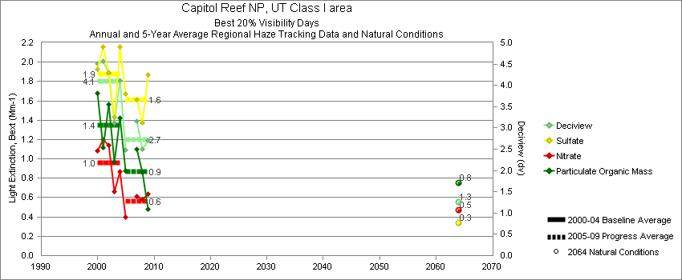
Capitol Reef - Best 20% Visibility Days – 5-Year Average, Natural Conditions and Annual Data
Parameter | 2000-2004 | 2005-2009 | 2064 NC | 2000 | 2001 | 2002 | 2003 | 2004 | 2005 | 2006 | 2007 | 2008 | 2009
Deciview (dv) | 4.1 | 2.7 | 1.3 | 4.5 | 4.5 | 4.2 | 3.1 | 4.1 | 2.6 |  | 3.1 | 2.5 | 2.7
Sulfate Bext | 1.9 | 1.6 | 0.3 | 1.8 | 2.1 | 1.8 | 1.4 | 2.2 | 1.6 |  | 1.6 | 1.4 | 1.9
Nitrate Bext | 1.0 | 0.6 | 0.5 | 1.1 | 1.1 | 1.1 | 0.7 | 0.9 | 0.4 |  | 0.6 | 0.6 | 0.6
POM Bext | 1.4 | 0.9 | 0.7 | 1.7 | 1.1 | 1.6 | 1.0 | 1.4 | 1.0 |  | 1.1 | 0.9 | 0.5
EC Bext | 0.6 | 0.3 | 0.1 | 0.6 | 0.6 | 0.8 | 0.5 | 0.5 | 0.4 |  | 0.4 | 0.3 | 0.2
Soil Bext | 0.3 | 0.2 | 0.2 | 0.2 | 0.4 | 0.2 | 0.4 | 0.4 | 0.1 |  | 0.3 | 0.1 | 0.3
Coarse Mass Bext | 1.0 | 0.6 | 0.5 | 1.2 | 1.4 | 0.8 | 0.7 | 0.7 | 0.4 |  | 0.7 | 0.6 | 0.7
Sea Salt Bext | 0.1 | 0.0 | 0.0 | 0.0 | 0.1 | 0.0 | 0.1 | 0.1 | 0.0 |  | 0.1 | 0.1 | 0.0

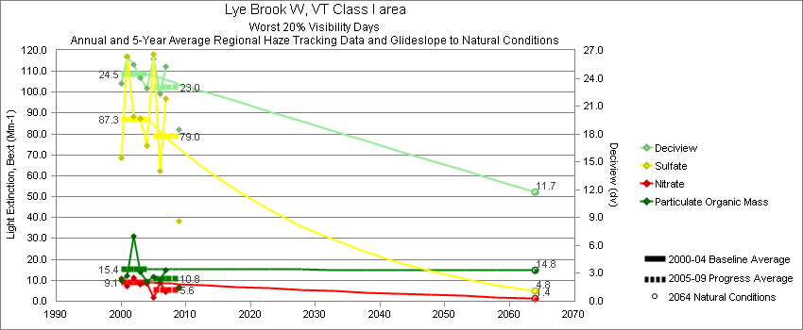
Lye Brook - Worst 20% Visibility Days – 5-Year Average, Natural Conditions and Annual Data
Parameter | 2000-2004 | 2005-2009 | 2064 NC | 2000 | 2001 | 2002 | 2003 | 2004 | 2005 | 2006 | 2007 | 2008 | 2009
Deciview (dv) | 24.4 | 23.0 | 11.7 | 23.5 | 26.3 | 25.5 | 24.0 | 22.9 | 26.0 | 22.3 | 25.3 |  | 18.4
Sulfate Bext | 87.3 | 79.0 | 4.8 | 68.7 | 117.4 | 88.2 | 87.7 | 74.4 | 117.9 | 62.4 | 97.1 |  | 38.4
Nitrate Bext | 9.1 | 5.6 | 1.4 | 10.7 | 7.1 | 11.3 | 7.9 | 8.4 | 2.0 | 8.9 | 4.5 |  | 6.9
POM Bext | 15.3 | 10.8 | 14.8 | 10.0 | 12.1 | 31.2 | 14.0 | 9.4 | 11.8 | 10.2 | 14.7 |  | 6.5
EC Bext | 4.8 | 4.0 | 0.4 | 5.2 | 4.7 | 5.7 | 4.8 | 3.4 | 4.4 | 4.2 | 4.9 |  | 2.5
Soil Bext | 0.6 | 0.5 | 0.7 | 0.4 | 0.8 | 0.8 | 0.5 | 0.7 | 0.4 | 0.4 | 0.7 |  | 0.5
Coarse Mass Bext | 1.8 | 2.5 | 2.0 | 1.6 | 2.1 | 1.4 | 2.2 | 1.7 | 2.1 | 2.3 | 3.1 |  | 2.2
Sea Salt Bext | 0.1 | 0.3 | 0.1 | 0.0 | 0.0 | 0.1 | 0.2 | 0.2 | 0.2 | 0.2 | 0.2 |  | 0.5

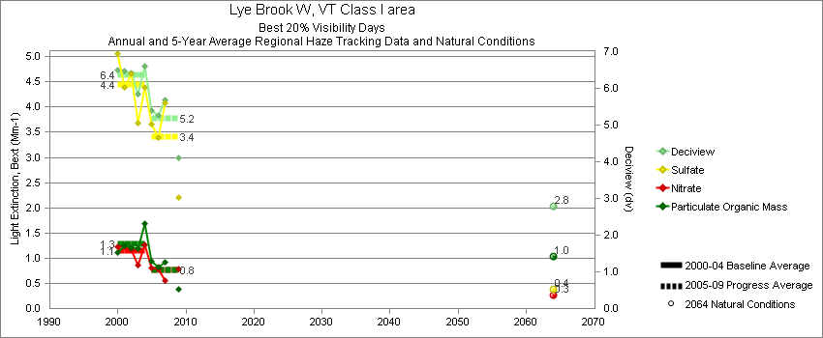
Lye Brook - Best 20% Visibility Days – 5-Year Average, Natural Conditions and Annual Data
Parameter | 2000-2004 | 2005-2009 | 2064 NC | 2000 | 2001 | 2002 | 2003 | 2004 | 2005 | 2006 | 2007 | 2008 | 2009
Deciview (dv) | 6.4 | 5.2 | 2.8 | 6.5 | 6.5 | 6.4 | 5.8 | 6.6 | 5.7 | 5.2 | 5.7 |  | 4.1
Sulfate Bext | 4.4 | 3.4 | 0.4 | 5.1 | 4.4 | 4.7 | 3.7 | 4.4 | 4.0 | 3.4 | 4.1 |  | 2.2
Nitrate Bext | 1.2 | 0.8 | 0.3 | 1.2 | 1.2 | 1.2 | 0.9 | 1.3 | 0.9 | 0.8 | 0.6 |  | 0.8
POM Bext | 1.3 | 0.8 | 1.0 | 1.1 | 1.2 | 1.2 | 1.2 | 1.7 | 1.0 | 0.8 | 0.9 |  | 0.4
EC Bext | 0.6 | 0.4 | 0.1 | 0.6 | 0.7 | 0.6 | 0.6 | 0.6 | 0.5 | 0.5 | 0.5 |  | 0.3
Soil Bext | 0.1 | 0.1 | 0.1 | 0.1 | 0.2 | 0.1 | 0.1 | 0.1 | 0.0 | 0.1 | 0.1 |  | 0.1
Coarse Mass Bext | 0.5 | 0.5 | 0.4 | 0.4 | 0.6 | 0.5 | 0.6 | 0.5 | 0.6 | 0.6 | 0.5 |  | 0.4
Sea Salt Bext | 0.0 | 0.1 | 0.0 | 0.0 | 0.0 | 0.1 | 0.1 | 0.1 | 0.0 | 0.1 | 0.1 |  | 0.1

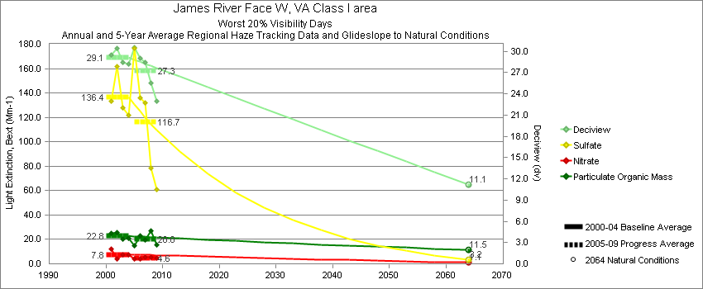
James River Face - Worst 20% Visibility Days – 5-Year Average, Natural Conditions and Annual Data
Parameter | 2000-2004 | 2005-2009 | 2064 NC | 2000 | 2001 | 2002 | 2003 | 2004 | 2005 | 2006 | 2007 | 2008 | 2009
Deciview (dv) | 29.1 | 27.3 | 11.1 |  | 29.5 | 30.4 | 28.4 | 28.2 | 30.5 | 29.0 | 28.5 | 25.5 | 22.9
Sulfate Bext | 136.4 | 116.7 | 3.2 |  | 133.4 | 161.8 | 128.1 | 122.1 | 176.1 | 135.8 | 132.0 | 78.6 | 60.8
Nitrate Bext | 7.8 | 4.6 | 1.1 |  | 12.2 | 4.3 | 7.4 | 7.2 | 3.8 | 4.3 | 5.1 | 5.2 | 4.6
POM Bext | 22.8 | 20.0 | 11.5 |  | 24.8 | 25.8 | 20.0 | 20.8 | 15.0 | 23.0 | 19.9 | 26.9 | 15.4
EC Bext | 7.4 | 7.5 | 0.3 |  | 8.5 | 7.0 | 7.2 | 6.9 | 8.6 | 8.7 | 7.3 | 7.1 | 5.8
Soil Bext | 0.8 | 0.7 | 0.8 |  | 0.9 | 1.1 | 0.6 | 0.8 | 0.5 | 0.6 | 0.8 | 0.7 | 0.6
Coarse Mass Bext | 3.0 | 3.0 | 2.8 |  | 3.5 | 3.0 | 2.8 | 2.8 | 3.7 | 2.6 | 3.0 | 2.8 | 2.7
Sea Salt Bext | 0.2 | 0.3 | 0.2 |  | 0.5 | 0.0 | 0.0 | 0.5 | 0.2 | 0.4 | 0.3 | 0.3 | 0.1

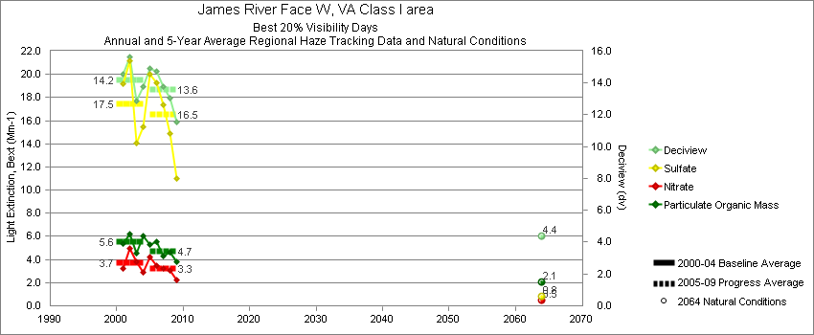
James River Face - Best 20% Visibility Days – 5-Year Average, Natural Conditions and Annual Data
Parameter | 2000-2004 | 2005-2009 | 2064 NC | 2000 | 2001 | 2002 | 2003 | 2004 | 2005 | 2006 | 2007 | 2008 | 2009
Deciview (dv) | 14.2 | 13.6 | 4.4 |  | 14.5 | 15.6 | 12.8 | 13.8 | 14.9 | 14.8 | 13.8 | 13.0 | 11.6
Sulfate Bext | 17.5 | 16.5 | 0.8 |  | 19.2 | 21.2 | 14.1 | 15.5 | 20.0 | 19.3 | 17.3 | 14.9 | 11.0
Nitrate Bext | 3.7 | 3.3 | 0.5 |  | 3.3 | 4.9 | 3.8 | 2.9 | 4.3 | 3.5 | 3.2 | 3.1 | 2.3
POM Bext | 5.6 | 4.7 | 2.1 |  | 5.4 | 6.2 | 4.6 | 6.0 | 5.3 | 5.6 | 4.3 | 4.7 | 3.8
EC Bext | 3.0 | 2.8 | 0.1 |  | 2.8 | 3.4 | 2.5 | 3.2 | 3.2 | 3.4 | 2.7 | 2.7 | 2.1
Soil Bext | 0.2 | 0.2 | 0.2 |  | 0.2 | 0.2 | 0.3 | 0.2 | 0.2 | 0.3 | 0.2 | 0.2 | 0.2
Coarse Mass Bext | 1.2 | 1.5 | 0.8 |  | 1.2 | 1.3 | 1.2 | 1.2 | 1.4 | 1.8 | 1.5 | 1.3 | 1.6
Sea Salt Bext | 0.1 | 0.1 | 0.1 |  | 0.1 | 0.0 | 0.0 | 0.2 | 0.1 | 0.2 | 0.2 | 0.1 | 0.2

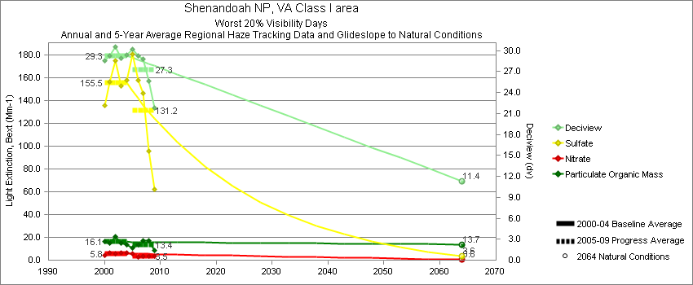
Shenandoah - Worst 20% Visibility Days – 5-Year Average, Natural Conditions and Annual Data
Parameter | 2000-2004 | 2005-2009 | 2064 NC | 2000 | 2001 | 2002 | 2003 | 2004 | 2005 | 2006 | 2007 | 2008 | 2009
Deciview (dv) | 29.3 | 27.3 | 11.4 | 28.5 | 29.2 | 30.5 | 28.9 | 29.3 | 30.8 | 29.3 | 28.8 | 25.6 | 21.8
Sulfate Bext | 155.5 | 131.2 | 3.6 | 135.9 | 156.2 | 174.8 | 153.0 | 157.6 | 193.4 | 158.0 | 146.6 | 95.8 | 62.0
Nitrate Bext | 5.8 | 3.5 | 0.6 | 4.5 | 6.2 | 5.9 | 6.3 | 6.1 | 4.5 | 2.7 | 3.3 | 3.5 | 3.6
POM Bext | 16.1 | 13.4 | 13.7 | 16.7 | 15.1 | 20.4 | 14.7 | 13.7 | 10.8 | 13.9 | 16.9 | 17.1 | 8.5
EC Bext | 5.7 | 4.7 | 0.3 | 6.5 | 5.9 | 5.5 | 5.6 | 5.1 | 5.3 | 5.2 | 5.2 | 4.4 | 3.5
Soil Bext | 0.7 | 0.7 | 0.8 | 0.4 | 0.6 | 1.1 | 0.5 | 1.0 | 0.5 | 0.7 | 0.8 | 0.8 | 0.6
Coarse Mass Bext | 2.5 | 2.4 | 3.0 | 2.8 | 2.8 | 3.3 | 2.0 | 1.8 | 2.1 | 2.5 | 2.7 | 2.5 | 2.3
Sea Salt Bext | 0.1 | 0.3 | 0.2 | 0.0 | 0.0 | 0.0 | 0.0 | 0.4 | 0.4 | 0.4 | 0.4 | 0.3 | 0.2

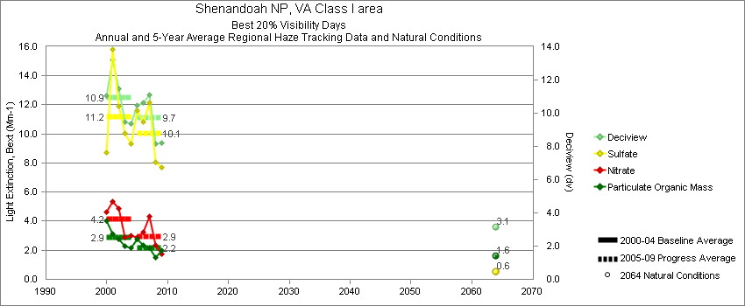
Shenandoah - Best 20% Visibility Days – 5-Year Average, Natural Conditions and Annual Data
Parameter | 2000-2004 | 2005-2009 | 2064 NC | 2000 | 2001 | 2002 | 2003 | 2004 | 2005 | 2006 | 2007 | 2008 | 2009
Deciview (dv) | 10.9 | 9.7 | 3.1 | 11.1 | 13.2 | 11.5 | 9.5 | 9.4 | 10.5 | 10.6 | 11.1 | 8.2 | 8.2
Sulfate Bext | 11.2 | 10.1 | 0.6 | 8.7 | 15.8 | 11.9 | 10.0 | 9.4 | 11.6 | 10.8 | 12.2 | 8.1 | 7.7
Nitrate Bext | 4.2 | 2.9 | 0.6 | 4.7 | 5.4 | 4.9 | 2.9 | 3.0 | 2.9 | 3.2 | 4.3 | 2.3 | 1.8
POM Bext | 2.9 | 2.2 | 1.6 | 4.0 | 3.1 | 2.8 | 2.3 | 2.1 | 2.8 | 2.4 | 2.2 | 1.5 | 2.0
EC Bext | 1.6 | 1.3 | 0.1 | 2.1 | 1.8 | 1.6 | 1.3 | 1.2 | 1.7 | 1.5 | 1.4 | 0.9 | 1.0
Soil Bext | 0.2 | 0.1 | 0.1 | 0.2 | 0.2 | 0.1 | 0.2 | 0.1 | 0.1 | 0.2 | 0.1 | 0.1 | 0.1
Coarse Mass Bext | 1.1 | 0.9 | 0.7 | 1.4 | 1.4 | 0.9 | 1.1 | 0.7 | 0.8 | 1.1 | 0.9 | 0.8 | 1.1
Sea Salt Bext | 0.1 | 0.2 | 0.1 | 0.1 | 0.3 | 0.0 | 0.1 | 0.3 | 0.1 | 0.3 | 0.2 | 0.1 | 0.1

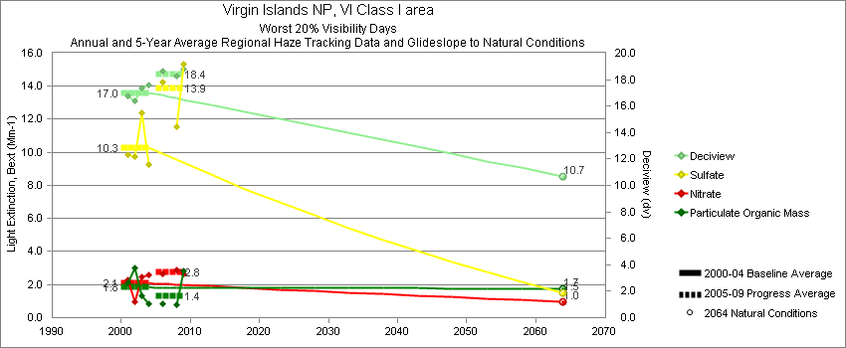
Virgin Islands - Worst 20% Visibility Days – 5-Year Average, Natural Conditions and Annual Data
Parameter | 2000-2004 | 2005-2009 | 2064 NC | 2000 | 2001 | 2002 | 2003 | 2004 | 2005 | 2006 | 2007 | 2008 | 2009
Deciview (dv) | 17.0 | 18.4 | 10.7 |  | 16.8 | 16.4 | 17.4 | 17.6 | 17.9 | 18.6 |  | 18.2 | 18.8
Sulfate Bext | 10.3 | 13.9 | 1.5 |  | 9.8 | 9.7 | 12.4 | 9.3 | 14.5 | 14.2 |  | 11.6 | 15.3
Nitrate Bext | 2.1 | 2.8 | 0.9 |  | 2.3 | 1.0 | 2.5 | 2.6 | 2.9 | 2.7 |  | 2.9 | 2.7
POM Bext | 1.8 | 1.4 | 1.7 |  | 2.1 | 3.0 | 1.3 | 0.9 | 0.9 | 0.9 |  | 0.8 | 2.8
EC Bext | 1.5 | 1.0 | 0.3 |  | 1.4 | 2.1 | 1.3 | 1.4 | 0.9 | 0.6 |  | 0.3 | 2.3
Soil Bext | 5.9 | 8.2 | 1.4 |  | 5.8 | 7.0 | 4.1 | 6.7 | 7.8 | 9.3 |  | 7.4 | 8.4
Coarse Mass Bext | 15.7 | 15.0 | 3.3 |  | 15.1 | 14.9 | 15.2 | 17.6 | 14.8 | 17.2 |  | 14.1 | 13.9
Sea Salt Bext | 7.5 | 11.2 | 9.4 |  | 6.5 | 3.8 | 9.7 | 9.9 | 8.4 | 9.9 |  | 15.7 | 10.7

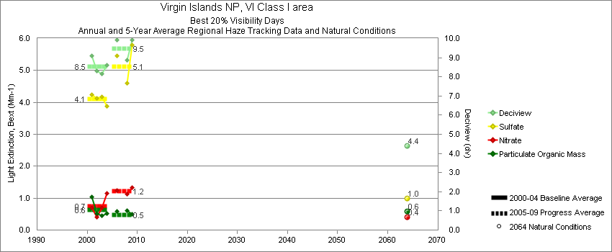
Virgin Islands - Best 20% Visibility Days – 5-Year Average, Natural Conditions and Annual Data
Parameter | 2000-2004 | 2005-2009 | 2064 NC | 2000 | 2001 | 2002 | 2003 | 2004 | 2005 | 2006 | 2007 | 2008 | 2009
Deciview (dv) | 8.5 | 9.5 | 4.4 |  | 9.1 | 8.3 | 8.1 | 8.6 | 9.2 | 9.9 |  | 8.9 | 9.9
Sulfate Bext | 4.1 | 5.1 | 1.0 |  | 4.2 | 4.1 | 4.2 | 3.9 | 4.6 | 5.4 |  | 4.6 | 5.8
Nitrate Bext | 0.7 | 1.2 | 0.4 |  | 0.7 | 0.4 | 0.7 | 1.2 | 1.2 | 1.2 |  | 1.1 | 1.3
POM Bext | 0.6 | 0.5 | 0.6 |  | 1.0 | 0.5 | 0.5 | 0.5 | 0.2 | 0.6 |  | 0.6 | 0.5
EC Bext | 0.5 | 0.4 | 0.1 |  | 0.4 | 0.5 | 0.5 | 0.6 | 0.4 | 0.5 |  | 0.4 | 0.4
Soil Bext | 0.3 | 0.3 | 0.1 |  | 0.4 | 0.4 | 0.2 | 0.2 | 0.3 | 0.2 |  | 0.3 | 0.3
Coarse Mass Bext | 4.0 | 3.2 | 0.9 |  | 4.3 | 4.4 | 3.6 | 3.5 | 3.2 | 3.4 |  | 2.9 | 3.3
Sea Salt Bext | 2.3 | 4.2 | 1.4 |  | 2.7 | 1.7 | 1.9 | 2.8 | 4.3 | 4.6 |  | 3.5 | 4.5

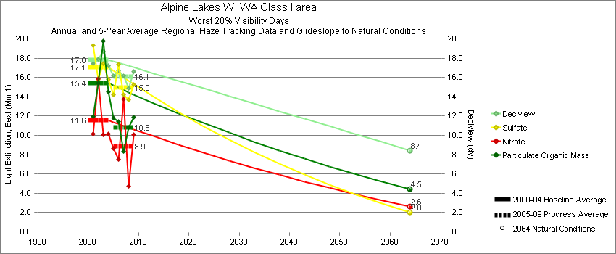
Snoqualmie Pass - Worst 20% Visibility Days – 5-Year Average, Natural Conditions and Annual Data
Parameter | 2000-2004 | 2005-2009 | 2064 NC | 2000 | 2001 | 2002 | 2003 | 2004 | 2005 | 2006 | 2007 | 2008 | 2009
Deciview (dv) | 17.8 | 16.1 | 8.4 |  | 17.5 | 17.9 | 18.7 | 17.2 | 16.1 | 16.7 | 16.2 | 14.9 | 16.6
Sulfate Bext | 17.1 | 15.0 | 2.0 |  | 19.3 | 15.8 | 17.4 | 15.8 | 14.3 | 17.3 | 14.2 | 13.7 | 15.3
Nitrate Bext | 11.6 | 8.9 | 2.6 |  | 10.1 | 15.8 | 10.1 | 10.2 | 8.4 | 7.5 | 13.8 | 4.7 | 10.1
POM Bext | 15.4 | 10.8 | 4.4 |  | 12.0 | 15.4 | 19.8 | 14.5 | 11.6 | 11.4 | 8.4 | 10.8 | 11.9
EC Bext | 4.2 | 3.3 | 0.4 |  | 4.3 | 4.4 | 4.7 | 3.5 | 3.4 | 3.9 | 3.4 | 2.9 | 2.9
Soil Bext | 0.4 | 0.4 | 0.5 |  | 0.4 | 0.5 | 0.4 | 0.4 | 0.3 | 0.5 | 0.3 | 0.5 | 0.4
Coarse Mass Bext | 1.5 | 1.5 | 1.7 |  | 1.2 | 1.6 | 1.9 | 1.3 | 1.4 | 2.1 | 1.0 | 1.7 | 1.4
Sea Salt Bext | 0.4 | 0.4 | 1.0 |  | 0.0 | 0.1 | 1.3 | 0.3 | 0.9 | 0.3 | 0.3 | 0.2 | 0.5

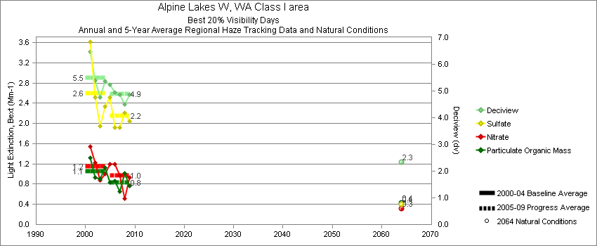
Snoqualmie Pass - Best 20% Visibility Days – 5-Year Average, Natural Conditions and Annual Data
Parameter | 2000-2004 | 2005-2009 | 2064 NC | 2000 | 2001 | 2002 | 2003 | 2004 | 2005 | 2006 | 2007 | 2008 | 2009
Deciview (dv) | 5.5 | 4.9 | 2.3 |  | 6.5 | 5.4 | 4.7 | 5.4 | 5.4 | 4.9 | 4.9 | 4.5 | 4.9
Sulfate Bext | 2.6 | 2.1 | 0.4 |  | 3.6 | 2.5 | 1.9 | 2.3 | 2.6 | 1.9 | 1.9 | 2.2 | 2.0
Nitrate Bext | 1.2 | 1.0 | 0.3 |  | 1.5 | 1.2 | 0.9 | 1.0 | 1.3 | 1.2 | 1.0 | 0.5 | 0.9
POM Bext | 1.1 | 0.8 | 0.4 |  | 1.3 | 0.9 | 0.9 | 1.1 | 0.8 | 0.9 | 0.7 | 1.0 | 0.8
EC Bext | 0.9 | 0.7 | 0.1 |  | 1.1 | 0.7 | 0.8 | 1.0 | 0.7 | 0.7 | 0.8 | 0.6 | 0.5
Soil Bext | 0.1 | 0.0 | 0.1 |  | 0.1 | 0.0 | 0.0 | 0.1 | 0.0 | 0.0 | 0.0 | 0.1 | 0.0
Coarse Mass Bext | 0.2 | 0.1 | 0.2 |  | 0.3 | 0.2 | 0.2 | 0.2 | 0.1 | 0.2 | 0.1 | 0.1 | 0.1
Sea Salt Bext | 0.5 | 0.7 | 0.2 |  | 0.4 | 0.6 | 0.5 | 0.6 | 0.7 | 0.6 | 0.8 | 0.3 | 1.0

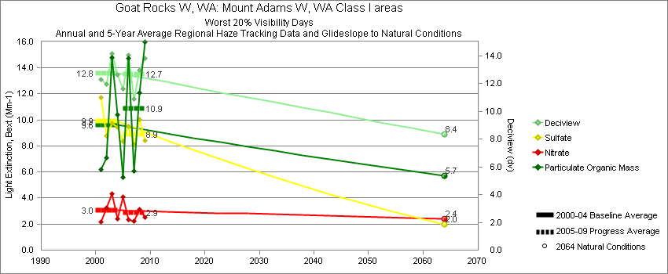
White Pass - Worst 20% Visibility Days – 5-Year Average, Natural Conditions and Annual Data
Parameter | 2000-2004 | 2005-2009 | 2064 NC | 2000 | 2001 | 2002 | 2003 | 2004 | 2005 | 2006 | 2007 | 2008 | 2009
Deciview (dv) | 12.8 | 12.7 | 8.4 |  | 12.3 | 11.9 | 14.1 | 12.6 | 11.6 | 14.0 | 10.9 | 13.0 | 13.8
Sulfate Bext | 9.9 | 8.9 | 2.0 |  | 11.7 | 8.8 | 9.7 | 9.5 | 8.4 | 9.5 | 8.1 | 10.1 | 8.4
Nitrate Bext | 3.1 | 2.9 | 2.4 |  | 2.2 | 3.3 | 4.4 | 2.4 | 4.1 | 2.3 | 2.2 | 3.1 | 2.5
POM Bext | 9.6 | 10.9 | 5.7 |  | 6.2 | 7.1 | 14.8 | 10.4 | 5.6 | 14.7 | 6.1 | 12.1 | 16.0
EC Bext | 1.8 | 2.1 | 0.5 |  | 1.6 | 1.5 | 2.3 | 1.8 | 1.8 | 2.8 | 1.6 | 1.9 | 2.4
Soil Bext | 0.6 | 0.5 | 0.6 |  | 0.9 | 0.4 | 0.4 | 0.5 | 0.4 | 0.7 | 0.4 | 0.6 | 0.5
Coarse Mass Bext | 1.7 | 2.5 | 1.9 |  | 1.6 | 2.0 | 2.0 | 1.4 | 2.2 | 2.4 | 1.6 | 2.0 | 4.5
Sea Salt Bext | 0.4 | 0.1 | 0.5 |  | 0.7 | 0.5 | 0.3 | 0.1 | 0.3 | 0.0 | 0.1 | 0.2 | 0.1

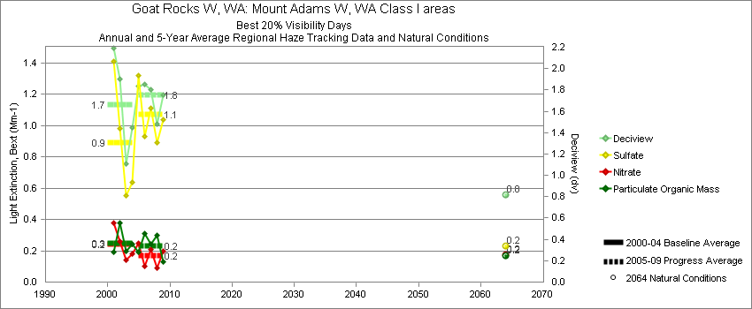
White Pass - Best 20% Visibility Days – 5-Year Average, Natural Conditions and Annual Data
Parameter | 2000-2004 | 2005-2009 | 2064 NC | 2000 | 2001 | 2002 | 2003 | 2004 | 2005 | 2006 | 2007 | 2008 | 2009
Deciview (dv) | 1.7 | 1.8 | 0.8 |  | 2.2 | 1.9 | 1.1 | 1.5 | 1.9 | 1.8 | 1.8 | 1.5 | 1.7
Sulfate Bext | 0.9 | 1.1 | 0.2 |  | 1.4 | 1.0 | 0.5 | 0.6 | 1.4 | 0.9 | 1.1 | 0.9 | 1.0
Nitrate Bext | 0.2 | 0.2 | 0.2 |  | 0.4 | 0.3 | 0.1 | 0.2 | 0.3 | 0.1 | 0.2 | 0.1 | 0.2
POM Bext | 0.3 | 0.2 | 0.2 |  | 0.2 | 0.4 | 0.2 | 0.2 | 0.2 | 0.3 | 0.2 | 0.3 | 0.1
EC Bext | 0.1 | 0.1 | 0.0 |  | 0.1 | 0.3 | 0.1 | 0.1 | 0.1 | 0.2 | 0.1 | 0.1 | 0.1
Soil Bext | 0.0 | 0.0 | 0.0 |  | 0.1 | 0.0 | 0.0 | 0.0 | 0.0 | 0.0 | 0.0 | 0.0 | 0.0
Coarse Mass Bext | 0.1 | 0.2 | 0.1 |  | 0.2 | 0.2 | 0.1 | 0.2 | 0.1 | 0.2 | 0.1 | 0.1 | 0.4
Sea Salt Bext | 0.1 | 0.2 | 0.1 |  | 0.2 | 0.1 | 0.1 | 0.2 | 0.1 | 0.3 | 0.2 | 0.1 | 0.1

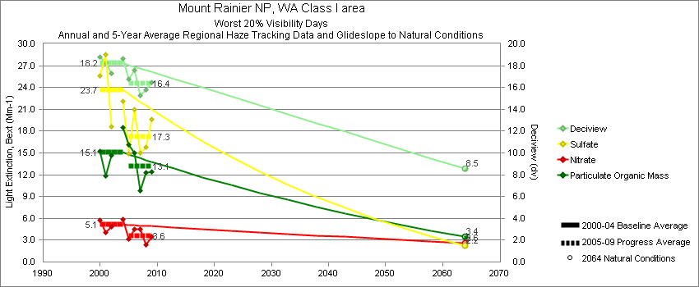
Mount Rainier - Worst 20% Visibility Days – 5-Year Average, Natural Conditions and Annual Data
Parameter | 2000-2004 | 2005-2009 | 2064 NC | 2000 | 2001 | 2002 | 2003 | 2004 | 2005 | 2006 | 2007 | 2008 | 2009
Deciview (dv) | 18.2 | 16.4 | 8.5 | 18.8 | 18.3 | 17.3 |  | 18.6 | 16.8 | 17.6 | 15.3 | 15.8 | 16.5
Sulfate Bext | 23.7 | 17.3 | 2.2 | 25.6 | 28.6 | 18.6 |  | 22.1 | 14.9 | 21.0 | 15.0 | 15.8 | 19.6
Nitrate Bext | 5.1 | 3.6 | 2.6 | 5.7 | 4.1 | 4.9 |  | 5.9 | 3.2 | 4.5 | 4.5 | 2.4 | 3.5
POM Bext | 15.1 | 13.1 | 3.4 | 15.3 | 11.8 | 14.7 |  | 18.5 | 16.2 | 15.0 | 9.8 | 12.3 | 12.4
EC Bext | 5.1 | 4.4 | 0.3 | 6.3 | 4.8 | 4.9 |  | 4.6 | 5.9 | 5.2 | 3.6 | 3.9 | 3.2
Soil Bext | 0.5 | 0.5 | 0.6 | 0.3 | 0.6 | 0.6 |  | 0.6 | 0.4 | 0.6 | 0.4 | 0.6 | 0.4
Coarse Mass Bext | 2.2 | 2.5 | 2.4 | 1.9 | 2.1 | 2.1 |  | 2.7 | 2.4 | 2.5 | 2.0 | 3.5 | 2.0
Sea Salt Bext | 0.1 | 0.4 | 1.0 | 0.0 | 0.0 | 0.0 |  | 0.2 | 0.3 | 0.2 | 0.7 | 0.3 | 0.4

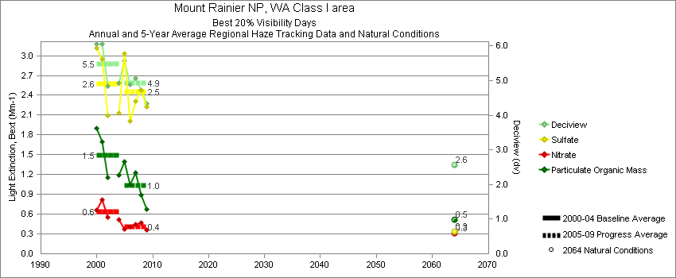
Mount Rainier - Best 20% Visibility Days – 5-Year Average, Natural Conditions and Annual Data
Parameter | 2000-2004 | 2005-2009 | 2064 NC | 2000 | 2001 | 2002 | 2003 | 2004 | 2005 | 2006 | 2007 | 2008 | 2009
Deciview (dv) | 5.5 | 4.9 | 2.6 | 6.1 | 6.1 | 4.8 |  | 4.9 | 5.7 | 4.8 | 5.1 | 4.7 | 4.3
Sulfate Bext | 2.6 | 2.5 | 0.3 | 3.1 | 3.0 | 2.1 |  | 2.1 | 3.2 | 2.0 | 2.3 | 2.5 | 2.2
Nitrate Bext | 0.6 | 0.4 | 0.3 | 0.7 | 0.8 | 0.6 |  | 0.5 | 0.4 | 0.4 | 0.4 | 0.5 | 0.4
POM Bext | 1.5 | 1.0 | 0.5 | 1.9 | 1.7 | 1.2 |  | 1.2 | 1.4 | 1.0 | 1.2 | 0.9 | 0.7
EC Bext | 0.7 | 0.5 | 0.1 | 0.7 | 0.9 | 0.5 |  | 0.5 | 0.7 | 0.7 | 0.5 | 0.3 | 0.4
Soil Bext | 0.0 | 0.0 | 0.1 | 0.1 | 0.1 | 0.0 |  | 0.0 | 0.0 | 0.0 | 0.0 | 0.0 | 0.1
Coarse Mass Bext | 0.5 | 0.4 | 0.5 | 0.5 | 0.6 | 0.6 |  | 0.5 | 0.6 | 0.3 | 0.5 | 0.4 | 0.4
Sea Salt Bext | 0.5 | 0.6 | 0.1 | 0.5 | 0.5 | 0.4 |  | 0.6 | 0.6 | 0.8 | 0.6 | 0.5 | 0.4

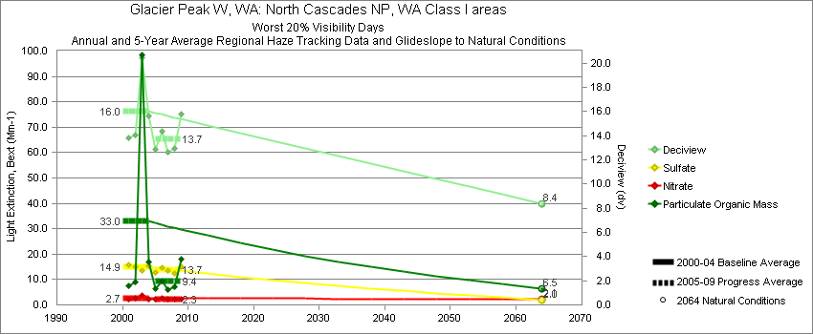
North Cascades - Worst 20% Visibility Days – 5-Year Average, Natural Conditions and Annual Data
Parameter | 2000-2004 | 2005-2009 | 2064 NC | 2000 | 2001 | 2002 | 2003 | 2004 | 2005 | 2006 | 2007 | 2008 | 2009
Deciview (dv) | 16.0 | 13.7 | 8.4 |  | 13.8 | 14.1 | 20.5 | 15.7 | 12.9 | 14.4 | 12.6 | 12.9 | 15.8
Sulfate Bext | 14.9 | 13.7 | 2.0 |  | 15.6 | 14.9 | 13.6 | 15.4 | 12.9 | 14.7 | 13.5 | 12.4 | 15.2
Nitrate Bext | 2.7 | 2.3 | 2.1 |  | 2.1 | 2.8 | 3.7 | 2.2 | 2.2 | 2.5 | 2.2 | 2.4 | 2.1
POM Bext | 33.0 | 9.4 | 6.5 |  | 7.6 | 9.0 | 98.7 | 16.8 | 6.4 | 9.4 | 5.9 | 7.3 | 18.1
EC Bext | 3.8 | 2.1 | 0.5 |  | 1.8 | 2.2 | 8.9 | 2.3 | 2.1 | 2.5 | 1.7 | 1.5 | 2.6
Soil Bext | 0.5 | 0.4 | 0.5 |  | 0.7 | 0.4 | 0.3 | 0.5 | 0.3 | 0.5 | 0.3 | 0.5 | 0.3
Coarse Mass Bext | 1.8 | 1.5 | 1.9 |  | 1.9 | 1.6 | 1.5 | 2.0 | 1.5 | 1.8 | 1.3 | 1.6 | 1.3
Sea Salt Bext | 0.0 | 0.2 | 0.2 |  | 0.0 | 0.0 | 0.0 | 0.0 | 0.2 | 0.2 | 0.3 | 0.3 | 0.1

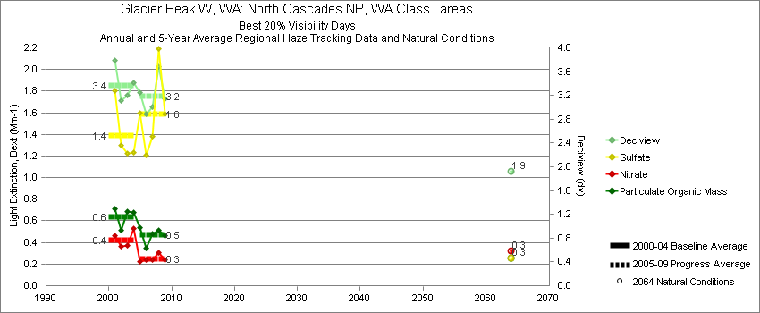
North Cascades - Best 20% Visibility Days – 5-Year Average, Natural Conditions and Annual Data
Parameter | 2000-2004 | 2005-2009 | 2064 NC | 2000 | 2001 | 2002 | 2003 | 2004 | 2005 | 2006 | 2007 | 2008 | 2009
Deciview (dv) | 3.4 | 3.2 | 1.9 |  | 3.8 | 3.1 | 3.2 | 3.4 | 3.3 | 2.8 | 3.0 | 3.7 | 3.2
Sulfate Bext | 1.4 | 1.6 | 0.3 |  | 1.8 | 1.3 | 1.2 | 1.2 | 1.6 | 1.2 | 1.4 | 2.2 | 1.6
Nitrate Bext | 0.4 | 0.2 | 0.3 |  | 0.5 | 0.4 | 0.4 | 0.5 | 0.2 | 0.2 | 0.2 | 0.3 | 0.2
POM Bext | 0.6 | 0.5 | 0.3 |  | 0.7 | 0.5 | 0.7 | 0.7 | 0.5 | 0.3 | 0.5 | 0.5 | 0.5
EC Bext | 0.2 | 0.2 | 0.0 |  | 0.3 | 0.2 | 0.2 | 0.3 | 0.2 | 0.2 | 0.1 | 0.1 | 0.2
Soil Bext | 0.0 | 0.0 | 0.0 |  | 0.0 | 0.0 | 0.0 | 0.0 | 0.0 | 0.0 | 0.0 | 0.1 | 0.0
Coarse Mass Bext | 0.2 | 0.2 | 0.2 |  | 0.2 | 0.2 | 0.2 | 0.2 | 0.2 | 0.1 | 0.2 | 0.2 | 0.1
Sea Salt Bext | 0.1 | 0.1 | 0.0 |  | 0.2 | 0.2 | 0.1 | 0.1 | 0.2 | 0.2 | 0.1 | 0.1 | 0.1

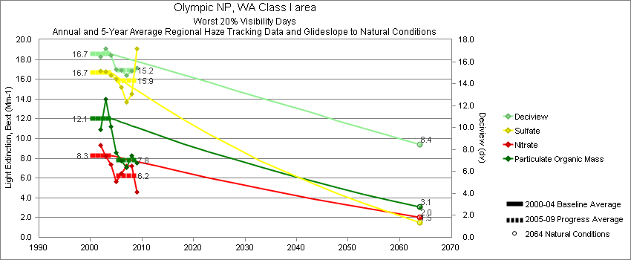
Olympic - Worst 20% Visibility Days – 5-Year Average, Natural Conditions and Annual Data
Parameter | 2000-2004 | 2005-2009 | 2064 NC | 2000 | 2001 | 2002 | 2003 | 2004 | 2005 | 2006 | 2007 | 2008 | 2009
Deciview (dv) | 16.7 | 15.2 | 8.4 |  |  | 16.5 | 17.2 | 16.6 | 15.4 | 15.2 | 14.8 | 15.2 | 15.4
Sulfate Bext | 16.7 | 15.8 | 1.5 |  |  | 16.9 | 16.7 | 16.4 | 16.3 | 15.6 | 13.7 | 14.5 | 19.1
Nitrate Bext | 8.3 | 6.2 | 2.0 |  |  | 9.3 | 8.2 | 7.4 | 5.7 | 6.5 | 7.2 | 7.2 | 4.6
POM Bext | 12.1 | 7.8 | 3.1 |  |  | 10.9 | 14.0 | 11.2 | 8.8 | 7.5 | 7.0 | 8.3 | 7.5
EC Bext | 2.7 | 2.1 | 0.3 |  |  | 2.6 | 3.1 | 2.5 | 2.6 | 2.2 | 2.3 | 1.8 | 1.4
Soil Bext | 0.3 | 0.3 | 0.3 |  |  | 0.4 | 0.2 | 0.3 | 0.2 | 0.3 | 0.2 | 0.4 | 0.3
Coarse Mass Bext | 1.8 | 1.6 | 1.9 |  |  | 1.7 | 1.7 | 1.9 | 1.4 | 2.1 | 1.4 | 1.5 | 1.6
Sea Salt Bext | 1.4 | 1.4 | 3.4 |  |  | 0.3 | 1.6 | 2.5 | 1.0 | 1.1 | 1.2 | 1.4 | 2.0

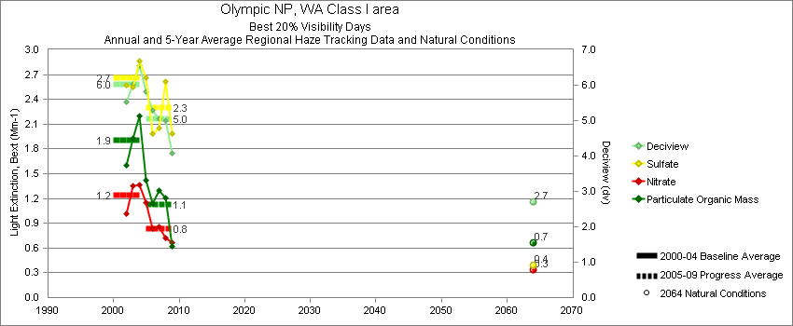
Olympic - Best 20% Visibility Days – 5-Year Average, Natural Conditions and Annual Data
Parameter | 2000-2004 | 2005-2009 | 2064 NC | 2000 | 2001 | 2002 | 2003 | 2004 | 2005 | 2006 | 2007 | 2008 | 2009
Deciview (dv) | 6.0 | 5.0 | 2.7 |  |  | 5.5 | 6.0 | 6.5 | 5.9 | 5.2 | 5.1 | 5.0 | 4.1
Sulfate Bext | 2.7 | 2.3 | 0.4 |  |  | 2.6 | 2.6 | 2.9 | 2.8 | 2.0 | 2.1 | 2.6 | 2.0
Nitrate Bext | 1.2 | 0.8 | 0.3 |  |  | 1.0 | 1.4 | 1.4 | 1.1 | 0.8 | 0.9 | 0.7 | 0.7
POM Bext | 1.9 | 1.1 | 0.7 |  |  | 1.6 | 1.9 | 2.2 | 1.4 | 1.1 | 1.3 | 1.2 | 0.6
EC Bext | 0.6 | 0.4 | 0.1 |  |  | 0.6 | 0.6 | 0.8 | 0.5 | 0.5 | 0.5 | 0.4 | 0.2
Soil Bext | 0.0 | 0.0 | 0.0 |  |  | 0.0 | 0.0 | 0.0 | 0.0 | 0.0 | 0.0 | 0.0 | 0.0
Coarse Mass Bext | 0.3 | 0.3 | 0.3 |  |  | 0.4 | 0.3 | 0.3 | 0.3 | 0.3 | 0.2 | 0.3 | 0.2
Sea Salt Bext | 0.6 | 0.8 | 0.3 |  |  | 0.4 | 0.6 | 0.9 | 1.2 | 1.2 | 0.6 | 0.5 | 0.5

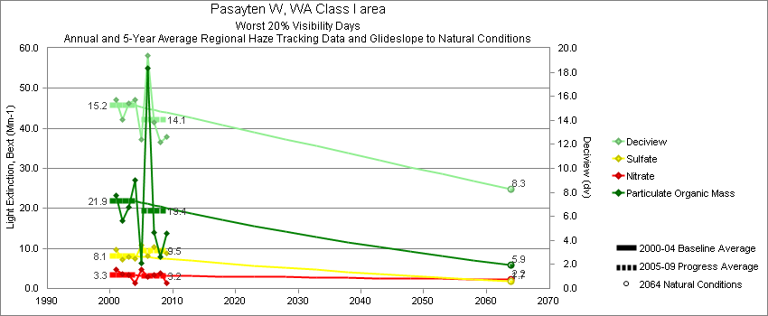
Pasayten - Worst 20% Visibility Days – 5-Year Average, Natural Conditions and Annual Data
Parameter | 2000-2004 | 2005-2009 | 2064 NC | 2000 | 2001 | 2002 | 2003 | 2004 | 2005 | 2006 | 2007 | 2008 | 2009
Deciview (dv) | 15.2 | 14.1 | 8.3 |  | 15.7 | 14.1 | 15.4 | 15.7 | 12.4 | 19.4 | 13.8 | 12.2 | 12.7
Sulfate Bext | 8.1 | 9.5 | 1.7 |  | 9.7 | 7.1 | 7.9 | 7.5 | 10.9 | 8.1 | 10.3 | 9.3 | 8.8
Nitrate Bext | 3.3 | 3.2 | 2.2 |  | 4.8 | 3.5 | 3.5 | 1.3 | 4.7 | 2.8 | 3.3 | 3.8 | 1.3
POM Bext | 21.9 | 19.4 | 5.9 |  | 23.3 | 16.9 | 20.3 | 27.1 | 6.2 | 55.1 | 13.9 | 7.9 | 13.8
EC Bext | 3.3 | 3.0 | 0.6 |  | 3.9 | 3.0 | 3.2 | 3.2 | 1.8 | 7.5 | 2.5 | 1.4 | 1.9
Soil Bext | 0.8 | 0.6 | 0.8 |  | 1.4 | 0.7 | 0.6 | 0.5 | 0.5 | 0.8 | 0.6 | 0.7 | 0.5
Coarse Mass Bext | 2.1 | 2.1 | 2.2 |  | 2.6 | 1.6 | 2.2 | 1.9 | 1.3 | 2.8 | 2.2 | 1.9 | 2.2
Sea Salt Bext | 0.1 | 0.1 | 0.2 |  | 0.2 | 0.0 | 0.1 | 0.0 | 0.2 | 0.0 | 0.1 | 0.1 | 0.2

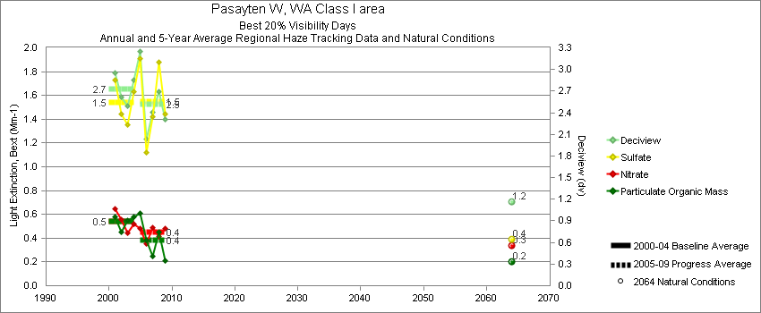
Pasayten - Best 20% Visibility Days – 5-Year Average, Natural Conditions and Annual Data
Parameter | 2000-2004 | 2005-2009 | 2064 NC | 2000 | 2001 | 2002 | 2003 | 2004 | 2005 | 2006 | 2007 | 2008 | 2009
Deciview (dv) | 2.7 | 2.5 | 1.2 |  | 3.0 | 2.6 | 2.5 | 2.9 | 3.2 | 2.0 | 2.4 | 2.7 | 2.3
Sulfate Bext | 1.5 | 1.5 | 0.4 |  | 1.7 | 1.4 | 1.4 | 1.6 | 1.9 | 1.1 | 1.4 | 1.9 | 1.4
Nitrate Bext | 0.5 | 0.4 | 0.3 |  | 0.6 | 0.6 | 0.4 | 0.5 | 0.5 | 0.3 | 0.5 | 0.4 | 0.5
POM Bext | 0.5 | 0.4 | 0.2 |  | 0.6 | 0.5 | 0.6 | 0.6 | 0.6 | 0.4 | 0.3 | 0.4 | 0.2
EC Bext | 0.2 | 0.1 | 0.0 |  | 0.2 | 0.1 | 0.2 | 0.2 | 0.2 | 0.2 | 0.1 | 0.1 | 0.1
Soil Bext | 0.1 | 0.1 | 0.1 |  | 0.1 | 0.1 | 0.1 | 0.1 | 0.1 | 0.1 | 0.0 | 0.1 | 0.1
Coarse Mass Bext | 0.2 | 0.2 | 0.1 |  | 0.1 | 0.2 | 0.1 | 0.2 | 0.2 | 0.1 | 0.2 | 0.2 | 0.2
Sea Salt Bext | 0.1 | 0.2 | 0.1 |  | 0.1 | 0.2 | 0.1 | 0.1 | 0.3 | 0.1 | 0.3 | 0.1 | 0.1

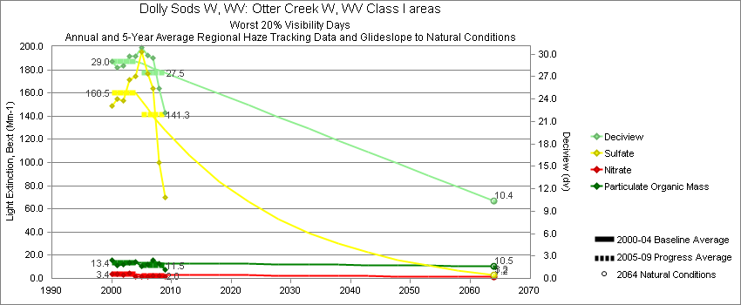
Dolly Sods - Worst 20% Visibility Days – 5-Year Average, Natural Conditions and Annual Data
Parameter | 2000-2004 | 2005-2009 | 2064 NC | 2000 | 2001 | 2002 | 2003 | 2004 | 2005 | 2006 | 2007 | 2008 | 2009
Deciview (dv) | 29.0 | 27.6 | 10.4 | 29.0 | 28.2 | 28.5 | 29.7 | 29.8 | 30.9 | 29.8 | 29.5 | 25.4 | 22.2
Sulfate Bext | 160.5 | 141.3 | 3.2 | 148.6 | 155.1 | 153.3 | 171.2 | 174.4 | 195.3 | 176.9 | 164.3 | 100.4 | 69.7
Nitrate Bext | 3.4 | 2.0 | 1.2 | 3.8 | 4.1 | 2.9 | 4.4 | 1.7 | 1.7 | 1.8 | 2.3 | 2.5 | 1.6
POM Bext | 13.4 | 11.5 | 10.5 | 15.4 | 11.5 | 11.8 | 13.5 | 14.6 | 10.2 | 11.8 | 15.7 | 12.6 | 7.3
EC Bext | 4.7 | 3.7 | 0.3 | 6.4 | 4.2 | 4.1 | 4.9 | 3.7 | 4.4 | 4.3 | 4.0 | 3.2 | 2.3
Soil Bext | 0.8 | 0.8 | 0.8 | 0.6 | 0.8 | 0.8 | 0.6 | 1.1 | 0.7 | 0.7 | 0.9 | 0.9 | 0.7
Coarse Mass Bext | 1.7 | 2.0 | 2.3 | 2.8 | 1.8 | 1.6 | 1.0 | 1.5 | 2.1 | 1.5 | 2.6 | 2.2 | 1.6
Sea Salt Bext | 0.1 | 0.1 | 0.3 | 0.0 | 0.3 | 0.0 | 0.0 | 0.3 | 0.1 | 0.2 | 0.1 | 0.1 | 0.0

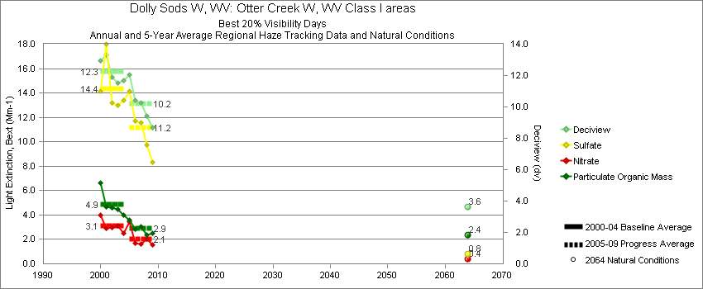
Dolly Sods - Best 20% Visibility Days – 5-Year Average, Natural Conditions and Annual Data
Parameter | 2000-2004 | 2005-2009 | 2064 NC | 2000 | 2001 | 2002 | 2003 | 2004 | 2005 | 2006 | 2007 | 2008 | 2009
Deciview (dv) | 12.3 | 10.2 | 3.6 | 13.0 | 13.3 | 11.9 | 11.5 | 11.7 | 12.1 | 10.6 | 10.3 | 9.4 | 8.7
Sulfate Bext | 14.3 | 11.2 | 0.8 | 14.1 | 18.0 | 13.2 | 13.0 | 13.4 | 14.2 | 12.0 | 11.6 | 9.7 | 8.3
Nitrate Bext | 3.1 | 2.1 | 0.4 | 4.0 | 2.9 | 3.0 | 3.1 | 2.5 | 3.5 | 1.6 | 1.6 | 2.0 | 1.6
POM Bext | 4.9 | 2.9 | 2.4 | 6.6 | 4.7 | 4.6 | 4.4 | 4.0 | 3.6 | 2.9 | 3.1 | 2.4 | 2.5
EC Bext | 2.1 | 1.4 | 0.1 | 2.9 | 2.1 | 2.0 | 1.7 | 1.6 | 1.9 | 1.6 | 1.4 | 1.0 | 1.0
Soil Bext | 0.2 | 0.2 | 0.2 | 0.2 | 0.2 | 0.1 | 0.2 | 0.2 | 0.2 | 0.2 | 0.2 | 0.2 | 0.3
Coarse Mass Bext | 0.7 | 0.8 | 0.6 | 0.7 | 0.7 | 0.7 | 0.7 | 0.8 | 0.9 | 0.8 | 0.8 | 0.8 | 0.7
Sea Salt Bext | 0.1 | 0.2 | 0.1 | 0.1 | 0.0 | 0.0 | 0.1 | 0.4 | 0.1 | 0.2 | 0.2 | 0.3 | 0.1

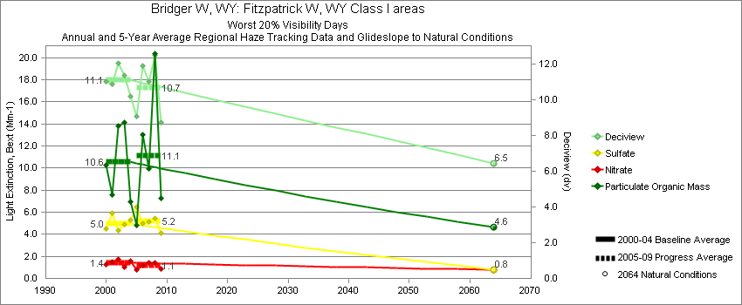
Bridger - Worst 20% Visibility Days – 5-Year Average, Natural Conditions and Annual Data
Parameter | 2000-2004 | 2005-2009 | 2064 NC | 2000 | 2001 | 2002 | 2003 | 2004 | 2005 | 2006 | 2007 | 2008 | 2009
Deciview (dv) | 11.1 | 10.7 | 6.5 | 11.0 | 10.9 | 12.1 | 11.4 | 10.2 | 9.1 | 11.9 | 11.0 | 12.5 | 8.8
Sulfate Bext | 5.0 | 5.2 | 0.8 | 4.5 | 5.9 | 4.3 | 4.9 | 5.3 | 6.3 | 5.0 | 5.1 | 5.4 | 4.1
Nitrate Bext | 1.4 | 1.1 | 0.8 | 1.3 | 1.5 | 1.7 | 1.1 | 1.6 | 0.8 | 1.2 | 1.4 | 1.4 | 0.9
POM Bext | 10.5 | 11.1 | 4.6 | 10.3 | 7.6 | 13.8 | 14.1 | 6.9 | 5.0 | 13.1 | 10.0 | 20.3 | 7.3
EC Bext | 2.0 | 1.9 | 0.4 | 2.6 | 1.5 | 2.4 | 2.1 | 1.4 | 1.3 | 2.5 | 1.9 | 2.5 | 1.3
Soil Bext | 1.1 | 1.0 | 1.1 | 0.9 | 1.5 | 1.1 | 0.7 | 1.3 | 0.8 | 1.1 | 0.9 | 1.4 | 0.9
Coarse Mass Bext | 2.5 | 2.3 | 2.7 | 2.5 | 3.0 | 2.2 | 2.1 | 2.7 | 2.1 | 2.3 | 2.5 | 2.6 | 1.8
Sea Salt Bext | 0.0 | 0.0 | 0.0 | 0.0 | 0.0 | 0.0 | 0.1 | 0.1 | 0.0 | 0.0 | 0.0 | 0.1 | 0.1

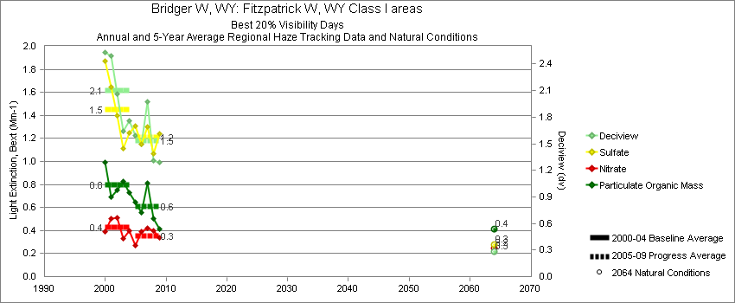
Bridger - Best 20% Visibility Days – 5-Year Average, Natural Conditions and Annual Data
Parameter | 2000-2004 | 2005-2009 | 2064 NC | 2000 | 2001 | 2002 | 2003 | 2004 | 2005 | 2006 | 2007 | 2008 | 2009
Deciview (dv) | 2.1 | 1.5 | 0.3 | 2.5 | 2.5 | 2.1 | 1.6 | 1.8 | 1.6 | 1.5 | 2.0 | 1.3 | 1.3
Sulfate Bext | 1.5 | 1.2 | 0.3 | 1.9 | 1.6 | 1.4 | 1.1 | 1.3 | 1.3 | 1.1 | 1.3 | 1.1 | 1.2
Nitrate Bext | 0.4 | 0.3 | 0.2 | 0.4 | 0.5 | 0.5 | 0.3 | 0.4 | 0.2 | 0.3 | 0.4 | 0.4 | 0.3
POM Bext | 0.8 | 0.6 | 0.4 | 1.0 | 0.7 | 0.7 | 0.8 | 0.7 | 0.7 | 0.6 | 0.8 | 0.5 | 0.4
EC Bext | 0.4 | 0.2 | 0.1 | 0.3 | 0.6 | 0.4 | 0.3 | 0.2 | 0.3 | 0.2 | 0.3 | 0.1 | 0.1
Soil Bext | 0.1 | 0.1 | 0.1 | 0.1 | 0.1 | 0.1 | 0.1 | 0.1 | 0.1 | 0.1 | 0.1 | 0.1 | 0.1
Coarse Mass Bext | 0.2 | 0.2 | 0.2 | 0.3 | 0.3 | 0.2 | 0.2 | 0.3 | 0.2 | 0.2 | 0.3 | 0.2 | 0.2
Sea Salt Bext | 0.0 | 0.0 | 0.0 | 0.0 | 0.0 | 0.0 | 0.0 | 0.0 | 0.0 | 0.0 | 0.0 | 0.0 | 0.0

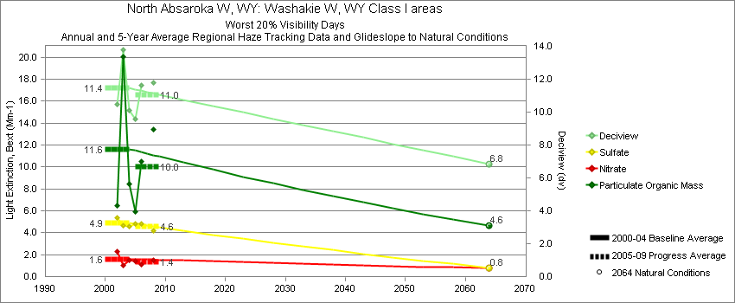
North Absaroka - Worst 20% Visibility Days – 5-Year Average, Natural Conditions and Annual Data
Parameter | 2000-2004 | 2005-2009 | 2064 NC | 2000 | 2001 | 2002 | 2003 | 2004 | 2005 | 2006 | 2007 | 2008 | 2009
Deciview (dv) | 11.5 | 11.0 | 6.8 |  |  | 10.5 | 13.8 | 10.1 | 9.6 | 11.6 |  | 11.8
Sulfate Bext | 4.9 | 4.6 | 0.8 |  |  | 5.3 | 4.7 | 4.6 | 4.8 | 4.8 |  | 4.2
Nitrate Bext | 1.6 | 1.4 | 0.8 |  |  | 2.3 | 1.1 | 1.5 | 1.4 | 1.1 |  | 1.5
POM Bext | 11.6 | 10.0 | 4.6 |  |  | 6.5 | 20.1 | 8.4 | 6.0 | 10.5 |  | 13.5
EC Bext | 1.9 | 1.8 | 0.4 |  |  | 1.3 | 2.9 | 1.4 | 1.6 | 2.1 |  | 1.7
Soil Bext | 0.8 | 0.8 | 0.9 |  |  | 1.0 | 0.8 | 0.7 | 0.6 | 1.2 |  | 0.7
Coarse Mass Bext | 2.9 | 3.4 | 3.4 |  |  | 3.4 | 2.9 | 2.4 | 2.9 | 4.4 |  | 2.9
Sea Salt Bext | 0.0 | 0.0 | 0.0 |  |  | 0.0 | 0.0 | 0.0 | 0.0 | 0.0 |  | 0.0

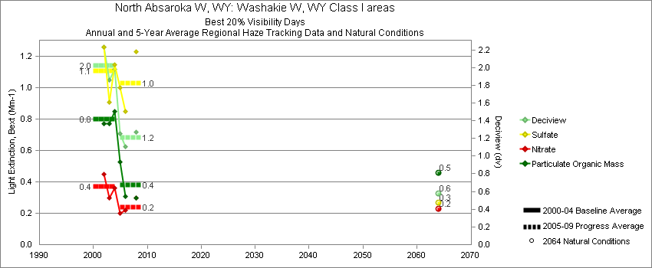
North Absaroka - Best 20% Visibility Days – 5-Year Average, Natural Conditions and Annual Data
Parameter | 2000-2004 | 2005-2009 | 2064 NC | 2000 | 2001 | 2002 | 2003 | 2004 | 2005 | 2006 | 2007 | 2008 | 2009
Deciview (dv) | 2.0 | 1.2 | 0.6 |  |  | 2.2 | 1.9 | 2.0 | 1.3 | 1.1 |  | 1.3
Sulfate Bext | 1.1 | 1.0 | 0.3 |  |  | 1.3 | 0.9 | 1.1 | 1.0 | 0.9 |  | 1.2
Nitrate Bext | 0.4 | 0.2 | 0.2 |  |  | 0.5 | 0.3 | 0.4 | 0.2 | 0.2 |  | 0.3
POM Bext | 0.8 | 0.4 | 0.5 |  |  | 0.8 | 0.8 | 0.9 | 0.5 | 0.3 |  | 0.3
EC Bext | 0.2 | 0.2 | 0.0 |  |  | 0.2 | 0.2 | 0.2 | 0.2 | 0.2 |  | 0.1
Soil Bext | 0.1 | 0.1 | 0.1 |  |  | 0.1 | 0.1 | 0.1 | 0.1 | 0.1 |  | 0.1
Coarse Mass Bext | 0.7 | 0.4 | 0.5 |  |  | 0.7 | 0.8 | 0.6 | 0.4 | 0.5 |  | 0.4
Sea Salt Bext | 0.0 | 0.0 | 0.0 |  |  | 0.0 | 0.0 | 0.0 | 0.0 | 0.0 |  | 0.0

Yellowstone - Worst 20% Visibility Days – 5-Year Average, Natural Conditions and Annual Data
Parameter | 2000-2004 | 2005-2009 | 2064 NC | 2000 | 2001 | 2002 | 2003 | 2004 | 2005 | 2006 | 2007 | 2008 | 2009
Deciview (dv) | 11.8 | 11.5 | 6.4 | 12.9 | 12.6 | 11.4 | 11.2 | 10.8 | 9.6 | 11.8 | 12.6 | 14.0 | 9.6
Sulfate Bext | 4.3 | 4.6 | 0.8 | 4.2 | 4.7 | 3.8 | 4.1 | 4.6 | 4.8 | 5.1 | 4.3 | 5.0 | 3.5
Nitrate Bext | 1.8 | 1.6 | 0.6 | 2.0 | 2.4 | 1.6 | 1.4 | 1.5 | 1.6 | 0.9 | 2.4 | 1.7 | 1.6
POM Bext | 13.5 | 15.5 | 4.6 | 18.4 | 16.1 | 11.2 | 12.8 | 8.9 | 6.7 | 15.1 | 14.7 | 25.6 | 15.2
EC Bext | 2.5 | 2.2 | 0.4 | 3.7 | 2.6 | 1.9 | 2.3 | 1.9 | 1.8 | 2.3 | 2.4 | 2.6 | 1.7
Soil Bext | 1.0 | 0.8 | 1.0 | 0.8 | 1.4 | 1.2 | 0.4 | 0.9 | 0.6 | 1.1 | 0.8 | 1.0 | 0.6
Coarse Mass Bext | 2.6 | 2.4 | 3.0 | 2.8 | 2.7 | 3.1 | 1.3 | 2.9 | 1.8 | 2.6 | 2.6 | 2.6 | 2.3
Sea Salt Bext | 0.0 | 0.1 | 0.0 | 0.0 | 0.0 | 0.0 | 0.0 | 0.1 | 0.1 | 0.0 | 0.0 | 0.1 | 0.1

Yellowstone - Best 20% Visibility Days – 5-Year Average, Natural Conditions and Annual Data
Parameter | 2000-2004 | 2005-2009 | 2064 NC | 2000 | 2001 | 2002 | 2003 | 2004 | 2005 | 2006 | 2007 | 2008 | 2009
Deciview (dv) | 2.6 | 2.0 | 0.4 | 2.8 | 3.0 | 2.6 | 1.9 | 2.6 | 2.1 | 2.3 | 2.2 | 1.8 | 1.9
Sulfate Bext | 1.5 | 1.4 | 0.3 | 1.7 | 1.9 | 1.3 | 1.1 | 1.3 | 1.5 | 1.6 | 1.2 | 1.1 | 1.4
Nitrate Bext | 0.7 | 0.5 | 0.3 | 0.9 | 0.8 | 0.8 | 0.5 | 0.6 | 0.3 | 0.4 | 0.7 | 0.6 | 0.6
POM Bext | 1.1 | 0.8 | 0.5 | 1.1 | 1.2 | 1.1 | 0.9 | 1.3 | 1.1 | 0.8 | 1.0 | 0.8 | 0.5
EC Bext | 0.3 | 0.3 | 0.1 | 0.2 | 0.4 | 0.3 | 0.2 | 0.5 | 0.3 | 0.4 | 0.3 | 0.1 | 0.2
Soil Bext | 0.1 | 0.1 | 0.1 | 0.1 | 0.1 | 0.1 | 0.1 | 0.1 | 0.1 | 0.1 | 0.1 | 0.1 | 0.1
Coarse Mass Bext | 0.2 | 0.2 | 0.2 | 0.3 | 0.2 | 0.3 | 0.2 | 0.3 | 0.1 | 0.2 | 0.2 | 0.3 | 0.3
Sea Salt Bext | 0.0 | 0.0 | 0.0 | 0.1 | 0.0 | 0.0 | 0.0 | 0.0 | 0.0 | 0.0 | 0.0 | 0.0 | 0.0

